NAME : K.Avinash
REG NO: (192412662)
COURSE NAME : 5G 6G COMMUNICTION (ECA5601)
DATE : 12/08/2026

EX NO: 6 | 5G NR Frame Structure Analysis with Different Subcarrier Spacing

Aim
To analyze the 5G NR frame structure by studying the effect of different subcarrier spacings, slot durations, and OFDM symbols using MATLAB.
Software Required
- MATLAB

Procedure
- Define the supported 5G NR subcarrier spacing values.
- Display the values using MATLAB.
- Plot the subcarrier spacing for different numerologies.
Objective – 1: Analyze Different Subcarrier Spacing Values MATLAB Program
clc; clear; close all;

scs = [15 30 60 120 240]; % Subcarrier Spacing (kHz) mu = 0:4; % Numerology Index bar(scs) grid on set(gca,'XTick',1:5) set(gca,'XTickLabel',mu)
xlabel('Numerology Index (\mu)') ylabel('Subcarrier Spacing (kHz)') title('5G NR Subcarrier Spacing for Different Numerologies')

OUTPUT:

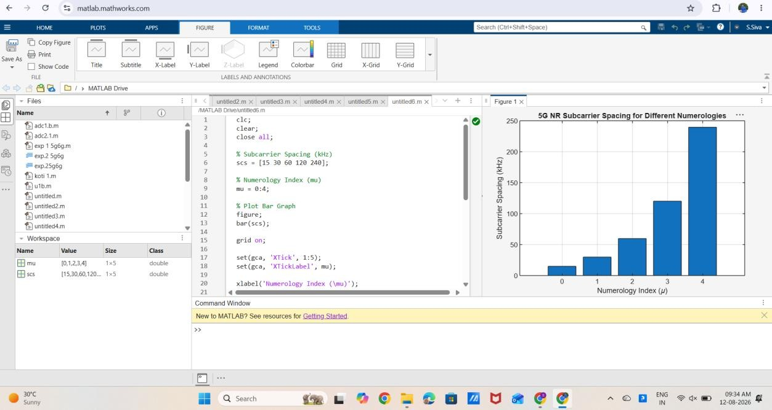

Result:
The MATLAB analysis successfully demonstrated the flexible numerology of 5G NR. The results showed that increasing the subcarrier spacing decreases the slot duration while maintaining a constant number of OFDM symbols per slot under the normal cyclic prefix configuration.

