NAME : K.Avinash
REG NO: (192412662)
COURSE NAME : 5G 6G COMMUNICTION (ECA5601)
DATE : 13/08/2026

EX NO: 7 | Analog Beamforming Analysis Using MATLAB

Aim
To analyze the performance of analog beamforming by studying beamforming gain, beam width, and main lobe direction using MATLAB.
Software Required
• MATLAB
MATLAB Code:
clc; clear; close all; antennas = [2 4 8 16 32]; % Number of Antenna Elements gain = 10*log10(antennas); % Beamforming Gain (dB) figure bar(antennas, gain) grid on

xlabel('Number of Antenna Elements') ylabel('Beamforming Gain (dB)') title('Beamforming Gain for Different Antenna Array Sizes') OUTPUT:

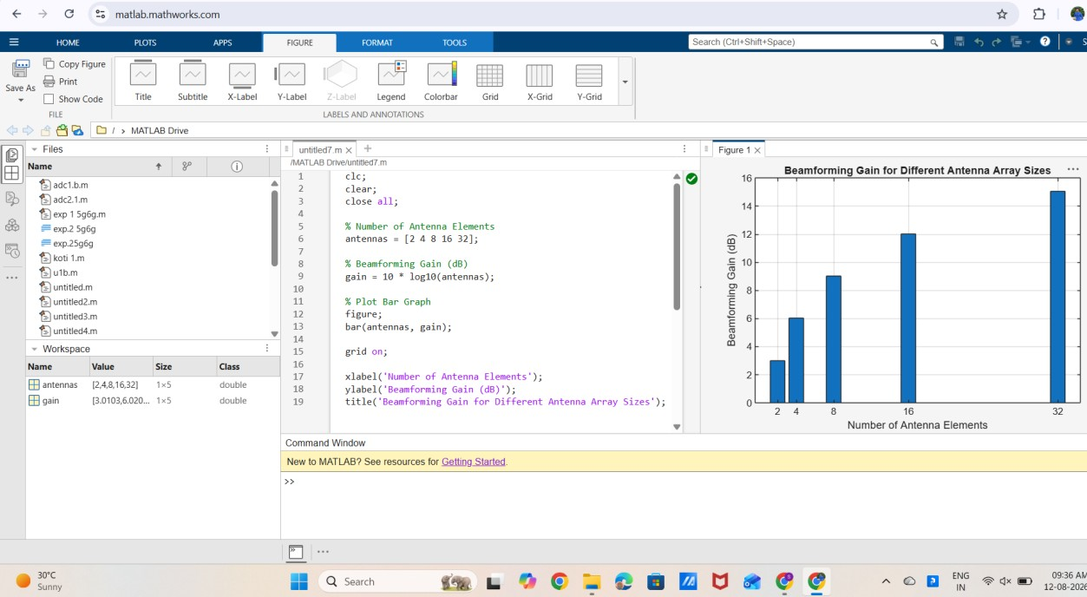

Result:
The MATLAB analysis successfully demonstrated the characteristics of analog beamforming. The results showed that increasing the number of antenna elements improves beamforming gain and reduces beam width, while phase adjustment enables the main lobe to be steered toward different directions.

