NAME : K.Avinash
REG NO: (192412662)
COURSE NAME : 5G 6G COMMUNICTION (ECA5601)
DATE : 12/08/2026

EX NO: 8 | Steering Angle Variation in MIMO Beamforming Using MATLAB

Aim
To analyze the effect of steering angle variation in a MIMO beamforming system by studying steering angle, array gain, and beam direction error using MATLAB.
Software Required
- MATLAB
MATLAB Code:
clc; clear; close all; angle = [-60 -30 0 30 60]; % Steering Angles (degrees) gain = ones(size(angle)); % Normalized Gain figure polarplot(deg2rad(angle), gain,'o-','LineWidth',2) title('Steering Angle Variation in MIMO Beamforming') OUTPUT:

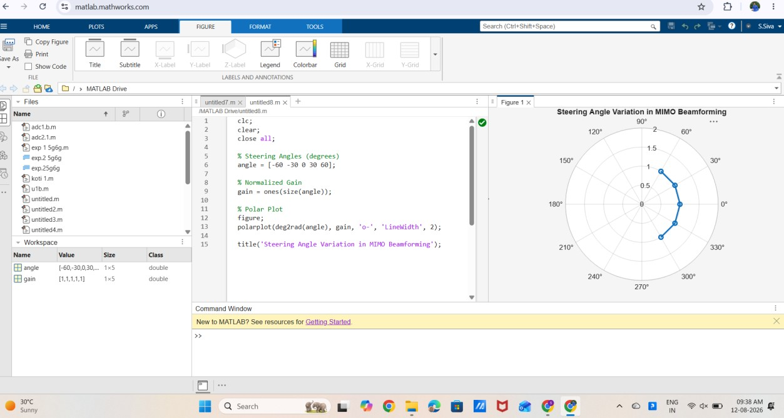

Result:
- Plot showing different steering angles.
- Beam steering visualization.

