NAME : K.Avinash
REG NO: (192412662)
COURSE NAME : 5G 6G COMMUNICTION (ECA5601)
DATE : 12/08/2026

EX NO: 9 | Massive MIMO Capacity vs SNR and Gain Using MATLAB

Aim
To analyze the performance of a Massive MIMO system by studying channel capacity, signal-to-noise ratio (SNR), and antenna gain using MATLAB.

Software Required
• MATLAB

MATLAB Code:
clc; clear; close all; snr = 0:5:30; snr_linear = 10.^(snr/10); capacity = log2(1 + snr_linear); figure; plot(snr,capacity,'-o','LineWidth',2,'MarkerSize',6); grid on; xlabel('SNR (dB)'); ylabel('Channel Capacity (bps/Hz)'); title('Channel Capacity vs SNR');

OUTPUT:

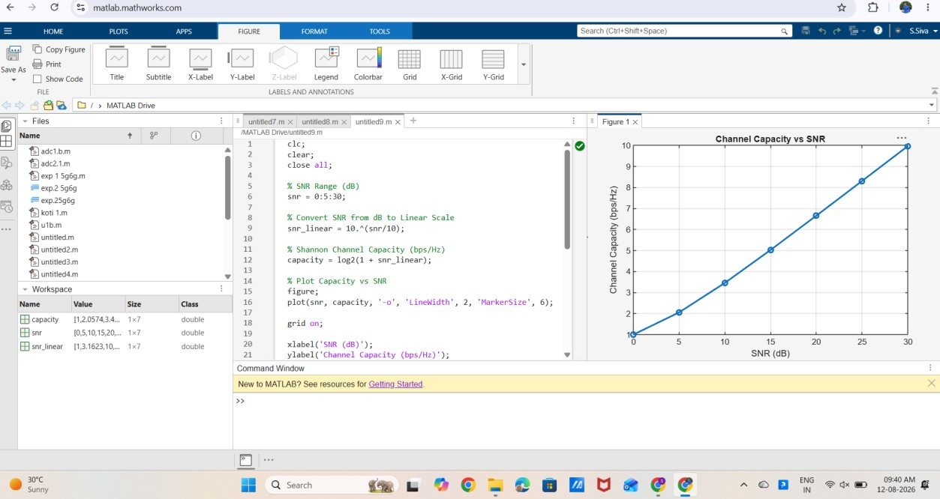

Result:
The MATLAB analysis successfully demonstrated the relationship between channel capacity, signal-to-noise ratio, and antenna gain in a Massive MIMO system. The results
showed that higher SNR and larger antenna arrays improve communication performance by increasing channel capacity and directional gain.

