1)Write a Python program to calculate the area of a rectangle given its length and width.

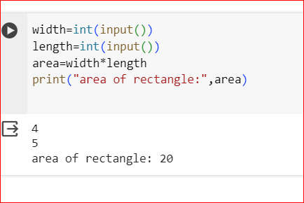

2)Write a program to convert miles to kilometers

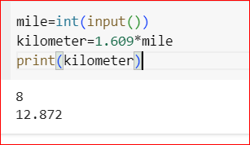

3)Write a function to check if a given string is a palindrome.

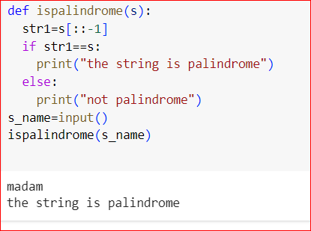

4)Write a Python program to find the second largest element in a list

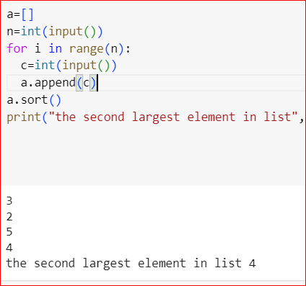

5)Explain what indentation means in Python.

In Python, indentation is used to indicate a block of code. It is the space at the beginning of a code line that determines the grouping and hierarchy of statements

Eg:

if name==manoj:

print(“hi manoj”)

6. Write a program to perform set difference operation

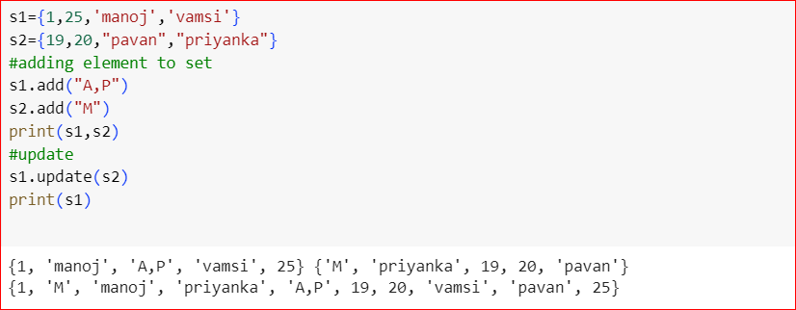

7. Write a Python program to print numbers from 1 to 10 using a while loop

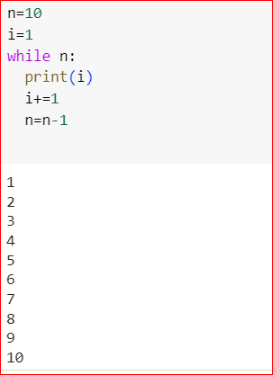

8. Write a program to calculate the factorial of a number using a while loop.

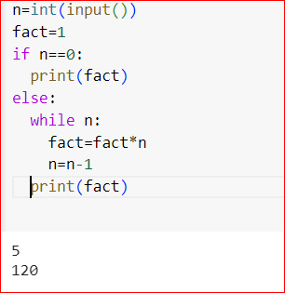

9)Write a Python program to check if a number is positive, negative, or zero using if-elif-else statements

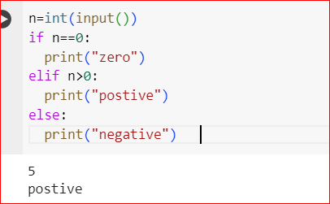

10)Write a program to determine the largest among three numbers using conditional statements.

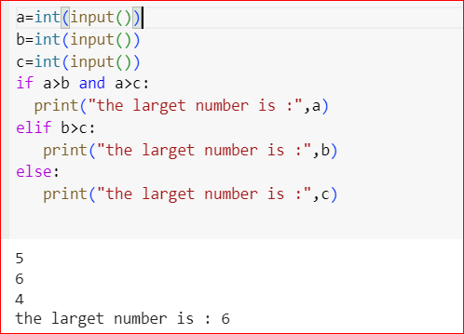

11)Write a Python program to create a numpy array filled with ones of given shape

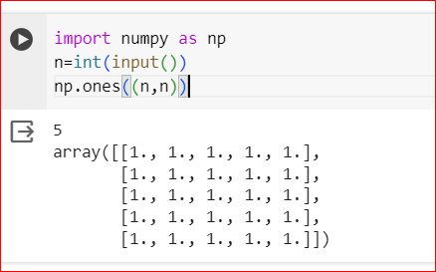

12)Write a program to create a 2D numpy array initialized with random integers

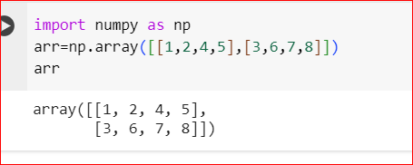

13)Write a Python program to generate an array of evenly spaced numbers over a specified range using linspace

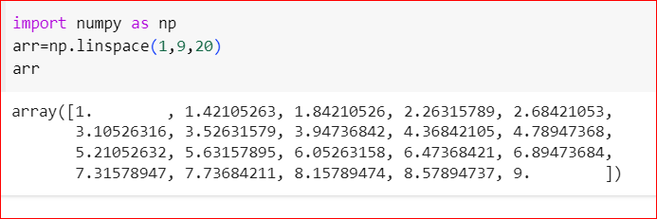

14. Write a program to generate an array of 10 equally spaced values between 1 and 100 using linspace

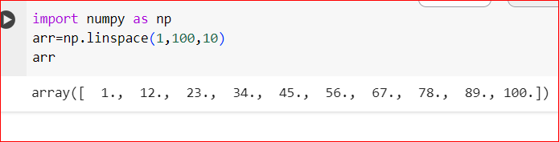

15. Write a Python program to create an array containing even numbers from 2 to 20 using arange.

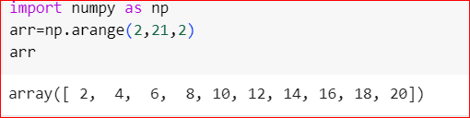

16)Write a program to create an array containing numbers from 1 to 10 with a step size of 0.5 using arrange

