1.PWD-it stands for print working directory

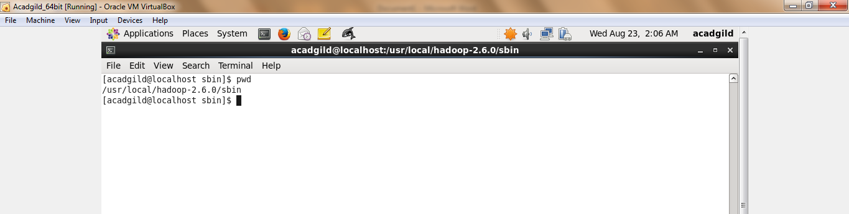

2.Vi-it is used to create a new file in editor.

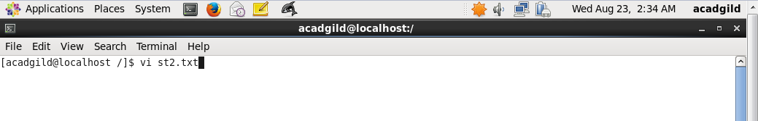

3.Touch--it is used to create a new file it it is not created and if the file is already there then it change the update time to current time.



4.mkdir--it is used to create a new directory.

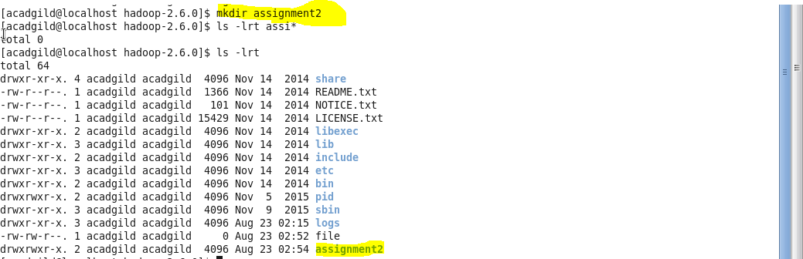

5.rm--it is used to delete to a file and a directory.



6.ls-it is list all the files in a directory.



7.echo-it is used to display a string on standard output.



8.cat --it is used to create or view content of a file



9.who--it is used to print about all users who are currently logged in.



10.cd--it is used to change directory.



11.date--it gives system current date and time.



12.cal--it is used to display calendar.

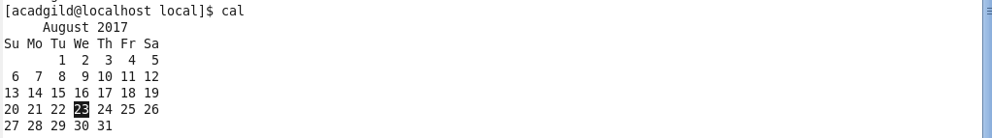

13.mv --this command is used to move a file from one folder to another.



14.cp--it is used to copy content of a file.



15.which--it gives location of the file which would be in argument.

