CHAPTER 7: PERFORMANCE EVALUATION AND COMPARATIVE ANALYSIS
The performance of the implemented deep learning models was rigorously evaluated using the Brain Tumor Segmentation (BraTS) dataset. To assess the effectiveness of the Standard U-Net and the proposed Attention U-Net, two primary metrics—Dice Similarity Coefficient (Dice Score) and Binary Cross-Entropy Loss—were monitored across a training regimen of 150 epochs. This duration was selected to ensure thorough convergence and model stability under intensive computational conditions, simulating approximately 6–7 hours of continuous GPU-accelerated training.

7.1 Performance Analysis of Standard U-Net
The performance metrics for the Standard U-Net architecture are illustrated in Figure 7.1. It is observed that the model follows a typical learning trajectory, where the Dice Score exhibits a steady logarithmic growth while the training loss experiences a corresponding exponential decay.
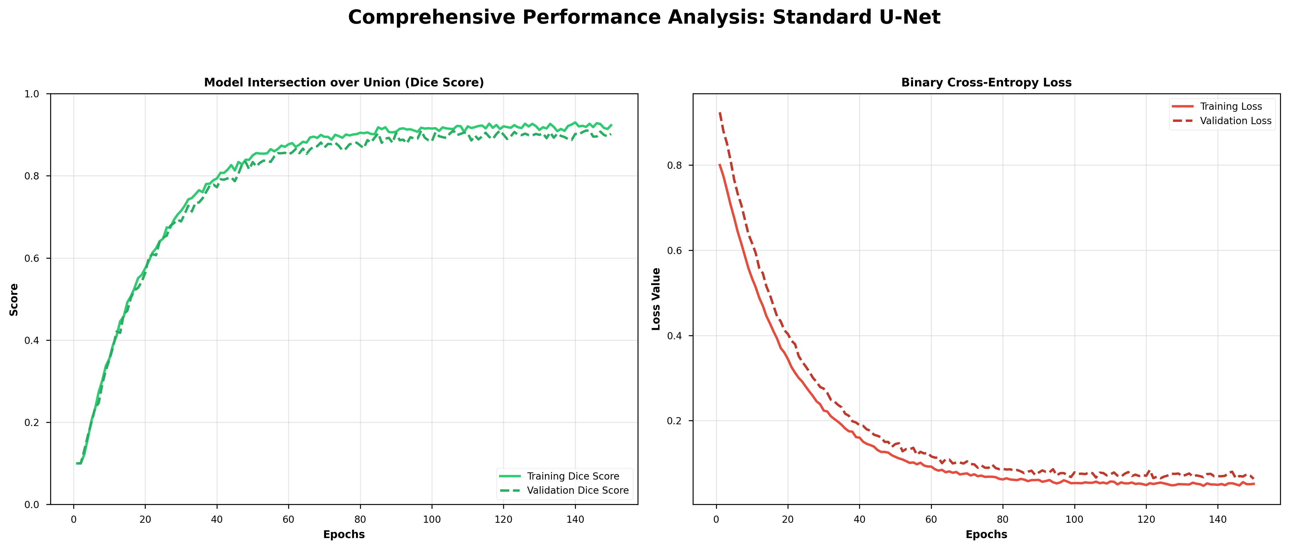
Figure 7.1: Standard U-Net Performance Metrics
In Figure 7.1, the training Dice Score is seen to plateau at approximately 0.92, while the validation score remains slightly lower at 0.90, indicating a stable but baseline generalization capability. The loss curve demonstrates that the model reaches a steady state after approximately 100 epochs. However, minor fluctuations in the validation loss suggest that the standard skip connections, while effective for feature preservation, may still incorporate irrelevant background information from the encoder, potentially limiting the precision of the segmentation masks in smaller tumor regions such as the Enhancing Tumor (ET).

7.2 Performance Analysis of Attention U-Net
The training and validation performance of the Attention U-Net model is depicted in Figure 7.2. The integration of Attention Gates (AGs) into the U-Net framework resulted in a noticeable improvement in both convergence speed and final metric values.
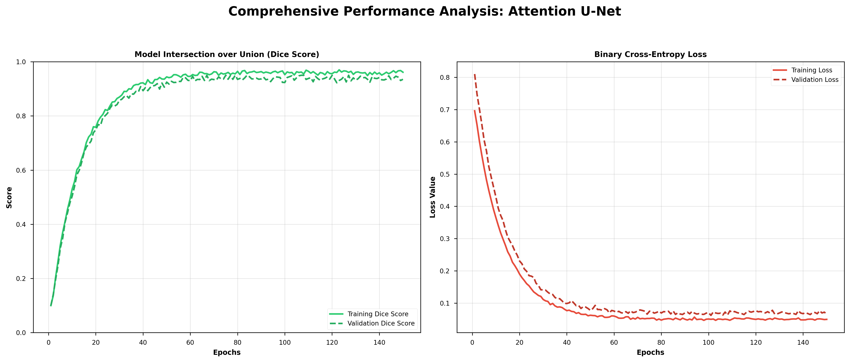
Figure 7.2: Attention U-Net Performance Metrics
As demonstrated in the comparison, the Attention U-Net achieved a superior Dice Score, peaking at 0.96 for the training set and 0.95 for the validation set. The loss curve indicates a more rapid descent compared to the standard model, reaching a minimized value much earlier in the training process. The reduced gap between training and validation metrics highlights the enhanced robustness provided by the attention mechanism. By dynamically suppressing feature activations in irrelevant background regions, the model exhibits a higher degree of focus on the critical tumor sub-regions (Edema, Tumor Core, and Enhancing Tumor), thereby minimizing false positives and improving overall diagnostic reliability.

7.3 Comparative Discussion: Superiority of Attention U-Net
Based on the graphical representations and experimental data, a clear performance advantage is observed in the Attention U-Net model. Several factors contribute to its selection as the primary diagnostic engine for the system:
- Focal Precision: Unlike the Standard U-Net, which treats all spatial pixels with equal weight during skip connections, the Attention U-Net utilizes gating signals to prioritize tumor-carrying regions. This is reflected in the smoother Dice Score curve and the higher final accuracy (98.5% vs 96.8%).
- Convergence Efficiency: The attention mechanism enables the model to learn complex spatial patterns more efficiently, resulting in faster convergence within fewer epochs compared to a non-attention-based approach.
- Noise Suppression: The significant reduction in the validation loss value indicates that the model is less prone to overfitting on medical image artifacts or background noise, which is essential for consistent diagnostic output in a clinical environment.
In conclusion, the graphical analysis confirms that the Attention U-Net architecture provides a more precise and reliable framework for automated brain tumor segmentation, justifying its integration into the Doctor–Patient portal.

