3 User Requirements 31

3.1 Prisoner Admission Management 31

[UR-1]. Capture of prisoners details 31

[UR-2]. Capture of Next-of-Kins and relatives 31

[UR-3]. Capture admission of mothers with babies 31

[UR-4]. Audit trails 31

[UR-5]. Identification of prisoners 31

[UR-6]. Automatic allocation of Unique Prisoner Numbers 31

[UR-7]. Detection of recidivism 31

[UR-8]. Reference to appropriate laws 32

[UR-9]. Generation of PF3 and PF4 32

3.2 Prisoner Discharge and Exit management 32

[UR-10]. Records of Discharge of prisoners 32

[UR-11]. Exits and escapes 32

[UR-12]. Ensure alerts of prisoners due for discharge at any point in time 32

[UR-13]. Description of escapees 32

[UR-14]. Discharge reports 32

3.3 Prisoner Sentence Management 32

[UR-15]. LPD for Single Sentence 33

[UR-16]. Principal of calculation of remission 33

[UR-17]. Release dates for consecutive sentences 34

[UR-18]. Consecutive sentences awarded on different days 35

[UR-19]. Release dates for concurrent sentences passed on the same day 36

[UR-20]. Concurrent sentences awarded on the different days 37

[UR-21]. Concurrent overlapping sentences 38

[UR-22]. Release dates for preventive detention 39

[UR-23]. PD and concurrent sentences on the same day 40

[UR-24]. PD and consecutive sentences awarded on different days 42

[UR-25]. Confirmation of sentences of imprisonment 43

[UR-26]. Appeals against sentence of imprisonment 43

[UR-27]. Confirmation of sentences of imprisonment and appeals 44

[UR-28]. Escapes from lawful custody 45

[UR-29]. Escapes from lawful custody and appeals 47

[UR-30]. Loss of remission 47

[UR-31]. Release on license to be at large 48

[UR-32]. Breach of Contract of License to be at large 50

[UR-33]. Release on Bail 50

[UR-34]. Part payment of fines 51

[UR-35]. Part payment of fines multiple counts 53

[UR-36]. Proper placement during rehabilitation 53

3.4 Prisoner Discipline Management 53

[UR-37]. Tracking of discipline 54

[UR-38]. Quick identification of dangerous prisoners 54

[UR-39]. Disciplinary proceedings 54

[UR-40]. Reference to appropriate laws 54

3.5 Prisoner Court Attendance Management 54

[UR-41]. Jurisdictions of courts and magisterial areas 54

[UR-42]. Computations of Case Backlogs 54

[UR-43]. Tracking of Cases before different courts 54

[UR-44]. Monitoring Court schedules 54

[UR-45]. Calculation of Length of stay of remand 54

3.6 Prisoner Classification and Progressive Stage System 55

[UR-46]. Placement of Prisoners into Stages 55

[UR-47]. Promotion to another stage 55

[UR-48]. Rights and privilege to receive and send letters 55

[UR-49]. Tracking of prisoners and stages 56

3.7 Prisoner Medical Records Management 56

[UR-50]. Medical Casebook 56

[UR-51]. State of prison and prisoners 56

[UR-52]. Report on nature and quality of the food or prisoners 56

[UR-53]. Medical records for each prisoner 56

[UR-54]. Recommendations for release on medical grounds 56

[UR-55]. Marking restricted prisoners 56

3.8 Prisoner Reports and Documents 57

[UR-56]. Ensure Immediate access 57

[UR-57]. Maintain Action lists 57

[UR-58]. Aggregation of information 57

[UR-59]. Provide Early warnings 57

[UR-60]. Provision of Dynamic Report and analysis 57

3.9 Prisoner Transfer Management 57

[UR-61]. Tracking of transfers 57

[UR-62]. Enforce Transfer of punishments 57

[UR-63]. Proper counting and tracking of Lodgers 57

[UR-64]. Transfers before release 57

3.10 Prison Station Management 58

[UR-65]. Calculation of Lockup per station 58

[UR-66]. Monitoring Shifts and Occurrences 58

[UR-67]. Link Morbidity and mortality 58

[UR-68]. Monitor Staff deployments at stations 59

[UR-69]. Automate Gate management 59

[UR-70]. Recording of phone calls 59

[UR-71]. Recording of visits 59

[UR-72]. Recording or received and written letters 59

[UR-73]. Calculate Congestion levels 59

[UR-74]. Monitor housing and location of prisoners 59

3.11 Prisoner Property Management 59

[UR-75]. Keep an inventory of prisoners property 59

[UR-76]. Manage prisoners property 59

[UR-77]. Records of destroyed property 60

[UR-78]. List of prohibited property on admission 60

3.12 Systems Management and Administration 60

[UR-79]. Backups and recovery 60

[UR-80]. User accounts 60

[UR-81]. Update software 60

3.13 Prisoner Biometric Management 60

[UR-82]. Capture and verification of Biometrics 60

[UR-83]. Compatibility with National Security Information System (NSIS) 60

3.14 Prisoners Earning Scheme and Gratuity 60

[UR-84]. Tracking earnings of prisoners 60

# User Requirements

This section covers the description of the system as per the different users and documented in different books and manual. It captures the system ‘as is’. Structured diagrams and expressions have been used to make the user requirements more precise.

## Prisoner Admission Management

1. Capture of prisoners details

The system should capture all details that allow a prisoner to be accurately identified.

1. Capture of Next-of-Kins and relatives

The system should allow capture of next-of-kins and relatives.The system should allow for capture of several relatives. A separate record of all people visiting the inmate as well as date of visit will also be kept.

1. Capture admission of mothers with babies

Where mothers have babies, the system should allow capture of babies at admission and those that are born while in custody in accordance with the standard operating procedures.

1. Audit trails

The system should provide audit trail on all changes made on all prisoner data.

1. Identification of prisoners

Prisoners need proper identification both at admission and release. A prisoner must be properly identified to provide proper management and control system is a critical component for achievement of UPS mandate.

1. Automatic allocation of Unique Prisoner Numbers

Each prisoner is assigned a unique number based on the year of admission and the station. For example the first prisoner admitted 2010 in Upper prison is assigned a number UPP/0001/10. The system should provide for a uniform numbering system for prisoners. The numbering system should be able to code some details about a prisoner.

1. Detection of recidivism

The system should be able to detect recidivism and link the prisoner to previous criminal behavior and rehabilitation/treatment programme

1. Reference to appropriate laws

The system must reference proper sections of Penal Code and different laws under which prisoners are charged.

1. Generation of PF3 and PF4

The system should be able to generate a comprehensive and consistent PF3 and PF4 personal records of prisoners

## Prisoner Discharge and Exit management

It is expected that every person admitted in custody must leave at some point. There are three ways in which a prisoner can leave: normal discharge, escape or death. The set of requirements described below relate to the process through which a prisoner can leave custody.

1. Records of Discharge of prisoners

The system must be able to provide record of discharged prisoners that include date of discharge, intended place of stay, items provided, property provided among others.

1. Exits and escapes

Exits from prisons such as death, escapes should be captured and used to show the proper lockup that is in custody.

1. Ensure alerts of prisoners due for discharge at any point in time

The system should provide lists indicating LPD, EPD and period remaining to be served.

1. Description of escapees

The system must print and forward description of escapees whenever a prisoner escapes

1. Discharge reports coincidence

The system must generate and discharge report indicating all necessary details about a discharged prisoner

## Prisoner Sentence Management

Prisons Act, 2006, Section 84; Prisons Regulations,2012, Rules 96-103, and Chapter 29 and Appendix 4 of Prisons Standing Orders part 2- provide for calculation of total length of stay for convicted prisoners in the prison. A convicted prisoner sentenced to imprisonment whether by one sentence or consecutive sentences for a period exceeding one month, may by industry and good conduct earn a remission of one third of his or her sentence or sentences.

A prisoner may lose remission as a result of its forfeiture as a punishment for an offence against prison discipline and shall not earn any remission in respect of any period spent in hospital through his or her own Fault or while malingering, or while undergoing confinement as a punishment in a separate cell.

Remission is awarded to all prisoners serving sentences of imprisonment exceeding one month except debtors and preventive detainees.

This process involves calculation of the period a prisoner will stay in the prison based on conditions set by court while awarding a sentence. Once the sentence is awarded, the OC determines the Earliest Possible date of Discharge (EPD) and Latest Possible date of Discharge (LPD). Whereas, EPD can change (depending on remission earned), LPD remains fixed throughout the period.

1. LPD for Single Sentence

The system should calculate the LPD of a single sentence based on the flow chart in Figure 5.



Figure : flowchart showing calculation of LPD for a single sentence

1. Principal of calculation of remission
2. Remission is the reduction of prisoners’ sentence (s) of imprisonment, which exceeds one (1) month by a third.
3. One (1) month is equal to 30 days.
4. The following categories of prisoners don’t earn remission
   * 1. Prisoners sentenced to less than one (1) month,
     2. Preventive Detention prisoners,
     3. Debtors,
     4. Vagrants,
     5. Condemned prisoners, and
     6. Remands



Figure : Flowchart showing calculation of remission

1. Release dates for consecutive sentences

The system must compute LPD, EPD and Remission for consecutive sentences. Consecutive means one sentence running after another. Court may order sentences to run consecutive either on same day or different days. A prisoner already serving a sentence of imprisonment if convicted for another offence before expiry of the first sentence, unless ordered by the court, the 2nd sentence shall be served after the completion of the first one. Therefore, the 2nd sentence is consecutive to the first sentence of imprisonment. Unless court orders, all sentences of imprisonment shall be treated as consecutive. To calculate LPD and EPD

1. Determine DOC,
2. Add the different sentences together and treat them as one sentence, then
3. Calculate EPD and LPD.



Figure : Flowchart showing calculation of release dates for consecutive sentences awarded on the same day

1. Consecutive sentences awarded on different days

A judge may order a new sentence to run consecutively with any of the existing sentences. If EPD of first sentence before DOC of 2nd sentence, it means the prisoner has completed serving the 1st sentence; then don’t treat the 2nd sentence as consecutive to the first one (ignore the first sentence of imprisonment).

If the prisoner has finished serving the first sentence, use the 2nd DOC in calculation of EPD. If the sentence did not expire, add all sentences and apply the original DOC to calculate the LPD and EPD.



Figure : Flowchart showing Calculation of release dates for consecutive sentences awarded on different days

1. Release dates for concurrent sentences passed on the same day

Concurrent means sentences being served at the same time. Concurrent sentences may be passed on same day or different days. The golden rule on concurrent sentences is that they commence to run from the same date on which they are passed. Concurrent sentences are neither postdated nor backdated. The longest sentence is taken as dominant sentence.



Figure : Flowchart showing calculation of release dates for concurrent sentences handed on the same day

1. Concurrent sentences awarded on the different days

A judge may passed and order a sentence to be served concurrently with an existing sentence. The principle is that if the new sentence after applying Remission ends before the first, then the second sentence remains silent. However, when the new sentence is longer, then two sentences will be served ‘concurrently’ until the first expires plus that part of the second sentence that goes beyond the first sentence.



Figure :Flowchart showing calculation of release dates for concurrent sentences awarded on different days. These can be concurrent overlapping or consecutive on different days

1. Concurrent overlapping sentences

Concurrent overlapping sentences are sentences where subsequent sentence of imprisonment lasts longer than the previous sentence when ordered to run concurrent. It should be noted that a prisoner was already serving a sentence before the second one was awarded.



Figure : Flow charts showing calculation of release dates for concurrent overlapping sentences

1. Release dates for preventive detention

PD sentences are awarded to habitual criminals. PD sentenced doesn’t earn remission. However, when awarded with other sentences, the following rules apply:-

1. The prisoner must be a habitual criminal.
2. The sentence must be more than three years long.
3. P.D sentence does not earn remission.
4. Where a P.D sentence is awarded alone, it begins to run from the date of its pronouncement.
5. A sentence of P.D passed in addition to a term of imprisonment will begin to run immediately on the conclusion of the sentence(s) of imprisonment including any loss of remission.
6. The P.D sentence must not be interrupted once a prisoner has started serving it.
7. Any other sentence awarded before the commencement of a PD sentence must be Consecutive to the first sentence of imprisonment the prisoner is already serving.
8. A second PD sentence awarded should be consecutive to the first PD sentence.
9. If a sentence of imprisonment is awarded on the same day with a PD sentence, calculate the Remission of the sentence of imprisonment in the usual way.
10. A sentence of imprisonment being served to be followed by a PD sentence and then a subsequent sentence of imprisonment, the subsequent sentence will be given full remission if it is awarded when the prisoner is already serving a PD sentence.
11. A PD sentence must not be interrupted. Subsequent sentences awarded before the beginning of a PD sentence must all be completed to be served first. And once a PD sentence has begun to run, all other sentences must be suspended and to be served after the PD sentence is over.



Figure : Flowchart showing calculation of release dates for preventive detention sentences

1. PD and concurrent sentences on the same day

A sentence of PD passed in addition to a term of imprisonment shall take effect immediately on the determination of the sentence of imprisonment whether that sentence is determined by effusion (normal serving of sentence by lawful) of time or by the order of the president.

This therefore, means that a PD sentence cannot be concurrent with a sentence of imprisonment awarded for the same offence. Is a prisoner has already been sentenced to a term of imprisonment,



Figure : Flowchart showing calculation of release dates for preventive detention and consecutive sentences awarded on the same day

1. PD and consecutive sentences awarded on different days

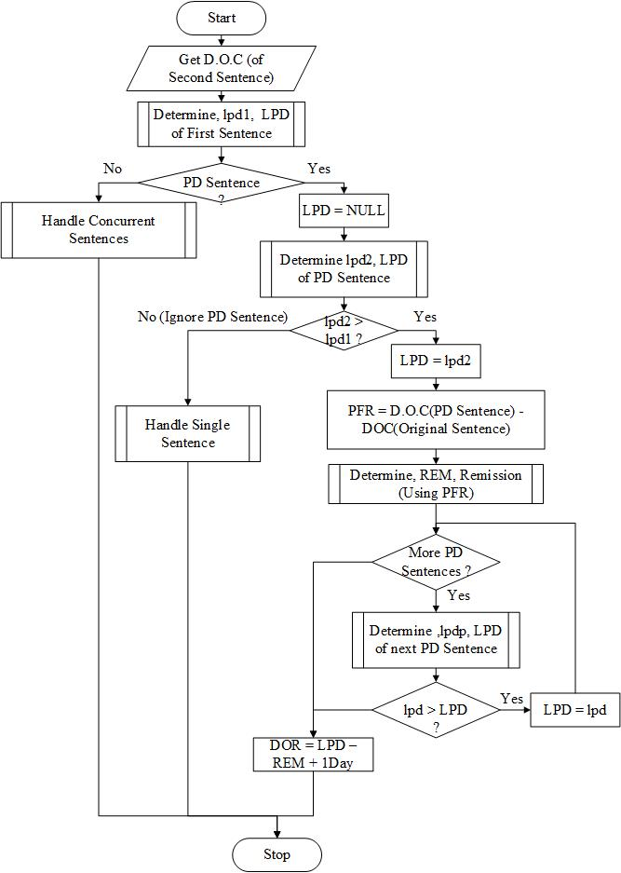

Figure : Flowchart showing calculation of release dates for preventive detention plus consecutive sentences awarded on different days

1. Confirmation of sentences of imprisonment

Courts of judicature are organized as Magistrates’ Court, High court, Court of Appeal, and Supreme Court. Some judgments passed by lower courts may require confirmation by a higher court. A prisoner has two (2) options- will begin to start serving a sentence while waiting for the confirmation or may not want to begin serving the sentence until the sentence is confirmed by a higher court. The prisoner’s decision has a direct effect on the DOC, hence EPD and LPD.



Figure : Flowchart algorithm for confirmation of sentence of imprisonment

1. Appeals against sentence of imprisonment

A prisoner may not be satisfied with a sentence of imprisonment. S/he may opt to appeal against the sentence (convict appellant) or conviction (un-convicted appellant) in a higher court. Convicted appellant- the sentence runs from the date the sentence if pronounced by court. Un-convicted appellant- sentence will begin to run from the day the appeal is dismissed by court or at the end of 42 days. The maximum appeal days are 42 days. On 43rd day, the prisoner is compelled to start serving the sentence. The sentence will have a new date of conviction.

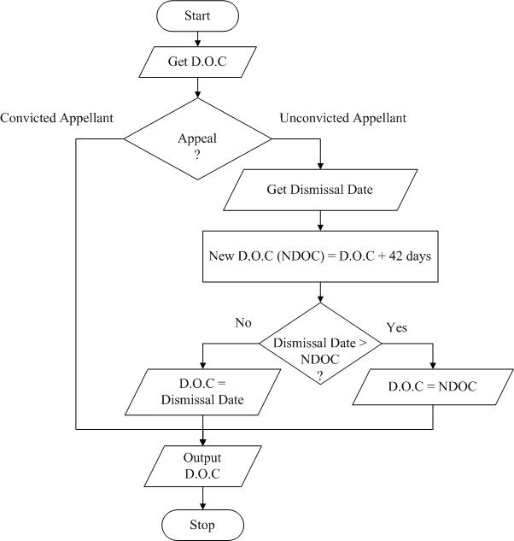

Figure : Flowchart for Appeal against Sentence of Imprisonment

1. Confirmation of sentences of imprisonment and appeals

A sentence of imprisonment passed by lower courts may require confirmation by a higher court. And at the same time the prisoner wishes to appeal against the sentence of imprisonment. In this case, the two (2) cases must be treated separately- confirmation of sentence and appeal.

Where a sentence requires confirmation, and the prisoner opts not serve the sentence, s/he cannot be allowed to appeal against the sentence until the sentence is confirmed.



Figure : Flowchart showing algorithm for confirmation of sentences and appeals

1. Escapes from lawful custody

The period a prisoner is out of lawful custody is known as time at large. It is time period between escape and recapture. The sentence of imprisonment does not continue to be served during the period when out of prison. The period the prisoner is out of lawful custody does not earn remission.



Figure : Flowchart showing calculation of release dates when a prisoner escapes from lawful custody only once



Figure : Flowchart showing calculation of Time at Large (TAL)

1. Escapes from lawful custody and appeals

A prisoner escapes from lawful custody while he had appealed as un-convicted or convicted. Calculation of TAL depends on the decision prisoner had taken before escaping from prison.

1. Loss of remission

Remission is earned. It can also be lost underspecified circumstances- direct loss and indirect loss. A data entry screen will be provided to capture EPD and LPD in cases of **loss of remission** in single, consecutive, or concurrent sentences.



Figure : Flowchart showing loss of remission

1. Release on license to be at large

Habitual criminals serving a sentence or consecutive sentences of imprisonment lasting three or more years are released on license upon completion of their sentences up to EPD. The license remains in force for the unexpired portion of the prisoner’s original sentence. The unexpired portion is that period between LPD and EPD. The unexpired portion is known as remnant of sentence (ROS). The prisoner within this period must not commit another crime.



Figure : Flowchart showing algorithm for releasing a prisoner on licensee

1. Breach of Contract of License to be at large



Figure : Flowchart show algorithm for determination of breach of contract. A contract is breached if the new offence is committed within ROS

1. Release on Bail

It is a constitutional right for someone to be given bail (convicts or remands). When a convicted prisoner is released on bail, the sentence calculation should be as in case of escape. A data entry screen will be provided to capture EPD and LPD in sentences involving **periods on bail**



Figure : Flowchart showing Calculation of release dates for convicted prisoner granted bail

1. Part payment of fines

Courts may award payments of fine or imprisonment as an alternative. Payments may be effected at later date while the prisoner is already in prison. A prisoner will have served part of imprisonment sentence. Only days remaining to complete imprisonment sentence are paid for.



Figure : Flowchart for calculation of part payment of fines for single count

1. Part payment of fines multiple counts



Figure : Flowchart for calculation of part payment of fines for multiple counts

1. Proper placement during rehabilitation

They system should be able apply all considerations such as previous criminal records and treatment to ensure proper placement during rehabilitation program and placement of various trades

## Prisoner Discipline Management

Prisoners may commit different disciplinary offences while in custody. The next set of requirements related to discipline management of prisoners in custody.

1. Tracking of discipline

The system should record the punishments that have been administered to a particular prisoner. It should be possible to know the history of a prisoner while in prison.

1. Quick identification of dangerous prisoners

The system should quickly identify dangerous prisoners as directed from time to time through standing orders by the OC.

1. Disciplinary proceedings

The system should keep track of disciplinary proceedings against a prisoner.

1. Reference to appropriate laws

The system must reference appropriate laws of the prisons act under which the prisoner is being punished for offences committed while in custody.

## Prisoner Court Attendance Management

Prisoners on remand continue to go attend court until their cases are dismissed or sentence is determined.

1. Jurisdictions of courts and magisterial areas

The system should keep details of different courts including location and magisterial area.

1. Computations of Case Backlogs

The system should provide analysis of details of the different loads at different courts. The load includes inmates on remand who have overstayed.

1. Tracking of Cases before different courts

The system should generated lists of cases to be handled by specific courts

1. Monitoring Court schedules

The system should provide details of schedules for every court and prisoners to be produced before the court

1. Calculation of Length of stay of remand

The system should calculate and determine in a timely manner the length of stay on remand for each prisoner to detect overstay beyond a given mandatory period – 180 days for capital offenders and 60 for petty offenders

## Prisoner Classification and Progressive Stage System

A convicted criminal prisoner shall serve his her sentence in accordance with the progressive stage system.[1] The requirements in this sub-section relate to management of the progressive stage system.

1. Placement of Prisoners into Stages

A long sentence prisoner shall on admission be placed in stage 2 while a short-term sentence will be placed and remain in stage 1.

1. Promotion to another stage

|  |  |  |  |  |  |
| --- | --- | --- | --- | --- | --- |
|  | Stage 1 | Stage 2 | Stage 3 | Stage 4 | Special Stage |
| **On admission** | Short term prisoners at admission | Long term prisoners at admission |  |  |  |
| **Minimum duration** |  | One (1) Month with no disciplinary offence | Three (3) Months with no disciplinary offence | Six (6) Months with no disciplinary offence |  |
| **Maximum duration** |  | Three (3) Months | Fifteen (15) months | Eighteen (18) months |  |
| **Promotion to stage conditions** |  |  | Three (3) Months or more on stage 2 | Fifteen (15) months or more on stage 3 | Eighteen (18) months or more on stage 4 |
| **Demotion from stage** |  |  |  |  |  |

1. Rights and privilege to receive and send letters

The requirements and restrictions on the letters are described in Table 7. A newly admitted prisoner is entitled to a reception letter.

Table 7: Showing stage based restrictions on receiving and writing of letters[2]

|  |  |  |  |
| --- | --- | --- | --- |
|  | Write letters | Receive letters | Receive Visits |
| Stage 1 | Every 4 weeks | Every 4 weeks | Every 6 weeks for 15 minutes |
| Stage 2 | Every 4 weeks | Every 4 weeks | Every 6 weeks for 20 minutes |
| Stage 3 | Every 3 weeks | Every 3 weeks | Every 4 weeks |
| Stage 4 | Every 2 weeks | Every 2 weeks | Every 4 weeks for 30 minutes |
| Special stage | Every week | No restriction | Every 4 weeks for 30 minutes |

1. Tracking of prisoners and stages

The system must track all prisoners and their corresponding stages.

## Prisoner Medical Records Management

There is need to manage prisoner’s medical records to ensure proper administration and verification. Information relating to the health of all prisoners must be effectively captured and updated. This module is not a comprehensive Electronic Medical Records Management (EMR) system; it only captures prisoner’s treatment details.

This system interacts with the other modules through meta-data and decisions made by the medical personnel.

1. Medical Casebook

The system should keep record of every treatment given to a prisoner while in custody. The casebook should capture the name, disease and treatment of every sick prisoner.

1. State of prison and prisoners

The system must record and should provide details and reports about different prison stations

1. Report on nature and quality of the food or prisoners

Medical officers should be able to record reports on the nature and quality of food at the stations. The reports may be made before the food is cooked, after the food is cooked or both

1. Medical records for each prisoner

A comprehensive record of all prisoner details needs to be captured detailing the treatments and medical history of a prisoner while in custody

1. Recommendations for release on medical grounds

The system should capture details for a prisoner recommended for release on medical grounds.

1. Marking restricted prisoners

The system should be able to mark and flag prisoners whose medical conditions restrict them from engaging in certain activities. These activities include (light labor, hard labor, infectious among others).

## Prisoner Reports and Documents

1. Ensure Immediate access

The system should allow immediate access to reports from all or part of the prison stations

1. Maintain Action lists

Provide a list of upcoming court attendances, keep records of court out comes.

1. Aggregation of information

There is need to aggregate information relating to different prisoners on a given station. There is need to aggregate information relating different prisoners in a given region

1. Provide Early warnings

The system should provide early warning that points out when each prisoner is due for a) release b) court appearance c) mandatory bail

1. Provision of Dynamic Report and analysis

The system should allow generation of dynamic reports based on selection of different variables.

## Prisoner Transfer Management

1. Tracking of transfers

The system should track the transfer of prisoners from one station to another. A prisoner may be transferred to another station for different reasons including medical reasons, security, labor needs, and congestion among other reasons.

1. Enforce Transfer of punishments

A punishment lawfully imposed against a prisoner may be carried out partly in one prison and partly in another. In such a case, transfers should be able to carry forward the punishments.

1. Proper counting and tracking of Lodgers

Prisoners may be temporarily moved from one station to another. This may be due to transit or for medical reasons. The system should be able to record and capture loggers out of stations and lodgers in station.

1. Transfers before release

Towards the completion of their sentences, a prisoner needs to be transferred to the station nearest his place of arrest. The system should identify such prisoners and alert the assistant commissioner in charge of convicts.

## Prison Station Management

1. Calculation of Lockup per station

The system should calculate Lockup and show lockup. The current manual lockup is indicated in Figure 26.

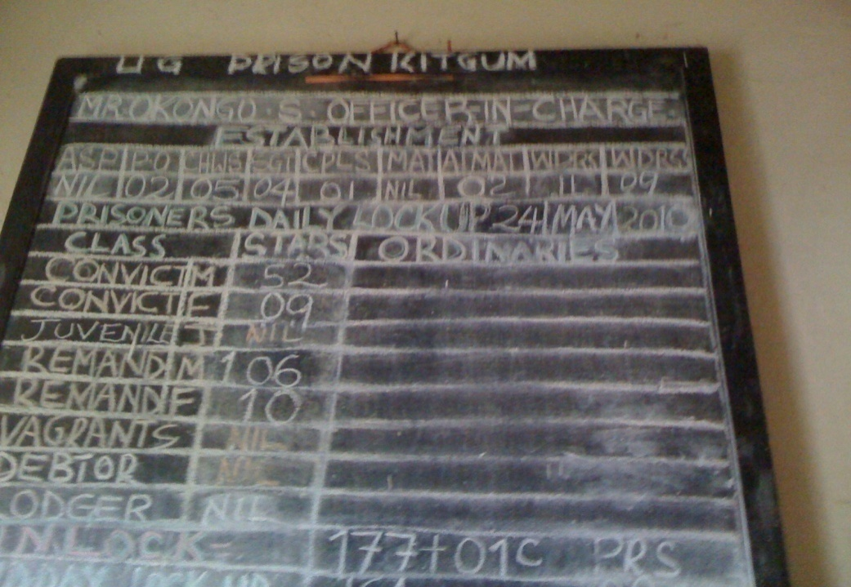

Figure : Manual lockup calculation at prison stations

1. Monitoring Shifts and Occurrences

Each shift hands over with a shift report that indicates incidents and occurrences during the shift. A shift commander heads a shift. The incoming shift should access the hand-over report of the preceding shift. All occurrences at night are recorded in the night occurrence book

|  |  |
| --- | --- |
| Shift | Time in |
| Early Shift | 05:45 |
| Late Shift | 12:00 |
| Night Shift | 19:45 |

1. Link Morbidity and mortality

The system should provide a means to link morbidity and mortality information among prisoners and staff to the prison conditions and management

1. Monitor Staff deployments at stations

The system should be able to capture daily staff deployments around the prison station.

1. Automate Gate management

The system must be able to manage entry and exit of persons and property from a prison station

1. Recording of phone calls

A prisoner may be allowed to receive a phone call under specific guidelines. The details of the call need to be captured.

1. Recording of visits

A prisoner may be allowed to receive visitors under specific guidelines as indicated in Table 7. Details of visitors must be recorded.

1. Recording or received and written letters

A prisoner may be allowed to receive and write letters under specific guidelines as indicated in Table 7. Details of outgoing and incoming letters must be captured.

1. Calculate Congestion levels

The system should compute and indicate congestion levels such that they can be shared across the criminal justice agencies for immediate action in a real time fashion.

1. Monitor housing and location of prisoners

The system should keep track of the exact ward and cell where a given prison is sleeping or located at any point in time

## Prisoner Property Management

A prisoner may be poses property at time of arrest or acquire property while in custody. UPS manages this property including cash.

1. Keep an inventory of prisoners property

The system should keep an inventory of all prisoners’ property. The property isboth physical and cash

1. Manage prisoners property

Considering the prisoners may receive new items while in custody and may send some of their items to friends and relations, it is important that system is able to manage and report on property transactions.

1. Records of destroyed property

Items may be destroyed for different reasons including those that are of perishable nature, property infected with vermin or property likely to spread disease.

1. List of prohibited property on admission

The CGP from time to time publishes a list of prohibited items. The system should capture and make this list available to all stations.

## Systems Management and Administration

1. Backups and recovery

The system should provide an interface to backup and recover.

1. User accounts

The system must provide an interface to create, edit, suspend, activate, delete, update, assign roles and delete user accounts. The accounts must be tiered to represent seniority and level of control.

1. Update software

The system should provide auser-friendly interface to update software.

## Prisoner Biometric Management

1. Capture and verification of Biometrics

The system must capture and verify biometrics of prisoners

1. Compatibility with National Security Information System (NSIS)

The biometric data captured must be compatible with that captured by the National Security Information System (NSIS)

## Prisoners Earning Scheme and Gratuity

1. Tracking earnings of prisoners

The system must track work parties and earnings of different prisoners.

1. Prisons Regulations (2012) section 17.
2. Prisons Regulations 2012, section 48(1-4)