**Project Name :PCB**

**Author Name** : Purbasha Priyadarshini Dash

**Spend MH :** **6.5hours**

->Upload bug fixation changes in server

-> Content changes in NAMP,,NWMP

-> Content changes Citizen Forum following pages

* [Procedure For Online Payment In Consent Management](http://ospcboard.org/citizen-forum/?post_id=1459)
* [Procedure For Authorization Under Municipal Solid Wastes](http://ospcboard.org/citizen-forum/?post_id=1454)
* [Procedure For Authorization Under Hazardous](http://ospcboard.org/citizen-forum/?post_id=1453)
* [User guide Consent to Operate OCMMS](http://ospcboard.org/citizen-forum/?post_id=1452)
* [User guide Consent to Establish OCMMS](http://ospcboard.org/citizen-forum/?post_id=1450)
* [What we are not responsible for?](http://ospcboard.org/citizen-forum/?post_id=240)
* [Procedure For Online Payment In Consent Management](http://ospcboard.org/citizen-forum/?post_id=1459)
* [Procedure For Authorization Under Municipal Solid Wastes](http://ospcboard.org/citizen-forum/?post_id=1454)
* [Procedure For Authorization Under Hazardous](http://ospcboard.org/citizen-forum/?post_id=1453)
* [User guide Consent to Operate OCMMS](http://ospcboard.org/citizen-forum/?post_id=1452)
* [User guide Consent to Establish OCMMS](http://ospcboard.org/citizen-forum/?post_id=1450)
* [What we are not responsible for?](http://ospcboard.org/citizen-forum/?post_id=240)

**Project Name :** OXFAM

**Author Name** : Purbasha Priyadarshini Dash

**Spend MH** : 1/2 hours

Tried to fix Isssue in

While sending messages 500 volunteer

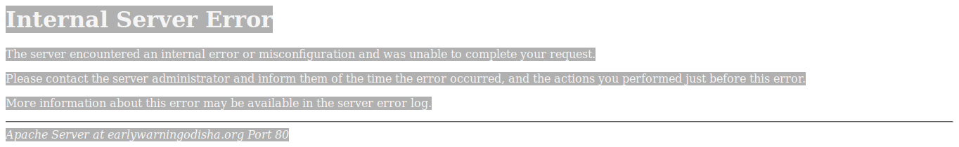

**Project Name :** **Project Name :** OVA

**Author Name** : Purbasha Priyadarshini Dash

**Spend MH** : 1 hours

->Giving KT To Anshuman

->Help in Odia feed back form