**WEB_ICP8**

DHARMA TEJA K

Email: dkbmy@umsystem.edu

GitHub Link:

Avinash Reddy T

Email: atfkh@umsystem.edu

GitHub link:

**In Class Programming:**

In this ICP, we are going to

Create the basic Login application, which consists of:

* Username and password should be included in the main action (make appropriate changes for the login app!) with login button.
* If the login credentials are genuine, the screen should navigate to the welcome screen when the 'Login' button is clicked, logout button after login. Otherwise, the app should show the user an appropriate message.
* When clicked on the logout button, the screen should navigate to the login screen

Below was the snippet of main_activity java code , written importing the packages required and used inheritance concepts as well.

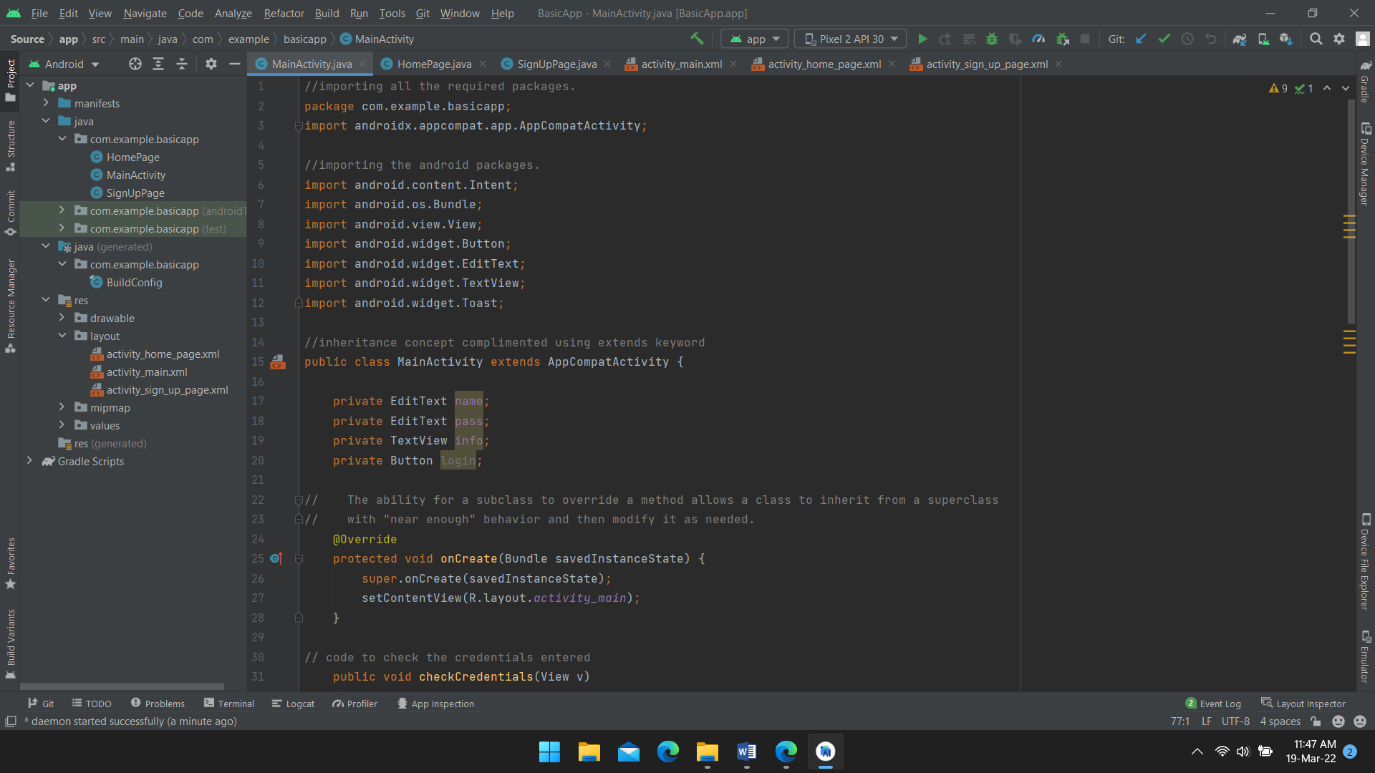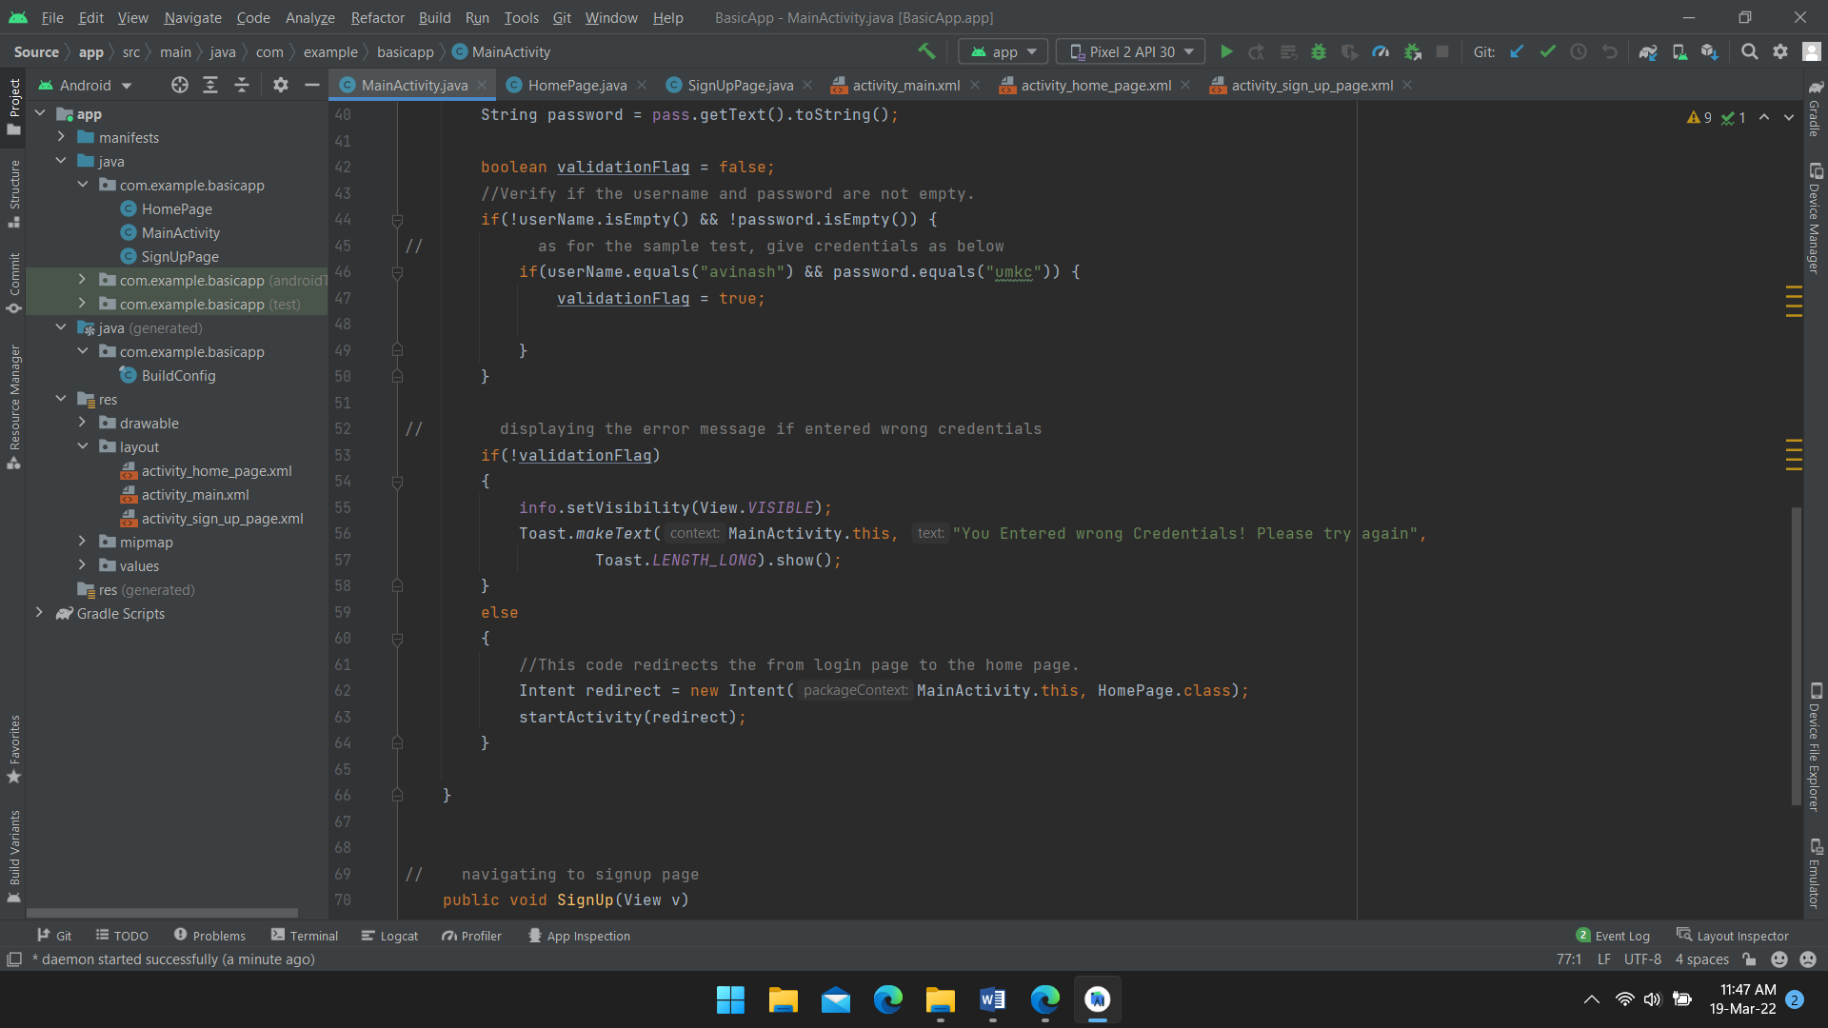

Java Code screenshot of homepage.

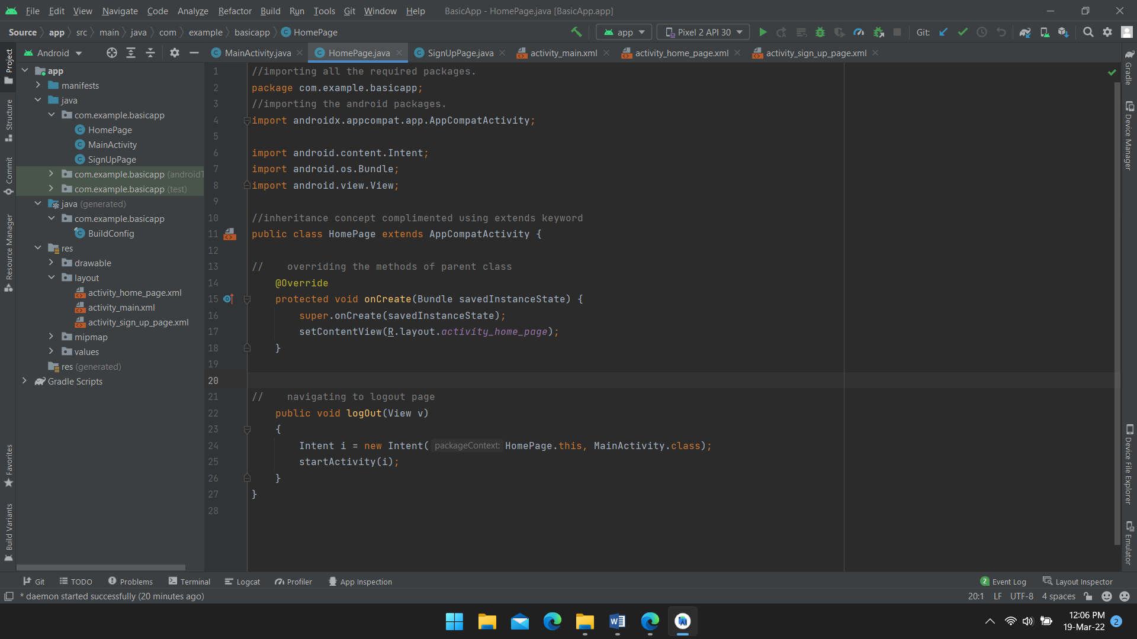

Java Code screenshot of signup page.

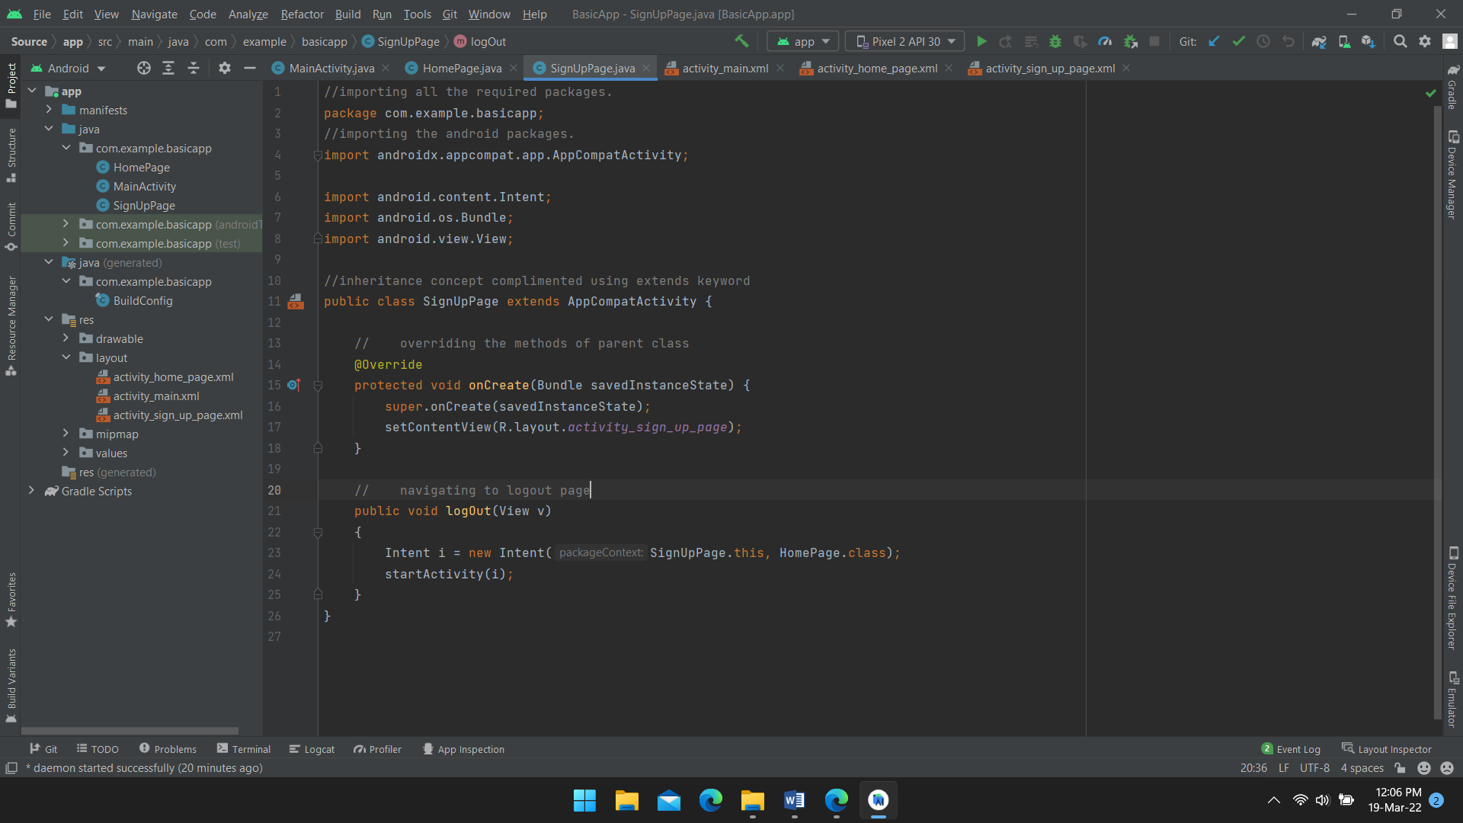

Below was the main login page designed with username and password fields with login button and text displayed below it.

Sample username and password is also displayed as a part of testing

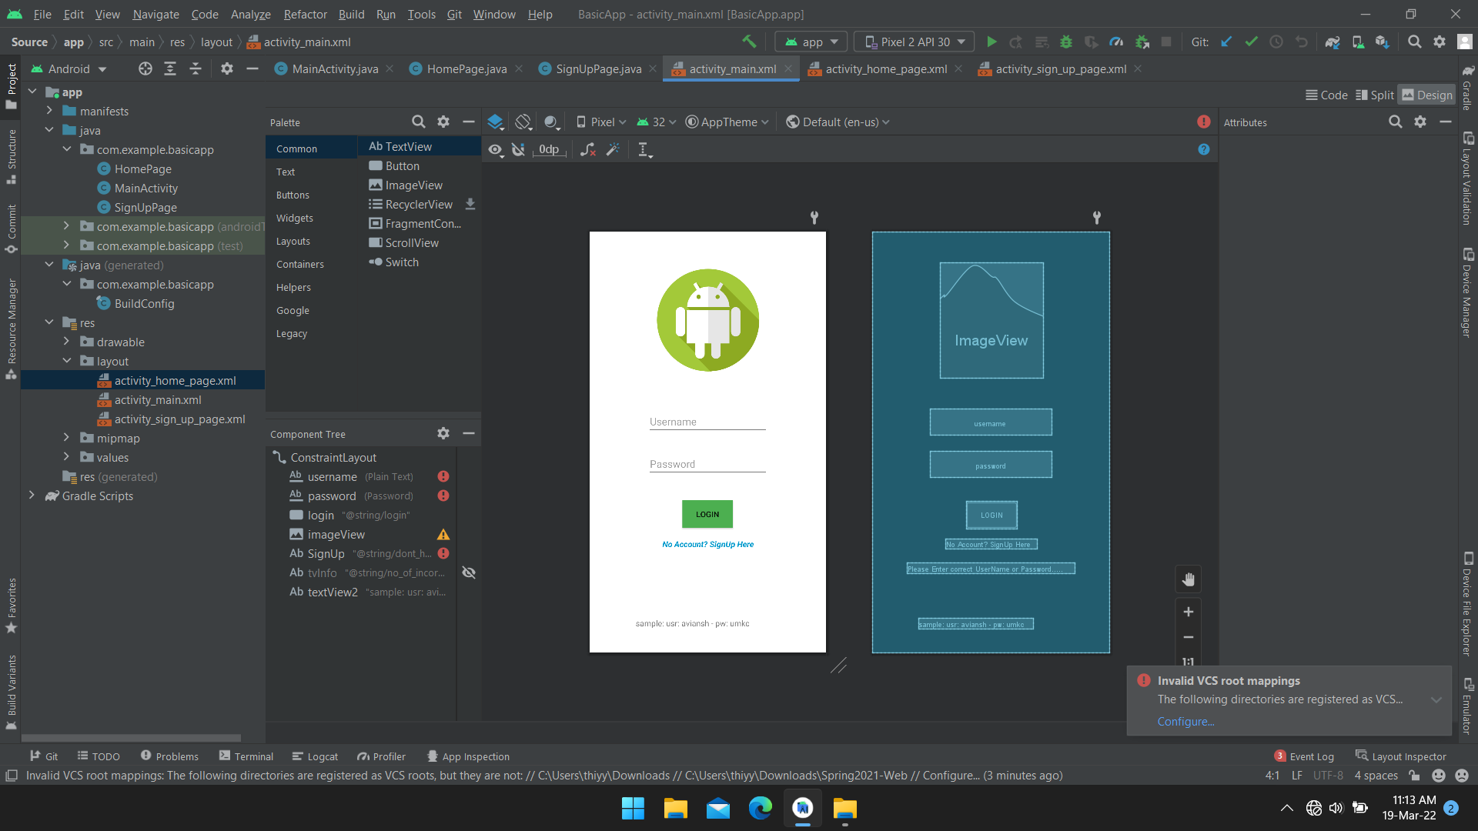

Below is the welcome page which comes after logging in

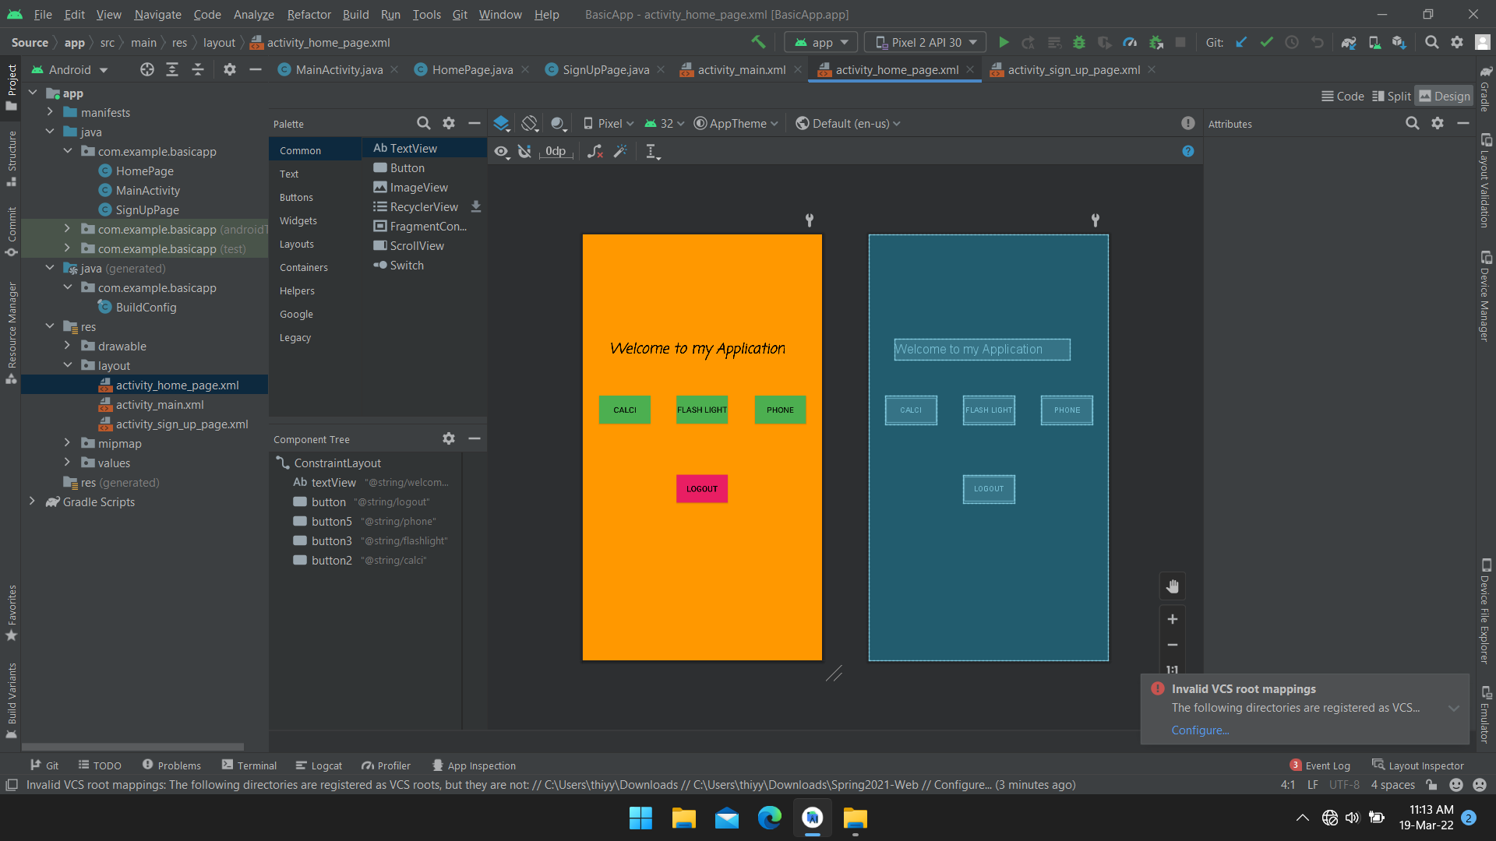

Below was the signup page designed with username, password, email address fields with signup button and text displayed below it.

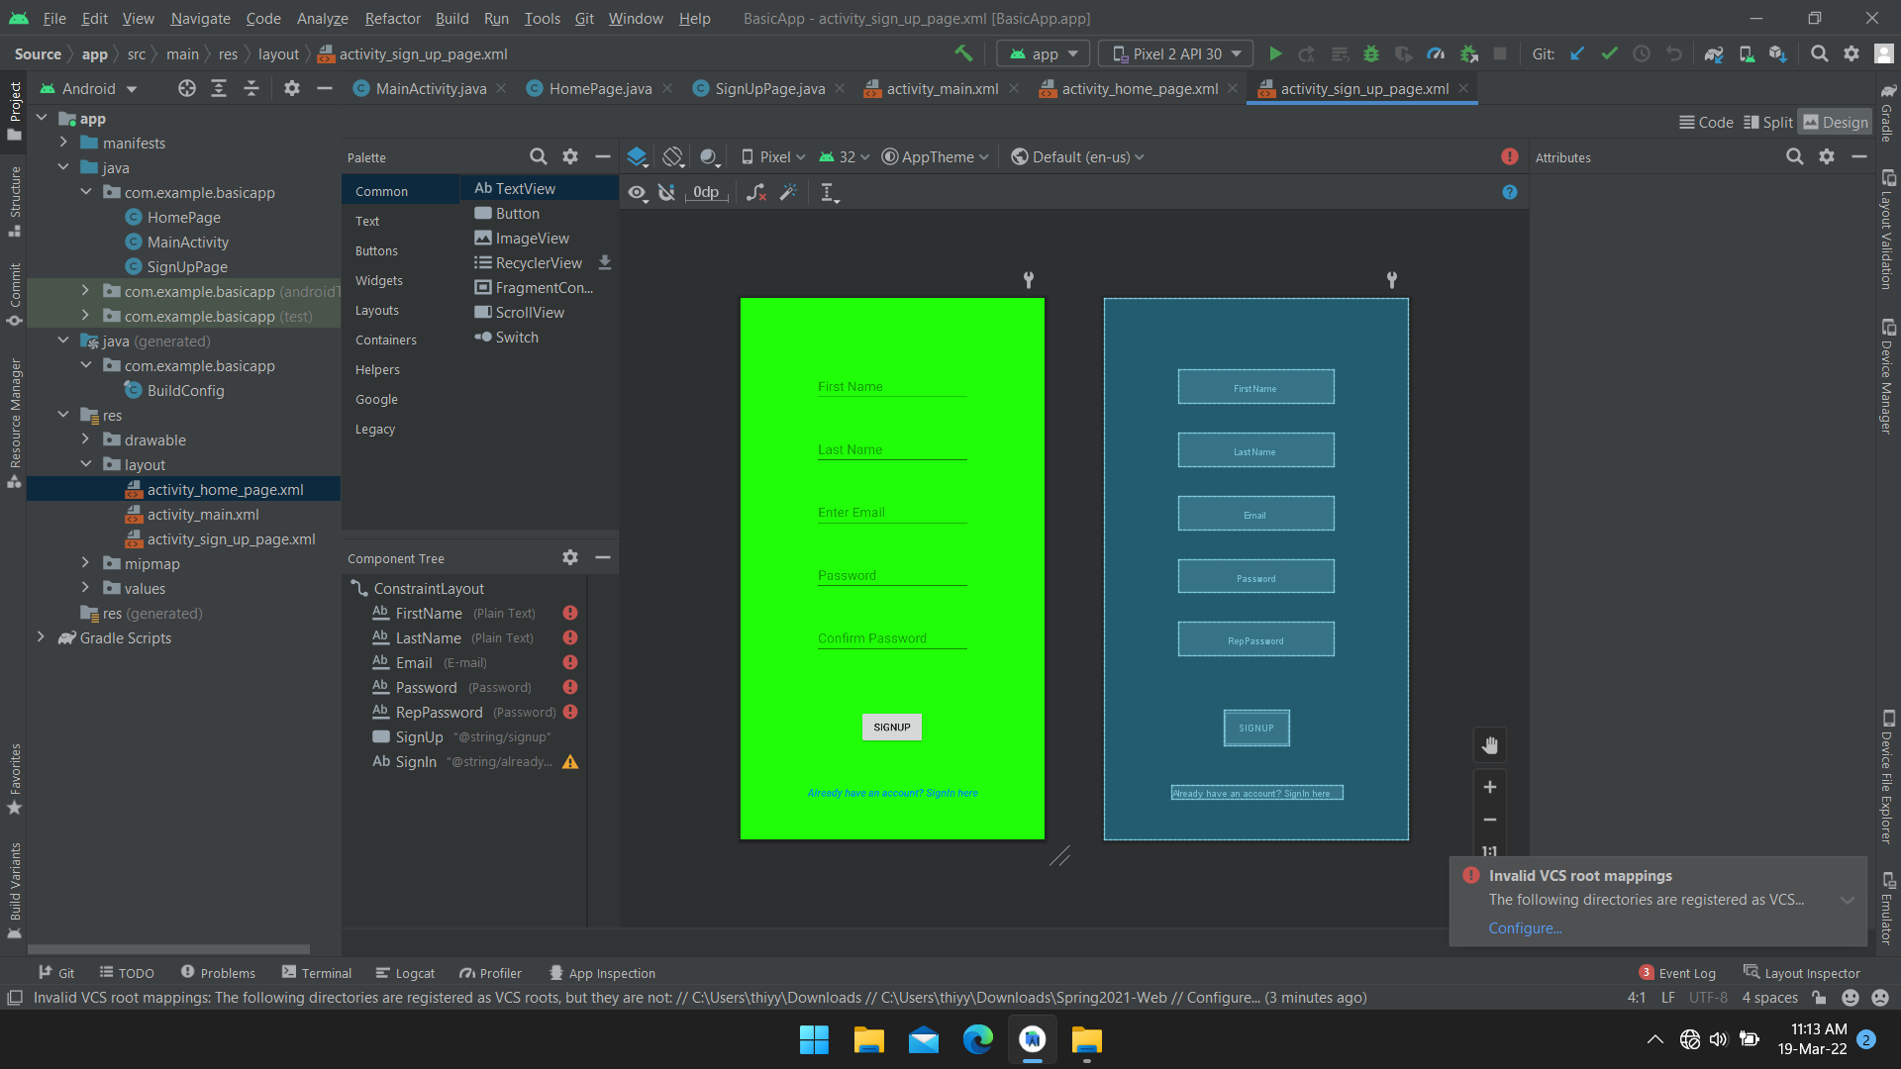

Below are the output samples screenshots after the running the code and installing the apk on any of the devices.

