1. **What is the computational resource you will be using for the rest of the semester? What are its specifications? What Operating System will you be using (Windows/Linux)?**

MacBook Air

Intel i5, 4GB RAM, No external GPU

MacOS High Sierra

If the above is not suitable I can use another laptop with,

Intel i7, 16GB RAM, Nvidia GTX1060

Windows 10

1. **Please include a screenshot of your computer with the “Hello World!” run on a Jupyter Notebook.**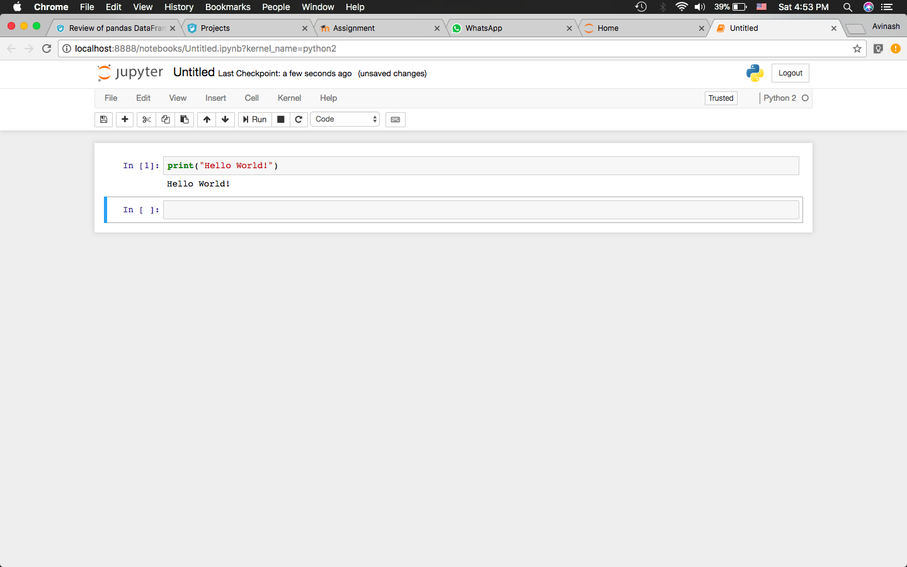
2. **Write a program in Python that prints out the output sequentially for the first 100 natural numbers.** **Include the text of the program below. Also include a screenshot of your program with a run on the Jupyter Notebook**

n = 100

for i in range(1,n+1):

div_by_two = False

div_by_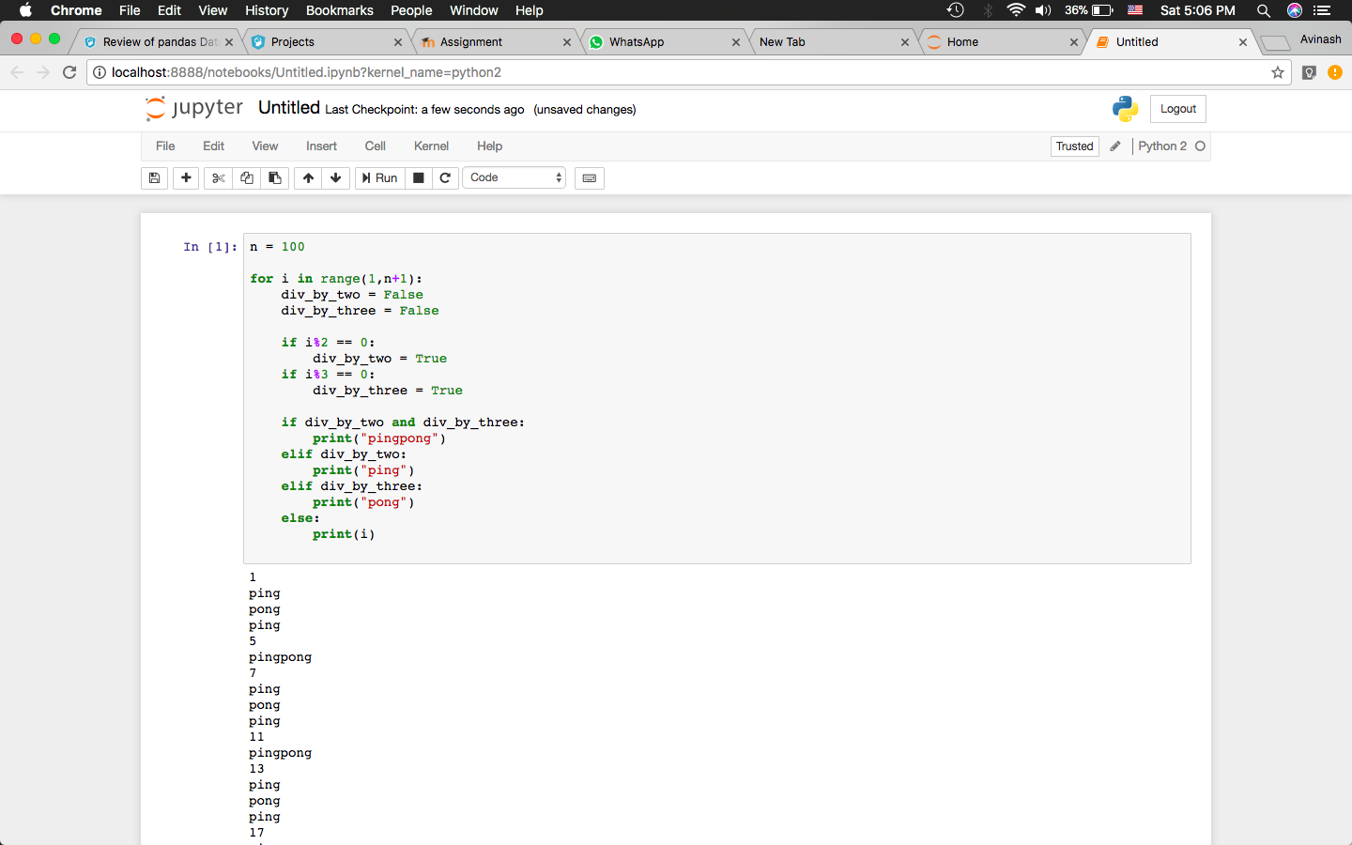three = False

if i%2 == 0:

div_by_two = True

if i%3 == 0:

div_by_three = True

if div_by_two and div_by_three:

print("pingpong")

elif div_by_two:

print("ping")

elif div_by_three:

print("pong")

else:

print(i)

1. **Please write down on paper the following sentence by your own hand, sign it and include a picture of this in the response below**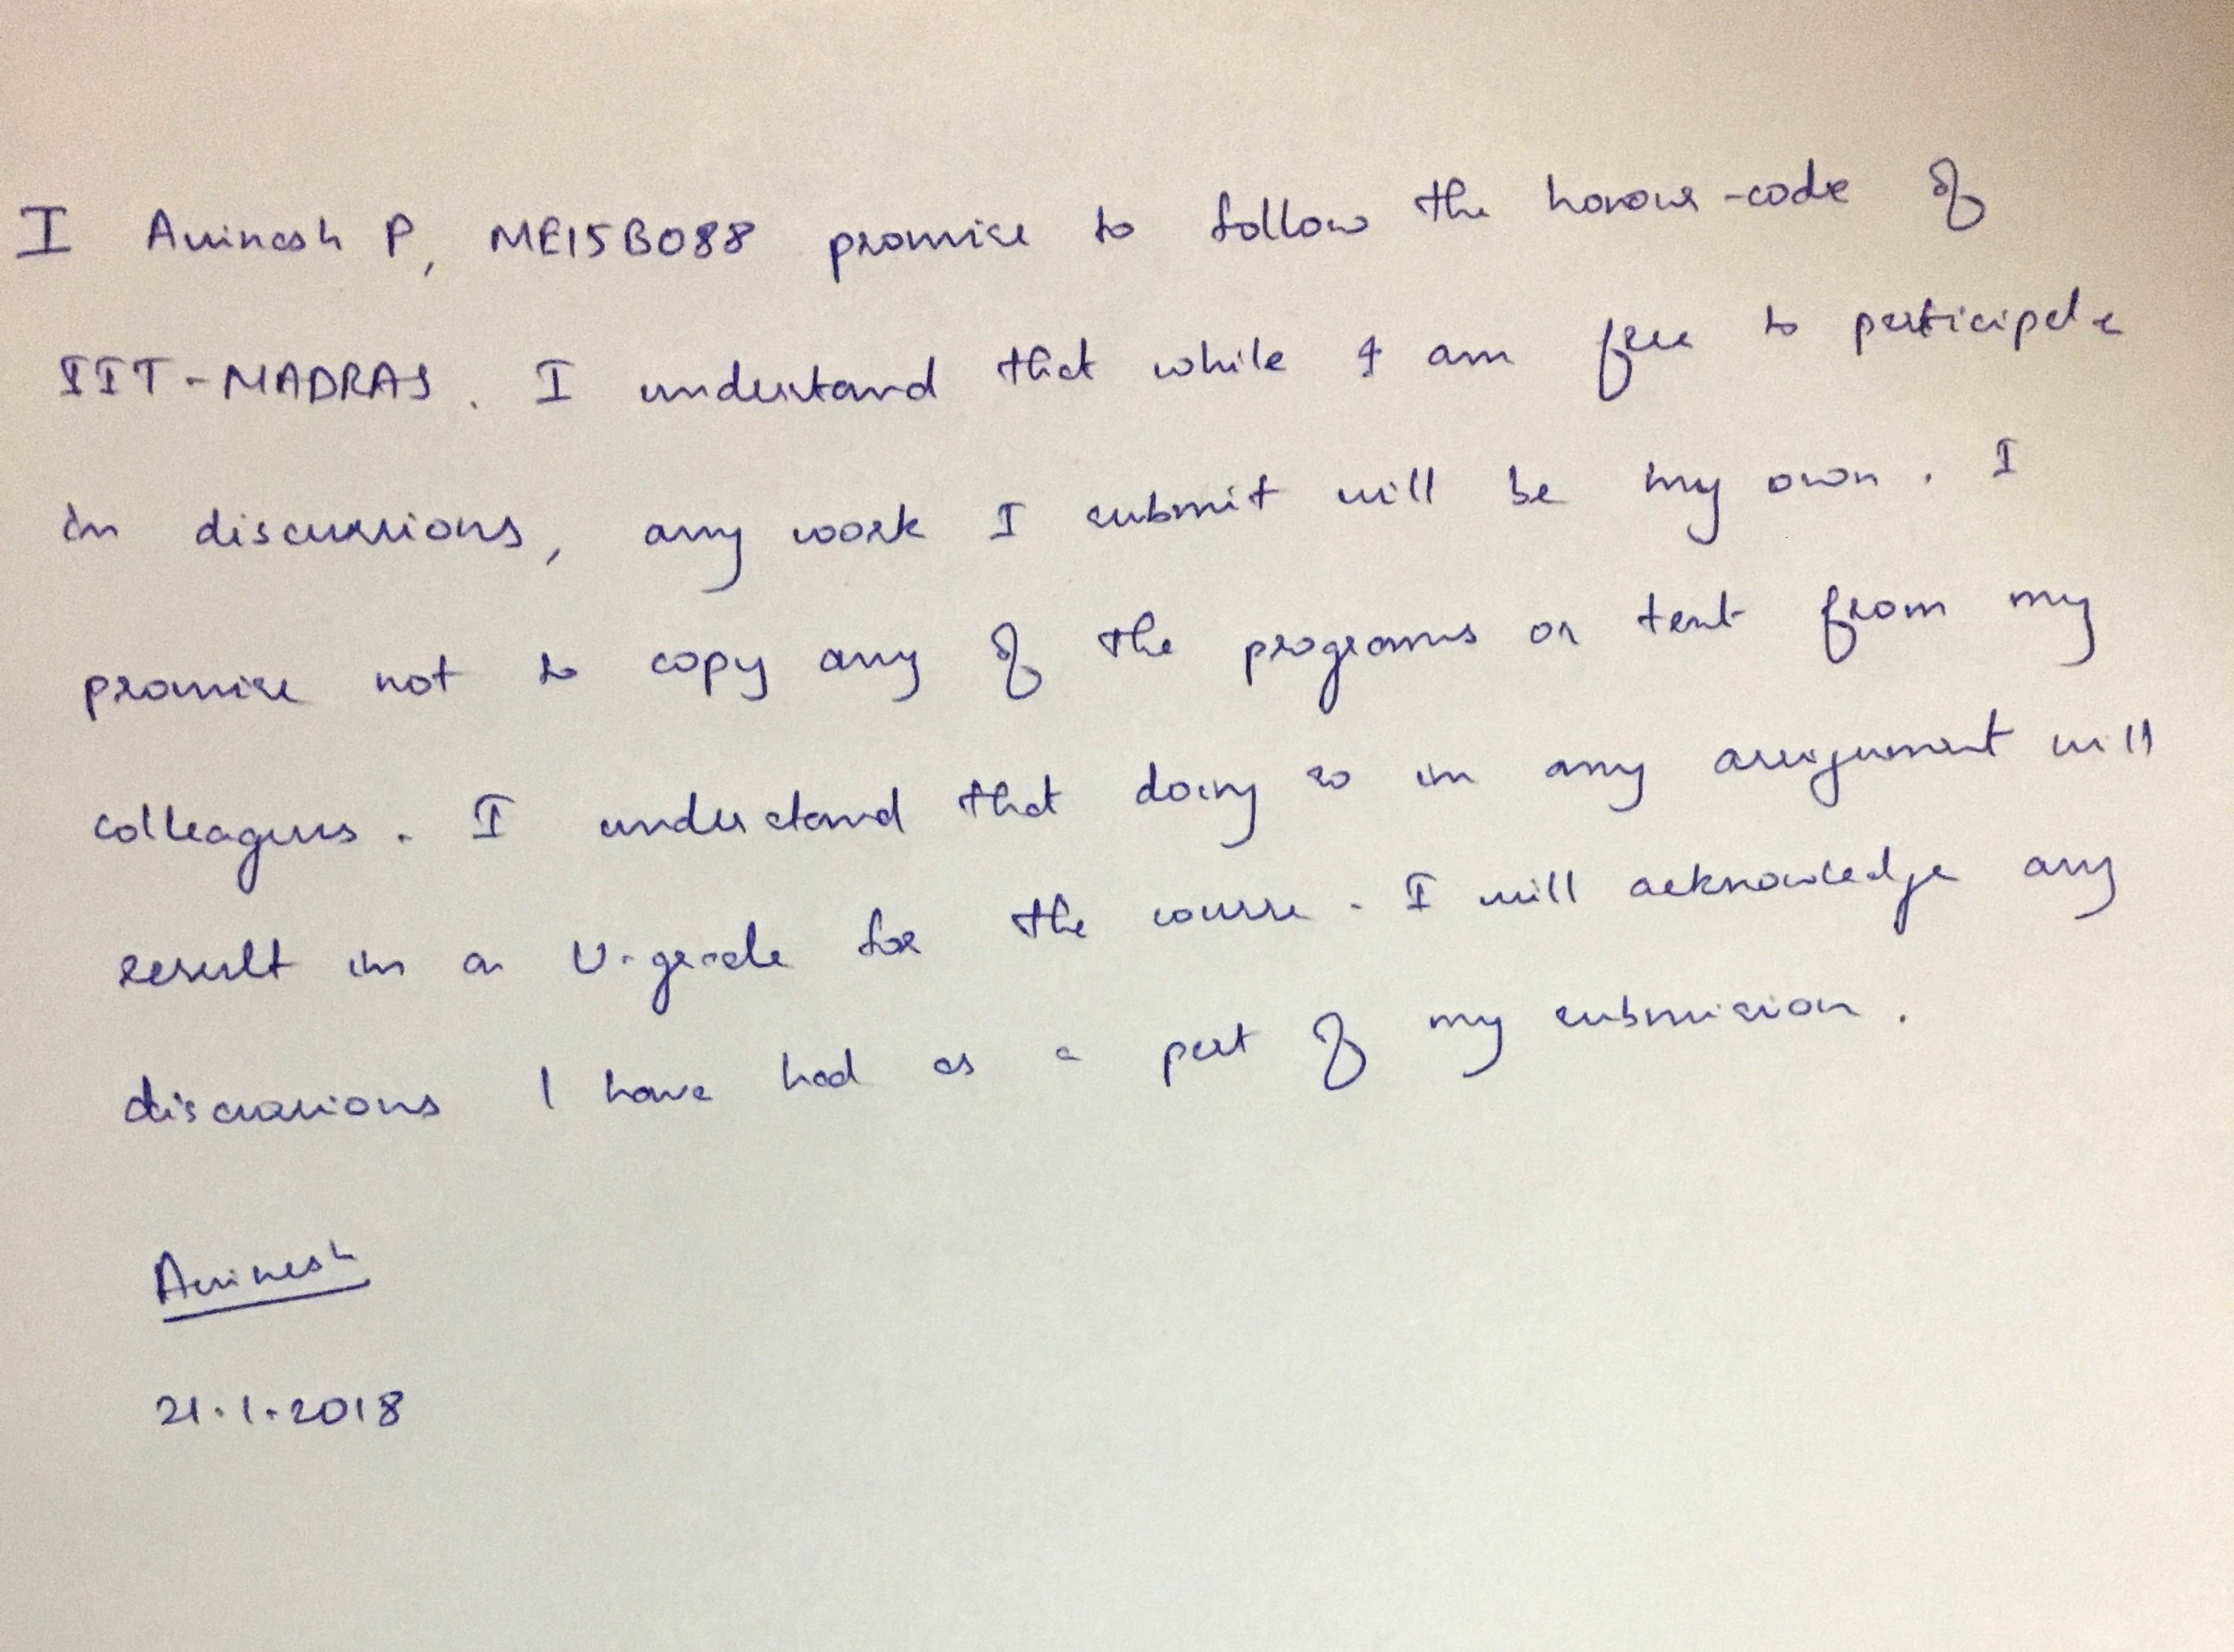
2. **Please mention the sources/people you have had help from in this assignment**

Anaconda Documentation for setting up jupyter and virtual environment