BLOOD BANK MANAGEMENT SYSTEM

DESIGNED BY:-

* Avinash Kumar Singh
* Anurag Raj
* AbhishekKumarSingh

__________________________________________________________________________

T

his is a project based on the management of Blood Bank online, where a user can register to donate and avail the blood online with ease. This project provides registration for any new user and validates the credentials while logging in.

There are three primary databases used during the management of blood bank:

1. 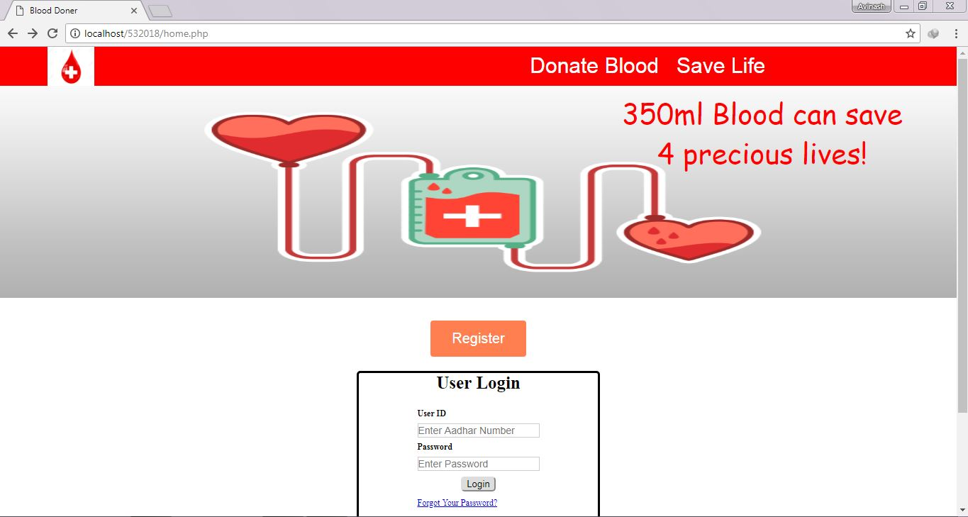Login- It is the database which stores the credentials of new user whilst registering and uses the same credentials to validate the login of user.
2. Stock- It is the database used to store the available blood stock in blood bank with the respective details of the donor which will be processed while any new donation or withdrawal of blood.

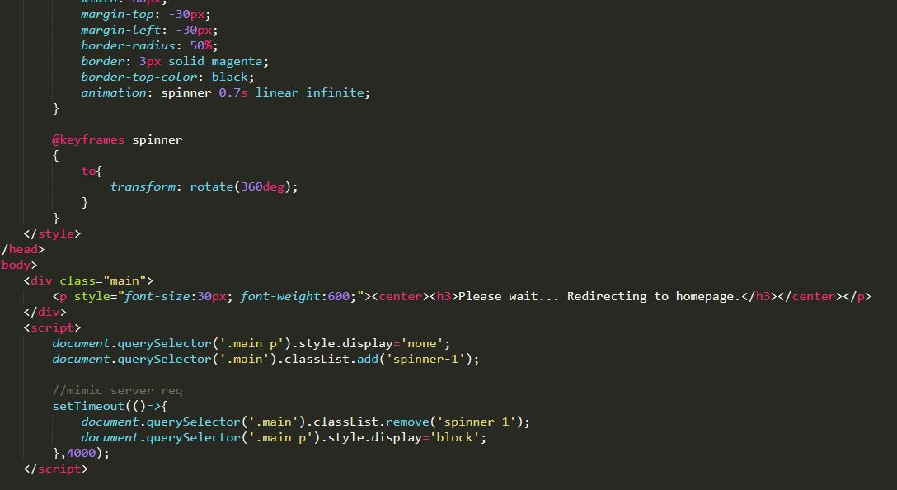

1. 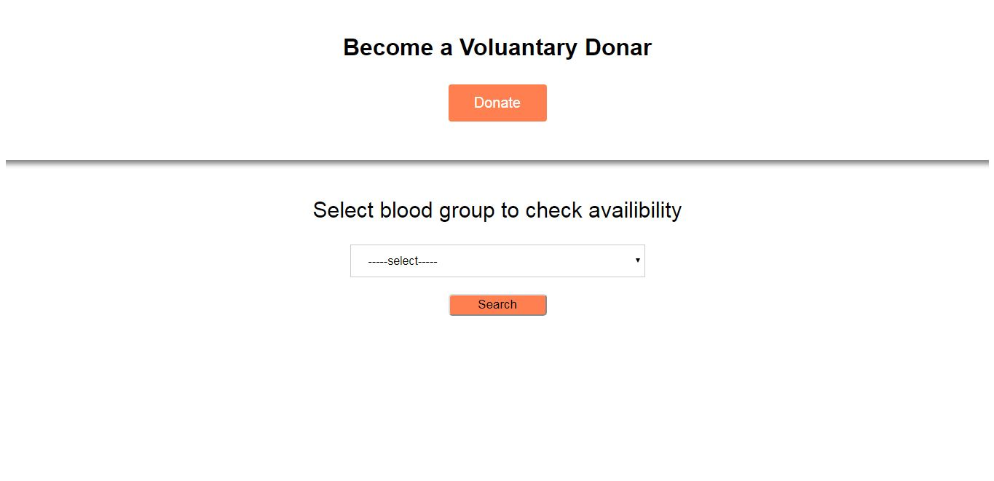Receivers- It maintains the record of user withdrawing blood with their details.
2. After Receiver –we show what they have chosen with price

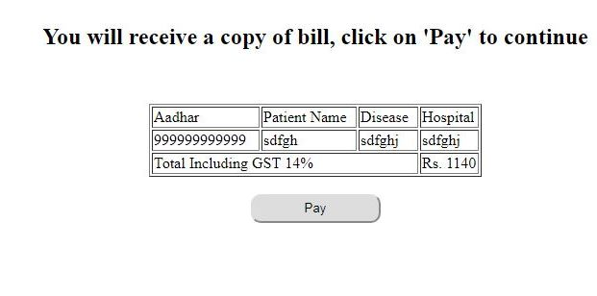

1. 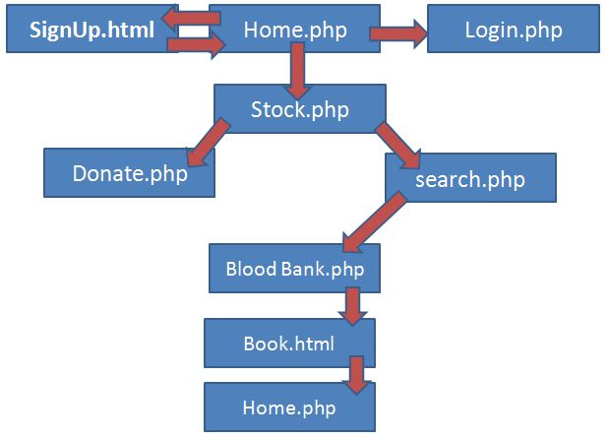Pay – After seeing all above their detail. Click on pay after that fill your detail and submit your blood is booked.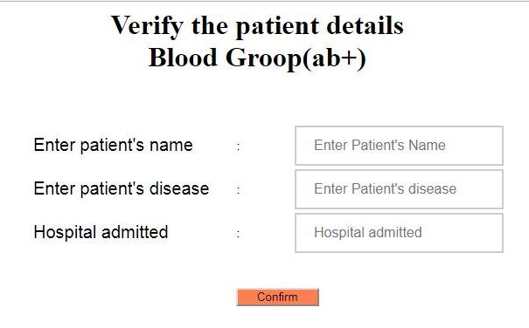

Flow Chart

Various PHP functions HTML tags and MySQL queries were used in order to complete the project, PHP features like session variables, date conversions, HTML /CSS inclusion within the PHP files helped to complete the project.