Table of Contents

MLOps Assignment 01 – End-to-End Heart Disease Risk Prediction
Course: AIMLCZG523 – Machine Learning Operations
Assignment: Experimental Learning Assignment 01 (2026)
Dataset: Heart Disease UCI (Cleveland processed subset)
Student: AVINASH TIWARI [2024AC05513] Repository: https://github.com/avinashtiwari18/heart-disease-mlops
Deployed API: Local Docker (localhost:8000) and Kubernetes on Rancher Desktop (kubectl port-forward svc/heart-disease-api-svc 8000:80)

1. Project Overview
This project designs, trains, packages, and deploys a production-style machine learning classifier that predicts the presence of heart disease from patient clinical measurements. The solution follows modern MLOps practices:
- Reproducible data acquisition and cleaning
- Professional exploratory data analysis (EDA)
- Feature engineering via an sklearn Pipeline / ColumnTransformer
- Multi-model training with hyperparameter tuning and cross-validation
- Experiment tracking with MLflow
- Automated testing and GitHub Actions CI/CD
- Containerized serving with FastAPI + Docker
- Deployment to Kubernetes (Minikube / Docker Desktop)
- Request logging and Prometheus metrics for monitoring
Business / clinical framing. Early risk stratification can support triage and follow-up decisions. The model is a decision-support classifier, not a diagnostic replacement for clinicians.

2. Dataset & Problem Statement
Item | Detail
Source | UCI Machine Learning Repository – Heart Disease
Primary file | processed.cleveland.data
Features | 13 clinical attributes (age, sex, cp, trestbps, chol, fbs, restecg, thalach, exang, oldpeak, slope, ca, thal)
Original label | num (0–4 severity)
Modelling label | Binary target: 0 if num == 0, else 1
Task | Supervised binary classification
Download instructions
python scripts/download_data.py
The script tries the official UCI Cleveland URL first, then a public mirror. It writes:
- data/raw/heart_disease_raw.csv
- data/cleaned/heart_disease_cleaned.csv
Missing values encoded as ? are parsed as NaN and median-imputed for the cleaned deliverable.

3. Setup & Installation

3.1 Prerequisites
- Python 3.11+
- Git
- Docker Desktop (for containerization)
- Minikube or Docker Desktop Kubernetes (for orchestration)
- Optional: kubectl, Helm, Grafana

3.2 Environment
cd AIML/heart-disease-mlops
python3 -m venv .venv
source .venv/bin/activate
pip install -r requirements.txt
python scripts/download_data.py
python -m src.eda
python -m src.train
pytest tests -v
uvicorn api.main:app --port 8000
All scripts are intended to run from a clean virtual environment using only requirements.txt.

4. Exploratory Data Analysis (EDA)
EDA artifacts are generated by python -m src.eda and notebooks/01_eda.ipynb into artifacts/eda/.

4.1 Missing value analysis
The Cleveland processed file historically contains missing values mainly in:
- ca (number of major vessels)
- thal (thalassemia status)
A missing-value bar chart and CSV report are saved under artifacts/eda/. Median imputation is used because the feature distributions are skewed and the missing rate is low relative to the sample size (~300 rows).

4.2 Class balance
The binary target is roughly balanced (near 46–54% depending on exact clean subset). This reduces the need for aggressive resampling; metrics beyond accuracy (precision, recall, F1, ROC-AUC) are still reported.

4.3 Distributions & relationships
- Histograms for age, trestbps, chol, thalach, oldpeak show clinical range spread and mild right-skew for cholesterol / ST depression.
- Boxplots vs target highlight that lower thalach and higher oldpeak tend to associate with disease presence.
- Correlation heatmap shows multi-collinearity among some ECG-related features; tree models tolerate this better than plain linear models, while Logistic Regression benefits from scaling + regularization.

4.4 Modelling implications
- Scale continuous features for linear models.
- One-hot encode categorical clinical codes.
- Prefer ROC-AUC for model selection because it is threshold-robust.
- Keep a single serializable preprocessing+model pipeline for inference parity.

EDA figures
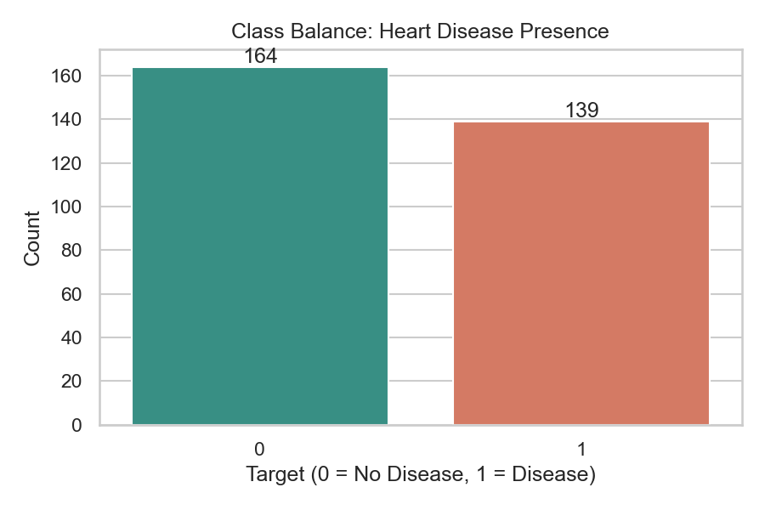
Class balance
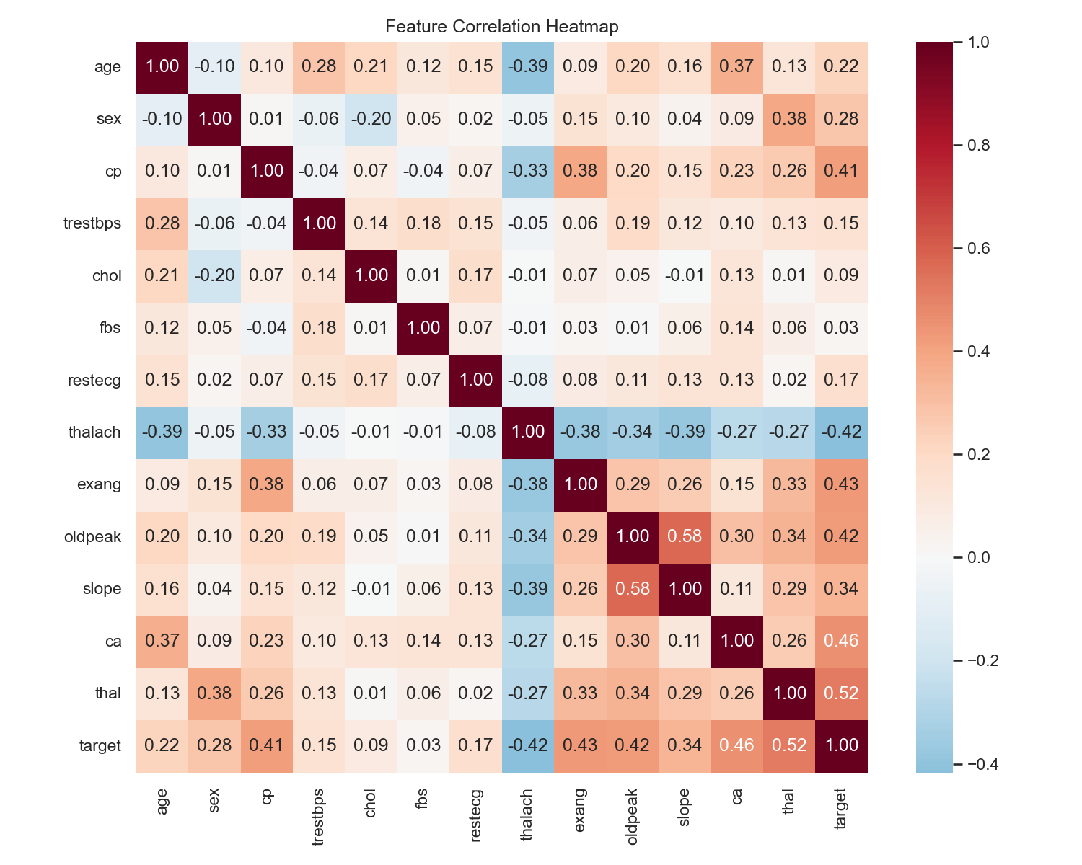
Correlation heatmap
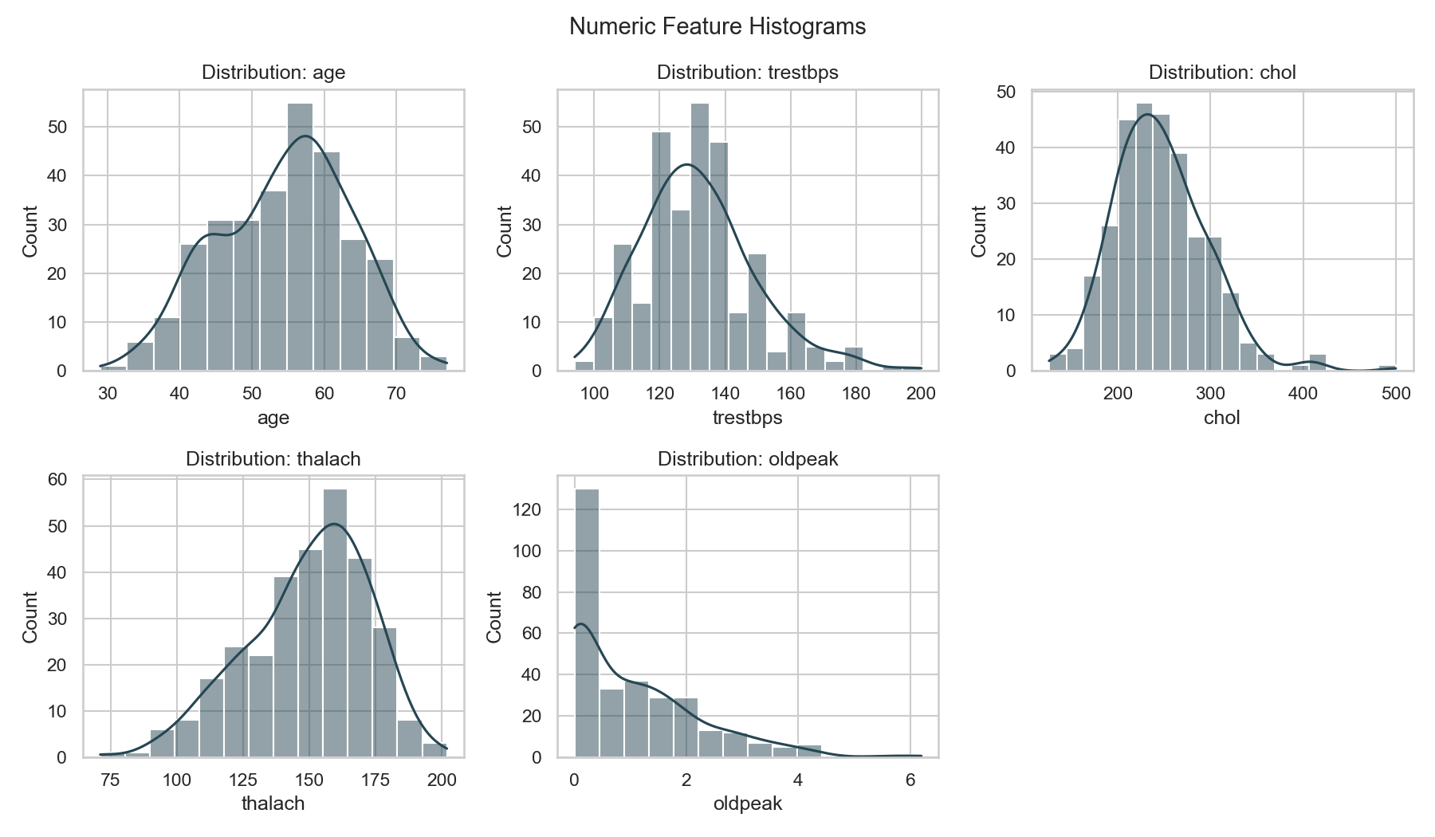
Numeric histograms

5. Feature Engineering & Model Development

5.1 Preprocessing pipeline
Implemented in src/features.py:
- Numeric: StandardScaler on age, trestbps, chol, thalach, oldpeak
- Categorical: OneHotEncoder(handle_unknown="ignore") on sex, cp, fbs, restecg, exang, slope, ca, thal
- Wrapped with the estimator in an sklearn Pipeline so training and serving use identical transforms

5.2 Models trained ( ≥ 2 required)
Model | Rationale
Logistic Regression | Strong linear baseline, calibrated probabilities, interpretable coefficients
Random Forest | Non-linear interactions, robust to feature scale
XGBoost | High-capacity gradient boosting for tabular data

5.3 Tuning & validation
- Stratified train/test split (80/20, random_state=42)
- GridSearchCV with 5-fold StratifiedKFold, scoring=roc_auc
- Final comparison on held-out test metrics: Accuracy, Precision, Recall, F1, ROC-AUC
- Leaderboard CSV: artifacts/metrics/model_leaderboard.csv
Hyperparameter grids (summary):
- LogReg: C ∈ {0.1, 1, 10}
- RF: n_estimators ∈ {100,200}, max_depth ∈ {None,5,10}, min_samples_split ∈ {2,5}
- XGB: n_estimators ∈ {100,200}, max_depth ∈ {3,5}, learning_rate ∈ {0.05,0.1}

5.4 Model selection
The model with the highest test ROC-AUC is serialized to:
models/heart_disease_pipeline.joblib
models/model_metadata.json
Selection rationale is logged in MLflow run best_model_selection.

6. Experiment Tracking (MLflow)
Tracking URI: ./mlflow_tracking (local file store).
For each model run we log:
- Parameters (best GridSearch hyperparameters, model name, split seed)
- Metrics (accuracy, precision, recall, F1, ROC-AUC, CV ROC-AUC mean/std)
- Artifacts (confusion matrix PNG, ROC curve PNG, sklearn model)
Launch UI:
mlflow ui --backend-store-uri ./mlflow_tracking --port 5000

MLflow experiment tracking
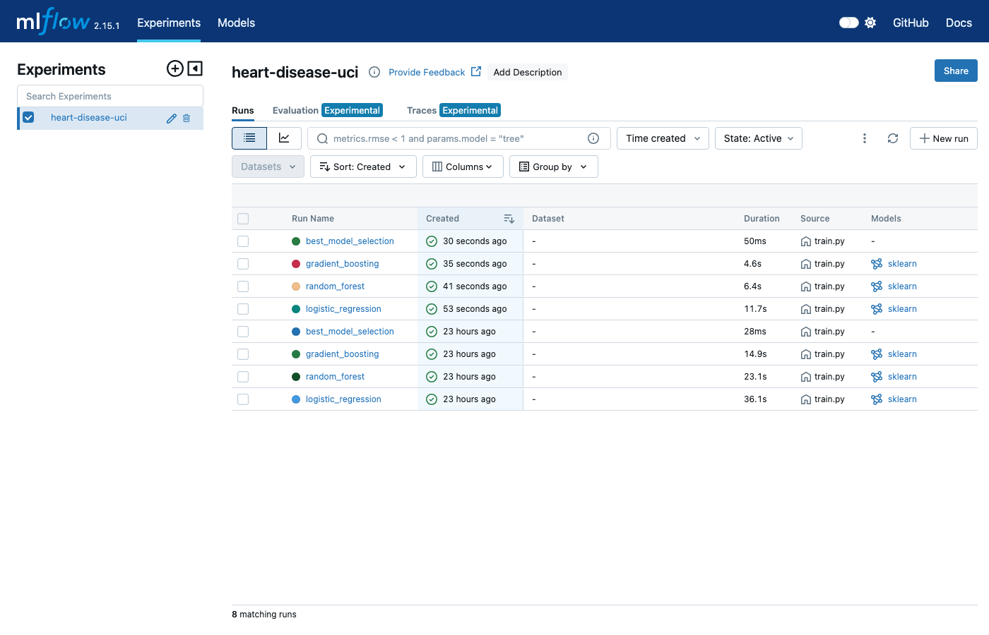
MLflow UI — heart-disease-uci runs

7. Model Packaging & Reproducibility
Concern | Approach
Environment | Pinned requirements.txt
Preprocessing | Saved inside the joblib Pipeline
Model binary | joblib (MLflow also stores sklearn flavor)
Metadata | model_metadata.json (best model name, AUC, feature order)
Data | Download script + cleaned CSV
Inference never re-implements ad-hoc scaling; it loads the full pipeline.

8. CI/CD Pipeline & Automated Testing

8.1 Tests (tests/)
- test_data_processing.py – schema, imputation, split, outlier clipping
- test_model.py – preprocessor shape, pipeline fit/predict, saved model smoke test
- test_api.py – /health, /predict contract, validation errors, /metrics

8.2 GitHub Actions (.github/workflows/ci.yml)
Stages: checkout → Python 3.11 → install → flake8 → download data → pytest → EDA → train → full pytest → upload artifacts → Docker build → container /predict smoke test.
Failure policy: critical flake8 errors or any pytest failure fail the workflow; logs are visible in the Actions UI.

CI/CD evidence
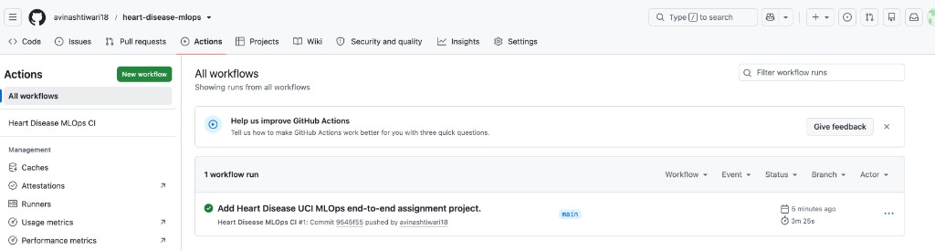
GitHub Actions green run

9. Model Containerization
Dockerfile packages:
- Python 3.11 runtime
- API code (api/, src/)
- Trained model (models/)
- Dependencies from requirements.txt
Exposes port 8000 with healthcheck on /health.
docker build -t heart-disease-api:1.0.0 .
docker run --rm -p 8000:8000 heart-disease-api:1.0.0
bash scripts/sample_predict.sh
FastAPI Swagger UI: http://127.0.0.1:8000/docs

Docker serving evidence
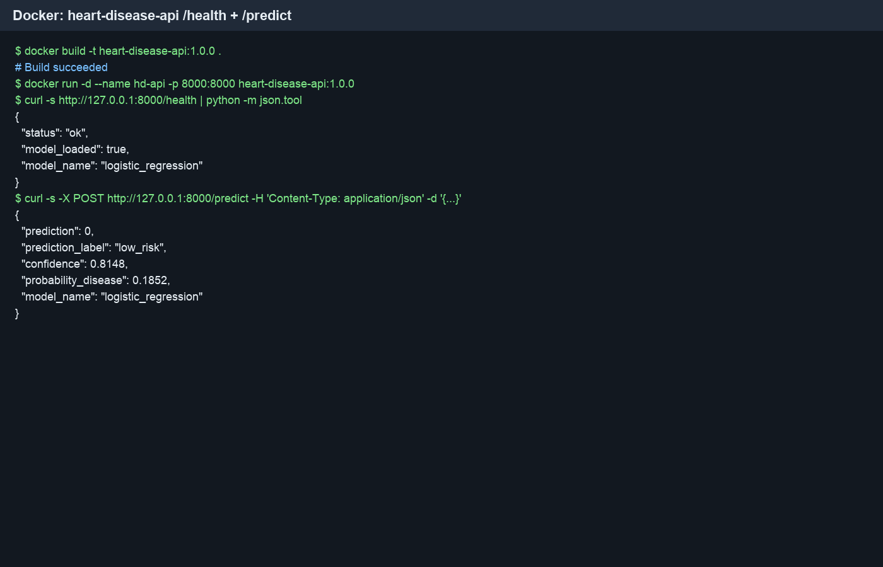
Docker /health and /predict
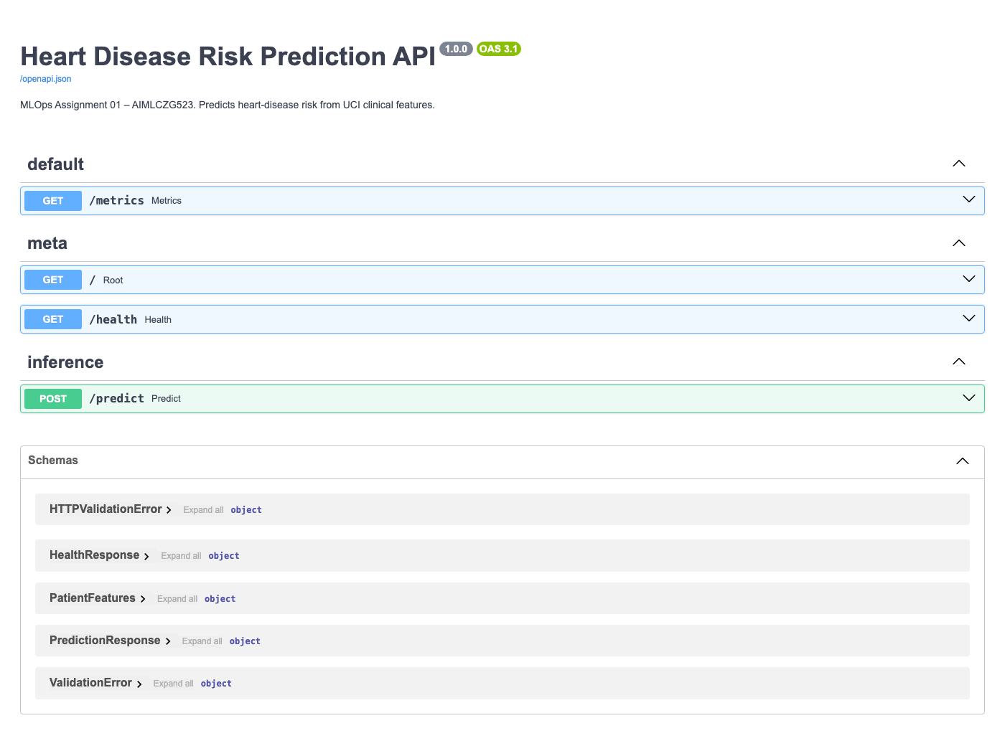
FastAPI Swagger UI

10. Production Deployment (Kubernetes)
Manifests:
- k8s/deployment.yaml – Deployment (2 replicas) + LoadBalancer Service
- k8s/service.yaml – NodePort 30080 for local clusters
- k8s/ingress.yaml – optional Ingress host heart-disease.local
- k8s/helm/heart-disease-api/ – Helm chart alternative
Local deploy:
bash scripts/deploy_minikube.sh
kubectl port-forward svc/heart-disease-api-svc 8000:80
Verification:
kubectl get pods,svc
bash scripts/sample_predict.sh http://127.0.0.1:8000

Kubernetes deployment evidence
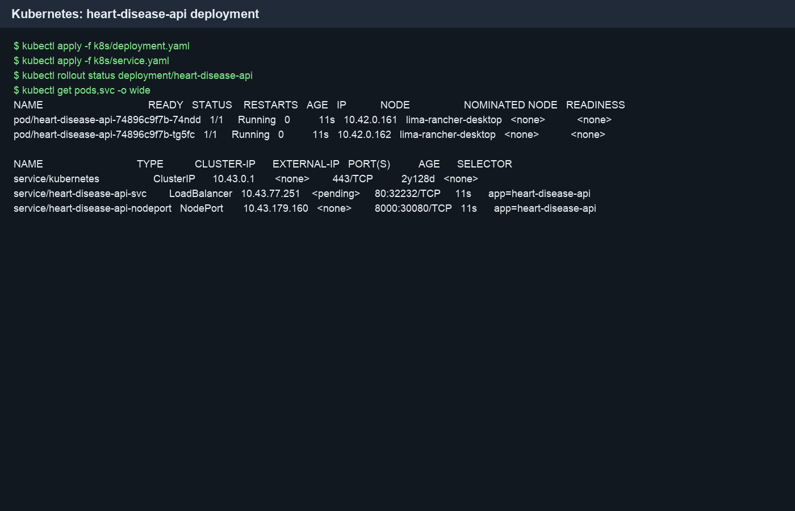
Kubernetes pods and services

Access instructions (local testing)
- Start Minikube / enable Kubernetes in Docker Desktop
- Run scripts/deploy_minikube.sh
- Port-forward service to localhost:8000
- Use Swagger /docs or scripts/sample_predict.sh
If a public cloud URL is later provisioned (GKE/EKS/AKS/Render), replace this section with the LoadBalancer external IP / Ingress hostname.

11. Monitoring & Logging
Signal | Implementation
Request logs | Middleware logs method, path, status, latency; file sink artifacts/logs/api_requests.log
Metrics | prometheus-fastapi-instrumentator exposes /metrics
Dashboards | Prometheus + Grafana via docker compose --profile monitoring up or k8s/monitoring/
Why monitoring matters for ML systems: detect API downtime, latency regressions, elevated 5xx rates, and (with future extensions) prediction drift / data drift.

Monitoring evidence
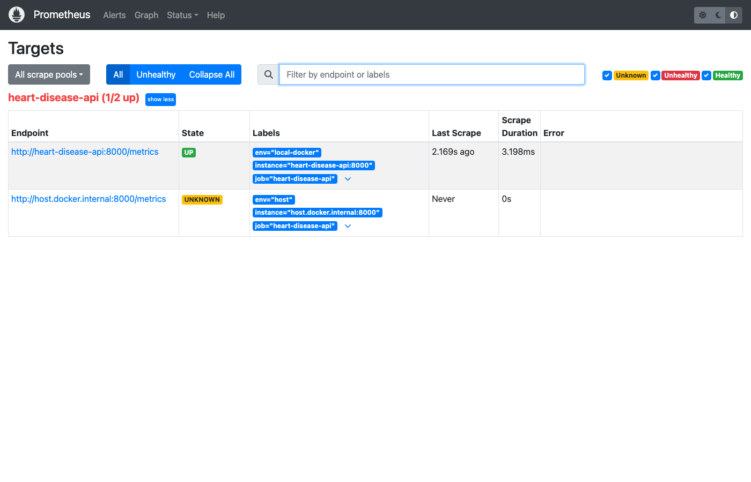
Prometheus targets UI

12. Solution Architecture
┌──────────────┐ download ┌─────────────┐
│ UCI Dataset │ ───────────► │ data/cleaned │
└──────────────┘ └──────┬──────┘
│
▼
┌──────────────┐ MLflow ┌─────────────┐ joblib ┌────────────┐
│ EDA + Train │ ───────────► │ Experiments │ ─────────► │ models/ │
│ (src/, nb) │ └─────────────┘ └─────┬──────┘
└──────┬───────┘ │
│ pytest ▼
▼ ┌────────────┐
┌──────────────┐ GitHub Actions │ FastAPI │
│ tests/ │ ──────────────► CI (lint/test/train/docker)│ /predict │
└──────────────┘ └─────┬──────┘
│
▼
┌────────────┐
│ Docker │
└─────┬──────┘
│
▼
┌────────────┐
│ Kubernetes │
│ + Prom │
└────────────┘

13. Results Summary
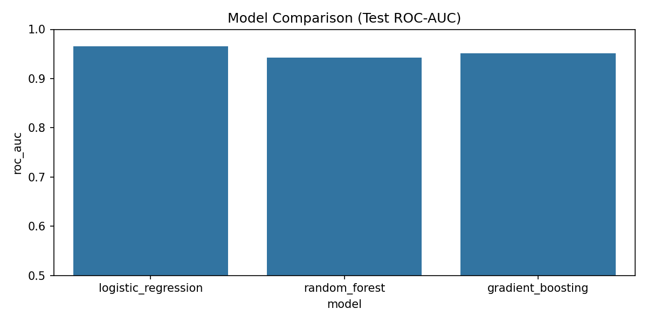
Model comparison ROC-AUC
Held-out test metrics from the local training run (python -m src.train):
Model | Accuracy | Precision | Recall | F1 | ROC-AUC | CV ROC-AUC (mean ± std)
logistic_regression | 0.885 | 0.839 | 0.929 | 0.881 | 0.965 | 0.903 ± 0.016
random_forest | 0.869 | 0.833 | 0.893 | 0.862 | 0.943 | 0.899 ± 0.031
gradient_boosting* | 0.885 | 0.839 | 0.929 | 0.881 | 0.951 | 0.875 ± 0.030
*XGBoost is used when native libs are available (Linux CI / brew install libomp on macOS); otherwise sklearn GradientBoostingClassifier is trained as the third model.
Selected model: logistic_regression (highest test ROC-AUC = 0.965)
Best params: C=1.0, penalty=l2, solver=lbfgs
Key observation: logistic regression outperformed the ensembles on this relatively small, well-structured clinical dataset, delivering strong discrimination (ROC-AUC ≈ 0.97) with a simpler, more interpretable model—suitable for a monitored production API.

14. Challenges & Lessons Learned
- Schema inconsistency across mirrors – Cleveland uses num + ? missings; some CSV mirrors already expose binary target. The loader normalizes both.
- Inference parity – Saving only a bare estimator would break production; packaging the full Pipeline is mandatory.
- CI hermeticity – The workflow downloads data and trains from scratch so runners do not depend on local binaries.
- Local K8s image pull – Minikube requires building inside its Docker daemon (minikube docker-env) when using IfNotPresent.

15. Future Improvements
- Add data-drift monitors (evidently / custom PSI)
- Model registry stage transitions (Staging → Production) in MLflow
- Canary deployment with Istio / Flagger
- Calibrated probability thresholds tuned for clinical recall targets
- Public cloud deploy with HTTPS Ingress and secrets management

16. Deliverables Mapping
Assignment requirement | Location
Data acquisition & EDA | scripts/download_data.py, src/eda.py, notebooks/01_eda.ipynb, artifacts/eda/
Feature eng. & models | src/features.py, src/train.py, notebooks/02_training.ipynb
Experiment tracking | MLflow in src/train.py, store mlflow_tracking/
Packaging | models/*.joblib, requirements.txt
CI/CD & tests | .github/workflows/ci.yml, tests/
Containerization | Dockerfile, docker-compose.yml
Deployment | k8s/, scripts/deploy_minikube.sh
Monitoring | API logging, /metrics, k8s/monitoring/
Documentation | README.md, this REPORT.md, screenshots/

17. References
- UCI Machine Learning Repository – Heart Disease Dataset
- MLflow Documentation – https://mlflow.org/docs/latest/index.html
- FastAPI Documentation – https://fastapi.tiangolo.com/
- Kubernetes Documentation – https://kubernetes.io/docs/home/
- Prometheus – https://prometheus.io/docs/

Appendix A – Example API response
{
"prediction": 1,
"prediction_label": "heart_disease_risk",
"confidence": 0.82,
"probability_disease": 0.82,
"model_name": "random_forest"
}

Appendix B – Video demo outline
Record a 3–5 minute screencast covering: repo walkthrough → EDA plots → MLflow UI → pytest/CI → Docker predict → Kubernetes pods → Prometheus metrics.

End of report. Export this Markdown to PDF/DOCX (e.g., Pandoc, Word, or VS Code Markdown PDF) and attach screenshots to reach the ~10-page submission length.

