**BERT Finetuning:**

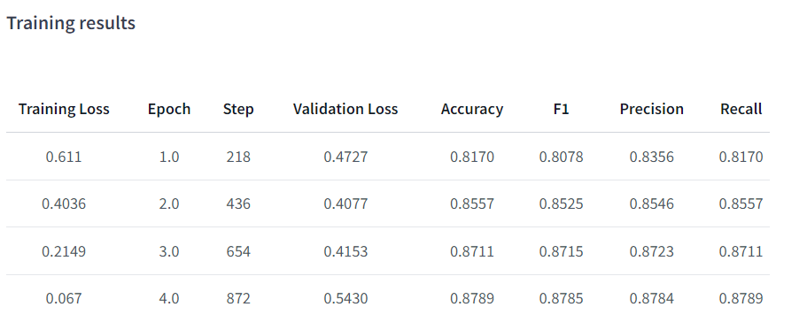

**Training hyperparameters**

The following hyperparameters were used during training:

* learning_rate: 5e-05
* train_batch_size: 16
* eval_batch_size: 64
* seed: 42
* optimizer: Adam with betas=(0.9,0.999) and epsilon=1e-08
* lr_scheduler_type: linear
* lr_scheduler_warmup_steps: 500
* num_epochs: 4

**Fine-tuned version achieves the following results on the evaluation set:**

* Loss: 0.5430
* Accuracy: 0.8789
* F1: 0.8785
* Precision: 0.8784
* Recall: 0.8789

**Classification report on test dataset:**

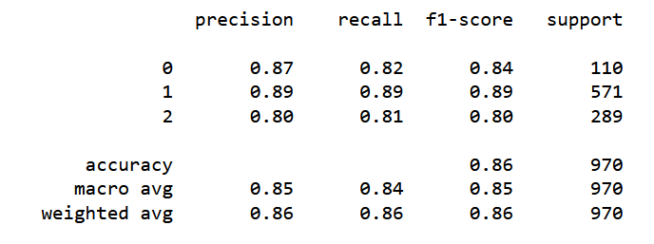

**RoBERTa Finetuning:**

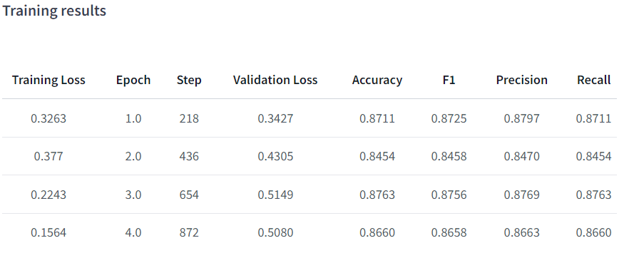

**Training hyperparameters**

The following hyperparameters were used during training:

* learning_rate: 5e-05
* train_batch_size: 16
* eval_batch_size: 64
* seed: 42
* optimizer: Adam with betas=(0.9,0.999) and epsilon=1e-08
* lr_scheduler_type: linear
* lr_scheduler_warmup_steps: 500
* num_epochs: 4

**Fine-tuned version achieves the following results on the evaluation set:**

* Loss: 0.5080
* Accuracy: 0.8660
* F1: 0.8658
* Precision: 0.8663
* Recall: 0.8660

**Classification report on test dataset:**

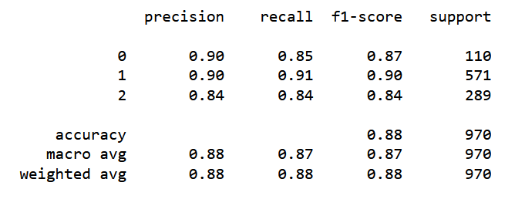

**SVM + CountVectorizer**

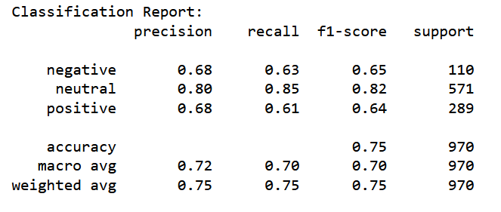

**SVM + TfidfVectorizer**

