**Data:**

The data is drawn from two Gaussian distributions, 50 samples from a Gaussian centered at (-1, -1) representing **class 0**. 50 samples from a Gaussian centered at (1, 1) representing **class 1**.

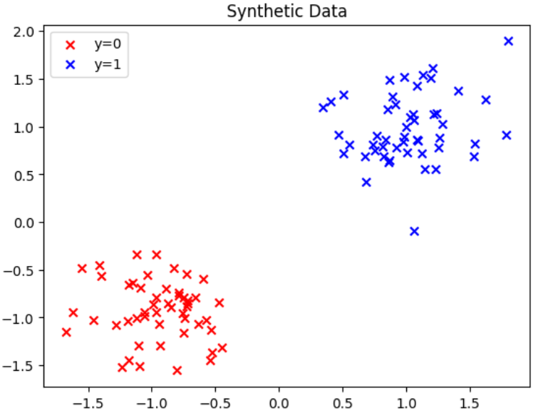

A simple **logistic regression model** is constructed using TensorFlow and **Cross-Entropy Loss** (tf.nn.sigmoid_cross_entropy_with_logits) is used as the loss function, which is standard for binary classification problems. The model uses the **Adam optimizer** with a learning rate of 0.01 to minimize the cross-entropy loss. This ensures efficient updates to the weights and biases.

**Training Process:**

The model is trained for 20,000 iterations using TensorFlow’s session-based API. During each iteration:

* The optimization step is performed to update the weights and bias.
* The training loss is recorded at regular intervals (every 1000 iterations).

The training loss decreases rapidly, as shown by the following steps:

* Initially, the loss starts at 234.27.
* By the 1000th step, the loss reduces to 2.85.
* By the 19000th step, the loss is as small as 0.000216.

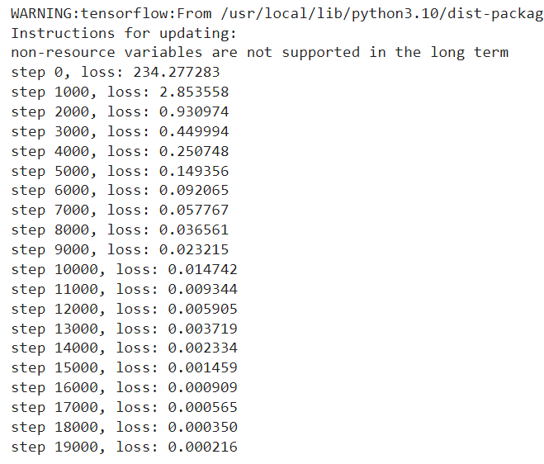

This rapid decline in loss indicates that the logistic regression model is learning the correct decision boundary between the two classes.

**Model Performance:**

After training, the model's parameters (weights and bias) are extracted, and predictions are made for the dataset. The results are then visualized by plotting the predicted class labels over the original data points.

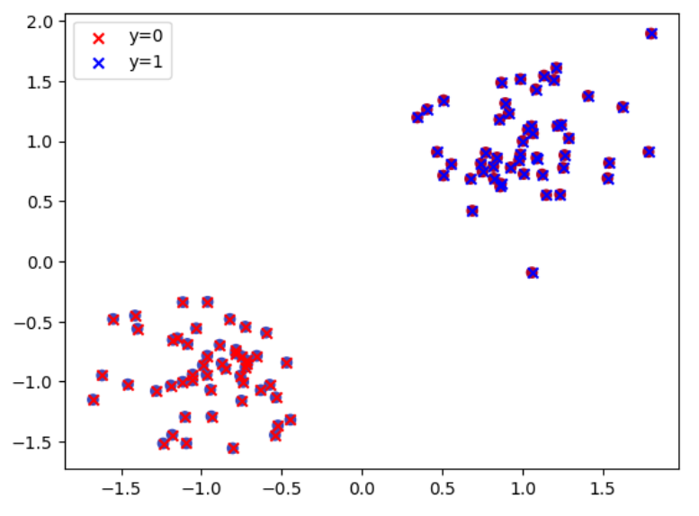

The plot confirms that the logistic regression model has **perfectly classified** the two classes, as the blue and red clusters are completely separated in the plot. This suggests that the model successfully learned the decision boundary between the two Gaussians.

The training loss steadily decreases, reaching extremely low values by the end of training. This is expected, given the simplicity and separability of the dataset. The visualization of the predicted outputs confirms that the model has correctly classified all points.