Introduction:

The project involved the HAM10000 dataset, a large collection of multi-source dermatoscopic images of common pigmented skin lesions used in several studies on skin cancer classification using deep features. The dataset has also been used in a systematic review of the diagnostic accuracy of reflectance confocal microscopy for melanoma diagnosis in patients with clinically equivocal skin lesions. The primary goal of the project is to train machine learning models to classify *(in seven classes)* skin lesions into different categories based on visual features.

Literature Review:

* Usama, M., Naeem, M. A., & Mirza, F. (2022). Multi-Class Skin Lesions Classification Using Deep Features. *Sensors (Basel, Switzerland)*, *22*(21), 8311. <https://doi.org/10.3390/s22218311>

This research presents an innovative approach for skin cancer classification. It balances the dataset and employs transfer learning to retrain CNN models. Deep features are extracted, and optimal features are selected using Moth Flame Optimization, resulting in high accuracy rates of 95.9%, 95.0%, and 95.8% for different classification methods, outperforming state-of-the-art approaches.

* Alam, T. M., Shaukat, K., Khan, W. A., Hameed, I. A., Almuqren, L. Abd., Raza, M. A., Aslam, M., & Luo, S. (2022). An Efficient Deep Learning-Based Skin Cancer Classifier for an Imbalanced Dataset. *Diagnostics*, *12*(9), 2115. <https://doi.org/10.3390/diagnostics12092115>

This study addresses the challenge of efficient skin cancer detection, emphasizing the critical importance of early diagnosis. It highlights the shortage of skilled dermatologists and the data imbalance issue in skin cancer datasets. The research proposes a novel deep learning-based skin cancer detector, using data augmentation to balance the dataset. Three deep learning models (AlexNet, InceptionV3, and RegNetY-320) are employed to classify skin cancer, with RegNetY-320 outperforming the others. The proposed framework achieves an accuracy of 91%, F1-score of 88.1%, and ROC curve value of 0.95, surpassing state-of-the-art methods. This advancement could save lives, reduce biopsies, and lower healthcare costs.

Models and/or Methods:- ResNet-50 is a deep convolutional neural network (CNN) with 50 layers, making it capable of learning complex hierarchical features from images. Skin lesion classification can benefit from deep architectures as they can capture intricate patterns and variations in skin textures and colors.ResNet-50 is pre-trained on a massive dataset like ImageNet. This pretraining imparts the model with a strong initial understanding of general image features, which can be fine-tuned for the specific task of skin cancer classification. This helps reduce the need for extensive training on the smaller HAM10000 dataset. Transfer learning allows it to leverage knowledge from a different but related task. In the case of ResNet-50, it can utilise the feature extraction capabilities developed on ImageNet to classify skin lesions in HAM10000. Fine-tuning the model's top layers for skin cancer classification can lead to better convergence and higher accuracy.

Experimental Setup:

Optimizer – Adam

Criterion – CrossEntropyLoss

Epochs – 300

batch_size – 64

Split: 80:20

Results: we were able to achieve 99% average F1, and what is interesting is that even on 2 classes with the smallest representations (only 78 and 58 training images), we still were able to achieve more than 100% F1 and AUC scores in both cases. The classification report and confusion matrix are shown below.

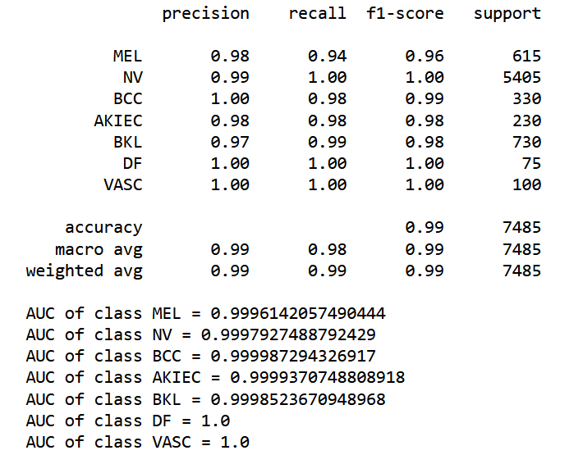

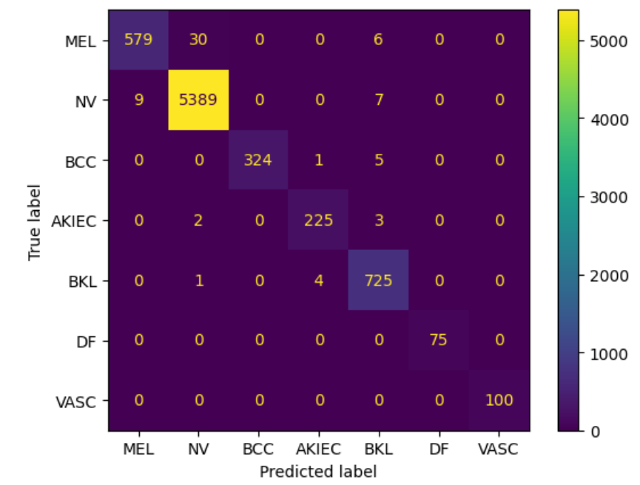

Conclusions:

*Strengths of the Proposed Solution*: The use of a pretrained ResNet-50 model with fine-tuning allows the model to leverage knowledge from a vast dataset, potentially improving classification accuracy. Early stopping helps prevent overfitting and efficiently saves the best model checkpoint during training.

*Weaknesses and Limitations*: Since it already gives near-perfect accuracy and F1 scores, we don’t find any weaknesses

*Recommendations for Future Work*: Investigate techniques for model interpretability to understand which image regions contribute to the model's predictions