GUI standards


Table of Contents
1.0 Introduction 5
2.0 What this Standard Covers 5
2.1 Ten Principles of User Interface Design 5
2.1.1 Understand the Users 5
2.1.2 Use Metaphors 5
2.1.3 Be Consistent 5
2.1.4 Give the User Control 6
2.1.5 Be Forgiving 6
2.1.6 Allow Flexibility 6
2.1.7 Provide Feedback 6
2.1.8 Provide Help 6
2.1.9 Provide Navigation Aids 7
2.1.10 Pay Attention to Detail 7
2.2 User Interface Design and Evaluation in the Research and Development Cycle 7
2.2.1 User Profiles 7
2.2.2 Task Analysis 7
2.2.3 Usability Goals 7
2.2.4 User Interface Design Inspection 8
2.2.5 Rapid Usability Evaluations 8
2.3 Development Goals 8
2.4 Mouse Input 8
2.4.1 Basic Mouse Operations 8
2.4.2 Double and Single Clicks 9
2.5 Keyboard Input 9
2.5.1 Mnemonics 9
2.5.2 Command Buttons 10
2.5.3 Shortcut Keys 10
2.5.4 Tabbing and Cursor Movement Keys 11
2.5.5 Use of the <Return> and <Escape> keys 11
2.6 Abbreviations, Acronyms, and Codes 11
2.6.1 Abbreviations 11
2.6.2 Acronyms 12
2.6.3 Codes 13
2.7 Color 14
2.8 Controls 14
2.8.1 Default Controls 14
2.8.2 Disabled Controls 15
2.9 Selection Mechanisms 15
2.10 Navigation Mechanisms 17
2.11 International Issues 17
2.12 Windows 18
2.12.1 Window Behavior 18
2.12.2 Text 19
2.12.3 The Status Bar 20
2.13 The Multiple Document Interface 22
2.13.1 Working with MDI 22
2.14 Dialog and Message Boxes 24
2.15 Controls 26
2.15.1 Type and Use of Controls 26
2.15.2 Labels 26
2.15.3 Command Buttons 27
2.15.4 Check Boxes 29
2.15.5 Radio Buttons 29
2.15.6 List Boxes 30
2.15.7 Text Entry Boxes 32
2.15.8 Combo (Combination) Boxes 32
2.15.9 Spin Boxes 33
2.15.10 Group Boxes 33
2.15.11 Spacing Controls on the Screen 34
2.16 Icons 34
2.16.1 Guidelines for New Icon Design 35
2.17 Types of Menus 36
2.17.1 Number of Items Per Menu 37
2.17.2 Displaying Menus and Selecting Menu Items 37
2.18 Standard Menus 38
2.19 Non-standard Menus 39
2.19.1 Menu Headings 39
2.19.2 Menu Items 39
2.20 Unavailable Menus and Menu Items 41
3.0 User Support Mechanisms 42
3.1 Help 42
3.1.1 Access to Help 42
3.1.2 The Help Window 42
3.1.3 What Kind of Help to Provide 42
3.1.4 Contents 43
3.1.5 Search 44
3.1.6 How to Use Help 45
3.1.7 Product Support 45
3.1.8 About... 45
3.1.9 Opening Screen 46
3.1.10 Style and Tone 47
3.2 Messages 47
3.2.1 Types and Presentation 47
3.2.2 Message Content 48
3.3 Feedback 49
3.3.1 Changing Pointers and Progress Indicators 49
3.3.2 Using the Status Bar for Feedback 50
3.3.3 Auditory Feedback 50
3.4 Navigation Aids 50
4.0 Annexure - I Checklists 52
4.1 Check List: Consistency 52
4.2 Check List: Windows - General 53
4.3 Check List: Controls 54
4.4 Check List: Metaphors and Icons 56
4.5 Check List: Menus 57
Check List: Data Representation 58
4.6 Check List: User Support Mechanisms 59

Introduction
This document is a guide to the design of the Graphical User Interface (GUI) for GUI based applications. Consistency between applications is important; it allows products to convey a standard corporate image, and increases product usability.

What this Standard Covers
This standard covers the basic interface elements that must be considered when developing a new application, or modifying an existing one. This document does not cover specific coding techniques or evaluation and testing methods.

Ten Principles of User Interface Design

Understand the Users
A fundamental tenet of user interface design is to know your users. Software developers often make two mistakes -- they assume that all users are similar, and that all users are like software developers.
Users have different backgrounds, experience, work environments, preferences, job requirements, skills, and learning styles. For example, users of an Accounting system in a University may have different needs to those of users in the Stock Exchange. As software developers produce an application, they may become less and less able to put themselves in the place of the intended user group. Field surveys, user profiles, task analyses, and the definition of usability goals provide valuable insights into user behavior.

Use Metaphors
Metaphors are conceptual analogies that help the user to transfer existing knowledge to the application interface. Metaphors can facilitate the construction of users’ mental models of the application, reduce learning time, and make new environments less threatening. The prototypical example of a metaphor is the computer desktop with folders, an inbox, and documents. Applications can (and often do) have more than one metaphor. For example, most GUIs have a desktop metaphor and a window metaphor.
Metaphors should be as simple and realistic as possible. A key design issue is to blend metaphors into a model that is coherent to users.

Be Consistent
Consistency within and between applications is one of the most important and desirable attributes of user interface design. Indeed, one of the goals of this document is to help software developers produce applications that have a consistent interface.
Consistency has many advantages:
- It reduces the time spent by users learning a new application
- It allows users to transfer skills between applications
- It strengthens users’ expectations when faced with new software, and increases their feelings of control
- It allows the developers to convey a corporate image in the interface
- It produces a more attractive and aesthetically pleasing look and feel to the application
- It increases the overall quality of the product by conforming to standard guidelines.
All components of the interface must be checked for consistency. A consistency check list is given in Annexure - I.

Give the User Control
It is important that the interface allows the user to feel in control of the application, and not led by it. A consistent, simple, and predictable interface helps users to feel that they are directing the interaction with the application, and increases their confidence in it.

Be Forgiving
Even with the best-designed interfaces, users will make mistakes. The interface should minimize the opportunity for user error, but if errors occur, it must respond in a forgiving way. In addition, it should allow for easy recovery, for example, with an ‘undo’ function. Error messages should simply state the problem, and offer possible subsequent user actions.

Allow Flexibility
Users vary in the way they interact with an application. For example, a new user may choose to access a function through the menus using the mouse, whilst experts may prefer to use keyboard shortcuts. The interface should provide a choice of interaction mechanism, so that users can select their preferred method. Allowing flexibility in this way enhances users’ feelings of control. However, beware of providing too much flexibility; giving users a wide range of choices may overwhelm and confuse even the expert user.

Provide Feedback
For every user action, the interface should provide some immediate feedback, whether it is in the form of status and confirmation messages, progress indicators, visual changes, or auditory feedback. For frequent and minor actions, the feedback should be subtle. For uncommon actions, the feedback should be more substantial.

Provide Help
Each screen must have available Help that describes valid responses, ways to get further information, where and how information will be used, and ways to cancel the current activity without impacting the system. Access to Help should be visible and flexible. The Help window should be large enough to avoid excessive scrolling, but should not cover the full screen and obscure the user’s work area.

Provide Navigation Aids
In some applications, particularly those in which the user may have several tasks open at a time; there is a danger of users becoming ‘lost’. The interface must provide some mechanism for users to determine where they are, and how they can move between tasks. In addition, the interface must allow easy navigation within tasks (for example, if the task is divided into sub tasks), as well as between them.

Pay Attention to Detail
Attention to details such as aligning text and graphics accurately, using colors effectively, and keeping the layout of the screen consistent gives rise to a more usable and aesthetically integral interface. Interfaces should be reviewed by user groups and experts to ensure that an interface is aesthetically pleasing, to complement the underlying functionality.

User Interface Design and Evaluation in the Research and Development Cycle
Where possible, involve users in the research and development cycle from an early stage. Continually revise and re-test the interface by measuring user performance. In addition to a detailed requirements analysis, include the following components in the design cycle.

User Profiles
To develop systems that meet users’ requirements, it is first necessary to define exactly who the users are. Details of users’ backgrounds, experience, job and task characteristics, work preferences, and learning styles are all important in the design of the interface. This information is crucial not only to the designers of the application screens, but to the writers, trainers, and other support personnel involved in the application.

Task Analysis
Users need to understand the tasks they perform with an application. By observing how users approach their work, how they meet their goals, and how they form relationships between objects and concepts, you can design an interface that will most closely mirror users’ current conceptual models.

Usability Goals
The usability of an application can be defined in a variety of ways depending on the objectives of the design. For example, one objective may be that novice users can learn an application within an hour, with a maximum 10% error rate. Another may be that users are 80% satisfied with an application based on certain satisfaction criteria. You should state these goals early in the interface design, and measure them throughout the various phases of analysis, design, and construction.

User Interface Design Inspection
Informal reviews with all members of a development team can uncover aspects of the interface that may have been overlooked by the individual developer, for example, consistency and standards issues. These reviews may involve simply looking at screen printouts. However, you should conduct more formal reviews to look in detail at the controls, navigation mechanisms, selection mechanisms, error messages, and on-line documentation.

Rapid Usability Evaluations
Usability testing is often a largely neglected part of the development of a new application. Although full-blown evaluations in usability laboratories provide a large amount of valuable feedback on the interface, they can be time consuming and costly. Instead, you can perform quick and informal testing, in the form of think aloud walk-throughs, phone interviews, and questionnaires. Try to include these in the research and design cycle iteratively.

Development Goals
The specific development goals of General GUI applications are:
- There should be only one Multiple Document Interface (MDI) frame
- There should be only one tool bar, which ideally users can choose to display or hide
- One window contains one application task or unit of work, thus: window = activity
- No messages may be hard coded in any application
- There should be keyboard access where possible (i.e. to all menus, menu items, and buttons.)

Mouse Input

Basic Mouse Operations
Mouse Button 1 (MB1) is the selection button. Most mouse actions rely on MB1.
By default, MB1 is the left mouse button. The user can change the left-right mapping of the mouse buttons in the Windows Control Panel.

Double and Single Clicks
A double click is a common shortcut for operations such as opening files and folders, and selecting items from lists.
A single click is used for activating buttons and opening menus. A single click can also be used to highlight and select items from lists.

Keyboard Input
Using mnemonics, shortcut keys, tabbing, and cursor movement keys, you should provide keyboard access for:
- Activating buttons
- Opening menus
- Working with lists
- Navigating through controls.
Note however, that it may not be possible to allow access all functions via the keyboard.

Mnemonics
Provide keyboard access to functions through <Alt>+letter combinations. The design goal is to use a letter in the label of a function as a mnemonic or memory aid. For example, File [Open] can be access by pressing <Alt>+F+O. Similarly, the Copy function in the Edit menu can be accessed by pressing <Alt>+E+C. Underline mnemonic access characters (the O for Open). Mnemonics must be unique within a menu bar and within each menu.
If you assign any new mnemonic access characters, use the following (in order of preference):
- The first letter of the label, unless another letter offers a stronger mnemonic link or the first letter conflicts with another label
- A distinctive consonant in the label
- A vowel in the label.
Below are examples of mnemonic access characters:
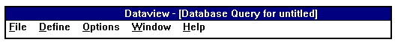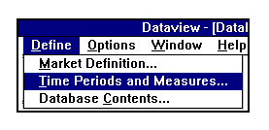

Command Buttons
Command buttons with text labels should include mnemonic access characters, as shown below:
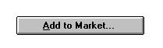
OK and Cancel buttons should not have mnemonic access characters because they are accessible through the <Enter> and <Escape> keys respectively (this follows Microsoft recommendations).

Shortcut Keys
Shortcut keys provide quick access to frequently used functions. Shortcut keys can be function keys (For example, F1, F2) or key combinations (For example, <Ctrl>+P, <Shift>+F2).
The following is a list of the Microsoft recommended shortcuts:
Key or Key Combination | Function
F1 | Help
<Alt>+F4 | Exit
<Ctrl>+F4 | Close
<Ctrl>+C | Copy
<Ctrl>+V | Paste
<Ctrl>+X | Cut
<Ctrl>+Z | Undo

If you use any of the above shortcuts, or create any new ones for frequently used items, then:
- Display the shortcut combinations to the right of the menu item they relate to, one tab position away from the longest menu item that has a shortcut; the shortcut combinations should be left justified
- Use key name abbreviations as they appear on the keyboard (Ctrl, Shift, Alt, F1, F2 etc.), with a plus sign between the keys (For example, Ctrl+V); no spaces appear on either side of the ‘+’.

An example of these two points is shown below:
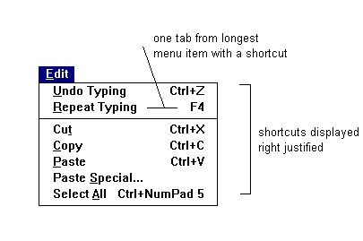

Tabbing and Cursor Movement Keys
Navigation around the screen and within dialog boxes should not always rely on the mouse, but should be possible using the <Tab> and cursor movement keys.
Use the cursor movement keys to move between and within menus.
Use the Tab key to move between controls within a dialog box.

Use of the <Return> and <Escape> keys
Use the <Return> (or <Enter>) key to press the default button in a window or dialog box (i.e. OK or Cancel). Use the <Escape> key to terminate a current process, to cancel a direct manipulation operation, and to press the Cancel button in a dialog box.

Abbreviations, Acronyms, and Codes

Abbreviations
Abbreviations are used for both displaying data to the user and for entry of data and commands by the user. In general, an application is more usable if the number of abbreviations is kept to a minimum. However, in the pharmaceutical industry, the nature and length of the terminology means that a system for abbreviating company and product names is vital. The following guidelines should help you to construct new abbreviations:
- Only use an abbreviation if it is significantly shorter than the full word, or if it is more meaningful to the user than the full word. If the abbreviation only saves one or two characters, then use the full word
- Do not invent a new abbreviation if there is an existing abbreviation for a word
- Be consistent in the use of abbreviations. For example, in a list, ensure that either the full word is always used (if there is enough space) or the abbreviation is always used
- Use the same abbreviation at all levels of the interface, unless the standard abbreviation is too large to fit into a column or row heading
- Do not use punctuation at the end of abbreviations, except when the abbreviation also spells a word (For example, no., in)
- Wherever possible, use a truncation of the full word as the abbreviation (For example, Syringe = SYR). Otherwise, use a first letter + consonants combination, which is useful when:
- A first letter + consonants combination is clearer (For example, UNKN is clearer than UNK for UNKNOWN)
- Words truncate to the same abbreviation as existing abbreviations, codes, or acronyms
- Several new abbreviations will truncate to the same abbreviation
- As far as possible, use the same length of abbreviation (For example, 5 letters long), providing this does not have an impact on the clarity of the abbreviation
- As far as possible, avoid multiple abbreviations. If there is a choice of which words to abbreviate, choose the most common abbreviations (For example, qty, no., amt.)
- Give new clients a dictionary of abbreviations (either on-line or printed)
- Check the abbreviation for clarity -- ask a few colleagues if they understand the abbreviation you have used, or if they can suggest any alternatives.

Acronyms
Acronyms are words formed from the initial letters or syllables of several words. For example, New Form Code is NFC. Acronyms are sometimes convenient replacements for long strings or words, but may not be directly translatable, so take care when using acronyms. In general, as is the case with abbreviations, an application is more usable if the number of acronyms is kept to a minimum. If you do use them, the client should be able to look them up in an on-line or printed acronym dictionary. Many of the guidelines for creating new abbreviations apply to the creation of acronyms, as follows:
- Ensure that there is not an existing acronym for the set of words
- Ensure that the acronym you create is not an existing acronym for another set of words, or an existing code or abbreviation
- Be consistent in the use of acronyms. For example, in a list, always use either the full words (if there is enough space) or the acronym
- As far as possible, avoid multiple acronyms
- Give new clients a dictionary of acronyms (either on-line or printed).

Codes
As with abbreviations and acronyms, codes are created for convenience and brevity. However, whereas abbreviations and acronyms (usually!) bear some resemblance to the full word, a code may be completely different to the word or words it represents. For instance, in a personnel department, the code ‘135’ could refer to an employee called ‘John Brookes.’ Note the following guidelines when you use codes:
- When using codes comprised of just letters, check that they are not already used as acronyms or abbreviations for other words
- Use meaningful codes in preference to meaningless, arbitrary codes
- When using an arbitrary code composed of letters and digits, group the letters together and the digits together, for example 132ABC, not 13B2CA
- For meaningless arbitrary codes, keep the number of alphanumeric to a maximum of five. Meaningful codes, such as one-word codes, can be longer because the user will remember the code as a single word instead of individual alphanumeric
- Use all upper case or all lower case for letters in a code made up of more than one letter
- Use a coding scheme that provides a single unique code for each coded element
- Use codes consistently; try to keep the meaning of codes consistent within and between applications
- Do NOT use codes in error messages to the user, for example, ‘Error of type 1759B’.

Date and Time Representation
Represent the date and time as follows:
Date: July, 13 1993 (always include full month name if possible)
Time: 16:20:35 (24 hour clock: hours, minutes and seconds - if applicable)

Color
Color can be used effectively for a variety of purposes:
- To highlight and emphasize data
- To distinguish between data
- To add meaning to data
- To group data into categories
- To make the interface more appealing.
However, incorrect use of color may confuse users, and produce a less usable interface. Note the following guidelines when using colors:
- Use color conservatively. Multiple colors may make the screen appear busy and may overwhelm the user. In addition, overuse of color looses the advantages of using color
- Use colors that are easy to distinguish from each other. For example, if you are using a color-coding system, do not use navy blue and purple. Be aware of the background screen color and make sure that any colors used will be easily visible. For example, do not use blue writing on a black screen
- Be aware of the inherent meaning of color. For example, in the Western World, red signifies danger or STOP, whilst green signifies safety and GO
- Make sure that the use of color does not decrease the legibility of the data
As far as possible, you should design the interface such that the user is allowed to choose their own color sequences for window components. For icons, restrict the colors you use to blue, red, yellow, and cyan.

Controls
Use the same type of control for the same fields in different windows. For example, a field that has a drop-down list box in one window should not have a set of radio buttons in another window or view. In addition, make sure that you use identical labels for the same function across all windows. Users will assume that any difference in labels implies a difference in function.

Default Controls
All dialog boxes should have default controls that are activated by pressing the <Enter> key. The default control must be easily distinguishable, so that users can scan a dialog box and ascertain the defaults. In the following example, the defaults are shown:
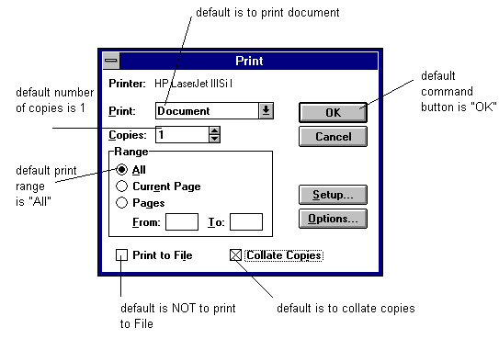
Note that the default command button is distinguished from other command buttons by a double width border. In some multi-purpose dialog boxes, the default controls may change depending on the user’s interaction with the dialog.
The default button should be the most likely operation that the user will make next. However, never designate a command button that will lead to a destructive action as the default button.

Disabled Controls
You can disable controls so that at certain times, they are unavailable to the user. Disable controls by dimming them, rather than by hiding them. The disabled controls should not change appearance when the user clicks on them.

Selection Mechanisms
There are three main methods to select items from a list:
The user clicks on one item, or clicks and drags on several items, and then clicks a confirm button (For example, OK) as shown below:
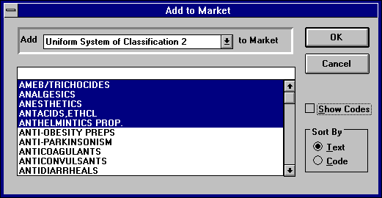

- The user holds down the <Ctrl> button and clicks on various non-contiguous items, followed by a confirm button, as shown below:
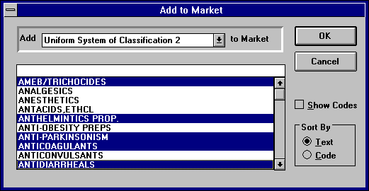
- The user clicks on one item, holds down the <Shift> key, and then clicks on an item further down in the list. This selects all items in between the two highlighted items. The user then clicks a confirm button. The whole list may be selected in this way by clicking on the first and last items in the list.
A further selection mechanism is to select or deselect individual items by double clicking on them, instead of using a single click and confirm method. However, this allows only one item to be selected at a time, and so where possible, use one of the single click and confirm methods. Whichever method you use, make sure that it is used consistently across the interface.

Navigation Mechanisms
As noted in the last chapter, ensure that the user does not always have to rely only on the mouse to move around the screen. This means that access to, and movement within menus, lists, and dialog boxes, must be available via the keyboard.
Use the cursor movement keys to move between and within menus and lists.
Use the Tab key to move between buttons in a window. The tabbing between buttons should be left to right and top to bottom, or top to bottom and left to right, whichever follows the most likely pattern of user operation.
Left to right, top to bottom Top to bottom, left to right

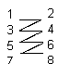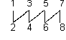

International Issues
From an early stage in the design of an application, it is important to think about the effect of the interface on different nationality audiences. You must consider the following points (these guidelines apply to applications designed for European and North American audiences only):

Collating sequences
A collating sequence defines the value and position of each character relative to other characters. If the application contains a sorting function, it must be flexible enough to accommodate individual country specific collating sequences.

Icons and symbols
Make sure that the icons and symbols you choose have the same meaning across cultures. For instance, North Americans equate a red circle with a stroke across it as meaning ‘Cancel’, but a European audience may not understand this meaning. If possible, it is better to avoid using text with icons; text maybe difficult to translate on a one-to-one basis (i.e. the same number of words or letters may not be used). However, if using text with icons greatly increases their comprehension, then do include text.

Text Expansion
Allow for text expansion in translation of headings, titles, and labels.

Keyboard differences
Remember that the keyboard is different in almost every country in Europe to the American keyboard. This may have an impact if you have designed keyboard shortcuts to minimize the user’s navigation around the keyboard.

Mnemonics
Because mnemonics are often based on the first letter or first few letters of the command or menu item name, the mnemonics, as well as the commands and menu titles and items, must be translated. To keep the mnemonic pattern, it may be necessary to constrain the translation of a menu item or command so that mnemonics do not overlap. If the mnemonics are not translated, then the memory aid to the user is lost.

Windows

Window Behavior
The default behavior for windows is layering (i.e. not cascading or tiling). An example of layered windows is shown below:
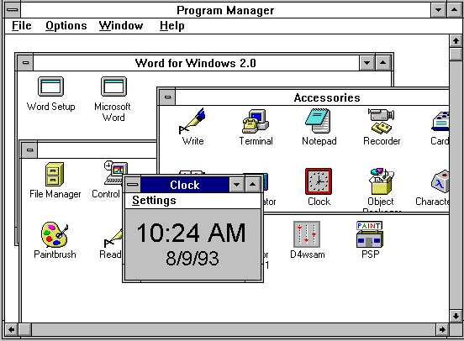

Text
Use the following text styles for window text (menus and window titles are pre-defined):
Text Element | Style
Dialog, Message, and List Text | System, bold, 12 pt.
Control Labels | System, bold, 12 pt.
User Input | System, bold, 12 pt.
Icon Labels | MS Sans Serif, plain, 10 pt.
Message Bar | MS Sans Serif, plain, 12 pt.

The Status Bar
The status bar appears at the bottom of every window, as shown below:
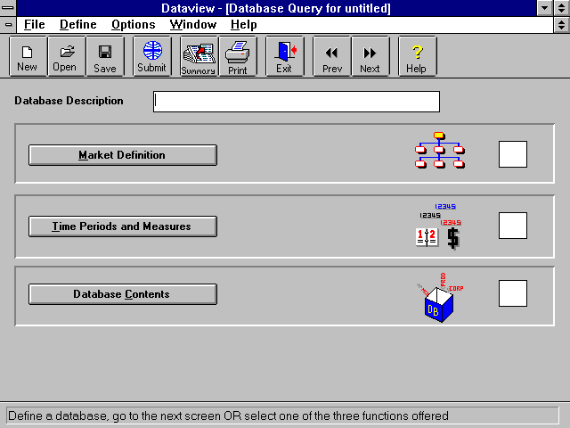

status bar

Use the status bar to inform users of standard processing situations that do not require user intervention. For example, when the user selects a menu item, the status bar provides a brief description of the function of that item. When a user first opens an application, it may describe the possible initial sequence of actions a user can take.
When creating messages that appear in the status bar, you should follow these guidelines:
- Omit the end punctuation
- Limit the length of the message to 60% of the length of the status bar
- With messages for menus, state clearly what users can do if they select the menu, for example:
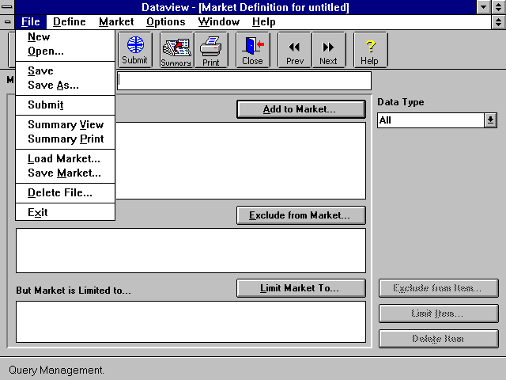

- With messages for menu items and buttons, describe what the application does if a user selects the menu item or button, for example:
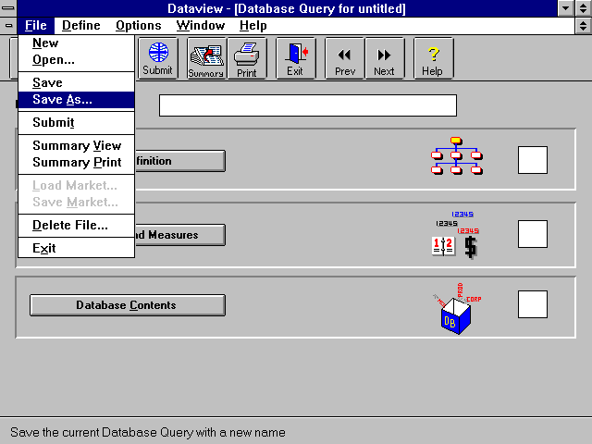

The Multiple Document Interface
Some GUI applications allow users to open multiple documents simultaneously. Users view each document in separate document window. This system is called a Multiple Document Interface (MDI). When only one document can be opened within an application at a time, the interface is called a Single Document Interface (SDI).

Working with MDI
In GUI application with one MDI frame, all windows are opened within the same window frame of the application. Within the application frame are the toolbar and the menu bar; hence, there is also only one toolbar and only one menu bar. The contents of the toolbar and menu bar may change depending on the window currently active in the application frame.
The application window is called the parent window; windows open within the parent window are called child windows. Any child windows open within the parent window are shown in the Window menu; the active window is checked, as shown below:

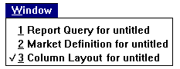
The user can switch to one of the other windows by selecting its name in the Window menu.
A child window can be maximized within the application window. If it is maximized, the parent and child windows change as follows:
- All the child window controls disappear except for control menu box
- A Restore button for the child window appears at the right of the menu bar
- The title bar changes to indicate the name of the application and the child window; note that each window title must be unique.
The maximized document window is shown below:
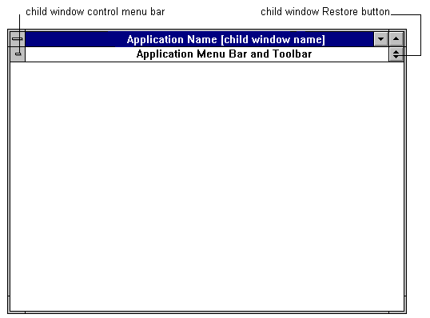

Clicking on the Restore button restores the controls and title of the child window:
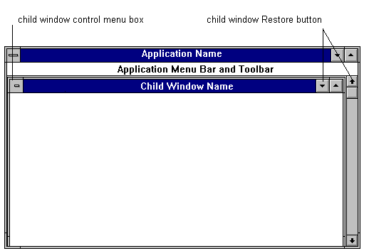
If the user minimizes a child window, it is represented by an icon on the main screen.
If a user attempts to open another instance of the application, for example from File Manager or Program Manager, then a new instance of the application appears, and has its own separate icon if the user minimizes it. That is, two instances of the application may be open simultaneously.

Dialog and Message Boxes
Dialog boxes are windows that contain controls to collect the user’s information and choices.
A message box is a special type of dialog box that is used to display error messages and other important information. It requires a response from the user before the user can proceed. The size message boxes should be proportional to the amount of text they contain, but you should keep the position of the icon and buttons within the box constant, as shown:
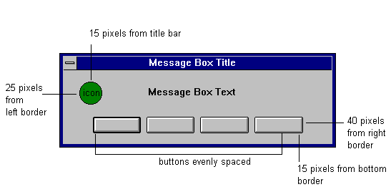

Controls

Type and Use of Controls
Controls are elements that allow the user to interact with the application. There are a variety of controls that you can use in GUI applications. These are listed below:
Control | Use
Command Buttons | To initiate actions or display a related dialog box for additional input, or to change from one view of the data to another with no further user input
Check Boxes | To control individual actions that are either on or off
Radio Buttons | To select a single choice from a set of mutually exclusive choices
List Boxes | To select one or more items from a list of data items
Text Entry Boxes | To enter information, by accepting current text, editing current text, or replacing current text with user’s own text
Combo Boxes | To accept user input and display a list of choices
Spin Boxes | To accept user input and to display of a limited set of values
Group Boxes | To provide a visual grouping of related controls

Labels
Label controls in title case, i.e. capitalize the first letters of each word in the label, except for articles (a, an, the), coordinating conjunctions (and, or, for), prepositions (of, by, which), and the ‘to’ in infinitives, for example:
- Number of Decimals
- Add to Market
- Exclude from Market.
Be consistent with labeling across controls and windows.

Label Position
Position the control labels as follows:
Control | Position
Command Button | Centre horizontally and vertically on top of button
Check-box or Radio button | To the right of the box or button, left justified
List Boxes, Combo Boxes, or Text Entry Boxes | Above or to the left of the control; if above, left-aligned with the text (i.e. lists, text in fields) that the control describes
Spin Boxes | To the left of the control, right justified
Group Boxes | Above, replacing part of the top line (centered), or if the label is too long to fit across the top, then to the left, right justified.

Command Buttons

Use
Use command buttons to initiate actions, to display a related dialog box for additional input, or to change from one view of the data to another with no further user input. When you use a command button to display a related dialog box for additional input, add an ellipsis to the end of the label to indicate that a further dialog box will be displayed, as shown below :

When a command button is not currently available, dim the label.

Size and Placement
The standard height for command buttons is 24 pixels. The minimum length of command buttons is 50 pixels.
Stack command buttons vertically along the right border window, or line up command buttons horizontally at the bottom of the box. The most common method is the vertical stack, except in message boxes, which use a horizontal method. For either method, buttons should be the same height, i.e. 24 pixels.
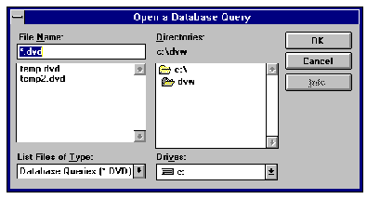
Dialog Box Command Button Layout
When lined up vertically, the command buttons should be the same length; that is, the length of the longest button text. With a horizontal alignment, buttons should be the same length unless there is an exceptionally long button text.

Labels
Label command buttons with a name that accurately describes the function of the command. Where possible, adopt an action-object labeling (i.e., Sort, Print, Limit Market to, etc.). Note that there may be some exceptions to this, for example, OK and Options. If a command button leads to a dialog box, make sure that the label of a command button is the same as the title of the dialog box. If the titles are even slightly different, users may think that they have made an error.
The following are the additional Microsoft Guidelines:
- Place the most important button (usually the default button) at the top of a vertically aligned group or to the left of a horizontally aligned group of buttons
- Place the Help button after all other buttons so that it is located at the bottom right of the box, where it is easily visible to the users
- If there is not enough room to fit all buttons in a single location, use a vertical grouping for the most important command buttons and a horizontal grouping for all the other command buttons
- Other arrangements may be used if there is a natural mapping relationship; for example, if the buttons are navigation buttons through a table, then it might be more intuitive to place them in the following arrangement:
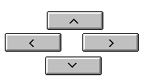

Check Boxes

Use
Use check boxes to control individual actions that are either on or off. Check boxes are useful when there are up to eight independent choices. However, for more than eight choices, they may take up too much screen space and may confuse the user.
A check box is indicated as marked by an black cross in a white box, as shown below:
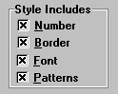
Surround a set of check boxes in a box to identify their function and to separate them from other controls. When a check box is inactive, dim its label.

Radio Buttons

Use
Use radio buttons to select a single choice from a set of mutually exclusive choices. Radio buttons are useful for showing users all available choices; however, they take up a large amount of space. If it is more important to preserve space than to show users all available choices, use drop-down lists (see below). Even if space preservation is not the priority, display a maximum of six items using radio buttons; any more than this may confuse the user. When a choice is either ‘on’ or ‘off’, use a check box instead of two radio buttons.
You can align radio buttons vertically or horizontally. Vertical arrangements are easier to scan, and so use a vertical arrangement where possible. However, you may choose a horizontal arrangement if there space is limited.
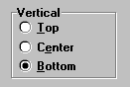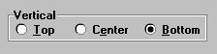
As with check boxes, surround a set of radio buttons with a box to identify their function and to separate them from other controls.
Place radio buttons in their most natural order. For example, in order of increasing value, sequence of use, or importance. If there is no natural order, arrange the buttons in alphabetical order. If you use the same set of radio buttons in more than one window, do not change the order of the buttons in the different windows.

If the label for a set of radio buttons is too long to fit on top of the box, place the label to the left of the box. The label is right justified.
Some radio buttons may have attached sub options; an example is shown below:
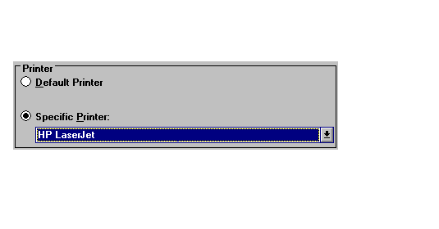
If you do include sub options with radio buttons, then note the following guidelines:
- Keep the number of radio buttons that have sub options to a minimum
- Keep the number of sub options to a minimum
- Keep the number of controls you use for sub options to a minimum; if you use a variety of controls (For example, a check box, a command button, and another set of radio buttons all under one radio button) it is difficult for the user to navigate through them all
- Align the control for the sub option with the label of the radio button.
Unless there is an clear order for the radio buttons to be in that you do not want to change, place the radio buttons with sub options at the bottom of the list. Sub options may detract users’ attention from the remaining radio buttons; placing radio buttons with sub options at the bottom helps direct users’ attention through all radio buttons.

List Boxes

Use
Use list boxes to display a list of items that the user can select. There are different types of list boxes:
- Standard single selection
- Drop-down single selection
- Extended selection.

Standard Single Selection
Use a standard single selection list when the user can select only one item from a list, and when the list has too many items to use radio buttons (more than six). Keep the size of standard lists constant within the dialog box, and long enough to show between three and eight items. When the user clicks on an item it becomes highlighted. If the scroll bar is not required, for example if all items in the list are visible, then change the scroll bar to the background color of the screen, remove the scroll box, and dim the scroll arrows.

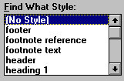
Standard Single Selection

Drop-Down Single Selection
Use a drop-down single selection list when there is not enough space for a standard single selection list. Again, the user can select only one item from the list; the item is highlighted when the user clicks on it. When the user opens the list by clicking on the arrow, the list drops down.
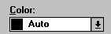
Drop-Down Single Selection List - Closed
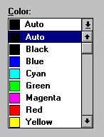
Drop-Down Single Selection List – Open
Note that there is no gap between the text field and the drop-down arrow. This distinguishes it from a combo box (see below).

Extended Selection Lists
Use a standard or drop-down extended selection list if the user can select more than one item. There are a variety of selection mechanisms for selecting contiguous or non-contiguous list items.
If a particular list item is not currently available in any list, omit it from the list unless it is important to show the user that the item is available in other situations. In this case, dim the item. If all the contents of a list box are not available, dim the list box label.

Text Entry Boxes

Use
Use text entry boxes to allow users to enter information, either by accepting current text, editing current text, or replacing current text with their own. Text entry boxes should be highly visible to users. Use a plain white box outlined in black as shown below. When users click in the text entry box, the I-beam flashes, to indicate they can enter text. If there is only one text entry box in the window, or if the order of navigation between several text entry boxes is defined by the application, position a flashing I-beam in the first box before the user even clicks in it, to direct users’ attention to it.
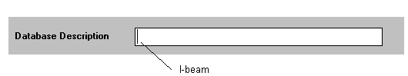
If the text entry box is inactive, dim the label of the box.

Combo (Combination) Boxes

Use
Use a combo box to both display a list of items for the user to select, and to accept users’ input as in a text entry box. When users click in the text box, the I-beam flashes, indicating that they can enter text. There are two types of combo boxes -- standard and drop-down. These are shown below:
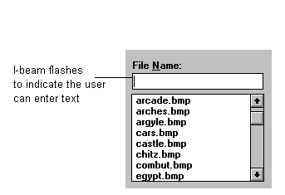
Standard combo box
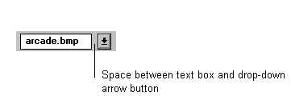
Drop-down combo box - closed
The drop-down combo box is characterized by the separation between the text box and the drop-down arrow button. This follows Microsoft’s guidelines and distinguishes it from a drop-down list box.
If the list of possible choices is fairly short and if there is enough room, use a standard combo box. However, for longer lists and when space is scarce, use a drop-down combo box.
With the standard combo box or with an open drop-down combo box, the items visible in the list change progressively to match the user’s input. For example, if the user enters ‘a’ in an alphabetically ordered list, the contents shown should be those beginning with ‘a’; if the user then enters ‘b’, the contents should be those beginning with ‘ab’. In this way a search mechanism is built into the combo box. If there are no list items that match the user input, then the list shows the nearest match (For example, items beginning ‘ac’).

Spin Boxes

Use
Use spin boxes to display only a limited set of values. The user types a value into the text box, and then uses the up and down arrows to increase or decrease that value, as shown below:
If the user inputs an invalid value, for example, ‘100’ when the limited set of values is ‘integers from 0-99’, then the interface must indicate that the value is invalid. This should be indicated as soon as the user inputs the invalid value, either by a beep, or simply by not displaying the input.

Group Boxes

Use
Use group boxes to provide a visual grouping of related controls. You must not use a group box to group miscellaneous, unrelated controls. A group box is a rectangle in a window. Do not use any other shape, for example, a round rectangle.
Label the group boxes in the same way as the boxes that surround radio buttons, i.e., at the top of the box, or if the label is too long, to the left side of the box, right justified.
The order of navigation between controls in a group box using the tab key should follow that of any window. If the tab key is used, each active control is visited before the group box is left.
Avoid multiple levels of grouping. Users may easily become lost with multiple levels, and the control box looks cluttered.

Spacing Controls on the Screen
Try to centre your controls within the window, leaving an even border. The general recommendation for the amount of white space per window is 30%.

Icons
The following are standard icons that you should use in GUI applications:
Icon | Description | Meaning
 | Standard gray command button with blue door, and bright red arrow | Exit application
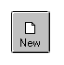 | Standard gray command button with single white document (standard Microsoft icon) | Open a new document
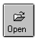 | Standard gray command button with dark gray and white opening folder (standard Microsoft icon) | Open an existing document
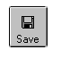 | Standard gray command button with gray, dark gray, and black floppy disc (standard Microsoft icon) | Save current document
 | Standard gray command button with gray and black printer, with red light on printer in top right corner of printer; text on paper is blue | Print current document
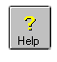 | Standard gray command button with yellow, shadowed question mark | Go to Help

The font of any text on the icons is MS Sans Serif Plain size 10 pt. The standard shape of the icon is square, with dimensions of 46x46 pixels. However, there should also be the option for the user to view the icons without the icon text. In this case, the size of the icons can be smaller.
The button icons lie in a toolbar at the top of the window just below the menu headings, as shown below:
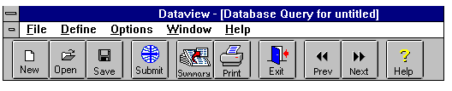

Guidelines for New Icon Design
Icons are an effective and attractive way to convey information. However, if they do not easily represent information, then they put more load on the users. The best icons are those that represent concrete objects, and are a miniature representation of the object they depict. The more abstract the concept, the more difficult it is to find an icon that represents it. Many of the concepts depicted by icons are fairly abstract. Thus, it may be necessary to label the icon as well. For consistency, if one icon is labeled in a series of icons (For example, a toolbar), then label them all.
When a user selects an icon, provide distinct visual feedback by turning the button edges from gray to black.
For each icon button, make sure there is a menu item equivalent as well as a mnemonic equivalent. For example, if there is a Close icon button, there should also be a Close item in the File menu, as well as a mnemonic, (For example, <Alt>+F and C).
If you can provide icons for only some functions but not all, make sure that the ones you choose are those that are the most frequently accessed by users. The best way to do this is by some form of user survey. If you cannot ask the users, then run through some imaginary tasks yourself.
Finally, be aware of any international issues that may have an impact on the design of your icons.

Types of Menus
There are two types of menus used in the windows environment -- drop-down and cascading (hierarchical) menus. These are shown below:
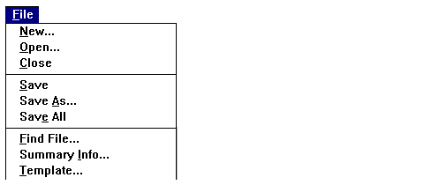
Drop-down menu
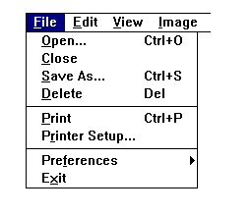
Cascading menu (first level)

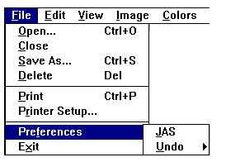
Second level of cascading menu

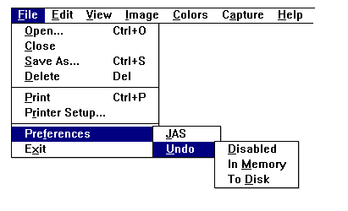
Third level of cascading menu
Cascading menus are attached as sub-menus to the right of a drop-down menu item. Their presence is indicated by a right pointing triangle next to the item they are attached to. Although cascading menus are a convenient way of adding additional menu items and simplify top-level menus, they are difficult to navigate through, and may place additional burden on the user’s memory. The user must either remember the path of a particular sub menu item, or waste time searching through each sub menu. Because of this, do not use more than three levels of menu, (i.e., main plus two sub-menu levels).

Number of Items Per Menu
Long menus are more difficult to scan for menu items, and obscure a larger part of the screen. Try to limit the number of items per menu (or sub-menu) to a maximum of eight. Instead of adding to the length of an existing menu, consider adding an extra menu heading to the menu bar. It is better to increase the breadth of a menu bar than its depth.

Displaying Menus and Selecting Menu Items
To display a menu, the user clicks on the menu heading. This opens the menu, and displays the menu items. If the user releases the mouse button while the pointer is still on the menu heading, the menu remains open; otherwise it closes. The user can scan through items in all main menus by moving the pointer across the menu headings without releasing the mouse button. If users open a menu and do not release the mouse button, they can move the pointer down to a menu item and then release the mouse button to select it. Otherwise, users simply click on an item within an open menu to select that item. If the item leads to a sub-menu, the selection of that item will open the sub-menu.
Whenever a menu is open and the user moves the pointer over a menu item, the menu item is highlighted to show that it will be selected if the user releases the mouse button.

Standard Menus
GUI applications should include certain standard Windows menus and menu items. The exception is if the application has a Single Document Interface (SDI) instead of a Multiple Document Interface (MDI). In this case, omit the Window Menu. The standard menus, the standard menu items, and their mnemonic access characters (underlined) are shown below:
File | Edit | Window | Help
New  Open...  Save  Save As  ..........................  Print...  Print Setup...  ..........................  Exit | Undo  ..........................  Cut  Copy  Paste | New Window  Arrange All  ..........................  1 Window 1  2 Window 2  3 Window 3 | Contents  Search for Help On...  How to Use Help  About...

The File menu is the first menu on the menu bar (far left), and the Help menu is the last (far right). The Edit menu follows the File menu, and if there is a Window menu, it directly precedes the Help menu. In addition, each window contains a control menu at the far left of its title bar. The control menu in dialog boxes contains only two items: Close and Move. However, application and child window control menus contain additional items, as shown below (mnemonic access characters are underlined):

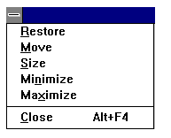
In addition, control menus for application windows contain a Switch To command for switching to other application windows.

Non-standard Menus
Clearly, the variety of non-standard menus that you include in the menu bar will depend on the application. However, there are general guidelines that you should follow for each of the menu components.

Menu Headings
The menu heading - or title - is the name that appears on the menu bar for drop-down menus. For cascading menus, it is the name of the item that the sub menu is attached to. Consider the following guidelines when creating menu headings:
- Use a menu heading that accurately describes the general purpose of all items in the menu
- Keep menu headings short; long headings may limit the number of menus you can display on the menu bar
- As far as possible, use only one word headings
- Assign a mnemonic access character to each menu heading.

Menu Items

Types of items
There are two main types of menu items:
- Items that take effect as soon as the user selects them
- Dialog box commands, which require additional information from the user before the command can be completed; these are indicated by an ellipsis at the end of the item name (For example, Open...)

Included in the first category are items that change the attributes of data or properties of the interface. These are called settings. When a user selects a setting, place a check mark to the left of the item name, as shown below:
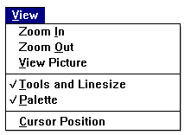

Item Names
Note the following guidelines when naming menu items:
- Choose item names that make the function of each item clear and distinct from other items
- Ensure that item names are unique within a menu; however, you can repeat the name of an item in a different menu for items that represent similar functions
- Do not use the name of the menu heading as one of the item names in the menu; if the menu heading accurately describes just one of its items, then the menu heading may be too specific
- Do not use abbreviations as item names
- Keep item names to a maximum of 25 characters in total (including spaces in between words); if the name has more than 25 characters, it appears too long within the menu and the menu obscures more of the screen
- Follow the names of items that lead to a dialog box with an ellipsis
- If the menu items opens a dialog box, make sure the item name is the same as the dialog box title that appears after the user has selected the item; if the dialog box title is even slightly different, users may believe that they have made a selection error
- Assign a mnemonic access character to each menu item.

Item order
Where possible, group together related menu items in a menu, and separate the groups with a line, as shown below:
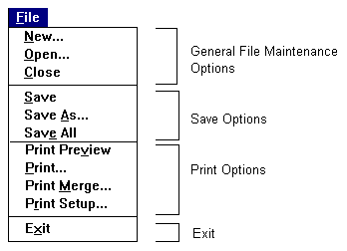
There are several different ways that you can order the items or groups of items. If menus contain some groups of items that are accessed more frequently than others, place the frequently used items at the top. Otherwise, choose one of the following ordering schemes:
- Chronological
- Numerical
- Alphabetical
- Sequential
- Order of importance.
The scheme you choose will depend on the nature of the application. If there is no clear order in terms of importance, chronological, or sequential use, you may choose a simple alphabetical scheme. However, once you have chosen a scheme, make sure that you use it consistently across the application.

Unavailable Menus and Menu Items
At certain times during a user’s interaction with an application, specific menu items may be unavailable. To indicate that items are currently unavailable, dim the item name. If all the items in a menu are currently unavailable, dim the menu title as well. If a menu name is dimmed, the user can still open the menu to explore its contents, but cannot select any of the items.

User Support Mechanisms

Help

Access to Help
Provide access to Help in three ways:
- Via the menu (either with the mouse, or the keyboard using mnemonics)
- Via the F1 key
- Via a Help button, as shown below (a yellow, shadowed question mark):

The Help Window
The Help window is the standard Microsoft Windows Help window:
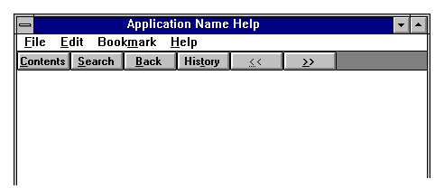
As with the Microsoft Windows Help facility, any topics that the user can double click on for more information are underlined and colored green.

What Kind of Help to Provide
Provide the following types of Help:
- A list of contents of Help
- A search facility on commands and functions
- ‘About this product’ information
- Information on product support
- Instructions on how to use the help facility
- Context-sensitive help via the F1 key.
Place items in the Help menu in the following order:
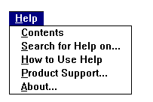

The Help button should take the user directly to the contents page.

Contents
Section the help contents into meaningful groups. For instance, in the sample on the below, the information is divided into:
- A general overview about the application (Dataview)
- Quick reference information
- Help on individual tasks that the user can perform, in chronological order.

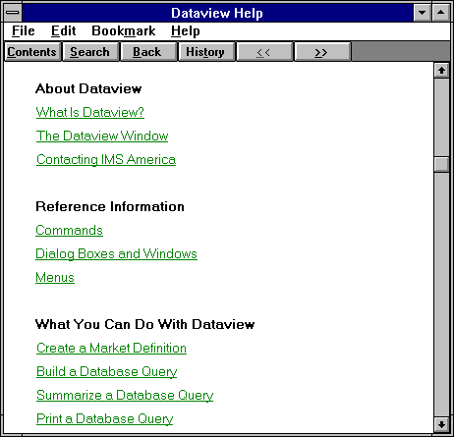

Search
The search facility is the standard Microsoft Windows facility, as shown below:
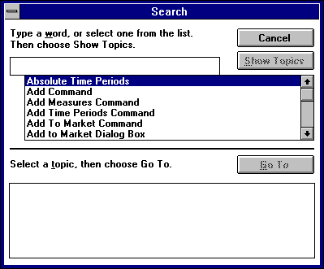

How to Use Help
In the ‘how to use help’ section, provide information on:
- How to move around within the help menu
- How to use the search facility
- How to use the bookmark facility
- How to manipulate the help window.

Product Support
In the product support section, provide information on:
- Who to contact for product support
- Where to contact them
- What information the user will need to have ready when they contact the support person.

About...
In the ‘about this product’ section, provide brief details on the product, including:
- Product/activity name
- Version number
- Copyright information.
Present this in the following format :
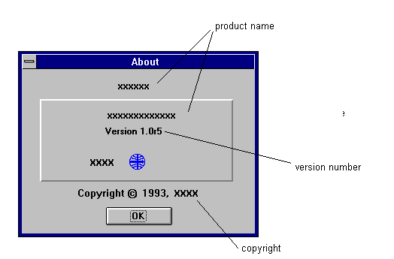

Opening Screen
Note that the ‘about this product’ type of information is also displayed when a user first opens an application, but in more detail, and in the format below:
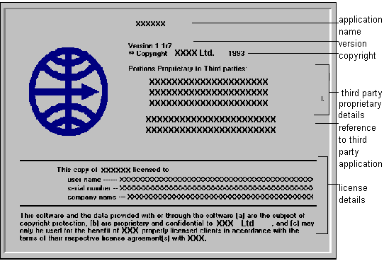

Style and Tone
The content of the help you give on line must adhere to the documentation house style. Guidelines on how to present reference material on line could take a whole document in itself, but in brief:
- Write in the first person (‘you’)
- Present instructions in steps, but do not use more than nine steps per task; if you need more than this, you should divide the task into separate sub tasks
- Use the imperative for instructions (For example, ‘Open the file...’ ‘Click on the button...’ ‘Select the item...’ etc.)
- Always test what you have written - even if it is only by asking a colleague to read through for any mistakes

Messages

Types and Presentation
There are four main types of message that the application may provide:
- Information messages
- Warning messages
- Questioning messages
- Error messages.
As noted in chapter 3, the status bar is a convenient way to provide users with brief information about menu headings, items, and buttons. However, if it is important that the user notes a message, then you should put the information in a message box. Forcing the user to click on an OK button does not guarantee that he or she will read the message, but it does make the information more noticeable.
The title of the message box should be the application name that the message relates to. The four types of message have related icons that appear in the message box. These are standard Microsoft icons, as shown below:

Icon | Description | Message Type | Meaning
 | Blue circle; white "i" | Information | Provides information about results of commands. Offers users no choices; users acknowledge message by clicking an OK button.
 | Yellow circle; black exclamation mark | Warning | Alerts user to a situation or error condition that requires user input before proceeding.
 | Green circle, white question mark | Question | Asks a question that the user must answer before proceeding, such as "Save changes before closing?"
 | Red octagon, white "STOP" | Critical | Informs user of a serious system-related problem that must be attended to before the user can continue.

Chapter 4 provides details of where to place the icons in the message box.

Message Content
The following gives basic guidelines about the content of messages:
- Be brief but informative
- Do not blame the user for errors
- Do not use error "codes"
- Do not use emotive words such as ‘fatal’, ‘catastrophic’, ‘disastrous’ or ‘illegal’
- Make sure that any questions, and the way that users can answer them, is clear; for example

The screen is not complete

OK Cancel

Is not as clear as

You have not filled in section 6.
Do you want to return to the
screen?

Yes No

- Provide help when users make errors, for example by giving a brief explanation of the problem, and actions that the user can take to rectify the error
- Offer a more detailed level of help than the current message provides, either through the F1 key to access context-sensitive help, or by presenting a Help command button in the message box
- Only use command buttons in message boxes; if the application needs additional information use a dialog box.

Feedback
Feedback is an important part of interface design. To feel in control of the application, the user needs to be constantly aware of what the system is doing. Feedback is provided in many forms across the interface. For example, scroll bars show a user’s position in a document, command buttons are highlighted when the user clicks on them, the pointer changes to an I-beam when the user enters a text entry box. An important time to provide feedback is when an operation takes more than two or three seconds to complete. If the application does not inform the user that operation is occurring, he or she may think the system has become locked in some way. There are three ways to show users that an operation is occurring -- by changing the shape of the pointer, with progress indicators, and using the status bar.

Changing Pointers and Progress Indicators
The primary pointer on screen is the arrow. When an operation takes more than two or three seconds to complete, change the arrow to an hourglass. When an operation takes more than ten seconds, use a progress indicator in a progress window. Progress indicators should be dynamic, indicating the proportion of a operation completed as it occurs. The best progress indicators are graphical, for example in the form of a horizontal sliding bar that shows the percentage of the operation completed. An example is shown over:
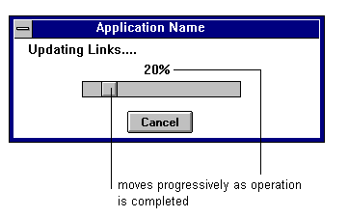
For operations that take longer than ten seconds, you should provide a Cancel or Stop button for the user to halt the operation. Use a Cancel button if halting the operation returns the data to the state it was in before the operation started. Use a Stop button if the data cannot be returned to its original state.

Using the Status Bar for Feedback
When an operation takes a relatively short time to complete, i.e., up to 90 seconds, you may also use the status bar to indicate that an operation is occurring. This may be a simple statement such as ‘Saving...’ or may involve some form of ‘percentage completed’ indicator. However, users are less likely to notice a status bar indicator than a progress window, and so in general, use progress windows for operations that take more than ten seconds to complete.

Auditory Feedback
Beeps can be an effective way of providing feedback to the user. For example, the application might beep when a user continues to press the cursor movement keys after he or she has already reached the bottom of a document. However, use auditory feedback sparingly for the following reasons:
- Users may find the sound annoying or may be embarrassed by the disturbance it causes to others
- Users may become habituated to the sound and ignore it
- Users may turn the sound off
- Users may not be at their computer when the sound occurs.

Navigation Aids
Some applications may require the users to follow a fairly complex route through a task. Although you should design the interface to minimize the complexity of a task, it may sometimes be necessary to provide users with aids to navigate through tasks and screens. Any navigation aid that has an impact on the interface should be optional; novice user may find navigation aids helpful, but when they become expert users, they will want to remove any part of the interface they do not require. Examples of navigation aids are:
- Backward and forward icons to move the user through the correct sequence of screens
- A history of the user's past actions, and a list of possible future actions
- A continuing guide in the status bar that informs the user of the each succeeding action to take to complete the task.
The choice of navigation aid will depend on the application. As always, whichever type you use, make sure that you use it consistently across the interface.

Annexure - I Checklists

Check List: Consistency
- Do all controls for the same function have the same name? Yes/No
- Is the same control always used for the same function? Yes/No
- Are command buttons labeled consistently: are they all action-oriented, or all object-oriented?
Yes/No
- If a command button leads to another dialog box, is the label of the command button
the same as the title of the dialog box? Yes/No
- Are all abbreviations, acronyms, and codes consistent across the interface? Yes/No
- Is the method of selection consistent: can all items in the tool bar be selected? Yes/No
can users always double click, always point and drag,
or always click and confirm to select an item? Yes/No
- Is the method of navigation consistent: do users move around the screen top to bottom
and left to right, or left to right and top to bottom? Yes/No
- Are icons in the same place on the toolbar in all the windows? Yes/No
- Are all icons in the toolbar the same size? Yes/No
- If any icons in the toolbar are labelled, are they all labelled? Yes/No

If you have answered NO to any of these, you may need to look at the consistency of the application interface

Check List: Windows - General
- Does the opening screen contain all the necessary information? Yes/No
- Is the information in the opening screen arranged in the correct format? of the guide. Yes/No
- Is the default behaviour for windows layering? Yes/No
- If the application supports a Multiple Document Interface (MDI):
is there only one application frame (window)? Yes/No
is there only one toolbar? Yes/No
is there only one menu bar? Yes/No
can two instances of the application be open simultaneously? Yes/No
is the title in the format Application Name - [Activity Name]? Yes/No
- Is all the text in the window in the correct font and style? Yes/No
- Does the status bar provide clear information for each menu heading, menu item,
and command button? Yes/No
- If you are using a dialog box, is the title the same as the command button
label that opens it? Yes/No
- If you are using a message box:
is the size of the message box proportional to the amount of text it contains? Yes/No
does it have the correct icon?. Yes/No
are the buttons, icon, and text in the correct position? Yes/No

If you have answered NO to any of these, you may need to reconsider the design of the windows in the application interface

Check List: Controls
- Is the control the correct one to use? Yes/No
- Is the label positioned in the correct place? Yes/No
- Are all control labels in title case? Yes/No
- If you are using command buttons:
are they the correct dimensions?. Yes/No
is the most important button (usually the default button) first? Yes/No
is the Help button placed at the end of all other buttons? Yes/No
are the command buttons aligned correctly?. Yes/No
- If you are using check boxes:
are there only 8 or fewer independent choices? Yes/No
are they checked using a black check? Yes/No
- If you are using radio buttons:
are all the choices mutually exclusive? Yes/No
are there 6 or fewer choices? Yes/No
does the sequence of radio buttons follow the most natural order? Yes/No
- If you are using a standard single selection list box:
can the user select only one item from the list? Yes/No
are the boxes large enough to show 3-8 items? Yes/No
are all currently unavailable items omitted or hidden? Yes/No
- If you are using a standard extended selection list box:
can the user select more than one item from the list? Yes/No
are all currently unavailable items omitted or hidden? Yes/No
- If you are using a single or extended selection drop-down box:
is there no gap between the text field and the drop-down arrow? Yes/No
are all currently unavailable items omitted or hidden? Yes/No
- If you are using a text entry box:
is it clear where the user has to enter text? Yes/No
is the text entry box a plain white box? Yes/No
does the I-beam flash when the user clicks in the box? Yes/No
- If you are using a combo box:
does the I-beam flash when the user clicks in the text box? Yes/No
if the combo box is drop-down, is the drop-down arrow button separated
from the text box? Yes/No
do the items displayed in the list change progressively to match the user's input? Yes/No
- If you are using a spin box:
does the list contain a limited set of values that the user can select? Yes/No
if users inputs an invalid value, does the interface inform them immediately? Yes/No
- If you are using a group box:
are all the controls in the box related? Yes/No
are the controls surrounded by a rectangle? Yes/No
does the navigation through the controls follow the most natural order? Yes/No

If you have answered NO to any of these, you may need to reconsider the design and use of the controls in the application interface

Check List: Metaphors and Icons
- If there is a metaphor in the application interface:
is the metaphor simple and concrete? Yes/No
is the metaphor a meaningful one to the intended user group? Yes/No
s the metaphor culturally independent? Yes/No
- Are the standard icons used where appropriate? . Yes/No
- For any new icons, are the colours used limited to blue, black, white, red, yellow, and cyan? Yes/No
- Are any new icons culturally independent? Yes/No
- Are the button icons 46x46 pixels? Yes/No
- Do the button icons change in the standard way when the user clicks on them? Yes/No
- Do all button icons have equivalent menu items? Yes/No
- If there is a limit to the number of button icons you can use, have you chosen button icons for the most frequently used commands and functions? Yes/No
- If any button icons are labelled, are they all labelled? Yes/No
- If the button icons are labelled, is the font MS Sans Serif 10 pt. plain? Yes/No

If you have answered NO to any of these, you may need to reconsider the metaphors and icons in the application interface

Check List: Menus
- Are there no more than three levels of menu (main menu and two sub-menus)? Yes/No
- Are there no more than eight items in any one menu? Yes/No
- Does the application have all the standard menus and menu items? Yes/No
- If you have added new menu headings:
do they describe all the items in the menu? Yes/No
do they contain only one word? Yes/No
do they have a meaningful mnemonic access character? Yes/No
- If you have added new menu items:
do they describe the function of each item accurately? Yes/No
are they distinct from other items? Yes/No
are they unique within a menu (including menu heading)? Yes/No
are they a maximum of 25 characters long? Yes/No
do they have meaningful mnemonic access characters? Yes/No
if they lead to a cascading menu, do they have a right pointing triangle next to the label? Yes/No
if they lead to a dialog box, do they have an ellipsis after the label? Yes/No
if they lead to a dialog box, is the name of the dialog box the same as the menu item? Yes/No
- Are related items in a menu grouped together and separated by a line? Yes/No
- Are menu items, or groups of menu items, ordered consistently according to some system? Yes/No
- Are currently unavailable menu items dimmed? Yes/No
- If all items in a menu are currently unavailable, is the menu heading dimmed? Yes/No
If you have answered NO to any of these, you may need to reconsider the design of the menus in the application interface

Check List: Data Representation
- If you have created any new abbreviations, acronyms, or codes:
are you sure that there are no existing abbreviations, acronyms, orcodes for the word? Yes/No
is the new abbreviation, acronym, or code unique? Yes/No
have you used the abbreviation, acronym, or code consistently across the interface? Yes/No
have you tested the abbreviation, acronyms or code to see if it is easy to translate? Yes/No
have you omitted all punctuation from abbreviations (unless the abbreviation spells a word, e.g. no.)? Yes/No
have you used meaningful codes where possible? Yes/No
if the code is not meaningful, is there a maximum of five alphanumerics? Yes/No
are letters all upper case or all lower case? Yes/No
have you grouped letters together and digits together in a code? Yes/No
- If you have presented the date and time:
is the date in the format: July, 13 1993? Yes/No
is the time in the format: 12:20:35? Yes/No
- If you have used colour:
have you used colours conservatively? Yes/No
are the colours easy to distinguish from each other? Yes/No
have you checked that the colours do not imply any false meaning? Yes/No
If you have answered NO to any of these, you may need to reconsider the way you have represented data in the application interface

Check List: User Support Mechanisms
- Can the user access Help via the menu, via the f1 key, and via the Help button? Yes/No
- Are all types of Help provided? Yes/No
- Is the Help menu ordered in the correct way? . Yes/No
- Is the Contents page in Help divided into meaningful groups? Yes/No
- If you have produced any of the Help contents:
have you used the first person ("you")? Yes/No
have you presented instructions in steps? Yes/No
have you used the imperative for instructions (Click on a button; Select an item..)? Yes/No
have you tested what you have written? Yes/No
- If you have produced any of the message box contents:
have you used the correct icon for the message box? Yes/No
is the content brief, informative, and clear?. Yes/No
- Is there user feedback for any operation that takes more than two seconds to complete? If so, is it the correct type of feedback? Yes/No
- If the application is complex and involves several screens, is there some form of navigation aid to the user? Yes/No

If you have answered NO to any of these, you may need to reconsider the type of user support mechanisms in the application interface

