First Principles of Instruction
M. David Merrill (2002) identified five Instructional Design principles that promote learning when creating learning/training environments, processes, and products. He noted that the most effective learning processes or environments are problem-centered and involve the learner in the five distinct phases of:
- Learning is promoted when learners are engaged in solving real-world problems — start with simple problems and work through a progression of increasingly complex problems.
- Learning is promoted when existing knowledge is activated as a foundation for new knowledge — prior experience from relevant past experience is used as a foundation for the new skills and knowledge (also know as scaffolding).
- Learning is promoted when new knowledge is demonstrated to the learner — they are shown, rather than just being told.
- Learning is promoted when new knowledge is applied by the learner — they are required to use their new knowledge or skill to solve problems.
- Learning is promoted when new knowledge is integrated into the learner’s world — they are able to demonstrate improvement in their newly acquired skills and to modify it for use in their daily work.
Merrill uses the following diagram to show the four phases surrounding problems:
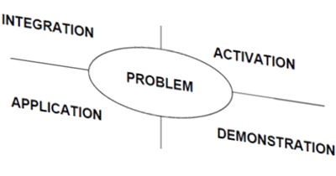
According to Merrill, the definition of a problem varies among theorists, such as engaging in a simulation or being involved in a real world task. He uses the word problem to include a wide range of activities, with the most critical characteristics being that the activity is a whole task, rather than components of a task and that the task is representative of those the learner will encounter in the real world.
Davids Merrill instructional model :
1.Friendly opening the lecture
2.Introduction to the topic , topics and sub topics to be discussed
3.Definition of the topic
4 Examples of the Topic , More specific Real time example.
5. co relating it with real time example
6.Critical questions and thinking about the topic
7 . Summarize the topic .
Here is one sample scenario jdbc
- Good morning and some friendly conversation for making the students active to participation
- Introduction – what is jdbc , why jdbc , how like wise
Jdbc steps
A
B
C
D
E
A .1
A 2
B.1
3 standard definition : if it is universal stamen .
4 Example 1, 2 ,3 and specific real time example (mobile phone communincation )
5 Co relating the jdbc concept with real time example (opening sub cycle , means sub topics belongs to it .
6 Critical thinking and questions
1 Why jdbc is only one API .
2 JDBC dos and donts
7 Summarize:
Jdbc-def
Steps to establish connection
Example for jdbc
Limitations and dos and dont

