**LET’S UPGRADE AWS**

**Assignment-1:**

**Project-1**: Create a windows instance using AMI :Windows 2012 R2 base

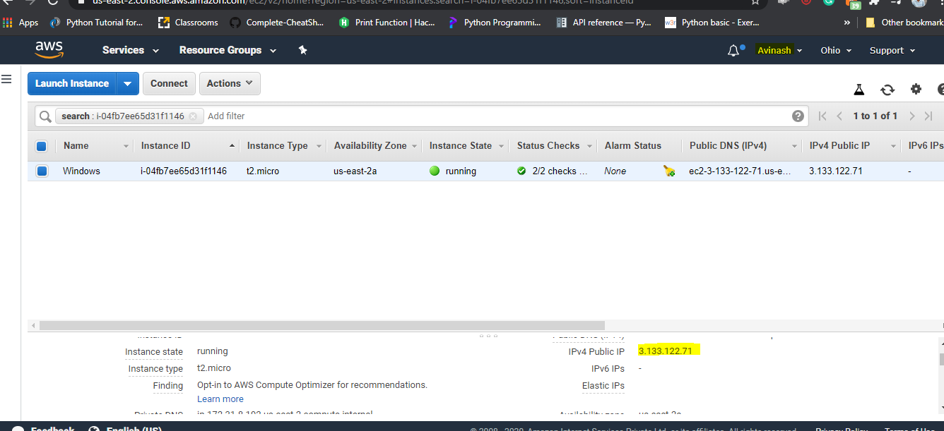

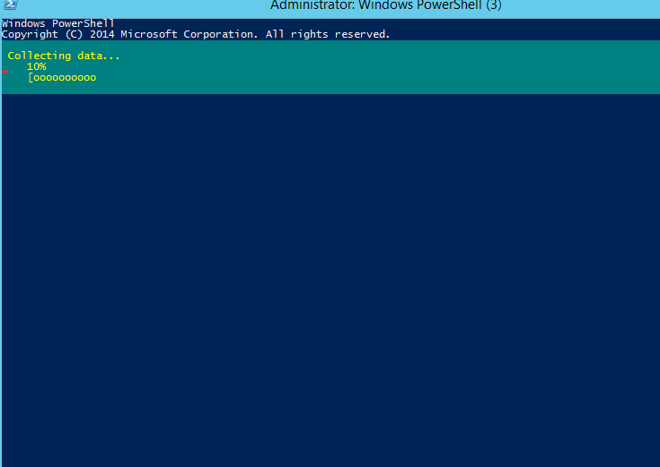

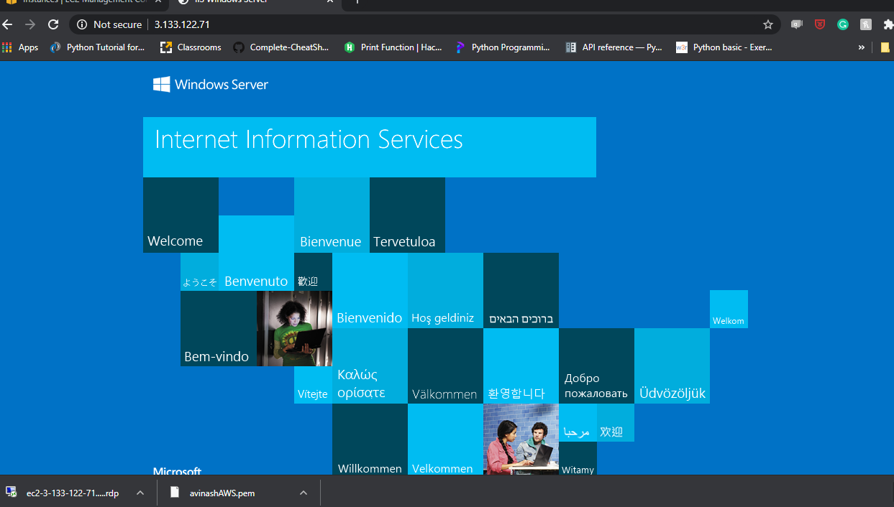

Project-2: Creating a windows instance : Ubuntu server 18.04 LTS

