NETFLIX

**Introduction-**

Netflix is a streaming service that offers a wide variety of award-winning TV shows, movies, anime, documentaries and more – on thousands of internet-connected devices.

**OVERVIEW\***

Home Page> Sign in / login button >language select button >get start search panel >about us section >footer(contact us).

**HOME PAGE-**

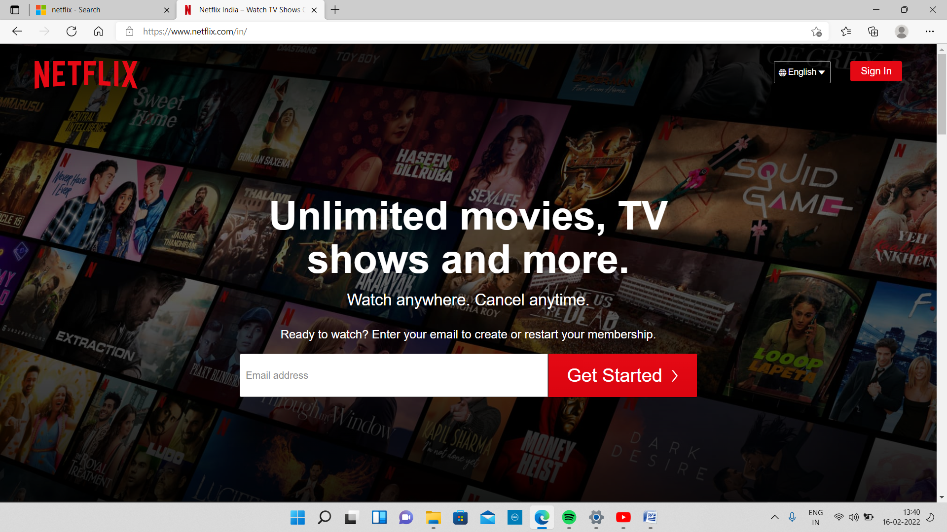

Home page contains **NETFLIX** logo , sign in / login button, language select button and registration panel where you can enter your email to take subscription.

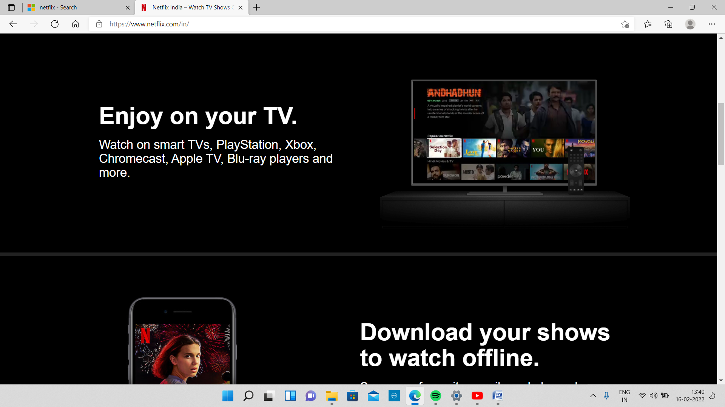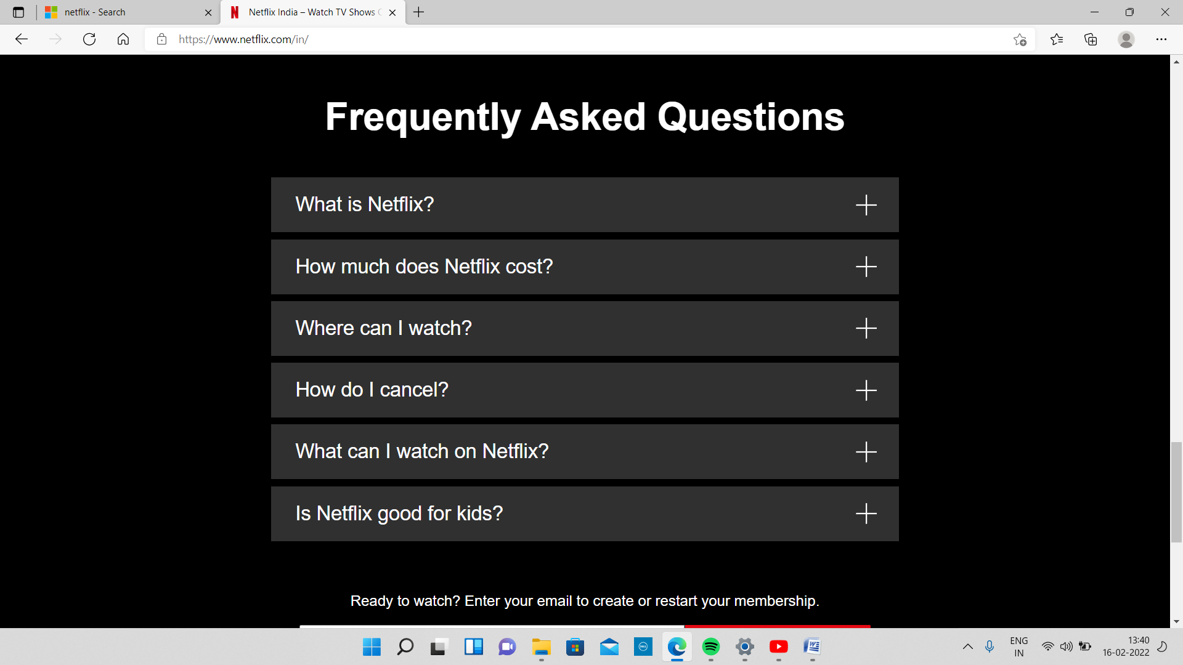

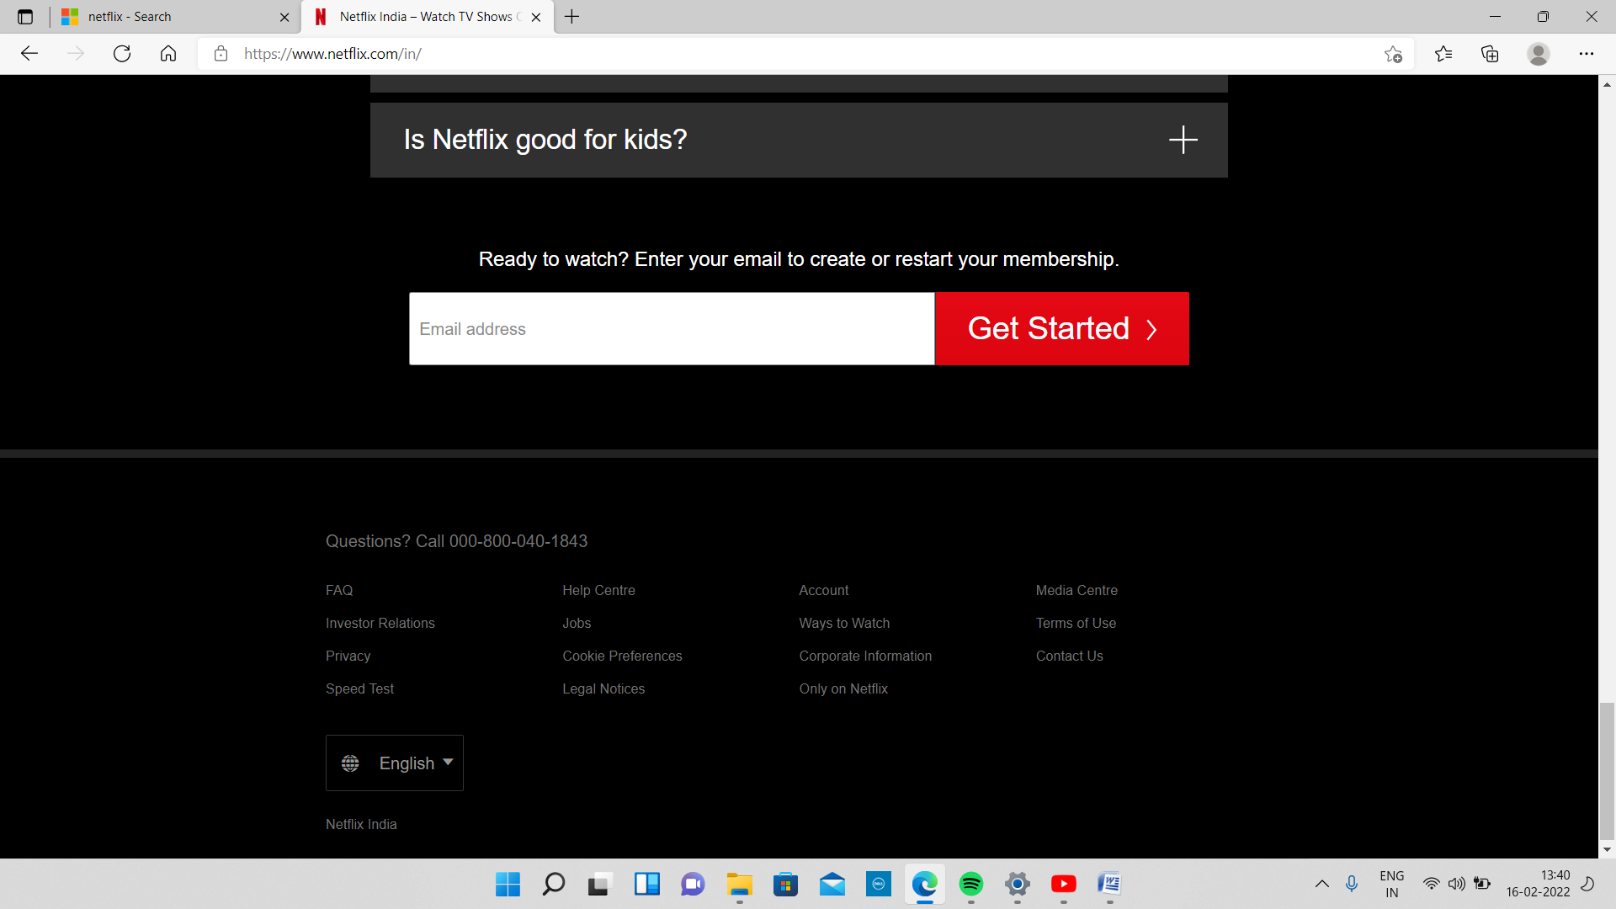

FOOTER PART

**Payment Interface-**