**Help for Snapshot tool via an example**

**Condition A:**

**Snapshot1 contains snapshot of ‘D:\A’ which is a root directory for ‘D:\A\B’(Snapshot2)**

**Therefore, both snapshots have different parent directory**

**Structure of D:**

E

B

C

A

D:

F

temp.txt

G

**Snapshot1 contains the structure of A**

**Snapshot for creation of Snapshot1**

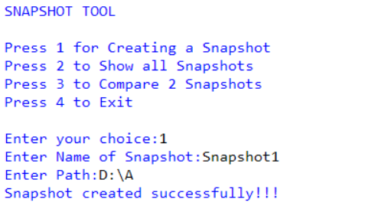

**Displaying data of Snapshot1**

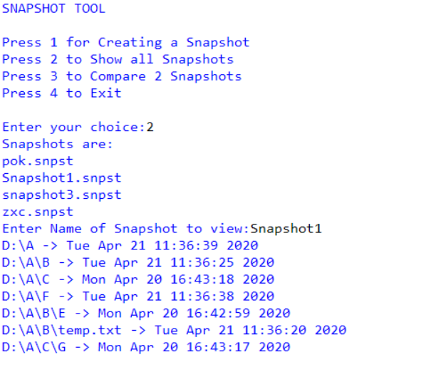

**Snapshot2 contains the structure of B(sub-dir of ‘D:\A’) in which dir ‘E’ is deleted and file ‘temp.txt’ is modified**

**Snapshot for creation of Snapshot2**

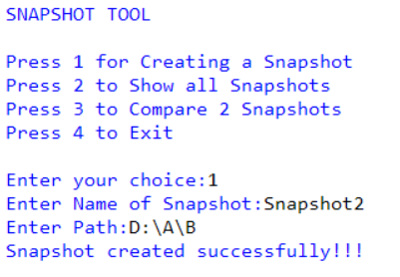

**Displaying data of Snapshot2**

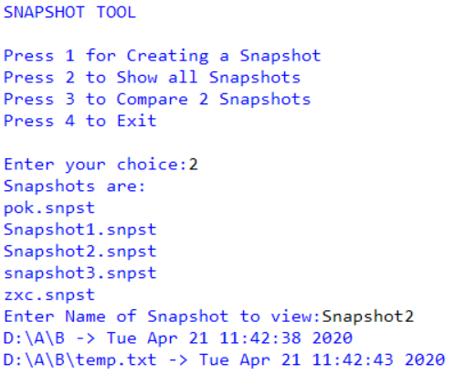

**Finally, the comparison between Snapshot1 and Snapshot2**

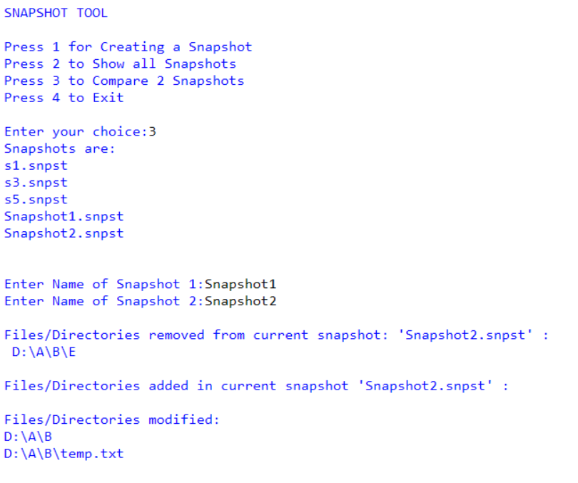

**Condition B:**

E

B

C

A

D:

F

temp.txt

G

**S1 and S2 are snapshot of ‘D:\A’**

**S1 contains structure of A**

**Snapshot for creation of S1**

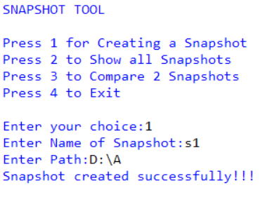

**Displaying data of S1**

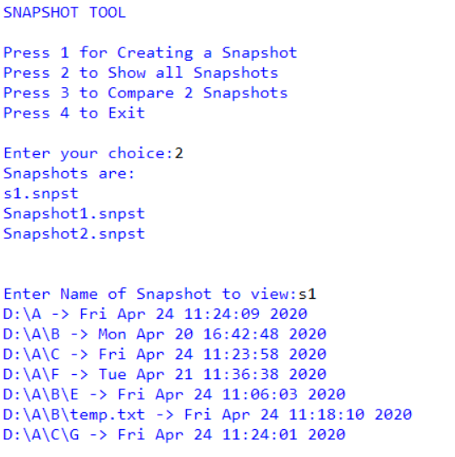

**Deleting folder ‘C’, modifying file ‘temp.txt’ and adding folder ‘Z’ in ‘A’ for S2**

**Snapshot for creation of S2**

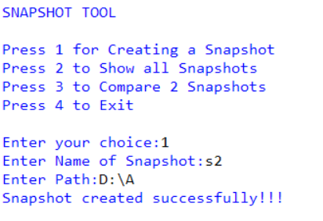

**Displaying data of S2**

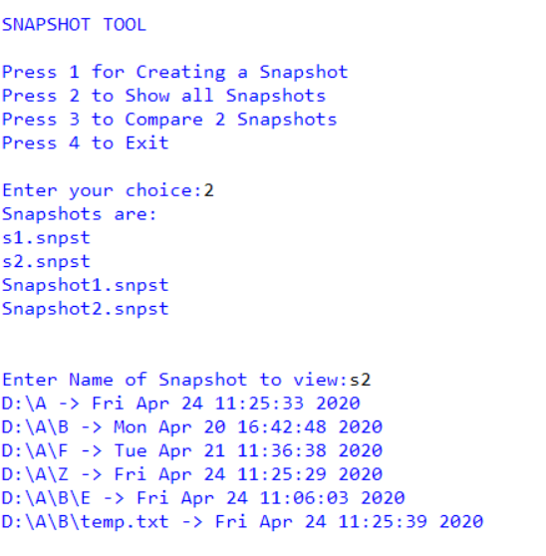

**Finally, the comparison between S1 and S2**

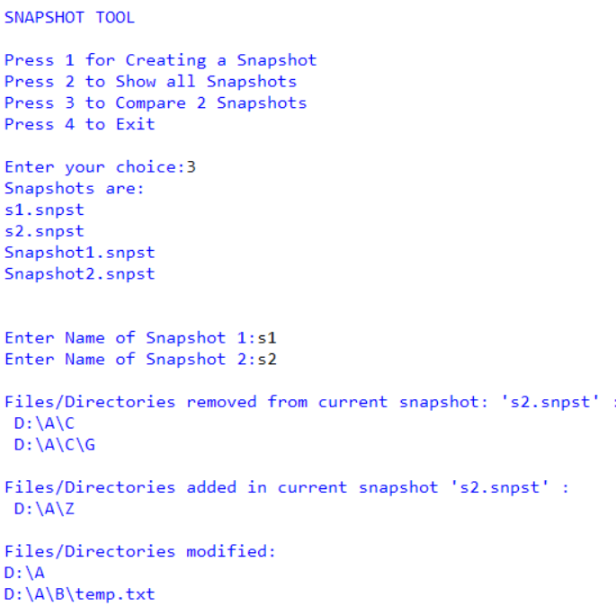

**1.This program doesn’t limit you to compare 2 snapshots having same path. Since Folder hierarchy is maintained, you can compare 2 snapshots with different path as explained above. This is the extra functionality added.**

**Eg: S1 contain snapshot of C: drive, S2 contain snapshot of any sub-directory of C: drive. Then this program can still compare them**

**2.While comparing, order of entering snapshot name is not mandatory**