

**Assignment Cover Sheet**

|  |  |  |  |
| --- | --- | --- | --- |
| **Qualification** | | **Module Number and Title** | |
| HND in Computing/ HND in Software Engineering | | SED52010 Windows Application Development | |  |
| **Student Name & No.** | | **Assessor** | |
| Widana Gamage Avindi Premaratne – ST/HNDCOM/19/15 | | Aruna Indika | |
| **Hand out date** | | | **Submission Date** |
| //2016 | | | //2016 |
| **Assessment type**  Coursework | **Duration/Length of**  **Assessment Type**  Practical project/report | | **Weighting of Assessment**  **100%** |

|  |  |
| --- | --- |
| **Learner declaration** | |
| I certify that the work submitted for this assignment is my own and research sources are fully acknowledged. | |
| |  |  |  |  | | --- | --- | --- | --- | | **Marks Awarded** | | | | | First assessor | |  | | | IV marks | |  | | | Agreed grade | |  | | | Signature of the assessor |  | Date |  | |

**Feedback Form**

**International College of Business & Technology**

**Module:** Windows Application Development

**Student: Widana Gamage Avindi Premaratne**

**Assessor:**

**Assignment:**

**Strong features of your work:**

**Areas for improvement:**

**Marks Awarded:**

**Learning outcomes covered**

* Critically evaluate and select appropriate windows platform and development tools
* Design and develop Windows applications
* Critically test and deploy Windows applications

**Scenario and the Task**

**“Total Fitness”** is the largest and very busy pharmacy in Matara. They are the sole agent for the Cipla product in the region.

They have number of suppliers to supply verity of medicine and some types of milk powders. Some of them are cash and some of them are credit. For the credit suppliers you have to pay your total bill within 3 weeks. As well that must notify when the particular date comes closer. As well they can terminate any supplier at any time.

As **“Total Fitness”** is the sole agent for the Cipla, they have separate transport division to distribute Cipla products to all over the region. When they deliver particular products to distance pharmacy they will keep following records. Pharmacy name, contact person, contact number (mobile/fix) product(s), quantity, price and any other required details. Normally end of the year they will awarding pharmacies that are having bestselling performance for Cipla products and that should automatically calculate and display by the system.

Also **“Total Fitness”** having two types of customers they are register and non-register. Register customers always get 2% discount for their every bill when they buy more than LKR 750.00. To register; every customer has to pay LKR 2500.00 per year. If someone unable to update their registration automatically they will remove form the registered customers group. As well register customers are allowed to buy products for a 1 week credits, but it only for below LKR 1500.00 bills. Customers cannot buy anything without paying previous credit bills. As well registered customers can check their purchase history.

All purchasing order invoices, purchasing bills, customer bills have to maintain and in any case **“Total Fitness”** wants to find that particular record by all possible ways…

Finally, **Total Fitness** wants to keep all medicines, Cipla product’s, Milk powder product’s inventory up to date…

**Tasks**

1. Critically compare different windows or other platforms and select the suitable platform for different user groups? (Word count 500 [+- 50] ) (10 marks)
2. Critically compare and select development tools and technologies for the above mention application? (Word count 500[+- 50]) (10 marks)
3. Design a solution for above mention requirements. (30 marks) Provide
   1. System architecture diagram
   2. UML diagrams (Class, Use case, sequence etc...)
   3. Data model design (ER diagram)
   4. Sample UI designs (Wireframe will be fine)
4. Develop suitable application based on the design. Should be able to demonstrate and provide all source codes. Need use proper coding standards and must focus on reusability and maintainability of the application. (30 marks)
5. Select appropriate test technique(s). Test and provide proper test cases and critically evaluate the test result. (10 marks)
6. Explain deployment techniques that are selected and critically evaluate suitability of the selection. ( 10 marks)

**Submission Guidelines**

* Submission format Report
* Paper Size: A4
* Words: 3000 words
* Printing Margins: LHS; RHS: 1 Inch
* Binding Margin: ½ Inch
* Header and Footer: 1 Inch
* Basic Font Size: 12
* Line Spacing: 1.5
* Font Style: Times New Roman
* **Referencing should be done strictly using Harvard system**

**Source code, database backup and installation packages should be submitted in a single zip file.**

**Assessment Criteria**

**Task 1 contains 10 marks**

|  |  |  |
| --- | --- | --- |
| **Criteria** | **Marks** | **Marks obtained by the student for the answer provided** |
| **Out of 10** |
| **Excellent**  Excellent level of understanding of platforms, critical comparison technically and also focusing other environment factors, Higher level of depth and breadth of study with extensive reading and integration of information from a wide range of sources. | **7-10** |  |
| **Good**  Reasonable level of understanding of platforms and critical comparison technically, Good level of depth and breadth of study, | **6-7** |  |
| **Satisfactory**  Reasonable level of understanding of platforms and comparison, satisfactory level of depth and breadth of study | **4-6** |  |
| **Poor**  Limited understanding of platforms and poor comparison. Limited reading, lack of depth and breadth of study | **0-4** |  |

**Task 2 contains 10 marks**

|  |  |  |
| --- | --- | --- |
| **Criteria** | **Marks** | **Marks obtained by the student for the answer provided** |
| **Out of 10** |
| **Excellent**  Excellent level of understanding of platforms, critical comparison and proper justification for the selections, Higher level of depth and breadth of study with extensive reading and integration of information from a wide range of sources. | **7-10** |  |
| **Good**  Reasonable level of understanding of platforms and critical comparison technically, Good level of depth and breadth of study, | **6-7** |  |
| **Satisfactory**  Reasonable level of understanding of related tools and comparison with correct selection, satisfactory level of depth and breadth of study | **4-6** |  |
| **Poor**  Limited understanding of related tools and poor comparison. Limited reading, lack of depth and breadth of study | **0-4** |  |

**Task 3 contains 30 marks**

|  |  |  |
| --- | --- | --- |
| **Criteria** | **Marks** | **Marks obtained by the student for the answer provided** |
| **Out of 30** |
| **Excellent**  Excellent level work shown on design, Complete set of UI designs focus on easy navigation and proper structure , Exceptional solution focus on reuse, maintainability, use of proper architecture, and error free,correctness and completeness of the UML diagrams. | **21-30** |  |
| **Good**  Good set of diagram with proper separation of layers and communication, Correct notations and evidence of effort to design user friendly design. Detail diagrams. | **18-21** |  |
| **Satisfactory**  Reasonable level of diagrams, has identified basic data requirements and evidence of basic UML diagrams. | **12-18** |  |
| **Poor**  Limited or no of evidence given for design, incorrect use of notations and diagrams are incomplete. No proper architecture | **0-12** |  |

**Task 4 contains 30 marks**

|  |  |  |
| --- | --- | --- |
| **Criteria** | **Marks** | **Marks obtained by the student for the answer provided** |
| **Out of 30** |
| **Excellent**  Exceptional solution focus on reuse, maintainability, use of proper architecture, error free and innovative features, demonstration with proper planning, proper flow and good presentation skills with clear explanations. | **21-30** |  |
| **Good**  Good solution complete application satisfying all user requirements, Proper error handling, Proper demonstration planed and well structured | **18-21** |  |
| **Satisfactory**  Basic application that can run without any build errors, fulfil the basic requirements. Presentation and demonstration is reasonable but flawed in structure or in some other way | **12-18** |  |
| **Poor**  Develop solution run with build errors, lack of error handling and validation, the presentation and demonstration is incoherent, incomplete or seriously weak in other ways | **0-12** |  |

**Task 5 contains 10 marks**

|  |  |  |
| --- | --- | --- |
| **Criteria** | **Marks** | **Marks obtained by the student for the answer provided** |
| **Out of 10** |
| **Excellent**  Excellent justification for the selected test techniques. Proper set of test cases to conduct a comprehensive test for the develop solution with proper test data. Selection of appropriate test data. Conduct test and critically analysis test results. | **7-10** |  |
| **Good**  Good justification for the selected test technique. Test cases to cover testing of entire application with meaningful data. Conduct test and a critically analysis test results. | **6-7** |  |
| **Satisfactory**  Reasonable justification of test techniques and test cases to test the basic functionalities successfully. Analysis of test results. | **4-6** |  |
| **Poor**  Limited justification for test technique selection and incomplete set of test cases, improper set of test data. Poor analysis of test result. | **0-4** |  |

**Task 6 contains 10 marks**

|  |  |  |
| --- | --- | --- |
| **Criteria** | **Marks** | **Marks obtained by the student for the answer provided** |
| **Out of 10** |
| **Excellent**  Excellent justification for the selected deployment techniques, by critically comparing with other available deployment options. Excellent explanation on selected technique. | **7-10** |  |
| **Good**  Good justification for the selected deployment techniques, by critically comparing with other available deployment options. Proper explanation on selected technique. | **6-7** |  |
| **Satisfactory**  Reasonable justification for the selected deployment techniques, by comparing with other available deployment options. Satisfactory explanation on selected technique. | **4-6** |  |
| **Poor**  Limited justification, limited comparison with poor explanation | **0-4** |  |

|  |  |  |
| --- | --- | --- |
| **Total Marks** | **Out of 100** |  |

# Task 01



# Task 2



## Compare and select development tools and technologies for the above mention application

In this section, we have to compare some development tools and technologies for the application that we are going to build for the Total Fitness Pharmacy. As this system is for a pharmacy management system, the users would be pharmacist. So, there will be no users with computer knowledge to use this system. Therefore, this system should be more user-friendly which make pharmacists easy to use the system. To build up a system we should first select a programming language. There are many languages like Java, C++, C#.net, Python etc... But, among these programming languages the learner chooses c#.net to build up this system. The reasons are

* It’s facilitates with many methods for variables
* Microsoft Corporation developed C#.net. Therefore, it is very famous for building desktop applications, mobile applications, REST APIS, websites, games and even native Android or iOS apps. As we have selected Microsoft Windows as the suitable platform, the application will run more well if we use C#.net.
* In addition, C#.net uses the .net framework too provides hundreds of libraries for building websites, implementing security, working with the file system, etc.

Next, we have to choose a suitable IDE to develop the system. An Integrated Development Environment is a software application that helps programmers to design and develop software. Therefore, in here the learner chooses Visual Studio as the best IDE for the C#.net.

* Visual Studio is very user friendly for developers. It has a good interface and it helps for the developer while coding providing suggestions, declared variables, classes, methods, etc. in a pop up menu.
* It consists of a variety of tools, which can be more helpful in designing the interface of the system. Tools like error provider, date time picker, timer are some significant tools that you cannot find even in java.
* There is a solution explorer and class view to view and open the forms and classes.
* Also, this IDE has debugging tools and compiling which the developer can easily test each part of the system easily.

C# language uses .net framework rather than any other languages. The latest .net framework is .net 4.5. This framework provides an environment to run any kind of .net based applications.

# Task 3



## Entity Relationship Diagram

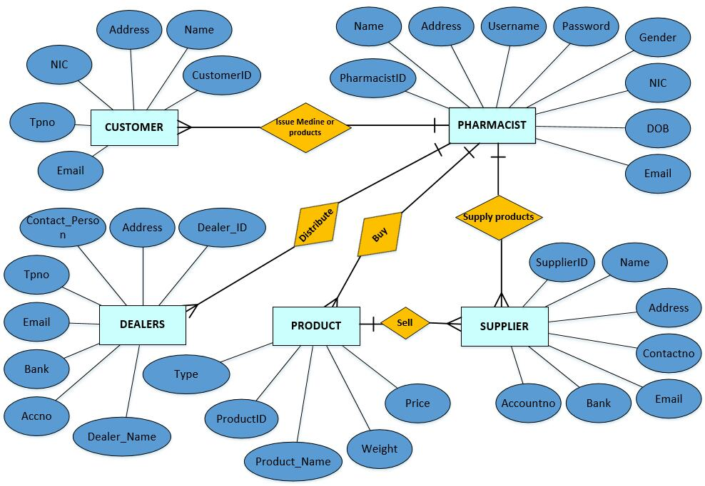

Figure 1 - ERD

## Wireframe Design

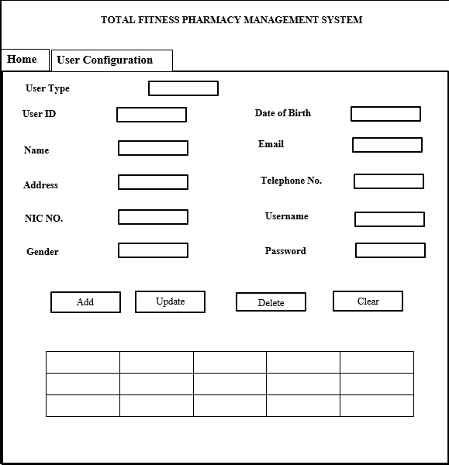

Figure 2 - User Configuration Wireframe

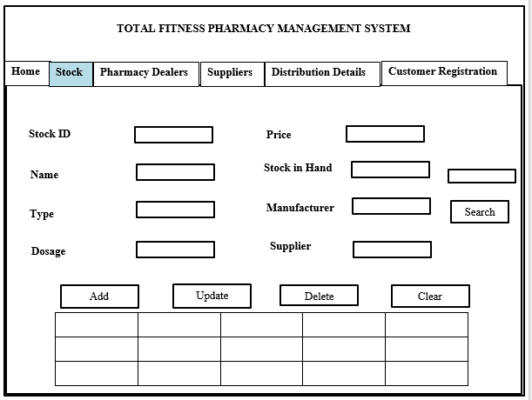

Figure 3 - Stock Wireframe

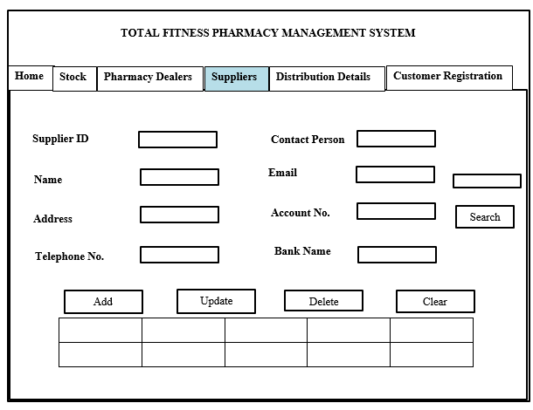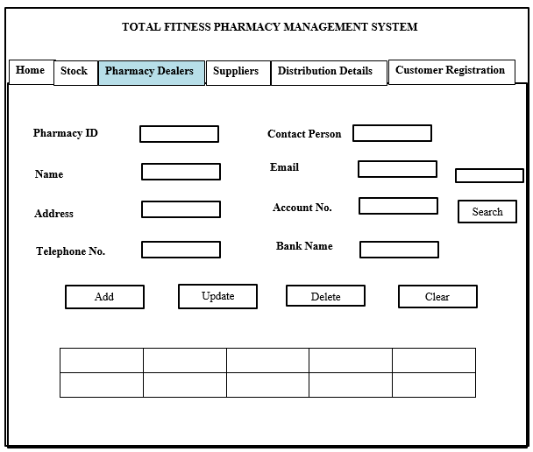

Figure 4 - Pharmacy Dealers Wireframe

Figure 5 - Suppliers Wireframe

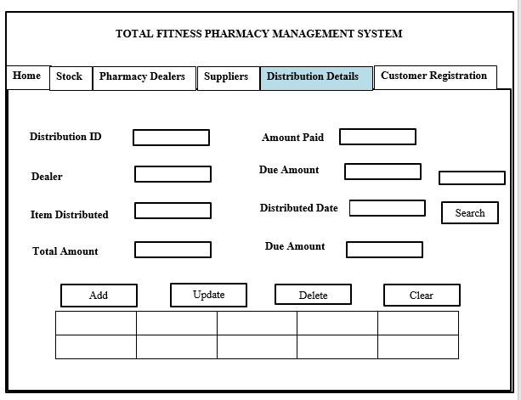

Figure 6 - Distribution Details Wireframe

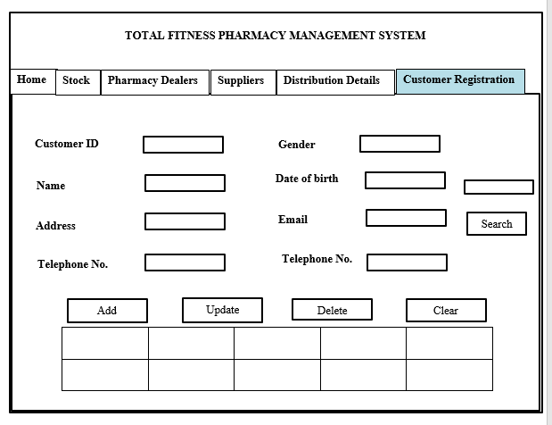

Figure 7 - Customer Registration Wireframe

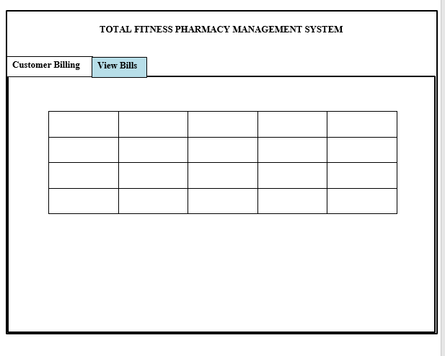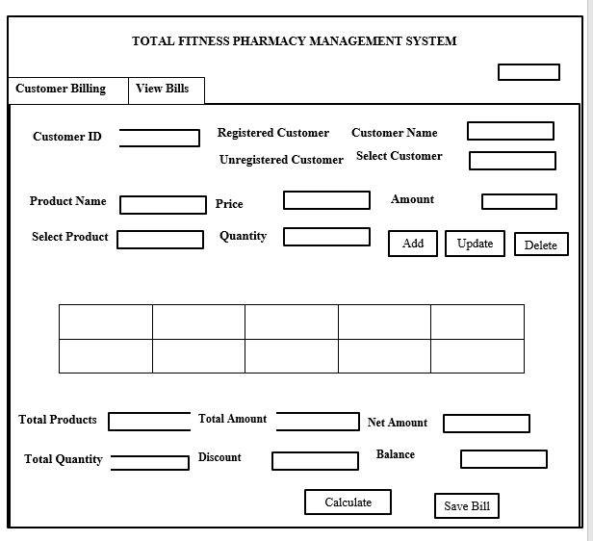

Figure 8 - View Bills Wireframe

Figure 9 - Billing Wireframe

# Task 04



# Task 05



## System Testing

Before implementing the system to the Total Fitness Pharmacy, the system needs to be tested properly. System testing means testing each and every components of the system whether the expected output is received or not when giving the input to the system. There are different types of testing techniques.

1. Black Box Testing
2. White Box Testing
3. Gray Box Testing
   * 1. **Black Box Testing**

Black box testing means examining requirement functionality of the application without testing the interior part of it. Interior part means the structure of the program, codes, etc. In here we check the interface of the application, performance errors, and check whether we get the expected output from the application when data inserted. It’s very easy to test than the white box testing. In here programming knowledge isn’t required to test. Also, we can start the test cases too using this technique.

* + 1. **White Box Testing**

White Box testing means, examining the interior part of the application like examining the codes, design, conditions etc...as mentioned before. This testing is known as the Clear Box Testing, Open Box Testing, Glass Box Testing. In here the GUI isn’t needed for testing like black box testing. Testing is more thorough, with the possibility of covering most paths. Also we need programming knowledge is required to test the codes. Also, this testing is quite expensive and consume more time.

1. **Grey Box Testing**

Grey box testing is a combination of white box and black box testing. In here the tester knows only the interior part to some extent only

So among these three testing techniques we have to choose a one for our application to test. When we consider about black box testing technique, we have to test only the exterior part of the application. Also its easy to start and we can start test cases too, programming knowledge isn’t required for this. But in white box testing, we have to test only the interior part of the application. We need the programming knowledge for this and we have to examine the code, interior structure and design error handlings etc.... So it takes time when doing this type of testing. Grey box testing is a combination of both black box and white box testing. Though it’s a hybrid of both the techniques the tester can’t get access to test the source code. Therefore, by comparing these three techniques the leaner chooses Black Box Testing for this application. It is because, as mentioned before this technique is easy and we can start the test case too and many other benefits mentioned above.

# Task 06



# Conclusion

Finally, we have created an application for the Total Fitness pharmacy. Before creating the system, we had to select a suitable platform for the application. We compared some operating systems like Microsoft Windows, Mac OS and Linux and selected Microsoft Windows as the suitable platform. Then we compared programming languages and IDE’s’ and selected C#.net and Visual Studio as the programming language and the IDE.

Next, we drew Entity Relationship Diagram to identify relationships, attributes and entities and also we drew the Wireframe Design to get a sketch of the interfaces that we are going to design. Then we developed a suitable application based on the designs using C#.net language and Visual Studio. We showed how the application has been developed by adding screenshots of the interface and source codes. We demonstrated the system too.

Then we created a user manual for the users who are going to use this system. Then, we test the whole system. We mentioned about system testing techniques and drew the test case. Finally, we discussed about deployment techniques for the system which should be implemented for the pharmacy and finally choose parallel technique for the system deployment.

Now we are satisfied that we have built up a good application for the Total Fitness pharmacy.

# Recommendation

In this section we are going to discuss some recommendations for the application. So the learner would like to recommend some ideas for his system. As we haven’t built up reports the learner suggest to build reports using report building tool.

# Gantt Chart

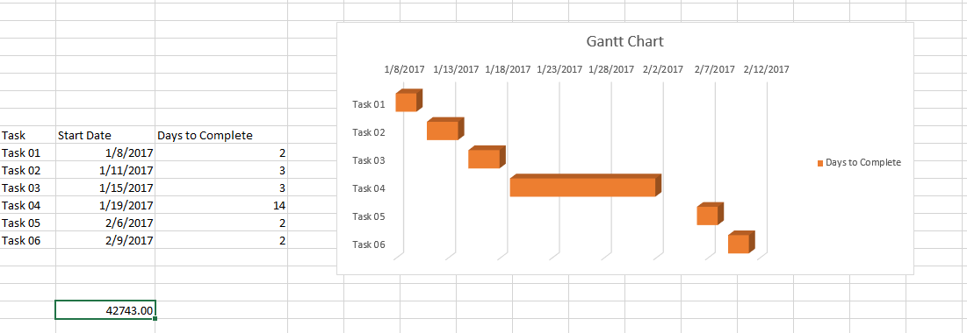

# References

Webopedia (no date) *What is C# programming language? Webopedia definition*. Available at: http://www.webopedia.com/TERM/C/C_sharp.html (Accessed: 8 January 2017).

Technopedia (2017) *What is an integrated development environment (IDE)? - definition from Techopedia*. Available at: https://www.techopedia.com/definition/26860/integrated-development-environment-ide (Accessed: 29 January 2017).

BBC Bitesize (2017) *Programming software and the IDE*. Available at: http://www.bbc.co.uk/education/guides/zgmpr82/revision/ (Accessed: 29 January 2017).

RJ Systems (2003) *Windows pros and cons*. Available at: http://www.rjsystems.nl/en/3200.php (Accessed: 31 January 2017).

Soffar, H. (2016) *Linux operating system advantages and disadvantages | science online*. Available at: http://www.online-sciences.com/computer/linux-operating-system-advantages-and-disadvantages/ (Accessed: 11 February 2017).

Inc, B.H. (2010) *A look at the advantages and disadvantages of Mac OS*. Available at: http://www.brighthub.com/computing/mac-platform/articles/73326.aspx (Accessed: 31 January 2017).

Parker, J. (2013) *Types of system testing - Enfocus solutions Inc*. Available at: http://enfocussolutions.com/types-of-system-testing/ (Accessed: 9 February 2017).

Software Testing Help (2016) *Types of software testing and definitions of testing terms — software testing help*. Available at: http://www.softwaretestinghelp.com/types-of-software-testing/ (Accessed: 9 February 2017).

Software Testing Fundamentals (2016) *Black box testing*. Available at: http://softwaretestingfundamentals.com/black-box-testing/ (Accessed: 9 February 2017).

Software Testing Fundamentals (2016) *Test case*. Available at: http://softwaretestingfundamentals.com/test-case/ (Accessed: 9 February 2017).