How to execute the project

1. Installed Intellij
2. Unzip the project into local
3. Import the project as maven
4. Update the dependency from POM.xml
5. Into project tree right click TestBestSellersHeadphone.java

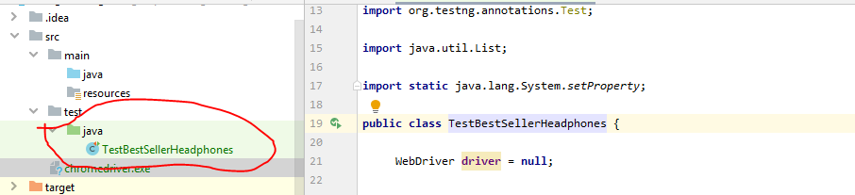

See the run result as below

