**Capstone Blog**

**Summary**

**Introduction:**

The premise of my capstone is to provide insights into where someone should open a new business based on rental prices and surrounding competition.

**Business Problem:**

Many new business owners face a challenge of understanding where exactly they should open their business. Should it be in the heart of the city? Can he/she afford rental prices? Will he/she have too much competition to where the business will suffer? We can explore these problems and reduce the risk by evaluating rental prices in a given area while also comparing the ratings of similar restaurants within the same industry to gauge the risk of the location.

**Discussion:**

Starting a business in a more city like area reduces the risk of default purely due to foot traffic and population. For this exercise, we will be focusing on the Northern Virginia area. The goal is to find a location within this area that has high foot traffic, low rent, and a low volume of competitors within the surrounding area. Places like town centers, malls, and local shopping areas are good areas to evaluate. I will be looking at how rent prices increase/decrease for the Northern Virginia area. It's also important to evaluate foursquare check in data to better understand how foot traffic is engaging with the local businesses.

The dataset illustrates rental values for top neighborhoods in the Northern Virginia area. This data will be used to generate an overall neighborhood score for a specific location that can then be compared against the other neighborhoods. Rental price and rental price change over 6 months will be one data point used when generating the overall neighborhood score.

**Explaining the data  
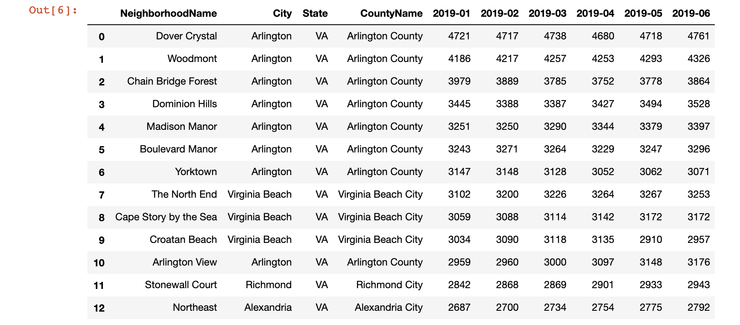**

The above data was collected from Zillow.com. It highlights the largest neighborhoods in the Northern Virginia/DC area based on rent prices for 6 months. The rent prices will be 1 out of the 2 data points used to calculate a neighborhood score.

**Get Lat/Long for neighborhood**

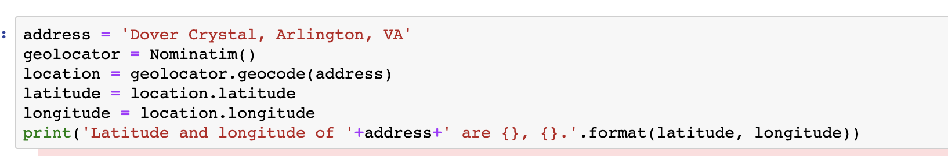

This function pulls the long/lat for the specific neighborhood name that will be inputted into the foursquare script below. You will need to repeat this for each neighborhood row name, looping the entire process for each neighborhood and running each neighborhood through the formula at the end.

**FourSquare Input lat/long**

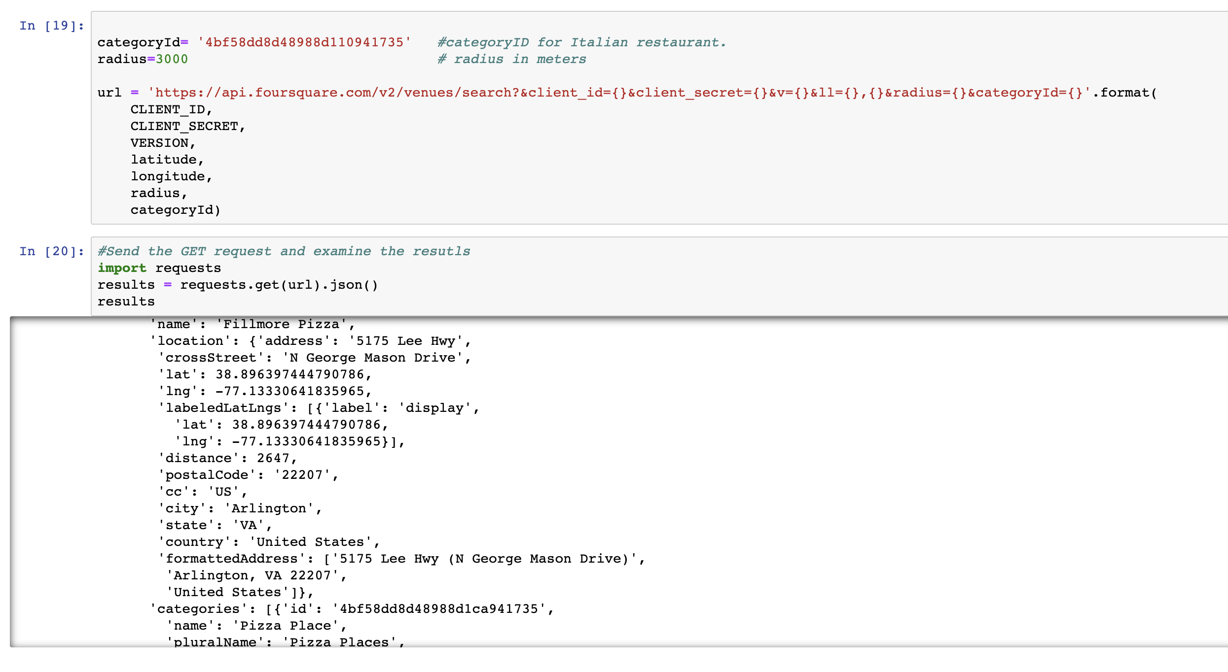

This section shows the data foursqure outputs for that lat/long within a 3000 meter radius

**Venue ID**  
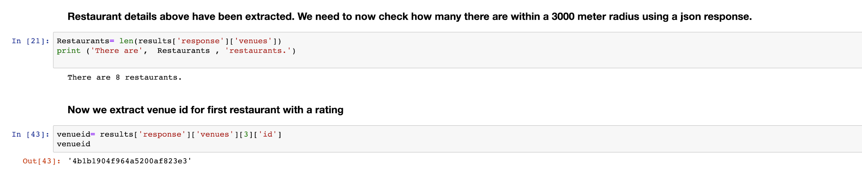

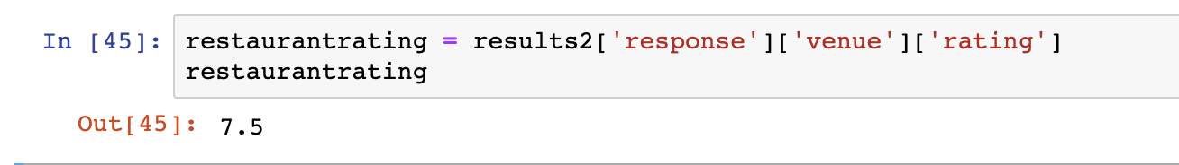

This section shows how many restaurants are within the 3000 miles radius based on the lat/long inputted. You then extract the first venue ID out of the 8 restaurants to find the restaurant rating. You repeat this step for all 8 restaurants to find the max and min restaurant rating between the 8 restaurants. Those max/min restaurant values will be used in the final neighborhood rating formula.

#### **How to use the data:**

As explained in the previous report, we need to evaluate rental prices and ratings of surrounding restaurants in the area to determine a final output score. It's important to note that I am just using a sample data set to illustrate the underlying process to the project. The process itself can be rerun to evaluate and compare neighborhood "scores".

To calculate an overall score for each neighborhood we're going to be giving rent a score and restaurant rating a score with a weight. The closer the score is to 1, the better rating that overall location is.

Location score formula: Score= (rentscore).3+(ratingscore).7

Rentscore Formula: (MaxNeighborhoodrent-averagerentofneighborhood)/(maxrentofneighborhood-minrentofneighborhood). Use the data set above to calculate rent score.

Ratingscore: (maxrating-restaurantrating)/(maxrating-minrating). Use the foursquare location data below to find rating of restaurant.