

Comcast Video Software

OCATS Build Guide

Document Status
Document Control Number:
Document Title: | OCATS Build Guide
Revision History: | OCATS Build Guide 0_2 (Addressing review comments)
Date: | October 03, 2013
Status: | Draft
Distribution:
Document Status Codes:
Work in Progress (WIP) An incomplete document designed to guide discussion and generate feedback that may include several alternative requirements for consideration.
Draft (D) A document in specification format considered largely complete, but lacking review. Drafts are susceptible to substantial change during the review process.
Issued (I) A stable document which has undergone rigorous review and is suitable for product design and development. It will serve as a /basis for testing requirements.
History Information
Date | Version | Updated | Section impacted | Comments
9/27/2013 | 0.1 | Sajay jK | All | Initial Draft
10/03/2013 | 0.2 | Sajay jK |  | Addressing review comments

Author: Sajay Janardhana Kurup

Approved: _____________________

Reviewed:

Douglas Sanders ____________________
Chad Frederick____________________
Marcus Haebler____________________
Tahmina Husain__________________
Sreejith Sivasankar_______________________

Sign-off for Issue:
Douglas Sanders

Table of Contents
1 Introduction 1
1.1 Scope 1
2 OCATS Architecture 2
3 Tools Required 3
4 Building the OCATS project 4
4.1 Building from Source 4
4.1.1 Packaging CATSVision for webstart 4
4.1.2 Packaging OCATS stability jar 4
4.1.3 Packaging OCATS release bundle 4
4.1.4 Building individual artifacts 4

Introduction
OCATS is a test automation framework that enables automated testing of customer premise equipment specifically designed for the cable industry. The OCATS framework provides an exhaustive API set to perform operations on settops and to verify its output: the two basic building blocks of any automation framework. The OCATS framework provides the ability to run automated tests from one settop on someone’s desktop to settops from multiple racks through a centrally manageable test environment. The same framework can be used to automate functional testing, run stability tests that monitor reboots on boxes, performance testing, and manual and semi automate testing of boxes.

Scope
This document describes how one can build the OCAT project from source. The document does not describe how the build artifacts can be used and deployed. Please refer to the install guide and user guide on details regarding how to use OCATS to write tests and how OCATS framework can be deployed.

OCATS Architecture

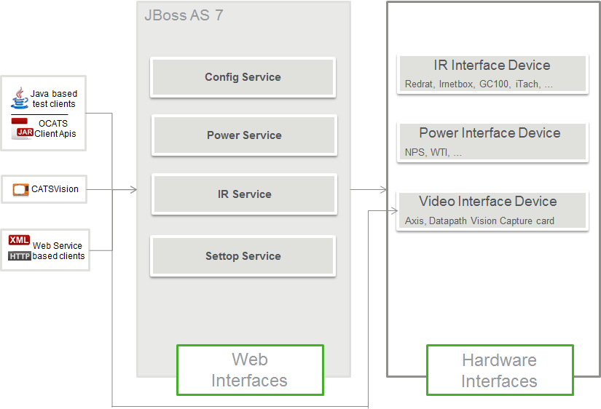
OCATS framework consists of three essential parts.
- Hardware Interfaces
The Hardware interfaces are the devices that interact with the device under test. For settops, they are usually IR blasters, video streamers or capture cards, power controller devices etc. These devices collectively will be able to perform operations on the box and verify its output.
- Web Interfaces
The CATS web services provide means to centrally manage multiple racks and settops at the same time.
- Client Side APIs
The client side apis consume the webservices so that CATS based test cases are abstracted and can focus more on the test case rather than on configurations.

Tools Required

Tool | Version | Download Link
JDK | 1.7 | http://www.oracle.com/technetwork/java/javase/downloads/jdk7-downloads-1880260.html
Maven | 3.1.0 | http://maven.apache.org/download.cgi
GIT | 1.8.4 | http://git-scm.com/downloads

Make sure JAVA_HOME and M2_HOME are properly set as per the installation instructions provided by each tool.

Building the OCATS project

Once JDK, Maven and git have been properly installed and configured, the OCATS source repository can be cloned and built using maven.

Building from Source
Checkout the source code from git repo using the following command
cd yourPreferredFolder
git clone https://cats-dev3.cable.comcast.com:8443/git/OCATS.git

These will checkout the OCATS source to yourPreferredFolder.
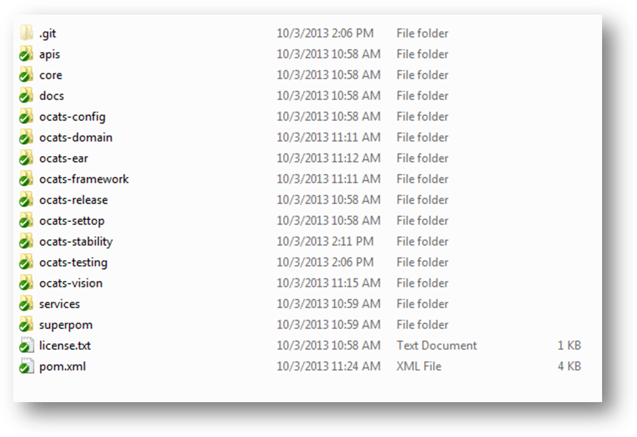

To build the OCATS project, you’ll need to build the superpom for the project first.

cd superpom
mvn clean install

All repositories required for the OCATS project is available in the superpom pom itself.
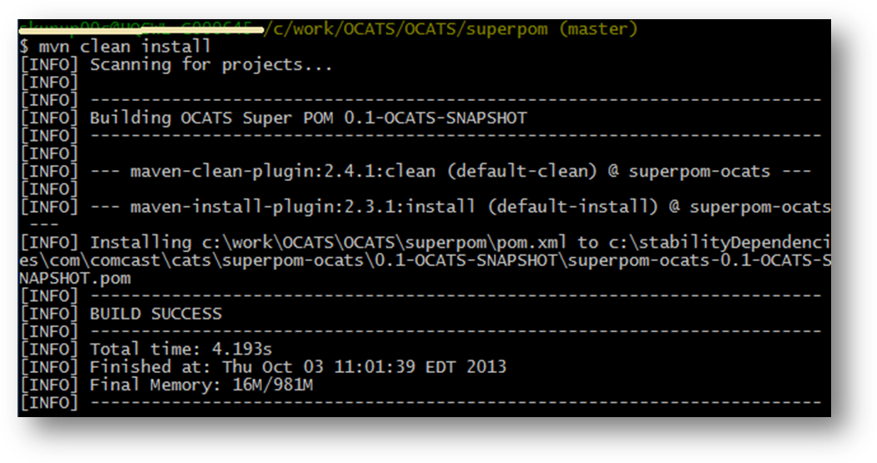
After building the superpom, you can build the POCATS project as a whole by going to the root folder and
mvn clean install
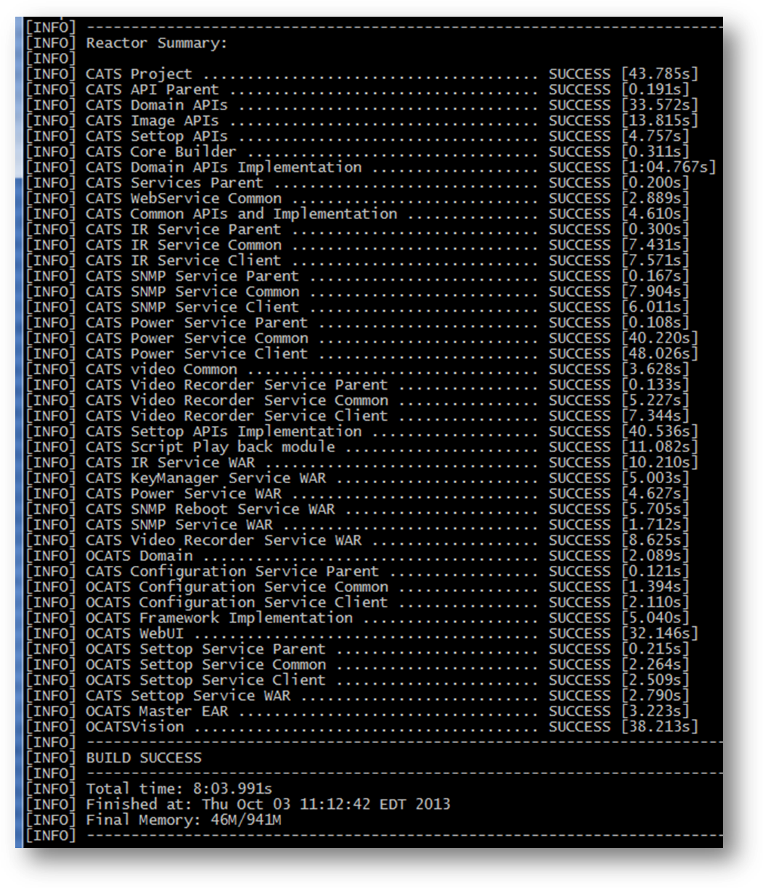

Packaging CATSVision for webstart
To bundle up CATSVision and its dependencies as a zip, which can then be used to launch CATSVision from webstart or bat or .sh file, execute the following command in the ocats-catsvision folder
cd ocats-vision
mvn clean package –P webstart
This will create catsvision.zip file in the target folder.
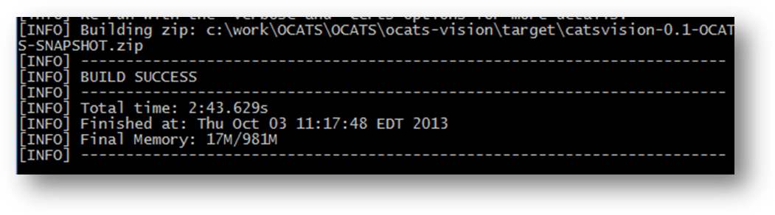
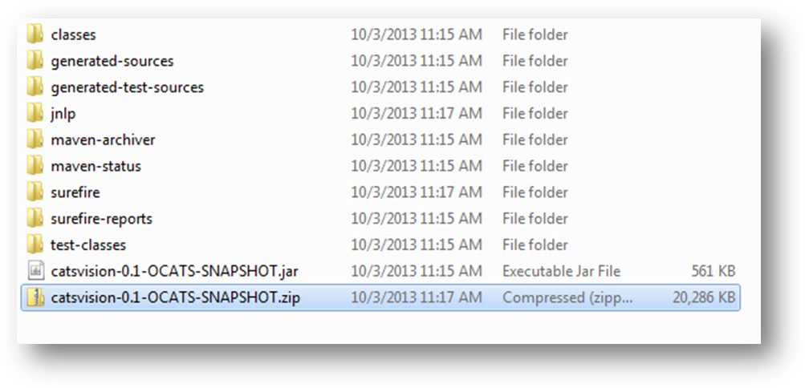

Packaging OCATS stability jar
To get the OCATS Stability jar, navigate to ocats-stability folder and execute the following command:
cd ocats-stability
mvn clean install –P stability
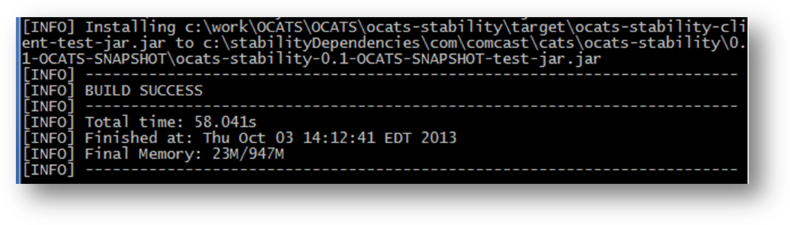
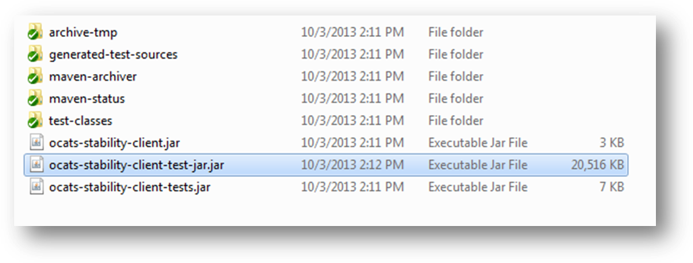

Packaging OCATS release bundle
To package all of OCATS artifacts into a release bundle zip execute the following command at the ocats-release folder

mvn clean install

Building individual artifacts
Individual artifacts can be built by executing mvn clean install in the respective folders.
The ocats-master-ear that includes ir-service, power-service, snmp-service, keymanager-service and settop-service wars can be built by building the ocats-ear project using mvn clean install command.

