1. **Anaconda**

Download Anaconda from URL - <https://www.anaconda.com/distribution/>

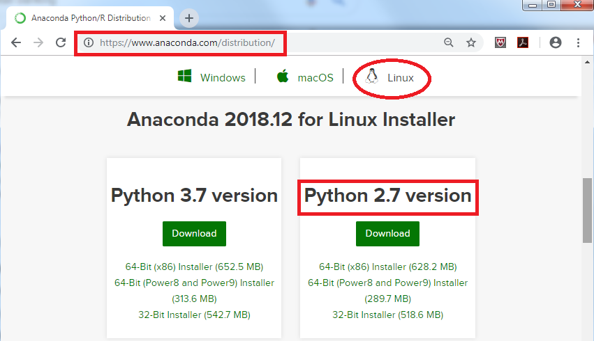

Choose Linux and download the required version. Below sh file will be downloaded.

**Anaconda2-2018.12-Linux-x86_64.sh**

**Installation Steps**

* Login to your unix session and run below command
* bash Anaconda2-2018.12-Linux-x86_64.sh



* It will show the welcome message. Press ENTER few times till below screen comes up.

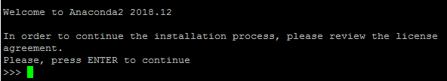

* Message for license terms agreement will show up as below

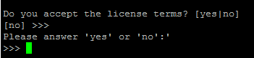

Enter “yes” and press Enter

* This will ask to enter installation location

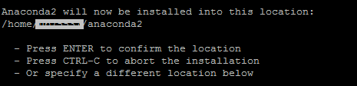

Confirm the location where anaconda will be installed and press Enter.

* Below message indicates installation has **started**

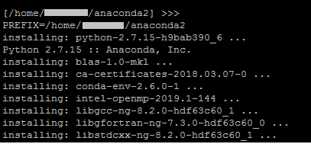

* Below message indicates installation has **finished successfully**

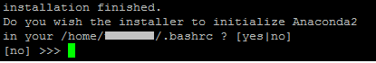

* Initialize anaconda

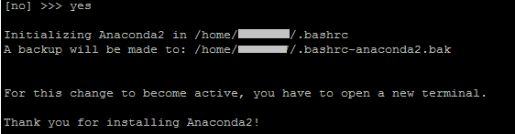

* Optional VS installation option (this is not needed)

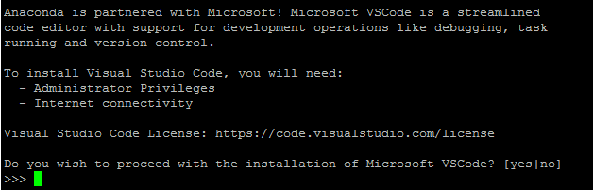

1. **SWAT**

The SAS SWAT package is a Python interface to the SAS Cloud Analytic Services (CAS) engine (the centerpiece of the SAS Viya framework).

URL - <https://github.com/sassoftware/python-swat/releases>

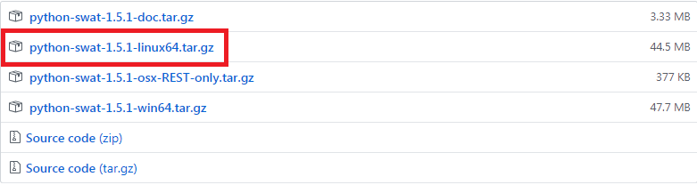

Pick the linux version file and download the tar file.

* Uncompress the tar file

tar – xvzf python-swat-1.5.1-linux64.tar.gz



* Once successfully uncompressed, you should see a directory created as “python-swat-1.5.1”



* Execute setup.py file using below commands

cd python-swat-1.5.1

/home/usr/anaconda2/bin/python setup.py install

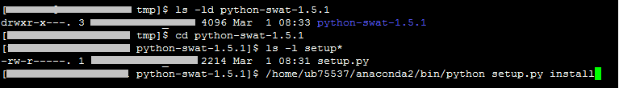

* Below message indicates SWAT is successfully installed.



1. **Jupyter**

* Make sure Jupyter Notebook is installed part of anaconda installation. If not, it can be installed separately.

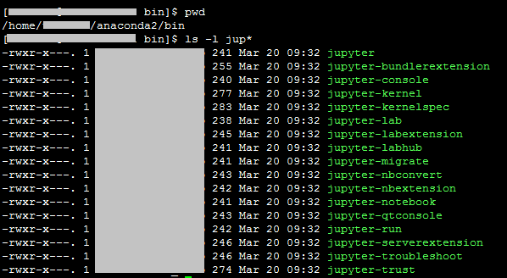

* **SSH Tunneling using Windows and PuTTY**

PuTTY is an open-source SSH client for Windows which can be used to connect to your server. After downloading and installing PuTTY on your Windows machine (as described in the prerequisite tutorial), open the program and enter your server URL or IP address, as shown here:

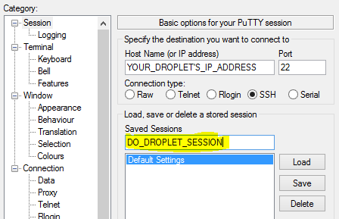

Next, click **+ SSH** at the bottom of the left pane, and then click **Tunnels**. In this window, enter the port that you want to use to access Jupyter on your local machine (8000 ). It is recommended to use a port greater or equal to 8000 as those port numbers are unlikely to be used by another process. If 8000 is used by another process, though, select a different, unused port number. Next, set the destination as localhost:8888, since port 8888 is the one that Jupyter Notebook is running on. Then click the **Add**button and the ports should appear in the **Forwarded ports** field:

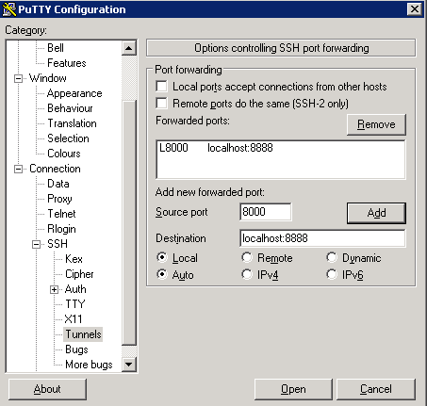

Finally, click the **Open** button. This will both connect your machine to the server via SSH and tunnel the desired ports. If no errors show up, go ahead and activate your virtual environment:

1. Login to the host where anaconda is installed
2. Set the environment by using below command

source /home/user/anaconda2/bin/activate

1. check if any Jupyter Notebook server already running

jupyter notebook list

1. Start Jupyter Notebook Server

jupyter notebook --no-browser

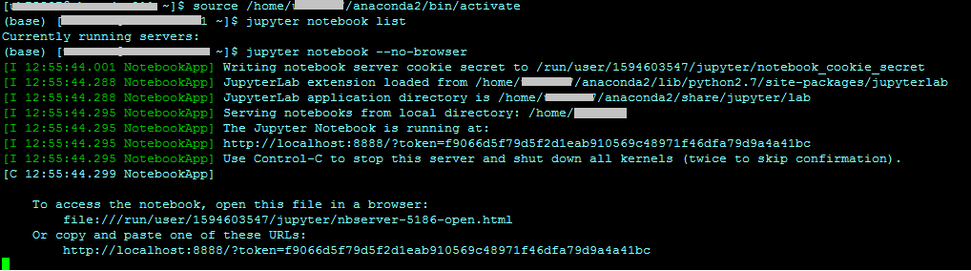

1. In browser type url : (enter token id when asked)

<http://localhost:8000>

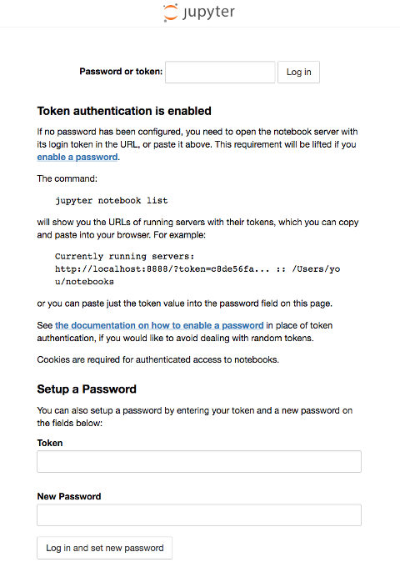

In the **Password or token** field at the top, enter the token shown in the output after you ran jupyter notebook from your server:

**References:**

* **SSH Tunneling** <https://www.digitalocean.com/community/tutorials/how-to-install-run-connect-to-jupyter-notebook-on-remote-server>
* **Encryption (SSL)** <https://sassoftware.github.io/python-swat/encryption.html>