Project Report

Orhan Kocak, Enis Arda Iskender, Kerem Efe Akyurt

2024-01-13

## Research Question

Is there any relation between inflation, unemployment and suicide data over the years?

## Datasets Used

* - [Consumer Price Index](https://data.tuik.gov.tr/Bulten/DownloadIstatistikselTablo?p=VNahkuJlRdjGi186A0UyGFl4/vvuLqcU9WNSamrnmn2BsuZQSCYHsScr/wPRAsfd)
* - [Unemployment Rates](https://data.tuik.gov.tr/Bulten/DownloadIstatistikselTablo?p=8qvM/mN5mN8/qVhH4ZBw5Oevs/TvsYlRCOC2Dg/dcM7k8bk7Eod5aaqpj9EGFPTS)
* - [Yearly Suicide Data](https://data.tuik.gov.tr/Bulten/DownloadIstatistikselTablo?p=9u2oCqacK3ZUqx4qFHbuTulw5EqmeCn1xvvQcrq4mI95KN20YzGH7r0a1Be7Bz1y)
* - [Global Suicide Data](https://apps.who.int/gho/data/node.main.MHSUICIDEASDR?lang=en)
* - [Global Inflation Data](https://data.oecd.org/price/inflation-cpi.htm)
* - [Global Unemployment Rates](https://data.oecd.org/unemp/unemployment-rate.htm)

# Data Views (Cleaned)

## Unemployment Data

## # A tibble: 6 × 3  
## Year Count Percentage  
## <chr> <dbl> <dbl>  
## 1 2014 2853 9.91  
## 2 2015 3057 10.3   
## 3 2016 3330 10.9   
## 4 2017 3454 10.9   
## 5 2018 3537 11.0   
## 6 2019 4469 13.7

## Consumer Price Index

## # A tibble: 6 × 14  
## Year Total January February March April May June July August September  
## <chr> <dbl> <dbl> <dbl> <dbl> <dbl> <dbl> <dbl> <dbl> <dbl> <dbl>  
## 1 2014 2904. 234. 235. 237. 240. 241. 242. 243. 243. 244.  
## 2 2015 3127. 250. 252. 255. 259. 261. 260. 260. 261. 263.  
## 3 2016 3370. 274. 274. 274. 276. 278. 279. 283. 282. 282.  
## 4 2017 3746. 300. 302. 305. 309. 311. 310. 310. 312. 314.  
## 5 2018 4358. 331. 333. 336. 343. 348. 357. 359. 368. 391.  
## 6 2019 5019. 398. 399. 403. 410. 414. 414. 419. 423. 427.  
## # ℹ 3 more variables: October <dbl>, November <dbl>, December <dbl>

## Suicide Data

## # A tibble: 6 × 15  
## Year Sex Total January February March April Mayıs June July August  
## <dbl> <chr> <chr> <chr> <chr> <chr> <chr> <chr> <chr> <chr> <chr>   
## 1 2014 Erkek-Male 2352 188 158 193 210 231 189 194 186   
## 2 2015 Erkek-Male 2358 201 173 203 211 235 198 174 208   
## 3 2016 Erkek-Male 2426 175 196 208 200 231 185 234 219   
## 4 2017 Erkek-Male 2445 204 199 188 212 237 182 228 202   
## 5 2018 Erkek-Male 2529 172 204 205 221 222 215 212 236   
## 6 2019 Erkek-Male 2684 219 191 230 231 223 254 284 225   
## # ℹ 4 more variables: September <chr>, October <chr>, November <chr>,  
## # December <chr>

## Global Inflation Data

## LOCATION TIME Value  
## 1 OECD 2000 4.057151  
## 2 OECD 2001 3.671325  
## 3 OECD 2002 2.781272  
## 4 OECD 2003 2.480571  
## 5 OECD 2004 2.411514  
## 6 OECD 2005 2.644015

## Global Unemployment Data

## LOCATION INDICATOR TIME Value  
## 1 OECD HUR 2005 6.863380  
## 2 OECD HUR 2006 6.353146  
## 3 OECD HUR 2007 5.858194  
## 4 OECD HUR 2008 6.187783  
## 5 OECD HUR 2009 8.313142  
## 6 OECD HUR 2010 8.534647

## Global Suicide Data

## # A tibble: 6 × 3  
## # Groups: year [6]  
## year Sex rate  
## <chr> <chr> <dbl>  
## 1 2000 " Male" 21.0  
## 2 2001 " Male" 20.6  
## 3 2002 " Male" 20.4  
## 4 2003 " Male" 20.0  
## 5 2004 " Male" 19.8  
## 6 2005 " Male" 19.7

# Plots

## Turkey: Suicide - Consumer Price Index

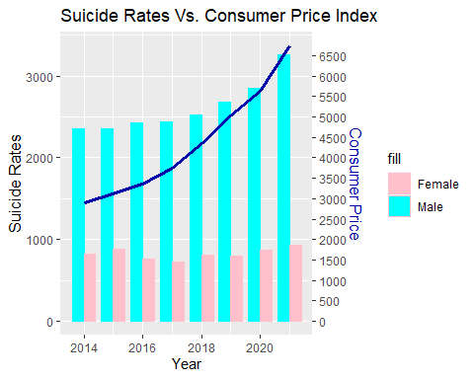

Results show there might be a correlation between consumer prices and suicides, and steadily growing.

## Turkey: Suicide - Unemployment

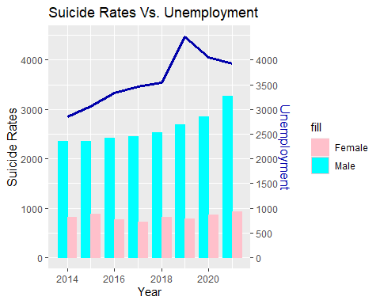

Results show there is no relation between unemployment and suicides.

## World: Suicide - Inflation

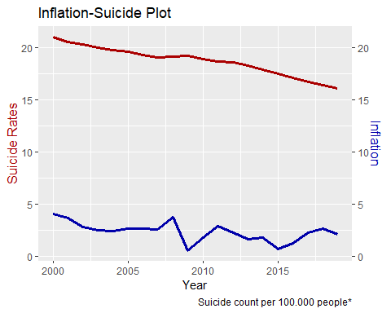

Contrary to Turkey, suicide rates have been going down for about 18 years.

## World: Suicide - Unemployment

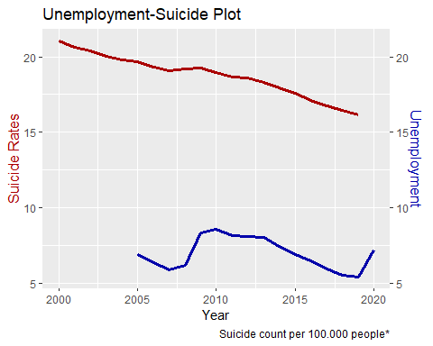

# Conclusion

Turkey’s inflation rates and, maybe with a correlation, suicide rates has been going up aswell. While world took actions to reduce suicides, such as, National Suicide Prevention hotlines, Turkey currently has none. Because of this, the results show suicide numbers could go higher in next years.