**Introduction to Machine Learning (Spring 2019)**

**Homework #4 (50 Pts, May 22)**

**Student ID 2014310279**

**Name 김 승현**

**Instruction:** We provide all codes and datasets in Python. Please write your code to complete Perceptron & MLP. Compress ‘Answer.py’ & your report ONLY and submit with the filename ‘HW2_STUDENT_ID.zip’.

1. **[30 pts]** Implement Perceptron & MLP in ‘Answer.py’.
2. **[Perceptron, 10 pts]** Implement sign function and perceptron in ‘Answer.py’ (‘sign’, ‘Perceptron’).

**Answer: Fill your code here. You also have to submit your code to i-campus.**

*# ============================ Perceptron ==============================*

def sign(z):

sign_z = None

*# =============== EDIT HERE ===============*

sign_z = np.where(z > 0 , 1, -1)

*# =========================================*

*return* sign_z

class Perceptron:

def __init__(self, num_features):

*# NOTE : In this assignment, weight and bias are separated. Be careful.*

*self*.W = np.random.rand(num_features, 1)

*self*.b = np.random.rand(1)

def forward(self, x):

out = None

*if* len(x.shape) < 2:

x = np.expand_dims(x, 0)

*# =============== EDIT HERE ===============*

out = sign(np.dot(x, *self*.W) + *self*.b)

*# =========================================*

*return* out

def stochastic_train(self, x, y, learning_rate):

num_data = x.shape[0]

*while* True:

*# Repeat until quit condition is satisfied.*

quit = True

*for* i in range(num_data):

*# =============== EDIT HERE ===============*

predicted_y = int(*self*.forward(x[i]))

*if*(predicted_y != y[i]):

quit = False

*for* j in range(x.shape[1]):

*self*.W[j] += learning_rate*y[i]*(x[i][j])

*self*.b += learning_rate*y[i]

*# =========================================*

*if* quit:

*break*

def batch_train(self, x, y, learning_rate):

num_data = x.shape[0]

*while* True:

*# gradients of W & b*

dW = np.zeros_like(*self*.W)

db = np.zeros_like(*self*.b)

*# Repeat until quit condition is satisfied.*

quit = True

*for* i in range(num_data):

*# =============== EDIT HERE ===============*

predicted_y = int(*self*.forward(x[i]))

*if*(predicted_y != y[i]):

quit = False

*for* j in range(x.shape[1]):

dW[j] += y[i]*x[i][j]

db += y[i]

*self*.W += learning_rate* dW

*self*.b += learning_rate* db

*# =========================================*

1. **[MLP, 20 pts]** Implement activation functions and MLP layers in ‘Answer.py’ (‘Sigmoid’, ‘ReLU’, ‘Input/Hidden/(Sigmoid, Softmax) Output Layers’).

**Answer: Fill your code here. You also have to submit your code to i-campus.**

*# ====================== MultiLayer Perceptron =========================*

class ReLU:

def __init__(self):

*# 1 (True) if ReLU input < 0*

*self*.zero_mask = None

def forward(self, z):

out = None

*# =============== EDIT HERE ===============*

*self*.zero_mask = (z < 0)

out = z.copy()

out[*self*.zero_mask] = 0

*# =========================================*

*return* out

def backward(self, d_prev):

dz = None

*# =============== EDIT HERE ===============*

d_prev[*self*.zero_mask] = 0

dz = d_prev

*# =========================================*

*return* dz

class Sigmoid:

def __init__(self):

*self*.out = None

def forward(self, z):

*self*.out = None

*# =============== EDIT HERE ===============*

*self*.out = 1 / (1 + np.exp(-z))

*# =========================================*

*return* *self*.out

def backward(self, d_prev):

dz = None

*# =============== EDIT HERE ===============*

dz = d_prev * ( 1.0 - *self*.out) * *self*.out

*# =========================================*

*return* dz

class InputLayer:

def __init__(self, num_features, num_hidden_1, activation):

*# Weights and bias*

*self*.W = np.random.rand(num_features, num_hidden_1)

*self*.b = np.zeros(num_hidden_1)

*# Gradient of Weights and bias*

*self*.dW = None

*self*.db = None

*# Forward input*

*self*.x = None

*# Activation function (Sigmoid or ReLU)*

*self*.act = activation()

def forward(self, x):

*self*.x = None

*self*.out = None

*# =============== EDIT HERE ===============*

*self*.x = x

out = np.dot(*self*.x, *self*.W) + *self*.b

*self*.out = *self*.act.forward(out)

*# =========================================*

*return* *self*.out

def backward(self, d_prev):

*self*.dW = None

*self*.db = None

*# =============== EDIT HERE ===============*

dz = *self*.act.backward(d_prev)

*self*.dW = np.dot(np.transpose(*self*.x), dz)

*self*.db = np.sum(dz, axis=0)

*# =========================================*

class SigmoidOutputLayer:

def __init__(self, num_hidden_2, num_outputs):

*# Weights and bias*

*self*.W = np.random.rand(num_hidden_2, num_outputs)

*self*.b = np.zeros(num_outputs)

*# Gradient of Weights and bias*

*self*.dW = None

*self*.db = None

*# Input (x), label(y), prediction(y_hat)*

*self*.x = None

*self*.y = None

*self*.y_hat = None

*# Loss*

*self*.loss = None

*# Sigmoid function*

*self*.sigmoid = Sigmoid()

def forward(self, x, y):

*self*.y_hat = *self*.predict(x)

*self*.y = y

*self*.x = x

*self*.loss = *self*.binary_ce_loss(*self*.y_hat, *self*.y)

*return* *self*.loss

def binary_ce_loss(self, y_hat, y):

eps = 1e-10

bce_loss = None

*# =============== EDIT HERE ===============*

batch_size = y.shape[0]

cost = -np.sum(y*np.log(y_hat+eps) + (1-y)*np.log(1+eps-y_hat))

bce_loss = cost / batch_size

*# =========================================*

*return* bce_loss

def predict(self, x):

y_hat = None

*# =============== EDIT HERE ===============*

z = np.dot(x, *self*.W) + *self*.b

y_hat = *self*.sigmoid.forward(z)

*# =========================================*

*return* y_hat

def backward(self, d_prev=1):

batch_size = *self*.y.shape[0]

dx = None

*# =============== EDIT HERE ===============*

dy_hat = *self*.y_hat - *self*.y

dz = dy_hat * d_prev

dx = np.dot(dz,(*self*.W).T) / batch_size

*self*.dW = np.dot(np.transpose(*self*.x), dz) / batch_size

*self*.db = np.sum(dz, axis=0) / batch_size

*# =========================================*

*return* dx

class HiddenLayer:

def __init__(self, num_hidden_1, num_hidden_2):

*# Weights and bias*

*self*.W = np.random.rand(num_hidden_1, num_hidden_2)

*self*.b = np.zeros(num_hidden_2)

*# Gradient of Weights and bias*

*self*.dW = None

*self*.db = None

*# ReLU function*

*self*.act = ReLU()

def forward(self, x):

*self*.x = None

*self*.out = None

*# =============== EDIT HERE ===============*

*self*.x = x

*self*.out = np.dot(x, *self*.W) + *self*.b

*self*.out = *self*.act.forward(*self*.out)

*# =========================================*

*return* *self*.out

def backward(self, d_prev):

dx = None

*self*.dW = None

*self*.db = None

*# =============== EDIT HERE ===============*

dz = *self*.act.backward(d_prev)

*self*.dW = np.dot((*self*.x).T, dz)

*self*.db = np.sum(dz, axis=0)

dx = np.dot(dz, (*self*.W).T)

*# =========================================*

*return* dx

class SoftmaxOutputLayer:

def __init__(self, num_hidden_2, num_outputs):

*# Weights and bias*

*self*.W = np.random.rand(num_hidden_2, num_outputs)

*self*.b = np.zeros(num_outputs)

*# Gradient of Weights and bias*

*self*.dW = None

*self*.db = None

*# Input (x), label(y), prediction(y_hat)*

*self*.x = None

*self*.y = None

*self*.y_hat = None

*# Loss*

*self*.loss = None

def forward(self, x, y):

*self*.y_hat = *self*.predict(x)

*self*.y = y

*self*.x = x

*self*.loss = *self*.ce_loss(*self*.y_hat, *self*.y)

*return* *self*.loss

def ce_loss(self, y_hat, y):

eps = 1e-10

ce_loss = None

*# =============== EDIT HERE ===============*

batch_size = y.shape[0]

log_probs = -y * np.log(y_hat + eps)

ce_loss = np.sum(log_probs) / batch_size

*# =========================================*

*return* ce_loss

def predict(self, x):

y_hat = None

*# =============== EDIT HERE ===============*

z = np.dot(x, *self*.W) + *self*.b

y_hat = softmax(z)

*# =========================================*

*return* y_hat

def backward(self, d_prev=1):

batch_size = *self*.y.shape[0]

dx = None

*# =============== EDIT HERE ===============*

dProb = (*self*.y_hat).copy()

dProb[np.arange(batch_size), np.argmax(*self*.y,axis=1)] -= 1

dProb /= batch_size

dz = dProb * d_prev

*self*.dW = np.dot((*self*.x).T, dz)

*self*.db = np.sum(dz, axis=0)

dx = np.dot(dz, (*self*.W).T)

*# =========================================*

*return* dx

*# ======================================================================*

NOTE: You should write your codes in ‘EDIT HERE’ signs. It is not recommended to edit other parts. Once you complete your implementation, run the check codes (‘PLA_Checker.py’, ‘‘MLP_Checker.py’’) to check if it is done correctly.

1. **[20 Pts]** Experiment results
2. **[MLP-1]** Adjust ‘num_epochs’ and ‘learning_rate’ and run ‘MLP_1.py’ to solve XOR problem. Report training accuracy with given code and explain how the MLP solve XOR problem by analyzing values of hidden nodes.

**Answer: Fill your code here. You also have to submit your code to i-campus.**

*# =============== EDIT HERE ===============*

num_epochs = 10000

learning_rate = 1

print_every = 1000

*# =========================================*

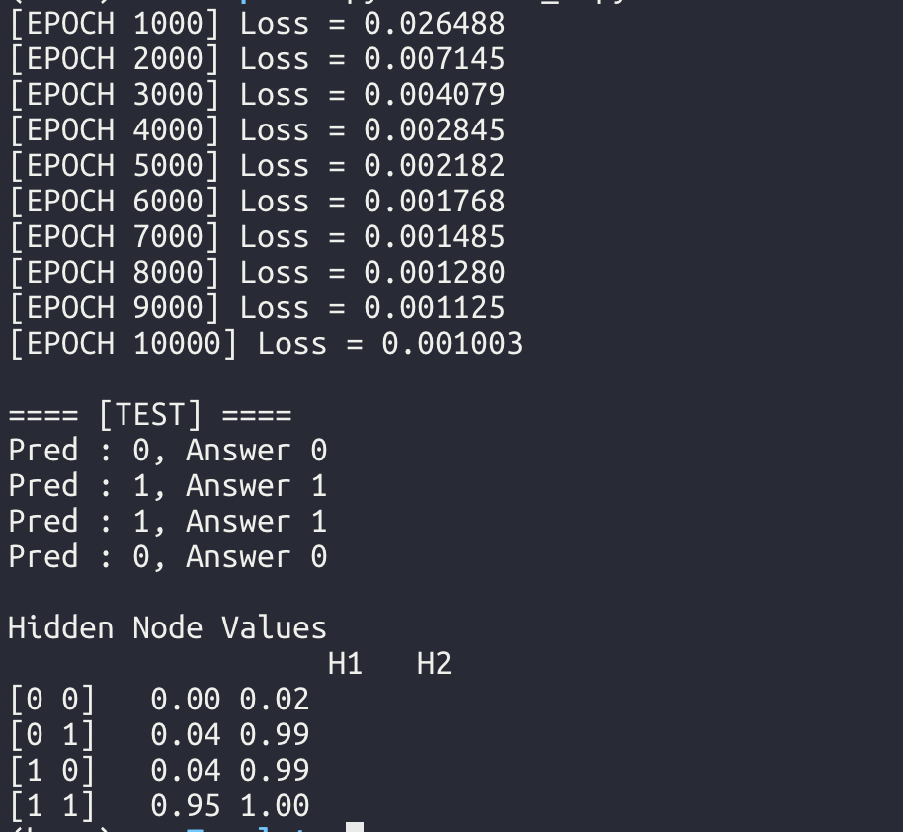

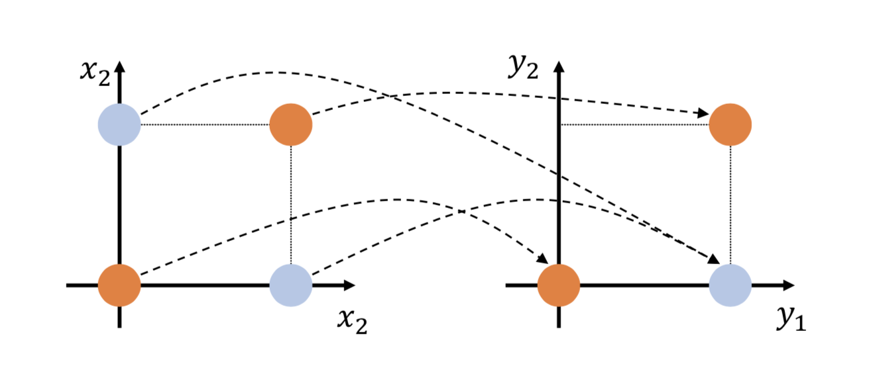

위와 같은 원리로 hidden node에서 input [0, 0] 은 [0, 0] input [0, 1], [1,0] 은 [0,1] input [1, 1] 은 [1, 1] 로 변환하여 초기 input을 linearly seperable 하게 변환한다.

1. **[MLP-2]** Adjust hyperparameters and run ‘MLP_2.py’ on fashion MNIST to get the best results. Report your best results with the hyperparameters. Show the plot of training and test accuracy according to the number of training epochs with the given code and briefly explain the plot. (batch size = 100)

**Answer: Fill the blank in the table. Show the plot of training & test accuracy with a brief explanation.**

|  |  |  |  |  |
| --- | --- | --- | --- | --- |
| **Hidden 1** | **Hidden 2** | **# of epochs** | **Learning rate** | **Acc.** |
| **10** | 10 | 10000 | 0.0004 | 0.836 |

