This is a live centre – the data is not a test.

Login:

[**ceo@saadallahtraining.com**](mailto:ceo@saadallahtraining.com)

DRMO2020

The centre have filled in the form here: <https://qualitas.focusawards.org.uk/add_pop_n.php?page=fqp>

And I can see the admin notification for it:

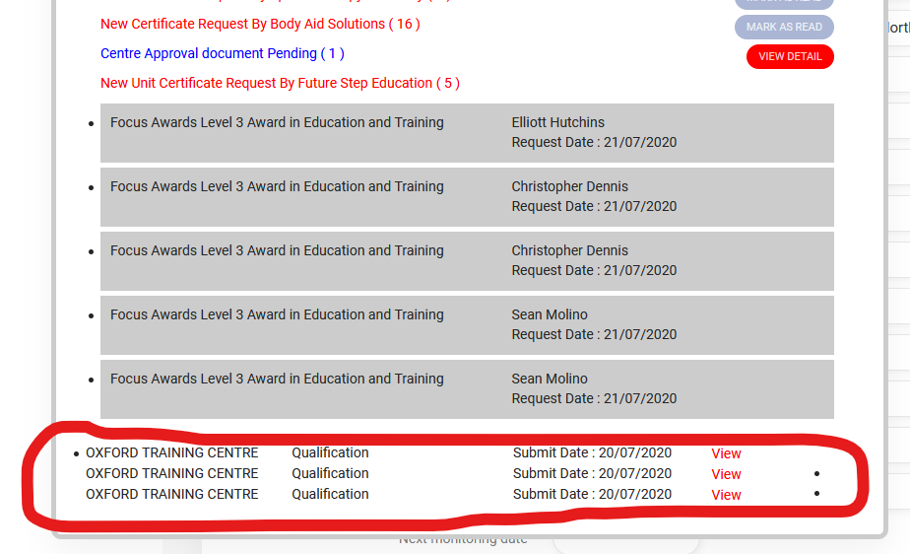

But when I click to view the completed form, I just get this:

<https://qualitas.focusawards.org.uk/super_c_support.php>

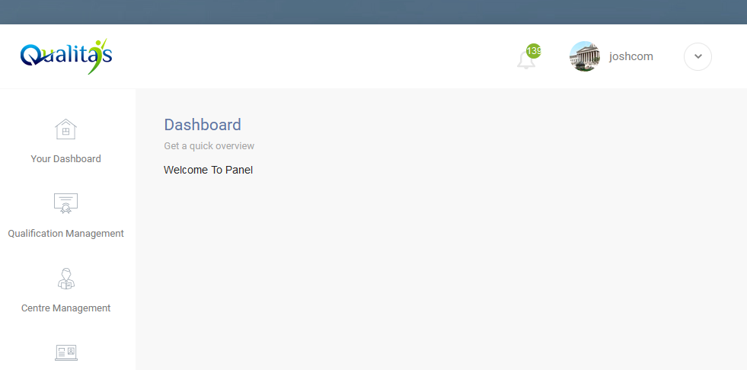

I cannot see the form to be able to approve / deny their request.

This happens on the joshcom / college2565 login.

But if I login as sarah / harvey123 I can see the completed forms here: <https://qualitas.focusawards.org.uk/course_confirm.php?id=6235>

Both the sarah and joshcom logins are admin, so both should be able to see the form.