## Introduction

### Strategic objectives of the infrastructure

Step 1. Verify the business goals and technical requirements. Step 2. Determine the features and functions required to meet the needs identified in Step 1. Step 3. Perform a network-readiness assessment. Step 4. Create a solution and site acceptance test plan. Step 5. Create a project plan.

## Network requirements

There are a few requirements for this small business network. Business goals include ability to sustain a working environment among few small offices and warehouse. Technical requirements include skills needed to work with routers, switches, firewalls, ethernet and coaxial wiring.

Necessary features and functions required to meet the needs will be the ability to expand the network in case of business growth if needed to a wide area network, wireless network and add computers. Other features include client to server access of services, sign on, and resources. The ability to securely contain the networks based on only access as needed is achieved through firewalls.

Lack of internet, wan, and previous wiring leaves a lot of ground work to be made.

### Funding

Funding options can be either a high quality enterprise hardware based or a cheaper alternative of cloud based computing. Wired network will be much cheaper than wireless(sacrificing only mobility). The client server model is much more expensive to setup then peer to peer networks, however the gain from expansion and central organization of data is invaluable. Also peer to peer networks end up with performance and security. The cost of small-enterprise level network capabilities is about 4600 dollars.

### Reliability Performance(Bandwidth)

Businesses need 100Mbps per 1,000 users or 100Kbps per user. 100Mbs is the standard for category 5 cable which is the most common.

### Availability

Availability: A network designed for availability is one that delivers consistent, reliable performance, 24 hours a day, 7 days a week. In addition, the failure of a single link or piece of equipment should not significantly impact network performance.

### Scalability

Scalable network designs can grow to include new user groups and remote sites and can support new applications without impacting the level of service delivered to existing users

#### Wifi

Wifi expansion will allow easier access of resources through portable devices and bring-to-work computers.

#### Internet

Allows full use of the power of cloud computing and virtual networks and virtual connections. Costs can be cut dramatically by moving all servers to the cloud. Virtual connections allow employees to work from anywhere.

### Security

Security: Security is a feature that must be designed into the network, not added on after the network is complete. Planning the location of security devices, filters, and firewall features is critical to safeguarding network resources. Infrastructure and Architecture overview

## Network Diagram

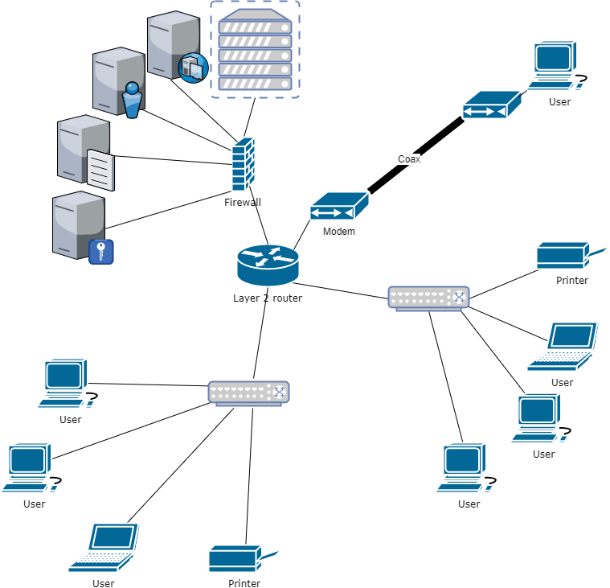

### Benefits

In networking, a hierarchical design is used to group devices into multiple networks. The hierarchical design model has three basic layers: Core layer: Connects distribution layer devices. Distribution layer: Interconnects the smaller local networks. Access layer: Provides connectivity for network hosts and end devices

The benefits of this **hierarchal network design** using router allows multiple separate networks to be created. By organizing in a layered approach a core layer connects smaller local networks. Access layer’s intermediary frame: provides connectivity for network hosts and end devices.

In a **Client-server network**, all computers are connected to a central server that acts as the hub of you business’ data. Applications and files are a available on the server and everyone can use these resources at anytime, provided they are authorized to access the information.

The main difference between the two is that P2P network relies on information provided by the clients (users) and it could have other issues such as limited performance and security, and can only carry a small number of users.

Although client-server networks are a little bit pricier, it allows for faster processes, more RAM and storage space, all which plays an important part in ensuring the efficiency of your organization.

### Enterprise Physical Facility

The main distribution frame should contain the main router, security system and servers. Management of cables include proper connections and labeling, decreased airflow, controlled temperature, and cable management equipment.

## Hardware Details and Configuration

### All hardware needed

|  |  |  |  |  |
| --- | --- | --- | --- | --- |
| **Network hardware** | **quantity** | **Cost($)** |  | **Reason** |
| Cisco 880 Series Integrated Services Routers | 1 | 400 | 400 | capabable of wan lan wlan and various security settings |
| Cisco 250 Series Smart Switches SG250-26 | 2 | 250 | 500 | business-class switch |
| ASA 5506-X with FirePOWER Services | 1 | 600 | 600 | optional extra protection allows finer control of access control lists and more security incase of internet operablility |
| Synology DiskStation 4-Bay (Diskless) Network Attached Storage DS412+ | 1 | 500 | 500 | file storage server |
| HP ProLiant MicroServer Gen8 Ultra Micro Tower Server (783958S01) | 1 | 700 | 700 | application server |
| D-Link DCM 301 - Cable modem - Gigabit Ethernet - 340 Mbps | 1 | 50 | 50 | change coax back to ethernet for long distance |
| TPA-311 (Version v1.0R) Mid-Band | 1 | 50 | 50 | ethernet to coax |
| HP Officejet Pro 8600 Plus | 2 | 200 | 400 | office printing |
| Wyse Technology 902175-05L-ES | 20 | 70 | 1400 | thin clients which have just enough computing to access servers |

### IP configuration (DHCP)

Manually assigning IP addresses to a network is time consuming as you need to record which address you have used and which computer that you have assigned it to. This is suitable for a one-room computer room as you can quickly check which addresses are available. For a large or widespread network, you should automatically assign IP addresses using DHCP. This assigns dynamic IP addresses to each computer when they ask for one when starting up from a set range allocated by the administrator. DHCP should be enabled on router

### Virtualization

Virtualization Many separate logical servers can be located on one physical server. The physical server uses an operating system specifically designed to support multiple virtual images. This feature is known as virtualization. This technology reduces the cost of providing redundant services, load balancing, and failover for critical network services

## Wiring

Wired LANs use Ethernet cables and network adapters. Ethernet cables must be run from each computer to another computer or to the central device. It can be time-consuming and difficult to run cables under the floor or through walls, especially when computers sit in different rooms.

Wired LANs need ethernet cables and network adapters. When connecting devices of the same type (ie computer to computer) a cross over cable is needed however for the current design only straight through cables are needed. It can be time-consuming and difficult to run cables under the floor or through walls, especially when computers sit in different rooms but it would be much for faster than ethernet over power line.

Some newer buildings are pre-wired with CAT5 cable, greatly simplifying the cabling process and minimizing unsightly cable runs.

The correct cabling configuration for a wired LAN varies depending on the mix of devices, However, none of these options pose any more difficulty than, for example, wiring a home theater system.

Wired LANs offer superior performance. Traditional Ethernet connections offer only 10 Mbps bandwidth, but 100 Mbps Fast Ethernet technology costs little more and is readily available. Although 100 Mbps represents a theoretical maximum performance never really achieved in practice.

Wired LANs utilizing hubs can suffer performance slowdown if computers heavily utilize the network simultaneously. Use Ethernet switches instead of hubs to avoid this problem; a switch costs little more than a hub.

## Servers

Creating a server farm results in the following benefits: Network traffic enters and leaves the server farm at a defined point. This arrangement makes it easier to secure, filter, and prioritize traffic. Redundant, high-capacity links can be installed to the servers and between the server farm network and the main LAN. This configuration is more cost-effective than attempting to provide a similar level of connectivity to servers distributed throughout the network. Load balancing and failover can be provided between servers and between networking devices. The number of high-capacity switches and security devices is reduced, helping to lower the cost of providing services.

**File server** - Stores network users' data files

**Print server** - Manages the printers that are connected to the network and the printing of user documents on the network printers

**Application server** - Shares network-enabled versions of common application software and eliminates the need for software to be installed on each workstation

**Database server** - Manages common databases for the network, handling all data storage, database management and requests for data

**Domain server** - Authenticates and authorises computers and users to access resources within the logical domain

## Security

This should also be factored in to your small business networking service, and it all boils down to how secure you need your network to be. As mentioned before, a client-server network would be a better business IT solution because it provides a high level of security. A client-server set-up also allows you to limit access level to certain users only such as top level management.

Identify risk areas and mitigation strategies

### Business continuity

Preventing Failures The network designer must strive to provide a network that is resistant to failures and that can recover quickly in the event of a failure. Core routers and switches can contain the following:

#### UPS

Larger enterprises often install generators and large uninterruptible power supply (UPS) devices. These devices prevent minor power outages from causing large-scale network failures.

#### Firewalls

Hardware-based firewalls protect all the computers on your network. A hardware-based firewall is easier to maintain and administer than individual software firewalls.

The ideal solution for small businesses is a hardware firewall integrated into a comprehensive security solution. In addition to a firewall, the solution should include virtual private network (VPN) support, antivirus, antispam, antispyware, content filtering, and other security technologies.

## Maintenance

Document updating infrastructure and change management procedures. Many network failures are the result of poorly planned, untested updates or additions of new equipment. Never make a configuration change on a production network without first testing it in a lab environment.

Manageability: No matter how good the initial network design is, the available network staff must be able to manage and support the network. A network that is too complex or difficult to maintain cannot function effectively and efficiently.

## Implementation

Plan a phased approach to implementation. Introduce the computer room core switches first, providing connectivity to the servers. Depending on the size of the company and business process needs, it might be possible to immediately follow this activity on the same day by implementing the new access layer switches. Schedule wide area connectivity following the introduction of the core switches in the computer room, selecting a time that does not conflict with the access layer installation. Coordinate wide area connectivity with the telecommunication vendor providing this portion of the network service.

Inform all employees of the scope of implementation for each phase, along with dates and times. Implementation of new equipment generally means systems and data will not be available at the time of the change. This gives employees the opportunity to plan their work around the resulting downtime. Pre-configure network equipment and test it prior to implementation. Schedule the personnel and support needed from among IT department staff members and any vendor staff that must support the implementation