Founder Sourcing & Portfolio Intelligence Platform
Technical Architecture, Data Logic & Cost Analysis | May 2026
Current hosting: https://aviral-droid.github.io/vc-sourcing-agent/

1 Overview
A fully automated, AI-powered sourcing platform that identifies high-quality founders across India and Southeast Asia by continuously scanning the web, processing signals through a Groq LLM enrichment pipeline, and surfacing ranked candidates into a live dashboard. Seven source types run in parallel daily — news feeds, semantic web search (including LinkedIn), product launch trackers, developer activity, research publications, community forums, and 30+ curated Substack newsletters. The entire system runs on GitHub with zero hosting or backend server cost: GitHub Actions executes the pipeline at 8am IST, results are stored in a single data.json file, and the frontend is served via GitHub Pages.
2 Signal Sources & Data Logic
Source | Type | What It Captures | Status
Google News RSS | News feed | Funding announcements, executive departures, product launches from 50+ publications | Active (free)
Exa Neural Search | Semantic web | LinkedIn posts, Substack articles, Twitter/X threads, forum discussions, industry blogs | Active (free tier)
Product Hunt RSS | Product feed | New product launches — Groq filters for India/SEA maker origin | Active (free)
GitHub Trending | Dev activity | Engineers building in public; India/SEA-maintained repos gaining stars | Active (free)
arXiv / HuggingFace | Research feeds | Deep tech founders publishing research before commercialising (cs.AI, cs.LG) | Active (free)
Reddit communities | Community signals | r/indianstartups, r/MachineLearning, r/IndiaInvestments — stealth builders posting | Active (free)
30+ Substack newsletters | Curated intel | Ben's Bites, Import AI, Sajith Pai, Not Boring, The Generalist, Prarambh, Entrackr | Active (free)

3 How LinkedIn Is Currently Used (Without the Official API)
LinkedIn data is accessed via Exa's neural search engine, which indexes public LinkedIn profile pages and posts without requiring LinkedIn's official API. The pipeline runs targeted keyword queries through Exa with a site:linkedin.com/in domain filter, surfacing founder profiles and activity:
Exa Query Pattern | What It Finds
site:linkedin.com/in "ex-Swiggy" OR "ex-Zepto" OR "ex-Razorpay" | Former unicorn executives building independently
site:linkedin.com/in "ex-Grab" OR "ex-Gojek" OR "ex-Sea Group" | Southeast Asia operator alumni going independent
site:linkedin.com/in "VP" OR "Director" "stealth" India | Senior India executives in stealth-mode ventures
site:x.com "leaving to build" OR "building in stealth" India 2025 | Twitter/X announcements of founders going independent
site:zaubacorp.com OR site:tofler.in new company registration | India MCA registrations — new company director filings
Each Exa result returns the URL, page title, and a text snippet. The LLM then extracts the person's name and validates India/SEA relevance. This approach captures publicly available signal with no API cost. Adding the LinkedIn Research API ($299/mo, Phase 3) would improve freshness and depth but the discovery logic remains unchanged.

4 Pipeline Scoring Logic
All sources run in parallel (ThreadPoolExecutor, 4 workers), collecting 200–400 raw person-signals per day. These are batched to Groq Llama 3 70B which extracts names, rejects fund/org names, and geo-tags India/SEA signals — cutting noise by ~70%. Each surviving signal is scored:
Signal Type | Score | Rationale
Funding announcement | 30 pts | Direct evidence of validated traction; founder is raising or has raised
Executive departure | 18 pts | Strong leading indicator — exec leaving to build independently
Product launch (PH/GH) | 10 pts | Confirmed shipping; builder with public traction
LinkedIn / Substack post | 8 pts | Weaker signal but confirms active building in public
India/SEA geo bonus | +8 pts | Confirmed regional relevance; applies to all signal types
Threshold to surface | > 30 | Only candidates clearing this score appear in the founder feed

5 VC Intelligence Module — Active Market & News Feed
Alongside founder sourcing, a parallel VC Intelligence module aggregates market-level signals across three thematic feeds, refreshed daily. This gives the team a curated briefing on sectors they invest in — sourced from 30+ RSS/Atom feeds, Substack newsletters, Reddit, and Exa neural search across the full web (LinkedIn, Twitter, forums, industry blogs).
Feed | Sources | What It Covers
AI / ML Trends | TechCrunch, VentureBeat, Ben's Bites,  Import AI, The Batch, arXiv, HuggingFace,  r/LocalLLaMA, Every.to | Foundation model releases, AI startup fundraises, new tooling, enterprise deployment — 150+ articles/run
India / SEA Market | Inc42, YourStory, Entrackr, e27, KrASIA,  DealStreetAsia, Sajith Pai, Prarambh,  r/indianstartups, r/IndiaInvestments | Seed/pre-seed rounds, operator alumni moves, B2B SaaS launches, regulatory news across India and SEA
Emerging Tech | Wired, IEEE Spectrum, Not Boring,  The Generalist, r/startups, r/Futurology,  Climate tech blogs | Deep tech, climate/cleantech, defence dual-use, biotech, robotics — frontier sectors before mainstream coverage
Sector Heatmap | Computed from all feeds above | Keyword-frequency heat map across 9 sectors (Fintech, AI, SaaS, Health, Edtech, Logistics, Climate, Consumer, Deep Tech) showing which sectors are generating most signal each week
Consumer & Demand Pulse | India/SEA articles + Exa queries | Demand-side signals: consumer behaviour shifts, D2C brand momentum, market expansion news relevant to portfolio themes

6 Portfolio Companies Under Active Monitoring
Each portfolio company has a dedicated monitoring profile combining Google News RSS with 3 targeted Exa neural searches: company name directly, sector/industry context, and key competitive market signals. Up to 15 articles per company are stored per run, tagged by company name and surfaced in the Portfolio Intelligence tab.
Company | Sector | Exa Search Coverage
Distil | Specialty Chemicals | Direct company news + specialty chemicals / green chemistry / advanced materials startup India
Sanlayan | Defence Electronics | Direct + defence tech electronics / Make in India / dual-use systems startup news
Escape Plan | Travel / Lifestyle | Direct + experiential travel / lifestyle experiences booking startup India 2025
NirogStreet | Ayurveda Healthtech | Direct + ayurveda digital health / alternative medicine platform India startup funding
Enerzolve | Energy / Cleantech | Direct + energy storage / battery tech / renewable energy startup India 2025
GetRight | B2B Platform | Direct + B2B SaaS / platform startup India product launch funding 2025
Coto | Community / Women | Direct + women community platform / creator economy social startup India
Dat Bike | EV Motorbikes (Vietnam) | Direct + electric motorbike / EV two-wheeler / Vietnam Southeast Asia startup funding
Prosperr | Tax Fintech | Direct + tax compliance / SME accounting fintech India startup 2025

7 Full Pipeline Architecture Diagram
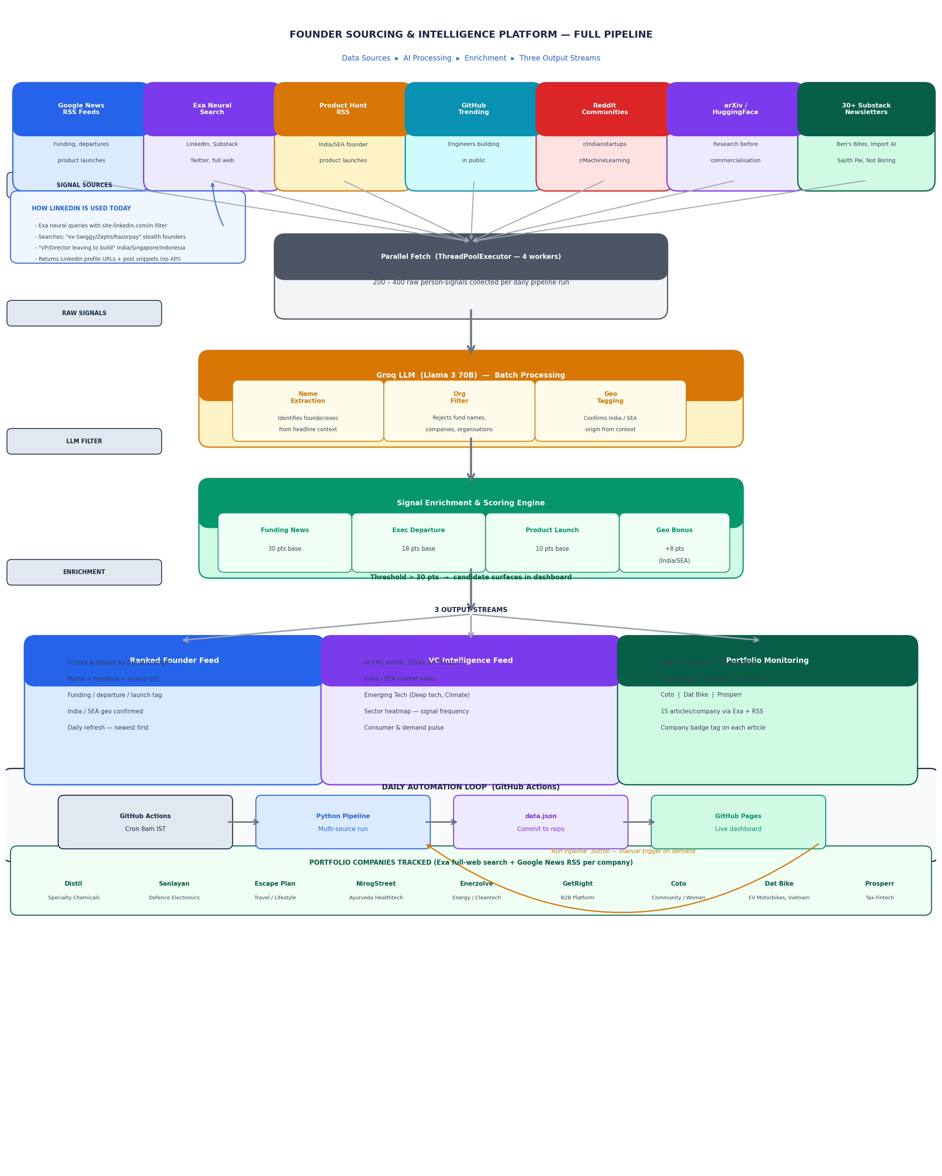

8 Current Cost — Free Tier Stack
The entire platform currently operates at zero cost on free-tier services:
Tool | Provider | Plan | Monthly | Annual
Groq LLM | Groq | Free tier (rate-limited RPM, Llama 3 70B) | $0 | $0
Exa Search | Exa.ai | Free tier (1,000 searches/mo) | $0 | $0
GitHub Actions | GitHub | Free (2,000 min/mo on public repo) | $0 | $0
GitHub Pages | GitHub | Free (public repo, static hosting) | $0 | $0
RSS / Reddit | Various | All public feeds — no authentication | $0 | $0
TOTAL |  |  | $0 | $0

9 Cost to Scale — Premium API Stack (Crunchbase excluded)
To lift rate limits, add real-time LinkedIn monitoring, and access verified funding data, the projected annual spend is as follows (Crunchbase excluded per team preference):
API | Provider | What It Adds | Unit Price | Est. Usage | Annual
LinkedIn API | LinkedIn / RapidAPI | Real-time profile scraping, post & job-change monitoring | $299/mo | Full | $3,588
Twitter / X API | X Corp | Tweet search, thread tracking, account-level monitoring | $100/mo | 500K tweets/mo | $1,200
Exa.ai Pro | Exa.ai | 10,000 searches/mo; full-text article retrieval | $50/mo | ~8,000/mo | $600
Groq API (paid) | Groq | No rate limits; higher RPM; priority queue | ~$30/mo | ~2M tokens/mo | $360
Tracxn / VI | Tracxn | India/SEA deal flow, company profiles, sector reports | $199/mo | Monitoring | $2,388
Apollo.io (Can skip) | Apollo | Verified founder email/phone for outreach | $99/mo | Outreach | $1,188
MCA / Tofler | Tofler | India company registrations, director lookup, RoC filings | $50/mo | 500 queries/mo | $600
TOTAL |  |  |  |  | ~$9,924
(Can consider replacing GROQ API with Claude API, but still need Groq for social media / X scans)

