**Human Emotion Recognizer**

A Project Report submitted in partial fulfilment of the

requirements for the award of the degree of

BACHELOR OF TECHNOLOGY

in

COMPUTER SCIENCE AND ENGINEERING

with IBM specialization in IT Infrastructure

Submitted by

Amit Kumar (Enroll No. R111216009)

Ankit Khandelwal (Enroll. No. R111216013)

Aviral Khandelwal (Enroll. No. R111216018)

Mayank Choudhary (Enroll. No. R111216033)

Under the guidance of

Mrs. Bhavana Kaushik

(Assistant Professor)

SoCSE



**SCHOOL OF COMPUTER SCIENCE**

UNIVERSITY OF PETROLEUM & ENERGY STUDIES

Bidholi Campus, Energy Acres, Dehradun – 248007.

**Aug-Dec(2019)**

**DECLARATION**

I hereby declare that this submission is my own and that, to the best of my knowledge and belief, it contains no material previously published or written by another person nor material which has been accepted for the award of any other Degree or Diploma of the University or other Institute of Higher learning, except where due acknowledgement has been made in the text.

Amit Kumar (Enroll No. R111216009)-

Ankit Khandelwal (Enroll. No. R111216013)-

Aviral Khandelwal (Enroll. No. R111216018)-

Mayank Choudhary (Enroll. No. R111216033)-

**CERTIFICATE**

This is to certify that the project titled **Human Emotion Recognizer** submitted by Amit Kumar (Enroll No. R111216009),Ankit Khandelwal (Enroll. No. R111216013)**,**Aviral Khandelwal (Enroll. No. R111216018) & Mayank Choudhary (Enroll. No. R111216033)to the University of Petroleum & Energy Studies, for the award of the degree of BACHELOR OF TECHNOLOGY in COMPUTER SCIENCE AND ENGINEERING is a Bonafede record of project work carried out by them under my supervision and guidance. The content of the project, in full or parts have not been submitted to any other Institute or University for the award of any other degree or diploma.

Date: __________________

**Project Guide HOD**

**Mrs. Bhavana Kaushik Dr. Neelu Jhyoti Ahuja**

**(Assistant Professor)**  **(Dept. of Systemics)**

**ACKNOWLEDGEMENT**

We wish to express our deep gratitude to our guide, for all advice **Mrs. Bhavana Kaushik**,

encouragement and constant support she has given us through out our project work. This

work would not have been possible without her support and valuable suggestions.

We sincerely thank to our respected Program Head of the Department, **Dr. Neelu Jyoti**

**Ahuja**, for his great support in doing our project in Area (like Network, Big data etc.) at

SoCS.

We are also grateful to **Dr. Manish Prateek, Director of CoES, UPES** for giving us the

necessary facilities to carry out our project work successfully.

We would like to thank all our friends for their help and constructive criticism during our

project work. Finally we have no words to express our sincere gratitude to our parents who

have shown us this world and for every support they have given us.

Amit Kumar (Enroll No. R111216009)

Ankit Khandelwal (Enroll. No. R111216013)

Aviral Khandelwal (Enroll. No. R111216018)

Mayank Choudhary (Enroll. No. R111216033)

**ABSTRACT**

Human emotion recognition is an emerging field which use in many nowadays application including social robots, neuromarketing and games. Non-verbal communication methods like facial expressions, eye movement and gestures are used in many applications of human computer interaction, which among them facial emotion is widely used because it conveys the emotional states and feelings of persons. The emotion recognition is not an easy task because there is no landmark distinction between the emotions on the face and also there are a lot of complexity and variability. In the traditional machine learning algorithm, some important extracted features used for modeling the face, so, it cannot achieve high accuracy rate for recognition of emotion because the features are hand-engineered and depend on prior knowledge. Convolutional neural networks (CNN) have developed in this work for recognition facial emotion expression and classify them into seven basic categories.

The aim of the project is to recognize the facial emotion expression and classify them into seven basic categories- Happy, Sad, Angry, Surprise, Neutral, Disgusted and Fearful using Deep Convolutional neutral network (CNN). The system achieved 63.77% accuracy and 0.64 precision on testing dataset.

**Keywords:** Emotion Recognition, Neural Network, Deep Learning

**TABLE OF CONTENTS**

|  |  |  |  |
| --- | --- | --- | --- |
| DECLARATION | | | ii |
| CERTIFICATE | |  | iii |
| ACKNOWLEDGEMENTS | | | iv |
| ABSTRACT | |  | v |
|  | INTRODUCTION | | 1 |
|  | OBJECTIVE | | 2 |
|  | SEQUENCE DIAGRAM | | 3 |
|  | USE CASE DIAGRAM | | 4 |
|  | LITERATURE REVIEW | | 5 |
|  | METHODOLOGY | | 6 |
|  | SYSTEM REQUIREMENTS | | 7 |
| SCHEDULE | |  | 8 |
| SCREENSHOT | |  | 9 |
| REFERENCES | |  | 10 |
|  |
|  |
|  |
|  |

**INTRODUCTION**

Ever since computers were developed, scientists and engineers thought of artiﬁcially intelligent systems that that are mentally and/or physically equivalent to humans. In the past decades, the increase of generally available computational power provided a helping hand for developing fast learning machines, whereas the internet supplied an enormous amount of data for training. These two developments boosted the research on smart self-learning systems, with neural networks among the most promising techniques. One of the current top applications of artiﬁcial intelligence using neural networks is the recognition of faces in photos and videos. An even more advanced development in this ﬁeld is emotion recognition. In addition to only identifying faces, the computer uses the arrangement and shape of e.g. eyebrows and lips to determine the facial expression and hence the emotion of a person. One possible application for this lies in the area of surveillance and behavioral analysis by law enforcement.

The most promising applications involve the humanization of artiﬁcial intelligent systems. If computers are able to keep track of the mental state of the user, robots can react upon this and behave appropriately. Emotion recognition therefore plays a key-role in improving human-machine interaction. In this Project, we’re using deep convolutional neural network (CNN) and datasets to recognize the facial emotion expression and classify them into seven basic categories- Happy, Sad, Angry, Surprise, Neutral, Disgusted and Fearful. The system achieved 56.77% accuracy and 0.57 precision on testing dataset. In this Project, we mainly focus on neural network based artiﬁcially intelligent systems capable of deriving the emotion of a person through pictures of his or her face.

**OBJECTIVES**

The purpose of proposed work is to recognize the facial emotion expression and classify them into seven basic categories- Happy, Sad, Angry, Surprise, Neutral, Disgusted and Fearful.

**Sub Objectives: ​**

**I.** Make an efficient program to successfully trained the datasets.

**II**. To recognize emotions from human facial expressions by using live webcam feed in the system.

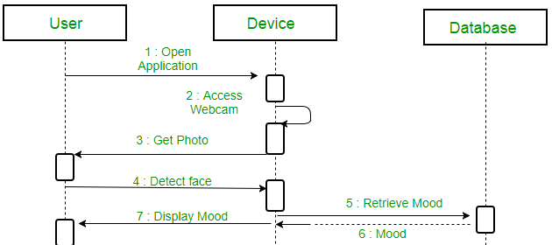

Fig. 1

Sequence Diagram

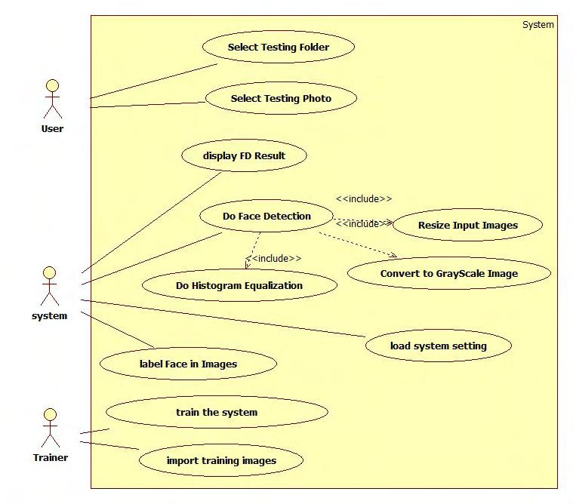

Fig. no. 2

Use Case Diagram

**LITERATURE REVIEW**

Ekman & Friesen (1971) [1], they declared that facial behaviors are universally associated with particular emotions. Apparently, humans, but also animals, develop similar muscular movements belonging to a certain mental state, despite their place of birth, race, education, etcetera. Hence, if properly modelled, this universality can be a very convenient feature in human machine interaction: a well-trained system can understand emotions, independent of who the subject is.

Krizhevsky and Hinton [2], their work shows a deep neural network that resembles the functionality of the human visual cortex. Using a self-developed labelled collection of 60000 images over 10 classes, called the CIFAR-10 dataset, a model to categorize objects from pictures is obtained. Another important outcome of the research is the visualization of the ﬁlters in the network, such that it can be assessed how the model breaks down the pictures.

Raghuvanshi A. et al [3], He built a Facial expression recognition system upon recent research to classify images of human faces into discrete emotion categories using convolutional neural networks.

Cohn and Kanade [4], they later on tried geometrical modeling and tracking of facial features by claiming that each AU is presented with a specific set of facial muscles. The disadvantages of this method are the contours of these features and components have to be adjusted manually in this frame, the problems of robustness and difficulties come out in cases of pose and illumination changes while the tracking is applied on images, as actions & expressions tend to change both in morphological and in dynamical senses, it becomes hard to estimate general parameters for movement and displacement. Therefore, ending up with robust decisions for facial actions under these varying conditions becomes to be difficult.

**METHODOLOGY**

Deep CNN, based Human Emotion Recognition consists of three steps:

1.Import a dataset which consists of 35887 grayscale, 48x48 sized face images with seven emotions- angry, disgusted, fearful, happy, neutral, sad and surprised.

2.Train and test the dataset in given way.

2.1 Import TensorFlow-GPU, tflearn, numpy, keras and openCV-python packages in the program.

2.2 During training, the system received a training data from dataset comprising grayscale images

of faces with their respective expression label.

2.3 The training step took as input an image with a face from live webcam feed in the system

and learns a set of weights for the network.

2.4 Thereafter, an intensity normalization is applied to the image. The normalized images are used

to train the Convolutional Network.

2.5 To ensure that the training performance is not affected by the order of presentation of the

examples, validation dataset is used to choose the final best set of weights out of a set of trainings

performed with samples presented in different orders.

2.6 During test, the system received a grayscale image of a face from test dataset, and output the

predicted expression by using the final network weights learned during training.

3. The output will be the display of recognized emotion from the human facial expression on the live webcam feed in the system.

**SYSTEM REQUIREMENTS**

**Software Requirements:**

|  |  |  |
| --- | --- | --- |
| • | Programming Language | : Python |
| • | Operating System | : Windows |
| • | Editor | : PyCharm |

**Hardware Requirements:**

|  |  |  |
| --- | --- | --- |
| • | Processor | : 6Gen Core i5 |
| • | Hard Disk | : Minimum 200 MB |
| • | RAM | : 8 GB |

**SCHEDULE**

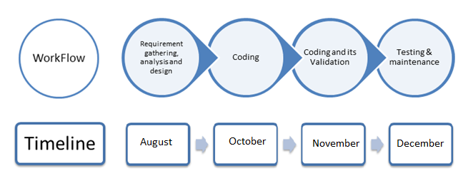

Fig:3

**SCREENSHOTS**

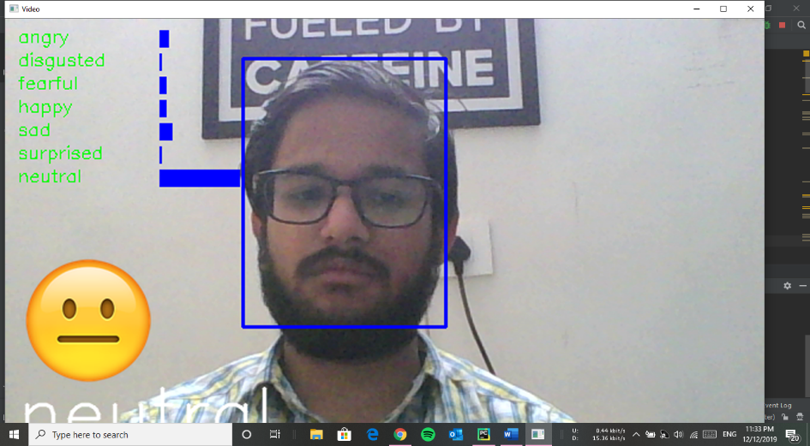

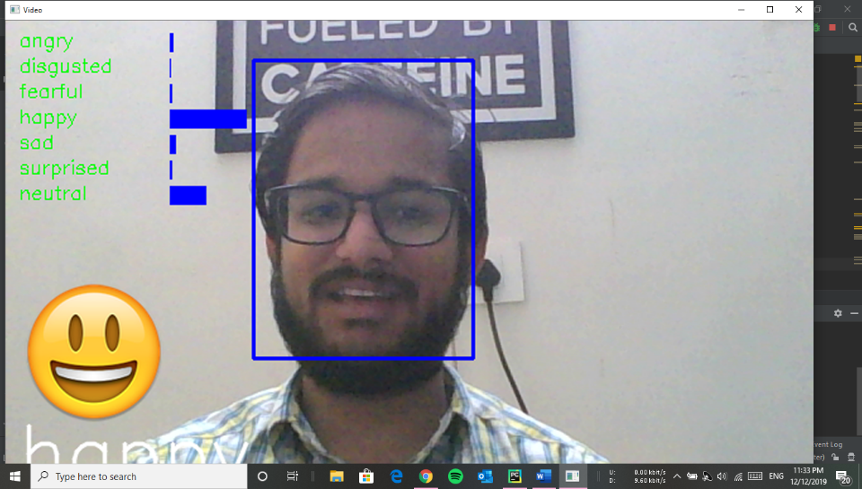

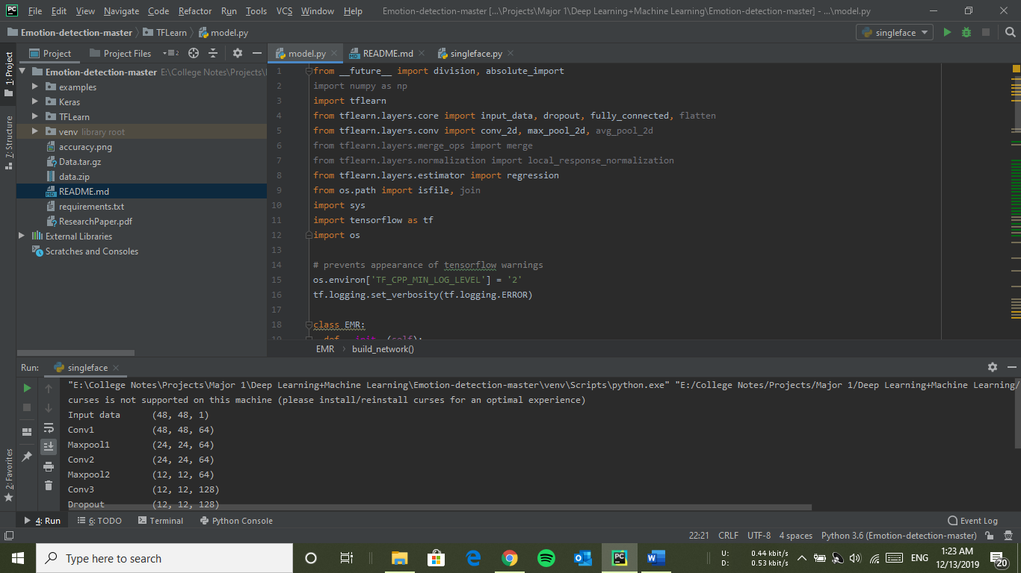

**REFERENCES**

[1] T. Ahsan, T. Jabid, and U.-P. Chong. Facial expression recognition using local transitional pattern on gabor ﬁltered facial images. IETE Technical Review, 30(1):47–52, 2013.

[2] D. Ciresan, U. Meier, and J. Schmidhuber. Multi-column deep neural networks for image classiﬁcation. In Computer Vision and Pattern Recognition (CVPR), 2012 IEEE Conference on, pages 3642–3649. IEEE, 2012.

[3] C. R. Darwin. The expression of the emotions in man and animals. John Murray, London, 1872.

[4] J. Deng, W. Dong, R. Socher, L.-J. Li, K. Li, and L. Fei-Fei. Imagenet: A large-scale hierarchical image database. In Computer Vision and Pattern Recognition, 2009. CVPR 2009. IEEE Conference on, pages 248–255. IEEE, 2009.

[5] P. Ekman and W. V. Friesen. Constants across cultures in the face and emotion. Journal of personality and social psychology, 17(2):124, 1971.

[6] B. Fasel and J. Luettin. Automatic facial expression analysis: a survey. Pattern recognition, 36(1):259–275, 2003.

[7] TFlearn. Tﬂearn: Deep learning library featuring a higher-level api for tensorﬂow. URL http://tflearn.org/.