

Aviral Rajput

A00258751

Assignment Report

Telephone Directory Implementation using hash table

# Abstract

The objective of this project was to develop a Telephone Directory in java. The purpose of implementing this application was to create a system to index the telephone directory with name and number and search through it. Directory implements The Learning of Hash Table and implementing the learning of design patterns.

The application was successfully implemented by using Java programming languages. This application does not aim to target any specific domain but any individual who wants to seek help building small telephone directory and iterate and search through it.

# Introduction

Telephone Directory System aims to create a platform where the user can access the system add telephone and name. The aim of this project is to create a platform where user can efficiently keep the telephone records.

# Scope

The scope of the project is limited to telephone entities for now focusing on name and associated number where it could be extended to have more information about an individual.

# Limitations and Future Implementation

The biggest limitation being on usage and access, where the usage is limited to single functionality and access is restricted to single user.

# Features

* Use Hash Table To Insert And Search Data.
* Iterator To Show Data
* Inheritance
* Efficient Memory Management to Release the Resources When Required.

# Code Snippets

### Insert in Hash table

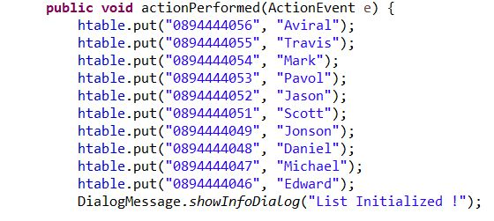

### Iterator HashTable

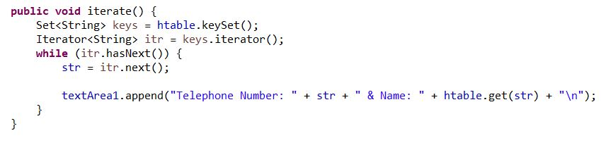

### Search from Hash table

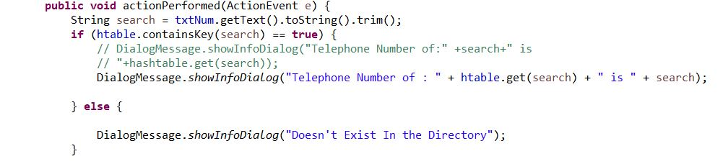

### Aggregation in Appointment Class

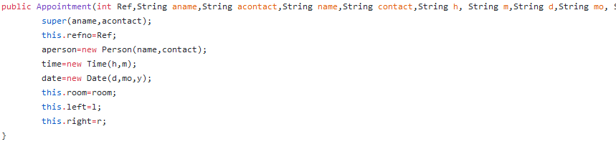

# Screenshots

### Welcome Screen



## Initialize List Onclick()

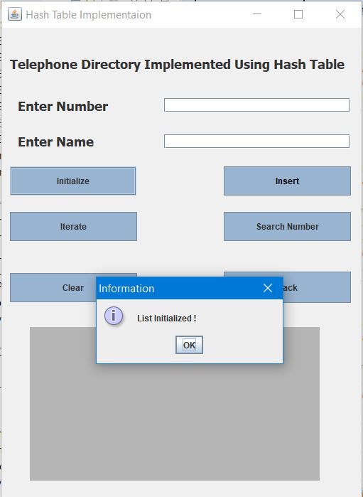

## Find Onclick

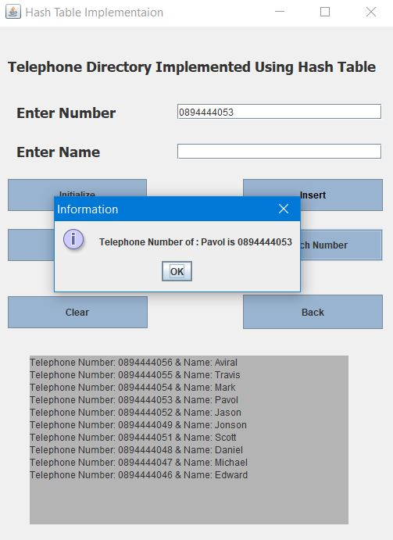

# Performance

Cost of search and insert Hash Table.

Ideally every time complexity should be *0(1)* according to the code.  
*But,*

*0(1)* is achieved only when load-factor is less than 1.  
Worst Case is always *(n)* where we need to look at every entry.

# Conclusion

A- Simple Telephone Directory created by using Hash table as data structures, values are iterated using hash table, also object oriented concept are kept in mind as seen in the features.