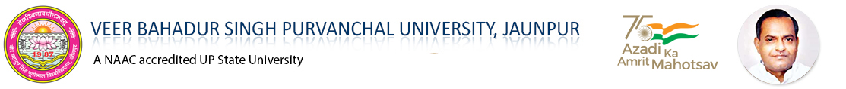

PRACTICAL FILE

ON

**SESSION: (2022-23)**

**SUBMITTEDTO**:- **SUBMITTEDBY**:-

Mr. PC Yadav ----------------------

Branch: - (E.C.E)

4th Year, 7thSem

Roll No-

|  |  |  |
| --- | --- | --- |
| **INDEX** | | |
| **S.No.** | **Object** | **Signature** |
| 1. | Introduction to MATLAB and Image Processing Toolbox. |  |
| 2. | MATLAB Program for to learn basic operations on Image |  |
| 3. | MATLAB Program for Geometric Transformation |  |
| 4. | MATLAB Program for Image Enhancing using Histogram Equalization |  |
| 5. | MATLAB Program to perform smoothing or averaging filter using spatial domain. |  |
| 6. | MATLAB Program to perform smoothing or averaging filter using frequency domain. |  |
| 7. | MATLAB Program for Image Restoration |  |
| 8. | MATLAB Program for Sharpening of image using gradient mask |  |
| 9. | MATLAB Program to performing morphological operations on image |  |
| 10. | MATLAB Program to fill the region of interest of image |  |
| 11. | MATLAB Program for edge detection of an image |  |
| 12. | MATLAB Program for DCT Based image compression |  |