**EXPERIMENT-1**

**Object:** Introduction to MATLAB & to study Image Processing Toolbox

**Software/Hardware used:**

* MATLAB 9.0 R2016a
* Personal Computer (64 bits)

**Introduction to MATLAB**: MATLAB (matrix laboratory) is a fourth-generation high-level programming language and interactive environment for numerical computation. visualization and programming.

After logging into your account, you can enter MATLAB by double-clicking on the MATLAB shortcut icon (MATLAB 7.8.0) on your Windows desktop: When you start MATLAB, a special window called the MATLAB desktop appears. The desktop is a window that contains other windows. The major tools within or accessible from the desktop are:

* Command Window
* Command History
* Editor Window
* Workspace
* Current Directory
* Help Browser

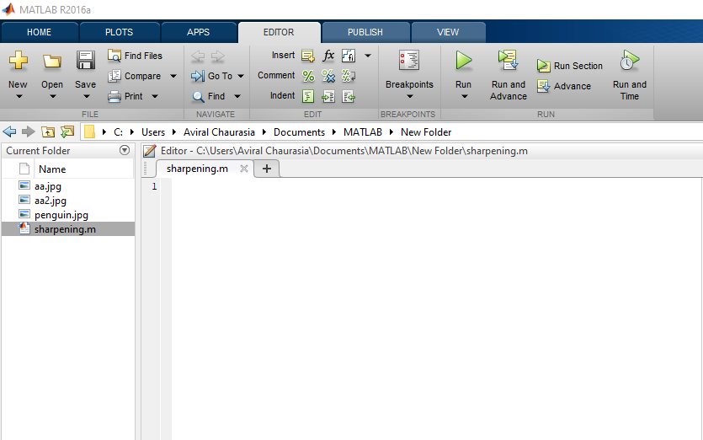

**FIGURE 1: EDITOR WINDOW**

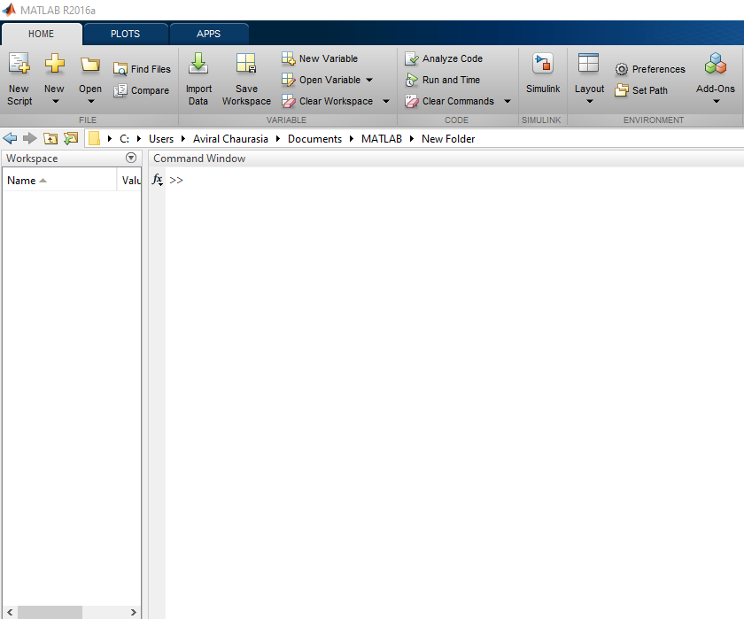

**FIGURE 2: COMMAND WINDOW**

MATLAB is widely used as a computational tool in science and engineering encompassing the fields of physics, chemistry, math and all engineering streams. It is used in a range of applications including-

* Signal Processing and Communications
* Image and Video Processing
* Control Systems
* Test and Measurement
* Computational Finance
* Computational Biology

**Steps to MATLAB program:**

1. Start the MATLAB program.

2. Open new M-file

3. Type the program

4. Save in current directory

5. Compile and Run the program

6. If any error occurs in the program correct the error and run it again

7. For the output see command window Figure window

8. Stop the program.

**Image Processing Toolbox**

(Perform image processing, visualization, and analysis)

Image Processing Toolbox™ provides a comprehensive set of reference-standard algorithms and workflow apps for image processing, analysis, visualization, and algorithm development. You can perform image segmentation, image enhancement, noise reduction, geometric transformations, and image registration using deep learning and traditional image processing techniques. The toolbox supports processing of 2D, 3D, and arbitrarily large images.

Image Processing Toolbox apps let you automate common image processing workflows. You can interactively segment image data, compare 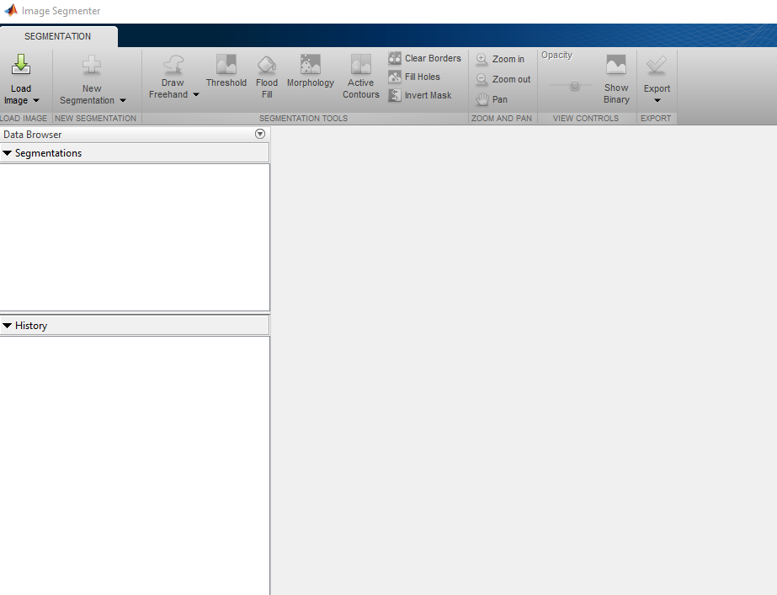

data se **Figure 2: Image Processing Toolbox: Image Segmentation** interest (ROIs).

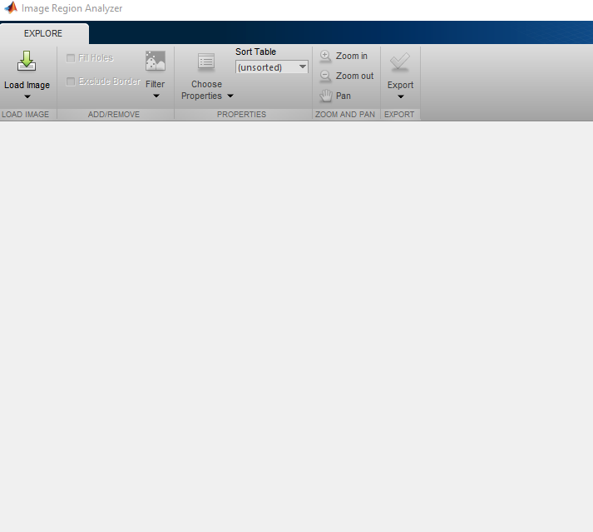

**Figure 3: Image Region Analyser**

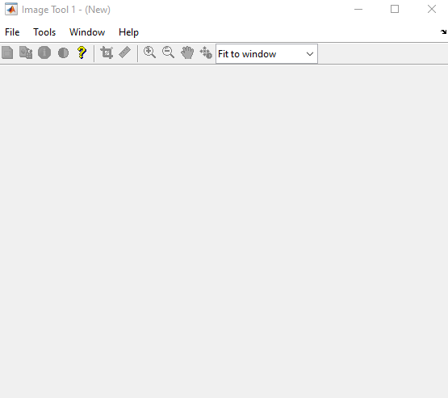

**Figure 4: Image Tool**

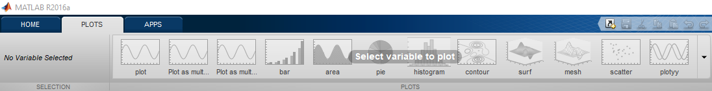

**Representation of Image**

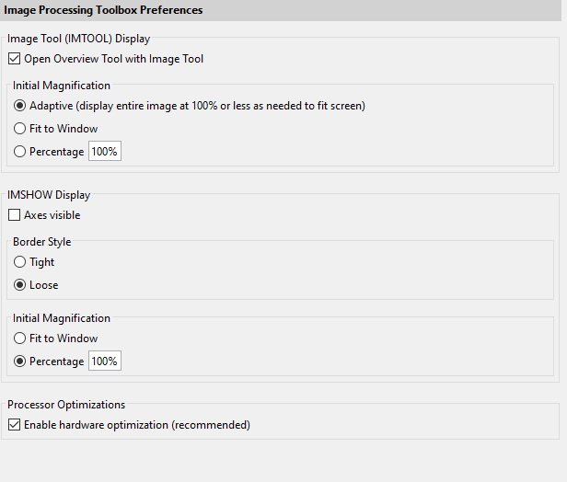

**Image Processing Toolbox: TOOLS**

