

Data Science Intern

Task 1 Report

By Aviral Soni

# Task 1

Derive at least 5 business insights from the EDA.

Write these insights in short point-wise sentences (maximum 100 words per

insight).

Ans:

BUSSINESS INSIGHTS:

1. Top 10 products

Top products contribute significantly to sales.

Insights:

1. Activewear Smart watch and Soundwave Headphones are leading the sales.
2. Top 3 products are from electronics and décor category.
3. These products contribute to sales significantly.

Recommendations:

1)Ensure that the availability of the top selling products is 24*7.

2)Optimize marketing, focus on high demand products.

3)Offer combo deals for complementary items to increase sales revenue.

TOP CATEGORIES:

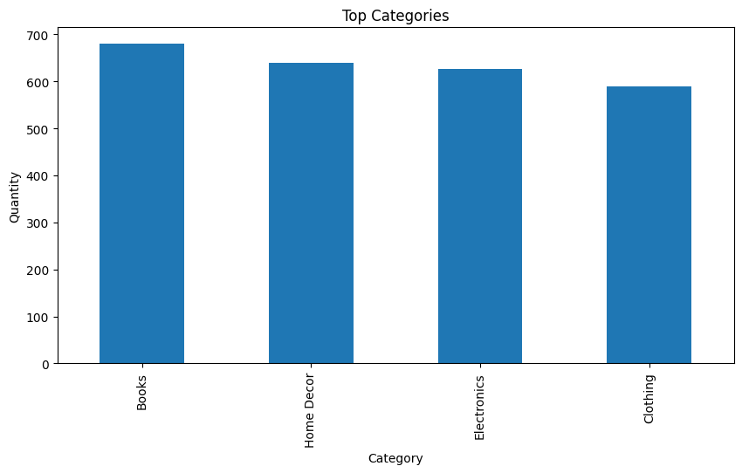

Insights:

1)Books and Home decor are top selling categories.

2) Sales differ by season and region.

Recommendations:

1. Boost high selling categories with targeted promotions on social media.
2. Introduce personal recommendations based on past purchases.
3. Use seasonal promotions to boost sales. Ex: Mega Republic Day sales, Diwali sales etc.
4. Reach out to social media influencers of respective categories to promote underperforming products.

Insights:

1. There was a strong start in Jan. It was likely due to New Year promotions.
2. There is sudden spike in sales in Month of Jan, May, Jul and Dec. It makes them critical months for company.

Recommendations:

1. Analyze peak seasons and increase the stock availability before high-demand periods.
2. Run seasonal promotions.
3. Sun off seasonal promotions of products whose demands are for season.
4. Optimize advertising spending based on historical trends.

Insights:

1. South America’s sales are significantly higher than Europe. It shows that SA has a strong customer base or effective marketing.
2. Europe and North America are not far behind SA. This shows that there is some potential of growth by using better strategies.

Recommendations:

1. Expand operation in high performing regions by offering localized promotions.
2. Improve marketing strategies by focusing on local culture and needs.
3. Offer localized payment options to support in unserved areas.

Insights:

1. A small percentage of customers contribute to a large portion of sales.
2. Some customers buy less and spend more and vice versa.

Recommendations:

1. Create loyalty programs by giving loyal customers early access to new launches and give them exclusive discounts.