An Internship Report
Of
WEB DEVELOPMENT

Submitted
To
School of Computer Science and Engineering
IILM University, Greater Noida, U.P.
In partial fulfilment of the requirement of degree of
B.Tech (Computer Science & Engineering with AIML)
By
Name of Student: AVIRAL TRIPATHI
Roll Number of Student: 25SCS1003004212
Batch: 2025-2029

CANDIDATE'S DECLARATION
I, AVIRAL TRIPATHI, do hereby declare that the internship report titled “Web Development” has been completed by me to fulfil the requirement for the award of the degree of Bachelor of Technology in Computer Science and Engineering with AIML. All the references have been quoted and I have not taken as such any material from any other source. I affirm that this report is my own and has not been submitted to any other institute for any degree/diploma requirement, and further I shall be solely responsible for any kind of copyright violation in this regard.
Signature: _______________________
Student Name: AVIRAL TRIPATHI
Roll No.: 25SCS1003004212

ACKNOWLEDGEMENT
I am using this opportunity to express my gratitude to everyone who supported me throughout the Internship Program. I am thankful for their aspiring guidance, invaluably constructive criticism and friendly advice during this work. I am sincerely grateful to them for sharing their truthful and illuminating views on a number of issues related to this work.
I would like to thank the Codec Technologies team and Dr. Anurag Shrivastava (Program Manager / Talent Acquisition Manager) for providing me the opportunity and the structured platform to learn and gain hands-on exposure in the domain of Web Development. I am also thankful to my institute, IILM University, Greater Noida, and the faculty of the School of Computer Science and Engineering for their continuous support and encouragement.
I express my gratitude to my parents for their blessings.
Signature: _______________________
Student Name: AVIRAL TRIPATHI
Roll No.: 25SCS1003004212

TABLE OF CONTENTS

1. Candidate's Declaration ................................................ i
2. Acknowledgement ........................................................ ii
3. Internship Completion Certificate & Offer Letter ....................... iii
4. Project Description .................................................... 1
4.1 Introduction .................................................... 1
4.2 Organization Profile ............................................ 2
4.3 Problem Statement ............................................... 3
4.4 Project Objectives .............................................. 3
4.5 Scope of the Project ............................................ 4
4.6 Technologies and Tools Used ..................................... 4
4.7 System Architecture ............................................. 5
4.8 Methodology & Project Showcase .................................. 6
4.9 Expected Outcomes ............................................... 7
4.10 Certificates of Completion and Communication Proof .............. 8
5. Bibliography/References ................................................ 9

3. INTERNSHIP COMPLETION CERTIFICATE
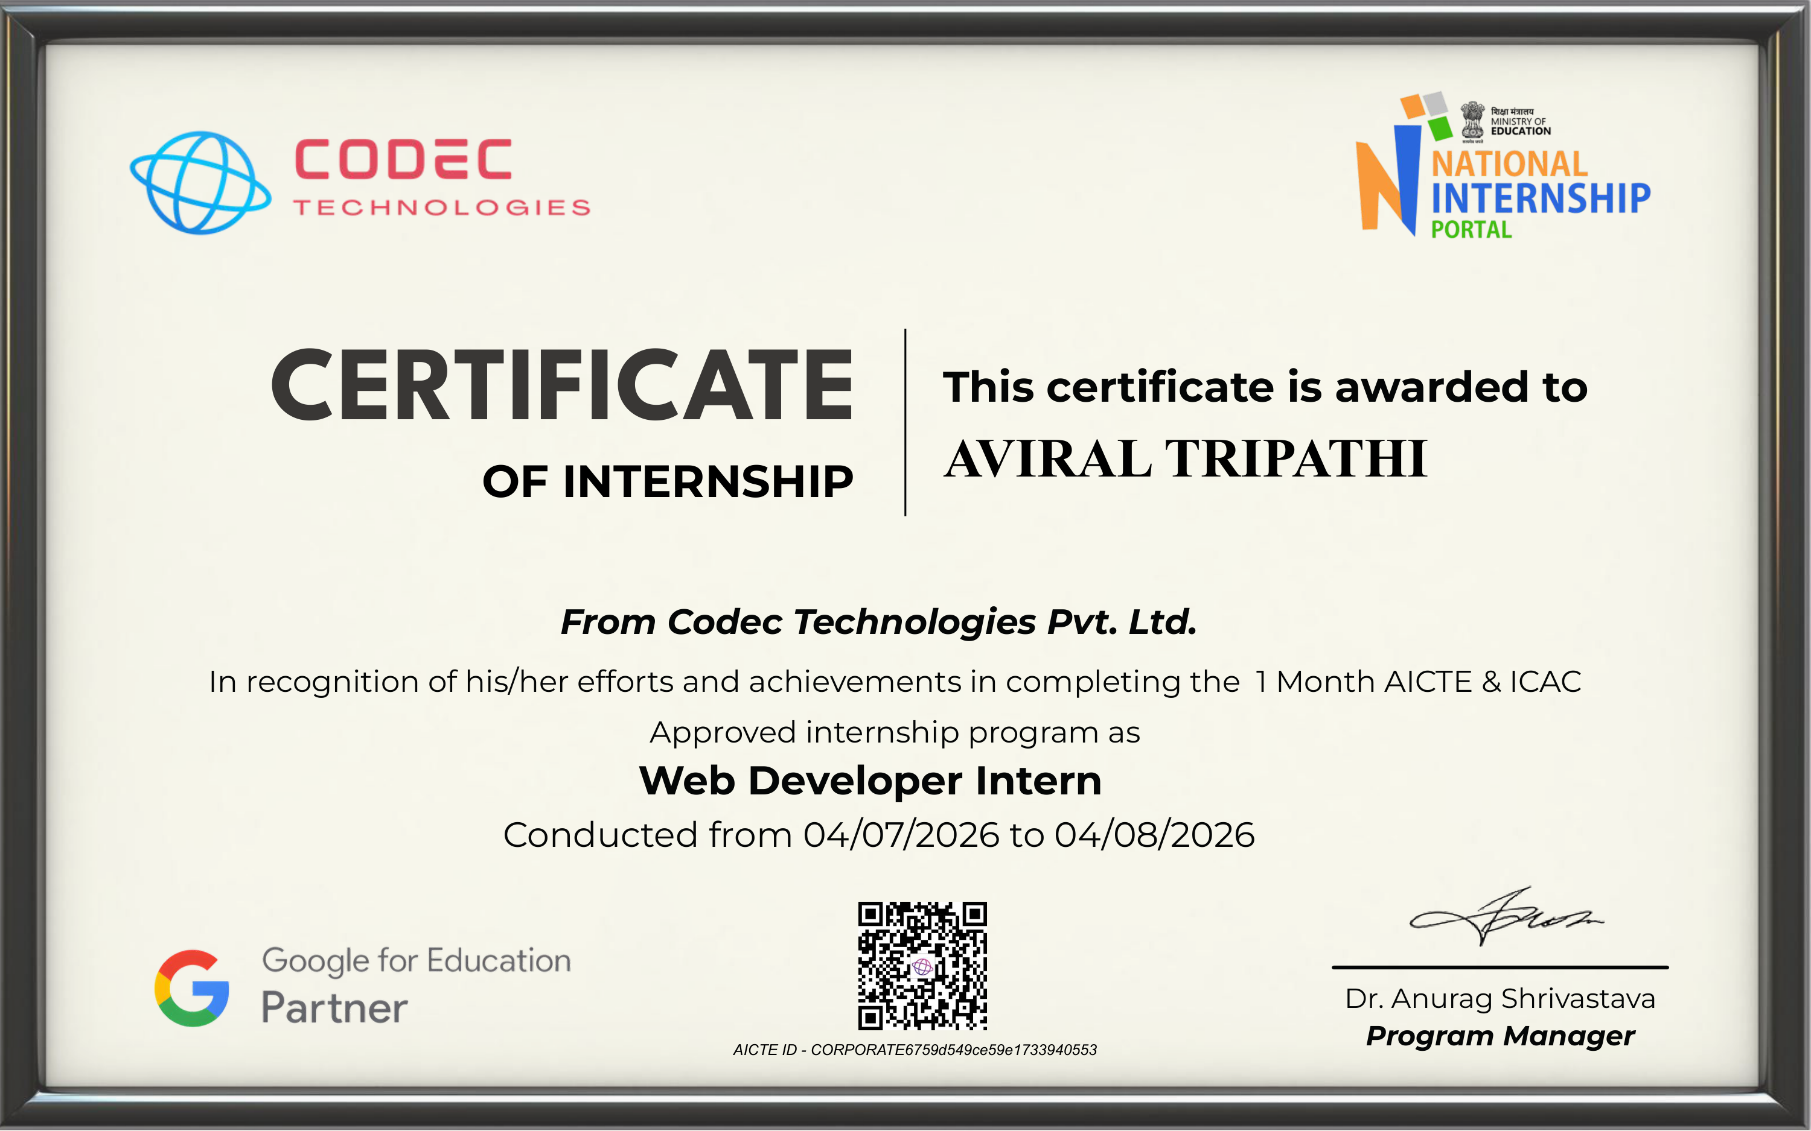
Internship Offer Letter
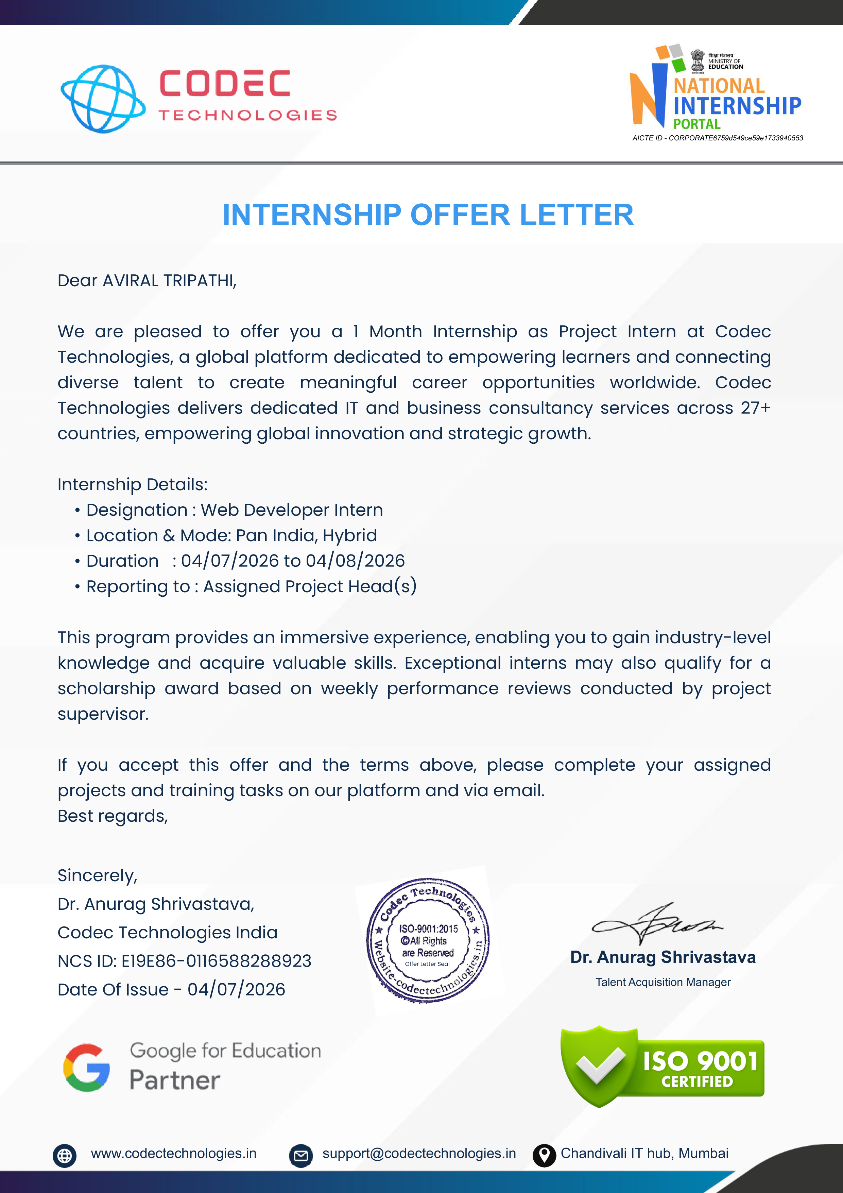

4. PROJECT DESCRIPTION
4.1 Introduction
This report presents a comprehensive account of the 1-Month Virtual Internship undertaken at Codec Technologies in the specialization domain of “Web Development”. The internship was carried out from 04/07/2026 to 04/08/2026 as part of the academic requirement for the Bachelor of Technology (Computer Science & Engineering with AIML) degree programme at IILM University, Greater Noida.
The primary objective of this internship was to bridge the gap between theoretical knowledge of computer science and full-stack web application engineering integrated with data-driven predictive modeling. During the tenure, the intern worked on modern web development technologies (HTML5, CSS3, JavaScript, Python, FastAPI, and Streamlit) to create dynamic web applications, build responsive user interfaces, and deploy predictive analytics modules including a Stock Price Predictor Web Application and a Customer Churn Prediction Web Dashboard.
4.2 Organization Profile
Codec Technologies (Codec Technologies Pvt. Ltd.) is a global technology platform dedicated to empowering learners, building industry-aligned IT solutions, and connecting talent to create impactful career opportunities worldwide. Operating across 27+ countries, Codec Technologies delivers dedicated IT consultancy, web development, cloud software engineering, and business intelligence services.
Key organizational details include:
• Corporate AICTE ID: CORPORATE6759d549ce59e1733940553
• NCS Registration ID: E19E86-0116588288923
• Headquarters / Hub: Chandivali IT Hub, Mumbai, India
• Leadership & Supervision: Dr. Anurag Shrivastava (Program Manager / Talent Acquisition Manager)
4.3 Problem Statement
In modern software engineering, web applications are no longer static displays of text and images. Modern web portals require dynamic data processing, responsive user interfaces, real-world API connectivity, and embedded machine learning logic to provide actionable insights to end users. However, engineering students frequently face challenges in integrating data analysis models with usable web frontends and backend REST APIs. This internship addressed this problem by guiding the development of production-grade web applications that combine full-stack web technologies with machine learning models for stock market forecasting and telecom customer retention.
4.4 Project Objectives
• To master modern web development principles, responsive UI layout design, and frontend-backend architecture.
• To build RESTful backend web APIs using Python and FastAPI for fast asynchronous data processing.
• To engineer interactive web dashboards using Streamlit and Plotly for real-time data visualization.
• To develop Project 1 (Stock Price Predictor): Build regression models (Linear Regression & Random Forest) to forecast stock returns based on daily OHLCV market data and technical indicators.
• To develop Project 2 (Customer Churn Prediction Dashboard): Build classification models (Logistic Regression & Random Forest) to flag at-risk telecom customers and visualize churn drivers.
• To integrate machine learning models seamlessly into user-friendly web interfaces for non-technical stakeholders.
• To apply version control, modular code practices, and web project documentation standards.
4.5 Scope of the Project
The scope of this internship covered the complete lifecycle of modern data-driven web application development. This included data ingestion, feature engineering, predictive model training, REST API design with FastAPI, and web interface creation using Streamlit and HTML/CSS elements. The internship was completed under the mentorship of Codec Technologies, Mumbai.
4.6 Technologies and Tools Used
• Web Languages & Frontend: HTML5, CSS3, JavaScript, Streamlit, Gradio Web UI
• Backend Frameworks & APIs: Python 3.10+, FastAPI (Async REST Endpoints), Uvicorn
• Machine Learning & Data: Pandas, NumPy, Scikit-Learn (Linear Regression, Random Forest, Logistic Regression)
• Data Visualization: Plotly, Matplotlib, Seaborn, Chart.js
• Development Tools: VS Code, Git, GitHub, Virtual Environments
4.7 System Architecture
The web application system architecture developed during the internship consists of four modular layers:
• Frontend UI Layer: Built using Streamlit and HTML/CSS controls, providing interactive sliders, chart selectors, and input forms for end users.
• Backend API Layer: FastAPI web framework providing asynchronous endpoints to receive payload data, handle validation, and return JSON prediction results.
• Predictive Engine Layer: Trained Scikit-Learn machine learning pipelines (Stock Regressor and Churn Classifier) executing real-time inference.
• Data & Pipeline Layer: Pandas and NumPy routines performing automated data cleaning, moving average calculations, categorical encoding, and feature scaling.
4.8 Methodology & Project Showcase
The internship comprised two main applied web development projects showcase:
Project 1: Stock Price Predictor Web Application
This project involved building a web application to forecast next-day stock closing prices using historical OHLCV (Open-High-Low-Close-Volume) market data. The dataset spanned 1,258 trading days (~5 years). Technical indicators including 7-day Moving Average (MA-7), 30-day Moving Average (MA-30), rolling volatility, and lagged returns were engineered. Both Linear Regression and Random Forest Regressor models were trained on a chronological 80/20 train-test split. The models achieved an R² score of ~0.98 and Mean Absolute Percentage Error (MAPE) under 2%. The web interface allows users to select date ranges, inspect MA crossovers, and view predicted price trajectories.
Project 2: Customer Churn Prediction Web Dashboard
This project focused on developing an interactive customer retention dashboard for telecom service providers. Utilizing a dataset of 2,000 customer records (demographics, contract types, tenure, and billing details), binary classification models (Logistic Regression baseline and Random Forest) were built. The Random Forest classifier achieved 73.5% accuracy and an ROC-AUC of 0.78. Key churn drivers identified included month-to-month contracts, low tenure, and high monthly charges. The web dashboard enables retention managers to filter high-risk accounts and analyze targeted offer strategies.
Project Name | Primary Web / ML Tech | Key Features / Metrics | Web UI / Output
Project 1: Stock Price Predictor | Python, FastAPI, Streamlit, Scikit-Learn | 1,258 trading days; MA-7, MA-30; R² ≈ 0.98, MAPE < 2% | Interactive Plotly price chart & forecast panel
Project 2: Customer Churn Dashboard | Python, HTML/CSS, Logistic Reg, Random Forest | 2,000 subscriber records; 73.5% Accuracy, 0.78 ROC-AUC | Retention manager dashboard & churn drivers plot
API Layer Integration | FastAPI, Uvicorn, REST JSON endpoints | Async payload handling, request validation | Live API documentation (/docs)
Web Application Deployment | Streamlit Cloud / Local Web Server | Responsive multi-page layout, interactive widgets | Accessible browser-based web application
4.9 Expected Outcomes
• Ability to build responsive, dynamic web applications with interactive frontends and modular python backends.
• Practical understanding of API development using FastAPI for serving machine learning models.
• Demonstrated competence in technical data analysis, feature engineering, regression, and classification modeling.
• Experience in designing customer-facing retention dashboards and financial market visualization portals.
• Successful completion of 1-Month Web Development Internship certified by Codec Technologies.
4.10 Certificates of Completion and Communication Proof
The official Internship Offer Letter and Internship Completion Certificate issued by Codec Technologies India (AICTE Corporate ID: CORPORATE6759d549ce59e1733940553), confirming successful completion of the Web Development Internship Program from 04/07/2026 to 04/08/2026, are attached in Chapter 3 of this report.
5. BIBLIOGRAPHY/REFERENCES
1. Codec Technologies, “Internship Offer Letter – Web Developer Intern,” Ref Date: July 4, 2026, Corporate AICTE ID: CORPORATE6759d549ce59e1733940553, NCS ID: E19E86-0116588288923.
2. Codec Technologies, “Certificate of Internship – Web Developer Intern,” Awarded to Aviral Tripathi for internship completed from 04/07/2026 to 04/08/2026.
3. FastAPI Official Documentation, https://fastapi.tiangolo.com/
4. Streamlit Official Documentation, https://docs.streamlit.io/
5. Scikit-Learn User Guide: Machine Learning in Python, https://scikit-learn.org/
6. Plotly Interactive Graphing Libraries for Python and Web, https://plotly.com/python/
7. MDN Web Docs: HTML, CSS, and JavaScript Web Standards, https://developer.mozilla.org/

