Iam – IDENTITY MANAGEMENT APPLICATION

FUNDAMENTAL PROJECT



AVIRAL WALIA

ME(Exchange)-2018

Table of Contents

1 Description 2

2 Technical specifications 3

2.1 Major Features 3

2.2 Application Feasibility 4

2.3 Data Description 4

2.4 Global Schema 4

2.5 Expected Results 4

2.6 Scope of the Application (Limits, Evolutions) 4

3 User Guide 5

3.1 User Login 5

3.2 Menu 6

3.3 Create New User 6

3.4 Modify User Record 7

3.5 Delete User Record 7

3.6 List All Users 8

3.7 Quit the application 8

4 Bibliography 8

# Description

The IAM Application is an Identity Management Application. The main goal is to manage users of Information System. In summary, the application can –

* Access, create and modify user information
* Persist user’s data in a database

# Technical specifications

## Major Features

The IAM application is used to create and manage (modify, delete, list) user information.

An overview of the application is given below –

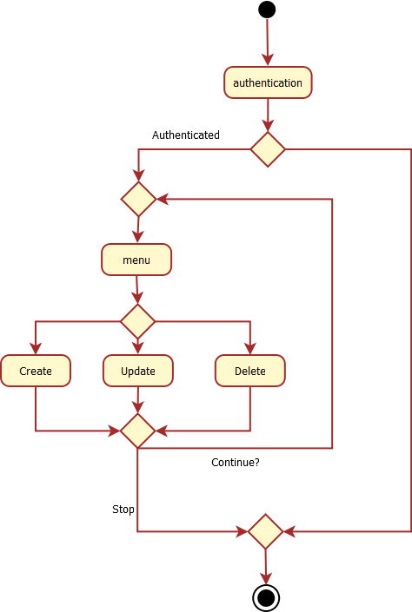

## Application Feasibility

This is a very basic application for Identity Management, and it’s scope is limited to add & manage identities. Only two parameters have been taken – Name and email address – for the present design.

## Data Description

|  |  |  |
| --- | --- | --- |
| Name | Type | Description |
| IDENTITY_BIRTHDATE | DATE | Record creation date |
| IDENTITY_EMAIL | VARCHAR 255 | User email |
| IDENTITY_DISPLAYNAME | VARCHAR 255 | User’s name as it’s to be displayed |
| IDENTITY_ID | INTEGER | Auto-generated unique number |

## Global Schema

**C:\Users\Yasin\Downloads\Untitled Diagram.png**

## Expected Results

The application should display a menu, allowing the user to select from the actions presented, and provide or take information as required to complete the action.

## Scope of the Application (Limits, Evolutions)

The application is limited in scope to using only two fields of information – user’s name and email address – to create records in the database. The records can be edited or deleted or listed as per user’s choice.

# User Guide

## User Login

When the application is started, the user is welcomed and prompted for the login details –

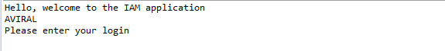

Once prompted, enter the login and password.



Once the password is entered and the details authenticated, the main menu is displayed.

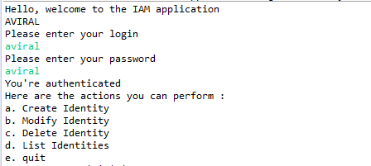

In case of an invalid login, a warning would be displayed and the application would stop.

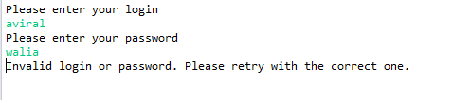

## Menu

The main menu is displayed and the user prompted to choose the action required.

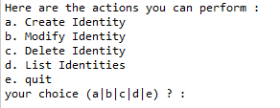

If any choice other than the 5 mentioned in the menu – i.e., a, b, c, d or e – is entered, the application will display an error warning and stop execution.



## Create New User

On entering choice as “a”, the user is prompted to enter the New User’s name –



Once the New User Name is entered, the user is prompted to enter the New User’s Email address –



Once the email is also provided, the New User is created and a message displayed on the screen to confirm success, and stops execution of the application.



To execute another option, we must restart the application.

## Modify User Record

Once the user login and password is authenticated, as above, the user must select the option “b”, if they want to modify an existing record, and the user will be prompted for email of the User they wish to modify.



After the Identity email address is entered, the user is prompted for the User’s name (the User to be modified). If the incorrect name is given, a warning will be displayed and the execution will stop.

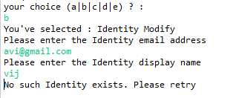

If the correct Identity name is entered, the user is then prompted to enter the new Name and Email Address, allowing one to change one or both, as required.

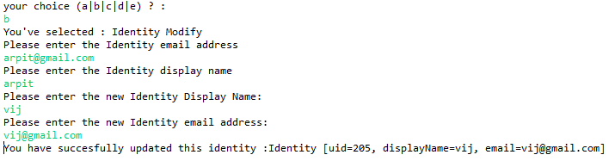

## Delete User Record

To delete an identity, the user must choose option “c” from the main menu. The user is then prompted for the User Email and the User Name to identify the record to be deleted –

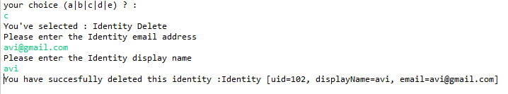

## List All Users

To view a list of all the Users in the database, the user must select option “d” and press “Enter”. This would list all the User Records currently in the database. 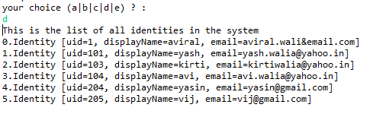

## Quit the application

To quit the application select the ‘e’ option and press “ENTER”



# Bibliography

* <http://thomas-broussard.fr/work/java/courses/project/fundamental.xhtml>
* <http://thomas-broussard.fr/index.xhtml>