1. On storage system create 3 Data Luns(100GB Each) & 3 Vote Luns(4GB each)
2. Install Clean RHEL 7.1 (Kick start clean).
3. To enable iptables(not mandatory), Run the following:
   * systemctl stop firewalld
   * systemctl mask firewalld
   * yum -y install iptables-services-1.4.21-13.el7.x86_64.rpm
   * open the following ports on iptables: 1521, 4889, 1830, 7777
   * systemctl enable iptables
   * systemctl restart iptables
4. yum -y install iscsi-initiator-utils.x86_64
5. systemctl enable iscsid
6. systemctl restart iscsid

**Ethernet Network Configuration / hosts File**

Eth0 public / connection to this machine

Eth1 private hart bit

Eth2 Iscsi network

/etc/hosts example

#Eth0 #public

10.10.10.203 rac1 rac1.redbend.com

10.10.10.202 rac2 rac2.redbend.com

#Eth1 #private-Hartbit

172.16.5.11 rac1-hb rac1-hb.redbend.com

172.16.5.10 rac2-hb rac2-hb.redbend.com

#Eth2 #vip

10.10.10.43 rac1-vip rac1-vip.redbend.com

10.10.10.42 rac2-vip rac2-vip.redbend.com

#scan vip locadbalancing ip

10.10.10.44 scan-rac scan-rac.redbend.com

#Iscsi Provider

192.168.200.5 iltlv_old

## System configuration (On both nodes)

1. Cd /etc/yum.repos.d/
2. wget <http://public-yum.oracle.com/public-yum-ol7.repo> (To manually Configure new repo  use this manual <http://www.krenger.ch/blog/oracle-linux-7-oracle-rdbms-server-12cr1-preinstall/> )
3. Make sure repository is enabled.
4. wget <http://public-yum.oracle.com/RPM-GPG-KEY-oracle-ol7> -O /etc/pki/rpm-gpg/RPM-GPG-KEY-oracle
5. gpg --quiet --with-fingerprint /etc/pki/rpm-gpg/RPM-GPG-KEY-oracle
6. yum install oracle-rdbms-server-12cR1-preinstall
7. vi /etc/security/limits.conf -> change line oracle soft nofile 1024 to oracle soft nofile 4096
8. echo session required pam_limits.so >>/etc/pam.d/login
9. configure NTP or add “0 0 * * * ntpdate 10.82.67.3” To crontab
10. vi /etc/security/limits.d/90-nproc.conf add # to line “ * soft nproc 1024” and add “ * - nproc 16384 ”
11. vi /etc/sysctl.conf -> Go to the End of file and add:

vm.swappiness = 1

vm.dirty_background_ratio = 3

vm.dirty_ratio = 80

vm.dirty_expire_centisecs = 500

vm.dirty_writeback_centisecs = 100

1. /sbin/sysctl -p
2. Stop & Disable the following services:
   1. systemctl stop avahi-dnsconfd
   2. systemctl stop avahi-deamon
   3. systemctl disable avahi-dnsconfd
   4. systemctl disable avahi-deamon

**Create necessary directories & files**

1. passwd oracle (Adminora123).
2. mkdir -p /u01/app/12.1.0.2/grid
3. mkdir -p /u01/app/grid-software
4. mkdir -p /u01/app/oracle/product/12.1.0.2/db_1
5. chown -R oracle:oinstall /u01
6. chmod -R 775 /u01/
7. su – oracle
8. vi /home/oracle/.bash_profile
9. copy the following to the .bash_profile file (change hostname):

# .bash_profile

# Get the aliases and functions

if [ -f ~/.bashrc ]; then

. ~/.bashrc

fi

# User specific environment and startup programs

PATH=$PATH:$HOME/.local/bin:$HOME/bin

export PATH

ORACLE_HOSTNAME=ora12-rac2.redbend.com; export ORACLE_HOSTNAME

ORACLE_UNQNAME=orcl; export ORACLE_UNQNAME

ORACLE_BASE=/u01/app/oracle; export ORACLE_BASE

GRID_HOME=/u01/app/12.1.0.2/grid; export GRID_HOME

DB_HOME=$ORACLE_BASE/product/12.1.0.2/db_1; export DB_HOME

ORACLE_HOME=$DB_HOME; export ORACLE_HOME

ORACLE_SID=orcl; export ORACLE_SID

ORACLE_TERM=xterm; export ORACLE_TERM

BASE_PATH=/usr/sbin:$PATH; export BASE_PATH

PATH=$ORACLE_HOME/bin:$BASE_PATH; export PATH

LD_LIBRARY_PATH=$ORACLE_HOME/lib:/lib:/usr/lib; export LD_LIBRARY_PATH

CLASSPATH=$ORACLE_HOME/JRE:$ORACLE_HOME/jlib:$ORACLE_HOME/rdbms/jlib; export CLASSPATH

if [ $USER = "oracle" ]; then

if [ $SHELL = "/bin/ksh" ]; then

ulimit -p 16384

ulimit -n 65536

else

ulimit -u 16384 -n 65536

fi

fi

alias grid_env='. /home/oracle/grid_env'

alias db_env='. /home/oracle/db_env'

1. create new file /home/oracle/grid_env with the following content:

ORACLE_SID=+ASM1; export ORACLE_SID

ORACLE_HOME=$GRID_HOME; export ORACLE_HOME

PATH=$ORACLE_HOME/bin:$BASE_PATH; export PATH

LD_LIBRARY_PATH=$ORACLE_HOME/lib:/lib:/usr/lib; export LD_LIBRARY_PATH

CLASSPATH=$ORACLE_HOME/JRE:$ORACLE_HOME/jlib:$ORACLE_HOME/rdbms/jlib; export CLASSPATH

1. create new file /home/oracle/db_env with the following content:

ORACLE_SID=RAC1; export ORACLE_SID

ORACLE_HOME=$DB_HOME; export ORACLE_HOME

PATH=$ORACLE_HOME/bin:$BASE_PATH; export PATH

LD_LIBRARY_PATH=$ORACLE_HOME/lib:/lib:/usr/lib; export LD_LIBRARY_PATH

CLASSPATH=$ORACLE_HOME/JRE:$ORACLE_HOME/jlib:$ORACLE_HOME/rdbms/jlib; export CLASSPATH

1. vi /etc/security/limits.d/99-grid-oracle-limits.conf – add the following:

oracle soft nproc 16384

oracle hard nproc 16384

oracle soft nofile 1024

oracle hard nofile 65536

oracle soft stack 10240

oracle hard stack 32768

**Install ASM Software:**

1. On Node 1:
   1. Copy the installation files from: \\iltlv3\ISO\Oracle\Grid\ to /u01/app/grid-software
   2. unzip linuxamd64_12102_grid_1of2.zip
   3. unzip linuxamd64_12102_grid_2of2.zip
   4. cd u01/app/grid-software/grid/rpm
   5. scp cvuqdisk-1.0.9-1.rpm node2:/tmp/
   6. On both Nodes run : rpm –Uvh cvuqdisk-1.0.9-1.rpm
2. On both Nodes:
   1. yum –y install kmod-oracleasm.x86_64
   2. yum –y install oracleasm-support
   3. Install ASM libs:
      1. wget <http://download.oracle.com/otn_software/asmlib/oracleasmlib-2.0.12-1.el7.x86_64.rpm>
      2. rpm –Uvh oracleasmlib-2.0.12-1.el7.x86_64.rpm
   4. yum install device-mapper-multipath
   5. cp /usr/share/doc/device-mapper-multipath-0.4.9/multipath.conf /etc/
   6. systemctl start multipathd.service
   7. systemctl enable multipathd.service
   8. iscsiadm -m discovery -t st -p 192.168.200.5 (to discover NetApp ISCSI address)
   9. you will get something like: “iqn.1992-08.com.netapp:sn.135101699”
   10. iscsiadm -m node -T iqn.1992-08.com.netapp:sn.135101699 -p 192.168.200.5:3260 –login
   11. **Uncomment the defaults section found within the /etc/multipath.conf file.**
   12. Run multipath –ll (to discover the iscsid for each device) : it should show something like 360a9800032307078305d47322d727148
   13. **Edit /etc/multipath.conf and create the following lines (You can create it on first node and then copy to the 2nd) :**

multipaths

{

multipath

{

wwid 360a9800032307078305d47322d727148

alias vote1

}

multipath

{

wwid 360a9800032307078305d47322d727148

alias vote2

}

multipath

{

wwid 360a9800032307078305d47322d727148

alias data

}

}

* 1. systemctl restart multipathd.service

1. On the first Node Only Run the following for each device discovered according to alias:

parted /dev/mapper/vote1 mklabel gpt mkpart primary "1 -1"

parted /dev/mapper/vote2 mklabel gpt mkpart primary "1 -1"

parted /dev/mapper/data mklabel gpt mkpart primary "1 -1"

1. An alias & partition should be created as follows:

/dev/mapper/vote1p1 -> ../dm-3

/dev/mapper/vote2p1 -> ../dm-4

/dev/mapper/data1 -> ../dm-5

1. On the second Node run: kpartx -a /dev/mapper/aliasname for all devices.
2. Run the following to determine mappings are correct:

“ for i in vote1p1 vote2p1 data1p1 ……; do printf "%s %s\n" "$i" "$(udevadm info --query=all --name=/dev/mapper/$i | grep -i dm_uuid)" ; done “

1. Create file as follows: vi /etc/udev/rules.d/99-oracle-asmdevices.rules
2. Put the following content for each device including DATA disks:

KERNEL=="dm*",ENV{DM_UUID}=="DM_UUID",OWNER="oracle",GROUP="oinstall",MODE="0660"

1. Copy this file to the 2nd machine: scp /etc/udev/rules.d/99-oracle-asmdevices.rules node2:/etc/udev/rules.d/
2. To test and set the permissions for the disks (on all nodes):
   1. ls –la /dev/mapper (you will get the device name at the end of the lines like: /dev/mapper/vote1p1 -> ../dm-3).
   2. Run: udevadm test /sys/block/dm-3 (for all devices – partitions ending with p1 only).
   3. ls -lh /dev/dm-3 (verify oracle is the owner and group is oinstall for all partitions).
3. Before installation implement the following script on both nodes and reboot(it should take several minutes) :

MYSWAP=$(free –m | grep –I Swap | awk ‘{print $2}’

(( MYSWAP = $MYSWAP / 1024 / 1024 ))

sysmem_MB=$(cat /proc/meminfo | grep MemTotal | awk '{ print $2}')

let "sysmem_MB = $sysmem_MB / 1024"

if [[ $sysmem_MB -gt 0 && $sysmem_MB -le 4 ]];

then

R_SWAP="4"

echo "Recommended swap: $R_SWAP GB"

elif [[ $sysmem_MB -gt 4 && $sysmem_MB -le 16 ]];

then

R_SWAP=$sysmem_MB

elif [ $sysmem_MB -gt 16 ];

then

R_SWAP="17"

fi

if [[ $R_SWAP -gt $MYSWAP ]];

then

((grow=$R_SWAP-$MYSWAP))

fi

dd if=/dev/zero of=/"$grow"GB.swap bs="$grow"M count=1024

mkswap /"$grow"GB.swap

swapon -V /"$grow"GB.swap

echo "/"$grow"GB.swap swap swap defaults 0 0" >> /etc/fstab

echo "tmpfs /dev/shm tmpfs defaults,size=8g 0 0" >> /etc/fstab

**Installation of Grid**

**On 1st Node Only:**

* 1. Login as oracle to GUI
  2. Open terminal
  3. Su – (enter root password)
  4. Run: DISPLAY=hostname:0.0 then export DISPLAY
  5. Go back to Oracle user (CTRL + D)
  6. Cd /u01/app/grid-software/grid/
  7. run the grid installer ./runIntsaller
  8. Within the Installation Option window, select Install and Configure Oracle Grid Infrastructure for a Cluster and click next.
  9. Within the Cluster Type window, select Configure a Standard cluster and click next.
  10. Within the Installation Type window, select Advanced Installation and click next.
  11. Within the Product Languages window, select the appropriate language, and click next.
  12. You will get the following:

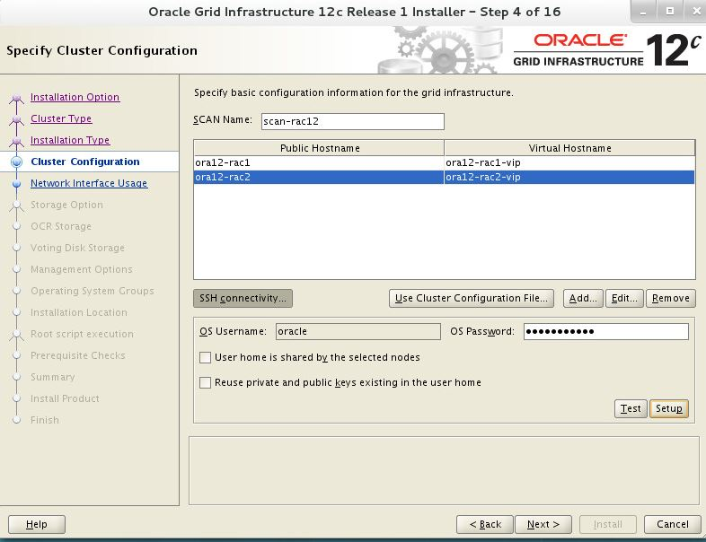

* + 1. Change Scan Name to hostname that was agreed to provide the Load Balancing (scan-rac) (from hosts-file) provide public name & virtual name for both nodes.
    2. Establish password less ssh between the nodes (can be done from “setup” button on the above screen).
  1. On the Next screen verify the interfaces are as follows:

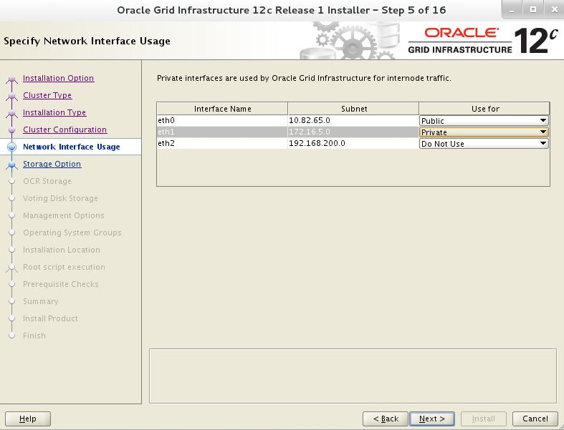

* 1. On the next screen:

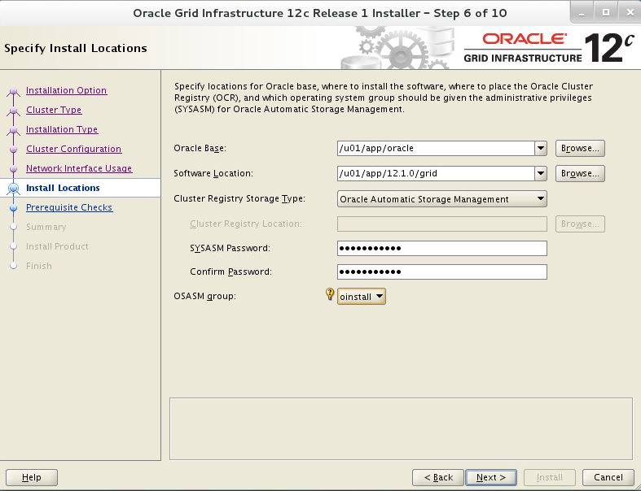

* + 1. Choose Oracle Base as: /u01/app/oracle
    2. Change software location to grid directory (/u01/app/12.1.0.2/grid).
    3. Change cluster registry storage type to OASM
    4. Change OSASM group to oinstall
  1. On the following screen:

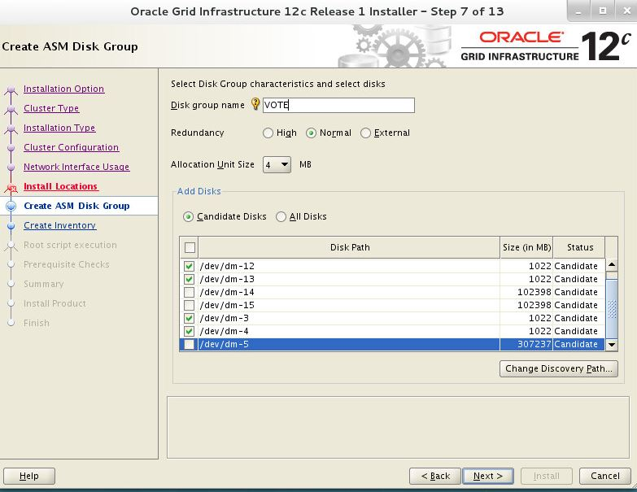

* + 1. Change “Disk Group name” to VOTE
    2. Change redundancy to “Normal” and select only vote disk (small 1 GB disk) ASM disks.
    3. Choose “Allocate Unit Size” 4 MB.
    4. Click on “Change Discovery Path” and specify the path: /dev/mapper/*
    5. Choose Only the Vote partitions (vote1p1, vote2p1 & vote3p1).
  1. Click next to the default inventory Directory (/u01/app/oraInventory).
  2. At the “Root Scripts Execution” screen leave default settings and click next.
  3. You will see the prerequisites check, ignore the /dev/shm (tmpfs) message and continue.
  4. Installation is now in progress.

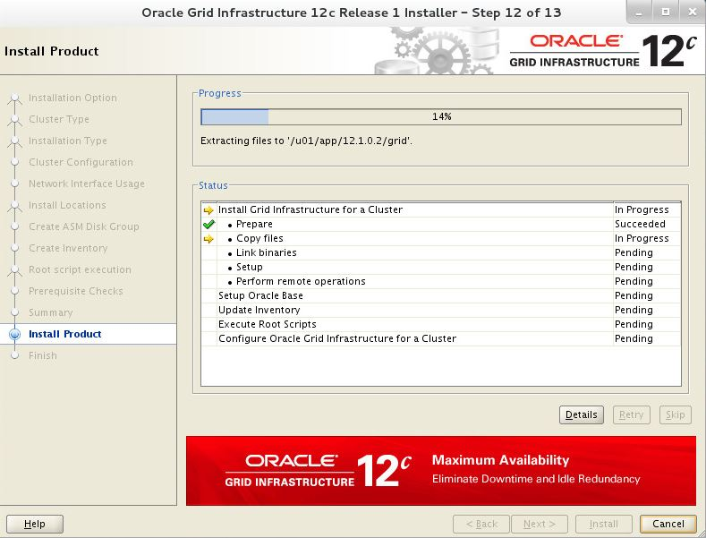

* 1. After a while you will get this prompt

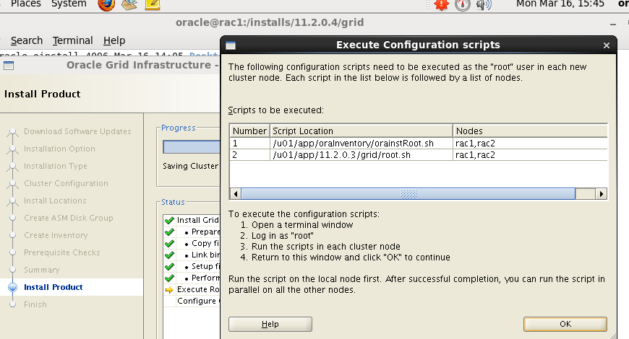

**You need to open a new terminal window and run both shell scripts on both nodes as user root - Wait untill the 1st node is finished and then do the the 2nd node.**

* 1. Once second Node is finished go to the 1st Node and continue the installation.

**If all goes well you will get Installation Successful.**