**Name: Aviral Kumar Srivastava**

**Class: CSE IoT B1**

**Roll No. : 20**

**SAP ID: 500068442**

**Date : 30-10-2020**

LINK TO GITHUB : <https://github.com/aviraw/AviralTableau>

**Descriptive Analysis**

**Tableau Test**

1. "What was the Moving Average of Sales in June of 2012, including six months prior and six months after?"

|  |  |  |
| --- | --- | --- |
|  |  | "$101,752 " |
|  |  | "$180,036 " |
|  |  | "$188,552 " |
|  |  | "$286,170 " |

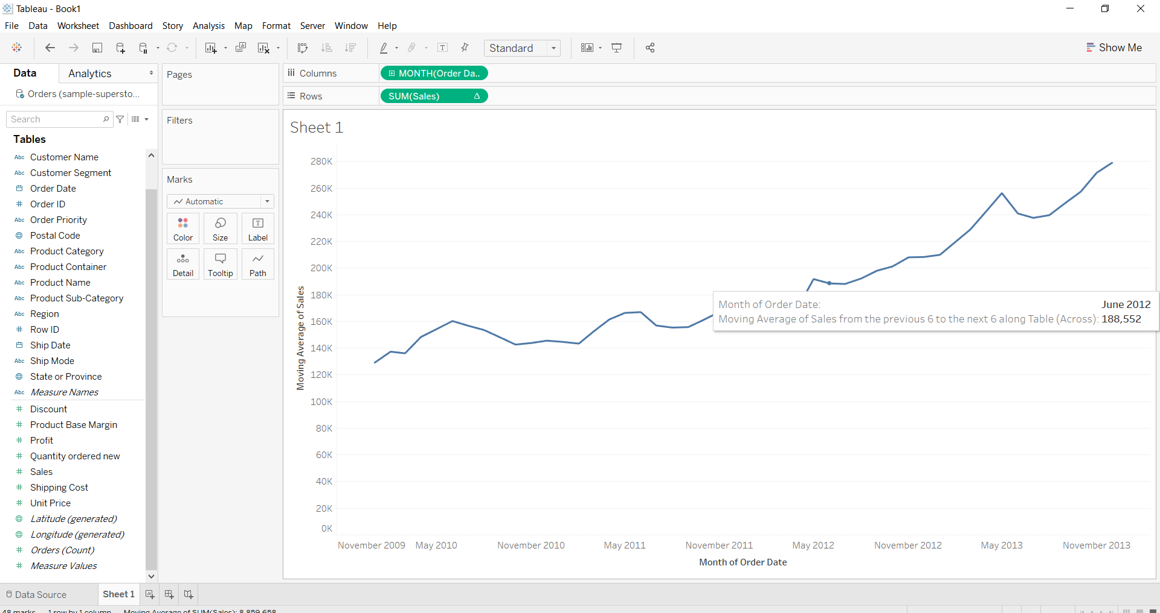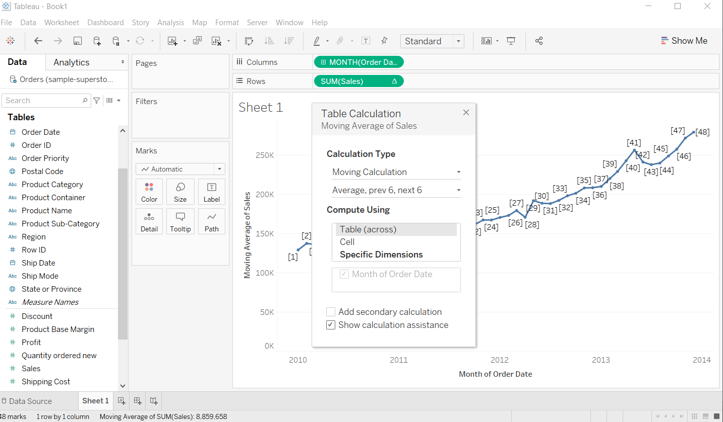

1. "In the Technology Product Category, which unprofitable state is surrounded by only profitable states?"

|  |  |  |
| --- | --- | --- |
|  |  | Colorado |
|  |  | Missouri |
|  |  | Wyoming |
|  |  | Utah |

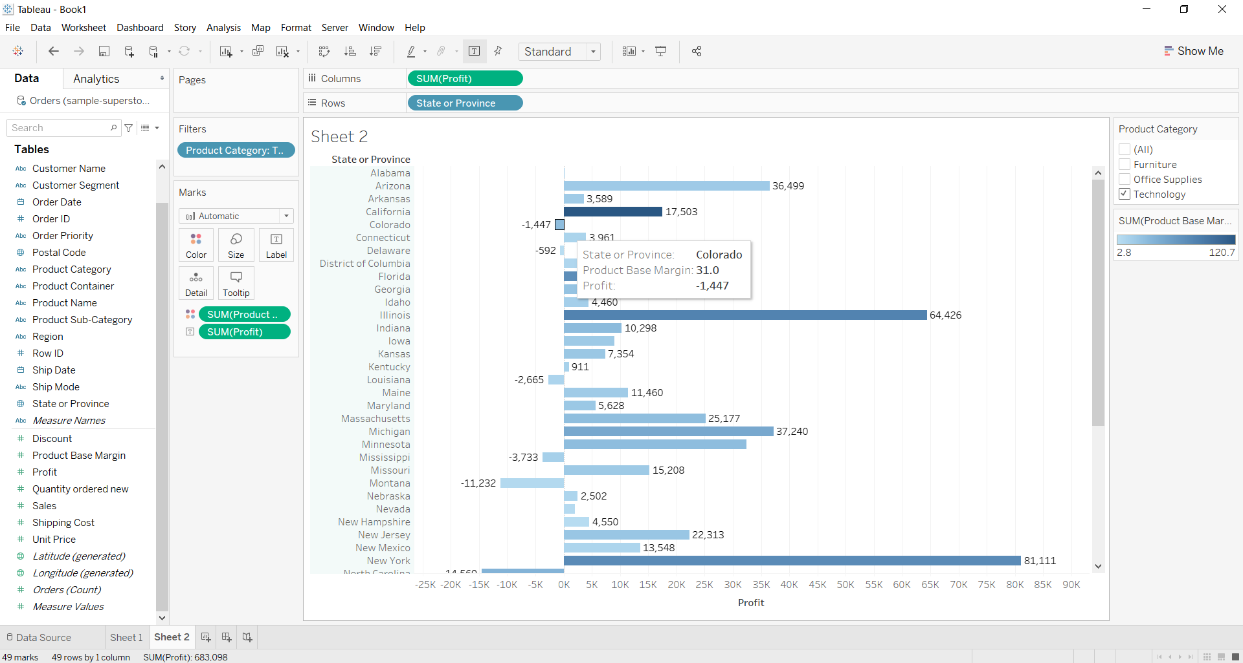

1. In which Region do all Product Categories fall beneath the overall average profit?

|  |  |  |
| --- | --- | --- |
|  |  | All Regions |
|  |  | Central |
|  |  | East |
|  |  | South |
|  |  | West |

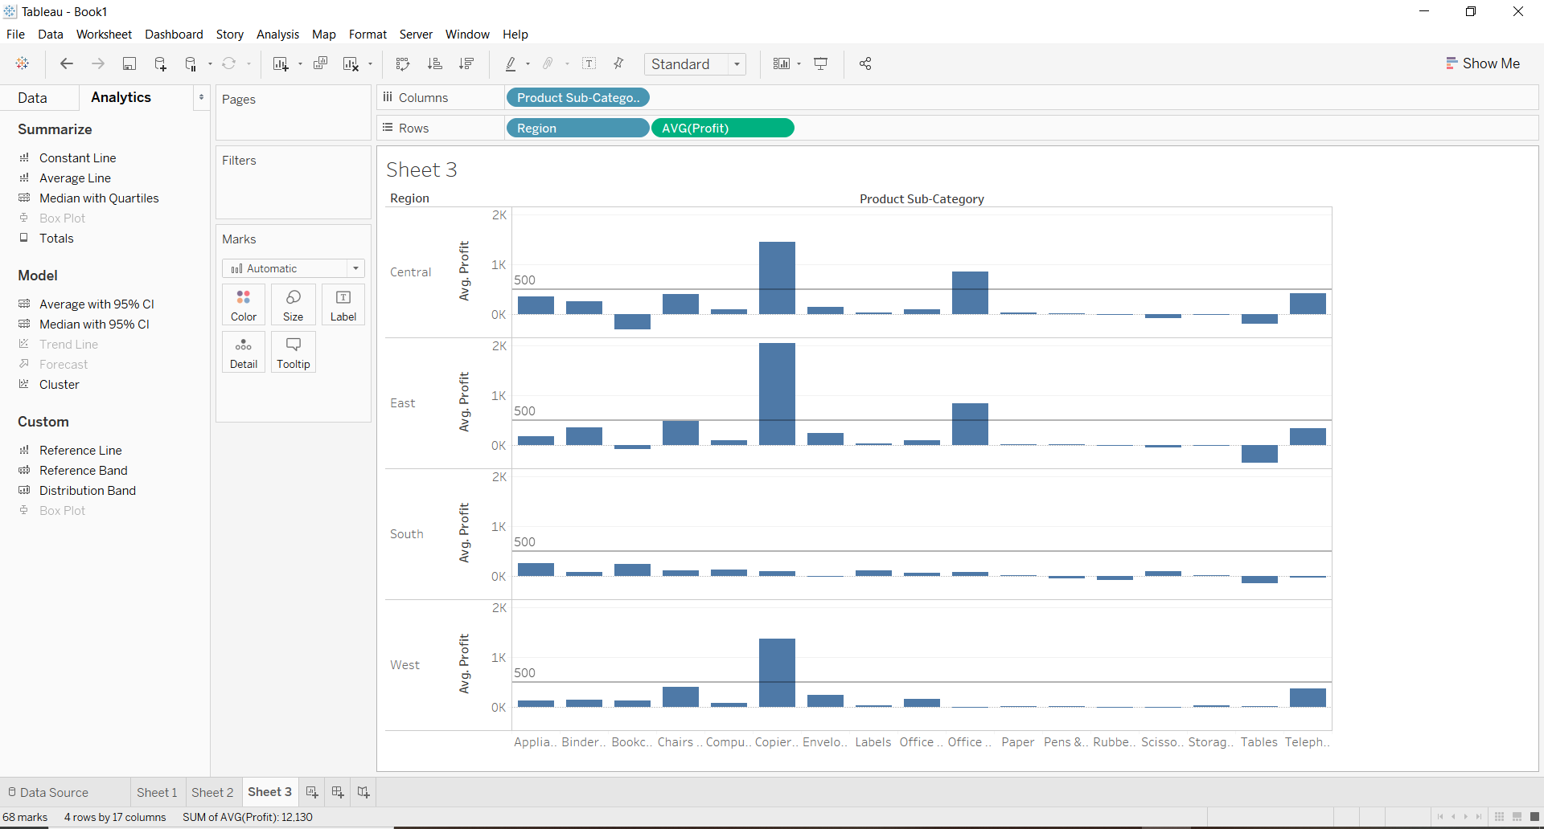

1. What is the percent of total Sales for the Home Office Customer Segment in July of 2012?

|  |  |  |
| --- | --- | --- |
|  |  | 23.50% |
|  |  | 23.97% |
|  |  | 20.14% |
|  |  | 32.56% |

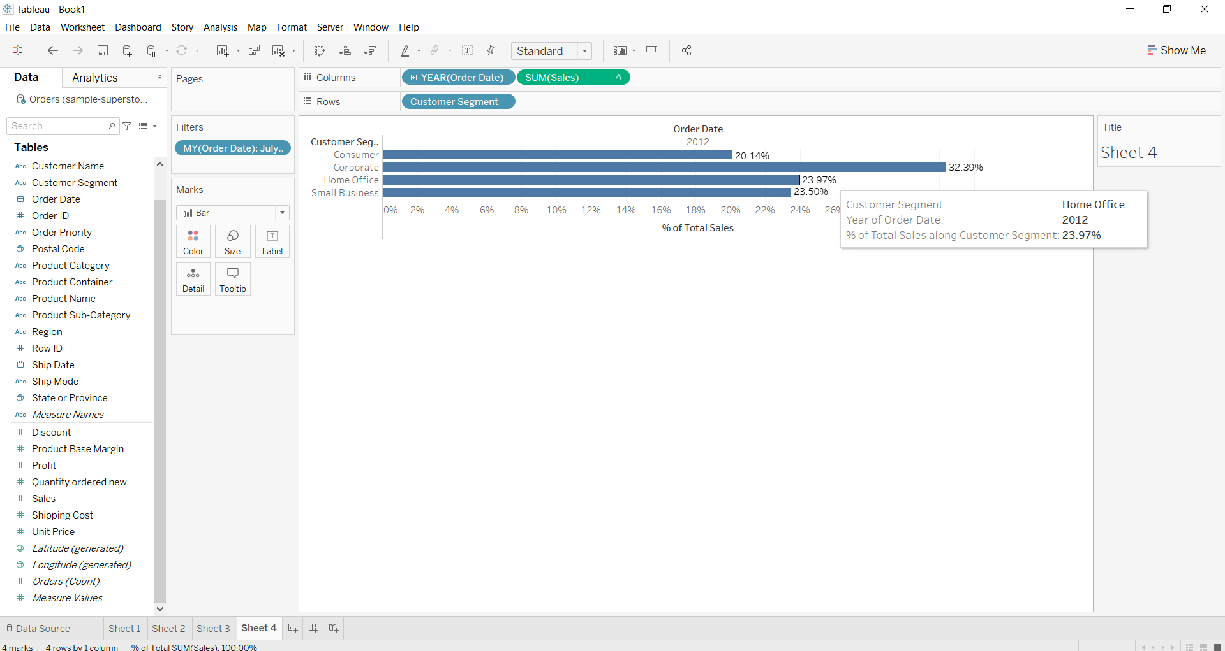

1. "Look at the sum of profits for each Product Sub-Category. Which sub-category is $31,069 below the average profit across all categories?"

|  |  |  |
| --- | --- | --- |
|  |  | Appliances |
|  |  | Bookcases |
|  |  | Envelopes |
|  |  | Paper |

|  |  |
| --- | --- |
|  |  |

1. Find the customer with the lowest overall profit. What is his/her profit ratio?

|  |  |  |
| --- | --- | --- |
|  |  | 2.35% |
|  |  | 1% |
|  |  | -17.54% |
|  |  | -771.39% |

