From Old Photos to 3D
A beginner's guide to recovering 3D point positions, camera locations, and error estimates from a set of historical photographs
No prior knowledge of computer vision is assumed. Every special term is explained in plain words the first time it appears.

What this guide gives you
You have about ten old photographs of the same object or scene, taken from different positions. By hand, you will mark a handful of points that show up in several photos. From those marks alone, you will work out four things:
- Where the points are in 3D — a set of (X, Y, Z) coordinates for each marked point.
- Where each camera was — the 3D position of every photo's viewpoint.
- Which way each camera pointed — the three direction arrows (left/right, up/down, and the way it was aimed) for every photo.
- How much to trust each result — an error value for every point and camera.
Everything will finally be expressed relative to the marked points themselves, so the points sit at the centre of your coordinate system and the cameras are placed around them.

The one idea behind everything
A camera takes a point floating in 3D space and flattens it onto a flat picture. If you knew exactly where the camera was, which way it pointed, and how zoomed-in it was, you could predict the exact pixel where any 3D point would land. Written compactly:
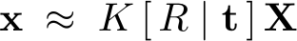
Here X is the 3D point, x is the pixel it lands on, R describes which way the camera points, and t is tied to where the camera sits. K is the part that needs a plain-words explanation.
What is K (the “internal settings”)?
K is just the camera's internal settings baked into a small table of numbers. The main one is the focal length — how zoomed-in the lens is. It also records where the centre of the image is and assumes the pixels are square. That is all. People call K the intrinsic matrix, “intrinsic” meaning “internal to the camera,” as opposed to where the camera is in the world.
The camera's position (often written 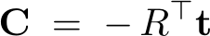) and its orientation (the arrows in R) are the things we actually want to find. The whole task is to run this idea backwards: starting only from the pixels you clicked, recover the 3D points and each camera's settings, position, and orientation.

Step 1 — Mark matching points by hand
A common point (also called a matching point or a correspondence) is one physical feature you can recognise in more than one photo — the corner of a window, the tip of a nose, a chip on a rim. You click the same feature in every photo where you can see it.

Rule A: how many photos each point must appear in
A single photo cannot tell you how far away a point is — depth is lost when 3D is flattened to 2D. You need the point seen from at least two different photos to pin down its depth, the same way your two eyes give you depth perception. Use three or more so there is a spare view to cross-check against. So: every point should appear in at least 3 photos.

Rule B: how many points you need in total
Think of it as a balance between what you don't know and what you measure.
- Unknowns. Each camera has 6 unknowns for its position and orientation, plus 1 unknown for its zoom (since old photos don't record it), so 7 per camera. Each 3D point adds 3 unknowns. Finally we subtract 7, because the whole scene can be freely slid, turned, and resized without changing any photo — those 7 free choices aren't really unknowns.
- Measurements. Every time you click one point in one photo, you record 2 numbers (its sideways and up-down pixel position).
For the puzzle to be solvable, your measurements must at least match your unknowns:
where N is the number of cameras (photos), P is the number of distinct 3D points, M is the total number of clicks (every point in every photo it appears in), and k is the number of unknown internal settings per camera. For historical photos we let only the zoom float, so k = 1.
The total number of clicks can be counted two ways — across photos or across points — and they must agree:
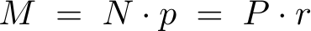
Here p is the number of points you mark in each photo, and r is the number of photos each point shows up in. Putting these together and solving for the points per photo gives the single formula that ties everything together:
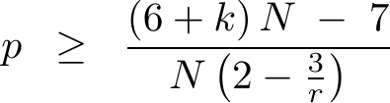
In words: the fewer photos each point appears in, the more points you must mark in every photo. With ten cameras and unknown zoom, this becomes:
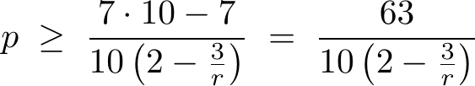
which produces this practical table:
Each point appears in... | Points needed per photo (p) | Distinct 3D points (P)
3 photos | at least 7 | about 23
4 photos | at least 6 | about 15
5 photos | at least 5 | about 10
all 10 photos | at least 4 | 4

Practical recommendation
Mark 6 to 8 common points in every photo. Make sure each point appears in at least 3 photos, and that your starting pair of photos (Step 4) shares about 8 points. Spread the points around the object and pick features at different depths — never all on one flat wall or surface. These numbers clear every requirement with room to spare for the noise you will get from scanned old photos.

Step 2 — Organise your measurements
Make one big table. Put the points down the side and the photos across the top. In each box, write the pixel position where you clicked that point in that photo, and leave it blank where the point isn't visible. This who-saw-what table is the raw material for everything that follows — keep it tidy and double-check that a given point really is the same feature in every photo.

Step 3 — Settle the camera's zoom
Old photographs almost never tell you the lens zoom, and there is no hidden data file to read. The standard, safe assumptions are: the centre of the image is the middle of the picture, the pixels are square, and the zoom (focal length) is unknown and will be estimated from the points themselves during the solving steps. You don't supply it; the method works it out.

Step 4 — Start with two photos
Reconstruction starts from a single pair of photos, called the seed pair. Pick the two photos that share the most marked points. From the way the shared points are arranged differently in the two pictures, you can work out how the second camera is positioned and oriented relative to the first.
This step has the strictest single requirement in the whole process: because the zoom is unknown, you need about 8 shared points in this one pair to lock down the relationship. (Four points is enough later on, but not here.) This is exactly why the recommendation is to mark generously and to choose a seed pair with strong overlap.

Step 5 — Build the first 3D points
Once you know where the two seed cameras are, each marked point gives a straight line of sight out from each camera through the pixel you clicked. The point in 3D is where the two lines meet. Recovering a 3D point this way is called triangulation — the same principle as fixing a location from two compass bearings.
In real data the two lines never meet perfectly because clicks are slightly off, so you take the point that comes closest to both lines. That best-fit crossing is found with a small, standard matrix calculation. Do this for every point the seed pair shares, and you have your first cloud of 3D points.

Step 6 — Add the remaining photos one at a time
Now bring in the other photos. Take any photo that contains some points you have already placed in 3D. Because you know both the 3D points and where they landed in this photo, you can work backwards to find where this camera sat and how it pointed. This needs at least 4 known points visible in the photo.
Once the new camera is placed, triangulate any extra points it shares with earlier photos to grow the 3D cloud. Repeat photo by photo until all ten are in.

Step 7 — Refine everything together
Adding cameras one at a time lets small errors pile up. The fix is to adjust all the cameras and all the 3D points at once so that everything agrees as well as possible. The measure of agreement is simple: take each 3D point, push it back through each camera to predict where it should have landed, and compare that to where you actually clicked. The gap between them is the reprojection error:
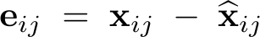
where the hat (ˆ) marks the predicted pixel. The refinement step nudges every number until the total of all these gaps, squared, is as small as it can be:
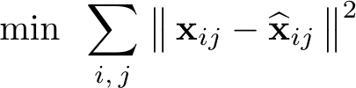
This is an ordinary best-fit (least-squares) calculation, carried out by repeatedly making small downhill adjustments until nothing improves. After it settles, both your 3D points and your cameras are as accurate as the data allows — and, as a bonus, the leftover gaps are exactly what you need for the error values next.

Step 8 — Read off the error values
Two kinds of error are worth reporting, and both come straight out of the refinement.

Reprojection error (in pixels)
For each point, average the leftover gaps across all the photos it appears in:
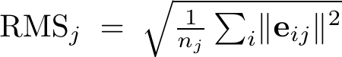
A small value (say a pixel or two) means the point is consistent across every photo; a large value flags a point you may have clicked carelessly or matched to the wrong feature.

3D uncertainty (in real-world units)
The refinement also tells you how much each 3D point could wobble before the fit noticeably worsens. From the fit you compute a spread-of-error quantity,
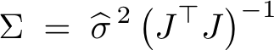
scaled by the typical leftover gap,
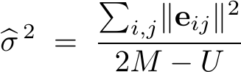
in which 2M is your total number of clicked numbers and U is the total number of unknowns. The chunk of this result belonging to one point describes a small blob of doubt around it — how far it might be off, and in which direction it is least certain. Report it per point alongside the pixel error.

Step 9 — Put everything in the points' coordinate system
Your reconstruction is correct in shape, but it floats: the entire scene can be slid, rotated, and resized without changing any photo. To make the numbers meaningful you anchor them to the marked points themselves.
- Set the origin at the average position of all the points (their centre):
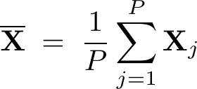
- Set the axes along the main directions the points spread out in. You find these directions from how the points scatter around their centre:
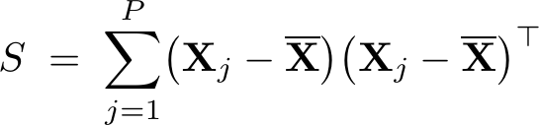
The strongest, second, and third spread directions of this scatter become your X, Y, and Z axes. (If you happen to have reference coordinates for the points already, you instead line your cloud up directly onto those.)
- Set the scale using one known real distance between two points, if you have one. Without a known distance, the overall size stays arbitrary — the shape is still correct.
Finally, apply that same shift, turn, and resize to every camera position and every camera direction arrow. The cameras are now described relative to the points: their centres and their pointing directions all live in the coordinate system defined by the object you photographed. The error blobs from Step 8 are read in this same frame, so they are directly meaningful.

One-page cheat sheet
The whole workflow, in order:
Step | What you do | Why / key number
1 | Mark matching points by hand in every photo | 6–8 points per photo, each in 3+ photos, not all on one flat surface
2 | Build the who-saw-what table of pixel positions | This table drives every later step
3 | Assume image center + square pixels; let the zoom be estimated | Historical photos have no zoom info
4 | Pick the two photos sharing the most points; solve their relative pose | Needs about 8 shared points here
5 | Cross the lines of sight to make the first 3D points | 2 photos minimum per point, 3+ to check
6 | Add each remaining photo using points already in 3D | Needs 4+ known points visible in that photo
7 | Refine all cameras and points together (best fit) | Makes predicted clicks match real clicks
8 | Read off the error values | Pixel gap per point + 3D wobble per point
9 | Re-express everything relative to the points | Origin = point average; axes = point spread

Common mistakes to avoid
- All points on one flat surface. If every point sits on a single wall or face, the math becomes unstable and can fail outright. Choose features at clearly different depths.
- A weak seed pair. Starting from two photos that share only a few points is the most common cause of failure. Give the starting pair about 8 shared points.
- Points seen in only two photos. These work but cannot be checked. Aim for three or more views per point so errors reveal themselves.
- Sloppy clicking. A point must be the exact same physical feature in every photo. A few pixels of carelessness shows up directly as error.
- Marking the bare minimum. The minimum counts assume perfect data. With scanned historical images, mark roughly twice the minimum so noise has somewhere to go.

