## Artificial Intelligence and Machine Learning

Project Report

Semester-IV (Batch-2022)

CAMPUS RECRUITMENT PREDICTION

**Supervised By: Submitted By:**

Faculty Name : DR. KIRAN DEEP SINGH CHARVI BANSAL - 2210990236

AVANTIKA - 2210990197

BHAVIKA ARORA - 2210990220

AVIREET KAUR - 2210990202

GROUP-G6

**Department of Computer Science and Engineering**

## Chitkara University Institute of Engineering & Technology,

## Chitkara University, Punjab

**ABSTRACT**

**Predictive Modelling for Campus Recruitment Using Machine Learning**

Campus recruitment is critical for both educational institutions and organisations looking for top talent. In this article, we provide a predictive modelling strategy that uses machine learning techniques to forecast the outcomes of campus recruitment events. Our approach tries to provide insights into the possibility of a candidate being chosen by prospective employers by analysing historical data such as applicant profiles, academic records, skill sets, and recruitment results.  
  
The collection is organised to include a variety of factors, such as academic performance, extracurricular activities, internship experiences, and demographic information. The predictive model is trained using a variety of machine learning algorithms, including decision trees, random forests, support vector machines, and neural networks. Feature engineering strategies are used to improve the model's predictive capacity. Feature engineering approaches are used to improve the model's predictive capability, resulting in optimal performance in capturing patterns .  
  
Furthermore, the study investigates the impact of various features on recruitment outcomes and finds critical elements that influence candidate selection. Understanding these variables enables educational institutions to better connect their curriculum and career services with industry expectations, while organisations may fine-tune their recruitment efforts to target people who are more likely to satisfy their needs.  
  
The suggested predictive model provides significant insights for stakeholders involved in campus recruitment, allowing them to make more informed decisions and optimise the overall recruitment process. Furthermore, the work adds to the expanding corpus of research at the confluence of machine learning and human resources, indicating the potential of data-driven approaches in addressing real-world challenges in talent acquisition and management.

**TABLE OF CONTENTS**

* **Introduction**
  + **Background**
  + **Objectives**
* **Problem Definition and Requirements**
  + **Problem Statement**
  + **Requirements**
  + **Resources Used**
* **Methodology**
* **Results**
* **References**

**INTRODUCTION**

In the contemporary landscape of talent acquisition, campus recruitment stands as a pivotal gateway for organizations to identify and engage with promising candidates from educational institutions. This process not only serves as a bridge between academia and industry but also plays a crucial role in shaping the career trajectories of students and meeting the evolving needs of businesses. However, the traditional methods of campus recruitment often rely on subjective evaluations and lack a systematic approach to candidate selection.

In response to these challenges, this study proposes the application of machine learning techniques to predict the outcomes of campus recruitment events. By harnessing the power of data analytics, we aim to provide a data-driven approach that enhances the efficiency and effectiveness of the recruitment process for both educational institutions and organizations.

**INTRODUCTION**

**Background:**

Campus recruitment is a dynamic process influenced by a myriad of factors ranging from academic performance and technical skills to extracurricular activities and interpersonal abilities. Historically, recruiters have relied on conventional methods such as resume screening, interviews, and assessments to evaluate candidates. However, these methods are often time-consuming, prone to bias, and may overlook valuable insights hidden within the data.

Machine learning, a subset of artificial intelligence, offers a promising solution to address these limitations. By leveraging algorithms and statistical models, machine learning enables computers to learn from data, identify patterns, and make predictions without being explicitly programmed. In the context of campus recruitment, machine learning can analyse vast amounts of candidate data to uncover hidden correlations, predict recruitment outcomes, and optimize decision-making processes.

Previous research in this domain has demonstrated the potential of machine learning techniques in various aspects of recruitment, including candidate screening, talent pipelining, and workforce planning. However, there remains a gap in the literature concerning the application of machine learning specifically to campus recruitment, where the dynamics and requirements differ significantly from traditional hiring processes.

**INTRODUCTION**

**Objective:**

The primary objective of this study is to develop a predictive model using machine learning techniques to forecast the outcomes of campus recruitment events. Specifically, we aim to achieve the following objectives:

1. Data Collection and Preprocessing: Gather comprehensive data sets encompassing candidate profiles, academic records, skillsets, and recruitment results from past campus recruitment events. Cleanse and preprocess the data to ensure accuracy and consistency.

2. Model Development: Explore a range of machine learning algorithms, including decision trees, random forests, support vector machines, and neural networks, to develop a predictive model. Employ feature engineering techniques to enhance the model's predictive power and interpretability.

3. Evaluation and Validation: Assess the performance of the predictive model using appropriate metrics such as accuracy, precision, recall, and F1-score. Validate the model through cross-validation techniques to ensure robustness and generalizability.

By achieving these objectives, we seek to provide educational institutions and organizations with a valuable tool for optimizing their campus recruitment strategies, identifying high-potential candidates, and fostering meaningful connections between talent and opportunities. Additionally, this research contributes to advancing the field of human resources by demonstrating the efficacy of data-driven approaches in addressing real-world challenges in talent acquisition and management.

**PROBLEM DEFINITION AND REQUIREMENTS**

**Problem Statement**

Campus recruitment serves as a pivotal strategy for organizations to attract and recruit young talent for internships and entry-level positions. However, optimizing this process involves multifaceted challenges, from identifying promising candidates to predicting their likelihood of placement.

The aim of this project is to develop a machine learning model that can predict the likelihood of a candidate being placed based on various factors such as work experience, exam scores, and other relevant metrics. By leveraging historical placement data, we seek to create a predictive model that assists recruiters and educational institutions in enhancing their campus recruitment strategies and improving placement outcomes.

**Requirements**

**Software Requirements**

* Jupyter Notebook: The project will be implemented using Jupyter Notebook for ease of code execution, visualization, and documentation.
* Python Libraries: The following Python libraries will be utilized for data manipulation, analysis, and machine learning model development:
* Pandas: For data manipulation and analysis.
* NumPy: For numerical computations.
* Scikit-learn: For implementing machine learning algorithms.
* Matplotlib and Seaborn: For data visualization.
* Plotly (optional): For interactive visualizations.
* Anaconda Distribution: Anaconda will be used as the primary Python distribution to ensure seamless integration of required libraries and easy package management.

**Hardware Requirements**

Since the dataset and model training do not demand extensive computational resources, the project can be executed on standard computing hardware. However, to ensure smooth performance, it is recommended to have:

* A computer with at least 4GB of RAM.

Sufficient storage space for dataset storage and model files.

A modern multi-core processor to expedite data processing and model training.

* Dataset

The project will utilize the "PlacementDataset.csv" dataset, which encompasses the placement season data of a Business School in India. The dataset comprises various attributes influencing candidate placement outcomes, including work experience, exam percentages, and recruitment status. Additionally, it contains details regarding remuneration offered to placed candidates.

**Resources Used**

File Setup: To initiate the project, follow these setup instructions:

* Download the Dataset: Obtain the "PlacementDataset.csv" dataset from the provided resources folder.
* Open Jupyter Notebook: Launch a Jupyter Notebook within the same directory containing the dataset.
* Import Dataset: Import the dataset into the Jupyter Notebook using Python's Pandas library.
* Install Necessary Packages: Ensure all required packages, such as Plotly, are installed. Use the Anaconda Prompt or terminal to install any missing packages via pip.

**METHODOLOGY**

* Problem Definition: Predict whether a student will be recruited by a company based on their academic and extracurricular profile.
* Data Collection: Gather data from past campus recruitment drives, including student profiles and recruitment outcomes. Collect information such as academic performance, skills, internships, extracurricular activities, and demographic details.
* Data Preprocessing: Handle missing values: Impute missing data using techniques like mean, median, or mode imputation.
* Outlier detection and treatment: Identify outliers and decide whether to remove them or transform them.
* Data encoding: Encode categorical variables using techniques like one-hot encoding or label encoding.
* Feature scaling: Scale numerical features to a similar range using techniques like min-max scaling or standardization.
* Feature Engineering: Create new features if needed based on domain knowledge and insights from the data.
* Examples include:
* Composite scores based on academic performance and extracurricular achievements.
* Binary indicators for specific skills or experiences.
* Model Selection:
* Choose appropriate machine learning models for binary classification tasks, such as:
  + Logistic Regression
  + Random Forest
  + Support Vector Machines
* Consider ensemble methods or deep learning approaches for more complex relationships in the data.
* Model Training: Split the dataset into training and testing sets (e.g., 70% training, 30% testing). Train the selected models on the training data.
* Model Evaluation: Evaluate the trained models using appropriate evaluation metrics for binary classification tasks, such as accuracy, precision, recall, and ROC-AUC.
* Compare the performance of different models and choose the best-performing one.

Model Validation: Validate the final model on a holdout dataset or through cross-validation to ensure its generalization performance.

* Develop a user-friendly interface for inputting student data and displaying prediction results.

**By following this methodology, you can systematically design and implement a campus recruitment prediction system using machine learning.**

**RESULTS**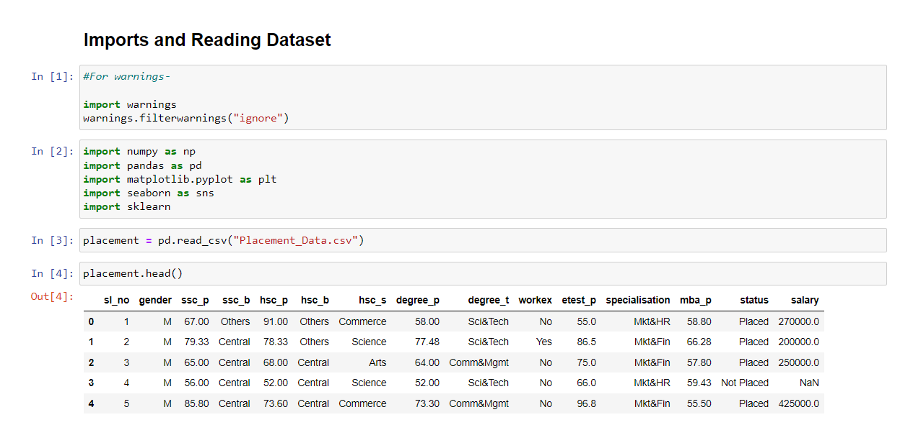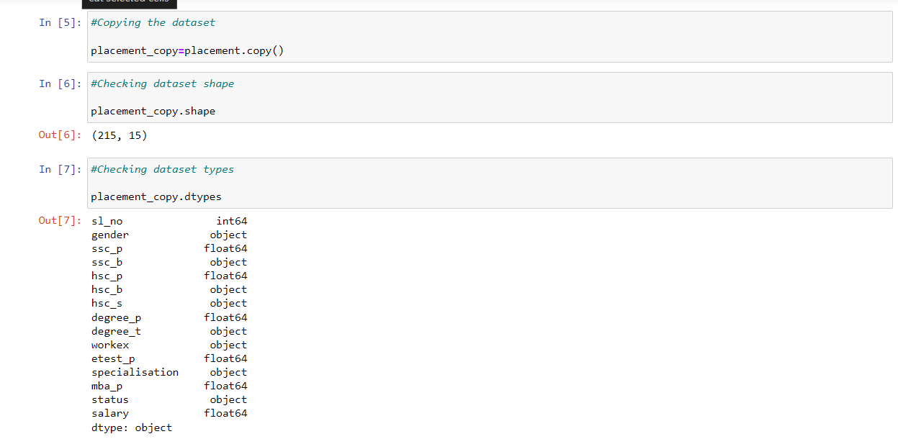

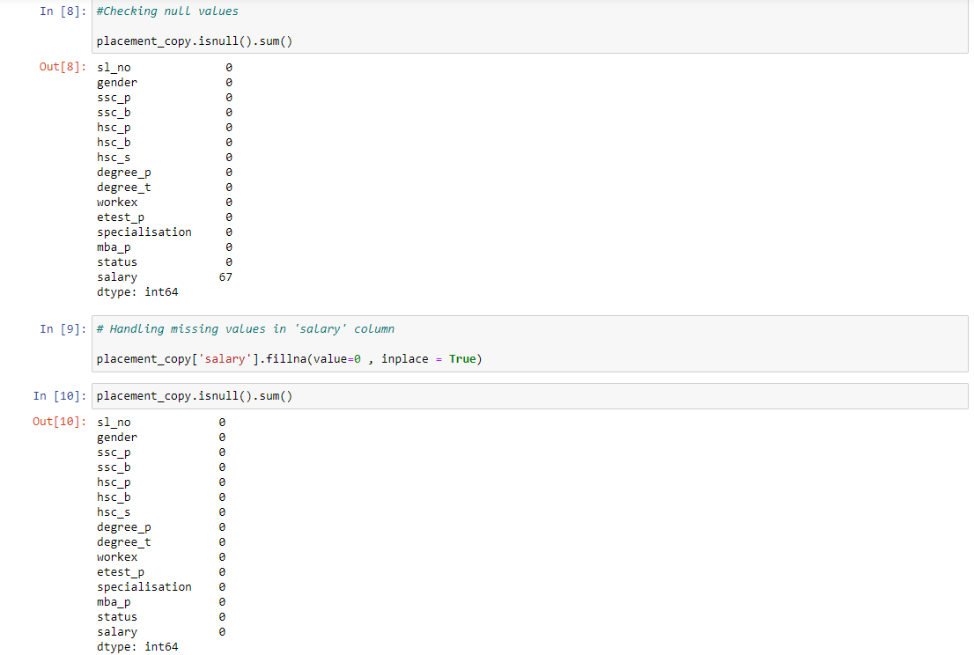

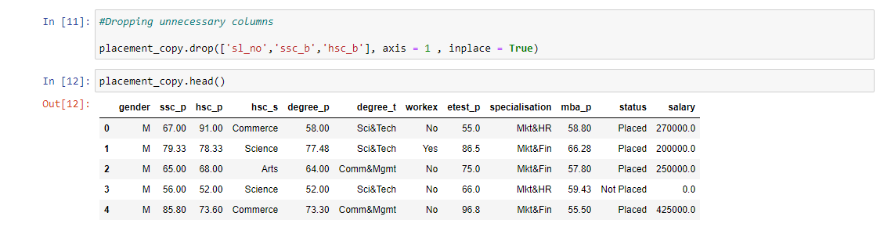

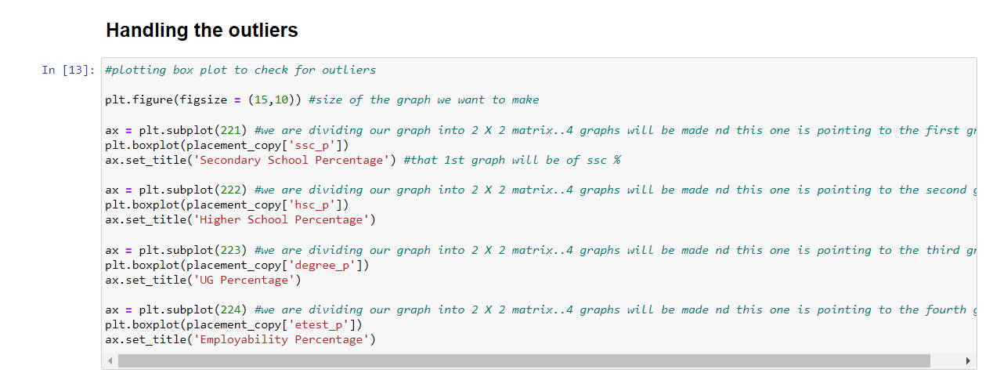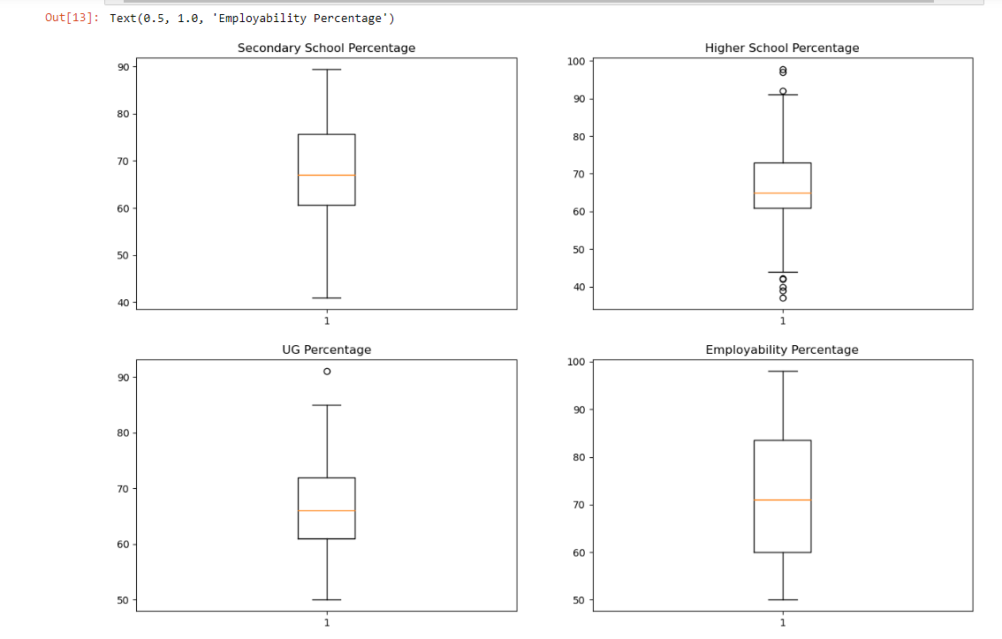

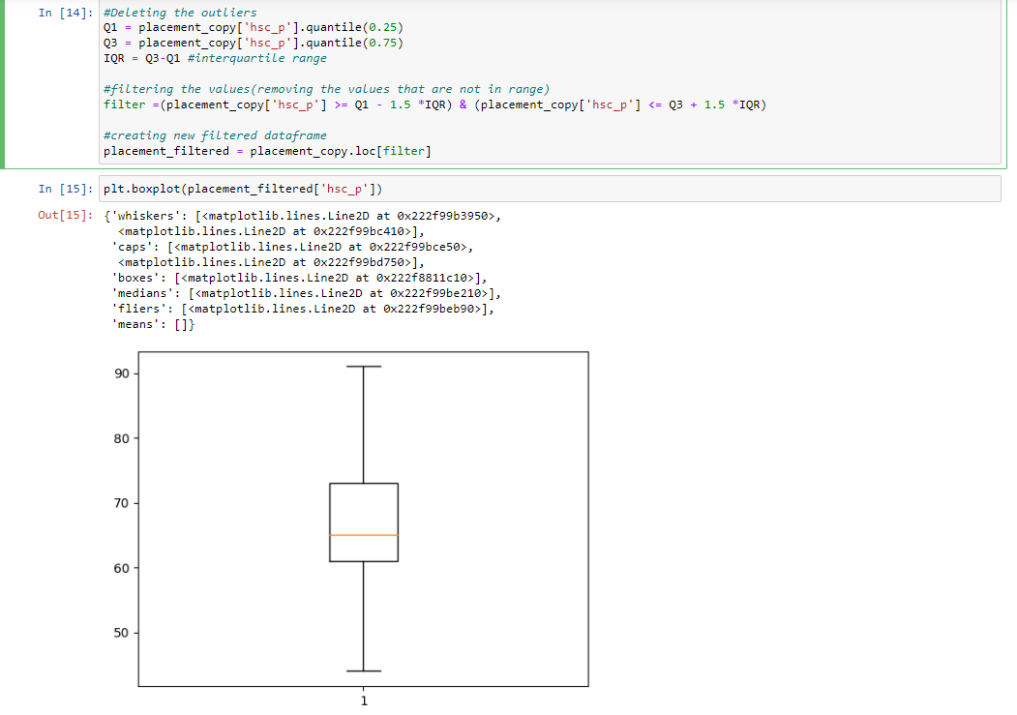

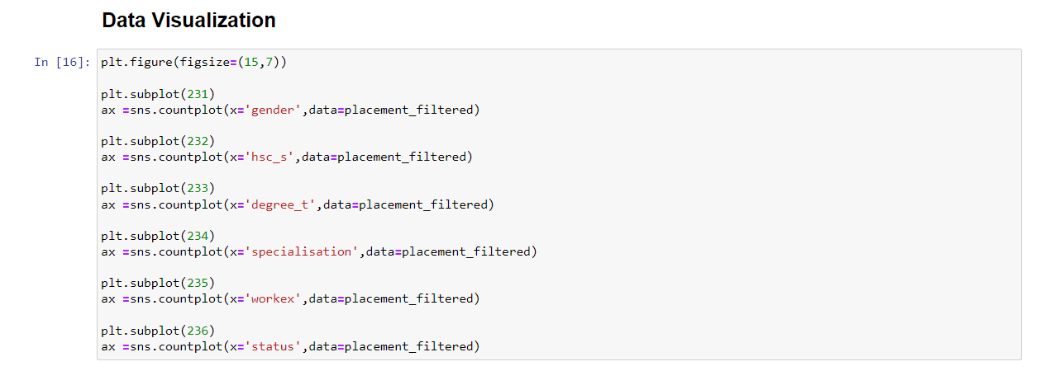

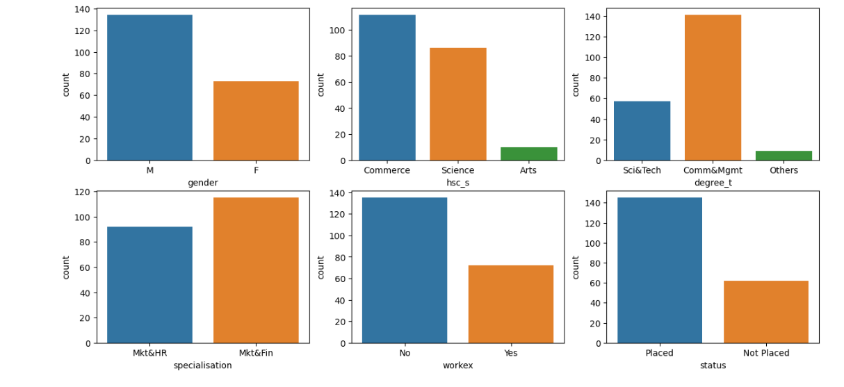

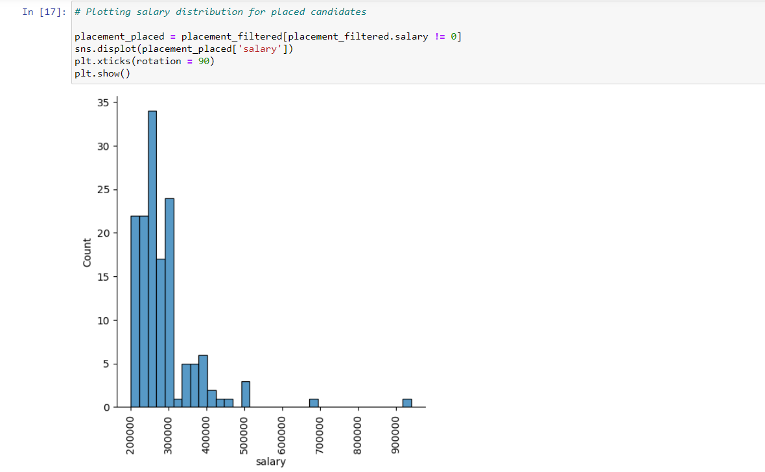

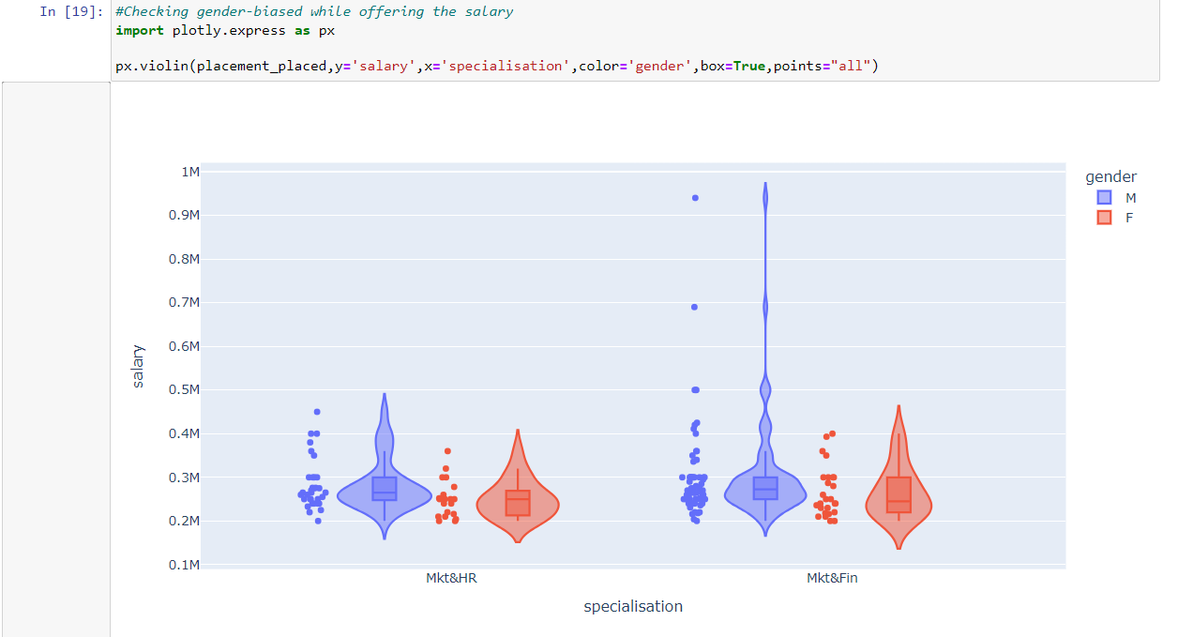

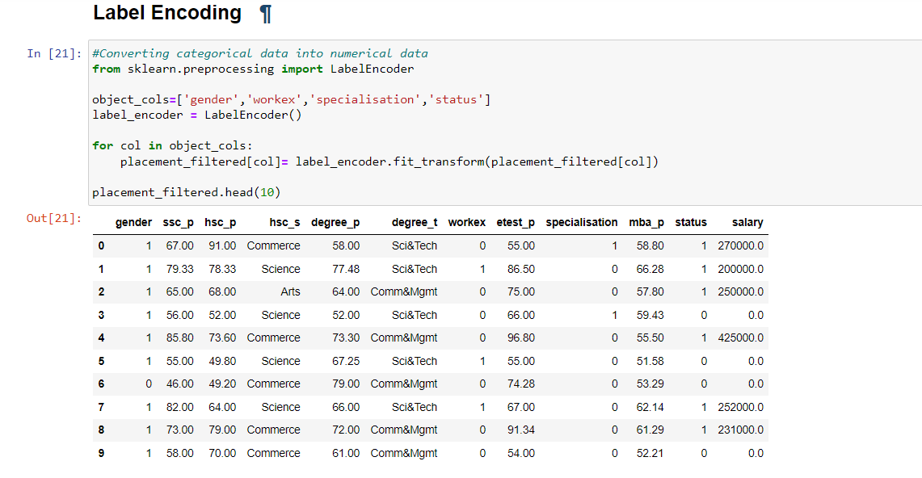

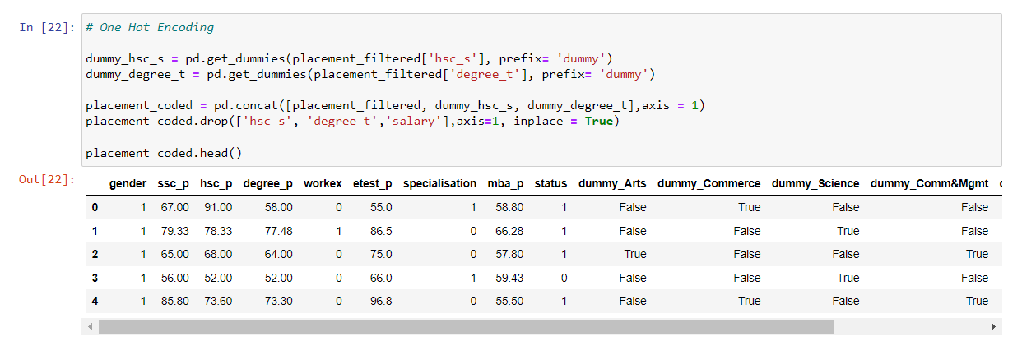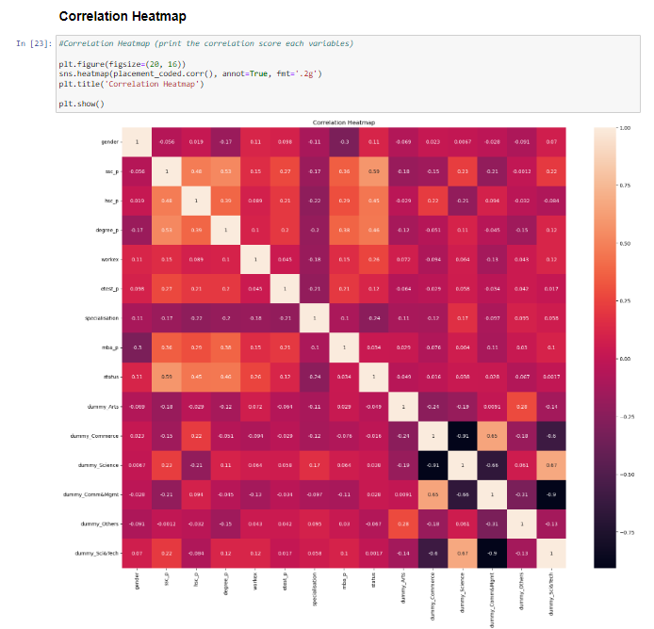

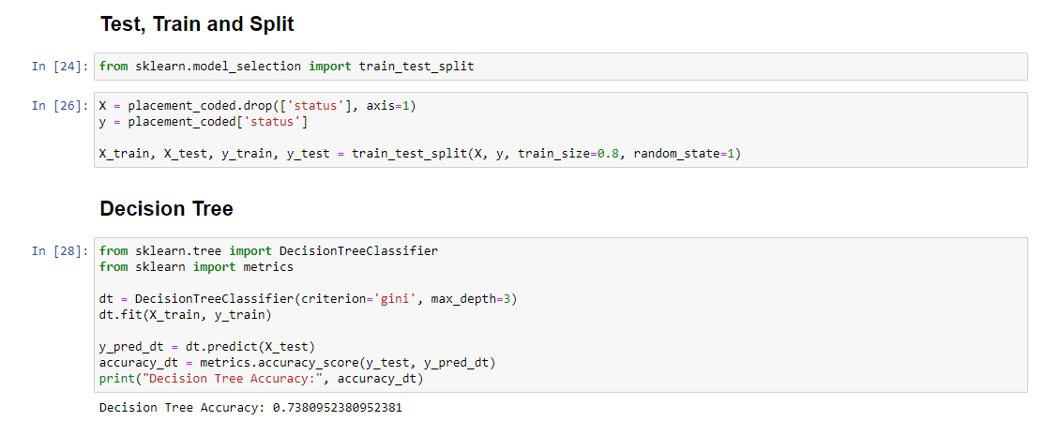

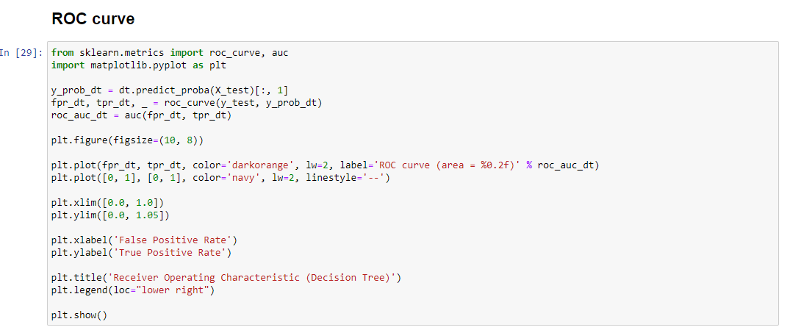

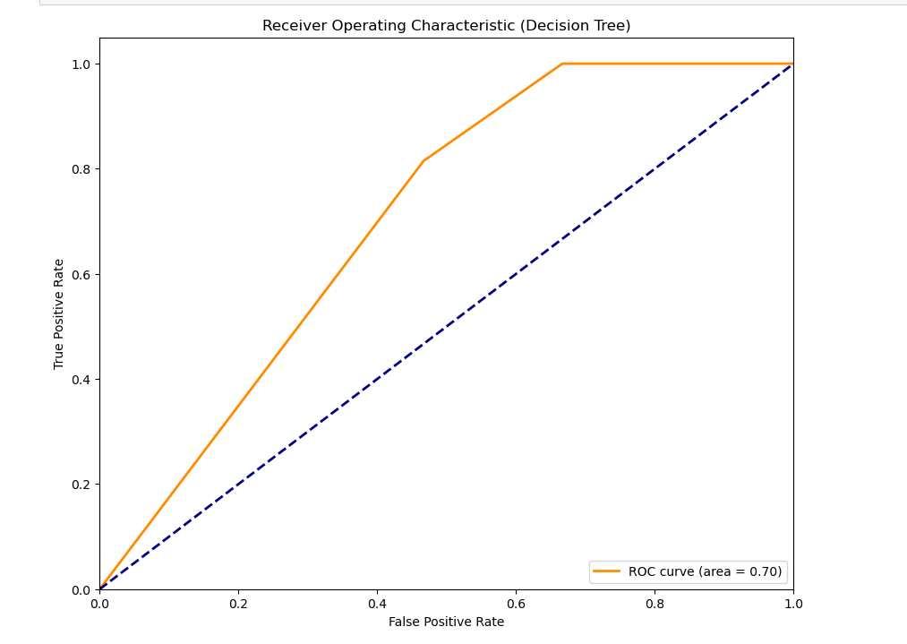

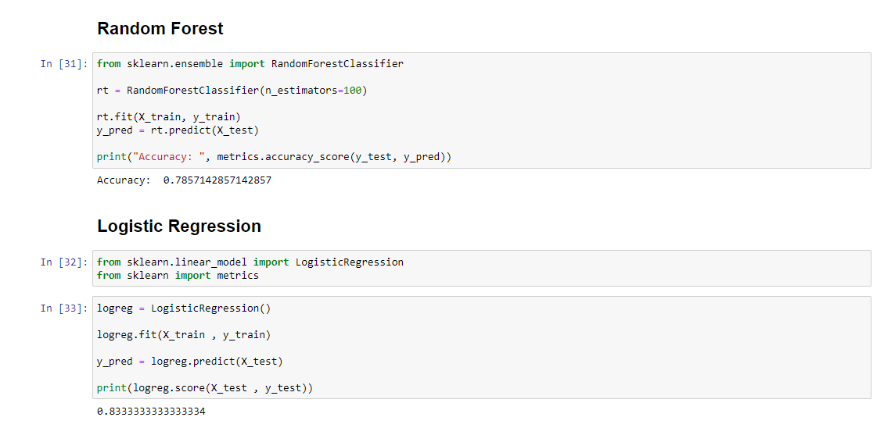

**REFERENCES**

* **YouTube channel:** [**www.youtube.com/siddhardhan**](http://www.youtube.com/siddhardhan)
* **Geeks for geeks:** [**www.geeksforgeeks.com**](http://www.geeksforgeeks.com)
* **W3schools:** [**www.w3schools.com**](http://www.w3schools.com)
* **Javatpoint: www.javatpoint.com**