**NOTE: This template is shareware downloaded from** [**www.processimpact.com**](http://www.processimpact.com)**. All shareware payments are donated to the Norm Kerth Benefit Fund to help a consultant who is disabled with a brain injury. Please visit** [**http://www.processimpact.com/norm_kerth.html**](http://www.processimpact.com/norm_kerth.html) **to make a shareware payment ($10 suggested). Thank you!**

Vision and Scope Document

for

“iStartDev” project

Version 1.0 approved

Prepared by Alexander Virkovski

Itransition Ltd.

1st August 2014

Table of Contents

1. Business Requirements 1

1.1. Background 1

1.2. Business Opportunity 1

1.3. Business Objectives and Success Criteria 1

1.4. Customer or Market Needs 1

1.5. Business Risks 1

2. Vision of the Solution 2

2.1. Vision Statement 2

2.2. Major Features 2

2.3. Assumptions and Dependencies 3

3. Scope and Limitations 3

3.1. Scope of Initial Release 3

3.2. Scope of Subsequent Releases 3

4. Business Context 3

4.1. Stakeholder Profiles 3

4.2. Project Priorities 3

4.3. Operating Environment 3

Revision History

|  |  |  |  |
| --- | --- | --- | --- |
| **Name** | **Date** | **Reason For Changes** | **Version** |
|  |  |  |  |
|  |  |  |  |

# Business Requirements

## Background

There was a decision from a senior management of the SD2 department to build a single website with a blog for marketing purposes. The website must be a single-page website similar to iWebDev website (direct link: http://www.iwebdev.com/) and modern corporate marketing trends.

## Business Opportunity

Python development language is very popular among the most modern web and business applications. Some examples:

* Odoo (an open source comprehensive suite of business applications),
* Pinterest (a visual discovery tool that you can use to find ideas for all your projects and interests),
* Instagram(an online mobile photo-sharing, video-sharing and social networking service),
* Dropbox (file hosting service),
* Youtube (a video-sharing website),
* World of Tanks (massively multiplayer online game).

According to the quick google search for a “Python Developer” there is a moderate competition in the market for Python / Django developers, however the market is very competitive with the pool of freelance resources as well.

## Business Objectives and Success Criteria

The single page iStartDev website needs to be built using the Python language within 2 weeks and the Blog website needs to be built within 4 weeks. The main idea of the blog, is to assist new companies (that are developing the product either for internal or external purpose) and start-ups (external purpose) with the useful information in the Python development and project start phase. The website iStatDev should exploit the opportunity to sell SD2 services to the website visitors using that website. The main goal of the website is to gather as many as possible quotes from clients.

## Customer or Market Needs

There is always a need for a relevant content that the audience is requiring when starting out a new project in the IT. People are looking for suitable sources of information that is interesting and useful to them. The three typical customer groups have been identified that might be interested in reading the new Python blog (iStartDev) and leaving a request for a quote on the website:

1. Clients and companies that are building the software product for the internal company purpose;
2. Software companies that are developing their software product for the external audience;
3. Start-up companies that have a great idea but need the company to build a Proof of Concept/ Prototype for them within a 5-10k budget.

## Business Risks

The business risks might include building a website and a blog that might not be relevant to the target audience or the content will be relevant, but the target audience may to be willing to visit the blog again or leave a request for a quote. Another risk can be that Python language and its high position among famous web products might be degraded and it might be replaced by other modern programming languages, so there will be less demand for the development under python.

# Vision of the Solution

## Vision Statement

The iStartDev website needs to be built on the Python technology, using Django CMS with a blog plug-in.

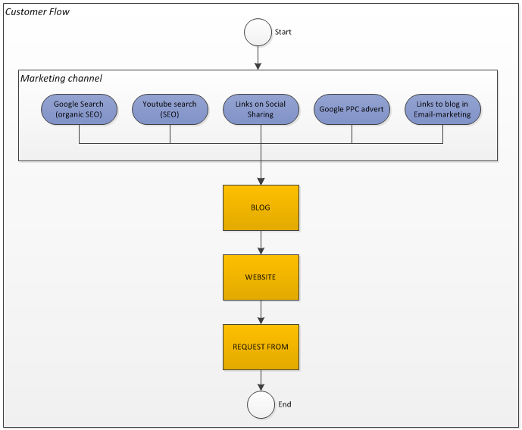

## Major Features

The major features of the product should include:

* User-friendly editing of the content via CMS;
* SEO-friendly website;
* Blog section;
* Comments on the blog;
* Social sharing: facebook, youtube, linkedin, vkontakte;
* Newsletter subscription;
* “Contact us” section;
* Portfolio section;
* Up-to-date company information;
* Video player;
* CAPTCHA validation on “contact us” form.

## Assumptions and Dependencies

The project must be built on a Python technology and the website needs to be completed within 2 weeks, while the blog should take no more than 4 weeks of development. The project must be completed using the internal free resources.

# Scope and Limitations

## Scope of Initial Release

The following needs to be built first place:

* Front-end website and CMS optimized for Desktop Browsers
* Blog plugin optimized for Desktop Browsers

## Scope of Subsequent Releases

Potentially there is a need to build a mobile version of the website that is optimized for mobile and tablet devices.

# Business Context

## Stakeholder Profiles

Stakeholders:

Vadim Nareyko, email: [v.nareyko@itransition.com](mailto:v.nareyko@itransition.com) , skype: nareyko

Konstantin Pilkevich, [k2.pilkevich@itransition.com](mailto:k2.pilkevich@itransition.com) , skype: kostya.pilkevich

Nadzeya Furs, [n.furs@itransition.com](mailto:n.furs@itransition.com) , skype: naduxa_lux

## Project Priorities

Deadline for the working website and blog is end of September.

## Operating Environment

Non-functional requirements for Desktop Browsers:

* Internet Explorer (IE9, IE10, IE11)
* Chrome (C34-36)
* Firefox (28-30)
* Safari (6-7)
* Opera (20)