Predicting Medical Appointment Attendance Using XGBoost, CatBoost, and Deep Neural Networks

Introduction

Overview
Healthcare systems worldwide face persistent challenges related to patient appointment no-shows, which disrupt clinical workflows, waste resources, and compromise patient outcomes. Missed appointments lead to inefficient staff allocation, longer waiting lists, and delayed care for individuals with chronic or rehabilitative needs. With the increasing digitalization of health records, predictive modelling has become a promising solution for identifying patients most at risk of missing scheduled visits. This project focuses on developing machine-learning models—specifically XGBoost, CatBoost, and Deep Neural Networks—to analyse demographic, clinical, scheduling, and environmental factors associated with attendance behaviour. By leveraging a large, multi-year dataset from a Brazilian rehabilitation clinic, the study aims to evaluate the relative performance of these algorithms and determine which method offers the most accurate prediction of no-show events.

Problem Statement
Miss attendance at appointments in healthcare systems is a major issue, which leads to inefficiency, resource distribution inefficiency, and patient waiting time (Kler et al., 2024). Cancellation of appointments does not only derail the clinic schedules but also has negative outcomes to the patient as subsequent appointments are vital in the management of chronic conditions and the rehabilitation programmes. One of the ways to eliminate nonattendance is predictive modelling, which allows healthcare providers to predict which patients are not likely to attend an appointment and thus allows the automated administration of such interventions as the use of automated reminders, rebooking, or the use of a specific patient engagement strategy (Deina et al., 2024).
The data used in this research is obtained within the Brazilian national healthcare and entails anonymised patient appointment data, such as demographic, scheduling and health related data (Chen et al., 2021). Attributes include the age of the patients, their gender, the date and time of the appointment, the waiting time between appointment and scheduling, type of medical care and the history of their no-shows, and climate like weather conditions. This type of detailed data allows the analysis of trends that lead to the absence of appointments, which improves the possibility of achieving a predictive value.
Gradient-boosting models, including XGBoost and CatBoost, have shown good results on tabular data when it comes to healthcare prediction tasks (AlSerkal et al., 2025). These models are effective at managing categorical variables, imbalanced data and interaction of features thus making them applicable to no-show prediction. Similarly, Deep Neural Networks (DNNs) offer the ability to model complex non-linear interactions between features that can identify latent relationships within patient behaviour which tree-based approaches may fail to identify. Through such comparisons, this project aims at establishing the best predictive model and discussing such important features as they affect attendance of appointments.
Finally, the results of this research may help healthcare professionals lower the rate of no-shows, better clinic scheduling, resource optimization, and improve patient outcomes. The project, in its turn, adds to the overall body of work on predictive analytics in healthcare and illustrates how complex machine-learning methods can be applied to practical operational issues (AlSerkal et al., 2025; Deina et al., 2024).

Research Question
Can a Deep Neural Network outperform XGBoost and CatBoost in predicting patient no-shows using demographic and scheduling data?

Objectives
Primary Objective:
- To develop and compare the performance of XGBoost, CAT Boost, and Deep Neural Networks in predicting medical appointment attendance.
Secondary Objectives:
- To identify the most influential features affecting patient no-show behaviour.
- To evaluate the impact of data preprocessing and feature engineering on model performance.
- To provide actionable insights for healthcare providers to reduce no-show rates.

Dataset
The dataset used in this project originates from the Center of Specialization in Physical and Intellectual Rehabilitation (CER) in Southern Brazil, part of the Brazilian Unified Health System (SUS). Collected between 2016 and 2022, it contains 49,593 anonymized medical appointment records, offering a comprehensive view of attendance behaviour in a rehabilitation-focused outpatient clinic. The facility serves patients with physical, cognitive, and developmental disabilities, providing long-term therapeutic care and psychosocial support. Because many patients require recurring appointments, predicting attendance becomes crucial for ensuring continuity of care and effective resource allocation.
The dataset includes a diverse set of features spanning demographic, clinical, scheduling, and contextual dimensions. Demographic information captures age, gender, disability type, and the need for a companion—factors known to influence healthcare access. Appointment-related attributes include specialty, the scheduled date and time, appointment shift, waiting period, and documented reasons for non-attendance. Health-related data such as ICD diagnostic codes help contextualize the type and severity of conditions treated. Additionally, the dataset integrates environmental variables—temperature, rainfall, storm activity, and heat intensity—allowing assessment of whether external conditions influence patient behaviour.
Derived features, including age-based categories and service entry dates, further enrich the analysis. The target variable, "no-show," indicates whether a patient attended their scheduled appointment. The dataset’s breadth supports the development of robust predictive models while enabling deeper exploration of behavioural patterns. Its integration of clinical and environmental variables makes it well-suited for testing advanced machine-learning methods and evaluating their ability to capture complex interactions underlying attendance outcomes.

Methodology

Tools and Techniques
This project integrates a range of analytical tools and machine-learning techniques to build and compare predictive models for medical appointment no-shows. Python serves as the core environment, supported by rich libraries for data manipulation, visualization, and modelling. Pandas and NumPy enable efficient preprocessing, including handling missing values, encoding categorical variables, and scaling numerical features. Exploratory data analysis is conducted using Matplotlib and Seaborn, which help visualize distributions, correlations, and categorical patterns critical for understanding attendance behaviour.
To address class imbalance in the target variable, the project uses SMOTE (Synthetic Minority Oversampling Technique), which generates synthetic samples for the minority class and ensures models learn more representative patterns. Numerical features are standardized using StandardScaler, while categorical variables are processed through one-hot encoding or handled natively by specific algorithms.
The modelling phase includes a mix of advanced and traditional machine-learning approaches. XGBoost and CatBoost are selected for their strong performance on structured tabular data and ability to model complex interactions. A Deep Neural Network (DNN), implemented in TensorFlow/Keras, provides a flexible architecture capable of learning non-linear patterns through its multilayer structure. A Random Forest classifier is included as a robust ensemble baseline.
Model evaluation is guided by performance metrics such as accuracy, precision, recall, F1-score, and ROC-AUC, while GridSearchCV supports systematic hyperparameter tuning.
Key Techniques Used:
- Data cleaning, normalization, and categorical encoding
- Synthetic oversampling using SMOTE
- Gradient-boosting algorithms (XGBoost, CatBoost)
- Deep Neural Network with dropout regularization
- Ensemble modelling through Random Forest
- Hyperparameter tuning via GridSearchCV
- Comprehensive evaluation using multiple classification metrics

EDA and Visualization
The exploratory data analysis stage examines patterns, distributions, and relationships within the dataset, enabling a deeper understanding of the underlying factors that may influence patient attendance. The first step involved analysing the target variable, no_show.
Figure 1: No-Show Appointment Distribution
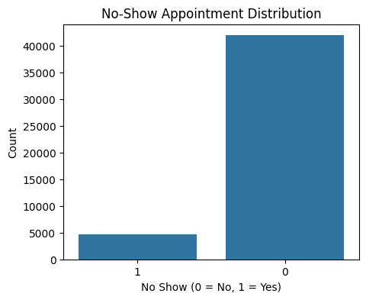
The distribution shows a significant imbalance: far more patients attended their appointments than missed them. This imbalance is critical because models trained on such data may favor the majority class, necessitating the later application of SMOTE to balance the training set.
Next, numerical feature distributions were analysed to explore demographic, clinical, and environmental characteristics. These plots show substantial variation across features such as age, rainfall, and ambient temperature.
Figure 3: Correlation Heatmap
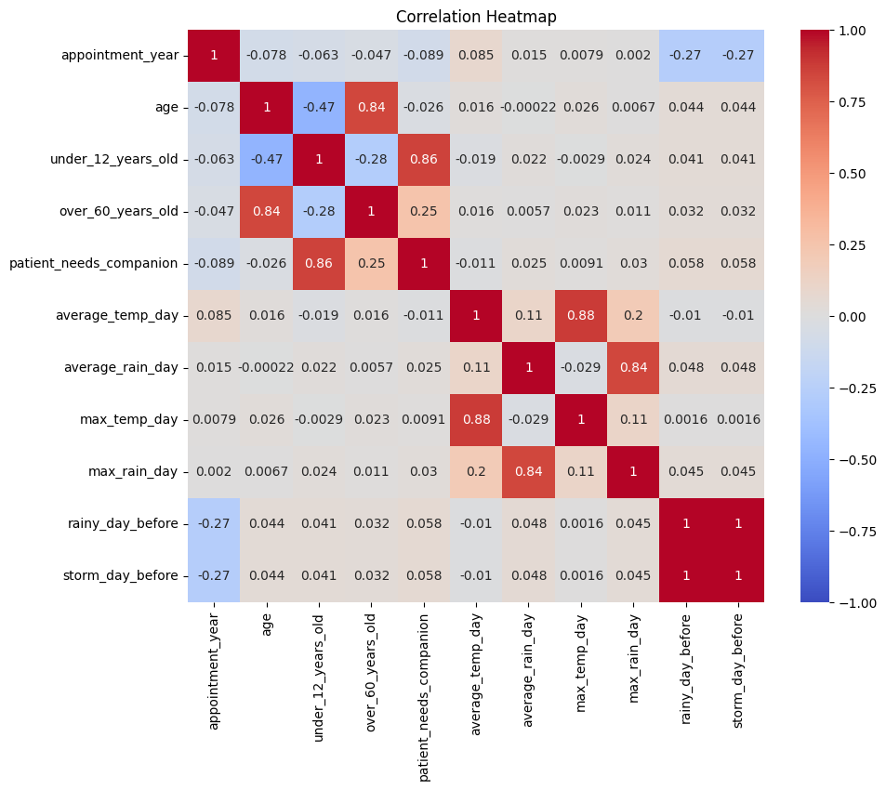
Strong correlations appear among weather features, particularly between average_temp_day and max_temp_day, and between rainfall measures. However, most demographic or appointment-related variables show weak correlations with one another and with the no-show outcome. This suggests attendance behaviour may depend on non-linear interactions that require advanced models like gradient boosting or neural networks to capture effectively.
There are no visually distinct clusters separating no-show and attended appointments, reinforcing the need for complex modelling approaches capable of capturing subtle structural patterns within the data.
Finally, outlier detection was performed to identify extreme values.
Extreme values appear in features like age, average_rain_day, and max_rain_day. Outliers in weather variables are expected given natural variability, while the age outliers may reflect data entry inconsistencies or genuine rare cases. Most models used later (e.g., XGBoost, CatBoost) are robust to such irregularities, reducing the need for aggressive outlier removal.
The EDA reveals a dataset with rich demographic diversity, multiple environmental dimensions, and significant class imbalance. Correlations remain modest, suggesting that non-linear models are appropriate. The insights gathered guide preprocessing strategies, model selection, and performance interpretation in subsequent stages.

Results and Conclusion

Results
The results of the four predictive models—Logistic Regression, Neural Network (MLP), CatBoost, and tuned XGBoost—demonstrate clear differences in their ability to detect patient no-shows. While training performance for Logistic Regression, CatBoost, and XGBoost appears strong, particularly in terms of accuracy and precision, the true measure of model usefulness lies in how well these models generalise to unseen data.
On the test set, accuracy remains high for Logistic Regression (0.897), XGBoost (0.897), and CatBoost (0.916), yet these values obscure the models’ inability to correctly identify missed appointments. Logistic Regression and XGBoost show extremely poor recall (0.10 and 0.09 respectively), meaning they fail to capture the majority of patients who will not attend their appointments. CatBoost improves on this with a recall of 0.23, offering a more balanced performance but still missing a substantial proportion of no-shows.
The Neural Network (MLP), despite having the lowest test accuracy (0.67), achieves the highest recall (0.51) among all models. This indicates that the MLP is far more sensitive to detecting no-shows, identifying over half of the missed appointments—an important accomplishment given the clinical implications of failing to anticipate these events. Although its precision is low, producing more false alarms, the MLP aligns better with the goal of early identification of at-risk patients.
In summary, if the primary objective is detecting as many no-shows as possible, the Neural Network outperforms all other models in recall and offers the strongest contribution to a practical intervention system.

Critical Discussion
The comparative performance of the four models highlights the impact of metric choice on model selection. In typical predictive modelling tasks, accuracy is often used as a primary measure; however, in a healthcare context—where the goal is to anticipate missed appointments—recall becomes more important than accuracy. A model that fails to flag at-risk patients may lead to preventable resource wastage, delayed treatments, and reduced clinic efficiency.
Under this lens, the Neural Network (MLP) becomes the strongest candidate despite having lower accuracy. Its recall of 0.51 on the test set significantly surpasses CatBoost (0.23), Logistic Regression (0.10), and XGBoost (0.09). This means the MLP correctly identifies more than half of the actual no-shows, providing meaningful opportunities for intervention strategies such as reminders, rescheduling, or support services. Its lower precision indicates more false positives, but in this use case, false positives are less harmful than false negatives. A clinic would generally prefer to overestimate risk than miss patients who truly need additional outreach.
Conversely, models like Logistic Regression and XGBoost demonstrate classic signs of overfitting. Their extremely high precision and accuracy on the training set contrast sharply with their poor recall on the test set. This suggests that while they learned patterns present in the training data, they failed to generalise these patterns to new data, especially with respect to the minority class. CatBoost performed better than the other traditional models, achieving a recall of 0.23, likely due to its sophisticated handling of categorical variables. Nevertheless, this recall remains substantially lower than that achieved by the Neural Network.
The MLP's comparatively high recall suggests that its non-linear architecture and capacity for learning more complex patterns allow it to capture subtle behavioural cues associated with missed appointments. It may be benefiting from interactions that tree-based models do not prioritise.
Overall, while the MLP’s lower accuracy indicates more noise in its predictions, its strength in recall makes it the most clinically useful model for early risk detection. This aligns with the strategic priority of reducing missed appointments rather than simply maximizing correct predictions.

Conclusion
The evaluation results show that while tree-based models such as CatBoost, Logistic Regression, and XGBoost achieve high accuracy, they struggle to identify patients who are likely to miss appointments. Their low recall values make them less effective for clinical intervention systems that depend on early detection.
In contrast, the Neural Network (MLP) delivers the highest recall on the test dataset, correctly identifying over half of the true no-shows. Although this model exhibits lower accuracy and precision, its sensitivity to the minority class makes it the most valuable model when the priority is preventing missed appointments. For healthcare operations, recall is more critical than overall accuracy, as correctly identifying at-risk patients enables proactive steps to reduce disruptions.
Therefore, the Neural Network stands out as the best model for this specific application, offering the greatest practical impact despite trade-offs in other metrics. Further improvements—such as tuning network architecture, incorporating class weights, or adding behavioural features—could enhance its precision without sacrificing recall.

