ASSIGNMENT 4

Avishek Roy

2020-09-25

# Markdown Basics

## Favorite Foods

1. Pizza
2. Smoothies
3. Pineapple

## Images

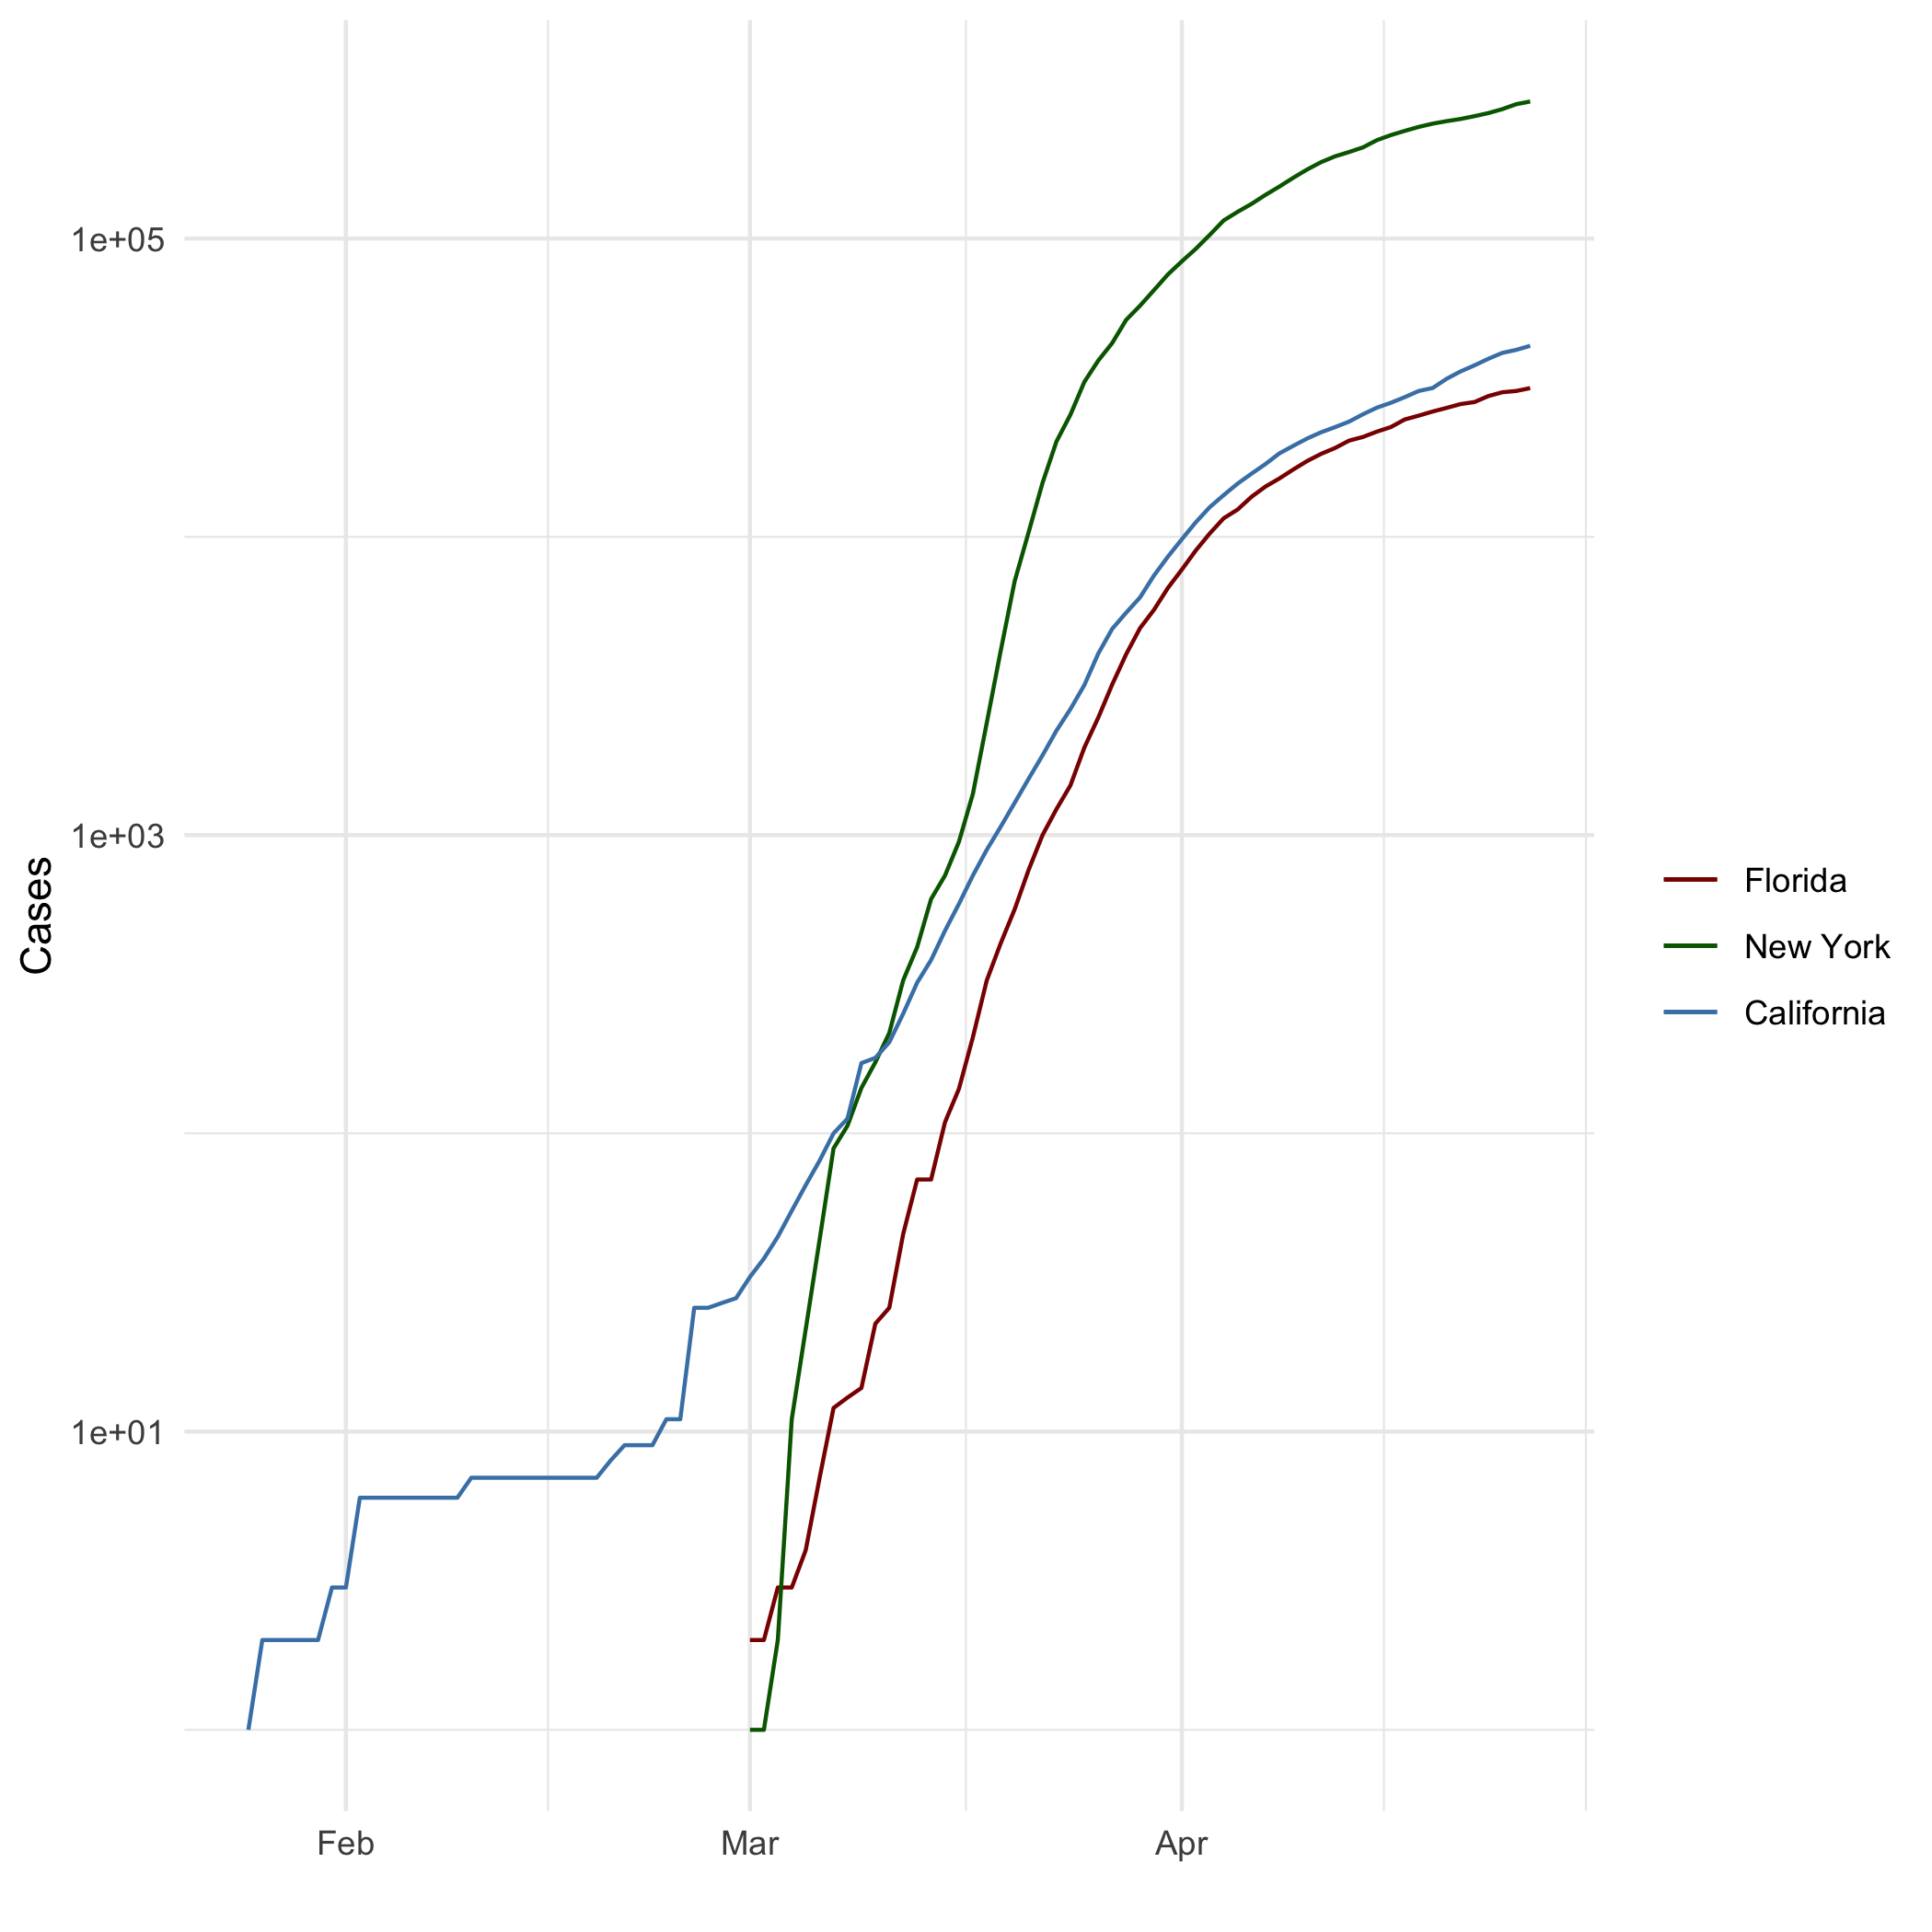

alt text

## Add a Quote

Pain is temporary , quitting lasts forever

## Add an Equation

$$e=mc2$$

## Add a Footnote

This is a footnote

## Add Citations

* R for Everyone
* Discovering Statistics Using R

# Inline Code

## NY Times COVID-19 Data

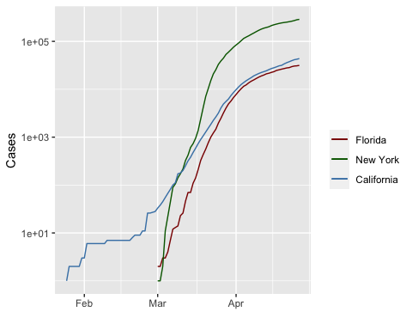

## R4DS Height vs Earnings

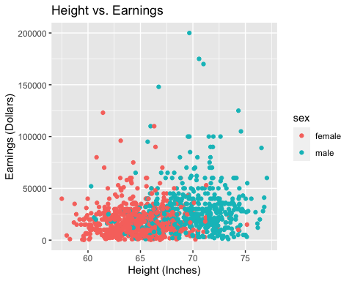

# Tables

## Knitr Table with Kable

One Ring to Rule Them All

|  |  |  |  |  |
| --- | --- | --- | --- | --- |
| name | race | in_fellowship | ring_bearer | age |
| Aragon | Men | TRUE | FALSE | 88 |
| Bilbo | Hobbit | FALSE | TRUE | 129 |
| Frodo | Hobbit | TRUE | TRUE | 51 |
| Galadriel | Elf | FALSE | FALSE | 7000 |
| Sam | Hobbit | TRUE | TRUE | 36 |
| Gandalf | Maia | TRUE | TRUE | 2019 |
| Legolas | Elf | TRUE | FALSE | 2931 |
| Sauron | Maia | FALSE | TRUE | 7052 |
| Gollum | Hobbit | FALSE | TRUE | 589 |

## Pandoc Table

#pandoc.table(characters_df, style = 'rmarkdown')

# References