Surrogate City Finder
Tool Architecture — Open-Data Edition
Web tool for shortlisting best-matched EnergyPlus weather files for any location
Based on: Garg V., Nikhil T.V.S., Rallapalli H., Bhatia A., Subhash J., Kasireddy C., "Surrogate City Finder — Weather Data Tool", Proceedings of BS2015, IIIT Hyderabad
August 2026

1. Purpose and Background
Weather data is a key input for building energy simulation, but many locations have no readily available weather file in EnergyPlus (EPW) format. Choosing the geographically nearest file can be misleading — two nearby locations may have very different climates. The Surrogate City Finder (SCF) addresses this by shortlisting, for any input location, the weather-file locations whose latitude, altitude and monthly temperature profile best match it, ranking them by root-mean-square (RMS) temperature error exactly as described in the BS2015 paper. Validation in the paper showed that annual energy consumption simulated with a surrogate city’s weather file deviates from the true location by roughly two percent in most cases.
The original 2015 implementation depended on the Google Maps, Places, Charts and Elevation APIs, scraped city temperatures from Wikipedia’s infobox HTML, and relied on a server-side city-climate database that was later lost. The tool has been rebuilt end-to-end on free and open data services, with no API keys required anywhere, and the lost candidate-city database has been replaced by a bundled worldwide index of EnergyPlus weather-file locations.

2. High-Level Architecture
The system is a classic three-tier web application: a browser front end (two HTML pages), a Python Flask back end, and a data layer consisting of a bundled station index plus a self-populating climate cache. External services are deliberately split between the two sides: interactive, per-user services (geocoding, map tiles, weather-file downloads) are called directly from the browser, while bulk climate-data acquisition is done server-side so results can be cached and shared across all users.
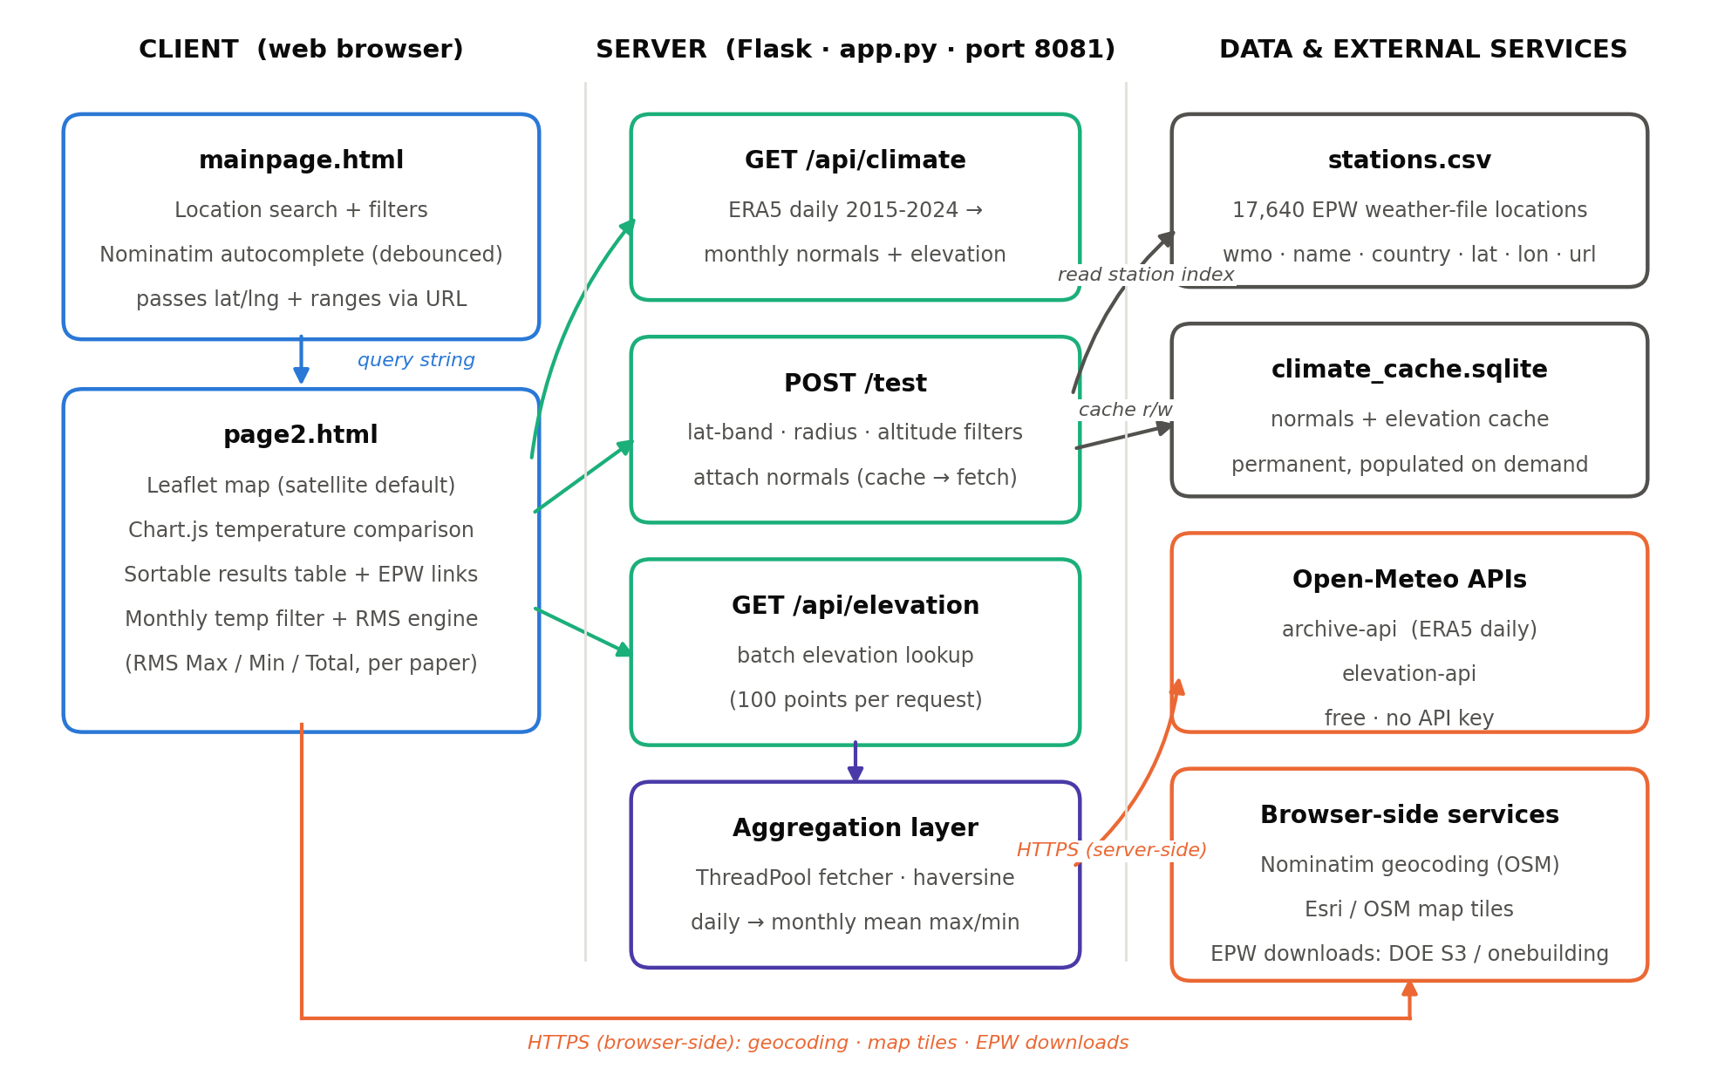
Figure 1 — System architecture and data flows

3. Front End

3.1 Landing page (templates/mainpage.html)
The landing page collects the two inputs the algorithm needs: a location and the filter ranges. Location entry uses a debounced autocomplete backed by OpenStreetMap’s Nominatim geocoder; selecting a suggestion captures the place name, state, country and coordinates. The filter panel mirrors Figure 1 of the paper: latitude range (±°), altitude range (±m), average high and low temperature ranges (±°C) and a distance radius (km). Submitting navigates to the results page with all values in the query string, using the same parameter names as the 2015 tool so bookmarks and legacy links keep working.

3.2 Results page (templates/page2.html)
The results page performs the entire matching workflow client-side, in three visual components backed by one script. The map is Leaflet with a satellite base layer by default (Esri World Imagery, which draws no political boundaries; an OpenStreetMap street layer is available from the layer switcher). It shows the input location, the search-radius circle, dashed latitude-band limits, and one marker per matched station, each with a popup linking to the actual EPW file. The chart is a Chart.js line chart of monthly average daily maxima and minima; the input city is always plotted, and clicking any result row overlays that station’s profile for direct comparison. The table lists every candidate that passed all filters with its distance, elevation, RMS Max, RMS Min and RMS Total, is sortable by any column, and links each row to its weather-file download.

3.3 Matching logic in the browser
After the page loads, the script requests the input location’s climate normals from the back end, then requests candidate stations. Candidates are accepted only if every one of the twelve months satisfies both temperature conditions: the absolute difference in monthly average high is within the chosen Avg High range, and the difference in monthly average low is within the Avg Low range. (The original PHP applied only the high-temperature test; applying both is a deliberate correction.) For accepted candidates the three paper metrics are computed:
RMS Max = √( Σ (Tmax,candidate − Tmax,input)² / 12 ) summed over the 12 months
RMS Min = √( Σ (Tmin,candidate − Tmin,input)² / 12 ) summed over the 12 months
RMS Total = √( Σ (both squared-difference series) / 24 )
Results are presented sorted by RMS Total ascending, so the best surrogate city appears first.

4. Back End (app.py)
The back end is a single Flask application. It serves the two pages and static assets, and exposes three JSON endpoints. The legacy endpoint path from the 2015 tool is preserved as an alias so the original URL contract still functions.
Endpoint | Method | Role
/api/climate | GET | Monthly climate normals and elevation for one point (the input location). Computes monthly mean daily max/min from ten years of ERA5 daily data.
/api/elevation | GET | Elevation for one point, served from cache or the Open-Meteo elevation API.
/test | GET / POST | Candidate surrogate stations. Filters the station index by latitude band, distance radius and altitude range, attaches monthly normals to each survivor, and returns them as JSON. Also mounted at the legacy path /finder/surrogate/test.php.

Candidate selection is staged so that the cheap filters run before any network access: first a geometric prefilter (latitude band, then haversine distance within the radius, capped at the closest 400 stations), then the altitude filter using cached or batch-fetched elevations, and only then climate retrieval for the survivors. Stations whose climate is already cached are answered immediately; the remainder are fetched concurrently from Open-Meteo through a small thread pool and written to the cache. Server-side temperature aggregation reduces ten years of daily maxima and minima (ERA5 reanalysis, 2015–2024, local time zone) to twelve monthly means of each series — the same “monthly average high / low” quantities the paper takes from Wikipedia climate boxes, but available uniformly for any coordinate on Earth.

5. Data Layer

5.1 Station index (data/stations.csv)
The candidate database that backed the original tool was lost; it has been replaced by a bundled index of 17,640 unique weather-file locations covering 247 countries and territories, derived from the Ladybug Tools EPW map project, which aggregates the US-DOE EnergyPlus collection and the climate.onebuilding.org TMYx collections. Where a location is published by several programmes, one representative record is kept, preferring authoritative sources (IWEC, TMY3, CWEC, ISHRAE and similar) and otherwise the most recent TMYx period. Every record carries a direct download URL for its EPW archive, which is what makes each search result actionable for simulation work.
Column | Example | Meaning
wmo | 431170 | WMO or programme station identifier
name | Sholapur | Station / city name
country | IND | ISO-style 3-letter country code
latitude | 17.67 | Decimal degrees
longitude | 75.9 | Decimal degrees
source | ISHRAE | Weather-file programme
epw_url | https://…/IND_Sholapur…zip | Direct EPW download link

5.2 Climate cache (data/climate_cache.sqlite)
A single-table SQLite database keyed by coordinates rounded to three decimals stores, for every point ever queried, its elevation and the twelve monthly mean-daily-maximum and mean-daily-minimum values. The cache is permanent and self-populating: the first search in a new region triggers the Open-Meteo fetches (typically up to a minute), and every subsequent search touching the same stations is answered locally in milliseconds. No scheduled rebuilds are needed because climate normals change on decadal timescales.

6. External Services
Service | Called from | Used for
Nominatim (OpenStreetMap) | Browser | Location autocomplete and geocoding
Esri World Imagery tiles | Browser | Default satellite base map (no political boundaries drawn)
OpenStreetMap tiles | Browser (optional layer) | Street base map
Open-Meteo archive API | Server | ERA5 daily temperature series for normals
Open-Meteo elevation API | Server | Batch elevation lookups (100 points/request)
US-DOE S3 / climate.onebuilding.org | Browser | EPW weather-file downloads from result links

All services are free and require no API key or registration. Leaflet and Chart.js are vendored under static/vendor/ rather than loaded from a CDN, so the interface has no third-party JavaScript dependency at runtime. The only fair-use obligations are Nominatim’s request etiquette (the autocomplete is debounced accordingly) and normal attribution, which the pages display in their footers.

7. Deployment, Configuration and Demo Mode
The tool is self-contained: a Python virtual environment, pip install -r requirements.txt (Flask and Requests are the only dependencies) and python app.py bring it up on port 8081. No database server, no build step and no credentials are involved; the SQLite cache file is created automatically on first use. For multi-user deployment the Flask app can be placed behind any WSGI server (gunicorn, waitress) without code changes.
An offline demonstration mode exists for environments without internet access: python scripts/seed_demo.py creates a separate cache (data/demo_cache.sqlite) covering the region around Hyderabad, and starting the app with the environment variable SCF_DEMO=1 serves exclusively from it. Hyderabad and Sholapur are seeded with real published normals so the paper’s reference pairing (Table 2: Hyderabad → Sholapur) is reproduced; all other demo values are synthetic and the mode must never be used for real work.

8. Differences from the 2015 Implementation
2015 implementation | Current implementation
Google Maps + Places autocomplete | Leaflet + OpenStreetMap tiles; Nominatim geocoding
Google Charts (deprecated loader) | Chart.js 4 (vendored locally)
Google Elevation API | Open-Meteo elevation API
Wikipedia infobox HTML scraping | Open-Meteo ERA5 monthly normals (2015–2024)
Server-side MySQL city database (lost) | Bundled index of 17,640 EPW locations + self-populating SQLite cache
PHP back end (four scripts) | Single Flask application (app.py)
Only the Avg High filter applied | Both Avg High and Avg Low filters applied (bug fix)
Satellite (hybrid) Google base map | Satellite (Esri) base map — no political boundaries drawn

The user-facing workflow, the filter semantics, the RMS ranking and the query-string contract between the two pages are unchanged from the paper, so results remain directly comparable with the published validation.

