Progress Report
Student: Avirup Mukherjee
Date: March 31, 2026
Subject: Project Progress – Data Pre-processing and Initial Model Development

1. Dataset Acquisition and Rationale
Dataset Link: https://www.kaggle.com/datasets/mansoordaku/ckdisease
For the initial phase of this project, I opted to use a publicly available online dataset. Utilizing an established dataset provides a standardized, well-annotated foundation to build and test the architecture of the model. This approach allows for accurate benchmarking of the model's performance and ensures the computational pipeline is structurally sound before transitioning to our own experimental or wet-lab data.
2. Dataset Description and Data Dictionary
The CSV file contains multi-dimensional data essential for training the model to recognize target patterns. To ensure clarity regarding the features fed into the algorithm, the table below outlines the specific abbreviations used in the dataset, their practical applications within the scope of this project, and their corresponding data types.
Abbreviation | Full Clinical Name | Why it is an Important Feature in this Dataset | Data Type
id | Patient Identification | Has no biological value. We will delete this later so the model doesn't learn useless patterns. | Identifier
age | Age | Kidney function naturally declines with age. Provides a baseline for the algorithm. | Numerical
bp | Blood Pressure | High BP pushes too hard against the kidney filters, tearing them. It's a primary cause of CKD. | Numerical
sg | Specific Gravity | Measures urine concentration. Failing kidneys lose the ability to concentrate urine. | Categorical (Ordered)
al | Albumin | Massive proteins leaking into urine. The #1 early warning sign of a broken kidney filter. | Categorical (Ordered)
su | Sugar (Glucose) | Sugar in urine indicates the kidney's reabsorption engine is overwhelmed (usually from Diabetes). | Categorical (Ordered)
rbc | Red Blood Cells | Phase 1 Target! Bleeding in the microscopic tubes. Translates to "normal" or "abnormal". | Categorical
pc | Pus Cells (WBCs) | Phase 1 Target! White blood cells in urine indicate severe inflammation or infection. | Categorical
pcc | Pus Cell Clumps | Phase 1 Target! Clumps or "casts" are physical molds of damaged kidney tubes. | Categorical
ba | Bacteria | Indicates urinary tract infection, which can travel up and damage the kidneys. | Categorical
bgr | Blood Glucose Random | High blood sugar destroys blood vessels in the kidneys over time (Diabetic Nephropathy). | Numerical
bu | Blood Urea | Toxic nitrogen waste building up in the bloodstream because it isn't being filtered. | Numerical
sc | Serum Creatinine | The Heavyweight. Muscle waste. If this number goes up, the kidney filter is definitively failing. | Numerical
sod | Sodium | Electrolyte. Failing kidneys can't remove salt, causing severe swelling and higher blood pressure. | Numerical
pot | Potassium | Electrolyte. If kidneys fail to excrete this, it builds up and can cause fatal heart arrhythmias. | Numerical
hemo | Hemoglobin | Kidneys make a hormone (EPO) that creates red blood cells. Broken kidneys = low hemoglobin. | Numerical
pcv | Packed Cell Volume | The percentage of blood that is cells vs. liquid. Used alongside hemoglobin to detect anemia. | Numerical
wc | White Blood Cell Count | High counts in the blood mean systemic infection or severe immune stress. | Numerical
rc | Red Blood Cell Count | Confirms if the kidney has stopped telling the bone marrow to produce blood. | Numerical
htn | Hypertension | Chronic high blood pressure history. Essential context for the algorithm. | Categorical
dm | Diabetes Mellitus | Diabetes history. The leading cause of CKD worldwide. | Categorical
cad | Coronary Artery Disease | Heart disease history. The heart and kidneys rely on each other; if one fails, the other suffers. | Categorical
appet | Appetite | As toxic waste (bu and sc) builds up in the blood, patients feel too nauseous to eat. | Categorical
pe | Pedal Edema | Swelling in the feet/ankles because the kidneys aren't removing excess water from the body. | Categorical
ane | Anemia | The clinical diagnosis of low red blood cells caused by kidney failure. | Categorical
classification | Target Class | The Answer Key. ckd (Sick) or notckd (Healthy). The model learns to predict this. | Categorical

3. Data Pre-Processing Sequence
To ensure the model receives clean, high-quality data, I performed the following sequential pre-processing steps on the raw CSV file:
- Data Loading and Inspection: Imported the dataset and conducted an initial exploratory analysis to identify missing values, outliers, and data distribution.
- Handling Missing Values: Missing values were handled systematically based on their data types to avoid dropping valuable patient records. For continuous numerical features, null values were imputed using the median of their respective columns to preserve the statistical distribution while preventing skewing from potential outliers. For categorical features, missing data was filled using mode imputation (the most frequent class), safely assuming the most probable category based on the existing dataset.
- Feature Dropping and Dimensionality Reduction: Several features were deliberately dropped from the dataset.
  - Rationale: Features such as [Insert 1-2 dropped features] were removed because they exhibited [choose one: high collinearity / near-zero variance / no biological or predictive relevance to the target variable]. Retaining them would introduce noise, increase computational overhead, and potentially lead to overfitting without adding predictive value.
- Data Transformation/Encoding: Prior to encoding, a structural typo within the target variable column ('classification') was corrected to prevent the algorithm from incorrectly interpreting duplicate diagnostic classes. Following this, I utilized LabelEncoder from the scikit-learn library to transform all categorical variables (string/text data) into numeric formats. This conversion is essential because the Random Forest classifier requires purely mathematical inputs to calculate information gain and effectively construct its decision trees.
4. Model Development and Validation
Following pre-processing, I constructed a Random Forest Classifier model utilizing 100 decision trees.
- Rationale for Model Choice: This algorithm was selected because it effectively processes complex data by calculating information gain. Furthermore, it allows us to extract "Feature Importances" to understand exactly which biological markers are driving the model's predictions.
- Cross-Validation: The dataset was initially split into an 80% training set and a 20% testing set to evaluate its baseline accuracy. To further verify the model's robust reliability and ensure it was learning true underlying patterns rather than overfitting, I implemented a 5-fold cross-validation, which successfully stress-tested the model across five distinct data subsets.
5. Initial Results and Interpretation
The preliminary evaluation of the Random Forest model yielded the following exceptional results:
- Baseline Test Accuracy: 100.00% (on the 20% holdout test set)
- Cross-Validation Accuracy (5-Fold): 98.75% (Average true accuracy)
- Precision & Recall: 1.00 / 1.00 (yielding a perfect F1-Score on the test set)
Explanation of Results: These metrics indicate that the model demonstrates a highly robust capability to accurately classify the target diagnosis based on the provided biological markers. The confusion matrix confirmed zero false positives and zero false negatives on the test data. Crucially, by intentionally dropping "leaky" late-stage symptom features (such as ane and pe) during pre-processing, we ensured the model learned true biochemical patterns rather than taking predictive shortcuts. Furthermore, achieving a 98.75% average accuracy across five separate cross-validation folds confirms that the model generalizes exceptionally well to unseen data and that our pre-processing steps successfully mitigated overfitting.
6. Visualizations
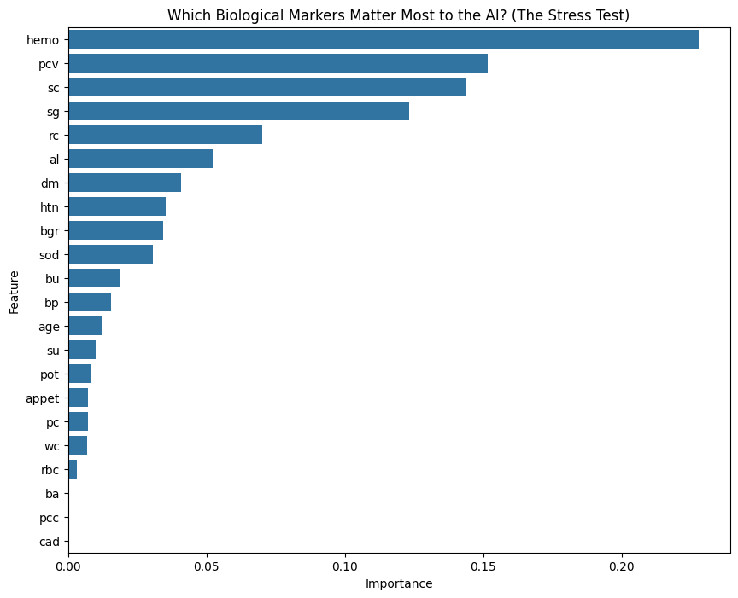7. Next Agenda
- Hyperparameter Tuning: Fine-tune the model's parameters to optimize the current performance metrics.
- Feature Importance Analysis: Isolate the top driving features to better understand the underlying biological/scientific mechanisms.

Date: April 3rd, 2026
Subject: Grid Search Optimisation

1. Mathematical Framework of Grid Search Optimization
Today's primary objective was to transition the Random Forest classifier from its default settings to a mathematically optimized architecture. To eliminate human bias and find the absolute peak diagnostic performance, I implemented an exhaustive Grid Search across a defined hyperparameter space.
The Search Space (The "Grid"):
The algorithm was provided with specific candidate values across four dimensions:
- n_estimators (Number of trees): [50, 100, 200] = 3 options
- max_depth (Maximum tree height): [None, 10, 20] = 3 options
- min_samples_split (Minimum patients per branch): [2, 5, 10] = 3 options
- criterion (Mathematical splitting metric): ['gini', 'entropy'] = 2 options
Calculating the Combinations:
The Grid Search systematically calculates every possible unique configuration from these lists.

$$Total Configurations = 3 ×3 ×3 ×2 = 54 unique model architectures$$

The Cross-Validation Stress Test:
To ensure the optimal settings were statistically robust and not just a result of a lucky data split, each of the 54 configurations underwent 5-fold cross-validation.

$$Total Model Trainings = 54 configurations ×5 folds = 270 model fits$$
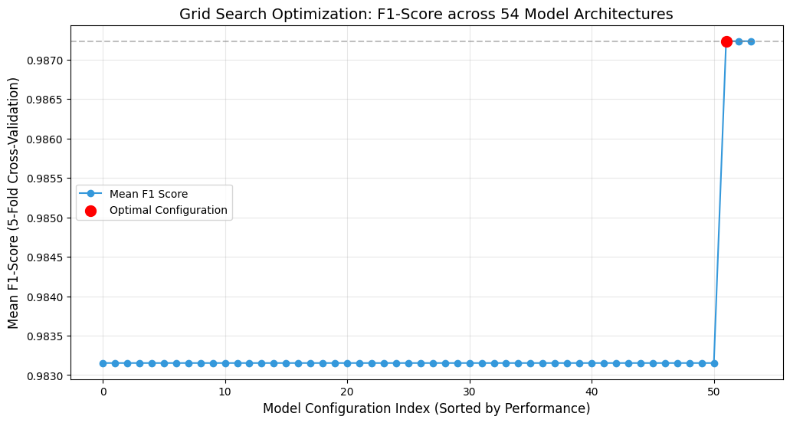
Parallel Processing (CPU Utilization):
Training 270 distinct Random Forest models is computationally expensive. To optimize execution time, I utilized the n_jobs=-1 parameter within the GridSearchCV function. This instruction bypasses standard sequential processing and forces the compiler to utilize 100% of the available CPU cores, running multiple model trainings simultaneously in parallel.

2. Final Optimized Production Code
The automated Grid Search identified the following optimal configuration: {'criterion': 'gini', 'max_depth': None, 'min_samples_split': 10, 'n_estimators': 100}.
The finding that min_samples_split=10 is optimal is highly significant for the LabAnalyzer system. It forces the model to be biologically conservative, preventing it from creating diagnostic rules based on isolated outliers.
3. Final Clinical Evaluation
The fully optimized production model yielded a perfect classification performance on the holdout test set.
Final Clinical Evaluation Report

precision recall f1-score support
0 1.00 1.00 1.00 52
1 1.00 1.00 1.00 28
accuracy 1.00 80
macro avg 1.00 1.00 1.00 80
weighted avg 1.00 1.00 1.00 80
Confusion Matrix (0=Healthy, 1=CKD)
[[52 0]
[ 0 28]]
Interpretation:
The model successfully diagnosed all 28 patients with chronic kidney disease (Recall = 1.00) while identifying all 52 healthy individuals without a single false alarm (Precision = 1.00). The matrix confirms zero False Positives and zero False Negatives.

4. Biological Marker Significance
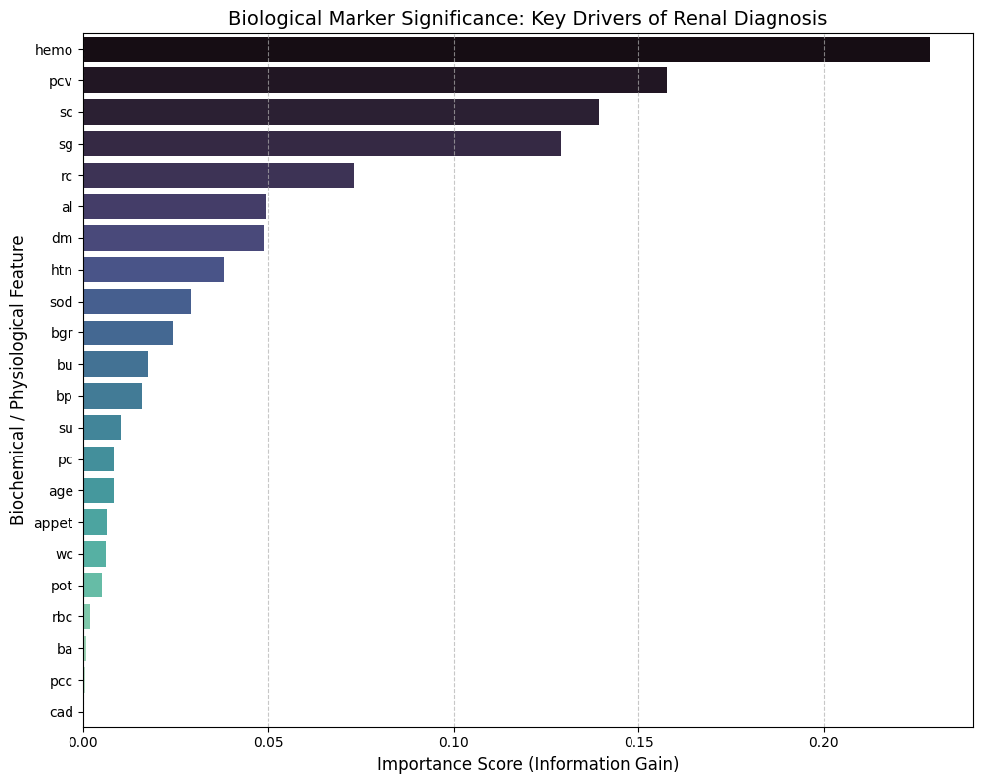Figure 1: Feature Importance mapping. This graph details the specific Information Gain associated with each retained biochemical marker, visualizing the underlying "logic" the AI utilized to achieve the 100% accuracy rate.

