**TO-DO-LIST**

* Project Description: - This project is aimed to create a live to-do-list management system, where every user is able to create a list followed by item name and sub item name.

The following technologies have been used to create this project: -

**Front End**: - HTML, CSS3, Angular 7

**Back End**: - Node.js, Express.js and Socket.io

**Server**: - Mongo DB

Every user should sign up at the beginning and need to fill the required parameters like: - First name, Last name, Email, Password and Country code and Mobile Number.

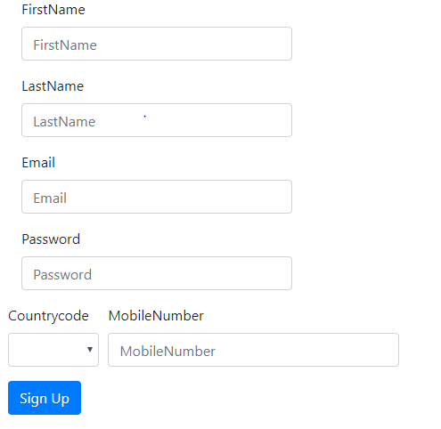

Once done user will be forwarded to login page where user has to provide Email and password, if user forgot his/her password user can able to reset it by providing Email and a temporary password will be generated to his/her Email and later user can update it.

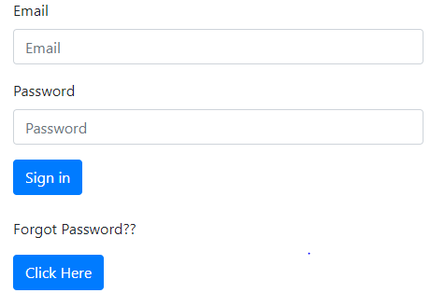

Once Login user can see his old To-do-list and he/she can able to add new item or sub-item to it. He/she can also be able to edit and delete the existing list.

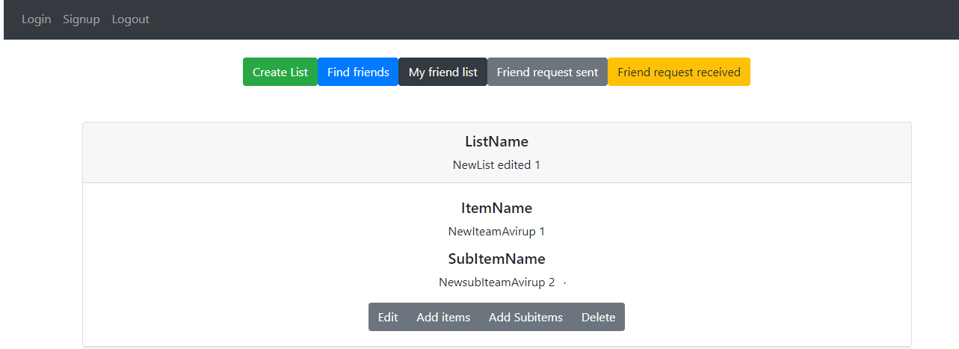

A separate option will be there if user wants to create a new to-do-list.

User can also able to send friend request to other user and a notification will be send in real time to the accepter. Once friend request accepted again notification will be generated in real time to both end and friend will be added in friend list.

All friends have the privilege to edit and delete friend’s to-do-list. Once done on every changes notification will be generated in real time to all the friends containing what changes has been done by which friend.

* GitHub Link: - https://github.com/avirup1994/Todolist backend

https://github.com/avirup1994/Todolist frontend

* URL: - www.mytodolist.xyz