Login as root to server (password is root or r00t or Un!X-11 or IronMan or r1nf1! Or 4Getit$ Or oracle Or Cramer@OSS0123)

Cramer@OSS0824

Cramer@OSS0225
After boot the server illin3643 do:
/etc/init.d/ds_agent stop

New: Un!X-11amdocsoss
l3amc:x:6032:100:l3amc user:/ossusers1/oss/users/l3amc:/bin/ksh
Oracle pass: 4Getit$

Root password cmm0028 & inoscmm003:
r1nf1!
Perforce:
Host/port: illin1697:1666
User/pass: mb_cccmm/Ccm4cmm7!
mb_cccmm2@iloscmm161 (Ccm4cmm7!)

Jumper: ssh cmmamc@cmildev130
HF TOOL DB: tooladm/tooladm@CMMTOOLS
ASM:
http://inoscmm022.corp.amdocs.com:30801/ASMAdminUI/
http://amxwlsom01.clarochile.org:30101/ASMAdminUI/
http://amxwlsom05.clarochile.org:30101/ASMAdminUI/
amcAdmin/Admin11
CLIPS Jenkins:
jenkins@indlin4678 (Unix11!)

COMMONALITY Jenkins:
sctool@illin1772

Unix11!

http://illin1772:7070/

property file on NAS
/infraoss/comcastmm/STORAGE/INFRA/CI/SOM_AD/Installation_Scripts/config/somwrk1_illnqw1976.properties
property file for ANN cmmadm@inoscmm003:/infraoss/comcastmm/STORAGE/INFRA/CI/ANN/Installation_Scripts/config> ll cmmann11.properties

Mapping of branch
R1.1 :- E2E2
R1.2 :- Releasble :- SOM99 , SOM 52 , PLAB , local Cluster , CRT1 :- 5000
R2.1 :- AD_Support :- 1620, 1629,E2E1 :- 6013
R2.2 :- DevMain :- 6000

4. Mount the NAS
vi /etc/fstab
#######################for israel
raaisilon:/ifs/vipr/VPFILEGSISLN133DLVOSS1/Delivery/PRJILGSFILEGSISLN133DLVO/VIPR_VRO_FILE_GS_ISLN_133_DLV_OSS1_infraoss_TFC /infraoss/tfc nfs rw,suid,soft,retry=4,nolock 0 0
#######################for india
ibox1443nfs1:/infraoss_tfc /infraoss/tfc nfs rsize=65536,wsize=65536,nolock,noacl,noatime 0 0

mount -a

mount /infraoss/l3

Jumper: ssh cmmamc@cmildev130

PLAB (SOM):
cmildev130:~cmmamc→site→plab
(unix11)

SOM:
E2E2: cmmsom21@mwhlvcmeoss02
E2E2:- somwrk1@mwhlvcmeoss02

E2E1: cmmsom21@mwhlvcmeoss01
somwrk1@mwhlvcmeoss01

CRT1: somwrk1@mwhlvcmeoss03
ARM:
QA1 ossenv0@10.26.225.4 (QA1rm10!) (cramer/cRameRQA1@ICRMQA11)
QA2 ossenv1@10.26.225.4 (QA2RM10!) (sqlplus CRAMER/cRameR2@ICRMQA21)
CRT1: ossenv0@10.26.225.4 (QA1rm10!)
USM:
QA1 ossusm1@10.26.226.106 (ComcastQA1!)
QA2 ossusm1@10.26.226.107 (Infra11!)
CRT1: ossusm1@10.26.226.106

ASD:
QA1: ossand0@10.26.226.20 (ComcastQA1!)
QA2: ossand1@10.26.224.157 (ComcastQA2!)
E2E2: ossand1@10.26.226.20 ( ASD_E2E2/ASD_E2E2@clipdb-dt-2grd.ula.comcast.net:1555/ICRMQA11 )

E2E1 ossand2@10.26.224.157)
itvasd@10.26.226.39 (Unix11!)

ANN
QA1: ossann0@10.26.226.20 (ComcastQA1!)
QA2 ossann1@10.26.226.192 (ComcastQA2!)
REPRT:
QA1 ossrep1@10.26.223.188 (RepQA1!)
QA2 ossrep1@10.26.226.192 (REPQA2!)

Remotedesktop for Report:

24.40.50.181
CRAMRD-WC-01P\ernesto
Welcome123

ARM QA1/2 restart:

1.startadmin

2.startnodemanager

3.startmanaged

CI env:
cmmci01@iloscmm087

INDIA NAS SERVER:

cmmadm@inoscmm003

/infraoss/comcastmm/STORAGE/BUILDS/rm/801

Login to password page:
http://10.26.224.137:8080/wiki/doku.php?id=infra:infra_codes

deepali/Feb@2016

login to site:

- Via chrom on my desktop login to http://gssnaweb1/
- Put user avisaa and get the token from RSA

Hi Team,

For running the provided sequence please copy the script to E2E2 and run it with the following parameters:

./reset_odo_cpq_seq.ksh somwrk1_DB/somwrk1_DB@CMMOSS02 CPQSRV1/CPQSRV1@CMMCME02 ASD_E2E2/ASD_E2E2@clipdb-dt-2grd.ula.comcast.net:1555/ICRMQA11 CPQCPQ1/CPQCPQ1@CMMCME02

Send mail to "cmmadm@cmm0028.corp.amdocs.com" with following subject patterns

To check ENV status [ Subject: ENV_STATUS|ENVNAME ]
eg : ENV_STATUS|CMMSOM99

To Restart the ARM/ASD/USM [ Subject: RESTART_ENV|ENVNAME|PRODUCT_NAME ]
eg : RESTART_ENV|cmmarm10@inoscmm082|ARM

To Take Backup of SOM Envrionment [ Subject: BACKUP_ENV|ENVNAME ]
eg : BACKUP_ENV|cmmsom50@inoscmm050

TO Clone SOM Environment [ Subject: SOM_CLONING|SOURCE_ENVNAME|TARGET_ENVNAME ]
SOURCE_ENVNAME=Details of the Environment from where data needs to be copied
TARGET_ENVNAME=Details of the Target Environment where data will be copied
eg: SOM_CLONING|cmmsom99@inoscmm111|cmmsom50@inoscmm050

TO Upgrade ASD Environment [ Subject: ASD_UPGRADE|ENVNAME|BRANCH_NAME|BUILD_NUMBER ]
eg: ASD_UPGRADE|cmmasd29@inoscmm191|DevMain|LAST
BRANCH=DevMain,PI6, PI6_MACD, PI7, PI8, PI9, b_stage_DE_11111, b_Releasable_Branch_DE_33333, b_Integration_Branch_DE_22222

To Do Indexing on SOM Envrionment [ Subject: INDEXING|ENVNAME ]
eg : INDEXING|cmmsom50@inoscmm050
eg : INDEXING|E2E2

TO Clone SITE, E2E2/CRT1/E2E1 SOM Environments [ Subject: SITE_CLONING_SOM|SOURCE_ENVNAME|TARGET_ENVNAME ]
SOURCE_ENVNAME=Details of the Environment from where data needs to be copied
TARGET_ENVNAME=Details of the Target Environment where data will be copied

Jenkins job : http://cmm0028:7070/job/BUILDS_TO_SAVE/
Below is the Syntax for Subject
BUILDS_TO_SAVE|<branch_name>|<build_num>|<product_name>

Examples :
BUILDS_TO_SAVE|DevMain|LAST|ARM
BUILDS_TO_SAVE|Orion_DevMain|78|USM
BUILDS_TO_SAVE|AsdProduction|555| ASD
BUILDS_TO_SAVE|DevMain|672|SOM

1) For SOM99 to E2E2
eg: SITE_CLONING_SOM|cmmsom99@inoscmm111|somwrk1@mwhlvcme02
2) For E2E2 to CRT1
eg: SITE_CLONING_SOM|somwrk1@mwhlvcme02|somwrk1@mwhlvcme03
3) For SOM195 to E2E1
eg: SITE_CLONING_SOM|cmmst02@inoscmm195|cmmsom21@mwhlvcmeoss01

PFB steps How you add users to the list?
- Login to cmmadm@cmm0028
- cd /ossusers2/oss/users/cmmadm/MAIL_AUTO
- Goto the respective task/folder like SOM_CLONING in this case
- Open som_cloning.ksh or respective script
- Check for mailing list and a new one like || [ $SEND_MAIL == DheerajKumar.Chopra@amdocs.com ]

The job that run in Jenkins for clone site/e2e2/crt1/ene1: http://cmm0028:7070/view/Utilities/job/CLONING_SOM10.1_ENV_CMI/

The job that run in Jenkins for clone/copy ARM env:
http://cmm0028:7070/view/Utilities/job/ARM_IMPDP_DVCI_4/

Indexing
We have configured cleanIndexingRestart.sh on E2E1 and CRT1 at 1701 hrs CST. Scripts are having execute permissions on both the environments .

REQUEST:
Please set DEBUG is SOM env.

We just need to add below 2 lines in setenvServer.sh.

cmmsom56@iloscmm164:~cmmsom56/JEE/scripts>grep -i debug setenvServer.sh
export JAVA_DEBUG_FLAG="on"
export JAVA_DEBUG_PORT="22568"

Request:
Could you please clone the environments ARM01 at the earliest.

Prepare them from latest ARM 11.

Solution:

The job that run in Jenkins for clone ARM env:
http://cmm0028:7070/view/Utilities/job/ARM_IMPDP_DVCI_4/

The job that run in Jenkins for clone ARM env only cramer,cramer_script schema:
http://cmm0028:7070/view/Utilities/job/ARM_IMPDP_ISR/

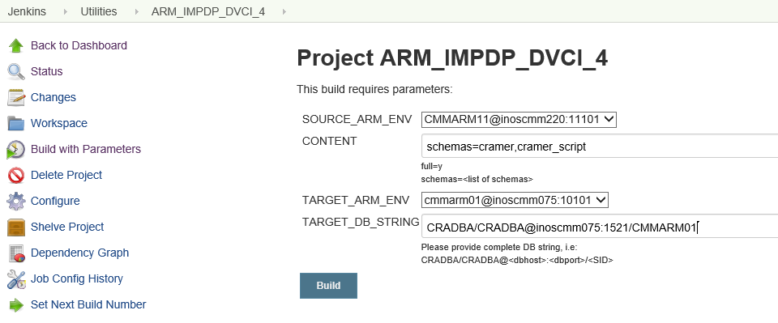

Request:

- We need to clone ARM55 DB from ARM11 backup (CMMARM11_201808141739) only cramer,cramer_script schema.
- Refresh ARM55 with R1 Rel # 87 build after clone.
Solution:

http://cmm0028:7070/view/Utilities/job/ARM_IMPDP_ISR/

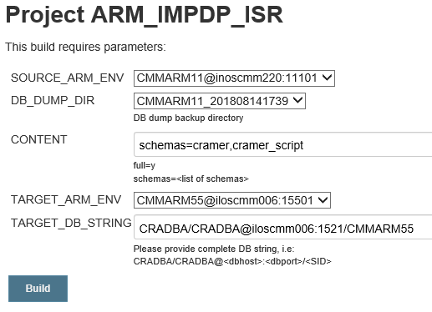
Request:
Debug port enabled or disable

Solution:
export JAVA_DEBUG_FLAG=off
export JAVA_DEBUG_PORT=30195
export JAVA_ENV=" ${USER_JAVA_ENV}"

Issue:
When trying to login to SOM GUI I am getting
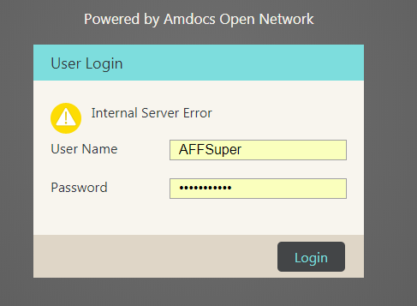

And I can see in log:

<Jun 17, 2018, 1:55:02,387 PM IDT> <Error> <Deployer> <BEA-149231> <Unable to set the activation state to true for the application "sfo [/]".
weblogic.application.ModuleException: java.lang.RuntimeException: Login has failed: Error in login step amdocs.uamsimpl.server.login.step.session.SessionStepModule$TraceSessionStep in commit method
at weblogic.application.internal.ExtensibleModuleWrapper.start(ExtensibleModuleWrapper.java:140)
at weblogic.application.internal.flow.ModuleListenerInvoker.start(ModuleListenerInvoker.java:124)
at weblogic.application.internal.flow.ModuleStateDriver$3.next(ModuleStateDriver.java:233)
at weblogic.application.internal.flow.ModuleStateDriver$3.next(ModuleStateDriver.java:228)
at weblogic.application.utils.StateMachineDriver.nextState(StateMachineDriver.java:45)
Truncated. see log file for complete stacktrace
Caused By: java.lang.RuntimeException: Login has failed: Error in login step amdocs.uamsimpl.server.login.step.session.SessionStepModule$TraceSessionStep in commit method
at com.amdocs.oss.common.core.services.security.impl.ASMSecurityService.login(ASMSecurityService.java:96)
at com.amdocs.oss.asmf.core.session.Session.predefinedLogin(Session.java:184)
at com.amdocs.oss.asmf.core.session.SessionProvider.initPredefinedSession(SessionProvider.java:184)
at com.amdocs.oss.asmf.core.session.SessionProvider.getPredefinedSession(SessionProvider.java:111)
at com.amdocs.oss.asmf.core.session.SessionProvider.getSession(SessionProvider.java:93)
Truncated. see log file for complete stacktrace
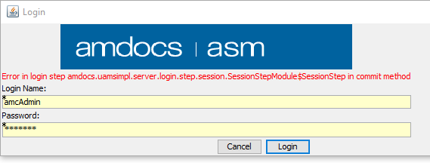
Solution:

Please login to the USM/ARM env which your SOM env is connected:

cmmusm02@iloscmm006:cmmusm02> sqlplus UAMS/UAMS@CMMUSM02

SQL> truncate table SEC_EVENT;
Table truncated.

SQL> truncate table SEC_SESSION;

Table truncated.

SQL> truncate table SEC_SESSION_IDLE;

Table truncated.

SQL> commit;

Commit complete.

SQL> exit
And try to login now.

user/pass: AFFSuper/AFFSuper123

Issue:

I got this request to change in the env
URL should be http://illin213:26500/CustomerProductSetup_EG

Solution:

Please login to the env

And update the file delivery.properties
cmmsom52@iloscmm136:~cmmsom52/pushToCC/dbp>vi delivery.properties
AMIL_URL_FOR_CPM=http://illin213:26500/CustomerProductSetup_EG
Then run updateCC

Issue:

Pointing cmmsom12@inoscmm026 to ARM03 instead ARM50

Solution:

Login to pushToCC/dbp/delivery.properties and update all ARM connect

Run updateCC

Please login to: cmmadm@inoscmm026:cmmadm> cd /infraoss/comcastmm/STORAGE/INFRA/CI/SOM_AD/Installation_Scripts/config

vi cmmsom12_inoscmm026.properties
Update the file with the new ARM

RM_APP_HOST=inoscmm040
RM_APP_PORT=10301
RM_DB_INST=CMMARM03

Request:

Hi Infra Team,

Oss Ui Shared lib was in failed status, in SOM51

Please reinstall UI Sharedl lib war.it will be fine.

Solution:

Please copy the Ui Shared from env 52 and put it in env51
Under: /ossusers1/oss/users/cmmsom51/JEE/dop/WLS/affDomain/servers/affServer/stage

cmmsom51@inoscmm204:~cmmsom51/JEE/dop/WLS/affDomain/servers/affServer/stage/ui-shared-lib

now login to 51 console:

http://inoscmm204:25100/console
(xpiadmin/xpiadmin@123)
Login to Deployments and click on install (you will see the war there)

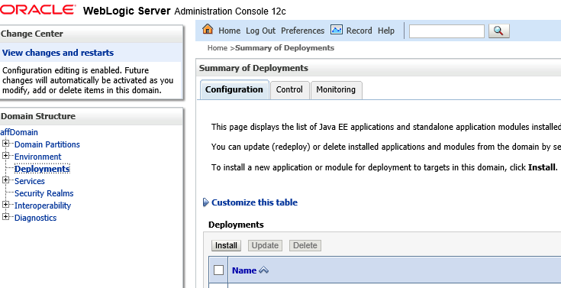

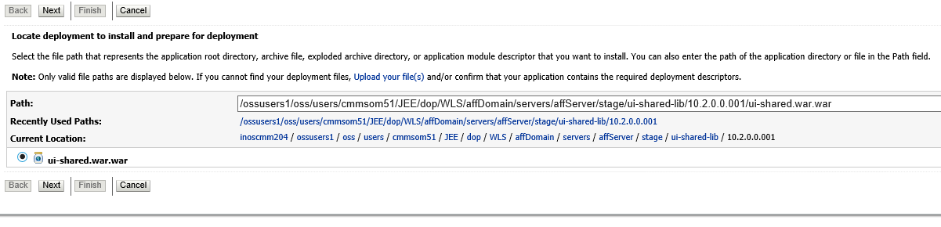

Then next all the way.
Then ask them to restart the env.

Issue:

I tried refreshing my env with build #2391 and I’m getting the following Error :

TASK [cc-utils : copy asm default to home] *************************************
fatal: [localhost]: FAILED! => {"changed": true, "cmd": "/opt/amdocs/fnd/central-config-utils1/activate.sh", "delta": "0:00:00.013150", "end": "2018-07-04 08:49:07.446648", "failed": true, "rc": 127, "start": "2018-07-04 08:49:07.433498", "stderr": "/bin/sh: /opt/amdocs/fnd/central-config-utils1/activate.sh: No such file or directory", "stderr_lines": ["/bin/sh: /opt/amdocs/fnd/central-config-utils1/activate.sh: No such file or directory"], "stdout": "", "stdout_lines": []}
to retry, use: --limit @/ossusers1/oss/users/cmmsom43/CentralConfig/deploy-cc-utils.retry

PLAY RECAP *********************************************************************
localhost : ok=4 changed=0 unreachable=0 failed=1

ERROR: Install Consul Server failed to execute !
Returned ERROR CODE while running CC installation, terminating script..
Build step 'Execute shell' marked build as failure
Finished: FAILURE

Solution:
You need to rebuild rpmdb

These are the steps :

login as root (password Un!X-11):
sudo rm -f /var/lib/rpm/__db*
sudo rpm --rebuilddb
setenv
sudo yum remove amdocs-central_config-utils-1.noarch
run the refresh again
Request:

Please change ARM configuration in SOM env’s cmmst01 and cmmst03 to ARM56

Solution:

- Login to cmmadm@inoscmm003 (Infra_11)
- Go to /infraoss/comcastmm/STORAGE/INFRA/CI/SOM_AD/Installation_Scripts/config
- vi cmmst01_inoscmm193.properties
- Update the following:

RM_APP_HOST=iloscmm071
RM_APP_PORT=15601
RM_DB_INST=CMMARM56

- We can take all details from ARM56 env (cmmarm56@iloscmm071)
Answer the mail and ask them to refresh again.

Problem:

When deploy HF from HF tool I am getting this errors:

Deploy operation [ARM_LOAD_JAVA_JAR] of file [IPControl.jar] to [cmmarm10@inoscmm082] failed, error: Execute deploy operation has failed, error: The following error has occured:
arguments: -u sqlplus s/***@CMMARM10 -r -v -synonym IPControl.jar
SQL Error while connecting with oci8 driver to CMMARM10: ORA-01017: invalid username/password; logon denied

Error while processing resource META-INF/MANIFEST.MF
Exception oracle.aurora.server.tools.loadjava.ConnectionError: could not open connection
SQL Error while connecting with oci8 driver to CMMARM10: ORA-01017: invalid username/password; logon denied

Or getting this error for USM:

Deploy operation [CLIPS_USM_Cramer_SQL] of file [107994_bkp.sql] to [usmwrk1@illnqw1434] failed, error: Execute deploy operation has failed! Seems that enviroment variable are missing in the deploy environemnt
Please check: The variables that used in Hot-fix Deploy Methods Screen are exist in the .profile as well

Solution:

Login to the ARM env and check in .profile that the HF variables user/password are correct

export HOSTNAME=`hostname`
export HOTFIX_DB_USER=CRAMER
export HOTFIX_DB_PASS=CRAMER
export HOTFIX_DB_INST=CMMDB1434
export HF_DB_USER=CRAMER
export HF_DB_PASS=CRAMER
export HF_DB_INST=CMMDB1434
export HF_CRAMERDB_USER=CRAMER
export HF_CRAMERDB_PASS=CRAMER
export HF_CRAMERSCRIPT_USER=CRAMER_SCRIPT
export HF_CRAMERSCRIPT_PASS=CRAMER_SCRIPT
export HF_CRADBA_USER=CRADBA
export HF_CRADBA_PASS=CRADBA
export wl_managed_server=CramerServer

Problem:

Getting this issue when trying to deploy HF in ARM

Deploy operation [ARM_HotfixMethod_deploy_Ears_Wars.ksh] of file [IPControlV9-ear.ear] to [cmmarm10@inoscmm082] failed, error: Execute deploy operation has failed, error:
Solution:

Add to .profile the following if they are missing:

< ### Server parameters added for MNGP run
< export DB_INST=CMMARM08
< export LEGACY_DB_INST=VFNZDM3
< export MNGP_DIR=/ossusers1/oss/users/cmmarm08/MNGP/Install
< alias main='cd /E2E_Execution; main'
export wl_managed_server=CramerServer

Request:

Hi Infra,

Please deploy below HF on E2E2 ENV :

• 300003577
• 300003556
• 300004065 and TRN185.

Solution:

Login to http://cmildev130:5555
This is the hf tool for these envs

And apply according to HF the

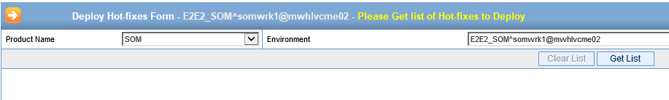

Request:

Refresh ARM50 with Upgrade mode with Build #55

Solution:

Please do the following in jenkins for refresh
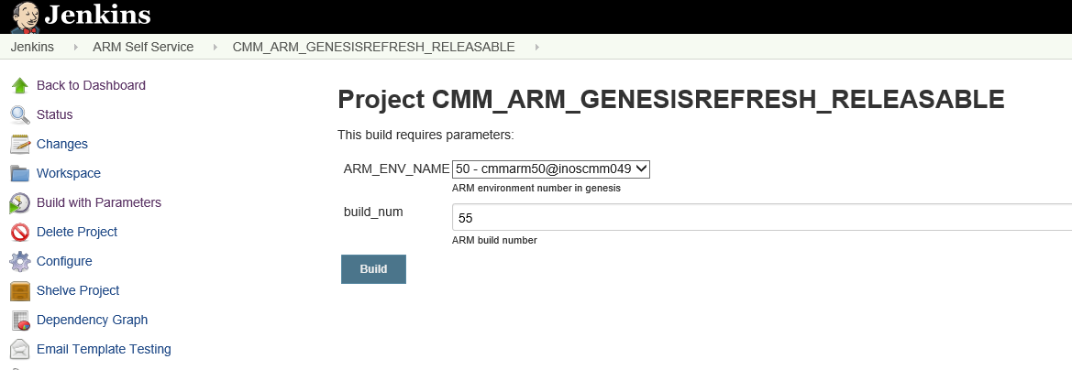

Request:

Please rebuild USM migration DB CMMUSM09 on inoscmm051 to be exactly as QA1 USM DB (metadata and tables structure)

Solution:

http://cmm0028:7070/view/USM%2010%20Self%20Service/job/CMM_USM_METADATA_REFRESH/

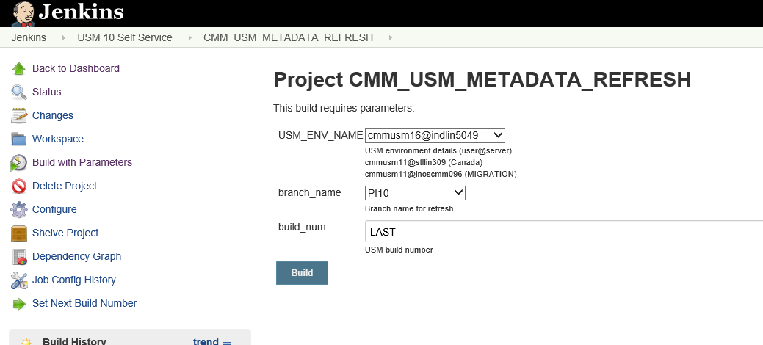

setenv ORACLE_HOME /oravl01/oracle/12.1.0.2
setenv PATH ${ORACLE_HOME}/bin:${PATH}
setenv ORACLE_SID L3STUSM4

To restart instance CMMINF57:
- Login to oracle@iloscmm057 (password: 4Getit$)
- Run :
setenv ORACLE_SID CMMINF57 (export ORACLE_SID=ATTAUA1)
sqlplus / as sysdba
shutdown immediate (shutdown abort)
startup;

CMMSOM78 /oravl01/oracle> lsnrctl

LSNRCTL> start

l3stusm4@illin2134.corp.amdocs.com:l3stusm4> psu -ef |grep pmon
oracle 13501 1 0 08:53 ? 00:00:00 ora_pmon_L3STUSM4
l3stusm4 14519 13063 0 08:55 pts/0 00:00:00 grep --color=auto pmon

ISSUE:

SQL*Plus: Release 19.0.0.0.0 - Production on Wed Jun 14 14:22:58 2023
Version 19.3.0.0.0

Copyright (c) 1982, 2019, Oracle. All rights reserved.

ERROR:
ORA-28547: connection to server failed, probable Oracle Net admin error

FIX:

restarting the listener:
stop and start

ISSUE:

PLDRMM15 /oravl01/oracle> sqlplus MNGP/MNGP@PLDRMM15

SQL*Plus: Release 12.2.0.1.0 Production on Wed Feb 8 10:05:36 2023

Copyright (c) 1982, 2016, Oracle. All rights reserved.

ERROR:
ORA-28000: the account is locked

Enter user-name: MNGP
Enter password:
ERROR:
ORA-28000: the account is locked

FIX:

Login with:
PLDRMM15 /oravl01/oracle> sqlplus / as sysdba

SELECT username, account_status, lock_date, PROFILE FROM dba_users WHERE account_status like '%LOCK%';

SELECT username, account_status, lock_date, PROFILE FROM dba_users WHERE account_status like '%EXP%';

ALTER USER CRADBA IDENTIFIED BY CRADBA ACCOUNT UNLOCK;

ALTER USER CRAMER IDENTIFIED BY CRAMER ACCOUNT UNLOCK;
ALTER USER ANN01METADATA IDENTIFIED BY ANN01METADATA ACCOUNT UNLOCK;
ALTER USER UAMS IDENTIFIED BY UAMS ACCOUNT UNLOCK;
ALTER USER CRAMER_COMMON IDENTIFIED BY CRAMER_COMMON ACCOUNT UNLOCK;
ALTER USER CRAMERDIRECTORY IDENTIFIED BY CRAMERDIRECTORY ACCOUNT UNLOCK;
ALTER USER CRAMER_SHARED IDENTIFIED BY CRAMER_SHARED ACCOUNT UNLOCK;
ALTER USER CRAMERSSO IDENTIFIED BY CRAMERSSO ACCOUNT UNLOCK;
ALTER USER CRAMER_INSTALLER IDENTIFIED BY CRAMER_INSTALLER ACCOUNT UNLOCK;

[oracle@ilospld184 mapper]$ pwd
/dev/mapper
[oracle@ilospld184 mapper]$ df -i /dev/mapper/vg00-var
Filesystem Inodes IUsed IFree IUse% Mounted on
/dev/mapper/vg00-var 320000 15256 304744 5% /var
[oracle@ilospld184 mapper]$

usmusr01@tfcwloss22.pai.tchile.local:usmusr01> sqlplus CRADBA/amdocs@tfcdboss22:1521/UATSUM22 AS SYSDBA

SQL> select * from global_name;

GLOBAL_NAME
--------------------------------------------------------------------------------
TFCLSM1

Problem:

[oracle@ntdevapp36 ~]$ sqlplus / as sysdba

SQL*Plus: Release 11.2.0.3.0 Production on Sun Sep 2 15:47:41 2018

Copyright (c) 1982, 2011, Oracle. All rights reserved.

Connected to an idle instance.

SQL> startup;
ORACLE instance started.

Total System Global Area 3457368064 bytes
Fixed Size 2233240 bytes
Variable Size 2113932392 bytes
Database Buffers 1325400064 bytes
Redo Buffers 15802368 bytes
ORA-00201: control file version 12.1.0.0.0 incompatible with ORACLE version
11.2.0.0.0
ORA-00202: control file: '/u01/app/oracle/oradata/ATTAUA1/control01.ctl'

Crate CRADBA user

CREATE USER CRADBA
IDENTIFIED BY CRADBA
DEFAULT TABLESPACE USERS
TEMPORARY TABLESPACE TEMP
PROFILE DEFAULT
ACCOUNT UNLOCK;

GRANT CRAMER$6L TO CRADBA WITH ADMIN OPTION;
GRANT CONNECT TO CRADBA;
GRANT IMP_FULL_DATABASE TO CRADBA;
GRANT EXP_FULL_DATABASE TO CRADBA;
GRANT DEVELOPER TO CRADBA WITH ADMIN OPTION;
GRANT RESOURCE TO CRADBA;
ALTER USER CRADBA DEFAULT ROLE ALL;
GRANT CREATE SESSION TO CRADBA;
GRANT DROP ANY ROLE TO CRADBA;
GRANT ALTER USER TO CRADBA;
GRANT UNLIMITED TABLESPACE TO CRADBA;
GRANT CREATE ANY CONTEXT TO CRADBA;
GRANT EXECUTE ANY TYPE TO CRADBA;
GRANT DROP USER TO CRADBA;
GRANT DROP PUBLIC SYNONYM TO CRADBA;
GRANT CREATE USER TO CRADBA;
GRANT CREATE ANY JOB TO CRADBA;
GRANT CREATE ANY DIRECTORY TO CRADBA;
ALTER USER CRADBA QUOTA UNLIMITED ON USERS;
GRANT ALTER SYSTEM TO CRADBA;
GRANT SELECT ON SYS.DBA_JOBS TO CRADBA;
GRANT SELECT ON SYS.DBA_JOBS_RUNNING TO CRADBA;
GRANT SELECT ON SYS.DBA_ROLES TO CRADBA;
GRANT SELECT ON SYS.DBA_ROLE_PRIVS TO CRADBA;
GRANT SELECT ON SYS.DBA_SCHEDULER_JOBS TO CRADBA;
GRANT SELECT ON SYS.DBA_SCHEDULER_RUNNING_JOBS TO CRADBA;
GRANT SELECT ON SYS.DBA_SEC_RELEVANT_COLS TO CRADBA;
GRANT SELECT ON SYS.DBA_USERS TO CRADBA;
GRANT EXECUTE ON SYS.DBMS_LOCK TO CRADBA;
GRANT EXECUTE ON SYS.DBMS_PIPE TO CRADBA;
GRANT EXECUTE ON SYS.DBMS_RLS TO CRADBA;
GRANT EXECUTE ON SYS.UTL_FILE TO CRADBA;
GRANT SELECT ON SYS.V_$INSTANCE TO CRADBA;
GRANT SELECT ON SYS.V_$PARAMETER TO CRADBA;
GRANT SELECT ON SYS.V_$SESSION TO CRADBA;

Solution:

cat /etc/oratab

export ORACLE_HOME=/u01/app/oracle/product/12.1.0/db_1

export PATH=${ORACLE_HOME}/bin:${PATH}

[oracle@ntdevapp36 ~]$ env | grep -i oracle
USER=oracle
ORACLE_SID=ATTAUA1
ORACLE_BASE=/u01/app/oracle
MAIL=/var/spool/mail/oracle
PATH=/u01/app/oracle/product/12.1.0/db_1/bin:/usr/local/bin:/bin:/usr/bin:/usr/local/sbin:/usr/sbin:/sbin:/u01/app/oracle/product/11.2.0/db_1/bin
PWD=/home/oracle
HOME=/home/oracle
LOGNAME=oracle
ORACLE_HOME=/u01/app/oracle/product/12.1.0/db_1

Problem:

CMMSOM62 inoscmm258 /oravl01/oracle > sqlplus / as sysdba

SQL*Plus: Release 12.2.0.1.0 Production on Thu Sep 27 15:25:35 2018

Copyright (c) 1982, 2016, Oracle. All rights reserved.

ERROR:
ORA-12170: TNS:Connect timeout occurred

Solution:
CMMSOM62 inoscmm258 /oravl01/oracle > vi .env_ora_host

Look for the instance CMMSOM62

Change it from 12.1.0.2 to 12.2.0.1

CMMSOM62:inoscmm059:/oravl01/oracle/12.2.0.1:AL32UTF8:1521::Y:

Problem:
The oracle path is not correct:

CMMSOM62 inoscmm258 /oravl01/oracle > env | grep -i oracle
HOME=/oravl01/oracle
USER=oracle
LOGNAME=oracle
PATH=.:/oravl01/oracle/12.1.0.2/bin:/oravl01/oracle/dba/BKUP:/oravl01/oracle/dba/dbmon:/local/bin:/usr/bin:/usr/bin/X11:/usr/contrib/bin/X11:.:/oravl01/oracle/12.1.0.2/bin:/usr/local/bin:/bin:/usr/bin:/usr/local/sbin:/usr/sbin:/opt/puppetlabs/bin:/oravl01/oracle/dba/dbmain/perl54hp/bin
PWD=/oravl01/oracle
MAIL=/var/spool/mail/oracle
ORACLE_DIR=/oravl01/oracle
ORACLE_MON=/oravl01/oracle/dba/dbmon
ORACLE_BKUP=/oravl01/oracle/dba/BKUP
ORACLE_SID=CMMSOM62
ORACLE_HOME=/oravl01/oracle/12.2.0.1
ORACLETOOLS=/oravl01/oracle/12.1.0.2
SHLIB_PATH=/oravl01/oracle/12.1.0.2/lib:/usr/lib:
LD_LIBRARY_PATH=/oravl01/oracle/12.1.0.2/lib:/usr/lib
PROCOB=/oravl01/oracle/12.1.0.2/bin/procob
PROCOB18=/oravl01/oracle/12.1.0.2/bin/procob18
PROC=/oravl01/oracle/12.1.0.2/bin/proc
LIBHOME=/oravl01/oracle/12.1.0.2/lib
ORACLE_TERM=vt100
ENV_PRECOMP=/oravl01/oracle/12.1.0.2/precomp
PCCINC=/oravl01/oracle/12.1.0.2/precomp/public

Solution:

setenv ORACLE_HOME /oravl01/oracle/12.2.0.1

setenv PATH $ORACLE_HOME/bin:$PATH

Problem:

Last login: Sun Oct 7 12:16:40 IST 2018 on pts/0
##################################################
instance is on a remote machine working with TWO_TASK
##################################################
##################################################
instance is on a remote machine working with TWO_TASK
##################################################

Solution:
unsetenv TWO_TASK

Request:
We get this request from Alex Markovich
You can install SOM as stand alone product.
For env somwrk1@illnqw1427

We login to the env and run it like this

somwrk1@illnqw1427
/users/gen/somwrk1/storage_root/Installation_Scripts/bin/install_som_ad_10.2.sh "root" na Full na

[‎7/‎15/‎2018 10:25 AM] Karla Arguedas:
http://ilcecmm018:5000/amc_ilcecmm018/
amcAdmin/Admin11
unix user/pass: tooladm/Unix11!
tooladm@ilcecmm018
Unix11!

Request:
Can you please delete the indexes , Restart the server and then do indexing again (solr indexing)
Solution:
- Delete the data folder from:

JEE/search-dist/tasks/data
JEE/search-dist/projatt/data

- Restart the SOM env.
- Login to http://inoscmm230:21150/search
http://illin4331.corp.amdocs.com:20200/search/
user/pass: weblogic/weblogic123
- xpiadmin/xpiadmin@123
- run for projatt and tasks: Execute then Refresh Status

http://iloslvl010.corp.amdocs.com:20800/search

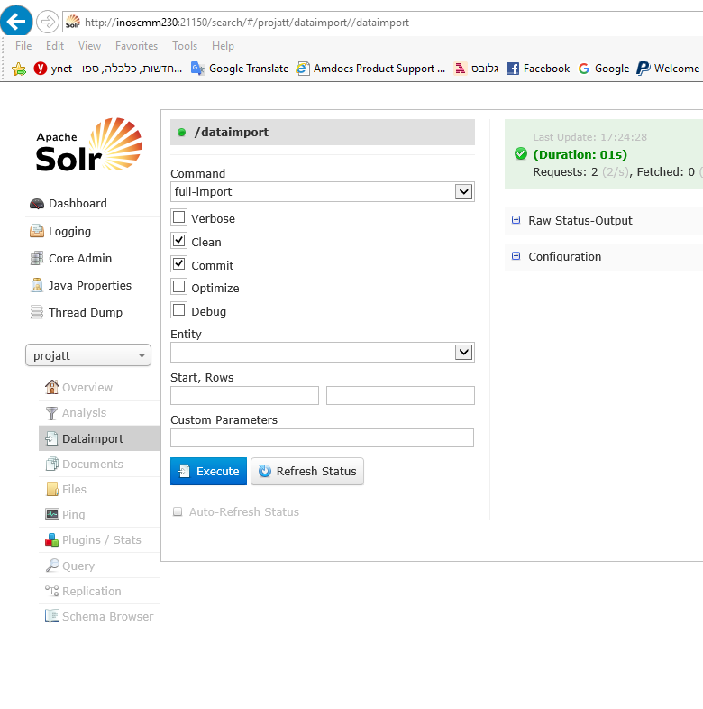

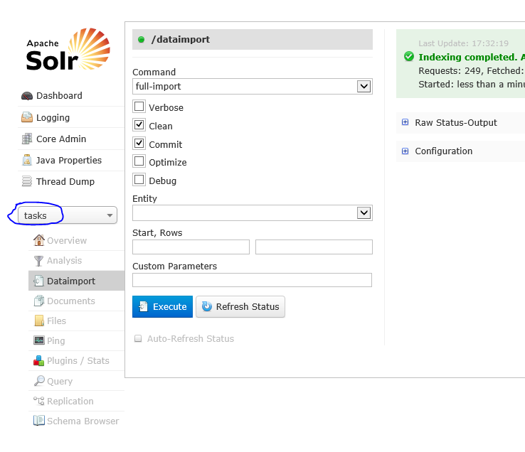
Problem:

Hi,

While running the FULL devMain refresh on SOM I am failing on this issue:

http://ilospru025.corp.amdocs.com:7070/job/SOM_INSTALLATION_prucls01_inospru139/414/console

"Failed to apply WLS configuration. check /ossusers1/oss/users/prucls01/acd/WLS/logs/puppet/installWLS.log"

In server inospru144 & inospru143

Any idea what can be the issue?

FIX:

It was described in the logs for WLS:

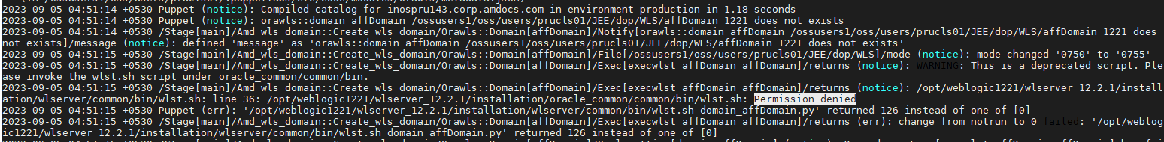
The fix was by replacing the weblogic under /opt/weblogic1221

Problem:

Oracle file sys is full.

Please login to
/oravl01/diag/rdbms/cmmsom78/CMMSOM78/trace

Clean the files:
find ./ -type f -name "*.trc" -mtime +90 -exec rm {} \; -print

Problem:

CMMSOM78 /oravl01/oracle> sqlplus CRADBA/CRADBA@CMMSOM78

ERROR:
ORA-12541: TNS:no listener

Enter user-name:
ERROR:
ORA-01017: invalid username/password; logon denied

Enter user-name:
ERROR:
ORA-01017: invalid username/password; logon denied

Solution:

CMMSOM78 /oravl01/oracle> lsnrctl

LSNRCTL> start

Problem:

Caused by: java.net.ConnectException: Tried all: '1' addresses, but could not connect over HTTP to server: 'iloscmm128.corp.amdocs.com', port: '49172'
failed reasons:
[0] address:'iloscmm128.corp.amdocs.com/10.234.101.53',port:'49172' : java.net.ConnectException: Connection refused

Solution:
In that case we just need to Boot the ASD env.

Every time we are getting issue with the port 49172 it’s mean there is a problem with ASD env.

The ASD env will be in the same place as SOM env.

cmmasd45@iloscmm128:/ossusers1/oss/users> ll
drwxr-xr-x 14 cmmasd45 wladmin 4096 Jul 21 23:33 cmmasd45
drwxr-xr-x 58 cmmsom45 cmmsom45 4096 Jul 22 16:43 cmmsom45

Status mail:
Get status my by:

Send mail to cmmadm@cmm0028.corp.amdocs.com and in subject provide ENV_STATUS|E2E2

Request:

Invalid objects are compiled, CramerDatasource restarted
ARM50 restarted and its up and running

Solution:

For compiled the ARM please login to tod as CRADBA/CRADBA as sysdba
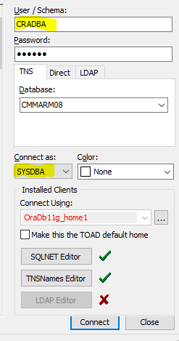

Problem:

ERROR: Install Consul Server failed to execute !
Returned ERROR CODE while running CC installation, terminating script..
Build step 'Execute shell' marked build as failure
Finished: FAILURE

Solution:

I checked the error and I found space issue under /usr

"msg": "\n\nTransaction check error:\n installing package amdocs-central_config-consul-1-10.0.0.pb02_RC02hf03-21.noarch needs 8KB on the /usr filesystem\n\nError Summary\n-------------\nDisk Requirements:\n At least 1MB more space needed on the /usr filesystem.",
"rc": 1,
"stderr": "\n\nTransaction check error:\n installing package amdocs-central_config-consul-1-10.0.0.pb02_RC02hf03-21.noarch needs 8KB on the /usr filesystem\n\nError Summary\n-------------\nDisk Requirements:\n At least 1MB more space needed on the /usr filesystem.\n\n",
"stderr_lines": [
"",
"",
"Transaction check error:",
" installing package amdocs-central_config-consul-1-10.0.0.pb02_RC02hf03-21.noarch needs 8KB on the /usr filesystem",
"",
"Error Summary",
"-------------",
"Disk Requirements:",
" At least 1MB more space needed on the /usr filesystem.",

I clean the space and run it again. (look in /usr/java if there is zip that you can delete)

Deploy ANY TRN related to CONF only (SFO_KitLayer.conf)

Hi Team,

Please use following method to deploy ANY TRN related to CONF only (No violation please)

- Go to Unix folder $HOME/JEE/config_files/asc/
- Update the conf in the unix box
- Run the script $HOME/deploy_asc.ksh

In case you got request to deploy TRN on any other env , Please copy below script at home directory and run it , $HOME/tempDeploy.ksh and $HOME/deploy_asc.ksh in case its missing

SOM cloning
Hi Team,
We have created job for SOM cloning as below.

- SOM195 to E2E1. (Tested and working fine.)
  - http://cmm0028:7070/view/Utilities/job/CLONING_SOM10.2_ENV_CMI/

- SOM99 to E2E2 and E2E2 to CRT1 (need to test this job on next request.)
  - http://cmm0028:7070/view/Utilities/job/CLONING_SOM10.1_ENV_CMI/

Problem:

Hi Infra Team ,
Build is failure because of MM distribution are getting some constraint violation issue. We will give MM by tomorrow.
Please skip MM and make a new build refresh as of now.
Console output : http://cmm0028:7070/job/CMM_ARM_GENESISREFRESH_RELEASABLE/68/console

Solution:
i removed this file from storage
/infraoss/comcastmm/STORAGE/BUILDS/rm/801/STORE_801_67
1.mm.list
Then run the refresh again on cmmarm50@inoscmm049.

For below error during 10.2 SOM refresh we need to apply below work around.
Problem:

Wiki Entry:- http://creativity/SpaceDirectory/Sites/Infra%20OSS/OSS%20Project/SOM%20AD%20Installation%20issue%20-%20Mismatch%20in%20fetching%20value%20from%20CC.aspx

FAILED - RETRYING: is running ? (1 retries left).Result was: {"censored": "the output has been hidden due to the fact that 'no_log: true' was specified for this result"}
Using module file /usr/lib/python2.7/site-packages/ansible/modules/commands/command.py
<localhost> EXEC /bin/sh -c 'echo ~ && sleep 0'
<localhost> EXEC /bin/sh -c '( umask 77 && mkdir -p "` echo /users/gen/somwrk1/.ansible/tmp/ansible-tmp-1534686895.88-246055010359426 `" && echo ansible-tmp-1534686895.88-246055010359426="` echo /users/gen/somwrk1/.ansible/tmp/ansible-tmp-1534686895.88-246055010359426 `" ) && sleep 0'
<localhost> PUT /tmp/tmpgSLrIb TO /users/gen/somwrk1/.ansible/tmp/ansible-tmp-1534686895.88-246055010359426/command.py
<localhost> EXEC /bin/sh -c 'chmod u+x /users/gen/somwrk1/.ansible/tmp/ansible-tmp-1534686895.88-246055010359426/ /users/gen/somwrk1/.ansible/tmp/ansible-tmp-1534686895.88-246055010359426/command.py && sleep 0'
<localhost> EXEC /bin/sh -c '/usr/bin/python /users/gen/somwrk1/.ansible/tmp/ansible-tmp-1534686895.88-246055010359426/command.py; rm -rf "/users/gen/somwrk1/.ansible/tmp/ansible-tmp-1534686895.88-246055010359426/" > /dev/null 2>&1 && sleep 0'
ok: [illnqw1976.corp.amdocs.com] => {"censored": "the output has been hidden due to the fact that 'no_log: true' was specified for this result"}

TASK [consul-server : report if is not running] ********************************
task path: /users/gen/somwrk1/CentralConfig/roles/consul-server/tasks/main.yml:91
fatal: [illnqw1976.corp.amdocs.com]: FAILED! => {
"changed": false,
"failed": true,
"msg": "Consul is not running"
}
to retry, use: --limit @/users/gen/somwrk1/CentralConfig/deploy-consul-server.retry

PLAY RECAP *********************************************************************
illnqw1976.corp.amdocs.com : ok=21 changed=13 unreachable=0 failed=1

ERROR: Install Consul Server failed to execute !
Returned ERROR CODE while running CC installation, terminating script..

Solution:

We need to kill all the existing consul processes and then re try Refresh.

Problem:

asdwrk1_illnqw1976 installation was failed.

WARNING - Unable to create log file </opt/weblogic1212/wlserver_12.1.2/installation/oracle_common/modules/../../logs/wlst_20180820001521.log>: java.io.IOException: Permission denied
Welcome to WebLogic Server Administration Scripting Shell

Solution:

I re-copied the weblogic1212 from working ASD environment, per me the existing weblogic1212 confs were not good

weblogic.management.scripting.ScriptException: Error occurred while performing deploy : The action you performed timed out after 300,000 milliseconds.
Problem invoking WLST - Traceback (innermost last):
File "/users/gen/asdwrk1/ASD_Installation/ASD-Installer/deploy.py", line 3, in ?
File "<iostream>", line 229, in deploy
File "<iostream>", line 520, in raiseWLSTException
WLSTException: Error occurred while performing deploy : Target exception thrown while deploying application: Error occurred while performing deploy : The action you performed timed out after 300,000 milliseconds. : Error occurred while performing deploy : The action you performed timed out after 300,000 milliseconds.
Use dumpStack() to view the full stacktrace :

Problem:
Current Path is /ossusers1/oss/users/cmmasd56
Path for ThirdPartyJars is:: /ossusers1/oss/users/cmmasd56/ThirdPartyJars
Copying jar from ORACLE_HOME into ThirdPartyJars Folder
cp: cannot stat '/oravl01/oracle/12.2.0.1/jdbc/lib/ojdbc6.jar': No such file or directory
Path for ojdbc jar is ::/ossusers1/oss/users/cmmasd56/ThirdPartyJars/ojdbc6.jar
--------- Creating ASD WL domain ----------
Domain dir is /ossusers1/oss/users/cmmasd56//JEE/ASDDomain
Domain does not exists.Creating new one
-----------Domain Creation At Path /ossusers1/oss/users/cmmasd56//JEE/ASDDomain using Weblogic /opt/weblogic1212/wlserver_12.1.2/installation/wlserver at port 49172 -------------------

Initializing WebLogic Scripting Tool (WLST) ...

WARNING - Unable to create log file </opt/weblogic1212/wlserver_12.1.2/installation/oracle_common/modules/../../logs/wlst_20180920134650.log>: java.io.IOException: Permission denied
Welcome to WebLogic Server Administration Scripting Shell

Type help() for help on available commands

/opt/weblogic1212/wlserver_12.1.2/installation/wlserver/common/templates/wls/wls.jar
iloscmm164

rw-r--r-- 1 root root 3692096 Mar 22 20:14 ojdbc6.jar
[root@inoscmm195 lib]#
[root@inoscmm195 lib]# pwd
/oravl01/oracle/12.2.0.1/jdbc/lib
[root@inoscmm195 lib]#
ojdbc6.jar this was missing

Solution:
Copy the jar from other env.

Problem:

Still failing BOSS_MSI_EJB_ERROR

Solution:

Install ASM or Change the integration of USM
Step 1. Update the USM details in ${LOGNAME}_{HOST}.properties present at home
Example:
ASM_DB_HOST=iloscmm005
ASM_DB_INST=CMMUSM01
ASM_DB_USERNAME=UAMS
ASM_DB_PASSWORD=UAMS

USM_INTEGRATION=true
USM_APP_HOST=iloscmm005.corp.amdocs.com
USM_DB_INST=CMMUSM01
USM_APP_PORT=30101
USM_USERNAME=weblogic
USM_PASSWORD=weblogic123

Step 2. Run below script at $HOME of Environment

Problem:

Hi Sesha,

It failed on ARM08 also. Please check.

Deploy operation [ARM_DB_SQL_CRAMER] of file [compile_all.sql] to [cmmarm08@inoscmm217] failed, error: Execute deploy operation has failed, error: The following error has occured:

SQL*Plus: Release 12.1.0.2.0 Production on Tue Aug 21 12:32:35 2018

Copyright (c) 1982, 2014, Oracle. All rights reserved.

Last Successful login time: Tue Aug 21 2018 12:29:56 +05:30

Connected to:
Oracle Database 12c Enterprise Edition Release 12.1.0.2.0 - 64bit Production
With the Partitioning, OLAP, Advanced Analytics and Real Application Testing options

SQL> SQL> SQL> SQL> SQL> SQL> SQL> SQL> SQL> SQL> Recompiling invalidated Objects...
SQL> SQL> *** INVALID OBJECTS BEFORE COMPILATION ***
SQL> SQL> 2 3 FUNCTION 2
JAVA CLASS 25
MATERIALIZED VIEW 24
PACKAGE BODY 11
PROCEDURE 3
SQL> SQL> 2 3 4 5 6 7 8 9 10 11 12 13 14 15 16 17 18 19 20 21 22 23 24 25 26 27 28 29 30 31 32 33 34 35 36 37 38 39 40 41 42 43 44 45 46 47 48 49 50 51 52 53 54 55 56 57 58 59 60 61 62 63 64 65 66 67 68 69 70 71 72 73 declare
*
ERROR at line 1:
ORA-29553: class in use: CRAMER.com/cramer/comcast/te/mecbh/r11_3/commonUtils/TEUtils
ORA-06512: at line 52
Solution:

Login to the ARM env and run the following:

sqlplus cramer/cramer@"DBSID" @$HOME/CRAMER_CLONING/scripts/recompile.sql

E.G: sqlplus cramer/cramer@cmmarm04 @recompile.sql

Problem:

Hi Infra ,

Please compile the below package and restart RM server .

CRAMER.PKGNAMING_COMCAST
Solution:

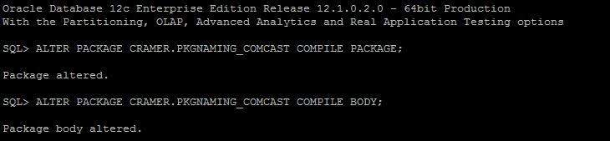

ARM04 restarted successfully.

Problem:

Caused By: weblogic.security.SecurityInitializationException: Authentication denied: Boot identity not valid. The user name or password or both from the boot identity file (boot.properties) is not valid. The boot identity may have been changed since the boot identity file was created. Please edit and update the boot identity file with the proper values of username and password. The first time the updated boot identity file is used to start the server, these new values are encrypted.

Solution:

Probably someone delete the boot.properties under:

cmmsom117@iloscmm167.corp.amdocs.com:~cmmsom117/JEE/dop/WLS/affDomain/servers/affServer/security>ll
total 12
-rwxrwxrwx 1 cmmsom117 cmmsom117 150 Aug 21 12:34 boot.properties

Problem:

failure: repodata/repomd.xml from orion-core: [Errno 256] No more mirrors to try.
file:///infraoss/comcastmm/STORAGE/BUILDS/SOM_AD/DevMain/2895/yum_core_10.1/repodata/repomd.xml: [Errno 14] curl#37 - "Couldn't open file /infraoss/comcastmm/STORAGE/BUILDS/SOM_AD/DevMain/2895/yum_core_10.1/repodata/repomd.xml"
Loaded plugins: product-id, search-disabled-repos, subscription-manager
This system is not registered to Red Hat Subscription Management. You can use subscription-manager to register.
file:///infraoss/comcastmm/STORAGE/BUILDS/SOM_AD/DevMain/2895/yum_core_10.1/repodata/repomd.xml: [Errno 14] curl#37 - "Couldn't open file /infraoss/comcastmm/STORAGE/BUILDS/SOM_AD/DevMain/2895/yum_core_10.1/repodata/repomd.xml"
Trying other mirror.

NO MORE HOSTS LEFT *************************************************************
to retry, use: --limit @/ossusers1/oss/users/cmmsom11/CentralConfig/deploy-consul-server.retry
PLAY RECAP *********************************************************************
inoscmm025.corp.amdocs.com : ok=16 changed=12 unreachable=0 failed=1
ERROR: Install Consul Server failed to execute !

Solution:

This is 10.1 Machine.
we cannot run 10.2 build on cmmsom11 as its 10.1 env

if you need this machine to be converted let us know.

Problem:

Hi Team,
If we see below error in SOM logs, we need to apply below work around( PFA mail from Kranth) to solve it:-

<Sep 14, 2018, 3:37:39,363 PM IDT> <Error> <Deployer> <BEA-149205> <Failed to initialize the application "u
i-shared-lib [Version=10.2.0.0.010]" due to error weblogic.application.library.LibraryDeploymentException:
[J2EE:160145]Failed to deploy library Extension-Name: ui-shared-lib, Specification-Version: 10.2.0.0.10.1,
because of conflicting library Manifest values, and library information registered with the server: [Specif
ication-Version: 10.2.0.0.10.1 vs. 10.2.0.0.10]. Check the library MANIFEST.MF file and correct version inf
ormation there to match server settings, or undeploy the misconfigured library.
weblogic.application.library.LibraryDeploymentException: [J2EE:160145]Failed to deploy library Extension-Na
me: ui-shared-lib, Specification-Version: 10.2.0.0.10.1, because of conflicting library Manifest values, an
d library information registered with the server: [Specification-Version: 10.2.0.0.10.1 vs. 10.2.0.0.10]. C
heck the library MANIFEST.MF file and correct version information there to match server settings, or undepl
oy the misconfigured library.
at weblogic.application.internal.library.LibraryDeploymentFactory.getLibData(LibraryDeploymentFacto
ry.java:121)
at weblogic.application.internal.library.LibraryDeploymentFactory.createDeployment(LibraryDeploymen
tFactory.java:49)
at weblogic.application.internal.DeploymentManagerImpl.createDeployment(DeploymentManagerImpl.java:
186)
at weblogic.application.internal.DeploymentManagerImpl.access$700(DeploymentManagerImpl.java:52)
at weblogic.application.internal.DeploymentManagerImpl$DeploymentCreatorImpl.createDeployment(Deplo
ymentManagerImpl.java:583)
Truncated. see log file for complete stacktrace

Solution:

- Un deploy/Delete and redeploy/Install ‘ui-shared-lib.war’ from WL console
- Remove tmp files
- Restart server.

Hi Team,

If we gets request to run warmup script for any environment, we need to follow TRN 347 steps. Script is attached to the TRN.

http://creativity/SpaceDirectory/Sites/VM%20Tool%20BSS3/comcast-Mid-Market/OrionRelease1/Lists/Environment%20Changes/EditForm.aspx?ID=347&Source=http%3A%2F%2Fcreativity%2FSpaceDirectory%2FSites%2FVM%2520Tool%2520BSS3%2Fcomcast%2DMid%2DMarket%2FOrionRelease1%2FLists%2FEnvironment%2520Changes%2FAllItems%2Easpx

Problem:

When running MEC installation I am getting the following issue:

[12:43:52] [ERROR] Command line activation failed with java.lang.IllegalStateException: /ossusers1/oss/users/cmmmec02/dist/mec-10.2.0.0.649-general-portfolio-package-2017071800.jar is not a valid installation package. The installation cannot continue. Please verify that the jar is a valid package file.
[12:43:52] [ERROR] Command line activation failed
java.lang.IllegalStateException: /ossusers1/oss/users/cmmmec02/dist/mec-10.2.0.0.649-general-portfolio-package-2017071800.jar is not a valid installation package. The installation cannot continue. Please verify that the jar is a valid package file.
at amdocs.installer.packager.impl.PackageIntrospectorImpl.getValueFromPropertyFile(PackageIntrospectorImpl.java:538)
at amdocs.installer.packager.impl.PackageIntrospectorImpl.getRootComponent(PackageIntrospectorImpl.java:549)
at amdocs.installer.packager.utils.PackageLayerAndVersionFilter.complies(PackageLayerAndVersionFilter.java:41)
at amdocs.installer.packager.utils.PackageUtils.sortPackagesByLayerAndVersion(PackageUtils.java:1200)
at amdocs.installer.packager.utils.PackageUtils.getAllPackagesInDirSortedByLayer(PackageUtils.java:1134)
at amdocs.installer.engine.workflow.InstallWorkflowExecutor.handleTopologyFile(InstallWorkflowExecutor.java:573)
at amdocs.installer.engine.workflow.InstallWorkflowExecutor.doExecute(InstallWorkflowExecutor.java:216)
at amdocs.installer.engine.workflow.AbstractSilentDeployExecutor.execute(AbstractSilentDeployExecutor.java:137)
at amdocs.installer.api.cli.services.MainFlowBootstrapService.execute(MainFlowBootstrapService.java:174)
at sun.reflect.NativeMethodAccessorImpl.invoke0(Native Method)
at sun.reflect.NativeMethodAccessorImpl.invoke(NativeMethodAccessorImpl.java:62)
at sun.reflect.DelegatingMethodAccessorImpl.invoke(DelegatingMethodAccessorImpl.java:43)
at java.lang.reflect.Method.invoke(Method.java:498)
at com.amdocs.installer.Main.executeFlow(Main.java:291)
at com.amdocs.installer.Main.main(Main.java:90)
Solution:

the reason of failure was someone moved the correct jar for 10.2 from IND NAS, I have copied it from ISR. PFB jar name.

mec-10.2.0.0.649-general-portfolio-package-2017071800.jar
Problem:

"msg": "sudo: >>> /etc/sudoers.d/cmmsom61: syntax error near line 1 <<<\nsudo: parse error in /etc/sudoers.d/cmmsom61 near line 1\nsudo: no valid sudoers sources found, quitting\nsudo: unable to initialize policy plugin",
"rc": 1,
"stderr": "sudo: >>> /etc/sudoers.d/cmmsom61: syntax error near line 1 <<<\nsudo: parse error in /etc/sudoers.d/cmmsom61 near line 1\nsudo: no valid sudoers sources found, quitting\nsudo: unable to initialize policy plugin\n",
"stderr_lines": [
"sudo: >>> /etc/sudoers.d/cmmsom61: syntax error near line 1 <<<",
"sudo: parse error in /etc/sudoers.d/cmmsom61 near line 1",
"sudo: no valid sudoers sources found, quitting",
"sudo: unable to initialize policy plugin"

Solution:
Vi /etc/sudoers.d/cmmsom61

Put only this line
cmmsom61 ALL=(ALL) NOPASSWD: ALL

Problem:

"msg": "sudo: /etc/sudoers.d/cmmsom61 is world writable\nsudo: no tty present and no askpass program specified",
"rc": 1,
"stderr": "sudo: /etc/sudoers.d/cmmsom61 is world writable\nsudo: no tty present and no askpass program specified\n",
"stderr_lines": [
"sudo: /etc/sudoers.d/cmmsom61 is world writable",
"sudo: no tty present and no askpass program specified"
],
"stdout": "",
"stdout_lines": []
}
to retry, use: --limit @/ossusers1/oss/users/cmmsom61/CentralConfig/deploy-consul-server.retry

PLAY RECAP *********************************************************************
inoscmm261.corp.amdocs.com : ok=18 changed=0 unreachable=0 failed=1

ERROR: Install Consul Server failed to execute !
Returned ERROR CODE while running CC installation, terminating script..
Build step 'Execute shell' marked build as failure
Finished: FAILURE

Solution:

/etc/sudoers.d/cmmsomxx
should have write permissions only for root
example:
-rw-r--r-- 1 root root 37 Oct 7 19:30 cmmsom61

Problem:
When install ASD env I am getting this error:
Deploying application from /ossusers1/oss/users/cmmasd61/ASD_Installation/ASD-Dist/and-ear-1.0-SNAPSHOT.ear to targets AdminServer (upload=false) ...
<Oct 8, 2018 1:04:36 PM IST> <Info> <J2EE Deployment SPI> <BEA-260121> <Initiating deploy operation for application, and-ear-1.0-snapshot [archive: /ossusers1/oss/users/cmmasd61/ASD_Installation/ASD-Dist/and-ear-1.0-SNAPSHOT.ear], to AdminServer .>
..........Failed to deploy the application with status failed
Current Status of your Deployment:
Deployment command type: deploy
Deployment State : failed
Deployment Message : weblogic.application.ModuleException: java.sql.SQLException: Exhausted Resultset
No stack trace available.
This Exception occurred at Mon Oct 08 13:05:08 IST 2018.
weblogic.management.scripting.ScriptException: Error occurred while performing deploy : Deployment Failed.
<Oct 8, 2018 1:05:08 PM IST> <Warning> <JNDI> <BEA-050001> <WLContext.close() was called in a different thread than the one in which it was created.>
Installation Failed - Failed To Deploy EARs During Deploy Artefacts
(END)
Solution:
same issue
i told u the fix
Copying jar from ORACLE_HOME into ThirdPartyJars Folder
cp: cannot stat '/oravl01/oracle/12.2.0.1/jdbc/lib/ojdbc6.jar': No such file or directory
Path for ojdbc jar is ::/ossusers1/oss/users/cmmasd61/ThirdPartyJars/ojdbc6.jar
java.lang.ClassNotFoundException: oracle.jdbc.driver.OracleDriver
at java.net.URLClassLoader$1.run(URLClassLoader.java:366)

Copy the file from other server

Problem:
When install SOM I am getting:
Failed to apply WLS configuration. check /ossusers1/oss/users/cmmsom61/acd/WLS/logs/puppet/installWLS.log"]}
to retry,
use: --limit @/ossusers1/oss/users/cmmsom61/ansible_playbook/dop-orchestrate.retry

PLAY RECAP *********************************************************************
localhost : ok=62 changed=49 unreachable=0 failed=1

ping server ...
server is already DOWN
Cleaning stage and cache..
\nTerminate signals (Ctrl-C, Ctrl-Z) are ignored in startServer
setting script arguments
ping server ...
server is DOWN , continue
no /ossusers1/oss/users/cmmsom61/JEE/dop/WLS/affDomain/config/config.xml found.
Server was started...
ping server ...
server is already DOWN
Cleaning stage and cache..
\nTerminate signals (Ctrl-C, Ctrl-Z) are ignored in startServer
setting script arguments
ping server ...
server is DOWN , continue
no /ossusers1/oss/users/cmmsom61/JEE/dop/WLS/affDomain/config/config.xml found.
Server was started...
Checking SOM installation status..
Returned ERROR CODE while running SOM installation, terminating script..
Build step 'Execute shell' marked build as failure
Finished: FAILURE
Solution:
Please update /infraoss/comcastmm/STORAGE/INFRA/utilities/tnsnames.ora
With the new instance server.

cmmsom61=(description=(address=(protocol=tcp)(host=inoscmm261)(port=1521))(connect_data=(service_name=CMMSOM61)))

I am failing on this issue.

http://cmm0028:7070/job/SOM_AD_INSTALLATION_cmmsom61_inoscmm261/14/consoleFull

Problem:

no /ossusers1/oss/users/cmmsom61/JEE/dop/WLS/affDomain/config/config.xml found.
Server was started...
Checking SOM installation status..
Returned ERROR CODE while running SOM installation, terminating script..
Build step 'Execute shell' marked build as failure
Finished: FAILURE

Solution:

Check that the following files are in home .puppetlabs .puppet

If not please copy from other env.

Problem:

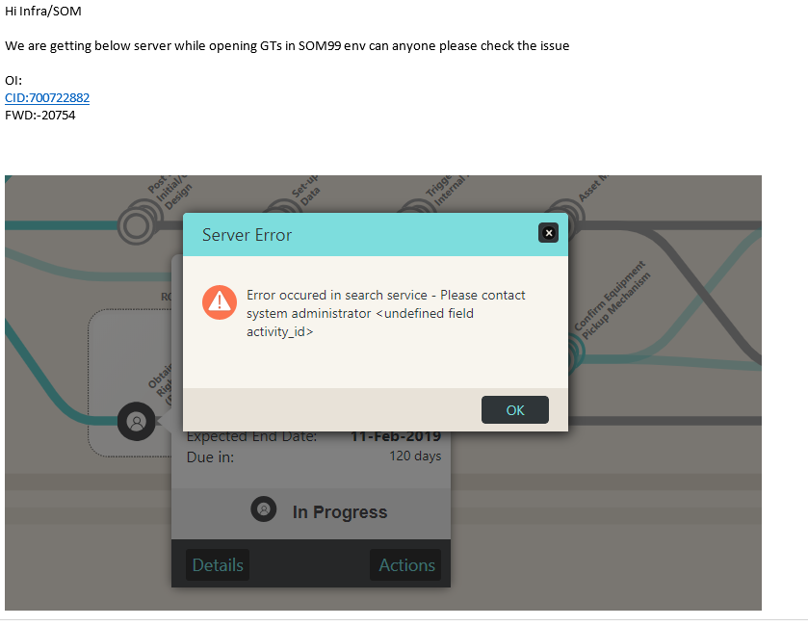

Solution:

Ask them to do solr indexing and then retry.

Problem:
inactive for ARM connection bridges

Solution:
This issue was coming due to missing patch in WL.

I copied the WL from SOM52 server and restart WL in SOM.

cmmsom117@iloscmm167.corp.amdocs.com:~/opt>ll weblogic1221

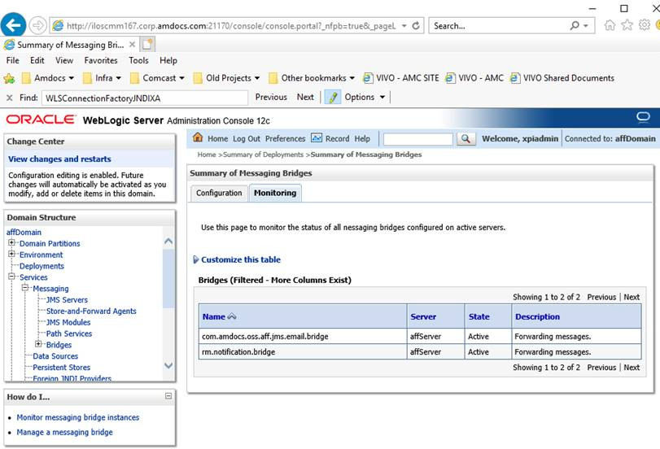

Problem:

In the flow that i need to check , every activity is failing on same error :
org.apache.cxf.service.factory.ServiceConstructionException: Failed to create service.

Solution:

Please boot ASD env

Problem:

Please update ARM License on ARM56.

Oct 17, 2018 11:19:36 AM com.cramer.mrsadapter.controller.ejb.OrderStateProcessor processRequest
SEVERE: Error in OrderStateProcessor.process
com.cramer.mrsadapter.exceptions.FulfillmentException caused by java.sql.SQLException: ORA-20001: License violation:\nThe license has expired:\nPlease contact Cramer for additional licenses.
ORA-06512: at "CRAMER.PKGSESSIONCONTEXT", line 565
ORA-06512: at "CRAMER.PKGSESSION", line 26
ORA-06512: at line 1

Solution:

Hi Avi,
We have job for it now.
http://cmm0028:7070/view/Utilities/job/License_update_ARM_USM/

we also have wiki page for the same.
http://creativity/SpaceDirectory/Sites/Infra%20OSS/OSS%20Project/license%20token%20update.aspx

Problem:
When installing ASD I am getting this error
Problem invoking WLST - Traceback (innermost last):
File "/ossusers1/oss/users/cmmasd47/ASD_Installation/ASD-Installer/dscreate.py", line 73, in ?
File "<iostream>", line 359, in activate
File "<iostream>", line 520, in raiseWLSTException
WLSTException: Error occurred while performing activate : Error while Activating changes. : oracle.net.ns.NetException: Listener refused the connection with the following error:
ORA-12504, TNS:listener was not given the SID in CONNECT_DATA

Use dumpStack() to view the full stacktrace :

Installation Failed - Failed To Create OSSUI Datasource During Deploy Artefacts
Installation Ended.
INSTALLATION Failed.. please check logs at location:ASD_Installation/ASD-Installer/logs
Process leaked file descriptors. See http://wiki.jenkins-ci.org/display/JENKINS/Spawning+processes+from+build for more information
Build step 'Execute shell' marked build as failure
Finished: FAILURE

Solution:

I copied the weblogic1212 from other env and replace it.
Then installation was running fine.

Problem:

Started by flow project ITR31_FLOW build number #9
Notifying parent flow ITR31_FLOW #9 that I have started
[EnvInject] - Loading node environment variables.
Building remotely on auabuild_ntcibuild in workspace /home/auabuild/workspace/ATT_MEXICO_AUA_ITR31_INC_BUILD_NUM
[ATT_MEXICO_AUA_ITR31_INC_BUILD_NUM] $ /bin/sh -xe /tmp/hudson99508486415273121.sh
+ p4 info
User name: cc_dev
Client name: auabuild_ntcibuild
Client host: illin2143
Client root: /home/auabuild
Current directory: /home/auabuild/workspace/ATT_MEXICO_AUA_ITR31_INC_BUILD_NUM
Peer address: 10.196.106.103:29064
Client address: 10.196.106.103
Server address: illin2143.corp.amdocs.com:1666
Server root: /p4/1/root
Server date: 2018/10/24 14:17:00 +0300 IDT
Server uptime: 80:07:20
Server version: P4D/LINUX26X86_64/2015.1/1477557 (2017/01/06)
Server license: Amdocs Software Systems Ltd 7501 users (support ends 2018/12/31)
Server license-ip: 127.0.0.1
Case Handling: sensitive
[bin] $ ant -file aua_inc_build.xml -DVERSION=mex-1610.31-Release -Dbuild.mode=daily -Dbranch.name=mex-1610.31-Release inc_build_number
Buildfile: aua_inc_build.xml

inc_build_number:
[echo] AUA_illin2143_mex-1610.31-Release_daily_build_number will be 9
[p4counter] error: Perforce password (P4PASSWD) invalid or unset.

BUILD FAILED
/home/auabuild/bin/aua_inc_build.xml:17: Problem exec'ing P4 command: error: Perforce password (P4PASSWD) invalid or unset.

Total time: 1 second
Build step 'Invoke Ant' marked build as failure
Notifying parent flow ITR31_FLOW #9 that I have completed
Finished: FAILURE

Solution:

Login to: auabuild@ntcibuild (Unix11!)

  - ntcibuild-/home/auabuild> mv .p4tickets .p4tickets.24Oct
  - Check that .cshrc file have the correct details:
setenv ANT_HOME "${HOME}/ant-1.7.0"
setenv PATH "${PATH}:/opt/perforce:${HOME}/bin:${ANT_HOME}/bin:${HOME}/tools/maven-3.0.4/bin/"
setenv P4PORT illin2143:1666
setenv P4HOST illin2143
setenv P4USER cc_dev
setenv P4PASSWD 'Dev4prfc!'
setenv P4CLIENT auabuild_ntcibuild
setenv LANG en_US.ISO8859-1

run in the env:

ntcibuild-/home/auabuild> p4 login

This will create new .p4tickets

  - Run the Jenkins job again.

Problem:

In the USM env:

issue related to the “Ticket is not encrypted with the configured resource”
2) probably user roles for AFFSuper will be incorrect again
3) HF probably will be needed re-installed

Solution:

We need to copy shared folder from working environment (cmmusm03@iloscmm007) after clean installation of USM.

cmmusm03@iloscmm007:cmmusm03/JEE/cmmusm03/WLS/cmmusm03/shared

after copy please restart the USM env.

Problem:

Update the excel env page:

http://creativity/SpaceDirectory/Sites/VM%20Tool%20BSS3/comcast-Mid-Market/Lists/Dev%20Environments%20Page/AllItems.aspx

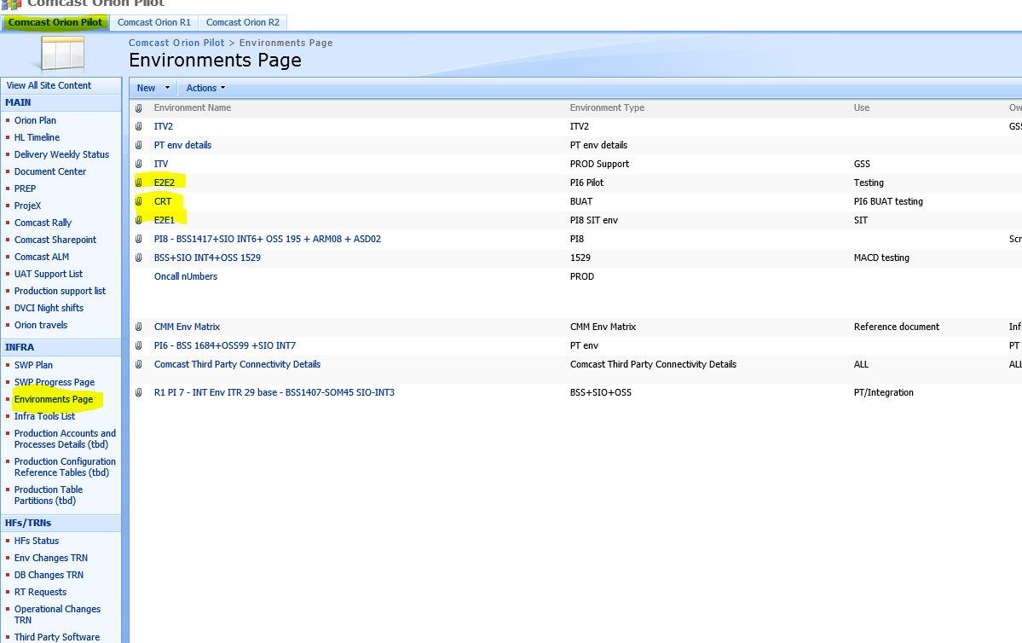

Request:

Can you please disabled the copy to Nexus(Orion) the artifacts from all build job under the ASD
Solution:
Please handle it

Remove –U from all ASD build jobs maven command .

For this please login to Jenkins BUILDS JOBS ASD

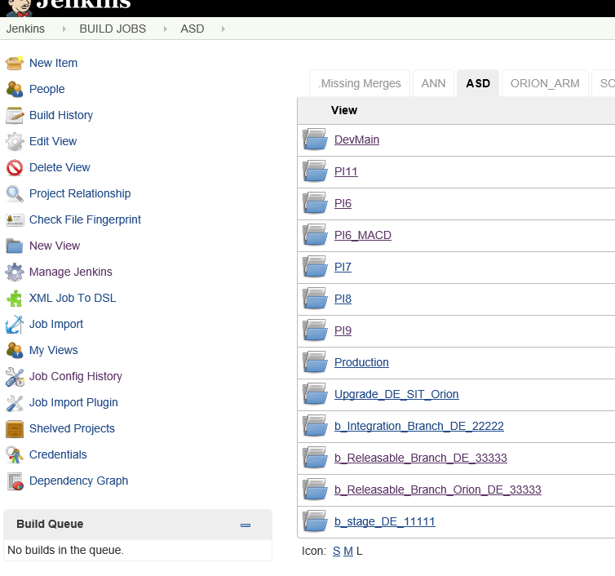

Login to every one and update the first job: CMM_ASD_BUILD
And update all one by one and remove the -U:

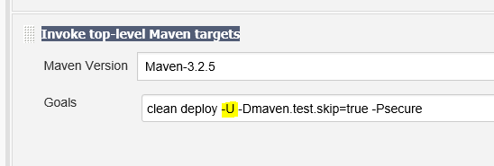

Problem:

[‎11/‎1/‎2018 12:12 PM] Avi Saar:
No Title
WARN: HHH000341: Could not obtain connection metadata : Cannot create PoolableConnectionFactory (ORA-00923: FROM keyword not found where expected
)
<Nov 1, 2018, 3:38:52,589 PM IST> <Warning> <org.hibernate.engine.jdbc.internal.JdbcServicesImpl> <BEA-000000> <HHH000341: Could not obtain connection metadata : Cannot create PoolableConnectionFactory (ORA-00923: FROM keyword not found where expected
)>
Nov 01, 2018 3:38:52 PM org.hibernate.engine.jdbc.internal.LobCreatorBuilder useContextualLobCreation
INFO: HHH000422: Disabling contextual LOB creation as connection was null
<Nov 1, 2018, 3:38:52,681 PM IST> <Warning> <HTTP> <BEA-101162> <User defined listener org.springframework.web.context.ContextLoaderListener failed: org.springframework.beans.factory.BeanCreationException: Error creating bean with name 'sessionFactory' defined in ServletContext resource [/WEB-INF/applicationContext-hibernate.xml]: Invocation of init method failed; nested exception is java.lang.NullPointerException.
org.springframework.beans.factory.BeanCreationException: Error creating bean with name 'sessionFactory' defined in ServletContext resource [/WEB-INF/applicationContext-hibernate.xml]: Invocation of init method failed; nested exception is java.lang.NullPointerException
at org.springframework.beans.factory.support.AbstractAutowireCapableBeanFactory.initializeBean(AbstractAutowireCapableBeanFactory.java:1553)
at org.springframework.beans.factory.support.AbstractAutowireCapableBeanFactory.doCreateBean(AbstractAutowireCapableBeanFactory.java:539)
at org.springframework.beans.factory.support.AbstractAutowireCapableBeanFactory.createBean(AbstractAutowireCapableBeanFactory.java:475)
at org.springframework.beans.factory.support.AbstractBeanFactory$1.getObject(AbstractBeanFactory.java:302)
at org.springframework.beans.factory.support.DefaultSingletonBeanRegistry.getSingleton(DefaultSingletonBeanRegistry.java:228)
Truncated. see log file for complete stacktrace
Caused By: java.lang.NullPointerException
at org.hibernate.engine.jdbc.internal.JdbcServicesImpl.configure(JdbcServicesImpl.java:207)
at org.hibernate.service.internal.StandardServiceRegistryImpl.configureService(StandardServiceRegistryImpl.java:75)
at org.hibernate.service.internal.AbstractServiceRegistryImpl.initializeService(AbstractServiceRegistryImpl.java:159)
at org.hibernate.service.internal.AbstractServiceRegistryImpl.getService(AbstractServiceRegistryImpl.java:131)
at org.hibernate.cfg.Configuration.buildTypeRegistrations(Configuration.java:1797)
Truncated. see log file for complete stacktrace
>
<Nov 1, 2018, 3:38:52,779 PM IST> <Error> <HTTP> <BEA-101267> <Failed while destroying filter: WebSocket filter.
java.lang.NullPointerException
at weblogic.websocket.tyrus.TyrusServletFilter.destroy(TyrusServletFilter.java:305)
at weblogic.servlet.internal.FilterManager$FilterDestroyAction.run(FilterManager.java:416)
at weblogic.security.acl.internal.AuthenticatedSubject.doAs(AuthenticatedSubject.java:326)
at weblogic.security.service.SecurityManager.runAsForUserCode(SecurityManager.java:197)
at weblogic.servlet.provider.WlsSecurityProvider.runAsForUserCode(WlsSecurityProvider.java:203)
Truncated. see log file for complete stacktrace
>
<Nov 1, 2018, 3:38:53,846 PM IST> <Error> <Deployer> <BEA-149231> <Unable to set the activation state to true for the application "snow [Version=10.2.0.0.010.02]".

Solution:
i copied snow.war

copy the file from cmmsom84@iloscmm127

cmmsom84@iloscmm127:~/opt/amdocs/delivery/snow1>ll
-rwxrwxrwx 1 root root 72389610 Nov 1 12:55 snow.war
Problem:

Hi Infra OSS/SOM Team,

HF300012726 failed during deployment in E2E1 environment. Please check. Below is the error message.

Deploy operation [DEPLOY_SFO_MEC_R1] of file [DE100332.zip] to [E2E1_PI7^cmmsom21@mwhlvcmeoss01] failed, error: Execute deploy operation has failed, error: [java] Java Result: 1

Please note, this HF is approved by Ajit and provided for IRR defect (SOM side fix) and CPQ side fix is already deployed in the environment.

Solution:

It was due to consle down and HF that was try to be deploy several times.

After I boot the console and delete old record of the HF it was deploy successfully.
I delete the HF from the env under:

cmmsom21@mwhlvcmeoss01:~cmmsom21/JEE/distribution-engine/source/elementsData>ll
-rw-r--r-- 1 cmmsom21 cmmsom21 17937 Nov 4 06:31 DE100332.zip

You may check in the log of the HF the error
cmmsom21@mwhlvcmeoss01:~cmmsom21/.hotfix/300012726

Problem:

Hi infra ,

ODO is trying to reach CPQ , but the response is : <General SSLEngine problem> .
What is the proper certificate in order to reach CPQ ?
And how to verify the jks file if it has the valid certifications ? .
Solution:

In this case just copy cacerts file from working PT env like SOM99 , SOM 52

$JAVA_HOME/jre/lib/security/cacerts and restart server.

Problem:

Hi Infra Team,

Getting below error while dev mains genesis refresh on ARM09.

looks like MM plugin issue. Please set it correctly.

http://cmm0028:7070/view/ARM%20Self%20Service/job/CMM_ARM_GENESISREFRESH_DevMain/224/console

[sshexec] [shellscript] Temporary project created.
[sshexec] [shellscript] Nov 14, 2018 6:17:55 PM com.amdocs.oss.ide.mm.cli.BuildDistribution run
[sshexec] [shellscript] SEVERE: Operation Failed : com/amdocs/oss/ide/mm/instancevalidation/ui/IVPreference
[sshexec] [shellscript] java.lang.NoClassDefFoundError: com/amdocs/oss/ide/mm/instancevalidation/ui/IVPreference
[sshexec] [shellscript] at com.amdocs.oss.ide.mm.cli.BuildDistribution.doBuildORDistribution(BuildDistribution.java:292)

Solution:

Hi Avi,

If we see below error then we need to delete below files from respective ARM env.

Path:- $HOME/ResourceManagementWebLogic3/ossstudio/configuration

- org.eclipse.update
- org.eclipse.core.runtime
- org.eclipse.osgi

[sshexec] [shellscript] SEVERE: Operation Failed : com/amdocs/oss/ide/mm/instancevalidation/ui/IVPreference
[sshexec] [shellscript] java.lang.NoClassDefFoundError: com/amdocs/oss/ide/mm/instancevalidation/ui/IVPreference

We removed below files from this location.
/ossusers1/oss/users/cmmarm09/ResourceManagementWebLogic3/ossstudio/configuration

org.eclipse.osgi
org.eclipse.update
org.eclipse.core.runtime

Problem:

Issue: ‘Assign To me’ action on any GT is taking time on CRT1.

Analysis:
As per HPD report, a query on SOM side is taking more than expected time.( 1+ min). (PFA).
We may gather stats on this table and see the performance.

Table name: OSS_CORRELATION

Solution:
For particular table we can use below command :-

1.Login to the CRT1 SOM env
2. Login to CRT1 DB (SOMWRK1_DB/SOMWRK1_DB@CMMUAT03)
3. run the following command:
exec DBMS_STATS.GATHER_TABLE_STATS(OWNNAME=>'SOMWRK1_DB', TABNAME => 'OSS_CORRELATION', CASCADE => TRUE, no_invalidate=>false,DEGREE => 4);

Problem:

SOM is not loading

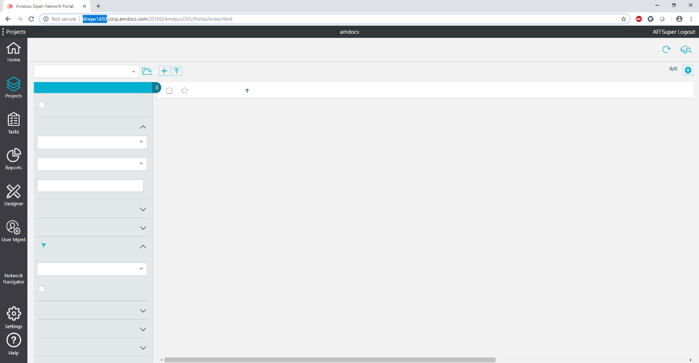

Solution:

Clean cache restart.

Guide for consul install
in case of next consul crash instead of reinstallation

Steps followed are as follows

- Stop consul servers

- Recreate the file with details of all consul servers e.g PLAB have two consul servers so we added the details here

som@mwhlvcbcntr02:~som/consul/data/raft>cat peers.json
["10.97.132.206:8300","10.97.132.207:8300"]

- Restart consul and it will work fine

- som@mwhlvcbcntr02:~som> /opt/amdocs/fnd/P2CC/scripts/populate_to_consul.sh -repo /opt1/fs_users/som/pushToCC
Populate to Central Configuration started at 15/Nov/2018 05:59:21 AM
Loading context from: /opt1/fs_users/som/pushToCC/context.properties
Loading Properties from: /opt1/fs_users/som/pushToCC/dbp/dop.sec.properties
Loading Properties from: /opt1/fs_users/som/pushToCC/dbp/ssl_tls.properties
Loading Properties from: /opt1/fs_users/som/pushToCC/dbp/odo.properties
Loading Properties from: /opt1/fs_users/som/pushToCC/dbp/odo.sec.properties
Loading Properties from: /opt1/fs_users/som/pushToCC/dbp/security.properties
Loading Properties from: /opt1/fs_users/som/pushToCC/dbp/sfo.sec.properties
Loading Properties from: /opt1/fs_users/som/pushToCC/dbp/security.sec.encrypted.properties
Loading Properties from: /opt1/fs_users/som/pushToCC/dbp/sfo.properties
Loading Properties from: /opt1/fs_users/som/pushToCC/dbp/dop.properties
Loading Properties from: /opt1/fs_users/som/pushToCC/dbp/delivery.properties
Connecting to Central Configuration...
Connected to Central Configuration [host=127.0.0.1, port=8500]
Data synchronization with Central Configuration has started
Data synchronization with Central Configuration has ended
Populate to Central Configuration ended successfully. (exitStatus: 0)
Populate to central configuration ended at 15/Nov/2018 05:59:22 AM
Total time: 0.023783333333333333 minutes.

Total recovery time :- 15 – 20 mins

Request:

Hi Infra team,

I need to do my env 91 integration for D2D (off-net, CPQ).
I tried to do it, but it still doesn’t work correct.
Please check or update my env.
My focal point https://illnqw1726.corp.amdocs.com:28501

Solution:

Update the properties file (cmmsom91_iloscmm124.properties)

Add this:

BSS_SIMULATOR=N
BSS_HOST=illnqw1726.corp.amdocs.com
BSS_PORT=28501
BSS_USER=ODOUser
BSS_PWD=Unix11

SQO_SIMULATOR=N
SQO_HOST=illnqw1726.corp.amdocs.com
SQO_PORT=28501

Instead of this:

BSS_SIMULATOR=Y
OGW_SIMULATOR=Y

Problem:
im getting the following issue in my env ( was working half an hour ago, no changes were made since then)
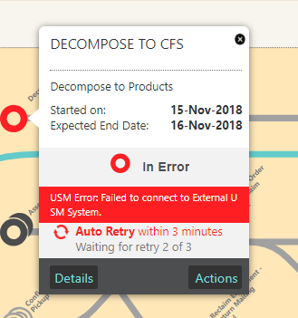
java.net.ConnectException: Tried all: '1' addresses, but could not connect over HTTP to server: 'iloscmm006', port: '30200'

Solution:

Hi Avi,
Data folder in admin server was corrupted, I simple cleaned ( tmp, cache, data & logs) folder of admin server and restarted it.

Problem:

Nested Exception/Error:
amdocs.uams.UamsOperationException: Failed to start UAMS Module Management:
Nested Exception/Error:
amdocs.uams.UamsOperationException: Failed to create connection for url=jdbc:oracle:thin:@(description=(address=(host=inoscmm218.corp.amdocs.com)(protocol=tcp)(port=1521))(connect_data=(sid=CMMARM04))) and dbUser=UASM
Nested Exception/Error:
java.sql.SQLException: ORA-01017: invalid username/password; logon denied

Solution:
Please update in JEE/ASDDomain/affDomain_anrs/uams.properties

The user and password to UAMS

# Database user
SEC_DB_USER=UAMS

# Database password
SEC_DB_PWD=<USE>K=<key>.uams.config.crypto.0;M=9AojfVOyOXA5mslaBRooV12;</USE>

Problem:

I am getting this when run CMM_USM_METADATA_REFRESH for Env12 (cmmusm12)

Started by user Avi Saar
[EnvInject] - Loading node environment variables.
Building remotely on mb_cccmm2_cmm0028 in workspace /ossusers2/oss/users/mb_cccmm2/workspace/CMM_USM_METADATA_REFRESH
[CMM_USM_METADATA_REFRESH] $ /bin/ksh /tmp/hudson2285223896400800969.sh
-----------------------------------------------------------------------
Starting USM Custom Metadata Refresh for environment cmmusm12@illin1201
Build number: 76
-----------------------------------------------------------------------
Checking tablespaces...
Permission denied, please try again.
Permission denied, please try again.
Permission denied (publickey,gssapi-keyex,gssapi-with-mic,password).
Preparing build...
Permission denied, please try again.
Permission denied, please try again.
Permission denied (publickey,gssapi-keyex,gssapi-with-mic,password).
Permission denied, please try again.
Permission denied, please try again.
Permission denied (publickey,gssapi-keyex,gssapi-with-mic,password).
lost connection
Permission denied, please try again.
Permission denied, please try again.
Permission denied (publickey,gssapi-keyex,gssapi-with-mic,password).
Permission denied, please try again.
Permission denied, please try again.
Permission denied (publickey,gssapi-keyex,gssapi-with-mic,password).
Finished: SUCCESS

Solution:
Please add ssh from mb_cccmm2@cmm0028 to cmmusm12

Please do [mb_cccmm2@cmm0028~:]./AddSSHEnv.ksh cmmusm12 illin1201

AMIL update simulator:
For AMIL you need to update details in delivery.properties for real endpoints.
You can update it in delivery.properties and updateCC and SOM restart.
#AMIL_URL_FOR_CPM
AMIL_URL_FOR_CPM=http://iloscmm167.corp.amdocs.com:21170/snow/ws_simulator/CustomerProductSetup_EG
#AMIL_URL_FOR_EM&M
AMIL_URL_FOR_EMM=http://iloscmm167.corp.amdocs.com:21170/snow/ws_simulator/SubmitEvents_EG
#AMIL_URL_FOR_OPE
AMIL_URL_FOR_OPE=http://iloscmm167.corp.amdocs.com:21170/snow/ws_simulator/prposalUpsertService

AMIL update real:
#AMIL_URL_FOR_CPM
AMIL_URL_FOR_CPM=http://illin4591:21500/CustomerProductSetup_EG

#AMIL_URL_FOR_EM&M
AMIL_URL_FOR_EMM=http://illin4591:21500/SubmitEvents_EG

#AMIL_URL_FOR_OPE
AMIL_URL_FOR_OPE=http://illin4591:21500/prposalUpsertService

aff.orderGateway.service.ws.endpoint=http://illin4591:20500/ODOGenericActivity/soap?WSDL
aff.orderGateway.service.username=weblogic
aff.orderGateway.service.password=weblogic123

Problem:

Hi Infra team,

Please check connectivity configuration as ASD server is throwing 404 Error for rest calls.

Error:

orImpl.getEJBHandle(65)] ] <APPLICATION> <LOOKUP_OF_REMOTE_SERVICEOBJECT_FAILED> Error Incident ID : b2e4d610-7070-448a-bf68-cb2f1265f2fa
Unable to perform a lookup to the external System. Url: t3://iloscmm006:15501, JNDI: RMQueryServiceBean

Failed with message: Unable to perform a lookup to the external System. Url: t3://iloscmm006:15501, JNDI: RMQueryServiceBean
Stack trace: com.amdocs.oss.and.core.error.CoreException: Unable to perform a lookup to the external System. Url: t3://iloscmm006:15501, JNDI: RMQueryServiceBean
at com.amdocs.oss.and.server.adaptor.service.impl.ANDAdaptorServiceLocatorImpl.getEJBHandle(ANDAdaptorServiceLocatorImpl.java:64)
Solution:
on uams.properties updated on ASD21. it was pointing to wrong ASM, so I make it same as SOM asm.

cmmasd21@iloscmm089:cmmasd21/JEE/ASDDomain/affDomain_anrs/uams.properties

Problem:

metadata refresh for jony

Solution:

Hi,

For fixing this issue please do the following steps:

- Login to tooladm@ilcecmd023 (Unix11!)
- Do ssh cmdamc@cmildev130
- Then ssh tooladm@mwhlvcmdhft01
- Then usmwrk1@mwhlvcmd71

do ssh all through this
pass is unix11
and then you can login

- for deleting data run USM_Purge_scripts_Quad.sql with cramer user (DB Details-- CRAMER/CRAMER@CMDDB71)

This script is in MOD NAS /infraoss/comcastmod/INFRA_SCRIPTS/USM/USM_Purge_scripts_Quad.sql (jenkins@ilosmod002 pass Unix11!)

- run distribution.sh script.

usmwrk1@mwhlvcmd71:usmwrk1/ResourceManagementWebLogic3/ossstudio/ResourceManagementWebLogic3/scripts/cli/distribution> ll distribution.sh
-rwxrwxrwx 1 usmwrk1 aimsys 8544 Oct 29 04:50 distribution.sh

Request:

Please provide DB deitals for ASD:

Solution:

asdwrk1@illnqw1410:asdwrk1/JEE/ASDDomain/config/jdbc> cat and-datasource-jdbc.xml

<url>jdbc:oracle:thin:@inoscmm082:1521:CMMARM10</url>
<driver-name>oracle.jdbc.xa.client.OracleXADataSource</driver-name>
<properties>
<property>
<name>user</name>
<value>ASD_1410</value>
</property>
Boot CROOS:

misc@illin2490
Password: Amdocs@11!
Stop: apache/apache-tomcat-8.0.30/bin/shutdown.sh
Start: apache/apache-tomcat-8.0.30/bin/startup.sh
Cross URL:
http://illin2490:8080/cross/environments.html

We have nexus : http://illin2490:8081/nexus/ with 94% storage .
Illin2490 - Nexus11/password: toolcmn102

Hello Team,

Created a wiki page for ASD active environments with passwords.
Lets keep it updated always, these details will be helpful whenever we gets site ASD refresh.

http://creativity/SpaceDirectory/Sites/Infra%20OSS/OSS%20Project/ASD%20Details.aspx

ENV | Connection details | Hostname | Password
E2E1 QA1 ASD | ossand0@10.26.226.20 | clipapp-dt-14s.ula.comcast.net | ComcastQA1!
E2E1 QA2 ASD | ossenv0@10.26.225.4 | clipapp-dt-12s.ula.comcast.net
E2E2 QA1 ASD | ossand2@10.26.226.20 | clipapp-dt-14s.cable.comcast.com | Welcome@123
E2E2 QA2 ASD | ossand2@10.26.224.157 | clipapp-dt-13s.ula.comcast.net
CRT1 QA1 ASD | ossand1@10.26.226.20 | clipapp-dt-14s.cable.comcast.com | Amdocs@123
CRT1 QA2 ASD | ossand1@10.26.224.157 | clipapp-dt-13s.ula.comcast.net
ITV1 ASD | ossand1@10.26.224.156 | clipapp-dt-03s.ula.comcast.net | STGC0mcast!
ITV2 ASD | ossand1@10.26.224.53 | clipappupg-dt-03s.ula.comcast.net | Stay0ut
PLAB ASD | plabasd@10.26.226.39 | clipappupg-dt-03s.ula.comcast.net | Amdocs@123

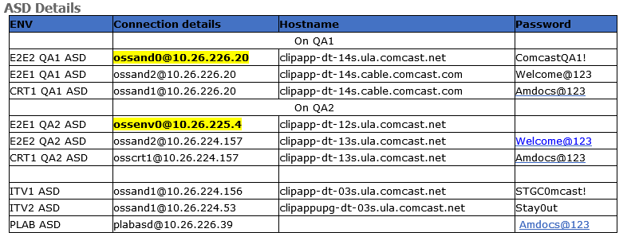

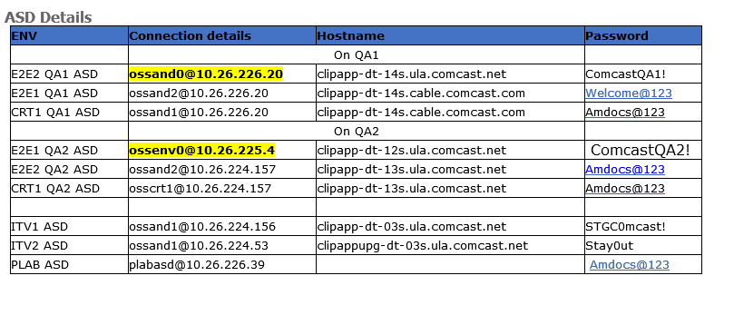
ossand1@10.26.226.20

ComcastQA2!

Request:

Seems this Env is not configured in Mail Utility. We are not able to get reply on below.
Solution:
If you go through the scripts, there is a command scp which requires passwordless connection, so we need to run AddSSHEnv.ksh from cmmadm@cmm0028 for new VMs.

Problem:

Getting this issue when trying to install core HF in USM:

User credentials have expired

Solution:

Please use the doc “Steps to Solve Installer1-000389” for solving this issue.

Problem:

When booting the ARM I am getting this Error:

i am getting this error when booting cramar
There is no server running at t3://inoscmm038:15400
Error occurred while performing connect : Error getting the initial context. There is no server running at t3://inoscmm038:15400 : t3://inoscmm038:15400: Destination 10.75.20.170, 15400 unreachable; nested exception is:
java.net.ConnectException: Connection refused (Connection refused); No available router to destination
Use dumpStack() to view the full stacktrace :
Connecting to t3://inoscmm038:15400 with userid xpiadmin ...
i can see the port is deferent when i login to the ARM

Solution:
- Check that java is ok in the server:
directory /usr/java/jdk1.8.0_74. (JAVA_HOME)

- check that port is correct in Comcast.properties

- Clean the following:

cmmarm02@inoscmm038.corp.amdocs.com:cmmarm02/JEE/cmmarm02_Domain/WLS/cmmarm02_Domain/servers/CramerServer> ll
drwxr-x--- 4 cmmarm02 amdocs 4096 Dec 10 19:09 cache
drwxr-x--- 4 cmmarm02 amdocs 4096 Dec 10 19:08 data
drwxr-x--- 4 cmmarm02 amdocs 4096 Dec 11 14:43 logs
drwxrwxr-x 2 cmmarm02 amdocs 4096 Jun 19 12:43 security
drwxrwxr-x 85 cmmarm02 amdocs 4096 Dec 10 19:15 stage
drwxr-x--- 85 cmmarm02 amdocs 4096 Dec 6 17:46 stage.bak
drwxr-x--- 6 cmmarm02 amdocs 4096 Dec 10 19:15 tmp

- Boot the ARM with:
nohup ./startManagedWebLogic.sh CramerServer &

netstat -an | grep 24423

Problem:

Hi Infra team,

Wrong SOM URL is configured in ASD workflow.properties : psom.orion.comcast.com:443

Please correct this and bounce ASD
Solution:

Login to ASD ossand1@10.26.224.53 (Stay0ut) ITV2

You need to apply the change in below workflow.properties of DEVINT ASD

#########################################################################################################
#### ORION ####
#########################################################################################################

WORKFLOW_ORION_NAME=Orion

WORKFLOW_ORION_PROTOCOL=https
WORKFLOW_ORION_HOSTNAME=psom.orion.comcast.com
WORKFLOW_ORION_PORT=443

WORKFLOW_ORION_SITEMINDER_PROTOCOL=https
WORKFLOW_ORION_SITEMINDER_HOSTNAME=odo.orion.comcast.com
WORKFLOW_ORION_SITEMINDER_PORT=18443

And then Go to below file

$HOME/ASD_Installation/ASD-Dist/ASC/config/DE_coreLayer.conf

Search for psom.orion.comcast.com:443 and replace with odo.orion.comcast.com:18443

And then run
java -cp $HOME/ASD_Installation/ASD-Dist/ASC/asc-deployment-db-1.0-SNAPSHOT.jar:$HOME/ThirdPartyJars/ojdbc6.jar -Dand.asc.home=$HOME/ASD_Installation/ASD-Dist/ASC/asc.deployment.db.properties com.amdocs.oss.de.core.db.install.DoInstallXMLToDB

and then restart ASD

Problem:

com.amdocs.oss.msi.MSIException: Error caught during user sync process.java.sql.SQLRecoverableException: No more data to read from socket
Solution:
Please ask someone to Restart DevINT USM
Problem:

When we are sending mail to check ENV_STATUS for CRT1, in response we are getting status for QA1 even though CRT1 is now connected to QA2.
Could you please check.

Solution:

Please login to jumper (cmmamc@cmildev130)

And update the file
cmildev130:~cmmamc/SCRIPTS/ fetch_CRT1.ksh and check_CRT1.ksh

We need to put correct SOM details

scp somwrk1@mwhlvcmeoss03:pushToCC/dbp/delivery.properties CRT1_TEMP/
scp somwrk1@mwhlvcmeoss03:pushToCC/dbp/sfo.properties CRT1_TEMP/

Request:

Please trigger full backup of SOM 195

Full dump of ref and aff schema and full backup of /opt/amdocs and JEE and push2CC folder , Please share the path once done, Then we need to clone it with SOM 52 .

Solution:

- Bacup folders:

Login to the env:

mkdir Full_bkp_do_not_delete
cd Full_bkp_do_not_delete/
cd ../
cp -r pushToCC JEE/ Full_bkp_do_not_delete/

login to root and copy the folder /opt/amdocs to Full_bkp_do_not_delete
cp -r amdocs/ /ossusers1/oss/users/cmmst02/Full_bkp_do_not_delete/
- Bacup dump:

cd Full_bkp_do_not_delete/

bacup AFF table:

exp CMMST02DB/CMMST02DB@CMMST02 file=AFF_Full.dmp full=y

bacup REF table:

cd Full_bkp_do_not_delete/
exp CMMST02ref/CMMST02ref@CMMST02 file=REF_Full.dmp full=y
- Copy the folder Full_bkp_do_not_delete to NAS

cp -r Full_bkp_do_not_delete/ /infraoss/comcastmm/STORAGE/INFRA/

- Login to http://cmm0028:7070/job/CLONING_SOM10.2_ENV/

Do the cloning:
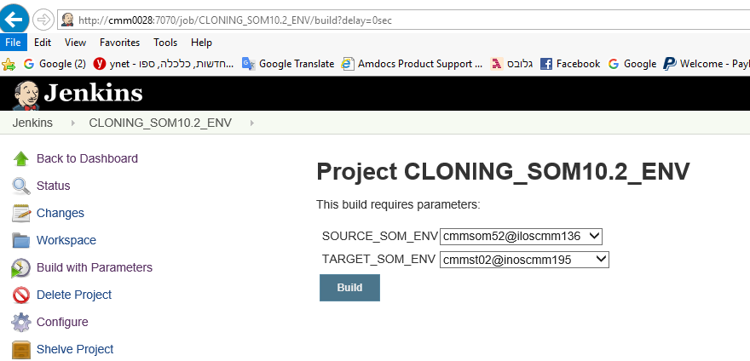

Problem:

When trying to install MEC mec00@ilcoment02:60000 I am getting the same issue you face below.

[08:16:29] [ERROR] Task "fail" finished with error.
/ossusers1/oss/comcast/mec00/.xpi/installations/MEC_PORTFOLIO/execution/current-execution/containers/MECJEE/jee/wls-configuration-handler.xml:29: The MECServer server failed to start after 10 minutes
Solution:
Start the installation and when it’s running login to mec-home/properties and replace the keystore.jks, RootCA.cer, SRootCA.cer from mec-home/properties (we can copy it from other MEC env)

Logs Location:

Application | Logs Location
SOM | First Location :-  $HOME/JEE/dop/logs/affDomain/affServer/affServer.log*  $HOME/JEE/dop/logs/affDomain/affServer/weblogic.*  $HOME/JEE/dop/logs/affDomain/affServer/affDomain.log*  Second Location :-  $HOME/JEE/dop/WLS/affDomain/aff_backend.log*  $HOME/JEE/dop/WLS/affDomain/search_debug.log*  $HOME/JEE/dop/WLS/affDomain/cxf_messages*  $HOME/JEE/dop/WLS/affDomain/aff_frontend.log*  Third Location :-  $HOME/asm_home/uams_dbg*.log  $HOME/asm_home/xps-container-services.log*
ASD | First Location :-  $HOME/JEE/ASDDomain/nohup.out*  Second Location:-  $HOME/JEE/ASDDomain/logs/de_backend.log*
USM | First Location :-  $HOME/JEE/usmwrk1/logs/CramerServer*.log  $HOME/JEE/usmwrk1/logs/weblogic.*.log  Second Location :-  $HOME/JEE/usmwrk1/WLS/usmwrk1/AmdocsCoreTest_en*.log  $HOME/JEE/usmwrk1/WLS/usmwrk1/Cramer_*log  Third Location :-  $HOME/JEE/usmwrk1/WLS/usmwrk1/servers/CramerServer/logs/CramerServer.log*

Problem:

Hi Infra Team,
Please help us deploying control files to the environment. MRS calls are failing due to this:
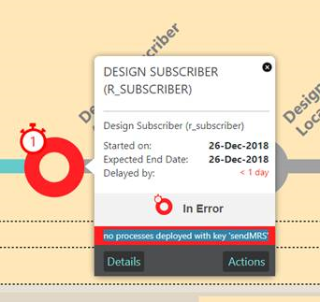
Solution:
Take backup of the controlfiles folder and Copy the controlfiles folder from other ARM to your ARM.

cmmarm10@inoscmm082.corp.amdocs.com:cmmarm10/JEE/cmmarm10_Domain> ll
drwxr-xr-x 2 cmmarm10 amdocs 20480 Dec 8 03:14 controlfiles

reboot the ARM

Request:
Hi Infra Team,
Can you please add below HF in HF automatic deployment script at the end. This must be done for SOM99 and SOM52.

- 300014027
Solution:

We have added it in Jenkins configuration after installation script.
Deployed HF form Unix box like below. You can check configuration for job.

ksh HotfixRunApi.ksh API_AUTO_DEPLOY 300014027 cmmsom99@inoscmm111;

Login to the env in jenkines and updated configuration script:

http://cmm0028:7070/job/SOM_AD_INSTALLATION_cmmsom99_inoscmm111/configure

Problem:

Hi Team,

We are facing an issue with below HF deployments in SOM150. Below are the exceptions received for respective HF’s. Could you please check it on priority.

Deploy operation [J2EE_DEPLOY] of file [portal-container-module.js] to [/ossusers1/oss/users/cmsom150/../../../..//opt/amdocs/dop/ossui1/core/applications/OSSUI/AmdocsOSS/ears/amdocs-ossui-portal.ear:ossui-portal-war.war:app/amdocs/ossui/portal/pages/portal-container-module.js] on [cmsom150@inoscmm298] failed, error: java.io.IOException: Permission denied
at java.io.UnixFileSystem.createFileExclusively(Native Method)
at java.io.File.createTempFile(File.java:2024)
at sun.tools.jar.Main.createTempFileInSameDirectoryAs(Main.java:144)
at sun.tools.jar.Main.run(Main.java:260)
at sun.tools.jar.Main.main(Main.java:1288)
Solution:
Its permission issue on /opt/amdocs
All the files are with root and user which is updating the files is $LOGNAME who didn’t have permission to update or delete files
Two option can be done where first one is preferred.

- Change the owner to cmsom150
sudo chown -R cmsom150:wladmin /opt/amdocs
- Change permission to 777

Problem:

Hi Infra,

Seems SOM150 is not configured in Mail Utility.

Request you to configure other OSS Component connected to SOM150 as well for Mail Utility.
Solution:

Simply do ssh to the env

cmmadm@cmm0028:cmmadm> ./AddSSHEnv.ksh cmsom150 inoscmm298

Request
Hi Infra,

Please add below simulator to the installation script as :

aff.OGW.service.ws.endpoint.projectStatusUpdate.resourceURI=/snow/ws_simulator/projectStatusUpdate

(please find attached reference delivery properties file)
Solution:
- Go to /infraoss/comcastmm/STORAGE/INFRA/CI/SOM_AD/Installation_Scripts/bin

- Update the script install_som_ad_10.2.sh with the new line

- Do the same in india server cmmadm@inoscmm003

Problem:

i have space issue in inoscmm237 for /usr/jave

Solution:

space added

run this 2 commands:

lvextend -L +2G /dev/mapper/vg00-usr
resize2fs /dev/mapper/vg00-usr

Problem:

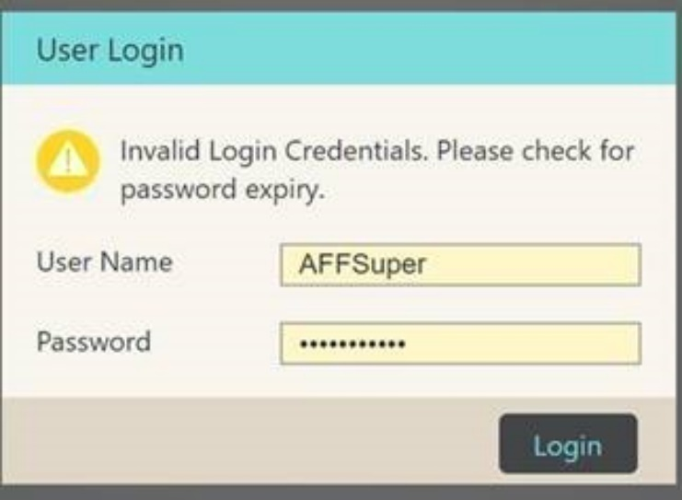

Solution:

Login to ASM in USM env and unlock the user AFFSuper

http://inoscmm003.corp.amdocs.com:30401/ASMAdminUI/

Problem:
Inactive for ARM connection bridges
WARN: failed to connect to the target.

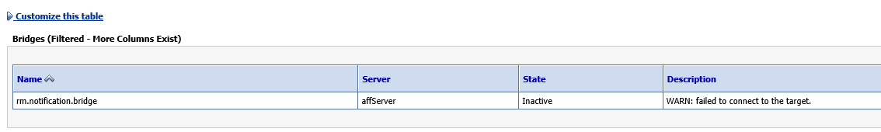

Solution:
This issue was coming due to missing patch in WL.

I copied the WL from SOM52 server and restart WL in SOM.

cmmsom117@iloscmm167.corp.amdocs.com:~/opt>ll weblogic1221

Problem:

We are getting below error while trying to generate CLLI in RO GT on SOM66 which is connected to ASD66.
Input={ntID=!clips, accountNumber=209104, houseNum=null, clliDerivationParameter=Address, prefix=null, zipCode=null, state=CA, address1=3104 DELTA FAIR BLVD, longitude=null, address2=null, latitude=null, sname=null, type=null, suffix=null, city=ANTIOCH}
,Output:{errorCode=0, locationList=null, errorText=Unable to derive Network Site CLLI. CLONES WS is not accessible and No Subscriber identified with Account Number : 209104}

Few points on this issue.

- ASD and SOM was not pointing to the same ARM.
- ARM was in “Inactive” Status in SOM.
- ASD was pointing to ARM9 but xml files under jdbs was pointing to wrong ARM:

cmmasd66@inoscmm257:cmmasd66/JEE/ASDDomain/config/jdbc> grep CMMARM *
and-datasource-jdbc.xml: <url>jdbc:oracle:thin:@inoscmm214:1521:CMMARM09</url>
and-datasource-jdbc.xml: <value>CMMARM09</value>
ossui-datasource-jdbc.xml: <value>CMMARM09</value>

Solution:
- Pointing ASD and SOM to the same ARM9.
- Fix the Inactive issue in SOM.
- Refresh again the ASD env and now all xml’s pointing to the correct ARM env.

Problem:
I am not able to export Full Zip from MEC02. We are getting below issue. Can you please check? If needed then please restart MEC02

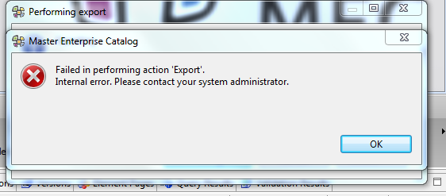

Solution:

In MEC.log we see there is tablespace issue so may be its not releasing the project
cd JEE/mecDomain/WLS/logs/ mec.log
Avi , Please increase it by 2 GB

... 48 more
Caused by: java.sql.BatchUpdateException: ORA-01691: unable to extend lob segment MEC02.SYS_LOB0000102467C00005$$ by 1024 in tablespace USERS

After increase the table space all is working fine

Request:

Please save the build

Solution:

http://cmm0028:7070/job/BUILDS_TO_SAVE/

run it with the needed parameters.

The storage will be saved in INDIA server

cmmadm@inoscmm003:/infraoss/comcastmm_backups/SOM/AD_Sup> ll 3926.zip
-rw-r--r-- 1 cmmadm amdocs 1897718398 Jan 16 15:32 3926.zip

Problem:
Getting this error when refresh SOM env.
"stdout": "Pushing the encrypted ASM DB Password to the Central Config\nPopulate to Central Configuration started at 16/Jan/2019 04:11:16 PM\nLoading context from: /ossusers1/oss/users/cmsom150/pushToCC_ASM/context.properties\nLoading Properties from: /ossusers1/oss/users/cmsom150/pushToCC_ASM/dbp/security.properties\nLoading Properties from: /ossusers1/oss/users/cmsom150/pushToCC_ASM/dbp/security.sec.encrypted.properties\nConnecting to Central Configuration...\nPopulate To Central Configuration cannot connect to the Central Configuration host. [host=127.0.0.1,
port=8500]\nPopulate to Central Configuration failed. (exitStatus: 1)\nPopulate to central configuration ended at 16/Jan/2019 04:11:17 PM\nTotal time: 0.00785 minutes.",
"stdout_lines": ["Pushing the encrypted ASM DB Password to the Central Config",
"Populate to Central Configuration started at 16/Jan/2019 04:11:16 PM",
"Loading context from: /ossusers1/oss/users/cmsom150/pushToCC_ASM/context.properties",
"Loading Properties from: /ossusers1/oss/users/cmsom150/pushToCC_ASM/dbp/security.properties",
"Loading Properties from: /ossusers1/oss/users/cmsom150/pushToCC_ASM/dbp/security.sec.encrypted.properties",
"Connecting to Central Configuration...",
"Populate To Central Configuration cannot connect to the Central Configuration host. [host=127.0.0.1,
port=8500]",
"Populate to Central Configuration failed. (exitStatus: 1)",
"Populate to central configuration ended at 16/Jan/2019 04:11:17 PM",
"Total time: 0.00785 minutes."]}
to retry,
use: --limit @/ossusers1/oss/users/cmsom150/ansible_playbook/dop-asm-setup.retry

PLAY RECAP *********************************************************************
localhost : ok=8 changed=3 unreachable=0 failed=1

Checking ASM status..
Returned ERROR CODE while running ASM installation, terminating script..
Build step 'Execute shell' marked build as failure
Finished: FAILURE

Solution:
When you run refresh via jenesis you need to boot consul then run the refresh.

cmsom150 56195 56186 0 16:19 pts/2 00:00:27 consul agent -config-dir=../config.d -pid-file=../work/pid.txt –ui

Problem:

i can see this error when booting USM
Enter username to boot WebLogic server:<Jan 17, 2019 12:12:09 PM IST> <Error> <Security> <BEA-090783> <Server is running in development mode and the Native Library (terminalio) to read the password securely from the command line wes not found.>
Solution:

Please copy the security folder from:

/ossusers1/oss/users/nbusm02/JEE/nbusm02Domain/WLS/nbusm02Domain/servers/CramerServer/security

To:

/ossusers1/oss/users/nbusm02/JEE/USMDomain/WLS/USMDomain/servers/CramerServer

Copy from $HOME/JEE/<domain>/WLS/<domain>/servers/adminServer/security to $HOME/JEE/<domain>/WLS/<domain>/servers/CramerServer/

Problem:

ASD server is up but got this error message:

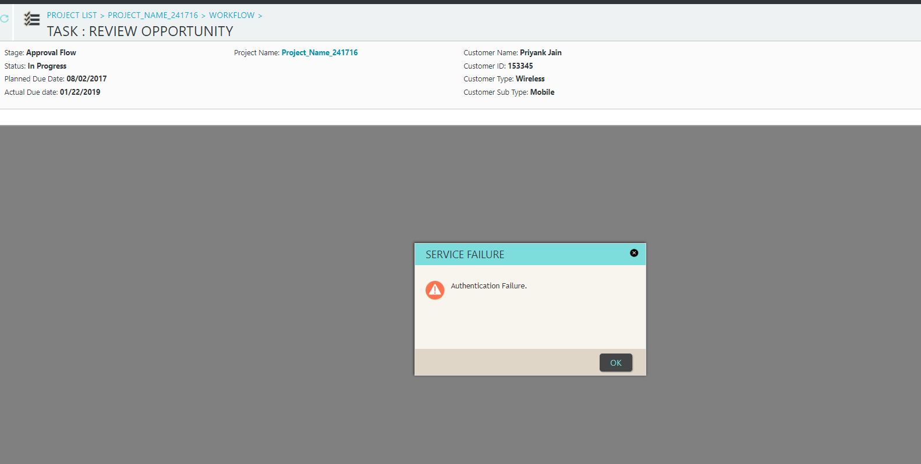

Solution:

Please check that SOM and ASD have the same ARM configuration.

Problem:
Decomposition Failing with BOSS_MSI_EJB_ERROR on SOM86/USM07

Error:
Jan 21, 2019 1:24:02 PM com.amdocs.oss.msi.impl.MSIDetailException <init>
WARNING: to Query Services.
java.sql.SQLSyntaxErrorException: ORA-00942: table or view does not exist

at oracle.jdbc.driver.T4CTTIoer.processError(T4CTTIoer.java:450)
at oracle.jdbc.driver.T4CTTIoer.processError(T4CTTIoer.java:399)
at oracle.jdbc.driver.T4C8Oall.processError(T4C8Oall.java:1059)
at oracle.jdbc.driver.T4CTTIfun.receive(T4CTTIfun.java:522)

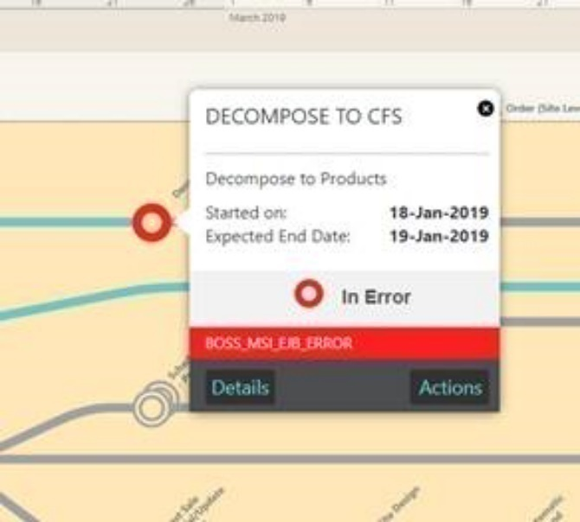

Solution:

- Check the table in error query is present or not.
- If its present then its Grants issue.
- For Dev env to fix this error we need to change the CRAMER_COMMON user to CRAMER user and restart USM.

      - Login to console of USM (user/pass: weblogic/weblogic123)
      - Go to: Data Sources CramerDataSource

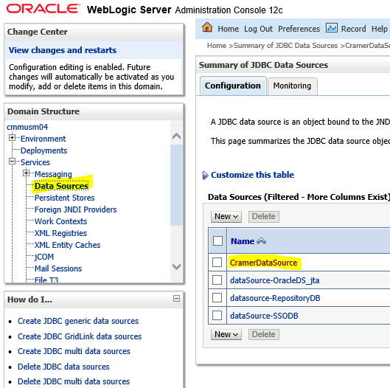

      - Change the CRAMER_COMMON user to CRAMER user and restart USM.

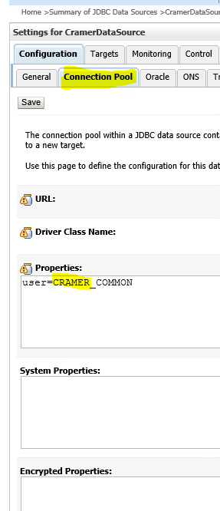

      - For PT/UAT/PROD environment’s it is not recommended to change the DB user, instead check the grants at table level and fix it one by one.

Problem:
Orion Testing | R2.2 | VAPP81 | SOM387/SQO1692 | Error in loading RO GT
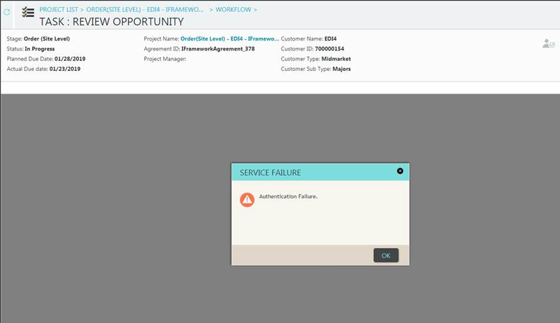

Solution:

Update uams.properties in ASD env with the new USM like in USM.

Problem:

HI OSS Infra Team,

We are getting Multiple Exceptions occurred error on Asset Management BOM Review GT on E2E1.

Can you please check this issue.
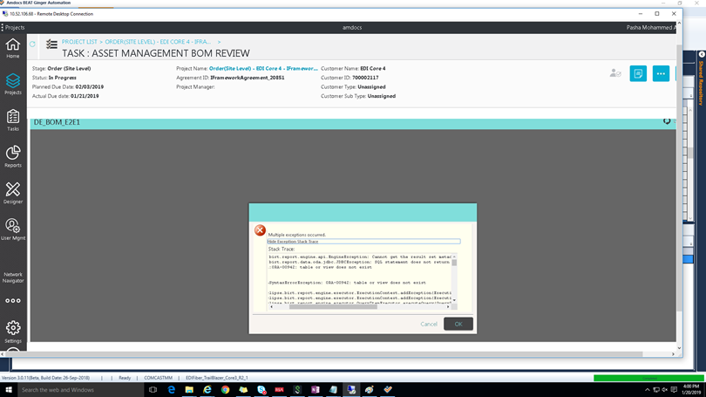
Solution:

http://creativity/SpaceDirectory/Sites/Infra%20OSS/OSS%20Project/SITE%20DE_BOM%20reports%20configuration.aspx

We need to upload new DE_BOM_E2E1.rptdesign file.

  - Login to report gui http://cramapp-dt-10s.ula.comcast.net:10100/OneOSS/main.jsf

Remotedesktop for Report:

24.40.50.181
CRAMRD-WC-01P\ernesto
Welcome123

Request:

Hi, Infra
Please rebuild migration environment of CMMLVT01
To be same as USM DB on QA2, metadata and tables structure
Please copy SOM Ref user DB from CRT1 to CMMLVT01 SOM ref user
This is for coming MR2 R1 execution tonight

Solution:

For part 1 use the Jenkins job:

http://cmm0028:7070/view/Utilities/job/USM_MM_MIGRATION_COPY/

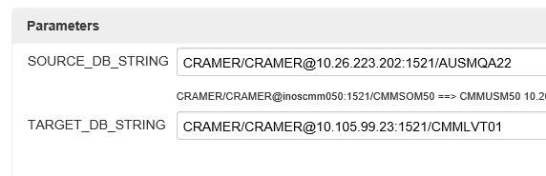

If it’s not running good we need to do it manually:

[‎2/‎4/‎2019 3:09 PM] Upendra kumar Bhushan:
sqlplus CRADBA/Infra4DBA@10.252.168.99:1521/AUSMQA22
create or replace directory mig_data as '/oravl01/oracle/QA2';
grant read,write on directory mig_data to public;
EXIT;
chmod -R 777 /oravl01/oracle/QA2
expdp CRAMER/CRAMER@10.252.168.99:1521/AUSMQA22 tables=usmattributegroup,usmattributegroupdefinition,usmattributegroupusage,usmservicetype_m,USMSERVICETYPEMAP,usmservicecharacteristic_m,USMSERVICETYPECHARACTERISTIC,USMSERVICEPARTITION_M,usmservice_o,USMSERVICEVERSION,USMSERVICEASSOCIATION,USMNVWireline,USMNVinternet,USMFTWireline,USMFTINternet,USMFTMEF_SVCS,USMNVMEF_SVCS directory=mig_data dumpfile=mig_QA2.dmp logfile=QA2_DB_SID.log
[‎2/‎4/‎2019 3:10 PM] Upendra kumar Bhushan:

Before we doing the imp we need to do the drop as in the Jenkins job:

impdp CRAMER/CRAMER@CMMFVT01 directory=CRAMER_DMP dumpfile=CRAMER01.dmp tables=usmattributegroup,usmattributegroupdefinition,usmattributegroupusage,usmservicetype_m,USMSERVICETYPEMAP,usmservicecharacteristic_m,USMSERVICETYPECHARACTERISTIC,USMSERVICEPARTITION_M,usmservice_o,USMSERVICEVERSION,USMSERVICEASSOCIATION,USMNVWireline,USMNVinternet,USMFTWireline,USMFTINternet,USMFTMEF_SVCS,USMNVMEF_SVCS ignore=y

For part 2 use this guide:

1.Login to source server from where schema(SOM_REF_USER) is to be imported , in this case
CRT(somwrk1@mwhlvcmeoss03)

2.Check which schema/user is to be exported and run below command to export dump :

exp SOMWRK1_REF/SOMWRK1_REF@CMMUAT03 file=REFQA1.dmp compress=n statistics=none

#Check count of tables exported

3.Login to the target server , in this case cmilvcmml1 , login with oracle

4.check user is present or not , check db details from dop.properties , then run below command to export dump :

exp SOMWRK1_REF/SOMWRK1_REF@CMMLVT01 file=REFLVT.dmp compress=n statistics=none

5.After completion of above do following :

run drop.sql in target db

[oracle@cmilvcmml1 ~]$ ll drop.sql
-rw-r--r-- 1 oracle dba 1346 Oct 5 03:46 drop.sql
[oracle@cmilvcmml1 ~]$ less drop.sql
[oracle@cmilvcmml1 ~]$ sqlplus SOMWRK1_REF/SOMWRK1_REF@CMMLVT01

copy REFQA1.dmp(source dump file) to target:

we can copy it to jumper and put it in LVT

cmildev130:~cmmamc : sftp somwrk1@mwhlvcmeoss03
Connecting to mwhlvcmeoss03...
sftp> get REFQA1.dmp
Fetching /users/gen/somwrk1/REFQA1.dmp to REFQA1.dmp
/users/gen/somwrk1/REFQA1.dmp 100% 2386MB 31.8MB/s 01:15
sftp>

6.Then , import the dump file using below command in target server:

imp SOMWRK1_REF/SOMWRK1_REF@CMMLVT01 file=REFQA1.dmp full=y IGNORE=Y

#Check count of tables imported

Problem:

When install ASD I am getting:

####################################
Image directory already exists. Create images folder inside it.
/users/gen/asdwrk1/ASD_Installation/ASD-Installer
Creating backup directory
--------- cleaning ASD DB schema ----------

SQL*Plus: Release 12.1.0.2.0 Production on Thu Feb 14 17:54:14 2019

Copyright (c) 1982, 2014, Oracle. All rights reserved.

ERROR:
ORA-01017: invalid username/password; logon denied

Enter user-name: SP2-0306: Invalid option.
Usage: CONN[ECT] [{logon|/|proxy} [AS {SYSDBA|SYSOPER|SYSASM|SYSBACKUP|SYSDG|SYSKM}] [edition=value]]
where <logon> ::= <username>[/<password>][@<connect_identifier>]
<proxy> ::= <proxyuser>[<username>][/<password>][@<connect_identifier>]
Enter user-name: Enter password:
ERROR:
ORA-12162: TNS:net service name is incorrectly specified

SP2-0157: unable to CONNECT to ORACLE after 3 attempts, exiting SQL*Plus
Installation Failed - Failed ASD Clean DB since could not login into DB.
Installation Ended.
INSTALLATION Failed.. please check logs at location:ASD_Installation/ASD-Installer/logs
Build step 'Execute shell' marked build as failure
Finished: FAILURE
Solution:
sysdba grant was missing

login to ARM oracle and do:

[oracle@inoscmm241 ~]$ sqlplus / as sysdba

SQL> grant sysdba to CRADBA;
SQL> grant sysdba to cradba;

If still not working check if in .profile of ASD cradba is small or big letter

If it’s small you can change it to big.

Problem:

Hi Infra,

QS getLocationsForAccount is taking longer than usual to complete on this env.
I can also see some occurrences of this QS which got completed in less than a minute on same env.

We are facing slowness on this Generate CLLI QS.
There is one JOB running on this env.

Could you please help us in killing this job.
Solution:

    - Login to QA2 ARM UNIX env
    - Login to DB sqlplus CRAMER/cRameR2@ICRMQA21
    - For stop the job run”

SQL> exec dbms_scheduler.stop_job ('PERTIERVIEW_REFRESH');

PL/SQL procedure successfully completed.

    - For disable the job run:

SQL> exec dbms_scheduler.disable ('PERTIERVIEW_REFRESH');

PL/SQL procedure successfully completed.

Request:
To add environment to HPD
- we have copy JavaAgent.tar to environment and extract it.
- Just make sure you copy tar for Amdocs network from SOM52 home and for CMI network you can copy it from E2E1 Home.
- Go to $HOME/JEE/scripts and add below parameter to serverStartprop.sh

-javaagent:/ossusers1/oss/users/cmmst02/JavaAgent/DiagnosticsAgent/lib/probeagent.jar -Dprobe.id=affServer -Dprobe.group=UPDATE_ENV_NAME_HERE

-javaagent:/users/gen/somwrk1/JavaAgent/DiagnosticsAgent/lib/probeagent.jar -Dprobe.id=somwrk1_illnqw1434 -Dprobe.group=SOM_illnqw1434 "

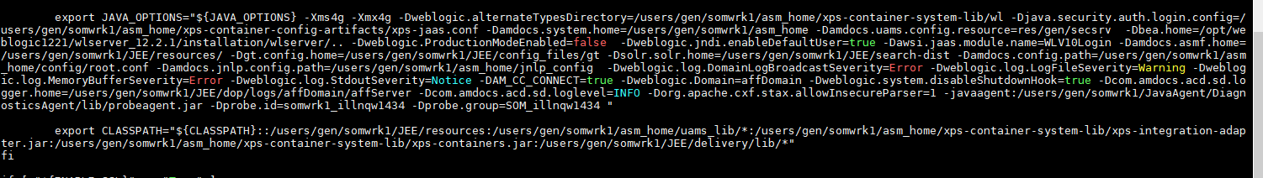
- Restart SOM
Site HPD:-
http://10.105.194.38:2006/ hpdread/Hpdread@11

Offshore HPD:-
http://illin076:2006 admin/admin

Request:

Hi Neha/Infra Team,
Please import below list of tables as per given source & target; as this includes the BI Migration with Ethernet for ARM run FVT6(R2.1) which is planned tomorrow early morning, BSS tables are ready on their env, it will save time for tomorrow's activity of import of CNV tables to QA2 ARM env.
Source :-
server: cmilvcmml2(BSS)
DB instance: CMMLVT02
The Source BSS schema is ABPAPP1.

- To know what is the server for CMMLVT02 please login to this link and check from the list the server name

http://cmm0028:7070/view/Utilities/job/USM_MM_MIGRATION_COPY/configure

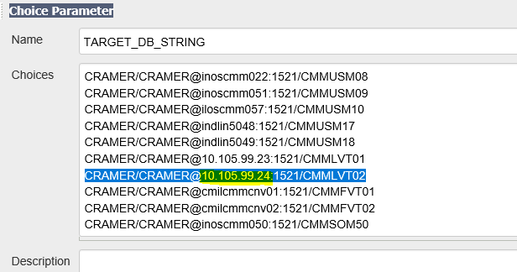
Solution:

      - cmmadm@cmm0028:cmmadm> ssh cmmamc@cmildev130

      - cmildev130:~cmmamc : ssh oracle@10.105.99.24

      - [oracle@cmilvcmml2 ~/dba]$ sqlplus ABPAPP1/ABPAPP1@CMMLVT02

      - SQL> create or replace directory mig_data as '/tmp/mig_data/';

      - SQL> grant read,write on directory mig_data to public;

Grant succeeded.

SQL> commit;

Commit complete.

SQL> exit
      - Do the export:
[oracle@cmilvcmml2 ~/dba]$ expdp ABPAPP1/ABPAPP1@CMMLVT02 tables=CNV_ADDRESS,CNV_SITE,CNV_SUB_LIST,CNV_SUB_ITEMS,CNV_CUST_LIST,CNV_SUB_ATTRS,CNV_SUB_ASSOCIATION,CNV_WHITE_LIST,CNV_ENTITIES_MAPPING,UF_SRV_PARAM directory=mig_data dumpfile=abp.dmp logfile=expdp_abp.log

Export: Release 12.1.0.2.0 - Production on Thu Feb 21 07:46:53 2019

Copyright (c) 1982, 2014, Oracle and/or its affiliates. All rights reserved.

Connected to: Oracle Database 12c Enterprise Edition Release 12.1.0.2.0 - 64bit Production
With the Partitioning, OLAP, Advanced Analytics and Real Application Testing options
Starting "ABPAPP1"."SYS_EXPORT_TABLE_01": ABPAPP1/********@CMMLVT02 tables=CNV_ADDRESS,CNV_SITE,CNV_SUB_LIST,CNV_SUB_ITEMS,CNV_CUST_LIST,CNV_SUB_ATTRS,CNV_SUB_ASSOCIATION,CNV_WHITE_LIST,CNV_ENTITIES_MAPPING,UF_SRV_PARAM directory=mig_data dumpfile=abp.dmp logfile=expdp_abp.log
Estimate in progress using BLOCKS method...
Processing object type TABLE_EXPORT/TABLE/TABLE_DATA
Total estimation using BLOCKS method: 120.3 MB
Processing object type TABLE_EXPORT/TABLE/TABLE
Processing object type TABLE_EXPORT/TABLE/CONSTRAINT/CONSTRAINT
Processing object type TABLE_EXPORT/TABLE/INDEX/STATISTICS/INDEX_STATISTICS
Processing object type TABLE_EXPORT/TABLE/STATISTICS/TABLE_STATISTICS
Processing object type TABLE_EXPORT/TABLE/STATISTICS/MARKER
. . exported "ABPAPP1"."CNV_SUB_ATTRS" 39.27 MB 197730 rows
. . exported "ABPAPP1"."CNV_SUB_ITEMS" 28.21 MB 92028 rows
. . exported "ABPAPP1"."UF_SRV_PARAM" 20.13 MB 97449 rows
. . exported "ABPAPP1"."CNV_ENTITIES_MAPPING" 2.882 MB 32658 rows
. . exported "ABPAPP1"."CNV_SUB_LIST" 3.136 MB 8740 rows
. . exported "ABPAPP1"."CNV_SUB_ASSOCIATION" 1.696 MB 7420 rows
. . exported "ABPAPP1"."CNV_ADDRESS" 1.503 MB 4163 rows
. . exported "ABPAPP1"."CNV_CUST_LIST" 693.8 KB 1332 rows
. . exported "ABPAPP1"."CNV_SITE" 454.5 KB 1497 rows
. . exported "ABPAPP1"."CNV_WHITE_LIST" 34.46 KB 1008 rows
Master table "ABPAPP1"."SYS_EXPORT_TABLE_01" successfully loaded/unloaded
******************************************************************************
Dump file set for ABPAPP1.SYS_EXPORT_TABLE_01 is:
/tmp/mig_data/abp.dmp
Job "ABPAPP1"."SYS_EXPORT_TABLE_01" successfully completed at Thu Feb 21 07:46:59 2019 elapsed 0 00:00:06

      - oracle@cmilvcmml2 ~/dba]$ cd /tmp/mig_data/

[oracle@cmilvcmml2 mig_data]$ ll
total 116808
-rwxr-xr-x 1 oracle dba 16052224 Feb 5 11:27 mig_USMDBSTG.dmp
drwxrwxrwt 23 root root 73728 Feb 21 07:46 ..
drwxrwxr-x 2 oracle dba 4096 Feb 21 07:46 .
-rw-r----- 1 oracle dba 103469056 Feb 21 07:46 abp.dmp
-rw-r--r-- 1 oracle dba 2198 Feb 21 07:46 expdp_abp.log

      - tar the mig_data folder
[oracle@cmilvcmml2 /tmp]$ tar cvf mig_data.tar mig_data
      - login again to jumper server and copy the tar to thr jumper server.
      - scp oracle@10.105.99.24:/tmp/mig_data.tar .
      - now copy the tar to QA2 ARM server.

cmildev130:~cmmamc : scp mig_data.tar ossenv1@10.26.225.4:

      - login to QA2 server and untar the folder.

[ clipapp-dt-12s: /app/home/ossenv1/mig_data ] ll
total 101060
-rw-r-----. 1 ossenv1 ossenv1 2198 Feb 21 13:46 expdp_abp.log
-rw-r-----. 1 ossenv1 ossenv1 103469056 Feb 21 13:46 abp.dmp
drwxr-x---. 2 ossenv1 ossenv1 40 Feb 21 13:48 .
drwxr-xr-x. 84 ossenv1 ossenv1 8192 Feb 21 13:53 ..

      - send mail:

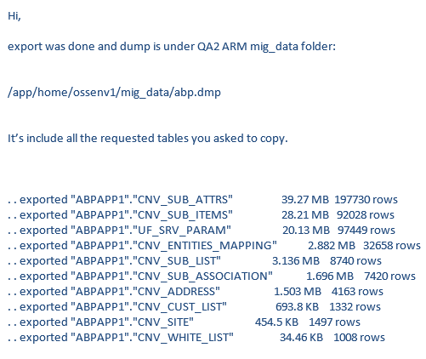

PROBLEM:

Hi Gopal/Itsik,

I need your help with this DB issue:

In oracle@ntdevapp36 getting this error when trying to boot instance ATTAUA1.

[oracle@ntdevapp36 ~]$ setenv ORACLE_SID ATTAUA1
-bash: setenv: command not found
[oracle@ntdevapp36 ~]$ export ORACLE_SID=ATTAUA1
[oracle@ntdevapp36 ~]$ sqlplus / as sysdba

SQL*Plus: Release 11.2.0.3.0 Production on Mon Feb 25 19:53:58 2019

Copyright (c) 1982, 2011, Oracle. All rights reserved.

Connected to an idle instance.

SQL> startup;
ORACLE instance started.

Total System Global Area 3457368064 bytes
Fixed Size 2233240 bytes
Variable Size 2113932392 bytes
Database Buffers 1325400064 bytes
Redo Buffers 15802368 bytes
ORA-00205: error in identifying control file, check alert log for more info
Solution:

before you startup this instance
export ORACLE_HOME=/u01/app/oracle/product/12.1.0/db_1
export PATH=$ORACLE_HOME/bin:$PATH
export ORACLE_SID=ATTAUA1

PROBLEM:

Please deploy below ARM and ASD build on VAPP98

Vapp98 - CPQ1256/SOM1433/ARM1745

ARM:
http://cmm0028:7070/view/BUILD%20JOBS/view/ORION_ARM/view/DevMain/job/ARM_DevMain_FLOW/580/

Solution:

If this ARM env is not in Jenkins we can run from the env it self the refresh:

ksh rm_deploy.ksh /infraoss/comcastmm/STORAGE/BUILDS/rm/101/STORE_101_580 | tee -a Refresh_2March_DevMain_580.log

JEE1/rm.global.user=CRAMER
JEE1/rm.global.password=CRAMER
JEE1/rm.global.db.host=inoscmm241
JEE1/rm.global.db.instance=CMMARM17
JEE1/rm.global.db.port=1521
JEE1/rm.global.url=jdbc:oracle:thin:@inoscmm241:1521:CMMARM17
JEE1/rm.global.oracle.ds.xa=dataSource-CRAMER_COMMON-user
JEE1/rm.global.wls.xa.connpool.init=1
JEE1/rm.global.wls.xa.connpool.max=15

PROBLEM:
When login to USM GUI I am getting this issues:

Unable to create user session. your session may have timed out or invalid, Please login again to continue.

Unable to obtain user DN from session properties, Invalid ASM / Cramer Ticket.
javax.naming.AuthenticationException: Unable to obtain user DN from session properties, Invalid ASM / Cramer Ticket

Solution:

Please add to usm .profile this alias

alias hostname='hostname -f'

now the link to the gui will be with full server name:
http://inostfc046.corp.amdocs.com:34601/CramerOSS/Login/SessionDefinition.jsp

instead of this:
http://inostfc046:34601/CramerOSS/Login/SessionDefinition.jsp

PROBLEM:

Can you please add these 2 tables spaces in below DB as well.

Table space Details : "USM_HFC_DTH_TFI_DATA" and "USM_HFC_DTH_TFI_INDEX".
Env Details : host: inosamx010
Solution:

Login to oracle user and run it:

create tablespace USM_HFC_DTH_TFI_DATA datafile ' /oravl02/oradata/TFCLUM1/USM_HFC_DTH_TFI_DATA.dbf' size 500m Extent management local uniform size 64k;

create tablespace USM_SATELLITE_DATA datafile '/oravl02/oradata/TFCLUM1/USM_SATELLITE_DATA_1.dbf' size 500m Extent management local uniform size 64k;

PROBLEM:

Start
Matching Defaults entries for somusr01 on this host:
!visiblepw, always_set_home, env_reset, env_keep="COLORS DISPLAY HOSTNAME
HISTSIZE INPUTRC KDEDIR LS_COLORS", env_keep+="MAIL PS1 PS2 QTDIR USERNAME
LANG LC_ADDRESS LC_CTYPE", env_keep+="LC_COLLATE LC_IDENTIFICATION
LC_MEASUREMENT LC_MESSAGES", env_keep+="LC_MONETARY LC_NAME LC_NUMERIC
LC_PAPER LC_TELEPHONE", env_keep+="LC_TIME LC_ALL LANGUAGE LINGUAS
_XKB_CHARSET XAUTHORITY", secure_path=/sbin\:/bin\:/usr/sbin\:/usr/bin

User somusr01 may run the following commands on this host:
(ALL) NOPASSWD: ALL
(ALL) NOPASSWD: ALL
(ALL) NOPASSWD: ALL
consul: no process found
Loaded plugins: product-id, search-disabled-repos, subscription-manager
This system is not registered to Red Hat Subscription Management. You can use subscription-manager to register.
Repository 'amdocs_version_yum_repo' is missing name in configuration, using id
Repository 'amdocs_yum_repo' is missing name in configuration, using id
Repository 'amdocs_yum_repo_external_v10.2' is missing name in configuration, using id
Repository 'amdocs_yum_repo_internal_v10.2' is missing name in configuration, using id
Repository 'amdocs_yum_repo_other' is missing name in configuration, using id
No Match for argument: amdocs-consul1
No Packages marked for removal

"",
"failure: repodata/repomd.xml from amdocs_version_yum_repo: [Errno 256] No more mirrors to try.",
"file:///installation_kits/TEST/RPMS/Amdocs_v10.2/repodata/repomd.xml: [Errno 14] curl#37 - \"Couldn't open file /installation_kits/TEST/RPMS/Amdocs_v10.2/repodata/repomd.xml\""
],
"stdout": "Loaded plugins: product-id, search-disabled-repos, subscription-manager\nThis system is not registered to Red Hat Subscription Management. You can use subscription-manager to register.\n",
"stdout_lines": [
"Loaded plugins: product-id, search-disabled-repos, subscription-manager",
"This system is not registered to Red Hat Subscription Management. You can use subscription-manager to register."
]
}
to retry, use: --limit @/ossusers1/oss/users/somusr01/CentralConfig/deploy-consul-server.retry

PLAY RECAP *********************************************************************
inosamx024.corp.amdocs.com : ok=4 changed=0 unreachable=0 failed=1

ERROR: Install Consul Server failed to execute !
Returned ERROR CODE while running CC installation, terminating script..
Build step 'Execute shell' marked build as failure
Finished: FAILURE

Solution:
Please login to /etc/yum.repos.d
and delete the unnecessary files.

-rw-r--r-- 1 root root 108 Feb 6 14:37 amdocs_yum_repo.repo
-rw-r--r-- 1 root root 104 Feb 6 14:37 amdocs_yum_repo_other.repo
-rw-r--r-- 1 root root 117 Feb 6 14:37 amdocs_version_yum_repo.repo
-rw-r--r-- 1 root root 168 Feb 6 14:37 amdocs_yum_repo_internal_v10.2.repo
-rw-r--r-- 1 root root 168 Feb 6 14:37 amdocs_yum_repo_external_v10.2.repo

You will need to have just this files:

drwxr-xr-x 2 root root 4096 Mar 14 2018 bkp
drwxr-xr-x 2 root root 4096 Apr 26 2018 old2
drwxr-xr-x. 100 root root 12288 Apr 17 13:28 ..
-rw-r--r-- 1 root root 358 Apr 18 14:51 redhat.repo
-rwxr-xr-x 1 root root 168 Apr 18 17:50 amxacd.repo

Hi ,

Regarding the error we have on local env –(Installation failed on local )
but may\nbe elsewhere in the file depending on the exact syntax problem.\n\nThe offending line appears to be:\n\n\n - replace: dest={{ansible_env.HOME}}/{{item}} regexp='\\${CPQ_PASSWORD}' replace='{{ansible_env.CPQ_PASSWORD}}'\n ^ here\nWe could be wrong,
but this one looks like it might be an issue with\nmissing quotes. Always quote template expression brackets when they\nstart a value. For instance:\n\n with_items:\n - {{ foo }}\n\nShould be written as:\n\n with_items:\n - \"{{ foo }}\"\n"}
to retry,

This error related to logic core have added some simulator properties
INFRA fix Installation Job on adoption CI by adding
export CPQ_PASSWORD="Unix11"
export CPQ_BE_PASSWORD="Unix11"
Which will not help to all environments ☹

I would like to add the following in Update_properties.ksh
…
export SQO_PORT=${SQO_PORT:-8443}

#CPQ_PASSWORD and CPQ_BE_PASSWORD not in use - added as core simulator add acd task needed that
export CPQ_PASSWORD=${APP_PASS:-Unix11!}
export CPQ_BE_PASSWORD=${APP_PASS:-Unix11!}
….

Request was:

Could you please upload attach artifact to Nexus?
[attachment is zip file which contains jar, please upload that]

And please clean the artifact from .m2 repo of releasable and support build server.

<groupId>com.amdocs.oss.and</groupId>
<artifactId>and-servicedesigner-ws-client</artifactId>
<version18.09.01.PI13</version>

Solution:

Copied to the following locations:

ssh nexus1@cmm0028

/ossusers2/oss/users/nexus1/sonatype-work/nexus/storage/releases/com/amdocs/oss/and/and-servicedesigner-ws-client/18.09.01.PI13
/ossusers2/oss/users/nexus1/sonatype-work/nexus/storage/releases/.nexus/attributes/com/amdocs/oss/and/and-servicedesigner-ws-client/18.09.01.PI13
/ossusers2/oss/users/nexus1/sonatype-work/nexus/storage/releases/.nexus/trash/.nexus/attributes/com/amdocs/oss/and/and-servicedesigner-ws-client/18.09.01.PI13

And under .m2:

/ossusers2/oss/users/mb_cccmm2/.m2/repository/com/amdocs/oss/and/and-servicedesigner-ws-client/18.09.01.PI13

Crating New Instance:

        - login to oracle user
        - run: Idba

(/oravl01/oracle/dba/dbmon/Idba)

***********************************************
*
* Hello Avi Saar
* WELCOME Idba TOOL
*
***********************************************
1) Start Database
2) Stop Database
3) Backup Database
4) Restore Database
5) Clone Database
6) Listener
7) Create New DB
8) Export DB
9) Import DB
10) Delete DB
11) Switch Archive mode
0) exit
PLEASE ENTER YOUR CHOICE > 7

###################
# CREATE DATABASE #
###################

PLEASE ENTER NEW DATABASE NAME > TFCLUM1

PLEASE ENTER ORACLE_VERSION x.x.x.x > 12.1.0.2

PLEASE ENTER CHARACTER SET [ default AL32UTF8 ] >

PLEASE ENTER INSTANCE TYPE > CRAMER

It will run sometime until it will done

L3OCI500

Hi,

You have database.

ssh oracle@inosamx024
The authenticity of host 'inosamx024 (10.77.168.14)' can't be established.
RSA key fingerprint is 2f:7f:ea:df:cc:31:5e:28:df:74:ba:43:ae:bb:dd:3e.
Are you sure you want to continue connecting (yes/no)? yes
Warning: Permanently added 'inosamx024,10.77.168.14' (RSA) to the list of known hosts.
oracle@inosamx024's password:
Last login: Wed Apr 17 13:42:24 2019
oracle sid not found
oracle sid not found

/oravl01/oracle> ps -ef | grep pmon
oracle 3990 1 0 13:12 ? 00:00:00 ora_pmon_AMXIND024
oracle 5909 5822 0 13:48 pts/1 00:00:00 grep -i pmon
/oravl01/oracle> bash
[oracle@inosamx024 ~]$ c
[oracle@inosamx024 ~]$ export PATH=$PATH:/oravl01/oracle/12.2.0.1/bin
[oracle@inosamx024 ~]$ tnsping AMXIND024

TNS Ping Utility for Linux: Version 12.2.0.1.0 - Production on 17-APR-2019 13:49:09

Copyright (c) 1997, 2016, Oracle. All rights reserved.

Used parameter files:
/oravl01/oracle/12.2.0.1/network/admin/sqlnet.ora

Used TNSNAMES adapter to resolve the alias
Attempting to contact (description=(address=(protocol=tcp)(host=inosamx024)(port=1521))(connect_data=(service_name=AMXIND024)))
OK (0 msec)
[oracle@inosamx024 ~]$

PROBLEM:

usmusr01@inostfc049

somusr01@inostfc049

Getting this error in SOM BOSS_MSI_EJB_ERROR

in USM we can see this issue:
I can see this error in USM: java.sql.SQLSyntaxErrorException: ORA-01775: looping chain of synonyms
Solution:

We found that there are missing tables in USM:
SQL> select * from Usmftfiber;
select * from Usmftfiber
*
ERROR at line 1:
ORA-01775: looping chain of synonyms

for fixing this issue we just refresh usm49 again.

Just refresh no full
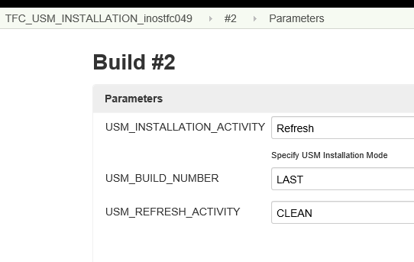

Now tables are available:

>sqlplus cramer/cramer@TFCPT002

Oracle Database 12c Enterprise Edition Release 12.2.0.1.0 - 64bit Production

SQL> select * from Usmftfiber;

no rows selected

SQL> exit

PROBLEM:

Please check

http://ilosamx004.corp.amdocs.com:7070/view/USM%20Self%20Service/job/AMX_USM_INSTALLATION_ilosamx027/8/console

org.eclipse.core.runtime.internal.adaptor.EclipseAppLauncher.runApplication(EclipseAppLauncher.java:134)
13:00:27 at org.eclipse.core.runtime.internal.adaptor.EclipseAppLauncher.start(EclipseAppLauncher.java:104)
13:00:27 at org.eclipse.core.runtime.adaptor.EclipseStarter.run(EclipseStarter.java:380)
13:00:27 at org.eclipse.core.runtime.adaptor.EclipseStarter.run(EclipseStarter.java:235)
13:00:27 at sun.reflect.NativeMethodAccessorImpl.invoke0(Native Method)
13:00:27 at sun.reflect.NativeMethodAccessorImpl.invoke(NativeMethodAccessorImpl.java:62)
13:00:27 at sun.reflect.DelegatingMethodAccessorImpl.invoke(DelegatingMethodAccessorImpl.java:43)
13:00:27 at java.lang.reflect.Method.invoke(Method.java:498)
13:00:27 at org.eclipse.equinox.launcher.Main.invokeFramework(Main.java:669)
13:00:27 at org.eclipse.equinox.launcher.Main.basicRun(Main.java:608)
13:00:27 at org.eclipse.equinox.launcher.Main.run(Main.java:1515)
13:00:27 at org.eclipse.equinox.launcher.Main.main(Main.java:1488)
13:00:27
13:00:27 Jun 26, 2019 10:30:27 AM com.amdocs.oss.ide.mm.cli.CLIDistributionController doDistribution
13:00:27 SEVERE: Distribution failed. Error(s) occured during distribution.
13:00:27
13:00:27 Distribution Failed. Please refer the Error Log for details
13:00:27 Jun 26, 2019 10:30:27 AM com.amdocs.oss.ide.mm.log.impl.MMLogHandlerImpl logMessage
13:00:27 SEVERE: Distribution operation failed.
13:00:27 *****************************************************************************
13:00:27 For Repository /ossusers1/oss/users/usmusr01/USM_MMdata_260/proj/metadata/bin/USMMetadata/repository operation distribute end...
13:00:27 *****************************************************************************
13:00:28
13:00:28 !ENTRY org.eclipse.core.resources 2 10035 2019-06-26 10:30:28.720
13:00:28 !MESSAGE The workspace will exit with unsaved changes in this session.
13:00:30 Distribution ended and checking status now
13:00:30 FAILED TO DISTRIBUTE THE MM REPO. FOR THE SPECIFIC ERROR PLEASE CHECK /ossusers1/oss/users/usmusr01/.installed/usmusr01/26-June-2019/10-28-34/CLI.log MM CLI LOG
13:00:30 Probable failure in USM Metadata installation. Please check for the error in logs..
13:00:40 Process leaked file descriptors. See https://jenkins.io/redirect/troubleshooting/process-leaked-file-descriptors for more information
13:00:40 Build step 'Execute shell' marked build as failure
13:00:40 Finished: FAILURE

Solution:

Hi Paarth,

The USM is up now. The issue was that is missing in database the tablespaces "USM_HFC_DTH_TFI_DATA" and "USM_HFC_DTH_TFI_INDEX" . I created this tablespaces and fixed the issue.

PROBLEM:

Getting the error in USM
javax.naming.AuthenticationException: The user does not have authorization to access Cramer OSS Suite, please contact system admin

and in SOM I see this:

12:06:29.144 [[ACTIVE] ExecuteThread: '11' for queue: 'weblogic.kernel.Default (self-tuning)'] DEBUG o.a.h.i.c.PoolingClientConnectionManager - Connection request: [route: {}->http://ilosamx037.corp.amdocs.c
om:20100][total kept alive: 3; route allocated: 3 of 100; total allocated: 3 of 100]
12:06:29.144 [[ACTIVE] ExecuteThread: '11' for queue: 'weblogic.kernel.Default (self-tuning)'] DEBUG o.a.h.i.c.PoolingClientConnectionManager - Connection leased: [id: 0][route: {}->http://ilosamx037.corp.am
docs.com:20100][total kept alive: 2; route allocated: 3 of 100; total allocated: 3 of 100]
12:06:29.144 [[ACTIVE] ExecuteThread: '11' for queue: 'weblogic.kernel.Default (self-tuning)'] DEBUG o.a.h.i.c.SystemDefaultHttpClient - Stale connection check
<Aug 1, 2019, 12:06:29,143 PM IDT> <Warning> <EJB> <BEA-010065> <MessageDrivenBean threw an Exception in onMessage(). The exception is:
com.amdocs.oss.common.core.error.CoreException: Exception Raised, <BOSS_MSI_EJB_ERROR>.
com.amdocs.oss.common.core.error.CoreException: Exception Raised, <BOSS_MSI_EJB_ERROR>
at com.amdocs.oss.common.components.dpm.engine.impl.ActivityInvoker$ActivityAsyncAction.executeImpl(ActivityInvoker.java:405)
at com.amdocs.oss.common.core.services.async.AsyncActionBase.execute(AsyncActionBase.java:105)
at com.amdocs.oss.common.core.services.async.impl.AsyncActionHandler.execute(AsyncActionHandler.java:97)
at com.amdocs.oss.common.core.internal.async.AsyncRequestManager.processRequest(AsyncRequestManager.java:21)
at com.amdocs.oss.common.core.internal.async.AsynchronousRequestMDB.onMessage(AsynchronousRequestMDB.java:41)
Truncated. see log file for complete stacktrace

Solution:

Please login to ASM http://ilosamx037.corp.amdocs.com:20100/

Add all Roles in ASM for USERS: Asmsa1 and AFFSuper

PROBLEM:

I would like to get your advice on this issue in CI env ilosamx005 when running simulator I can see the following issue in log:

</com.amdocs.services.servicedomain.FulfillmentOrderNotifySvcNotifyFulfillmentOrderItemInputs>', requestUri='null', requestUrl='null', contentType='application/xml', method='null', queryString='null', s
chema='null'}.
java.lang.RuntimeException: No rule selected. apiDefId: 834451624. request: SimulatorRequestContext{parameters={}, headers={}, payload='<com.amdocs.services.servicedomain.FulfillmentOrderNotifySvcNotify
FulfillmentOrderItemInputs>
<m__notification>
<ProductOrderItemResponse>
<com.amdocs.services.servicedomain.ProductOrderItemResponse>
<ID>821913</ID>
<ExternalID>
<Key>821913</Key>
</ExternalID>
<ErrorResponse/>
<ProductResponse>
<com.amdocs.services.servicedomain.ProductResponse>
<ID>531324</ID>
<ErrorResponse/>
<StatusResponse>
<Description>Submitted</Description>
<Status>oss_status_Submitted</Status>
</StatusResponse>
</com.amdocs.services.servicedomain.ProductResponse>
<com.amdocs.services.servicedomain.ProductResponse>
<ID>982598</ID>
<ErrorResponse/>
<StatusResponse>
<Description>Submitted</Description>
<Status>oss_status_Submitted</Status>
</StatusResponse>
</com.amdocs.services.servicedomain.ProductResponse>
<com.amdocs.services.servicedomain.ProductResponse>
<ID>312461</ID>
<ErrorResponse/>
<StatusResponse>
<Description>Submitted</Description>
<Status>oss_status_Submitted</Status>
</StatusResponse>
</com.amdocs.services.servicedomain.ProductResponse>
<com.amdocs.services.servicedomain.ProductResponse>
<ID>662439</ID>
<ErrorResponse/>
<StatusResponse>
<Description>Submitted</Description>
<Status>oss_status_Submitted</Status>
</StatusResponse>
</com.amdocs.services.servicedomain.ProductResponse>
</ProductResponse>
<StatusResponse>
<Description>Submitted</Description>
<Status>oss_status_Submitted</Status>
<StatusDate>2019-09-10 07:07:38.472 UTC</StatusDate>
</StatusResponse>
</com.amdocs.services.servicedomain.ProductOrderItemResponse>
</ProductOrderItemResponse>
<ProductOrderResponse>
<ID>456508</ID>
<ExternalID>456508</ExternalID>
<StatusResponse>
<Description>Submitted</Description>
<Status>oss_status_Submitted</Status>
</StatusResponse>
</ProductOrderResponse>
</m__notification>
<m__appCtx>
<LocaleString>EN</LocaleString>
<SystemId>SOM</SystemId>
</m__appCtx>
</com.amdocs.services.servicedomain.FulfillmentOrderNotifySvcNotifyFulfillmentOrderItemInputs>', requestUri='null', requestUrl='null', contentType='application/xml', method='null', queryString='null', schema='null'}
at com.amdocs.oss.odo.snow.core.utils.SimulatorResponseUtils.lambda$selectSimulationRule$5(SimulatorResponseUtils.java:139)
at java.util.Optional.orElseThrow(Optional.java:290)
at com.amdocs.oss.odo.snow.core.utils.SimulatorResponseUtils.selectSimulationRule(SimulatorResponseUtils.java:139)
at com.amdocs.oss.odo.snow.core.utils.SimulatorResponseUtils.generateResponse(SimulatorResponseUtils.java:55)
at com.amdocs.oss.odo.snow.core.utils.SimulatorResponseUtils.generateResponse(SimulatorResponseUtils.java:34)
Truncated. see log file for complete stacktrace
>
10:07:39.851 [[ACTIVE] ExecuteThread: '37' for queue: 'weblogic.kernel.Default (self-tuning)'] DEBUG java.lang.String - <APPLICATION> <a848106f-e88e-4fd7-a213-3099627d8821> <null> = <Authenticaiton Principal is null>
10:07:39.851 [[ACTIVE] ExecuteThread: '37' for queue: 'weblogic.kernel.Default (self-tuning)'] DEBUG java.lang.String - <APPLICATION> <a848106f-e88e-4fd7-a213-3099627d8821> <null> = <ASM Ticket is Tksmau3PVtJReJqd9N0YfVsaP5ljSu3auQvxMgt0>

Solution:

This is definitely INFRA issue.

Issue found in the WL installation in the server under /opt.

Every time we install new server in AMX/TEF/COMCAST we need to replace the WL installation.

It’s in the installation doc:

6. Replace /opt/weblogic1221 by patched WLS
Source location: /infraoss/amx/programs/weblogic1221_patch.tar
Change ownership to be wladmin

chown wladmin:wladmin weblogic1221

Nexus STOP/START

nexus@ilostfc001:nexus/nexus-2.14.9-01/bin> ./nexus stop
nexus@ilostfc001:nexus/nexus-2.14.9-01/bin> ./nexus start

PROBLEM:

ANN installation is failing

fatal: [inosamx063.corp.amdocs.com]: FAILED! => {
"changed": true,
"cmd": "/bin/bash -c \"/tmp/tmp.6dFTJJ4U3k/deploy_metadata.sh ANN01METADATA ANN01FOUNDATIONS\"",
"delta": "0:00:01.377441",
"end": "2019-10-16 17:16:38.502305",
"failed": true,
"invocation": {
"module_args": {
"_raw_params": "/bin/bash -c \"/tmp/tmp.6dFTJJ4U3k/deploy_metadata.sh ANN01METADATA ANN01FOUNDATIONS\"",
"_uses_shell": true,
"chdir": null,
"creates": null,
"executable": null,
"removes": null,
"warn": true
}
},
"rc": 1,
"start": "2019-10-16 17:16:37.124864",
"stderr": "",
"stderr_lines": [],
"stdout": "",
"stdout_lines": []
}
...ignoring

TASK [deploy_metadata : Fail if the metadata deployment script exits with Non-zero return code] ***
task path: /ossusers1/oss/users/annusr01/ann-ansible-orchestration/roles/deploy_metadata/tasks/main.yml:18
fatal: [inosamx063.corp.amdocs.com]: FAILED! => {
"changed": false,
"failed": true,
"msg": "Metadata distribution failed. Please check the logs."
}
to retry, use: --limit @/ossusers1/oss/users/annusr01/ann-ansible-orchestration/install-ann.retry

PLAY RECAP *********************************************************************
127.0.0.1 : ok=0 changed=0 unreachable=0 failed=0
inosamx063.corp.amdocs.com : ok=49 changed=29 unreachable=0 failed=1

Returned Error code while running ANN installation, terminating script..
Build step 'Conditional step (single)' marked build as failure
Finished: FAILURE

Solution:

Please do ssh from ANN to ARM
Please clean the rpm:

Please login to /etc/yum.repos.d and delete the unnecessary files.

-rw-r--r-- 1 root root 108 Feb 6 14:37 amdocs_yum_repo.repo
-rw-r--r-- 1 root root 104 Feb 6 14:37 amdocs_yum_repo_other.repo
-rw-r--r-- 1 root root 117 Feb 6 14:37 amdocs_version_yum_repo.repo
-rw-r--r-- 1 root root 168 Feb 6 14:37 amdocs_yum_repo_internal_v10.2.repo
-rw-r--r-- 1 root root 168 Feb 6 14:37 amdocs_yum_repo_external_v10.2.repo

PROBLEM:

I am getting this issue in ANN env

"file:///infraoss/tfc/STORAGE/SOM/DevMain/985/repodata/repomd.xml: [Errno 14] curl#37 - \"Couldn't open file /infraoss/tfc/STORAGE/SOM/DevMain/985/repodata/repomd.xml\"",

Solution:

Login to /etc/yum.repos.d and update tfcacd.repo with “LAST”

baseurl=file:///infraoss/tfc/STORAGE/SOM/DevMain/LAST/

PROBLEM:

Hello Team,

Below USM Refresh was failing with Datafile error at Oracle level for USM DB.
07:24:48 FAILED TO DISTRIBUTE THE MM REPO. FOR THE SPECIFIC ERROR PLEASE CHECK /ossusers1/oss/users/usmusr01/.installed/usmusr01/24-October-2019/09-53-40/CLI.log MM CLI LOG
07:24:48 Probable failure in USM Metadata installation. Please check for the error in logs..

08:41:07 Oct 24, 2019 7:11:07 PM com.amdocs.oss.ide.mm.usm.ormapping.USMPostDistributionCallout execute
08:41:07 SEVERE: Error during PKGUSM_CONFIGURATION.CONFIGURE_ATTRIBUTES execution
08:41:07 com.amdocs.oss.ide.mm.usm.util.USMException: Error in PKGUSM_CONFIGURATION.CONFIGURE_ATTRIBUTES Error code : 590090 Error Message :Error configuring USM configurable tables. Cannot create flat attribute table [USMFTHFC_DTH_TFI]. ORA-01116: error in opening database file 31

08:41:07 com.amdocs.oss.ide.mm.usm.util.USMException: Error in PKGUSM_CONFIGURATION.CONFIGURE_ATTRIBUTES Error code : 590090 Error Message :Error configuring USM configurable tables. Cannot create flat attribute table [USMFTHFC_DTH_TFI]. ORA-01116: error in opening database file 31

This was the hint that datafile 31 was corrupted in Oracle.
The was confirmed when I executed below query via cradba in USM DB.

select file_name, tablespace_name from dba_data_files where tablespace_name ='USM_HFC_DTH_TFI_DATA';

ERROR:
ORA-01115: IO error reading block from file (block # )
ORA-01110: data file 32:
'/oravl02/oradata/AMXIND061/USM_HFC_DTH_TFI_DATA_1.dbf'
ORA-27072: File I/O error
Additional information: 4
Additional information: 2

Solution:

To solve this, I executed below:
- Via cradba as sysdba, executed below 2 commands to drop the data file.
ALTER DATABASE DATAFILE '/oravl02/oradata/AMXIND067/USM_HFC_DTH_TFI_DATA_1.dbf' OFFLINE DROP;
ALTER DATABASE DATAFILE '/oravl02/oradata/AMXIND067/USM_HFC_DTH_TFI_INDEX_1.dbf' OFFLINE DROP;

- Once corrupted data file was dropped in offline mode, dropped the tablespace.
ALTER DATABASE DATAFILE '/oravl02/oradata/AMXIND067/USM_HFC_DTH_TFI_DATA_1.dbf' OFFLINE DROP;
ALTER DATABASE DATAFILE '/oravl02/oradata/AMXIND067/USM_HFC_DTH_TFI_INDEX_1.dbf' OFFLINE DROP;

- Once both tablespaces were dropped successfully, created both tablespace.
CREATE TABLESPACE "USM_HFC_DTH_TFI_DATA" DATAFILE '/oravl02/oradata/AMXIND067/USM_HFC_DTH_TFI_DATA_1.dbf' SIZE 500M LOGGING ONLINE PERMANENT BLOCKSIZE 8192 EXTENT MANAGEMENT LOCAL AUTOALLOCATE DEFAULT NOCOMPRESS SEGMENT SPACE MANAGEMENT AUTO;
CREATE TABLESPACE "USM_HFC_DTH_TFI_INDEX" DATAFILE '/oravl02/oradata/AMXIND067/USM_HFC_DTH_TFI_INDEX_1.dbf' SIZE 500M LOGGING ONLINE PERMANENT BLOCKSIZE 8192 EXTENT MANAGEMENT LOCAL AUTOALLOCATE DEFAULT NOCOMPRESS SEGMENT SPACE MANAGEMENT AUTO;

- Provided unlimited access on CRAMER Schema for these 2 tablespaces.
ALTER USER CRAMER QUOTA UNLIMITED ON USM_HFC_DTH_TFI_DATA;
ALTER USER CRAMER QUOTA UNLIMITED ON USM_HFC_DTH_TFI_INDEX;

After these steps, USM Refresh completed successfully.

PROBLEM:

When running new PT_DELIVERY flow I am getting this issue in

AMX_CHILE_PT_DELIVERY_INSTALLATION

Using module file /ossusers1/oss/users/somusr01/amx_playbook/roles/fnd_modules_role/library/yum_secure.py
<localhost> EXEC /bin/sh -c 'echo ~ && sleep 0'
<localhost> EXEC /bin/sh -c '( umask 77 && mkdir -p "` echo /ossusers1/oss/users/somusr01/.ansible/tmp/ansible-tmp-1572782662.38-111447322529527 `" && echo ansible-tmp-1572782662.38-111447322529527="` echo /ossusers1/oss/users/somusr01/.ansible/tmp/ansible-tmp-1572782662.38-111447322529527 `" ) && sleep 0'
<localhost> PUT /tmp/tmpD5EDb9 TO /ossusers1/oss/users/somusr01/.ansible/tmp/ansible-tmp-1572782662.38-111447322529527/yum_secure.py
<localhost> EXEC /bin/sh -c 'chmod u+x /ossusers1/oss/users/somusr01/.ansible/tmp/ansible-tmp-1572782662.38-111447322529527/ /ossusers1/oss/users/somusr01/.ansible/tmp/ansible-tmp-1572782662.38-111447322529527/yum_secure.py && sleep 0'
<localhost> EXEC /bin/sh -c 'JDBC_DRIVER_LIB_JAR=/oravl01/oracle/12.2.0.1/jdbc/lib/ojdbc8.jar PERSIST_PROPERTY_DEBUG=False ORACLE_HOME=/oravl01/oracle/12.2.0.1 PATH=/oravl01/oracle/12.2.0.1/bin:/usr/java/jdk1.8.0_131/bin:/bin:/usr/java/jdk1.8.0_131/bin:/infraoss/amx/programs/ant-1.9.2/bin:/usr/bin:/usr/local/bin:/usr/sbin:/usr/ucb:/ossusers1/oss/users/somusr01/bin:/usr/bin/X11:/sbin:.:/usr/local/bin:/oravl01/oracle/12.2.0.1/dba/dbmon:/oravl01/oracle/12.2.0.1/bin:/bin:/usr/java/jdk1.8.0_131/bin:/infraoss/amx/programs/ant-1.9.2/bin:/usr/bin:/usr/local/bin:/usr/sbin:/usr/ucb:/ossusers1/oss/users/somusr01/bin:/usr/bin/X11:/sbin:.:/usr/local/bin:/oravl01/oracle/12.2.0.1/dba/dbmon:/oravl01/oracle/12.2.0.1/bin:/bin:/usr/java/jdk1.8.0_131/bin:/infraoss/amx/programs/ant-1.9.2/bin:/usr/bin:/usr/local/bin:/usr/sbin:/usr/ucb:/ossusers1/oss/users/somusr01/bin:/usr/bin/X11:/sbin:.:/usr/local/bin:/oravl01/oracle/12.2.0.1/dba/dbmon:/oravl01/oracle/12.2.0.1/bin:/bin:/usr/java/jdk1.8.0_131/bin:/infraoss/amx/programs/ant-1.9.2/bin:/usr/bin:/usr/local/bin:/usr/sbin:/usr/ucb:/ossusers1/oss/users/somusr01/bin:/usr/bin/X11:/sbin:.:/usr/local/bin:/oravl01/oracle/12.2.0.1/dba/dbmon:/oravl01/oracle/12.2.0.1/bin:/bin:/usr/java/jdk1.8.0_131/bin:/infraoss/amx/programs/ant-1.9.2/bin:/usr/bin:/usr/local/bin:/usr/sbin:/usr/ucb:/ossusers1/oss/users/somusr01/bin:/usr/bin/X11:/sbin:.:/usr/local/bin:/oravl01/oracle/12.2.0.1/dba/dbmon:/oravl01/oracle/12.2.0.1/bin:/bin:/usr/java/jdk1.8.0_131/bin:/infraoss/amx/programs/ant-1.9.2/bin:/usr/bin:/usr/local/bin:/usr/sbin:/usr/ucb:/ossusers1/oss/users/somusr01/bin:/usr/bin/X11:/sbin:.:/usr/local/bin:/oravl01/oracle/12.2.0.1/dba/dbmon:/oravl01/oracle/12.2.0.1/bin:/usr/java/jdk1.8.0_131/bin:/usr/java/jdk1.8.0_131/bin:/usr/java/jdk1.8.0_131/bin:/infraoss/amx/programs/ant-1.9.2/bin:/amdocs/Perforce:/usr/java/jdk1.8.0_131/bin:/usr/lib64/qt-3.3/bin:/amdocs/Perforce:/amdocs/external/ant-1.8.4/bin:/amdocs/Maven-3.2.5/bin:/opt/perf/bin:/usr/local/bin:/usr/bin:/usr/local/sbin:/usr/sbin:/ossusers1/oss/users/jenkins/XMLTwig/bin:/oravl01/oracle/12.2.0.1/bin:/oravl01/oracle/12.2.0.1/bin JAVA_HOME=/usr/java/jdk1.8.0_131 LD_LIBRARY_PATH=/oravl01/oracle/12.2.0.1/lib:/oravl01/oracle/12.2.0.1/lib:/usr/sfw/lib/sparcv9:/usr/sfw/lib:/oravl01/oracle/12.2.0.1/lib:/usr/sfw/lib/sparcv9:/usr/sfw/lib:/oravl01/oracle/12.2.0.1/lib:/usr/sfw/lib/sparcv9:/usr/sfw/lib:/oravl01/oracle/12.2.0.1/lib:/usr/sfw/lib/sparcv9:/usr/sfw/lib:/oravl01/oracle/12.2.0.1/lib:/usr/sfw/lib/sparcv9:/usr/sfw/lib:/oravl01/oracle/12.2.0.1/lib:/usr/sfw/lib/sparcv9:/usr/sfw/lib:/oravl01/oracle/12.2.0.1/lib:/oravl01/oracle/12.2.0.1/lib: JDBC_DRIVER_JAR=/oravl01/oracle/12.2.0.1/jdbc/lib/ojdbc8.jar /usr/bin/python /ossusers1/oss/users/somusr01/.ansible/tmp/ansible-tmp-1572782662.38-111447322529527/yum_secure.py; rm -rf "/ossusers1/oss/users/somusr01/.ansible/tmp/ansible-tmp-1572782662.38-111447322529527/" > /dev/null 2>&1 && sleep 0'
failed: [localhost] (item={u'application_name': u'custom', u'version': u'10.2.0.0.0-580', u'activate': u'true', u'name': u'mec1', u'key': u'amdocs-custom-mec1'}) => {
"cmd": "sudo /bin/yum install -y -d 2 amdocs-custom-mec1-10.2.0.0.0-580",
"failed": true,
"invocation": {
"module_args": {
"exclude": null,
"name": [
"amdocs-custom-mec1-10.2.0.0.0-580"
],
"state": "present",
"update_cache": true,
"yum_path": "sudo /bin/yum"
}
},
"item": {
"activate": "true",
"application_name": "custom",
"key": "amdocs-custom-mec1",
"name": "mec1",
"version": "10.2.0.0.0-580"
},
"msg": "Error: Nothing to do",
"rc": 1,
"stderr": "Error: Nothing to do\n",
"stderr_lines": [
"Error: Nothing to do"
],
"stdout": "Loaded plugins: product-id, search-disabled-repos, subscription-manager\nThis system is not registered to Red Hat Subscription Management. You can use subscription-manager to register.\nNo package amdocs-custom-mec1-10.2.0.0.0-580 available.\n",
"stdout_lines": [
"Loaded plugins: product-id, search-disabled-repos, subscription-manager",
"This system is not registered to Red Hat Subscription Management. You can use subscription-manager to register.",
"No package amdocs-custom-mec1-10.2.0.0.0-580 available."
]
}
to retry, use: --limit @/ossusers1/oss/users/somusr01/amx_playbook/dop-orchestrate.retry

PLAY RECAP *********************************************************************
localhost : ok=20 changed=16 unreachable=0 failed=1

Checking SOM installation status..
Returned ERROR CODE while running SOM installation, terminating script..
Build step 'Execute shell' marked build as failure
Notifying parent flow AMX_CHILE_PT_DELIVERY_NIGHTLY_FLOW #6 that I have completed
Finished: FAILURE

Solution:

It’s due to wrong version 10.2.0.0.0 it should be 10.2.0.0.1

To find this issue you need to go to:

somusr01@ilosamx118:~somusr01/amx_playbook/group_vars/all>yum search amdocs-custom-mec1
Loaded plugins: product-id, search-disabled-repos, subscription-manager
======================================================================================= N/S matched: amdocs-custom-mec1 =======================================================================================
amdocs-custom-mec1.noarch : mec

Name and summary matches only, use "search all" for everything.

somusr01@ilosamx118:~somusr01/amx_playbook/group_vars/all>yum info amdocs-custom-mec1
Loaded plugins: product-id, search-disabled-repos, subscription-manager
Available Packages
Name : amdocs-custom-mec1
Arch : noarch
Version : 10.2.0.0.1
Release : 7
Size : 1.2 M
Repo : amx-som-repo
Summary : mec
License : (c) null
Description : MEC-RPM

To FIX this issue I did the following:

Login to mb_ccamx@ilosamx004:/amdocs/Infra_Scripts/
duplicate the file build_utils_AMX_SOMUSM_PT_V102.xml
vi build_utils_AMX_SOMUSM_PT_V102.xml
update:
inc_ad_build_number inc_pt_build_number
load_ad_build_number load_pt_build_number

update the version value:
<arg line="${remHost} -l ${account.admin.account} -n /bin/wget -q http://ilosamx004.corp.amdocs.com:8081/nexus/service/local/repositories/releases/content/com/amdocs/oss/amx/amx-orchestration/10.2.0.0.1/amx-orchestration-10.2.0.0.1-src.zip -P ${remote.target.dir}/sfo"/>

Now login to Jenkins and update all the jobs:

This value can be found in:

AMX_CHILE_PT_DELIVERY_COPY2LOCAL
AMX_CHILE_PT_DELIVERY_COPY2NAS
AMX_CHILE_USM_PT_DELIVERY_STORAGE

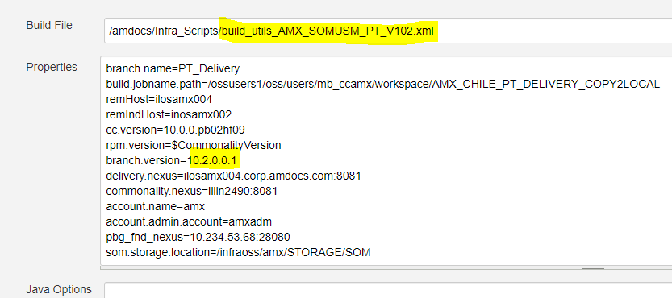

PROBLEM:

Any idea on this issue?

[11:31:03] [ERROR] (WORKFLOW/ilosnet012.corp.amdocs.com-nbarmc01) Finished with error installation unit: <Machine/Account/Container: ilosnet012.corp.amdocs.com/nbarmc01/DBCustomContainerDefinitionForDeployDatabase1>
amdocs.installer.exceptions.XPIException: (Installer1-000089) Exit point was failed in <execute> of container: <Machine/Account/Container: ilosnet012.corp.amdocs.com/nbarmc01/DBCustomContainerDefinitionForDeployDatabase1>. Error code is: <External_Messages_XPI_EXIT_POINT_STATUS>, Error message is: <(Installer1-000077) Exit point execution end with the following status<com.cramer.install.xpi.core.exitpoint.helper.LoadSqlImpl installation ended with the error. Please refer to /ossusers1/oss/users/nbarmc01/.xpi/installations/ResourceManagementWebLogic3/logs/database/ResourceManager/postmeta//create_cramer_roles.sql.out.log file for more details.>.>
at amdocs.installer.workflow.commands.impl.AbstractInstallationCommand.handleExitPointStatusList(AbstractInstallationCommand.java:599)
at amdocs.installer.workflow.commands.impl.AbstractUnitContainerCommand.runCustomExitPoint(AbstractUnitContainerCommand.java:230)
at amdocs.installer.workflow.commands.impl.AbstractUnitContainerCommand.doExecute(AbstractUnitContainerCommand.java:119)
at amdocs.installer.workflow.commands.impl.AbstractInstallationCommand.execute(AbstractInstallationCommand.java:149)
at amdocs.installer.workflow.AbstractWorkflowManager.runWorkFlow(AbstractWorkflowManager.java:429)
at amdocs.installer.workflow.AbstractWorkflowManager.runWorkFlow(AbstractWorkflowManager.java:456)
at amdocs.installer.workflow.AbstractWorkflowManager.runWorkFlow(AbstractWorkflowManager.java:456)
at amdocs.installer.workflow.AbstractWorkflowManager.execute(AbstractWorkflowManager.java:223)
at amdocs.installer.workflow.InstallerWorkflowManager.install(InstallerWorkflowManager.java:191)
at amdocs.installer.api.impl.InstallerToolkitImpl.install(InstallerToolkitImpl.java:369)
at amdocs.installer.engine.workflow.InstallWorkflowExecutor.doExecute(InstallWorkflowExecutor.java:449)
at amdocs.installer.engine.workflow.AbstractSilentDeployExecutor.execute(AbstractSilentDeployExecutor.java:137)
at amdocs.installer.api.cli.services.MainFlowBootstrapService.execute(MainFlowBootstrapService.java:174)
at sun.reflect.NativeMethodAccessorImpl.invoke0(Native Method)
at sun.reflect.NativeMethodAccessorImpl.invoke(NativeMethodAccessorImpl.java:62)
at sun.reflect.DelegatingMethodAccessorImpl.invoke(DelegatingMethodAccessorImpl.java:43)
at java.lang.reflect.Method.invoke(Method.java:498)
at com.amdocs.installer.Main.executeFlow(Main.java:291)
at com.amdocs.installer.Main.main(Main.java:90)
[11:31:03] [ERROR] (WORKFLOW/ilosnet012.corp.amdocs.com-nbarmc01) Finished with error installation unit: <Machine/Account/Container: ilosnet012.corp.amdocs.com/nbarmc01/DBCustomContainerDefinitionForDeployDatabase1>
[11:31:03] [ INFO] PROGRESS: <54.04%> - MESSAGE: <Failed with error: Machine/Account/Container: ilosnet012.corp.amdocs.com/nbarmc01/DBCustomContainerDefinitionForDeployDatabase1>

I can see also this problem:

Connected to:
Oracle Database 12c Enterprise Edition Release 12.1.0.2.0 - 64bit Production
With the Partitioning, OLAP, Advanced Analytics and Real Application Testing options

declare
*
ERROR at line 1:
ORA-04067: not executed, package body "CRAMER.PKGSIACCESS" does not exist
ORA-06508: PL/SQL: could not find program unit being called:
"CRAMER.PKGSIACCESS"
ORA-06512: at "CRAMER.PKGSESSION", line 27
ORA-06512: at line 84
Solution:

Hi Avi,

The issue is due the fact that the user CRAMER_COMMON is not dropped properly.
Please see below

Dropping CRAMER_COMMON user...
drop user CRAMER_COMMON cascade
*
ERROR at line 1:
ORA-01940: cannot drop a user that is currently connected

Can you try and manually drop this user before running the refresh.
sqlplus / as sysdba
SQL> Shutdown immediate;
Database closed.
Database dismounted.
ORACLE instance shut down.
SQL> startup restrict;
ORA-32004: obsolete or deprecated parameter(s) specified for RDBMS instance
ORACLE instance started.

Total System Global Area 1610612736 bytes
Fixed Size 8621232 bytes
Variable Size 1291846480 bytes
Database Buffers 251658240 bytes
Redo Buffers 58486784 bytes
Database mounted.
Database opened.
SQL> drop user CRAMER_COMMON cascade;

User dropped.

SQL> commit;

SQL> Shutdown immediate;
Database closed.
Database dismounted.
ORACLE instance shut down.
SQL> startup;
ORA-32004: obsolete or deprecated parameter(s) specified for RDBMS instance
ORACLE instance started.

Total System Global Area 1610612736 bytes
Fixed Size 8621232 bytes
Variable Size 1291846480 bytes
Database Buffers 251658240 bytes
Redo Buffers 58486784 bytes
Database mounted.
Database opened.
SQL> commit;

Commit complete.

SQL> exit

PROBLEM:

Hi,

I need your advice on MEC issue in mecusr01@ilostfc186 (Unix11!)

We did copy of data from other MEC env.

When booting WL we are getting this issue.

d/applicationContext-backend.xml]: Initialization of bean failed; nested exception is org.springframework.beans.factory.BeanCreationException: Error creating bean with name 'boAsynchronousServices' defined in class path resource [com/amdocs/pc/backend/applicationContext-backend.xml]: Initialization of bean failed; nested exception is org.springframework.beans.factory.BeanCreationException: Error creating bean with name 'securityManager' defined in class path resource [com/amdocs/pc/backend/applicationContext-backend.xml]: Instantiation of bean failed; nested exception is java.lang.ExceptionInInitializerError
at org.springframework.beans.BeanUtils.instantiateClass(BeanUtils.java:154)
at org.springframework.beans.factory.support.SimpleInstantiationStrategy.instantiate(SimpleInstantiationStrategy.java:122)
at org.springframework.beans.factory.support.ConstructorResolver.autowireConstructor(ConstructorResolver.java:271)
at org.springframework.beans.factory.support.AbstractAutowireCapableBeanFactory.autowireConstructor(AbstractAutowireCapableBeanFactory.java:1148)
at org.springframework.beans.factory.support.AbstractAutowireCapableBeanFactory.createBeanInstance(AbstractAutowireCapableBeanFactory.java:1050)
Truncated. see log file for complete stacktrace
Caused By: org.springframework.beans.factory.BeanCreationException: Error creating bean with name 'itemBusiness' defined in class path resource [com/amdocs/pc/backend/applicationContext-backend.xml]: Initialization of bean failed; nested exception is org.springframework.beans.factory.BeanCreationException: Error creating bean with name 'projectBusiness' defined in class path resource [com/amdocs/pc/backend/applicationContext-backend.xml]: Initialization of bean failed; nested exception is org.springframework.beans.factory.BeanCreationException: Error creating bean with name 'boAsynchronousServices' defined in class path resource [com/amdocs/pc/backend/applicationContext-backend.xml]: Initialization of bean failed; nested exception is org.springframework.beans.factory.BeanCreationException: Error creating bean with name 'securityManager' defined in class path resource [com/amdocs/pc/backend/applicationContext-backend.xml]: Instantiation of bean failed; nested exception is java.lang.ExceptionInInitializerError
at org.springframework.beans.factory.support.AbstractAutowireCapableBeanFactory.doCreateBean(AbstractAutowireCapableBeanFactory.java:562)
at org.springframework.beans.factory.support.AbstractAutowireCapableBeanFactory.createBean(AbstractAutowireCapableBeanFactory.java:482)
at org.springframework.beans.factory.support.AbstractBeanFactory$1.getObject(AbstractBeanFactory.java:306)
at org.springframework.beans.factory.support.DefaultSingletonBeanRegistry.getSingleton(DefaultSingletonBeanRegistry.java:230)
at org.springframework.beans.factory.support.AbstractBeanFactory.doGetBean(AbstractBeanFactory.java:302)
Truncated. see log file for complete stacktrace
Caused By: org.springframework.beans.factory.BeanCreationException: Error creating bean with name 'projectBusiness' defined in class path resource [com/amdocs/pc/backend/applicationContext-backend.xml]: Initialization of bean failed; nested exception is org.springframework.beans.factory.BeanCreationException: Error creating bean with name 'boAsynchronousServices' defined in class path resource [com/amdocs/pc/backend/applicationContext-backend.xml]: Initialization of bean failed; nested exception is org.springframework.beans.factory.BeanCreationException: Error creating bean with name 'securityManager' defined in class path resource [com/amdocs/pc/backend/applicationContext-backend.xml]: Instantiation of bean failed; nested exception is java.lang.ExceptionInInitializerError
at org.springframework.beans.factory.support.AbstractAutowireCapableBeanFactory.doCreateBean(AbstractAutowireCapableBeanFactory.java:562)
at org.springframework.beans.factory.support.AbstractAutowireCapableBeanFactory.createBean(AbstractAutowireCapableBeanFactory.java:482)
at org.springframework.beans.factory.support.AbstractBeanFactory$1.getObject(AbstractBeanFactory.java:306)
at org.springframework.beans.factory.support.DefaultSingletonBeanRegistry.getSingleton(DefaultSingletonBeanRegistry.java:230)
at org.springframework.beans.factory.support.AbstractBeanFactory.doGetBean(AbstractBeanFactory.java:302)
Truncated. see log file for complete stacktrace
Caused By: org.springframework.beans.factory.BeanCreationException: Error creating bean with name 'boAsynchronousServices' defined in class path resource [com/amdocs/pc/backend/applicationContext-backend.xml]: Initialization of bean failed; nested exception is org.springframework.beans.factory.BeanCreationException: Error creating bean with name 'securityManager' defined in class path resource [com/amdocs/pc/backend/applicationContext-backend.xml]: Instantiation of bean failed; nested exception is java.lang.ExceptionInInitializerError
at org.springframework.beans.factory.support.AbstractAutowireCapableBeanFactory.doCreateBean(AbstractAutowireCapableBeanFactory.java:562)
at org.springframework.beans.factory.support.AbstractAutowireCapableBeanFactory.createBean(AbstractAutowireCapableBeanFactory.java:482)
at org.springframework.beans.factory.support.AbstractBeanFactory$1.getObject(AbstractBeanFactory.java:306)
at org.springframework.beans.factory.support.DefaultSingletonBeanRegistry.getSingleton(DefaultSingletonBeanRegistry.java:230)
at org.springframework.beans.factory.support.AbstractBeanFactory.doGetBean(AbstractBeanFactory.java:302)
Truncated. see log file for complete stacktrace
Caused By: org.springframework.beans.factory.BeanCreationException: Error creating bean with name 'securityManager' defined in class path resource [com/amdocs/pc/backend/applicationContext-backend.xml]: Instantiation of bean failed; nested exception is java.lang.ExceptionInInitializerError
at org.springframework.beans.factory.support.AbstractAutowireCapableBeanFactory.instantiateBean(AbstractAutowireCapableBeanFactory.java:1110)
at org.springframework.beans.factory.support.AbstractAutowireCapableBeanFactory.createBeanInstance(AbstractAutowireCapableBeanFactory.java:1054)
at org.springframework.beans.factory.support.AbstractAutowireCapableBeanFactory.doCreateBean(AbstractAutowireCapableBeanFactory.java:512)
at org.springframework.beans.factory.support.AbstractAutowireCapableBeanFactory.createBean(AbstractAutowireCapableBeanFactory.java:482)
at org.springframework.beans.factory.support.AbstractBeanFactory$1.getObject(AbstractBeanFactory.java:306)
Truncated. see log file for complete stacktrace
Caused By: java.lang.ExceptionInInitializerError
at sun.reflect.NativeConstructorAccessorImpl.newInstance0(Native Method)
at sun.reflect.NativeConstructorAccessorImpl.newInstance(NativeConstructorAccessorImpl.java:62)
at sun.reflect.DelegatingConstructorAccessorImpl.newInstance(DelegatingConstructorAccessorImpl.java:45)
at java.lang.reflect.Constructor.newInstance(Constructor.java:423)
at org.springframework.beans.BeanUtils.instantiateClass(BeanUtils.java:142)
Truncated. see log file for complete stacktrace
: Caused By: com.amdocs.pc.exceptions.internal.EPCSecurityException: Login failed with the error code: User account is unknown or password is wrong.
at com.amdocs.pc.backend.security.SecurityUtils.loginAsCTC(SecurityUtils.java:1860)
at com.amdocs.pc.backend.security.SecurityUtils.getCTCTicket(SecurityUtils.java:1834)
at com.amdocs.pc.backend.security.SecurityDAOAsm.getCoreRoles(SecurityDAOAsm.java:219)
at com.amdocs.pc.backend.security.SecurityDAOAsm.<clinit>(SecurityDAOAsm.java:147)
at sun.reflect.NativeConstructorAccessorImpl.newInstance0(Native Method)
Truncated. see log file for complete stacktrace
>
<Dec 11, 2019, 10:46:24,349 AM IST> <Error> <Deployer> <BEA-149231> <Unable to set the activation state to true for the application "MECServer_mec".
weblogic.application.ModuleException: com.amdocs.pc.exceptions.internal.EPCSecurityException: Login failed with the error code: User account is unknown or password is wrong.
at weblogic.application.internal.ExtensibleModuleWrapper.start(ExtensibleModuleWrapper.java:140)
at weblogic.application.internal.flow.ModuleListenerInvoker.start(ModuleListenerInvoker.java:124)
at weblogic.application.internal.flow.ModuleStateDriver$3.next(ModuleStateDriver.java:233)
at weblogic.application.internal.flow.ModuleStateDriver$3.next(ModuleStateDriver.java:228)
at weblogic.application.utils.StateMachineDriver.nextState(StateMachineDriver.java:45)
Truncated. see log file for complete stacktrace
Caused By: com.amdocs.pc.exceptions.internal.EPCSecurityException: Login failed with the error code: User account is unknown or password is wrong.
at com.amdocs.pc.backend.security.SecurityUtils.loginAsCTC(SecurityUtils.java:1860)
at com.amdocs.pc.backend.security.SecurityUtils.getCTCTicket(SecurityUtils.java:1834)
at com.amdocs.pc.backend.security.SecurityDAOAsm.getCoreRoles(SecurityDAOAsm.java:219)
at com.amdocs.pc.backend.security.SecurityDAOAsm.<clinit>(SecurityDAOAsm.java:147)
at sun.reflect.NativeConstructorAccessorImpl.newInstance0(Native Method)
Truncated. see log file for complete stacktrace
>
<Dec 11, 2019, 10:46:24,416 AM IST> <Notice> <Log Management> <BEA-170027> <The server has successfully established a connection with the Domain level Diagnostic Service.>
<Dec 11, 2019, 10:46:25,39 AM IST> <Notice> <WebLogicServer> <BEA-000365> <Server state changed to ADMIN.>
<Dec 11, 2019, 10:46:25,112 AM IST> <Notice> <WebLogicServer> <BEA-000365> <Server state changed to RESUMING.>
<Dec 11, 2019, 10:46:25,358 AM IST> <Notice> <Security> <BEA-090171> <Loading the identity certificate and private key stored under the alias mecKey from the JKS keystore file /ossusers1/oss/users/mecusr01/mec-home/properties/keystore.jks.>
<Dec 11, 2019, 10:46:25,373 AM IST> <Notice> <Security> <BEA-090169> <Loading trusted certificates from the JKS keystore file /ossusers1/oss/users/mecusr01/mec-home/properties/keystore.jks.>
<Dec 11, 2019, 10:46:25,383 AM IST> <Warning> <Server> <BEA-002611> <The hostname "localhost", maps to multiple IP addresses: 127.0.0.1, 0:0:0:0:0:0:0:1.>
<Dec 11, 2019, 10:46:25,386 AM IST> <Notice> <Server> <BEA-002613> <Channel "DefaultSecure[1]" is now listening on 0:0:0:0:0:0:0:1%lo:60101 for protocols iiops, t3s, ldaps, https.>
:
Solution:

The CTC is expired. You need to generate a new CTC

: Caused By: com.amdocs.pc.exceptions.internal.EPCSecurityException: Login failed with the error code: User account is unknown or password is wrong.
at com.amdocs.pc.backend.security.SecurityUtils.loginAsCTC(SecurityUtils.java:1860)
at com.amdocs.pc.backend.security.SecurityUtils.getCTCTicket(SecurityUtils.java:1834)
at com.amdocs.pc.backend.security.SecurityDAOAsm.getCoreRoles(SecurityDAOAsm.java:219)
at com.amdocs.pc.backend.security.SecurityDAOAsm.<clinit>(SecurityDAOAsm.java:147)
at sun.reflect.NativeConstructorAccessorImpl.newInstance0(Native Method)
Truncated. see log file for complete stacktrace
>

Steps:
- Login to ASM client GUI
  - Take the zip file "SmartAdmin.zip" from our build tar file.
  - Extract the zip file.
  - If missing - take "ojdbc6.jar" from eclipse and put it in the "inproc" folder.
  - Update the file uams.properties in \SmartAdmin\inproc\asm_home
With the DB details.
- Run "inproc.cmd" and login using EPCAdmin\EPCAdmin1 (or root\Root00)

- Check for user EpcCtcUser
- Press on the “Set CTC” button. This will create in the PC side under asm_home (where the uams gui client is located) a uams_ctc.xml file
With the required information for this user
For example:
<?xml version="1.0" encoding="UTF-8"?>
<uams_credentials>
<ctc>
<owner>EpcCtcUser</owner>
<creationDate>1280049872581</creationDate>
<effectiveDate>0</effectiveDate>
<expirationDate>1311585872581</expirationDate>
<cryptoResource>uams.ctc.encryption</cryptoResource>
<signature>f5d7jzVbfjNHpnA{bDlxrncKoThzbClKoT9Vs7hFrSUKc3JdfkAOiQFPdSxPrQ5kinRNjmFLmkFWrj8OePMLkQtef22</signature>
</ctc>
</uams_credentials>
- Click on "save".
- Take the xml part for EpcCtcUser and put it in the uams_ctc.xml file in the environment (under epc-home/asm or mec-home/asm)
- If there is no such user, create a new EpcCtcUser with Role: UamsAdmin

PROBLEM:

FM_USER_PASS issue need to be fixed by DEV

PROBLEM:

JellyException: null:511:191: /ossusers1/oss/users/jenkins/apache-tomcat/apache-tomcat-9.0.5/logs/../mb_cctfc/workspace/TEF_CHILE_Adoption_NIGHTLY_FLOW/tools/automation/tfc-cucumber-project/tfc-cucumber/target/cucumber-html-reports/overview-features.html (No such file or directory) Nested exception: /ossusers1/oss/users/jenkins/apache-tomcat/apache-tomcat-9.0.5/logs/../mb_cctfc/workspace/TEF_CHILE_Adoption_NIGHTLY_FLOW/tools/automation/tfc-cucumber-project/tfc-cucumber/target/cucumber-html-reports/overview-features.html (No such file or directory)

Solution:

For fixing this issue please login to jenkins: jenkins@ilostfc001:/ossusers1/oss/users/jenkins/.jenkins/email-templates> vi TFC_SOM_Adoption_NIGHTLY_FLOW_Cucumber.jelly

And update the file with ../../../../

<x:parse xml="../../../../mb_cctfc/workspace/TEF_CHILE_SOM_AD_NIGHTLY_FLOW/tools/automation/tfc-cucumber-project/tfc-cucumber/target/cucumber-html-reports/overview-features.html" var="myxmldoc"/>
<h3><A href="${rooturl}/job/TFC_SOM_DevMain_Cucumber/${build.getNumber()}/cucumber-html-reports/overview-features.html">(Cucumber full report - Kindly use Chrome)</A></h3>

PROBLEM:

i think that the issue occurred due the yml already installed is equal to the application try install
sudo yum clean all
},
"msg": "\n\nError downloading packages:\n amdocs-custom-db-schema1-10.2.0.0.029.PI006-186.noarch: [Errno 256] No more mirrors to try.",
"rc": 1,
"stderr": "\n\nError downloading packages:\n amdocs-custom-db-schema1-10.2.0.0.029.PI006-186.noarch: [Errno 256] No more mirrors to try.\n\n",
in this case, i ran the command below for clean of memory all the yml or repo files
sudo yum clean all
and executed again the build

Solution:

Please run: sudo yum clean all

PROBLEM:

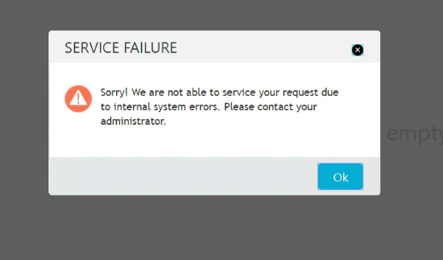

Solution:

As we discussed after reboot ARM+ANN issue was solved.

PROBLEM:

14:33:46 "stderr": "/bin/sh: /opt/amdocs/fnd/asm/amdocs-asm-core-1/activate.sh: No such file or directory",
14:33:46
14:33:46 "stderr_lines": [
14:33:46 "/bin/sh: /opt/amdocs/fnd/asm/amdocs-asm-core-1/activate.sh: No such file or directory"
14:33:46 ],
14:33:46
14:33:46 "stdout": "",
14:33:46
14:33:46 "stdout_lines": []
14:33:46 }
14:33:46 to retry,
14:33:46 use: --limit @/ossusers1/oss/users/tfclsm1/tfc_playbook/dop-asm-setup.retry
14:33:46
14:33:46 PLAY RECAP *********************************************************************
14:33:46 ilostfc020 : ok=4 changed=1 unreachable=0 failed=1
14:33:46
14:33:46 Checking ASM status..
14:33:56 Returned ERROR CODE while running ASM installation, terminating script..
14:33:56 Finished: SUCCESS

Solution:

i would suggest to execute "yum clean metadata" in each of the SOM servers, Admin, Managed hosts
to remove all the old yum cache

PROBLEM:

somusr01@inosamx071:~somusr01/JEE/distribution-engine>./startEngine.sh
Buildfile: /ossusers1/oss/users/somusr01/JEE/distribution-engine/start.xpi.ant.xml

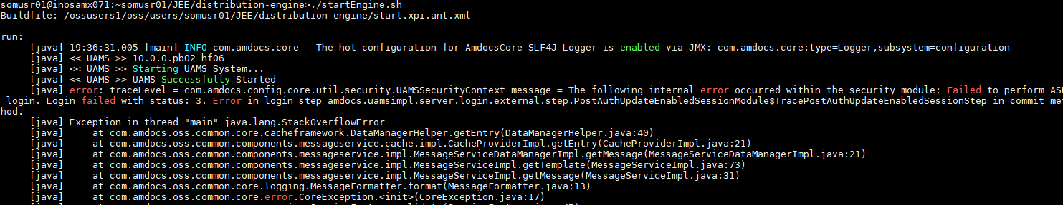
run:
[java] 19:36:31.005 [main] INFO com.amdocs.core - The hot configuration for AmdocsCore SLF4J Logger is enabled via JMX: com.amdocs.core:type=Logger,subsystem=configuration
[java] << UAMS >> 10.0.0.pb02_hf06
[java] << UAMS >> Starting UAMS System...
[java] << UAMS >> UAMS Successfully Started
[java] error: traceLevel = com.amdocs.config.core.util.security.UAMSSecurityContext message = The following internal error occurred within the security module: Failed to perform ASM login. Login failed with status: 3. Error in login step amdocs.uamsimpl.server.login.external.step.PostAuthUpdateEnabledSessionModule$TracePostAuthUpdateEnabledSessionStep in commit method.
[java] Exception in thread "main" java.lang.StackOverflowError
[java] at com.amdocs.oss.common.core.cacheframework.DataManagerHelper.getEntry(DataManagerHelper.java:40)
[java] at com.amdocs.oss.common.components.messageservice.cache.impl.CacheProviderImpl.getEntry(CacheProviderImpl.java:21)
[java] at com.amdocs.oss.common.components.messageservice.impl.MessageServiceDataManagerImpl.getMessage(MessageServiceDataManagerImpl.java:21)
[java] at com.amdocs.oss.common.components.messageservice.impl.MessageServiceImpl.getTemplate(MessageServiceImpl.java:73)
[java] at com.amdocs.oss.common.components.messageservice.impl.MessageServiceImpl.getMessage(MessageServiceImpl.java:31)
[java] at com.amdocs.oss.common.core.logging.MessageFormatter.format(MessageFormatter.java:13)
[java] at com.amdocs.oss.common.core.error.CoreException.<init>(CoreException.java:17)

Solution:

Please try to truncate SEC_SESSION and SEC_SESSION_IDLE tables in UAMS instance.

PROBLEM:

[Timer-3] ERROR com.amdocs.oss.common.components.solrscheduler.HttpPostScheduler – Failed to connect to the specified URL while trying to send HTTP POST
java.net.ConnectException: Tried all: '1' addresses, but could not connect over HTTP to server: 'inostfc009.corp.amdocs.com', port: '20100'
failed reasons:
[0] address:'inostfc009.corp.amdocs.com/10.75.20.159',port:'20100' : java.net.ConnectException: Connection refused

Solution:

connect to SOM REF DB
TRUNCATE TABLE OSS_REF_DATA;
TRUNCATE TABLE OSS_REF_ATTRIBUTE;
COMMIT;
run there queries
then connect the ALTREF DB

and then run the same queries again
then distribute the old zip from perforce
and refresh cache or restart the server

1. Connect to REF DB of the SOM:
2. Take backup and truncate the tables:
CREATE TABLE OSS_REF_DATA_BKP as (SELECT * FROM OSS_REF_DATA);
CREATE TABLE OSS_REF_ATTRIBUTE_BKP as (SELECT * FROM OSS_REF_ATTRIBUTE);
TRUNCATE TABLE OSS_REF_DATA;
TRUNCATE TABLE OSS_REF_ATTRIBUTE;
COMMIT;
3. Connect to ALT REF DB of the SOM (the data base details are same as REF DB, just the user and password changes. SOM01ALTREF/ SOM01ALTREF)
4. Take backup and truncate the tables:

CREATE TABLE OSS_REF_DATA_ALTBKP as (SELECT * FROM OSS_REF_DATA);
CREATE TABLE OSS_REF_ATTRIBUTE_ALTBKP as (SELECT * FROM OSS_REF_ATTRIBUTE);
TRUNCATE TABLE OSS_REF_DATA;
TRUNCATE TABLE OSS_REF_ATTRIBUTE;
COMMIT;
5. Place the Full MEC Zip file in the location – distribution-engine/source/elementsData/
6. Run the command without ACTIVE parameter:

./startEngine.sh
7. Distribute Successful
8. Place the Full MEC Zip file again to the same location, and run the distribution command again with ACTIVE parameter:

./startEngine.sh ACTIVE
9. Distribution Successful
10.Bounce env

PROBLEM:

Hi Sunil/Avi/Fernando
I was trying to configure report on the env inosamx022 but I am getting below exception when I click on Reports.
We had asked sometime back to configure report server on this env.
Could you please check and do the needful? We need to create report sample.
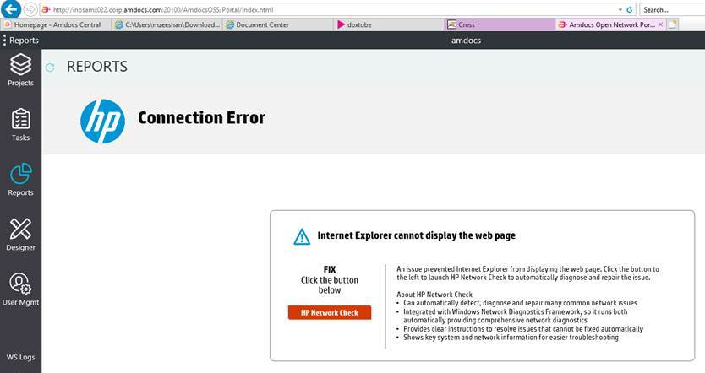

Solution:

The properties file in SOM side need to be updated with report server and host:

REPORT_HOST=inosamx092
REPORT_PORT=40100

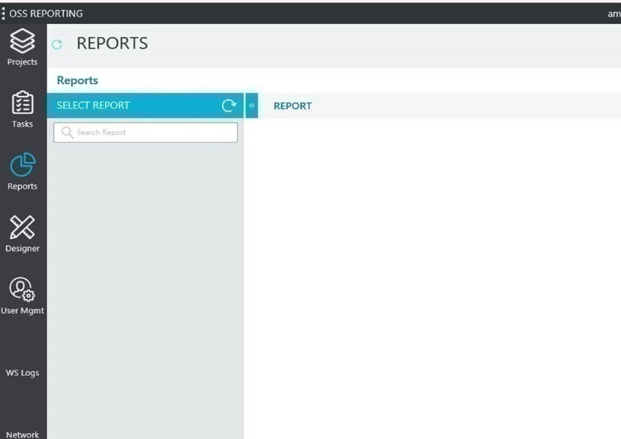

PROBLEM:

Sending the error we get in weblogic logs when grants are missing:
2020-03-24 11:22:47,731 : OSS Portal : Portal Ear : : org.apache.cxf.interceptor.AbstractFaultChainInitiatorObserver : onMessage : 114 : org.apache.cxf.interceptor.Fault: ORA-00942: table or view does not exist
at org.apache.cxf.service.invoker.AbstractInvoker.createFault(AbstractInvoker.java:162)
Caused by: com.amdocs.oss.ossui.exception.DataAccessException: ORA-00942: table or view does not exist
at com.amdocs.oss.ossui.portal.rs.config.ApplicationServiceImpl.getApplicationConfig(ApplicationServiceImpl.java:42)
Caused by: com.amdocs.oss.ossui.exception.DataAccessException: ORA-00942: table or view does not exist
at com.amdocs.oss.ossui.ossportalconfig.PortalApplicationServiceImpl.getAllApplicationConfig(PortalApplicationServiceImpl.java:137)
Caused by: java.sql.SQLSyntaxErrorException: ORA-00942: table or view does not exist

Error that made me look at OMS Weblogic port mismatch:
<Mar 24, 2020, 11:22:57,129 AM CLST> <Warning> <Connector> <BEA-190032> << eis/jms/internal/WLSConnectionFactoryJNDIXA > ResourceAllocationException generated by resource adapter on call to ManagedConnectionFactory.createManagedConnection(): "javax.resource.ResourceException: ConnectionFactory: failed to get initial context (InitialContextFactory =weblogic.jndi.WLInitialContextFactory, url = t3://tfcwltst27.pai.tchile.local:20100, user name = Jeeadmin) ">

Solution:

There were 2 things I fixed today to make UAT#27 working.

- Provided the following grants as per below.

sqlplus cradba/amdocs@UATSUM27

CREATE ROLE OSSUI_READ_ROLE NOT IDENTIFIED;

-- Object privileges granted to OSSUI_READ_ROLE
GRANT SELECT ON SOM01OSSUI.OSSUIAPPLICATION TO OSSUI_READ_ROLE;
GRANT SELECT ON SOM01OSSUI.OSSUIAPPLICATIONCOMPONENT TO OSSUI_READ_ROLE;
GRANT SELECT ON SOM01OSSUI.OSSUIAPPROLERESTRICTION TO OSSUI_READ_ROLE;
GRANT SELECT ON SOM01OSSUI.OSSUIDOCUMENT TO OSSUI_READ_ROLE;
GRANT SELECT ON SOM01OSSUI.OSSUIDOCUMENTMAPPING TO OSSUI_READ_ROLE;
GRANT SELECT ON SOM01OSSUI.OSSUIPORTALPARAMETER TO OSSUI_READ_ROLE;
GRANT SELECT ON SOM01OSSUI.OSSUIROLE TO OSSUI_READ_ROLE;

-- Grantees of OSSUI_READ_ROLE
GRANT OSSUI_READ_ROLE TO CRADBA WITH ADMIN OPTION;
GRANT OSSUI_READ_ROLE TO SOM01OSSCLIENT;

CREATE ROLE OSSUI_WRITE_ROLE NOT IDENTIFIED;

-- Object privileges granted to OSSUI_WRITE_ROLE
GRANT DELETE, INSERT, UPDATE ON SOM01OSSUI.OSSUIDOCUMENT TO OSSUI_WRITE_ROLE;
GRANT DELETE, INSERT, UPDATE ON SOM01OSSUI.OSSUIDOCUMENTMAPPING TO OSSUI_WRITE_ROLE;
GRANT SELECT ON SOM01OSSUI.SEQ_OSSUIDOCUMENTID TO OSSUI_WRITE_ROLE;

-- Grantees of OSSUI_WRITE_ROLE
GRANT OSSUI_WRITE_ROLE TO CRADBA WITH ADMIN OPTION;
GRANT OSSUI_WRITE_ROLE TO SOM01OSSCLIENT;

ALTER USER SOM01OSSCLIENT DEFAULT ROLE ALL;

- Corrected OMS port in pushToCC/dbp/custom.properties, correct port is 12720 (took reference from backup pushToCC)

somusr01@tfcwloss27.pai.tchile.local:~somusr01/pushToCC/dbp>grep oms *
custom.properties:delivery/t3.oms.weblogic.connection.url=t3://tfcwltst27.pai.tchile.local:20100
custom.properties:delivery/oms.weblogic.admin.username=Jeeadmin
custom.properties:delivery/oms.weblogic.admin.password=Jeeadmin1
custom.properties:delivery/oms.weblogic.connection.fact.jndi.name="AutoLaunchConnectionFactory"
we need to login now to console and fix the bridge:

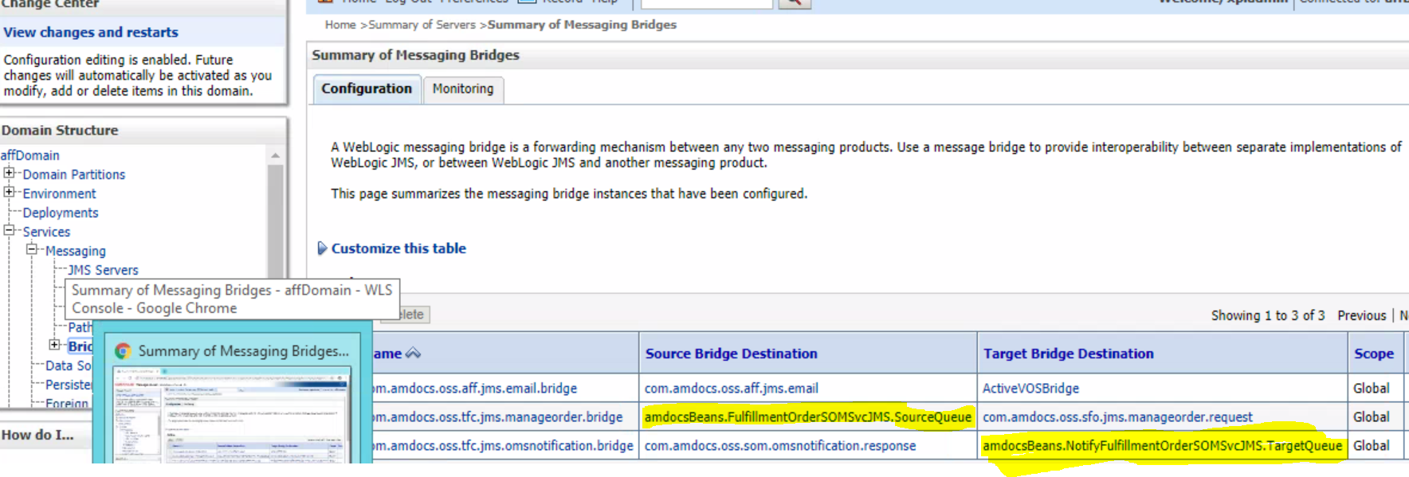

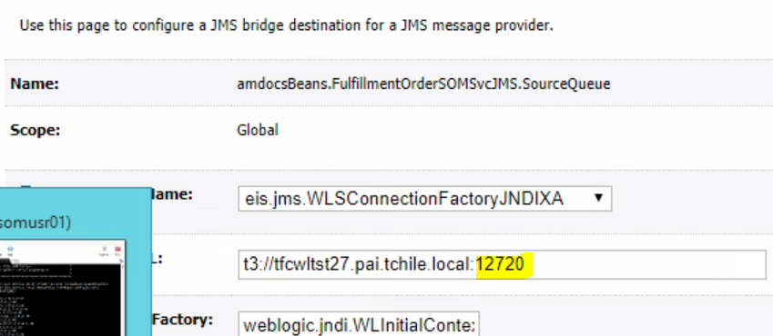

Post this change, restart SOM AppServer and placed 1 order which completed end to end.
Check that Bridges are in forwarding state.

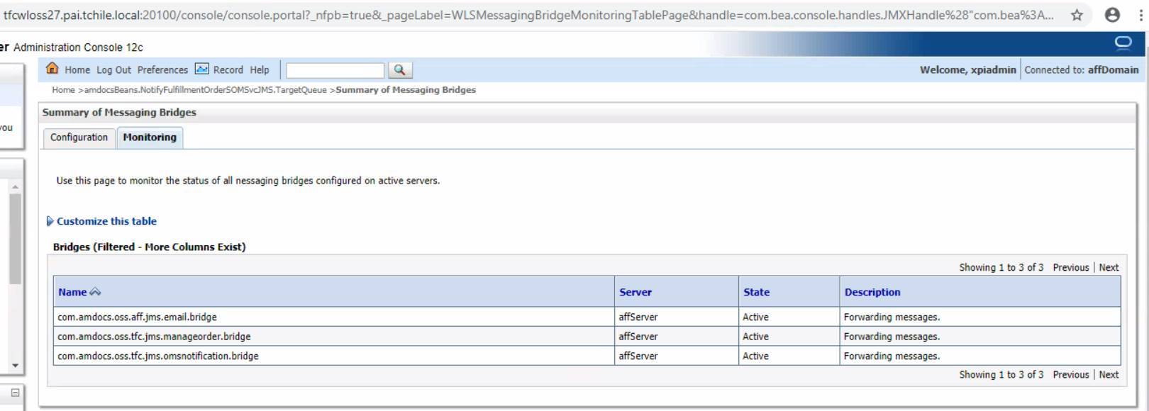

For make order login to snow:

http://tfcwloss27.pai.tchile.local:20100/snow

http://http://ilostfc119.corp.amdocs.com/:20800/snow

click on Ordering
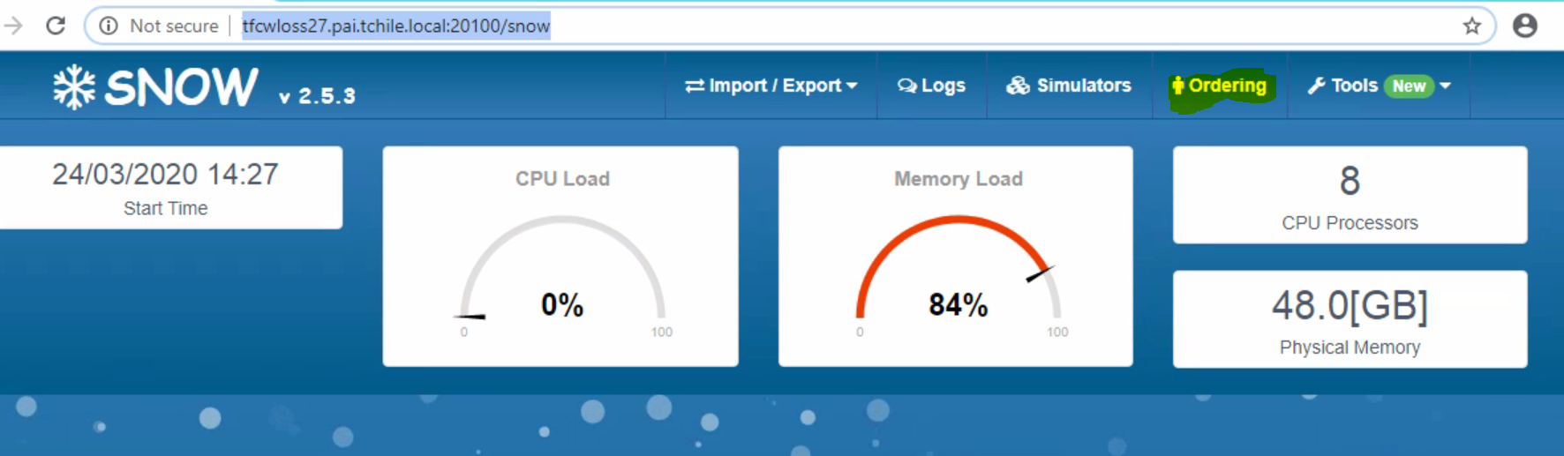

  - From Templates take number 1 (Broadband)
  - Click on Send.
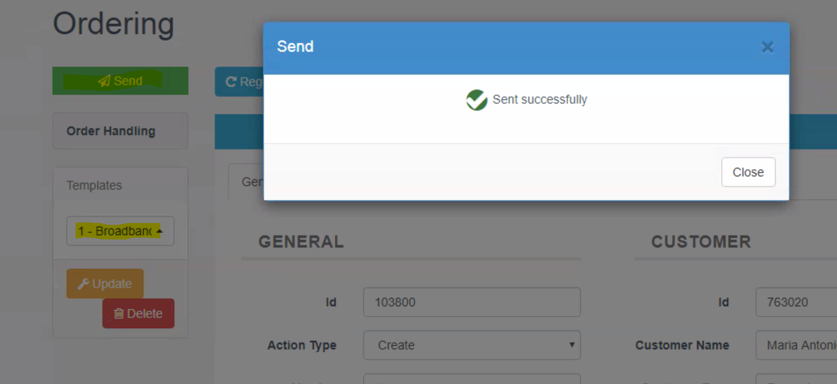

  - Copy the id:



  - Login to GUI http://tfcwloss27.pai.tchile.local:20100/AmdocsOSS/Portal/login.html

Put the number in below and click on the Order:

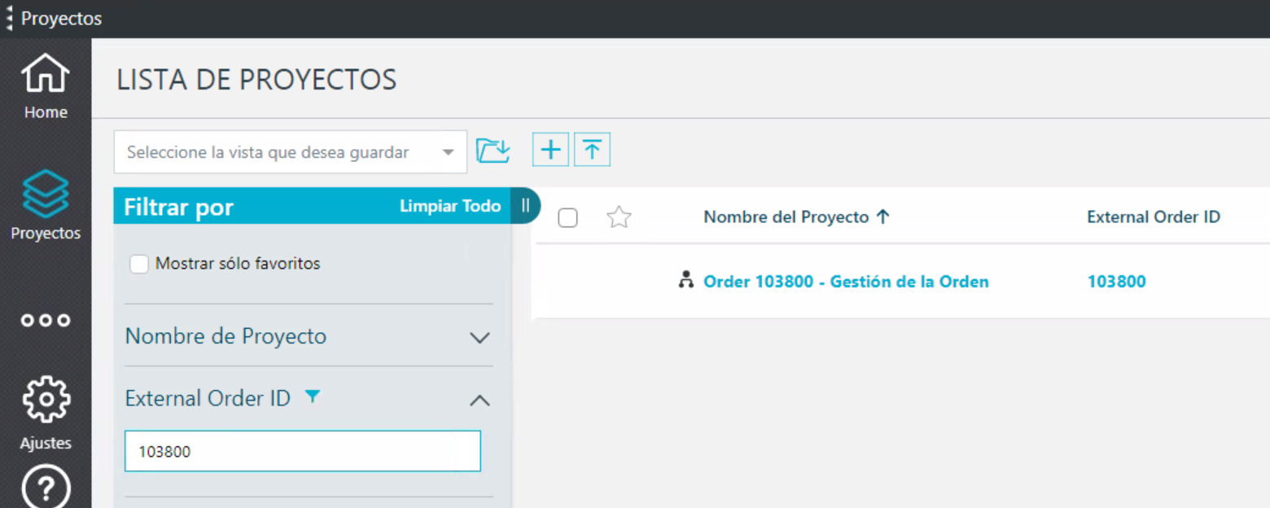

  - You will get this screen:
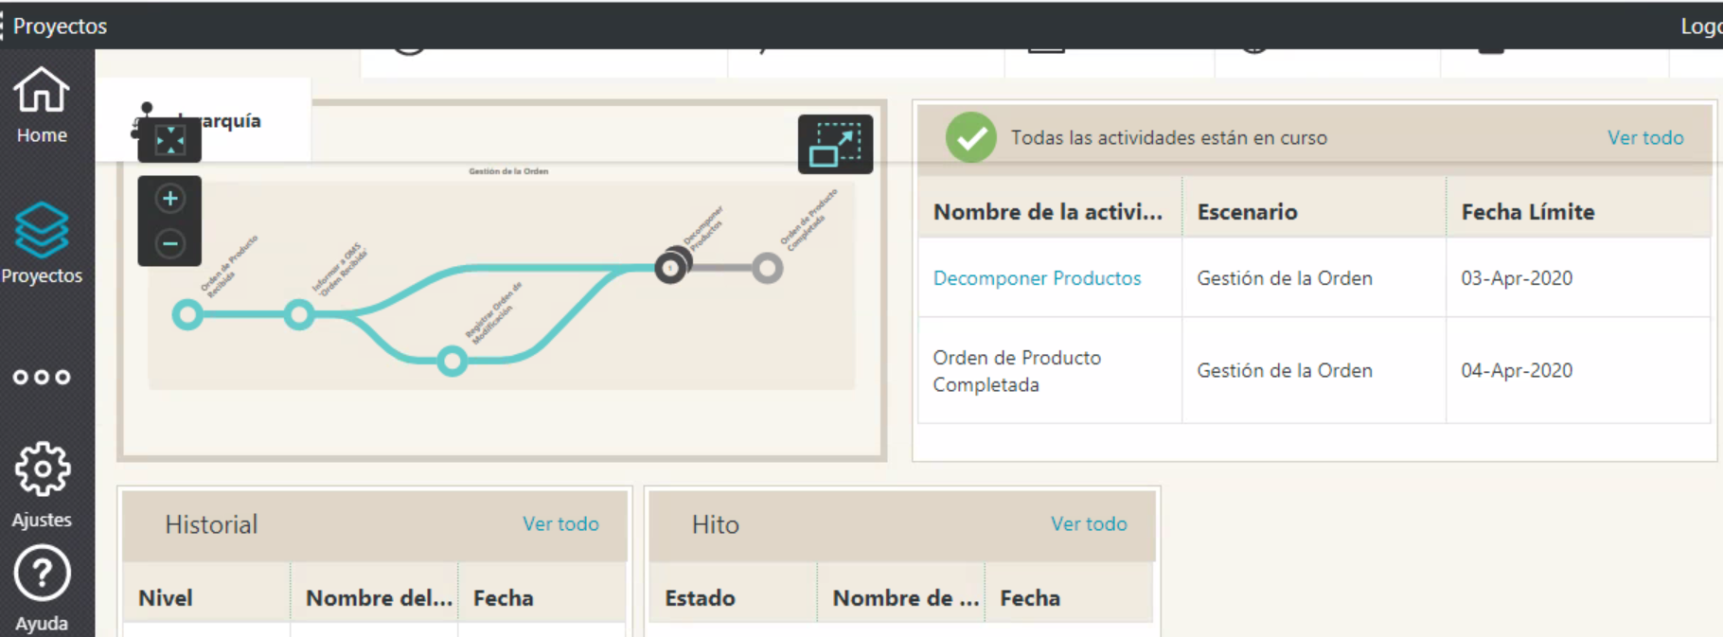

Hello Team,

In TEF Chile we were facing issue while placing expdp export dumps on project NFS mount /infraoss/tfc.

The error was as below:

SQL> 2 Disconnected from Oracle Database 12c Enterprise Edition Release 12.2.0.1.0 - 64bit Production
Export: Release 12.2.0.1.0 - Production on Wed May 27 19:53:34 2020
Copyright (c) 1982, 2017, Oracle and/or its affiliates. All rights reserved.
Connected to: Oracle Database 12c Enterprise Edition Release 12.2.0.1.0 - 64bit Production
ORA-39001: invalid argument value
ORA-39000: bad dump file specification
ORA-31641: unable to create dump file "/infraoss/tfc/STORAGE/BACKUP/SOM_DB_BACKUPS/SOM_202005271953_DB/expdp_TFCLSM1DB_202005271953.dmp"
ORA-27054: NFS file system where the file is created or resides is not mounted with correct options
Additional information: 3
Additional information: 18

As per the Oracle documentation, https://support.oracle.com/epmos/faces/DocumentDisplay?_afrLoop=303312664236910&id=359515.1&_afrWindowMode=0&_adf.ctrl-state=5ms9xgzfs_45 we had to mount NFS with below options:
rw,bg,hard,nointr,rsize=32768,wsize=32768,tcp,noac,actimeo=0,vers=3,timeo=600

To solve this, I did below. Sharing with you all so in case it happens in other projects, you may be able to solve it.

- On DB Server where DB instances are running, I logged it with root user.
- Executed below to unmount the NFS /infraoss/tfc/
umount -l /infraoss/tfc/
- Ensure that /infraoss/tfc is indeed unmounted.
- Mounted the NFS back with below command:
mount -t nfs -o rw,bg,hard,nointr,rsize=32768,wsize=32768,tcp,noac,actimeo=0,vers=3,timeo=600 raaisilon:/ifs/vipr/VPFILEGSISLN133DLVOSS1/Delivery/PRJILGSFILEGSISLN133DLVO/VIPR_VRO_FILE_GS_ISLN_133_DLV_OSS1_infraoss_TFC /infraoss/tfc

PROBLEM:

Yesterday when I was running the build transfer (TFC_Build_Transfer2Site_SOM) for SOM I was getting the following issue in log:

12:27:55 539865356
12:27:55 ssh: connect to host localhost port 2020: Connection refused
12:27:55 Permission denied, please try again.
12:27:55 Permission denied, please try again.
12:27:55 Permission denied (publickey,password).
12:27:55 lost connection
12:27:55 Build transfer failed. Please contact Infra.
12:27:55 Build step 'Execute shell' marked build as failure
12:27:56 Finished: FAILURE

Solution:

Hello Avi,

Since we have 2 Jump servers in TEF Chile Site to reach to UAT environments.
This is the reason SSH tunnel was setup to bypass 1st Jump server (10.233.245.190) and copy the files directly to 2nd Jump server (10.186.214.125).
If below error was being presented, it means that the ssh tunnel was down.

In this case, we can check in tfcadm@ilostfc001, running processes.
If the tunnel is running, it will appear like highlighted below:

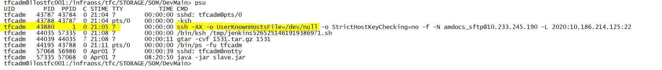

Command to start the tunnel is as below from tfcadm@ilostfc001:
ssh -f -N amdocs_sftp@10.233.245.190 -L 2020:10.186.214.125:22

ssh -f -N amdocs_sftp@10.64.201.12 -L 2020:10.186.243.53:22

PROBLEM:

We need to change the encrypted password in custom.sec.properties for OMS_SWAP_PASSWORD=SOMIVUser.

amx/oms/connection.password=<UEM>K=<key>.asc.sys.encryption.0;C=1592544583995;M=4Ndf}RAPnO1fOvODqtALnpC8}4}QQedq0;</UEM>

Solution:

I did the following in inoxamx102 for below change:

sed -i 's#amx/oms/connection.password=.*#''amx/oms/connection.password='"SOMIVUser"'#g' ${SOM_HOME}/pushToCC/dbp/custom.sec.properties

cd /ossusers1/oss/users/somusr01/amx_playbook
rm -rf encrypt.log
ansible-playbook preinstall/dop-p2cc-encrypt.yml -i hosts -vvv |tee encrypt.log

Updated CC with updateCC command.
Restarted SOM Application server to make the change into effect.

sed -i 's#amx/oms/connection.password=.*#''amx/oms/connection.password='"CAC101"'#g' ${SOM_HOME}/pushToCC/dbp/custom.sec.properties

Request:

Attach delta MEC zip fix from Navneet to apply on OSSUAT2.
Please deploy it on OSSUAT2.

Instructions:
1) open the path with the command "cd /ossusers1/oss/users/som*/JEE/distribution-engine/source/elementsData/ "
2) copy the zip for this path
3) do a backup of the currenct mec with "cd $HOME/JEE/distribution-engine;./createBackup.sh"
4) give permissions for the zip with "chmod -R 777 $HOME/JEE/distribution-engine/source/elementsData"
5) run the mec dist with "cd $HOME/JEE/distribution-engine;./startEngine.sh ACTIVE"
6) bounce the env to get the mec working

PROBLEM:

Avi was trying to run step 3 /createBackup.sh however it is failing on:

M01DB. Terminating connection pool (set lazyInit to true if you expect to start your database after your app). Original Exception: ------
[java] java.sql.SQLException: ORA-01017: invalid username/password; logon denied
[java]

Last time Raul encounter similar issues on offshore env can u look on it?

Regards,
Solution:

Hi Avi:

I made it work by uncomment following lines in createBackup.sh

You have to check the JAVA, ANT, CLASPATH. All of them have to be aligned with the current environment where you are running the script, I did the same step for startEngine.sh.

JAVA_HOME=|%JAVA_HOME%|
export JAVA_HOME

ANT_HOME=|%ANT_HOME%|
export ANT_HOME

CLASSPATH="${ANT_HOME}/lib/ant.jar"
export CLASSPATH

PATH="${JAVA_HOME}/bin:${PATH}:${ANT_HOME}/bin"
export PATH

Hi team,

Sunil guided me with this information, and asked me to share it with the team.

We had one warning of expiration of access of user in one environment. In this kind of scenario, follow below how we can fix and check this case:

Connect in the database with the user/password:

e.g: : sqlplus CRADBA/amdocs@UATSUM22 as sysdba

If show one message like this below, after connected in DB, means that we need renew the expiration of DB user.

ORA-28002: the password will expire within 5 days

For renew the validity of DB user, we need to run the command below and digit the same password for keep the structure of access:

Run in database:
password CRADBA(user DBA)

As show the screenshot, it is necessary digit 3 times the password, and see if it is ok.

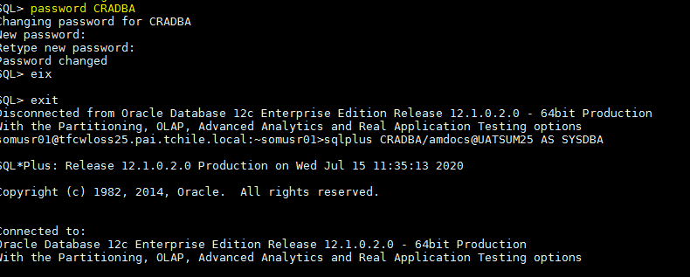

After the update, please reconnect in Database with the same user for check if the message don’t appear more, and have sure if the update have done.

Sunil also gave us a new task, for check periodically the all DB instances from UAT, for see if have some user with the near expiration date. For check this, we need to connect in each DB, with user CRADBA, and run the select command below:

select username,ACCOUNT_STATUS from dba_users;

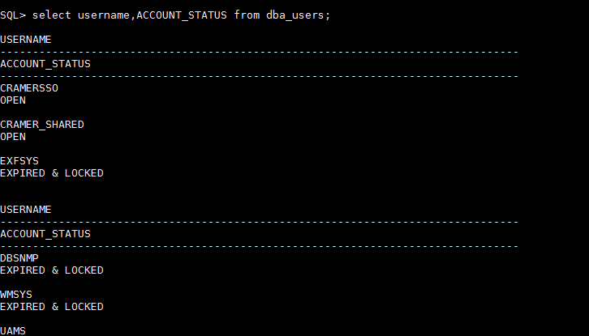

Copy all the data from return of select and paste in the notepad for check more clearly.

With this return, we can see if have some user near of expiration date, in the column of table account_status. If the value returned in this column is EXPIRED(GRACE). it is means that the user was expired or will be expire in the next days.

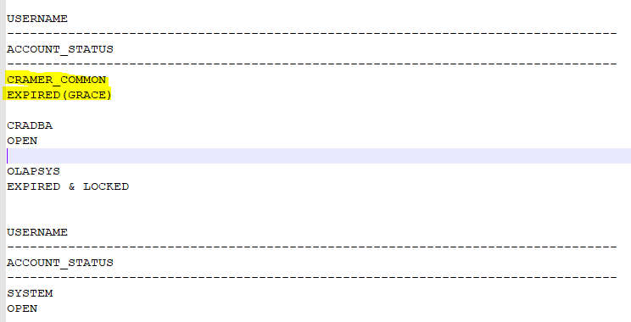

So, it is necessary connect in the database with this user and do the same process informed in this email for extend the period from access of DB user.
PROBLEM:

After adding the TFC_SOM_Purging_AD_BUILD job CI is failing with:
Started by user Avi Saar
[EnvInject] - Loading node environment variables.
Building remotely on somusr01_ilostfc006 in workspace /ossusers1/oss/users/somusr01/workspace/TEF_CHILE_SOM_AD_NIGHTLY_FLOW
Using remote perforce client: TEF_CHILE_SOM_AD_NIGHTLY_FLOW--866637593
[TEF_CHILE_SOM_AD_NIGHTLY_FLOW] $ /amdocs/Perforce/p4 -P 50E50B9004E6F06CF12FECC52F2397E6 workspace -o -S //OSSTEFCHILE/DevMain TEF_CHILE_SOM_AD_NIGHTLY_FLOW--866637593
Caught exception communicating with perforce. No output for: /amdocs/Perforce/p4 -P 50E50B9004E6F06CF12FECC52F2397E6 workspace -o -S //OSSTEFCHILE/DevMain TEF_CHILE_SOM_AD_NIGHTLY_FLOW--866637593 com.tek42.perforce.PerforceException: No output for: /amdocs/Perforce/p4 -P 50E50B9004E6F06CF12FECC52F2397E6 workspace -o -S //OSSTEFCHILE/DevMain TEF_CHILE_SOM_AD_NIGHTLY_FLOW--866637593
at com.tek42.perforce.parse.AbstractPerforceTemplate.getPerforceResponse(AbstractPerforceTemplate.java:409)
at com.tek42.perforce.parse.AbstractPerforceTemplate.getPerforceResponse(AbstractPerforceTemplate.java:302)
at com.tek42.perforce.parse.Workspaces.getWorkspace(Workspaces.java:58)
at hudson.plugins.perforce.PerforceSCM.getPerforceWorkspace(PerforceSCM.java:1641)
at hudson.plugins.perforce.PerforceSCM.getPerforceWorkspace(PerforceSCM.java:1602)
at hudson.plugins.perforce.PerforceSCM.checkout(PerforceSCM.java:907)
at hudson.model.AbstractProject.checkout(AbstractProject.java:1203)
at hudson.model.AbstractBuild$AbstractBuildExecution.defaultCheckout(AbstractBuild.java:574)
at jenkins.scm.SCMCheckoutStrategy.checkout(SCMCheckoutStrategy.java:86)
at hudson.model.AbstractBuild$AbstractBuildExecution.run(AbstractBuild.java:499)
at hudson.model.Run.execute(Run.java:1727)
at hudson.model.Build.run(Build.java:114)
at hudson.model.ResourceController.execute(ResourceController.java:97)
at hudson.model.Executor.run(Executor.java:429)
ERROR: Unable to communicate with perforce. No output for: /amdocs/Perforce/p4 -P 50E50B9004E6F06CF12FECC52F2397E6 workspace -o -S //OSSTEFCHILE/DevMain TEF_CHILE_SOM_AD_NIGHTLY_FLOW--866637593
Email was triggered for: Failure - Any
Email was triggered for: Failure - Still
Trigger Failure - Any was overridden by another trigger and will not send an email.
Sending email for trigger: Failure - Still
Sending email to: OSSTEFChileInfra@int.amdocs.com TEFChileSOMAllDevTeams@int.amdocs.com TEFChileSOMLeaders@int.amdocs.com
Finished: FAILURE

Solution:

In job configuration please remove this part:

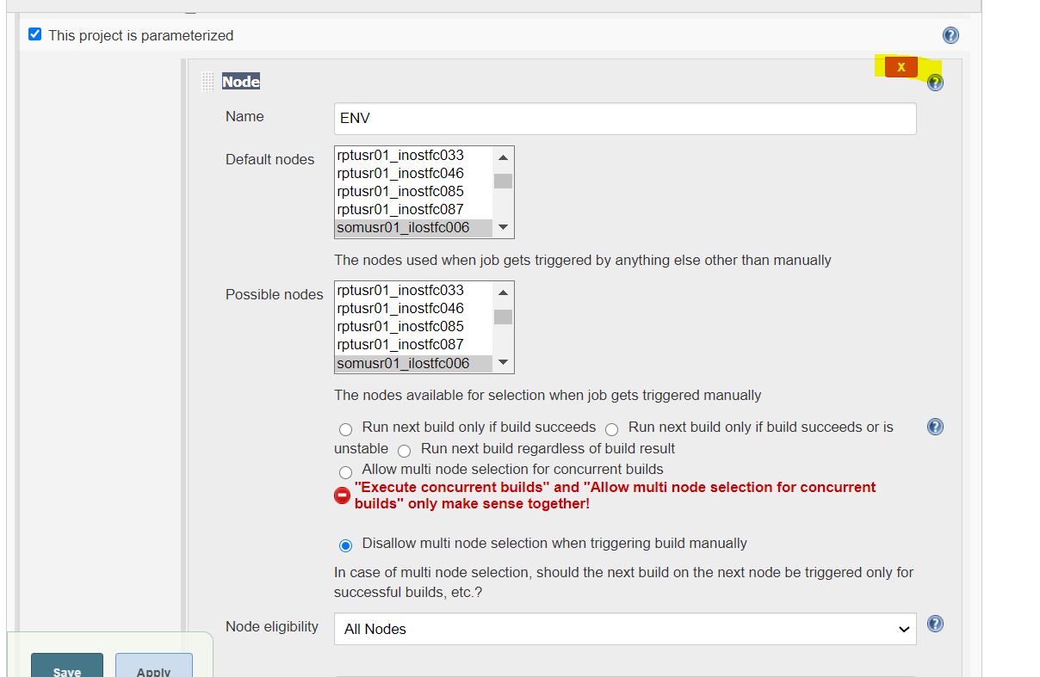

The CI need to run without the env parameters like this:

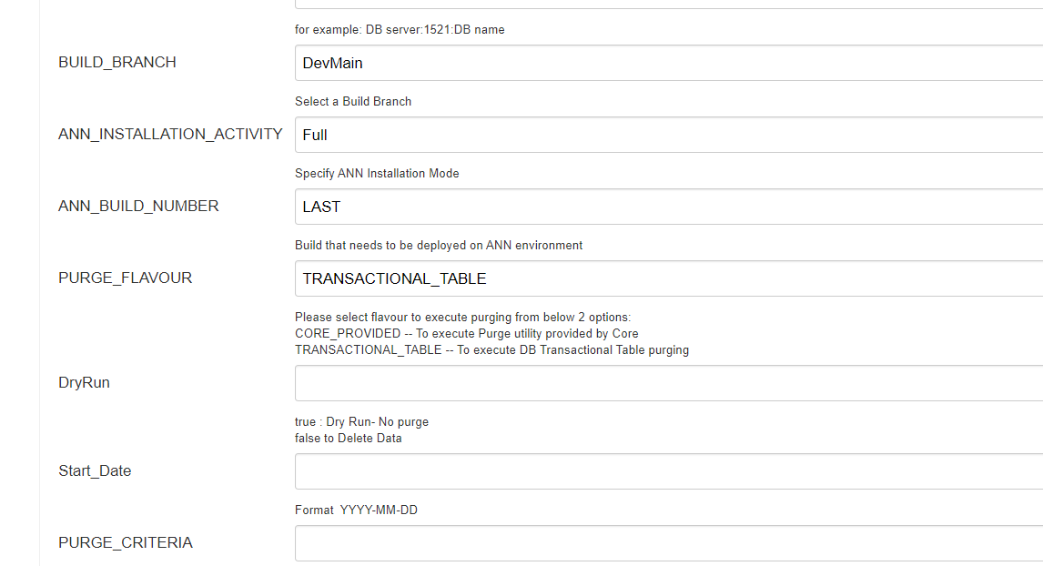

PROBLEM:

15:49:20 Building remotely on tfclum1_ilostfc020 in workspace /ossusers1/oss/users/tfclum1/workspace/USM10_REFRESH_tfclum1_ilostfc020
15:49:20 Also: hudson.remoting.Channel$CallSiteStackTrace: Remote call to tfclum1_ilostfc020
15:49:20 at hudson.remoting.Channel.attachCallSiteStackTrace(Channel.java:1737)
15:49:20 at hudson.remoting.UserResponse.retrieve(UserRequest.java:313)
15:49:20 at hudson.remoting.Channel.call(Channel.java:952)
15:49:20 at hudson.FilePath.act(FilePath.java:998)
15:49:20 at hudson.FilePath.act(FilePath.java:987)
15:49:20 at hudson.FilePath.mkdirs(FilePath.java:1170)
15:49:20 at hudson.model.AbstractProject.checkout(AbstractProject.java:1201)
15:49:20 at hudson.model.AbstractBuild$AbstractBuildExecution.defaultCheckout(AbstractBuild.java:574)
15:49:20 at jenkins.scm.SCMCheckoutStrategy.checkout(SCMCheckoutStrategy.java:86)
15:49:20 at hudson.model.AbstractBuild$AbstractBuildExecution.run(AbstractBuild.java:499)
15:49:20 at hudson.model.Run.execute(Run.java:1727)
15:49:20 at hudson.model.FreeStyleBuild.run(FreeStyleBuild.java:43)
15:49:20 at hudson.model.ResourceController.execute(ResourceController.java:97)
15:49:20 at hudson.model.Executor.run(Executor.java:429)
15:49:20 java.lang.NoClassDefFoundError: Could not initialize class sun.util.calendar.ZoneInfoFile
15:49:20 at sun.util.calendar.ZoneInfo.getTimeZone(ZoneInfo.java:589)
15:49:20 at java.util.TimeZone.getTimeZone(TimeZone.java:560)
15:49:20 at java.util.TimeZone.setDefaultZone(TimeZone.java:666)
15:49:20 at java.util.TimeZone.getDefaultRef(TimeZone.java:636)
15:49:20 at java.util.TimeZone.getDefault(TimeZone.java:625)
15:49:20 at java.util.Calendar.getInstance(Calendar.java:1640)
15:49:20 at java.util.Formatter$FormatSpecifier.printDateTime(Formatter.java:2826)
15:49:20 at java.util.Formatter$FormatSpecifier.print(Formatter.java:2740)
15:49:20 at java.util.Formatter.format(Formatter.java:2526)
15:49:20 at java.util.Formatter.format(Formatter.java:2455)
15:49:20 at java.lang.String.format(String.java:2940)
15:49:20 at java.util.logging.SimpleFormatter.format(SimpleFormatter.java:161)
15:49:20 at java.util.logging.StreamHandler.publish(StreamHandler.java:211)
15:49:20 at java.util.logging.ConsoleHandler.publish(ConsoleHandler.java:116)
15:49:20 at java.util.logging.Logger.log(Logger.java:738)
15:49:20 at java.util.logging.Logger.doLog(Logger.java:765)
15:49:20 at java.util.logging.Logger.log(Logger.java:876)
15:49:20 at hudson.remoting.UserRequest.perform(UserRequest.java:215)
15:49:20 at hudson.remoting.UserRequest.perform(UserRequest.java:53)
15:49:20 at hudson.remoting.Request$2.run(Request.java:364)
15:49:20 at hudson.remoting.InterceptingExecutorService$1.call(InterceptingExecutorService.java:72)
15:49:20 at java.util.concurrent.FutureTask.run(FutureTask.java:266)
15:49:20 at java.util.concurrent.ThreadPoolExecutor.runWorker(ThreadPoolExecutor.java:1142)
15:49:20 at java.util.concurrent.ThreadPoolExecutor$Worker.run(ThreadPoolExecutor.java:617)
15:49:20 at java.lang.Thread.run(Thread.java:748)
15:49:20 Caused: java.io.IOException: Remote call on tfclum1_ilostfc020 failed
15:49:20 at hudson.remoting.Channel.call(Channel.java:958)
15:49:20 at hudson.FilePath.act(FilePath.java:998)
15:49:20 Caused: java.io.IOException: remote file operation failed: /ossusers1/oss/users/tfclum1/workspace/USM10_REFRESH_tfclum1_ilostfc020 at hudson.remoting.Channel@77f1d65c:tfclum1_ilostfc020
15:49:20 at hudson.FilePath.act(FilePath.java:1005)
15:49:20 at hudson.FilePath.act(FilePath.java:987)
15:49:20 at hudson.FilePath.mkdirs(FilePath.java:1170)
15:49:20 at hudson.model.AbstractProject.checkout(AbstractProject.java:1201)
15:49:20 at hudson.model.AbstractBuild$AbstractBuildExecution.defaultCheckout(AbstractBuild.java:574)
15:49:20 at jenkins.scm.SCMCheckoutStrategy.checkout(SCMCheckoutStrategy.java:86)
15:49:20 at hudson.model.AbstractBuild$AbstractBuildExecution.run(AbstractBuild.java:499)
15:49:20 at hudson.model.Run.execute(Run.java:1727)
15:49:20 at hudson.model.FreeStyleBuild.run(FreeStyleBuild.java:43)
15:49:20 at hudson.model.ResourceController.execute(ResourceController.java:97)
15:49:20 at hudson.model.Executor.run(Executor.java:429)
15:49:20 Finished: FAILURE

Solution:

Please login to node tfclum1_ilostfc020 and restart it.

PROBLEM:

Hi team,

Sunil guided me with this information, and asked me to share it with the team.

We had one warning of expiration of access of user in one environment. In this kind of scenario, follow below how we can fix and check this case:

Connect in the database with the user/password:

e.g: : sqlplus CRADBA/amdocs@UATSUM22 as sysdba

If show one message like this below, after connected in DB, means that we need renew the expiration of DB user.

ORA-28002: the password will expire within 5 days
Solution:

For renew the validity of DB user, we need to run the command below and digit the same password for keep the structure of access:

Run in database:
password CRADBA(user DBA)

As show the screenshot, it is necessary digit 3 times the password, and see if it is ok.



After the update, please reconnect in Database with the same user for check if the message don’t appear more, and have sure if the update have done.

Sunil also gave us a new task, for check periodically the all DB instances from UAT, for see if have some user with the near expiration date. For check this, we need to connect in each DB, with user CRADBA, and run the select command below:

select username,ACCOUNT_STATUS from dba_users;



Copy all the data from return of select and paste in the notepad for check more clearly.

With this return, we can see if have some user near of expiration date, in the column of table account_status. If the value returned in this column is EXPIRED(GRACE). it is means that the user was expired or will be expire in the next days.



So, it is necessary connect in the database with this user and do the same process informed in this email for extend the period from access of DB user.

ISSUE:
When refresh the SOM env the distribution job getting timeout
After 50 min we need to check if we in loop.

SOM distribution problem during Jenkins Job

[rke@inosvfs024 ~]$ kubectl get jobs -n dop|grep distr
dop-distribution-engine 1 0 16h

1. Delete the job
kubectl -n dop delete job dop-distribution-engine

1. Run helm upgrade

helm upgrade -i vfgs-dop rancher-server/vfgs-dop --version=10.4.383 --namespace dop -f $HOME/IAASvalues-dop.yaml --timeout 3600

helm upgrade -i vfgs-dop rancher-server/vfgs-dop --version=10.4.19-UAT --namespace dop -f $HOME/IAASvalues-dop.yaml --timeout 3600

To verify : kubectl get jobs -n dop|grep distr
should be 1 1 - completed

( it can take few min)

[rke@inosvfs024 ~]$ kubectl get jobs -n dop|grep distr

dop-distribution-engine 1 1 2m

[‎8/‎13/‎2020 9:06 AM] Polina Tchernitski:

kubectl -n dop get pods|grep dop- |grep -v Completed|grep -v Running

ISSUE:

Hi Karla,

When booting WL I am getting this issue.

How can I know which DB expired.

<Feb 17, 2021, 12:02:36,821 PM CLST> <Notice> <Log Management> <BEA-170036> <The Logging monitoring service timer has started to check for logged message counts every 30 seconds.>
<Feb 17, 2021, 12:02:44,81 PM CLST> <Error> <Deployer> <BEA-149205> <Failed to initialize the application "ossui-datasource" due to error weblogic.application.ModuleException: java.sql.SQLException: ORA-28001: the password has expired

weblogic.application.ModuleException: java.sql.SQLException: ORA-28001: the password has expired

at weblogic.jdbc.module.JDBCModule.prepare(JDBCModule.java:412)
at weblogic.application.internal.flow.ModuleListenerInvoker.prepare(ModuleListenerInvoker.java:100)
at weblogic.application.internal.flow.ModuleStateDriver$1.next(ModuleStateDriver.java:192)
at weblogic.application.internal.flow.ModuleStateDriver$1.next(ModuleStateDriver.java:187)
at weblogic.application.utils.StateMachineDriver.nextState(StateMachineDriver.java:45)
Truncated. see log file for complete stacktrace
Caused By: java.sql.SQLException: ORA-28001: the password has expired

at oracle.jdbc.driver.T4CTTIoer.processError(T4CTTIoer.java:450)
at oracle.jdbc.driver.T4CTTIoer.processError(T4CTTIoer.java:392)
at oracle.jdbc.driver.T4CTTIoer.processError(T4CTTIoer.java:385)
at oracle.jdbc.driver.T4CTTIfun.processError(T4CTTIfun.java:1018)
at oracle.jdbc.driver.T4CTTIoauthenticate.processError(T4CTTIoauthenticate.java:501)
Truncated. see log file for complete stacktrace
>
<Feb 17, 2021, 12:02:44,170 PM CLST> <Warning> <JDBC> <BEA-001129> <Received exception while creating connection for pool "SmallCellApplicationDataSourceNoXA": Listener refused the connection with the following error:
FIXED:

Look for oracle user at DB that would be having password expired and rest it with the same existing password.
sqlplus CRADBA/amdocs@tfcdboss22:1521/UATSUM22 AS SYSDBA
To find users with account expired or locked:
SELECT username, account_status FROM dba_users WHERE account_status like '%LOCK%';
SELECT username, account_status FROM dba_users WHERE account_status like '%EXP%';

Ignore oracle system users and focus only on those users related to our products.

For every user with expired password or lock, execute this:
ALTER USER <USER> IDENTIFIED BY <PASSWORD>;

Example:
ALTER USER CRAMER IDENTIFIED BY CRAMER;
ALTER USER UAMS IDENTIFIED BY UAMS;
ALTER USER SFUSER IDENTIFIED BY SFUSER;

ISSUE:

After apply license on USM I am getting this:

usmusr01@ilostfc112:usmusr01> sqlplus CRAMER/CRAMER@TFCIS112
SQL> exec cramer.pkgsession.configuresession();
BEGIN cramer.pkgsession.configuresession(); END;

*
ERROR at line 1:
ORA-20100: Unauthorized API access
ORA-06512: at "CRAMER.PKGSESSIONCONTEXT", line 580
ORA-06512: at "CRAMER.PKGSESSION", line 26
ORA-06512: at "CRAMER.PKGSESSION", line 18
ORA-06512: at line 1

FIX:

SQL> exec pkgsession.configuresession('3f11cf0c22371bb0c64069db84727939b07f3eef1ee6d6fcd6c051f5936b79f0');

PL/SQL procedure successfully completed.

SQL> commit;

Commit complete.

(the token was sent in the zip with the license)

I put it also in tfcadm@ilostfc001:/infraoss/tfc/STORAGE/INFRA/CORE_INSTALLABLES/USM_10.2/license/token.txt

ISSUE:

"TypeError: Can not create providesname index: database or disk is full"

FIX:

Clean /var/tmp

Run refresh again.

Configured Tunneling:

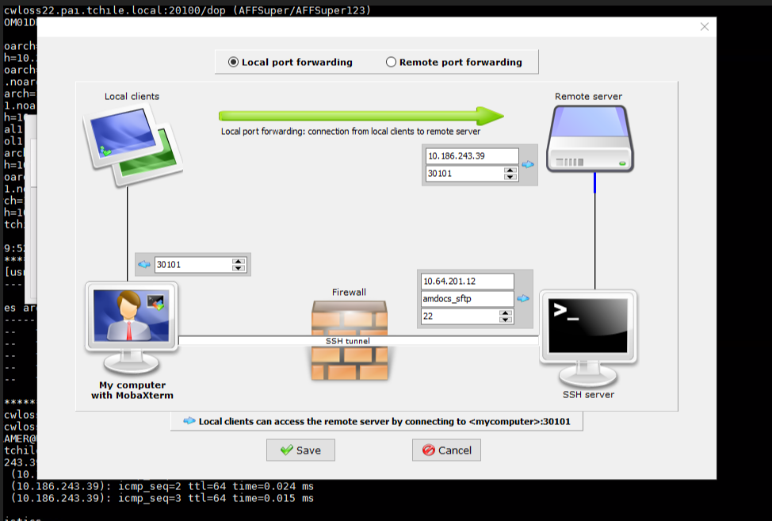

Ip for local PC: 10.64.201.12
IP for SOM:10.186.243.39
User: amdocs_sftp pass: amdocs

Login to this:
http://localhost:20100/

ISSUE:

Update password in custom.sec.properties

FIX:
[‎3/‎22/‎2021 3:10 PM] Tarun Madan:
cc:amx/toa/connection.password= TOAUser123

[‎3/‎22/‎2021 3:11 PM] Tarun Madan:
go to this path
/ossuser1/osshome/oss/somusr01/amx_playbook/preinstall
run this command
ansible-playbook dop-p2cc-encrypt.yml -i ../hosts -vvv

run: updateCC

check that the new password is encrypted in custom.sec.properties
somusr01@amxwlsom01.clarochile.org:~somusr01/pushToCC/dbp/custom.sec.properties

run this command to check that you get the correct password
${HOME}/cc_home/tools/cc-tool --string='${cc:amx/toa/connection.password}' -au SysCtcUser -ah $HOME/asm_home

Connect to site AMX

ssh -f -N amxadm@10.64.200.201

copy storage from site:

scp amxadm@10.64.200.201:/app/infraoss/amx/STORAGE/SOM/PT_Delivery/198.tar .

ISSUE:

I'm getting "Connection refused: connect" in MEC env

FIX:

Please copy the properties file from other MEC server and reboot

mecusr01@inostef073!:mecusr01/mec-home> scp -r properties amxmec01@ilosamx070:mec-home/

ISSUE:

<Apr 18, 2021, 1:26:18,881 PM IDT> <Error> <Deployer> <BEA-149231> <Unable to set the activation state to true for the application "MECServer_mec".
weblogic.application.ModuleException: com.amdocs.pc.exceptions.internal.EPCSecurityException: Login failed with the error code: User last login date preceded the allowed date.
at weblogic.application.internal.ExtensibleModuleWrapper.start(ExtensibleModuleWrapper.java:140)
at weblogic.application.internal.flow.ModuleListenerInvoker.start(ModuleListenerInvoker.java:124)
at weblogic.application.internal.flow.ModuleStateDriver$3.next(ModuleStateDriver.java:233)
at weblogic.application.internal.flow.ModuleStateDriver$3.next(ModuleStateDriver.java:228)
at weblogic.application.utils.StateMachineDriver.nextState(StateMachineDriver.java:45)
Truncated. see log file for complete stacktrace
Caused By: com.amdocs.pc.exceptions.internal.EPCSecurityException: Login failed with the error code: User last login date preceded the allowed date.
at com.amdocs.pc.backend.security.SecurityUtils.loginAsCTC(SecurityUtils.java:1860)
at com.amdocs.pc.backend.security.SecurityUtils.getCTCTicket(SecurityUtils.java:1834)
at com.amdocs.pc.backend.security.SecurityDAOAsm.getCoreRoles(SecurityDAOAsm.java:219)
at com.amdocs.pc.backend.security.SecurityDAOAsm.<clinit>(SecurityDAOAsm.java:147)
at sun.reflect.NativeConstructorAccessorImpl.newInstance0(Native Method)
Truncated. see log file for complete stacktrace
>

FIX:

The error code is: "Login failed with the error code: User last login date preceded the allowed date.":

This means that the user didn’t perform login for a long time.
To solve it -
- look for uams.properties (/epc-home/asm/uams.properties) on your machine and add this property:
STEP_CONS_INACTIVE_TIME=any large Integer, for example: 1000000
- restart weblogic

ISSUE:

For the following issue in WL:

<Jun 11, 2023 7:30:47 AM IDT> <Critical> <WebLogicServer> <BEA-000386> <Server subsystem failed. Reason: A MultiEx
ception has 2 exceptions. They are:
1. java.lang.IllegalStateException: TimerManager is in STOPPED state
2. java.lang.IllegalStateException: Unable to perform operation: post construct on weblogic.ejb.container.timer.EJ
BTimerStarterActivator

A MultiException has 2 exceptions. They are:
1. java.lang.IllegalStateException: TimerManager is in STOPPED state
2. java.lang.IllegalStateException: Unable to perform operation: post construct on weblogic.ejb.container.timer.EJ
BTimerStarterActivator

at org.jvnet.hk2.internal.ClazzCreator.create(ClazzCreator.java:447)
at org.jvnet.hk2.internal.SystemDescriptor.create(SystemDescriptor.java:456)
at org.glassfish.hk2.runlevel.internal.AsyncRunLevelContext.findOrCreate(AsyncRunLevelContext.java:225)
at org.glassfish.hk2.runlevel.RunLevelContext.findOrCreate(RunLevelContext.java:82)
at org.jvnet.hk2.internal.Utilities.createService(Utilities.java:2488)
Truncated. see log file for complete stacktrace
Caused By: java.lang.IllegalStateException: TimerManager is in STOPPED state
at weblogic.timers.internal.TimerManagerImpl.schedule(TimerManagerImpl.java:488)
at weblogic.ejb.container.timer.EJBTimerManager.scheduleTimer(EJBTimerManager.java:191)
at weblogic.ejb.container.timer.EJBTimerManager.enableDisabledTimers(EJBTimerManager.java:147)
at weblogic.ejb.container.timer.EJBTimerManager.start(EJBTimerManager.java:617)
at weblogic.ejb.container.timer.EJBTimerStarter.startTimerManagers(EJBTimerStarter.java:60)
Truncated. see log file for complete stacktrace
FIXED:
The uams.properties was updated with environment variable: STEP_CONS_INACTIVE_TIME=100000

ISSUE: AttMexOSS_1!

<Apr 29, 2021, 3:18:09,133 PM IDT> <Error> <Deployer> <BEA-149231> <Unable to set the activation state to true for the application "MECServer_mec".
weblogic.application.ModuleException: com.amdocs.pc.exceptions.internal.EPCSecurityException: Login failed with the error code: User credentials have expired.
at weblogic.application.internal.ExtensibleModuleWrapper.start(ExtensibleModuleWrapper.java:140)
at weblogic.application.internal.flow.ModuleListenerInvoker.start(ModuleListenerInvoker.java:124)
at weblogic.application.internal.flow.ModuleStateDriver$3.next(ModuleStateDriver.java:233)
at weblogic.application.internal.flow.ModuleStateDriver$3.next(ModuleStateDriver.java:228)
at weblogic.application.utils.StateMachineDriver.nextState(StateMachineDriver.java:45)
Truncated. see log file for complete stacktrace
Caused By: com.amdocs.pc.exceptions.internal.EPCSecurityException: Login failed with the error code: User credentials have expired.
at com.amdocs.pc.backend.security.SecurityUtils.loginAsCTC(SecurityUtils.java:1860)
at com.amdocs.pc.backend.security.SecurityUtils.getCTCTicket(SecurityUtils.java:1834)
at com.amdocs.pc.backend.security.SecurityDAOAsm.getCoreRoles(SecurityDAOAsm.java:219)
at com.amdocs.pc.backend.security.SecurityDAOAsm.<clinit>(SecurityDAOAsm.java:147)
at sun.reflect.NativeConstructorAccessorImpl.newInstance0(Native Method)
Truncated. see log file for complete stacktrace

Solution:

Steps:
- Login to ASM client GUI
  - Take the zip file "SmartAdmin.zip" from our build tar file.
  - Extract the zip file.
  - If missing - take "ojdbc6.jar" from eclipse and put it in the "inproc" folder.
  - Update the file uams.properties in \SmartAdmin\inproc\asm_home
With the DB details.
- Run "inproc.cmd" and login using EPCAdmin\EPCAdmin1 (or root\Root00)

- Check for user EpcCtcUser
- Press on the “Set CTC” button. This will create in the PC side under asm_home (where the uams gui client is located) a uams_ctc.xml file
With the required information for this user
For example:
<?xml version="1.0" encoding="UTF-8"?>
<uams_credentials>
<ctc>
<owner>EpcCtcUser</owner>
<creationDate>1280049872581</creationDate>
<effectiveDate>0</effectiveDate>
<expirationDate>1311585872581</expirationDate>
<cryptoResource>uams.ctc.encryption</cryptoResource>
<signature>f5d7jzVbfjNHpnA{bDlxrncKoThzbClKoT9Vs7hFrSUKc3JdfkAOiQFPdSxPrQ5kinRNjmFLmkFWrj8OePMLkQtef22</signature>
</ctc>
</uams_credentials>
- Click on "save".
- Take the xml part for EpcCtcUser and put it in the uams_ctc.xml file in the environment (under epc-home/asm or mec-home/asm)
- If there is no such user, create a new EpcCtcUser with Role: UamsAdmin

ISSUE:

Hi,

I need your advice regarding the zabbix tool.

How can I make the monitoring ONLINE?

I check all the configurations in ilosamx043 And all seems ok but it’s still OFFLINE.
Solution:

Hello Avi,

The problem was that in Grafana, Host Group had only “Linux Server” available as part of the drop down, while ilosamx043 in Zabbix is classified as “SOM Servers”.
Changing the Grafana dashboard variable logic from /.*Linux*/ to /.*/ makes all group available in Grafana UI.

Selecting “SOM Server” and then selecting “ilosamx143 – SOM” provides the results in Graphs.

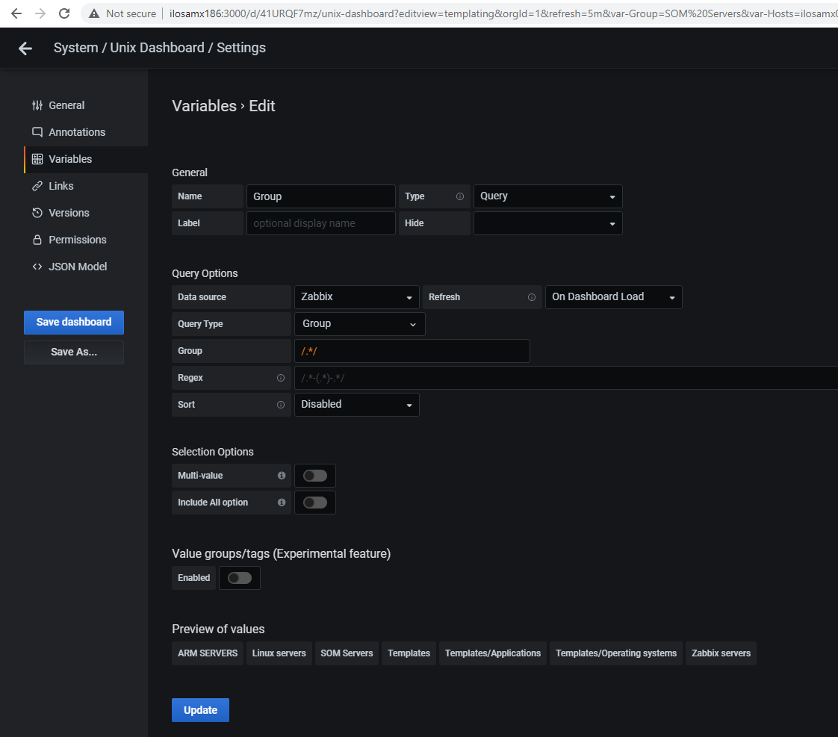

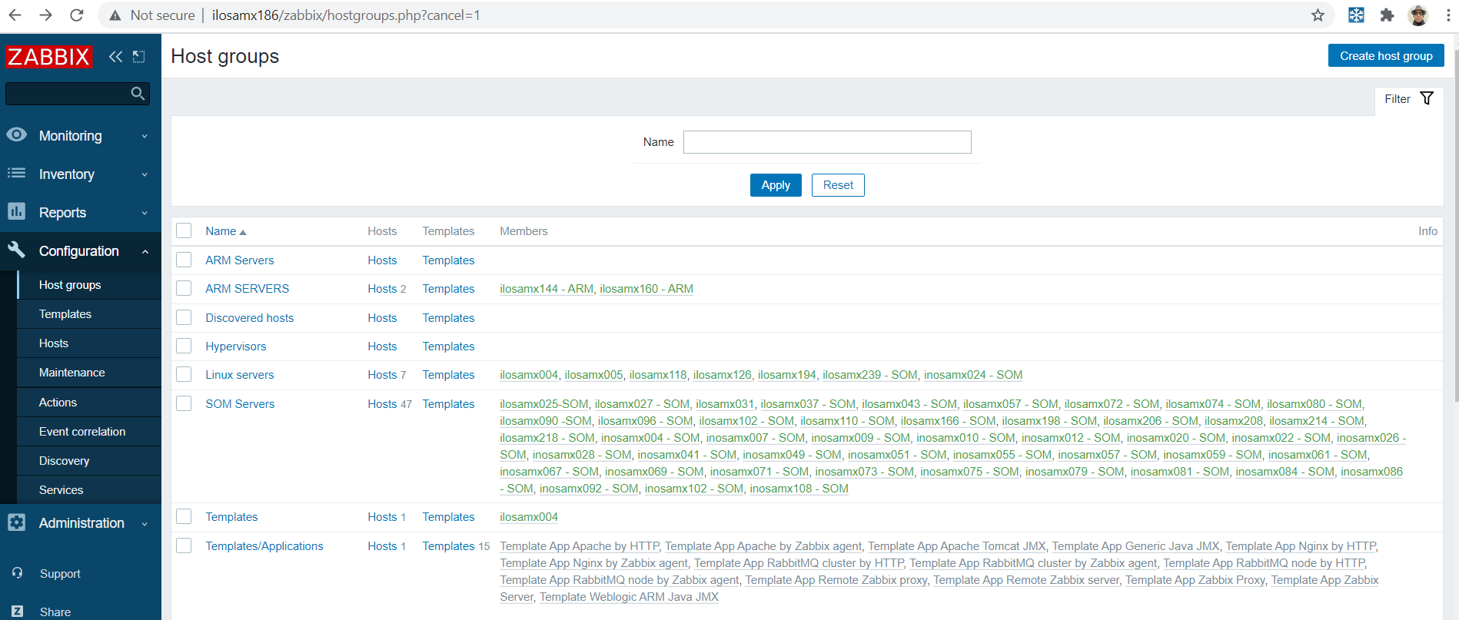

ISSUE:

When login to Zabbix gui http://ilosamx186/zabbix
i am getting in zabbix Database error
Error connecting to database

Fix:

logged in on ilosamx186
from root user
did
su - postgres
from home ran this command
nohup postgres -D /var/lib/pgsql/data 2>&1 </dev/null &

it is starting the postgres DB
DB was down
you can verify is DB is running by doing "psu" from postgres user
once DB was started, i restarted zabbix

with unix account "zabbix"
there is an alias to stop zabbix
stop
and then once it is completed
start
alias

alias stop
stop='sudo service zabbix-java-gateway stop; sleep 10; sudo service zabbix-agent stop; sleep 10; sudo service zabbix-server stop; sleep 10; sudo service httpd stop'
zabbix@ilosamx186:zabbix> alias start
start='sudo service httpd start; sleep 10; sudo service zabbix-server start; sleep 10; sudo service zabbix-agent start; sleep 10; sudo service zabbix-java-gateway start'
zabbix@ilosamx186:zabbix>

Prometheus installation:

Open new user:
prometheus@prd02zbx.pai.tchile.local

useradd -m -d /app/ossusers/prometheus -s /bin/ksh -u 5150 -g 555 prometheus

copy to it the .profile and prometheus-2.19.2.linux-amd64 ( I copy it from prometheus@prd01zbx.smt.tchile.local)

305 scp .profile prometheus@prd02zbx.pai.tchile.local:
307 scp -r prometheus-2.19.2.linux-amd64 prometheus@prd02zbx.pai.tchile.local:

Update the .profile

Login to prometheus-2.19.2.linux-amd64 and update the prometheus.yml

- targets:
- prd02adm:20161

Login to it again and start it
su - prometheus
16 alias
17 start

Login to prdadm1@prd02adm.pai.tchile.local

Open new user Prometheus

useradd -m -d /app/ossusers/prometheus -s /bin/ksh -u 5150 -g 555 prometheus

copy to it:

379 scp .profile prometheus@prd02adm.pai.tchile.local:
380 ll
381 scp -r prometheus_oracle_exporter prometheus@prd02adm.pai.tchile.local:

Update the .profile

Update the vi oracle.conf with the DB of the server

Login again to the user

cd prometheus_oracle_exporter

./start.sh

http://prd02zbx.pai.tchile.local:20190/

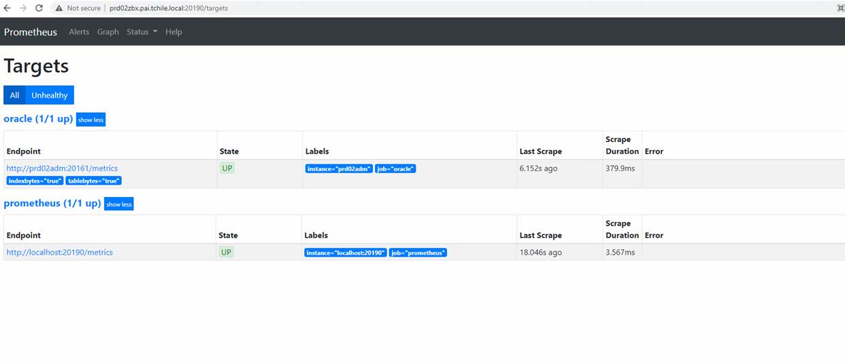

Hello Fernando/Team,

Production USM is installed successfully via XPI.
http://prd01jen.smt.tchile.local:20100/view/Cluster%20Jobs/job/PRD_USM102_CORE_INSTALLATION_PRDUSM2/14/

The problem that we had about the ManagedServers XPI being stuck was due to the fact that gssapi-with-mic SSH mechanism being preceded before publickey authentication.
This was leading RHEL Host look for Kerberos authentication details in interactive mode and was continuously waiting hence seeming like it was stuck.

Below items were done to solve this:
- SELinux was enabled in prd01adm, prd01usm, prd02usm, prd03usm due to which passwordless SSH was not working.
Disabled it by below command in each machine:
setenforce 0

- To disable Kerberos authentication temporarily, moved /etc/krb5.conf and /etc/krb5.keytab to a backup file in all of the above 4 servers.

- Commented out “PubkeyAuthentication yes” and restarted sshd in each of the above 4 machines.

Since this is the first time we were dealing with a cluster setup in TEF Chile network (till date all envs were standalone) and since these are TEF IT specific setting (not found in Amdocs server), we never faced it in TEF network.
I think with this effort, we are back on track about OSS Production installation.

ISSUE:

ssh is not working after we configured it.

FIX:

Disabled it by below command in each machine:
setenforce 0

somusr01@amxwlsom05.clarochile.org:~somusr01>sudo setenforce 0

login to root in the server and run:

/sbin/setenforce 0

ISSUE:

WARNING: Postgresql jdbc driver jars not found at location /usr/share/java",
"<< UAMS >> 10.0.0.pb12_hf04",
"<< UAMS >> Starting UAMS System...",
"<< UAMS >> UAMS Successfully Started",
"LoginSuccess",
"Resolved file path: /ossusers1/oss/users/rptusr01/JEE/scripts/startAdmin.input",
"LogoutSuccess",
"WARNING: Postgresql jdbc driver jars not found at location /usr/share/java",
"<< UAMS >> 10.0.0.pb12_hf04",
"<< UAMS >> Starting UAMS System...",
"<< UAMS >> UAMS Successfully Started",
"LoginSuccess",
"Resolved file path: /ossusers1/oss/users/rptusr01/data/hiera/common.yaml",
"LogoutSuccess",
"WARNING: Postgresql jdbc driver jars not found at location /usr/share/java",
"<< UAMS >> 10.0.0.pb12_hf04",
"<< UAMS >> Starting UAMS System...",
"<< UAMS >> UAMS Successfully Started",
"LoginSuccess",
"Resolved file path: /ossusers1/oss/users/rptusr01/data/hiera/hiera.yaml",
"LogoutSuccess",
"WARNING: Postgresql jdbc driver jars not found at location /usr/share/java",
"<< UAMS >> 10.0.0.pb12_hf04",
"<< UAMS >> Starting UAMS System...",
"<< UAMS >> UAMS Successfully Started",
"LoginSuccess",
"Resolved file path: /ossusers1/oss/users/rptusr01/data/hiera/report_1.yaml",
"LogoutSuccess",
"Running workaccount ..",
"1",
"Failed to apply WLS configuration. check /ossusers1/oss/users/rptusr01/acd/WLS/logs/puppet/installWLS.log"
]
}

PLAY RECAP *********************************************************************
localhost : ok=53 changed=41 unreachable=0 failed=1 skipped=12 rescued=0 ignored=0

Checking REPORTS installation status..
Returned ERROR CODE while running REPORTS installation, terminating script..
Build step 'Ejecutar linea de comandos (shell)' marked build as failure
Finished: FAILURE
FIX:

Puppet modules were missing, I have copied them now. Please retrigger again now.

rptusr01@ilosamx072:~rptusr01>puppet module list
/opt/puppetlabs/puppet/modules (no modules installed)
rptusr01@ilosamx072:~rptusr01>cd /opt/puppetlabs/puppet/modules
rptusr01@ilosamx072:~/opt/puppetlabs/puppet/modules>ll
total 8
drwxr-xr-x 2 root root 4096 May 2 2017 .
drwxr-xr-x 9 root root 4096 Jul 30 2019 ..
rptusr01@ilosamx072:~/opt/puppetlabs/puppet/modules>ll
total 32
drwxr-xr-x 9 root root 4096 Jul 30 2019 ..
drwxr-xr-x 10 root root 4096 Jul 6 19:04 easy_type
drwxr-xr-x 5 root root 4096 Jul 6 19:04 filemapper
drwxr-xr-x 9 root root 4096 Jul 6 19:04 orawls
drwxr-xr-x 5 root root 4096 Jul 6 19:04 sleep
drwxr-xr-x 9 root root 4096 Jul 6 19:04 stdlib
drwxr-xr-x 8 root root 4096 Jul 6 19:04 .
drwxr-xr-x 3 root root 4096 Jul 6 19:04 yamlfile
rptusr01@ilosamx072:~/opt/puppetlabs/puppet/modules>puppet module list
/opt/puppetlabs/puppet/modules
├── adrien-filemapper (v1.1.3)
├── biemond-orawls (v2.0.12)
├── fiddyspence-sleep (v1.2.0)
├── hajee-easy_type (v0.15.5)
├── puppetlabs-stdlib (v4.19.0)
└── reidmv-yamlfile (v0.2.0)
rptusr01@ilosamx072:~/opt/puppetlabs/puppet/modules>

Check if grup bea is part of the file group
cat /etc/group
to add the group please run:
sudo groupadd bea

you need to update this 2:

wladmin:x:1001:annusr01
zabbix:x:993:
bea:x:1010:annusr01

ISSUE:
Getting issue in PET console

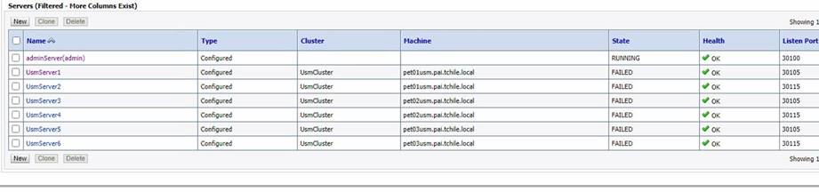

FIX:

Update this parameter:

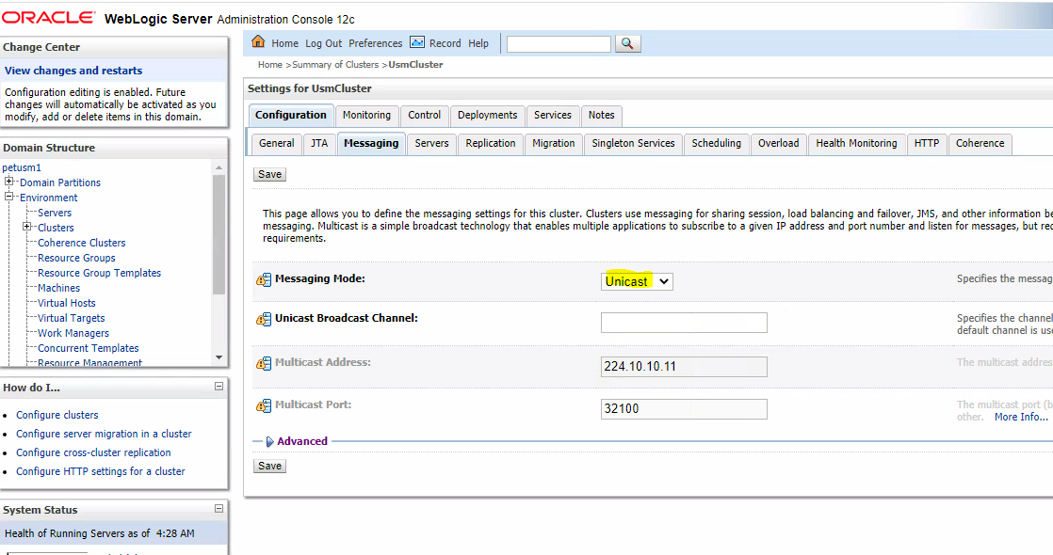

Restart consul:

sudo systemctl restart amdocs-consul-agent@$LOGNAME

consul members

ISSUE:
:26 PLAY RECAP *********************************************************************
04:28:26 localhost : ok=9 changed=3 unreachable=0 failed=1 skipped=0 rescued=0 ignored=0
04:28:26
04:28:26 Checking SOM installation status..
04:28:36 Returned ERROR CODE while running SOM installation, terminating script..
04:28:36 ping server step: script /ossusers1/oss/users/somusr01/JEE/scripts/pingServer.sh failed
04:28:37 Build step 'Ejecutar linea de comandos (shell)' marked build as failure
04:28:37 Failed to evaluate name macro:org.jenkinsci.plugins.tokenmacro.MacroEvaluationException: Unrecognized macro 'ENV_SOM' in '${ENV_SOM,var="SOM"} - ${ENV_SOM,var="BRANCH_NAME"} 281 - Full'
04:28:37 Finished: FAILURE

FIX:

Check if we have other env on the same fs with console up.

It can be rptusr01 which console is running.

ISSUE:

As we discussed we are getting the following issue when installing the SOM in PET:

19:34:22 "Failed to apply WLS configuration. check /app/ossusers/petsom1/acd/WLS/logs/puppet/installWLS.log"
19:34:22 ]
19:34:22 }
19:34:22 to retry,
19:34:22 use: --limit @/app/ossusers/petsom1/tfc_playbook/dop-orchestrate.retry
19:34:22
19:34:22 PLAY RECAP *********************************************************************
19:34:22 pet01adm : ok=69 changed=49 unreachable=0 failed=1
19:34:22
19:34:22 Returned ERROR CODE at SOM admin and MS servers installation, terminating script..
19:34:22 SOM Cluster Installation Failed
19:34:22 Build step 'Execute shell' marked build as failure
19:34:22 Finished: FAILURE

2021-07-13 19:34:18 -0400 Scope(Class[Amd_workaccount::Create_workaccount]) (notice): Creating necessary directories
2021-07-13 19:34:18 -0400 Puppet (err): Evaluation Error: Unknown function: 'prefix'. (file: /opt/amdocs/fnd/fnd-wls1/modules/amd_workaccount/manifests/create_workaccount.pp, line: 19, column: 27) on node pet01adm.pai.tchile.local
/app/ossusers/petsom1/acd/WLS/logs/puppet/installWLS.log (END)

FIX:

run this command:
puppet module list

PET TEF Chile pet01adm petsom1 /app/ossusers/petsom1 > puppet module list
/opt/puppetlabs/puppet/modules (no modules installed)

i have shared same last time as well in mail when your report install was failing
please copy that, and it will work

ISSUE:

"rc": 1,
"start": "2021-08-10 15:03:56.741450",
"stderr": "ERROR: OSSUI DB is not accessible. Please check that OSSUI is installed and also ensure that DB connection properties are configured correctly. ",
"stderr_lines": [
"ERROR: OSSUI DB is not accessible. Please check that OSSUI is installed and also ensure that DB connection properties are configured correctly. "
],
"stdout": "WL_HOME is set to /opt/weblogic1221/wlserver_12.2.1/installation/wlserver\nORACLE_HOME is set to /oravl01/oracle/12.2.0.1\n/oravl01/oracle/12.2.0.1/bin/sqlplus\nsqlplus is present\nMM_ECLIPSE_HOME is set to /ossusers1/oss/users/annusr01/pre-reqs/eclipse\nDB is up and running\nValidating ASM exist\nValidating OSSUI exist",
"stdout_lines": [
"WL_HOME is set to /opt/weblogic1221/wlserver_12.2.1/installation/wlserver",
"ORACLE_HOME is set to /oravl01/oracle/12.2.0.1",
"/oravl01/oracle/12.2.0.1/bin/sqlplus",
"sqlplus is present",
"MM_ECLIPSE_HOME is set to /ossusers1/oss/users/annusr01/pre-reqs/eclipse",
"DB is up and running",
"Validating ASM exist",
"Validating OSSUI exist"
FIX:

Check under all files under: /infraoss/amx/STORAGE/INFRA/CI/ANN_10.3.2/Installation_Scripts/config/annusr01_inosamx115

Check .secrets have the correct DB:

database.user.ossui.password=SOM01OSSUI
ossui.database.user.installer.password=CRADBA
database.user.ossuiclient.password=SOM01OSSCLIENT
ossui.asm.database.password=UAMS

[11:34 AM] Kuldeep Kumar Verma
then extract it in some temp dir
​
[11:34 AM] Kuldeep Kumar Verma
then go inside, export dir
​
[11:35 AM] Kuldeep Kumar Verma
and update the uams.prop with prod uams details
​
[11:35 AM] Kuldeep Kumar Verma
then come 1 step back and run export_files.ksh
​
[11:35 AM] Kuldeep Kumar Verma
this will generate 5 dir inside export directory
​
[11:36 AM] Kuldeep Kumar Verma
these will be all the xmls exported from prod
​
[11:36 AM] Kuldeep Kumar Verma
now copy the tool on PET
​
[11:37 AM] Kuldeep Kumar Verma
and this time, you need to update uams.prop under import
​
[11:38 AM] Kuldeep Kumar Verma
and if you want import roles only, then take the roles xml only from prod and put inside import dir
​
[11:38 AM] Kuldeep Kumar Verma
tefadm@indlin1556:tefadm/UASM_CLONING/import> cat uams.properties #Tue Jan 19 13:00:10 IST 2010 # DB details SEC_DB_HOST=indlin SEC_DB_USER=UAMS SEC_DB_INST=SID SEC_DB_PWD=<USE>K=<key>.uams.config.crypto.0;M=AAkpctHqSItUJz6MdFopt02;</USE> SEC_DB_PORT=1521 #SEC_DB_FULL_URL=jdbc\:oracle\:thin\:@indlin2560\:1521\VFIUSM05 # Objects importer configuration OBJ_IMPORTER_DELETE_FIRST=false OBJ_IMPORTER_UPDATE_EXISTING=true OBJ_IMPORTER_VALIDATE_XML=true OBJ_IMPORTER_GIVE_WARNING=true OBJ_IMPORTER_STOP_ON_FAIL=true OBJ_IMPORTER_XML_FILE=export_0_POLICY_31-03-2016_12-58-04.xml,export_0_KEY_31-03-2016_12-58-04.xml,export_0_USER_31-03-2016_15-22-07.xml,export_0_ROLE_31-03-2016_12-58-04.xml #OBJ_IMPORTER_XML_FILE=export_0_RESOURCE_16-02-2016_17-59-20.xml,export_0_USER_16-02-2016_17-59-20.xml,export_0_ROLE_16-02-2016_17-59-20.xml,export_0_POLICY_16-02-2016_17-59-20.xml tefadm@indlin1556:tefadm/UASM_CLONING/import>

https://www.udemy.com/course/certified-kubernetes-administrator-with-practice-tests/learn/lecture/14224074?start=15#questions

ISSUE:

What Sulbh mean here is that build was deployed but we see issues in MEC deployment .
MEC zip is seen in rejected directory and need to be fixed .

FIX:

  - mv /app/ossusers/petsom1/JEE/distribution-engine/rejected/elementsData/SC-TestData.zip

to

/app/ossusers/petsom1/JEE/distribution-engine/source/elementsData

  - login to REF DB:

sqlplus PETSOMREF/PETS0MREFPA55@PETUSM

and run the following:

TRUNCATE TABLE OSS_REF_DATA_BACKUP;
TRUNCATE TABLE OSS_REF_ATTRIBUTE_BACKUP;
INSERT INTO OSS_REF_DATA_BACKUP (SELECT * FROM OSS_REF_DATA);
INSERT INTO OSS_REF_ATTRIBUTE_BACKUP (SELECT * FROM OSS_REF_ATTRIBUTE);
TRUNCATE TABLE OSS_REF_DATA;
TRUNCATE TABLE OSS_REF_ATTRIBUTE;

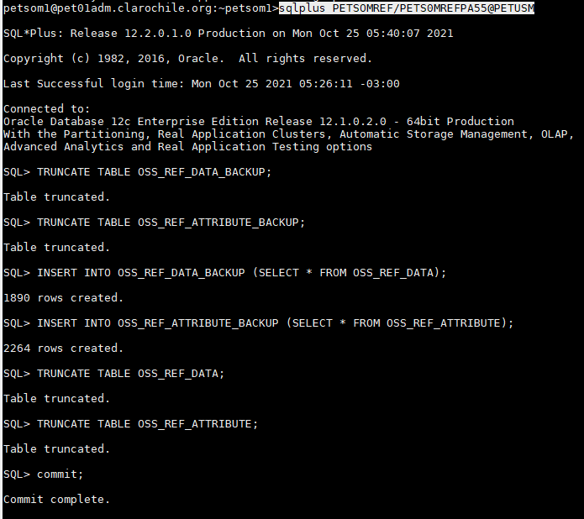

  - run: petsom1@pet01adm.clarochile.org:~petsom1/JEE/distribution-engine>./startEngine.sh ACTIVE

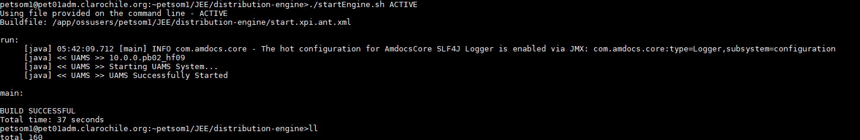

Reboot PET SOM via Jenkins:

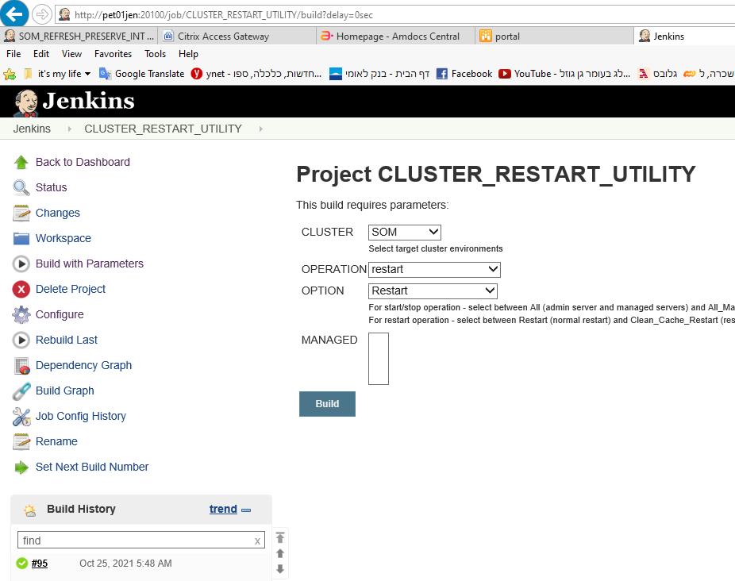

Problem: 08:30:48 Delta persisted to /app/ossusers/petusm1/.installed/petusm1/28-October-2021/08-30-08
08:31:14 Oct 28, 2021 8:31:14 AM com.amdocs.oss.ide.mm.usm.ormapping.USMPostDistributionCallout execute
08:31:14 SEVERE: Error during PKGUSM_CONFIGURATION.CONFIGURE_ATTRIBUTES execution
08:31:14 com.amdocs.oss.ide.mm.usm.util.USMException: Error in PKGUSM_CONFIGURATION.CONFIGURE_ATTRIBUTES Error code : 590089 Error Message :The "USM_FIBER_DATA" tablespace was expected for USMServiceType "Fiber", but was not found. Expected tablespaces for this USMServiceType are: "USM_FIBER_DATA" and "USM_FIBER_INDEX"
08:31:14 at com.amdocs.oss.ide.mm.usm.ormapping.USMPostDistributionCallout.execute(USMPostDistributionCallout.java:49)

FIX:

Hi Avi,
All Done

Issue: è CRAMER schema didn’t have grants to use USM_SATELLITE_DATA & USM_SATELLITE_INDEX Tablespaces.

SELECT TABLESPACE_NAME,
BYTES / 1024 / 1024 "UTILIZIED_SPACE",
MAX_BYTES / 1024 / 1024 "QUOTA_ALLOCATED"
FROM dba_ts_quotas
WHERE username = 'CRAMER';

Fix: è The below statements have been executed:

ALTER USER CRAMER QUOTA UNLIMITED ON USM_SATELLITE_DATA;
ALTER USER CRAMER QUOTA UNLIMITED ON USM_SATELLITE_INDEX;

http://ilostfc001:7070/view/Cluster%20Jobs/job/USM10_REFRESH_tfclum1_ilostfc020/36/console

We Can see all Tables by running this command:

PET TEF Chile pet01adm petusm1 /app/ossusers/petusm1 > sqlplus CRAMER/CRAMER@PETUSM1

SQL*Plus: Release 12.1.0.2.0 Production on Wed Dec 15 08:44:08 2021

Copyright (c) 1982, 2014, Oracle. All rights reserved.

Last Successful login time: Wed Dec 15 2021 08:36:10 -03:00

Connected to:
Oracle Database 12c Enterprise Edition Release 12.2.0.1.0 - 64bit Production

SQL> SELECT /* + RULE */ df.tablespace_name "Tablespace",
df.bytes / (1024 * 1024) "Size (MB)", SUM(fs.bytes) / (1024 * 1024) "Free (MB)",
Nvl(Round(SUM(fs.bytes) * 100 / df.bytes),1) "% Free",
Round((df.bytes - SUM(fs.bytes)) * 100 / df.bytes) "% Used"
FROM dba_free_space fs,
(SELECT tablespace_name,SUM(bytes) bytes
FROM dba_data_files
GROUP BY tablespace_name) df
WHERE fs.tablespace_name (+) = df.tablespace_name
GROUP BY df.tablespace_name,df.bytes
UNION ALL
SELECT /* + RULE */ df.tablespace_name tspace,
fs.bytes / (1024 * 1024), SUM(df.bytes_free) / (1024 * 1024),
Nvl(Round((SUM(fs.bytes) - df.bytes_used) * 100 / fs.bytes), 1),
Round((SUM(fs.bytes) - df.bytes_free) * 100 / fs.bytes)
FROM dba_temp_files fs,
(SELECT tablespace_name,bytes_free,bytes_used
FROM v$temp_space_header
GROUP BY tablespace_name,bytes_free,bytes_used) df
WHERE fs.tablespace_name (+) = df.tablespace_name
and df.tablespace_name='POOL_DATA'
GROUP BY df.tablespace_name,fs.bytes,df.bytes_free,df.bytes_used
ORDER BY 4 DESC;

Tablespace Size (MB) Free (MB) % Free % Used
------------------------------ ---------- ---------- ---------- ----------
USM_EQUIPMENT_INDEX 5120 5119 100 0
TOOLS 2048 2047 100 0
USM_EQUIPMENT_DATA 5120 5119 100 0
USM_FIBER_DATA 1024 1022.75 100 0
USM_BROADBAND_DATA 5120 5119 100 0
UNDOTBS2 20480 20462.5 100 0
USM_SATELLITE_DATA 1024 1022.75 100 0
USM_BROADBAND_INDEX 5120 5119 100 0
USM_ACCESS_INDEX 5120 5119 100 0
USM_PHONE_DATA 5120 5119 100 0
USM_FIBER_INDEX 1024 1021.75 100 0

Tablespace Size (MB) Free (MB) % Free % Used
------------------------------ ---------- ---------- ---------- ----------
USM_ACCESS_DATA 5120 5119 100 0
USM_SATELLITE_INDEX 1024 1021.875 100 0
UNDOTBS1 20480 20454 100 0
USM_TV_INDEX 5120 5119 100 0
USM_PHONE_INDEX 5120 5119 100 0
USM_TV_DATA 5120 5119 100 0
USERS 153600 148050.688 96 4
SYSTEM 10240 9186.375 90 10
SYSAUX 10240 7215.125 70 30

20 rows selected.

SQL>
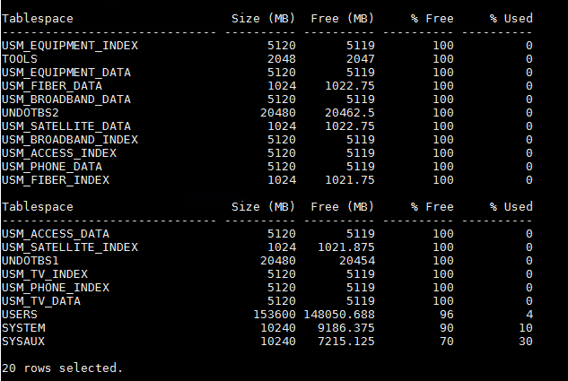

AMX HF:

HF TOOLS:

AMX Chile offshore HF tool: http://illin983:50200/ (avisaa/Unix11!)
AMX Chile offshore HF tools Unix:
server: illin983
credentials : chitools/Unix11!

AMX Chile UAT HF tool: http://dxuat1:50200/ (avisaa/Unix11!)
AMX Chile UAT HF tools Unix:
server: dxuat1
credentials : toolsamc/Tool@11!

consul install

1. Kill consul before installing:
2. Copy to home dir somusr01@inosamx088:~somusr01>cp ./amx_playbook/preinstall/install_CC_P2CC_GA.sh .
3.From env homedir run:
./ install_CC_P2CC_GA.sh
3. run updateCC

error:
file:///infraoss/comcastmm/STORAGE/BUILDS/SOM_AD/DevMain/5063/yum_core_repo/repodata/repomd.xml: [Errno 14] curl#37 - "Couldn't open file /infraoss/comcastmm/STORAGE/BUILDS/SOM_AD/DevMain/5063/yum_core_repo/repodata/repomd.xml"
Trying other mirror.
solution:
if it's for just installing consul then go to:
cd /etc/yum.repos.d
make sure build exists and change to last successful build folder in:
orionacd_10.2.repo

AMX Remote Desktop

USSTLCHROSS01

ISSUE:

Getting Undefine in snow

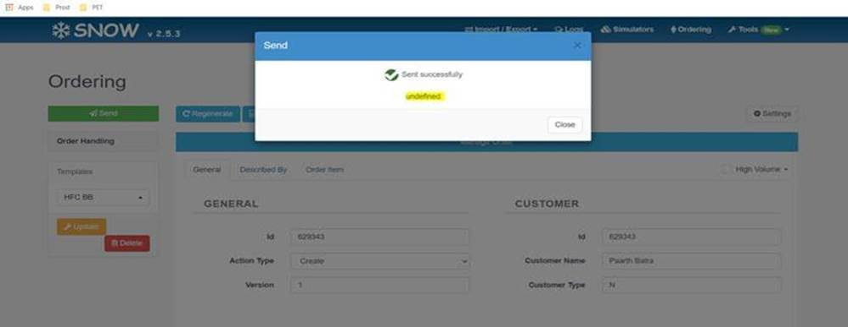

FIX:
Regarding Snow issue , please see cusom.properties doesn’t have snow properties , once changes are done please reboot with clean cache and test

############################ SNOW Properties ############################
amx/snow/wl/user=xpiadmin
amx/snow/wl/pwd=xpiadmin@123

Please compare with BUAT4 .

Getting this issue when running core HF

ISSUE:

armusr01@ilosamx138:armusr01/installer/bin> ./deploy_hotfix.sh RM_10.2.0.138-1918
[Fatal Error] :1:1: Content is not allowed in prolog.
Wrong XML file structure: Content is not allowed in prolog.
Error while performing pre-req check

FIX:
I copy the installer folder from other env armusr01@ilosamx216:

armusr01@ilosamx216:armusr01/installer

ISSUE:

I am getting this issue when refresh USM env.

ERROR at line 1:
ORA-00001: unique constraint (CRAMERDIRECTORY.DIR_ENTRY_UNIQUE) violated

old 1: Insert into &1..DIR_ENTRY
new 1: Insert into CRAMERDIRECTORY.DIR_ENTRY
old 4: (SEQ_DIRECTORY.NEXTVAL, '*', 'cn=CramerInstances,cn=CramerContext,&3')
new 4: (SEQ_DIRECTORY.NEXTVAL, '*', 'cn=CramerInstances,cn=CramerContext,dc=AMXIND108')
Insert into CRAMERDIRECTORY.DIR_ENTRY

FIX:
Please reboot instance

If reboot is not helping, please delete the table:

sqlplus CRADBA/CRADBA@PLDRMM21

SQL> delete CRAMERDIRECTORY.DIR_ENTRY;

91 rows deleted.

Update ANN url in SOM
- Run somusr01@amxwlsom01.clarochile.org:~somusr01> sqlplus SOM01OSSUI/SOM01OSSUI@AMXDBSOM01

desc OSSUIAPPLICATION;
select name,APPLICATIONURL from OSSUIAPPLICATION;

we need to get in Network Navigator
:

Network Navigator
http://amxwlarm01.clarochile.org:50101/AmdocsOSS/NetworkNavigator
Navegador de Red
http://amxwlarm01.clarochile.org:50101/AmdocsOSS/NetworkNavigator

Network Navigator
http://ilosamx156.corp.amdocs.com:50101/AmdocsOSS/NetworkNavigator

http://ilosamx156.corp.amdocs.com:10101

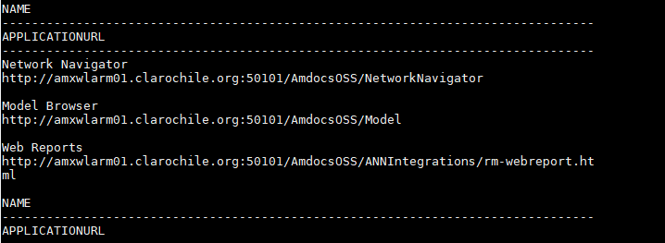

- If we are not getting it we can run:

update OSSUIAPPLICATION set APPLICATIONURL = 'http://amxwlarm01.clarochile.org:50101/AmdocsOSS/NetworkNavigator' where NAME='Navegador de Red';
update OSSUIAPPLICATION set APPLICATIONURL=’ http://ilospld184.corp.amdocs.com:40100/AmdocsOSS/Portal/index.html’ where NAME=' OSS Reporting';

http://ilospld184.corp.amdocs.com:40100/AmdocsOSS/Portal/index.html

OSS Reporting
/AmdocsOSS/NetworkNavigator/Report

update OSSUIAPPLICATION set APPLICATIONURL = ' http:// pet01arm.clarochile.org:50110/AmdocsOSS/NetworkNavigator' where NAME=' Network Navigator';

Network Navigator
http://annpet.clarochile.org:80/AmdocsOSS/NetworkNavigator

update OSSUIAPPLICATION set APPLICATIONURL = 'http://inosamx094.corp.amdocs.com:50101/AmdocsOSS/NetworkNavigator' where NAME='Network Navigator';

ISSUE:

usmusr01@inostfc068:usmusr01/installer/bin> ./deploy_hotfix.sh RM_10.2.0.169-1560
Pre-req check successful for HF: RM_10.2.0.169-1560
Creating the update package for hot fix: RM_10.2.0.169-1560
Update package creation failed for hot fix: RM_10.2.0.169-1560

FIX:

Please remove any of xpi_js, xpi_ir or xpi_rmr from patch.modules of hotfix.properties

Hi,

When checking the MS1 log I can see several issues.

####<Jan 4, 2022, 5:15:18,801 AM CLST> <Error> <HTTP> <pet01som> <affManaged2091> <[ACTIVE] ExecuteThread: '5' for queue: 'weblogic.kernel.Default (self-tuning)'> <<WLS Kernel>> <> <faaf0fb1-fe65-4aba-b1fe-6075e64b6c09-000002d5> <1641284118801> <[severity-value: 8] [rid: 0] [partition-id: 0] [partition-name: DOMAIN] > <BEA-101020> <[ServletContext@1136699084[app:sfo module:/dop/security path:null spec-version:3.1 version:10.2.0.0.2]] Servlet failed with an Exception
java.lang.reflect.UndeclaredThrowableException
at com.sun.proxy.$Proxy790.login(Unknown Source)
at com.amdocs.oss.security.service.rest.impl.LoginServiceRestfulImpl.login(LoginServiceRestfulImpl.java:16)
at sun.reflect.GeneratedMethodAccessor7265.invoke(Unknown Source)

Caused By: java.lang.reflect.InvocationTargetException
at sun.reflect.GeneratedMethodAccessor6811.invoke(Unknown Source)
at sun.reflect.DelegatingMethodAccessorImpl.invoke(DelegatingMethodAccessorImpl.java:43)
at java.lang.reflect.Method.invoke(Method.java:498)
at com.amdocs.oss.security.login.service.factory.LoginServiceFactory$InvalidTicketHandler.retry(LoginServiceFactory.java:68)
at com.amdocs.oss.security.login.service.factory.LoginServiceFactory$InvalidTicketHandler.invoke(LoginServiceFactory.java:61)
at com.sun.proxy.$Proxy790.login(Unknown Source)
at com.amdocs.oss.security.service.rest.impl.LoginServiceRestfulImpl.login(LoginServiceRestfulImpl.java:16)
at sun.reflect.GeneratedMethodAccessor7265.invoke(Unknown Source)
at sun.reflect.DelegatingMethodAccessorImpl.invoke(DelegatingMethodAccessorImpl.java:43)
at java.lang.reflect.Method.invoke(Method.java:498)
at org.apache.cxf.service.invoker.AbstractInvoker.performInvocation(AbstractInvoker.java:179)
at org.apache.cxf.service.invoker.AbstractInvoker.invoke(AbstractInvoker.java:96)

at weblogic.work.ExecuteThread.execute(ExecuteThread.java:406)
at weblogic.work.ExecuteThread.run(ExecuteThread.java:346)
Caused By: com.amdocs.oss.security.login.exception.LoginServiceException: Password has expired
at com.amdocs.oss.cmn.security.login.impl.CustomSecureLoginService.login(CustomSecureLoginService.java:36)
at sun.reflect.GeneratedMethodAccessor6811.invoke(Unknown Source)

Problem:

Snow issue is due variable not be resolved in custom.properties during the refresh

FIX:
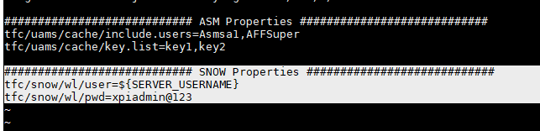

ISSUE
I am getting this error in ZIGGO

13:14:55.103 [localhost-startStop-1] ERROR c.a.o.o.o.AbstractPortalServiceImpl - Exception raised getting connection for datasource: Cannot create PoolableConnectionFactory (Listener refused the connection with the following error:
ORA-12504, TNS:listener was not given the SID in CONNECT_DATA

Mar 13, 2022 1:53:44 PM org.owasp.esapi.reference.JavaLogFactory$JavaLogger log
WARNING: [SECURITY FAILURE Anonymous:null@unknown -> /DefaultName/IntrusionDetector] Input required: context=HTTP s
cheme: ), input=
org.owasp.esapi.errors.ValidationException: HTTP scheme: : Input required.
at org.owasp.esapi.reference.validation.StringValidationRule.checkEmpty(StringValidationRule.java:248)
at org.owasp.esapi.reference.validation.StringValidationRule.checkEmpty(StringValidationRule.java:260)
at org.owasp.esapi.reference.validation.StringValidationRule.getValid(StringValidationRule.java:273)

FIX

I run this alias and reboot ossui

Pushossui

ISSUE

08:19:59
08:19:59 "skip_reason": "Conditional result was False"
08:19:59 }
08:19:59 skipping: [search2] =>
08:19:59 (item={u'application_name': u'dop',
08:19:59 u'version': u'10.2.0.0.046',
08:19:59 u'activate': u'true',
08:19:59 u'name': u'search-server1',
08:19:59 u'key': u'amdocs-dop-searchserver1'}) => {
08:19:59 "changed": false,
08:19:59
08:19:59 "item": {
08:19:59 "activate": "true",
08:19:59
08:19:59 "application_name": "dop",
08:19:59
08:19:59 "key": "amdocs-dop-searchserver1",
08:19:59
08:19:59 "name": "search-server1",
08:19:59
08:19:59 "version": "10.2.0.0.046"
08:19:59 },
08:19:59
08:19:59 "skip_reason": "Conditional result was False"
08:19:59 }
08:19:59 to retry,
08:19:59 use: --limit @/app/ossusers/petsom1/tfc_playbook/dop-orchestrate.retry
08:19:59
08:19:59 PLAY RECAP *********************************************************************
08:19:59 search1 : ok=4 changed=1 unreachable=0 failed=1
08:19:59 search2 : ok=4 changed=1 unreachable=0 failed=1
08:19:59
08:19:59 Returned ERROR CODE at SOM admin and MS servers installation, terminating script..
08:19:59 SOM Cluster Installation Failed
08:20:00 Build step 'Execute shell' marked build as failure
08:20:00 Finished: FAILURE

FIX

When you get this issue, please check the following in search env’s;

    - That you don’t have space issue under /var/tmp
    - That /opt/amdocs/fnd/central-config-utils1/cc_tools is available

In case it’s not available please copy just this folder from other env

Hi Avi,

Hereby the VF windows username, employee ID.

New User | VF EMP ID | Mail Add | Windows User | Password
Avi Saar | 11429698 | avi.saar1@vodafoneziggo.com | SaarA | Jenin211

NOTE: These are NOT citrix credentials!

For citrix access, kindly go through the attached process of Citrix account creation (Step-3) and proceed accordingly.
Please revert in case of any queries.”

vftsom1@nl6551yr:~vftsom1>cd ..
vftsom1@nl6551yr:~/opt/SP/vfz/users>ll
total 44
drwxr-xr-x. 2 vfnadm aimsys 16384 Nov 15 2019 lost+found
drwxr-xr-x. 3 root root 4096 Nov 15 2019 ..
drwxr-xr-x. 2 vfnadm aimsys 4096 Nov 15 2019 vfnadm
drwxr-xr-x. 2 vfnadm aimsys 4096 Nov 15 2019 amdba
drwxr-xr-x. 2 vfnadm aimsys 4096 Nov 15 2019 aim_dba
drwxr-xr-x. 8 vfnadm aimsys 4096 Jul 3 2020 .
drwx------. 2 dev2asm1 aimsys 4096 Jul 3 2020 dev2asm1
drwxr-xr-x. 34 vftsom1 aimsys 4096 Mar 23 15:44 vftsom1
vftsom1@nl6551yr:~/opt/SP/vfz/users>ssh dev2asm1@nl6387yr.dc-ratingen.de
^C
vftsom1@nl6551yr:~/opt/SP/vfz/users>

How to split tar.gz to 6

command used : split -C 1G RPM_103_PMX.tar.gz

to move it back:

cat xa* > RPM_103_PMX.tar.gz

Restart SOM env:

Find the process for tomcat, tomcat-frontend and ossui and kill them.

To start follow the sequence.

- Backend :
cd tomcat/bin
nohup ./startup.sh &, it will take 2 mins
Once Tomcat Started check the backend GUI : http://nl6579yr.dc-ratingen.de:8030/aff
- OSSUI :
cd ossui/bin
nohup ./startup.sh &
Once Tomcat Started check GUI : http://nl6579yr.dc-ratingen.de:8050/AmdocsOSS/Portal/index.html, only login screen will come

- Frontend:
cd tomcat-frontend
nohup ./startup.sh &, it will take 5 mins to start check the nohup
Once Tomcat Started check the GUI http://nl6579yr.dc-ratingen.de:8050/AmdocsOSS/Portal/index.html

HOT FIX TOOL in PROD:
ssh tfctools@prd01amc

HOT FIX TOOL in PET/UAT:
ssh tfctools@pet01amc

Jenkins ISSUE:

#1​2
(pending—Waiting for next available executor

FIX:
go to Jenkins -> Manage Jenkins -> Manage Nodes
change the mb_ccnor_ilosnor031

Change the # of executors to 10

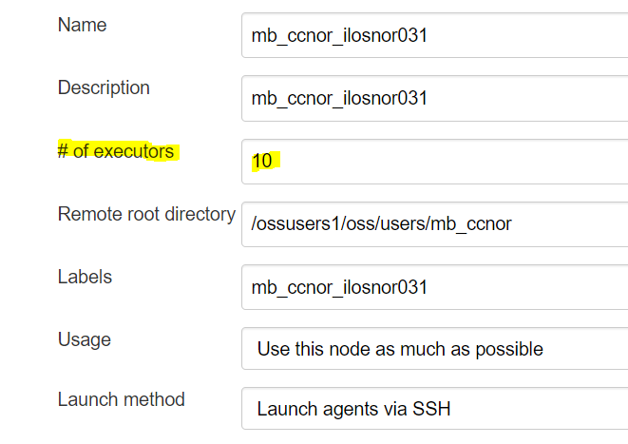

Issue:

Ping server (pingadminServer.sh) is not working properly in the AUA env:

FIX:

Change the line from:

server_pid=`ps -ef | grep ${LOGNAME} | grep -i java | grep -v grep | grep -v remoting.jar | grep AdminServer | cut -d " " -f2`

To:

server_pid=`ps -ef | grep ${LOGNAME} | grep -i java | grep -v grep | grep -v remoting.jar | grep AdminServer | tr -s ' ' | cut -d " " -f2`

ISSUE:

eploy_targets:
[echo] Installation of AUA-WLS started, please wait as it may take a while.
[echo] Running the ant target: configure-domain
[exec] Buildfile: /app/amdocs/nor/oss/noraua01/JEE/noraua01/aua_agents/deploy/build.xml
[exec] Trying to override old definition of task for
[exec] Trying to override old definition of task explode-archive
[exec]
[exec] do-license:
[exec]
[exec] BUILD FAILED
[exec] /app/amdocs/nor/oss/noraua01/JEE/noraua01/aua_agents/deploy/build-common.xml:461: java.lang.NoClassDefFoundError: fr/jayasoft/ivy/DependencyResolver
[exec] at java.lang.Class.getDeclaredConstructors0(Native Method)
[exec] at java.lang.Class.privateGetDeclaredConstructors(Class.java:2671)
[exec] at java.lang.Class.getConstructor0(Class.java:3075)
[exec] at java.lang.Class.getConstructor(Class.java:1825)
[exec] at org.apache.tools.ant.ComponentHelper.checkTaskClass(ComponentHelper.java:376)
[exec] at org.apache.tools.ant.ComponentHelper.addTaskDefinition(ComponentHelper.java:341)
[exec] at org.apache.tools.ant.Project.addTaskDefinition(Project.java:968)
[exec] at net.sf.antcontrib.logic.AntCallBack.initializeProject(AntCallBack.java:208)
[exec] at net.sf.antcontrib.logic.AntCallBack.execute(AntCallBack.java:303)
[exec] at org.apache.tools.ant.UnknownElement.execute(UnknownElement.java:292)
[exec] at sun.reflect.GeneratedMethodAccessor4.invoke(Unknown Source)
[exec] at sun.reflect.DelegatingMethodAccessorImpl.invoke(DelegatingMethodAccessorImpl.java:43)
[exec] at java.lang.reflect.Method.invoke(Method.java:498)
[exec] at org.apache.tools.ant.dispatch.DispatchUtils.execute(DispatchUtils.java:106)
[exec] at org.apache.tools.ant.Task.perform(Task.java:348)
[exec] at org.apache.tools.ant.taskdefs.Sequential.execute(Sequential.java:68)
[exec] at net.sf.antcontrib.logic.IfTask.execute(IfTask.java:197)
[exec] at sun.reflect.NativeMethodAccessorImpl.invoke0(Native Method)
[exec] at sun.reflect.NativeMethodAccessorImpl.invoke(NativeMethodAccessorImpl.java:62)
[exec] at sun.reflect.DelegatingMethodAccessorImpl.invoke(DelegatingMethodAccessorImpl.java:43)
[exec] at java.lang.reflect.Method.invoke(Method.java:498)
[exec] at org.apache.tools.ant.dispatch.DispatchUtils.execute(DispatchUtils.java:106)
[exec] at org.apache.tools.ant.TaskAdapter.execute(TaskAdapter.java:154)
[exec] at org.apache.tools.ant.UnknownElement.execute(UnknownElement.java:292)
[exec] at sun.reflect.GeneratedMethodAccessor4.invoke(Unknown Source)
[exec] at sun.reflect.DelegatingMethodAccessorImpl.invoke(DelegatingMethodAccessorImpl.java:43)
[exec] at java.lang.reflect.Method.invoke(Method.java:498)
[exec] at org.apache.tools.ant.dispatch.DispatchUtils.execute(DispatchUtils.java:106)
[exec] at org.apache.tools.ant.Task.perform(Task.java:348)
[exec] at org.apache.tools.ant.Target.execute(Target.java:435)
[exec] at org.apache.tools.ant.Target.performTasks(Target.java:456)
[exec] at org.apache.tools.ant.Project.executeSortedTargets(Project.java:1393)
[exec] at org.apache.tools.ant.Project.executeTarget(Project.java:1364)
[exec] at org.apache.tools.ant.helper.DefaultExecutor.executeTargets(DefaultExecutor.java:41)
[exec] at org.apache.tools.ant.Project.executeTargets(Project.java:1248)
[exec] at org.apache.tools.ant.Main.runBuild(Main.java:851)
[exec] at org.apache.tools.ant.Main.startAnt(Main.java:235)
[exec] at org.apache.tools.ant.launch.Launcher.run(Launcher.java:280)
[exec] at org.apache.tools.ant.launch.Launcher.main(Launcher.java:109)
[exec] Caused by: java.lang.ClassNotFoundException: fr.jayasoft.ivy.DependencyResolver
[exec] at java.net.URLClassLoader.findClass(URLClassLoader.java:381)
[exec] at java.lang.ClassLoader.loadClass(ClassLoader.java:424)
[exec] at java.lang.ClassLoader.loadClass(ClassLoader.java:357)
[exec] ... 39 more
[exec]
[exec] Total time: 1 second
BUILD FAILED
/app/amdocs/nor/oss/noraua01/aua_installation/scripts/installer.xml:481: exec returned: 1

FIX:

I found the issue😊

The jar ivy-1.4.jar was missing in ANT folder

noraua01@no001tstossapp:noraua01/ant-1.9.2/lib> ll *ivy*
-rwxr-xr-x. 1 noraua01 aimsys 567531 Sep 8 12:37 ivy-1.4.jar

Create DB user in Tela project:
create user AUA01 identified by AUAPRD01oss profile DEFAULT default tablespace USERS temporary tablespace TEMP;

/usr/bin/sqlplus AUA01/AUAPRD01oss@no001prdossdb.ddc.teliasonera.net:1521/PRDOSS

grant MAINT to AUA01;
grant CONNECT to AUA01;
grant RESOURCE to AUA01;
grant EXECUTE_CATALOG_ROLE to AUA01;
grant RECOVERY_CATALOG_OWNER to AUA01;

grant CREATE VIEW to AUA01;
grant CREATE SESSION to AUA01;
grant CREATE DATABASE LINK to AUA01;
grant UNLIMITED TABLESPACE to AUA01;
grant SELECT ANY DICTIONARY to AUA01;

test AUA1 tunneling:

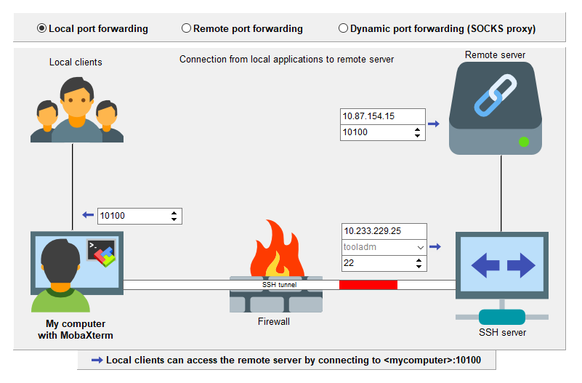

prod AUA1 tunneling:

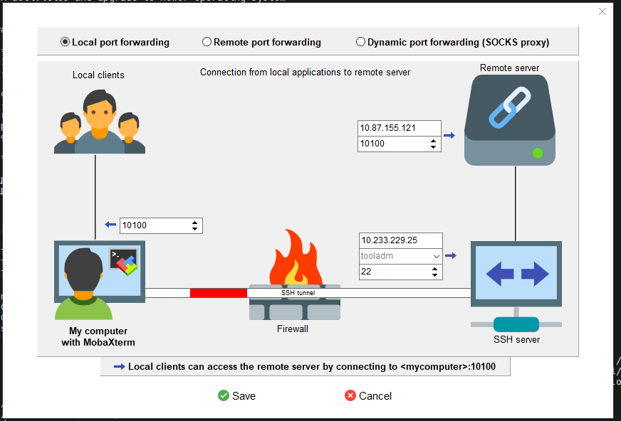

- Connect to DB (oracle user) to grant sysdba permission
SQL> grant sysdba to cradba;
Grant succeeded.

Optional check:
SQL> select * from v$pwfile_users;
USERNAME SYSDB SYSOP SYSAS SYSBA SYSDG SYSKM CON_ID
------------------------------ ----- ----- ----- ----- ----- ----- ----------
SYS TRUE TRUE FALSE FALSE FALSE FALSE 0
CRADBA TRUE FALSE FALSE FALSE FALSE FALSE 0

- TEMP tablespace dbf is not really attached to the tablespace
Error: Error initializing Team Coding: ORA-25153: Temporary Tablespace is Empty
CMMSOM99 /oravl01/oracle> sqlplus / as sysdba
SQL*Plus: Release 12.1.0.2.0 Production on Wed Nov 29 14:11:35 2017
Copyright (c) 1982, 2014, Oracle. All rights reserved.
Connected to:
Oracle Database 12c Enterprise Edition Release 12.1.0.2.0 - 64bit Production
With the Partitioning, OLAP, Advanced Analytics and Real Application Testing options
SQL> ALTER TABLESPACE TEMP ADD TEMPFILE '/oravl02/oradata/CMMSOM99/TEMP_1.dbf' reuse;
Tablespace altered.

ISUUE:

Ear is up now, however while opening UI we still see same issue –

ERROR_CODE=50701: java.sql.SQLSyntaxErrorException: ORA-01795: maximum number of expressions in a list is 1000
com.amdocs.oss.ann.exception.SearchException: java.sql.SQLSyntaxErrorException: ORA-01795: maximum number of expressions in a list is 1000

@Akshay Gupta – Please check once, if it is related to roles or not.

FIX:

Hi All,

After removing below AFF roles, GUI is working fine.

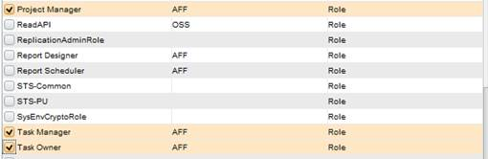

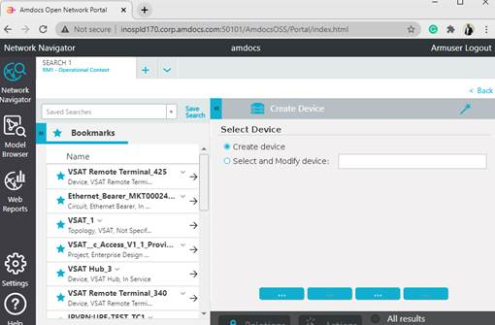

Problem in ARM refresh:

[11:00 AM] Aman Dua

[sshexec] [shellscript] weblogic.Deployer invoked with options: -adminurl t3://illin3882:10200 -username weblogic -name CramerServer_GLMARMRestAPI-ear -redeploy
[sshexec] [shellscript] <Dec 21, 2022 4:53:56 AM IST> <Info> <J2EE Deployment SPI> <BEA-260121> <Initiating redeploy operation for application, CramerServer_GLMARMRestAPI-ear [archive: null], to configured targets.>
[sshexec] [shellscript] [Deployer:149163]The domain edit lock is owned by another session in non-exclusive mode. This deployment operation requires exclusive access to the edit lock and therefore cannot proceed. If using "Automatically Aquire Lock and Activate Changes" in the Administration Console, then the lock will expire shortly, so retry this operation.

FIX:

Login to console and open the Lock & Edit

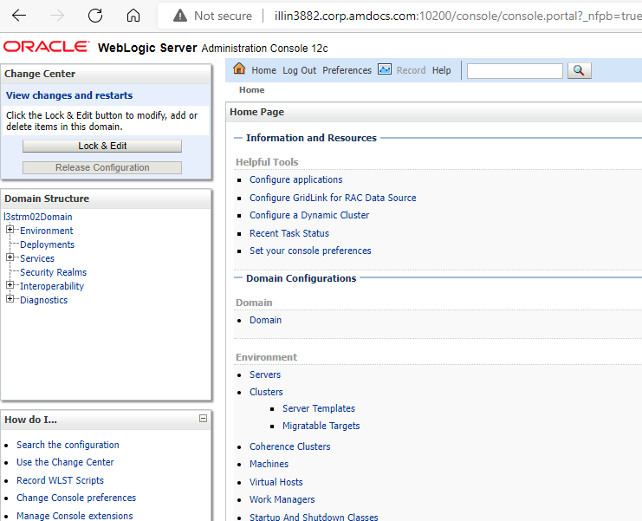

PROBLEM:

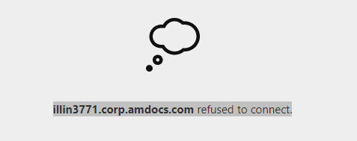

FIX:

Clean the /usr it was 100% and check DB users it’s have free space

Issue:

Hi Pankaj,

Still DB slowness issue persist. Here is the backend log.

java.lang.RuntimeException: java.sql.SQLException: Unexpected exception while enlisting XAConnection java.sql.SQLExce
ption: Tran1saction rolled back: Transaction timed out after 480 seconds
BEA1-0D53B61AA6A9EB0A1205
at weblogic.jdbc.jta.DataSource.enlist(DataSource.java:1766)
at weblogic.jdbc.jta.DataSource.refreshXAConnAndEnlist(DataSource.java:1651)
at weblogic.jdbc.jta.DataSource.getConnectionInternal(DataSource.java:517)
at weblogic.jdbc.jta.DataSource.getConnection(DataSource.java:494)
at weblogic.jdbc.common.internal.RmiDataSource.getConnectionInternal(RmiDataSource.java:565)
at weblogic.jdbc.common.internal.RmiDataSource.getConnection(RmiDataSource.java:545)
at weblogic.jdbc.common.internal.RmiDataSource.getConnection(RmiDataSource.java:538)
at com.amdocs.oss.asmf.core.util.JDBCUtil$JDBCAdapterImpl.getConnection(JDBCUtil.java:130)
at com.amdocs.oss.asmf.core.util.JDBCUtil$1.getConnection(JDBCUtil.java:55)
at com.amdocs.oss.common.core.util.JDBCUtil.getConnection(JDBCUtil.java:125)
at com.amdocs.oss.sfo.db.persist.DBBaseImp.execute(DBBaseImp.java:29)
at com.amdocs.oss.sfo.db.log.HandleLogToDB.writeLogToDb(HandleLogToDB.java:75)
at com.amdocs.oss.level3.rest.arm.service.LocationARMRestService.getSECLocationByName(LocationARMRestService.java:54)
at com.amdocs.oss.level3.rest.util.IdentifyOffnetDetailsUtil.initializeOffnetDetailsGTFromEvaluate(IdentifyOffnetDetailsUtil.java:480)
at com.amdocs.oss.aff.activity.level3.impl.EvaluateOffnetActivityImpl.createInput(EvaluateOffnetActivityImpl.java:67)
at com.amdocs.oss.aff.activity.level3.impl.BaseActivityImpl.createImpl(BaseActivityImpl.java:40)
at com.amdocs.oss.aff.activity.LongRunningActivityBase.create(LongRunningActivityBase.java:47)
at com.amdocs.oss.common.components.dpm.engine.impl.ActivityInvoker$ActivityAsyncAction.executeImpl(ActivityInvoker.java:313)
at com.amdocs.oss.common.core.services.async.AsyncActionBase.execute(AsyncActionBase.java:75)
at com.amdocs.oss.common.core.services.async.impl.AsyncActionHandler.execute(AsyncActionHandler.java:101)
at com.amdocs.oss.common.core.internal.async.AsyncRequestManager.processRequest(AsyncRequestManager.java:21)
at com.amdocs.oss.common.core.internal.async.AsynchronousRequestMDB.onMessage(AsynchronousRequestMDB.java:36)
at weblogic.ejb.container.internal.MDListener.execute(MDListener.java:453)
at weblogic.ejb.container.internal.MDListener.transactionalOnMessage(MDListener.java:376)
at weblogic.ejb.container.internal.MDListener.onMessage(MDListener.java:311)
at weblogic.jms.client.JMSSession.onMessage(JMSSession.java:4855)
at weblogic.jms.client.JMSSession.execute(JMSSession.java:4529)
at weblogic.jms.client.JMSSession.executeMessage(JMSSession.java:3976)
at weblogic.jms.client.JMSSession.access$000(JMSSession.java:120)
at weblogic.jms.client.JMSSession$UseForRunnable.run(JMSSession.java:5375)
at weblogic.work.SelfTuningWorkManagerImpl$WorkAdapterImpl.run(SelfTuningWorkManagerImpl.java:553)
at weblogic.work.ExecuteThread.execute(ExecuteThread.java:311)
at weblogic.work.ExecuteThread.run(ExecuteThread.java:263)
Caused by: weblogic.transaction.TimedOutException: Transaction timed out after 480 seconds
FIXED:

In The JTA please change this value:

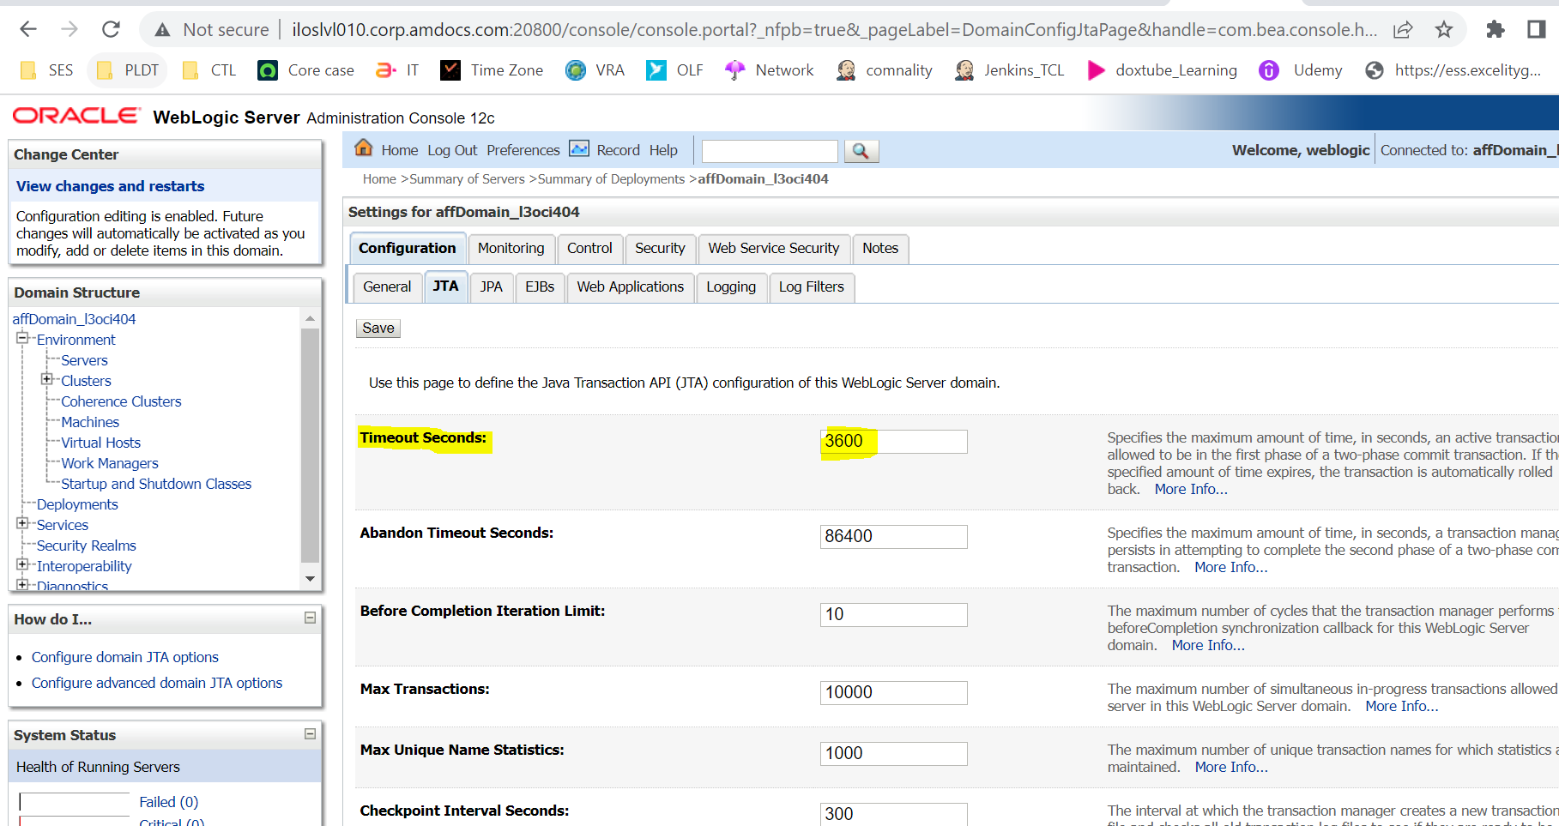

Issue:

After cleaning cache memory, now we have 70 GB of free memory.
But still, we are getting below error while starting the database, could you plz help on this.

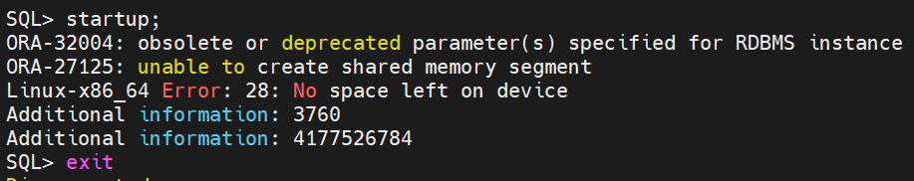

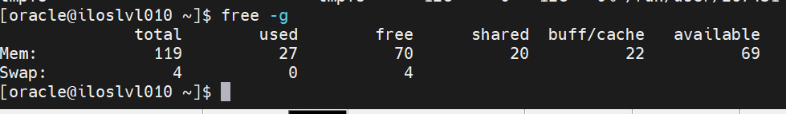

Fixed:

- vi /etc/sysctl.conf

update this value:

kernel.shmall=31457280

- run this: sysctl -p

- cat /proc/sys/kernel/shmall (to see the value was changed)

l3rci404@iloslvl010.corp.amdocs.com:/etc> cat /proc/sys/kernel/shmall
31457280

Change parameters in file for nexus issue:

  - Put the war file backup folder avi and open it:

/lvlhome/lvl/cclvl/mb_cclvl/.m2_CTL_V21_20232508_OGS_AUG25/repository/com/amdocs/oss/sfo/sfo-war/10.0.0.0.0/avi

jar xvf sfo-war-10.0.0.0.0.war

  - Run this coomend to change the ip from 10.247.24.18 to 10.247.24.11:

find -type f | xargs perl -p -i -e 's#10.247.24.18#10.247.24.11#g'

  - check if the ip was changed:

1026 find . -type f | xargs grep 10.247.24.18
1027 find . -type f | xargs grep 10.247.24.11

4. run this command to pack the war back in avi folder:

jar uf sfo-war-10.0.0.0.0.war *

put the war back to the main folder.

export XPI_ASM_USERNAME=osslookupuser
export XPI_ASM_PASSWORD=Manager1
Manager1
ISSUE:

In ANN CTL ST02

[sshexec] [shellscript] *****************************************************************************
[sshexec] [shellscript] For Repository /infraoss/l3/STORAGE/rm/400/STORE_400_9793/proj/ann/metadata/bin/ANNMetadata/repository/Level3ANNRepo operation distribute start...
[sshexec] [shellscript] *****************************************************************************
[sshexec] [shellscript] Temporary project created.
[sshexec] [shellscript] Repository loaded in memory.
[sshexec] [shellscript] Datasets validated.
[sshexec] [shellscript] Repository references resolved.
[sshexec] [shellscript] Build Completed.
[sshexec] [shellscript] Delta persisted to /ossuser1/oss/users/l3stann2/.Refreshlog/mmrepo_logs
[sshexec] [shellscript] May 21, 2023 10:43:04 AM org.hibernate.AssertionFailure <init>
[sshexec] [shellscript] SEVERE: an assertion failure occured (this may indicate a bug in Hibernate, but is more likely due to unsafe use of the session)
[sshexec] [shellscript] org.hibernate.AssertionFailure: force initialize loading collection
[sshexec]
[sshexec] [shellscript] at org.hibernate.collection.AbstractPersistentCollection.forceInitialization(AbstractPersistentCollection.java:446)
[sshexec] [shellscript] at org.hibernate.engine.StatefulPersistenceContext.initializeNonLazyCollections(StatefulPersistenceContext.java:755)
[sshexec] [shellscript] at org.hibernate.loader.Loader.doQueryAndInitializeNonLazyCollections(Loader.java:229)
[sshexec] [shellscript] at org.hibernate.loader.Loader.loadEntityBatch(Loader.java:1892)
[sshexec] [shellscript] at org.hibernate.loader.entity.BatchingEntityLoader.load(BatchingEntityLoader.java:69)
[sshexec] [shellscript] at org.hibernate.persister.entity.AbstractEntityPersister.load(AbstractEntityPersister.java:2977)
[sshexec]
[sshexec] [shellscript] at org.hibernate.event.def.DefaultLoadEventListener.loadFromDatasource(DefaultLoadEventListener.java:393)
[sshexec] [shellscript] at org.hibernate.event.def.DefaultLoadEventListener.doLoad(DefaultLoadEventListener.java:374)
[sshexec] [shellscript] at org.hibernate.event.def.DefaultLoadEventListener.load(DefaultLoadEventListener.java:137)
[sshexec]
[sshexec] [shellscript] at org.hibernate.event.def.DefaultLoadEventListener.proxyOrLoad(DefaultLoadEventListener.java:193)
[sshexec]
[sshexec] [shellscript] at org.hibernate.event.def.DefaultLoadEventListener.onLoad(DefaultLoadEventListener.java:101)
[sshexec]
[sshexec] [shellscript] at com.amdocs.oss.ide.mm.schema.hibernate.MMDefaultLoadEventListener.onLoad(MMDefaultLoadEventListener.java:74)
[sshexec]
[sshexec] [shellscript] at org.hibernate.impl.SessionImpl.fireLoad(SessionImpl.java:878)
[sshexec]
[sshexec] [shellscript] at org.hibernate.impl.SessionImpl.get(SessionImpl.java:815)
[sshexec]
[sshexec] [shellscript] at org.hibernate.event.def.DefaultMergeEventListener.entityIsDetached(DefaultMergeEventListener.java:229)
[sshexec] [shellscript] at org.hibernate.event.def.DefaultMergeEventListener.onMerge(DefaultMergeEventListener.java:120)
[sshexec] [shellscript] at org.hibernate.impl.SessionImpl.fireMerge(SessionImpl.java:687)
[sshexec] [shellscript] at org.hibernate.impl.SessionImpl.merge(SessionImpl.java:669)
[sshexec] [shellscript] at org.hibernate.engine.CascadingAction$6.cascade(CascadingAction.java:245)
[sshexec] [shellscript] at org.hibernate.engine.Cascade.cascadeToOne(Cascade.java:268)
[sshexec] [shellscript] at org.hibernate.engine.Cascade.cascadeAssociation(Cascade.java:216)
[sshexec] [shellscript] at org.hibernate.engine.Cascade.cascadeProperty(Cascade.java:169)
[sshexec] [shellscript] at org.hibernate.engine.Cascade.cascadeCollectionElements(Cascade.java:296)
[sshexec] [shellscript] at org.hibernate.engine.Cascade.cascadeCollection(Cascade.java:242)
[sshexec] [shellscript] at org.hibernate.engine.Cascade.cascadeAssociation(Cascade.java:219)
[sshexec]
[sshexec] [shellscript] at org.hibernate.engine.Cascade.cascadeProperty(Cascade.java:169)
[sshexec] [shellscript] at org.hibernate.engine.Cascade.cascade(Cascade.java:130)
[sshexec] [shellscript] at org.hibernate.event.def.DefaultMergeEventListener.cascadeOnMerge(DefaultMergeEventListener.java:390)
[sshexec] [shellscript] at org.hibernate.event.def.DefaultMergeEventListener.entityIsDetached(DefaultMergeEventListener.java:266)
[sshexec] [shellscript] at org.hibernate.event.def.DefaultMergeEventListener.onMerge(DefaultMergeEventListener.java:120)
[sshexec] [shellscript] at org.hibernate.impl.SessionImpl.fireMerge(SessionImpl.java:687)
[sshexec] [shellscript] at org.hibernate.impl.SessionImpl.merge(SessionImpl.java:669)
[sshexec] [shellscript] at org.hibernate.engine.CascadingAction$6.cascade(CascadingAction.java:245)
[sshexec] [shellscript] at org.hibernate.engine.Cascade.cascadeToOne(Cascade.java:268)
[sshexec] [shellscript] at org.hibernate.engine.Cascade.cascadeAssociation(Cascade.java:216)
[sshexec] [shellscript] at org.hibernate.engine.Cascade.cascadeProperty(Cascade.java:169)
[sshexec] [shellscript] at org.hibernate.engine.Cascade.cascade(Cascade.java:130)
[sshexec] [shellscript] at org.hibernate.event.def.DefaultMergeEventListener.cascadeOnMerge(DefaultMergeEventListener.java:390)
[sshexec] [shellscript] at org.hibernate.event.def.DefaultMergeEventListener.entityIsDetached(DefaultMergeEventListener.java:266)
[sshexec] [shellscript] at org.hibernate.event.def.DefaultMergeEventListener.onMerge(DefaultMergeEventListener.java:120)
[sshexec] [shellscript] at org.hibernate.impl.SessionImpl.fireMerge(SessionImpl.java:687)
[sshexec] [shellscript] at org.hibernate.impl.SessionImpl.merge(SessionImpl.java:669)
[sshexec] [shellscript] at org.hibernate.engine.CascadingAction$6.cascade(CascadingAction.java:245)
[sshexec] [shellscript] at org.hibernate.engine.Cascade.cascadeToOne(Cascade.java:268)
[sshexec] [shellscript] at org.hibernate.engine.Cascade.cascadeAssociation(Cascade.java:216)
[sshexec] [shellscript] at org.hibernate.engine.Cascade.cascadeProperty(Cascade.java:169)
[sshexec] [shellscript] at org.hibernate.engine.Cascade.cascade(Cascade.java:130)
[sshexec] [shellscript] at org.hibernate.event.def.AbstractSaveEventListener.cascadeBeforeSave(AbstractSaveEventListener.java:412)
[sshexec] [shellscript] at org.hibernate.event.def.DefaultMergeEventListener.entityIsTransient(DefaultMergeEventListener.java:178)
[sshexec] [shellscript] at org.hibernate.event.def.DefaultMergeEventListener.entityIsDetached(DefaultMergeEventListener.java:240)
[sshexec] [shellscript] at org.hibernate.event.def.DefaultMergeEventListener.onMerge(DefaultMergeEventListener.java:120)
[sshexec] [shellscript] at org.hibernate.event.def.DefaultMergeEventListener.onMerge(DefaultMergeEventListener.java:53)
[sshexec] [shellscript] at org.hibernate.impl.SessionImpl.fireMerge(SessionImpl.java:677)
[sshexec] [shellscript] at org.hibernate.impl.SessionImpl.merge(SessionImpl.java:661)
[sshexec] [shellscript] at com.amdocs.oss.ide.mm.schema.hibernate.MMHibernateBeanDAO.mergeRelationalBean(MMHibernateBeanDAO.java:474)
[sshexec] [shellscript] at com.amdocs.oss.ide.mm.schema.hibernate.MMHibernateBeanDAO.persistToActiveCramerDB(MMHibernateBeanDAO.java:272)
[sshexec] [shellscript] at com.amdocs.oss.ide.mm.distribution.MMDistribution.distribute(MMDistribution.java:111)
[sshexec] [shellscript] at com.amdocs.oss.ide.mm.distribution.DeltaDeployerToDB.deploy(DeltaDeployerToDB.java:288)
[sshexec] [shellscript] at com.amdocs.oss.ide.mm.distribution.MMDistributionManager.distribute(MMDistributionManager.java:690)
[sshexec] [shellscript] at com.amdocs.oss.ide.mm.distribution.MMDistributionManager.distribute(MMDistributionManager.java:557)
[sshexec] [shellscript] at com.amdocs.oss.ide.mm.distribution.MMDistributionManager.distributeFromCLI(MMDistributionManager.java:351)
[sshexec] [shellscript] at com.amdocs.oss.ide.mm.cli.CLIDistributionController.doDistribution(CLIDistributionController.java:292)
[sshexec] [shellscript] at com.amdocs.oss.ide.mm.cli.CLIDistributionController.handleBuildDistribution(CLIDistributionController.java:254)
[sshexec] [shellscript] at com.amdocs.oss.ide.mm.cli.CLIDistributionController.executeBuildDistribution(CLIDistributionController.java:213)
[sshexec] [shellscript] at com.amdocs.oss.ide.mm.cli.BuildDistribution.doBuildORDistribution(BuildDistribution.java:297)
[sshexec] [shellscript] at com.amdocs.oss.ide.mm.cli.BuildDistribution.run(BuildDistribution.java:197)
[sshexec] [shellscript] at sun.reflect.NativeMethodAccessorImpl.invoke0(Native Method)
[sshexec] [shellscript] at sun.reflect.NativeMethodAccessorImpl.invoke(NativeMethodAccessorImpl.java:62)
[sshexec] [shellscript] at sun.reflect.DelegatingMethodAccessorImpl.invoke(DelegatingMethodAccessorImpl.java:43)
[sshexec] [shellscript] at java.lang.reflect.Method.invoke(Method.java:498)
[sshexec] [shellscript] at org.eclipse.equinox.internal.app.EclipseAppContainer.callMethodWithException(EclipseAppContainer.java:587)
[sshexec] [shellscript] at org.eclipse.equinox.internal.app.EclipseAppHandle.run(EclipseAppHandle.java:198)
[sshexec] [shellscript] at org.eclipse.core.runtime.internal.adaptor.EclipseAppLauncher.runApplication(EclipseAppLauncher.java:134)
[sshexec] [shellscript] at org.eclipse.core.runtime.internal.adaptor.EclipseAppLauncher.start(EclipseAppLauncher.java:104)
[sshexec] [shellscript] at org.eclipse.core.runtime.adaptor.EclipseStarter.run(EclipseStarter.java:380)
[sshexec] [shellscript] at org.eclipse.core.runtime.adaptor.EclipseStarter.run(EclipseStarter.java:235)
[sshexec] [shellscript] at sun.reflect.NativeMethodAccessorImpl.invoke0(Native Method)
[sshexec]
[sshexec] [shellscript] at sun.reflect.NativeMethodAccessorImpl.invoke(NativeMethodAccessorImpl.java:62)
[sshexec] [shellscript] at sun.reflect.DelegatingMethodAccessorImpl.invoke(DelegatingMethodAccessorImpl.java:43)
[sshexec]
[sshexec] [shellscript] at java.lang.reflect.Method.invoke(Method.java:498)
[sshexec]
[sshexec] [shellscript] at org.eclipse.equinox.launcher.Main.invokeFramework(Main.java:669)
[sshexec]
[sshexec] [shellscript] at org.eclipse.equinox.launcher.Main.basicRun(Main.java:608)
[sshexec] [shellscript] at org.eclipse.equinox.launcher.Main.run(Main.java:1515)
[sshexec] [shellscript] at org.eclipse.equinox.launcher.Main.main(Main.java:1488)
[sshexec] [shellscript]
[sshexec] [shellscript] May 21, 2023 10:43:04 AM com.amdocs.oss.ide.mm.schema.hibernate.MMHibernateBeanDAO persistToActiveCramerDB
[sshexec] [shellscript] SEVERE: Distribution failure while merging the bean Ossobject : 1700005695
[sshexec] [shellscript] org.hibernate.AssertionFailure: force initialize loading collection
[sshexec] [shellscript] at org.hibernate.collection.AbstractPersistentCollection.forceInitialization(AbstractPersistentCollection.java:446)
[sshexec] [shellscript] at org.hibernate.engine.StatefulPersistenceContext.initializeNonLazyCollections(StatefulPersistenceContext.java:755)

FIXED:

Apply HF:100028578 on ST 02 ANN

ISSUE:

Hi,

We are facing issue when trying to boot ARM WL in iloslvl034.

It seems the Weblogic Authentication is denied.

I tried to fix this issue by changing the boot.properties user and password and clean the tmp and ldap (backup was taking) but still getting the same issue.

Will check it with Simon.

The following error from the log:

<Jun 4, 2023 6:16:48,649 PM IDT> <Critical> <Security> <BEA-090402> <Authentication denied: Boot identity not valid. The user name or password or both from the boot identity file (boot.properties) is not valid. The boot identity may have been changed since the boot identity file was created. Please edit and update the boot identity file with the proper values of username and password. The first time the updated boot identity file is used to start the server, these new values are encrypted.>
<Jun 4, 2023 6:16:48,686 PM IDT> <Critical> <WebLogicServer> <BEA-000386> <Server subsystem failed. Reason: A MultiException has 6 exceptions. They are:
1. weblogic.security.SecurityInitializationException: Authentication denied: Boot identity not valid. The user name or password or both from the boot identity file (boot.properties) is not valid. The boot identity may have been changed since the boot identity file was created. Please edit and update the boot identity file with the proper values of username and password. The first time the updated boot identity file is used to start the server, these new values are encrypted.
2. java.lang.IllegalStateException: Unable to perform operation: post construct on weblogic.security.SecurityService
3. java.lang.IllegalArgumentException: While attempting to resolve the dependencies of weblogic.jndi.internal.RemoteNamingService errors were found
4. java.lang.IllegalStateException: Unable to perform operation: resolve on weblogic.jndi.internal.RemoteNamingService
5. java.lang.IllegalArgumentException: While attempting to resolve the dependencies of weblogic.deployment.DeploymentRegistrationService errors were found
6. java.lang.IllegalStateException: Unable to perform operation: resolve on weblogic.deployment.DeploymentRegistrationService

A MultiException has 6 exceptions. They are:
1. weblogic.security.SecurityInitializationException: Authentication denied: Boot identity not valid. The user name or password or both from the boot identity file (boot.properties) is not valid. The boot identity may have been changed since the boot identity file was created. Please edit and update the boot identity file with the proper values of username and password. The first time the updated boot identity file is used to start the server, these new values are encrypted.
2. java.lang.IllegalStateException: Unable to perform operation: post construct on weblogic.security.SecurityService
3. java.lang.IllegalArgumentException: While attempting to resolve the dependencies of weblogic.jndi.internal.RemoteNamingService errors were found
4. java.lang.IllegalStateException: Unable to perform operation: resolve on weblogic.jndi.internal.RemoteNamingService
5. java.lang.IllegalArgumentException: While attempting to resolve the dependencies of weblogic.deployment.DeploymentRegistrationService errors were found
6. java.lang.IllegalStateException: Unable to perform operation: resolve on weblogic.deployment.DeploymentRegistrationService

at org.jvnet.hk2.internal.Collector.throwIfErrors(Collector.java:89)
at org.jvnet.hk2.internal.ClazzCreator.resolveAllDependencies(ClazzCreator.java:250)
at org.jvnet.hk2.internal.ClazzCreator.create(ClazzCreator.java:358)
at org.jvnet.hk2.internal.SystemDescriptor.create(SystemDescriptor.java:487)
at org.glassfish.hk2.runlevel.internal.AsyncRunLevelContext.findOrCreate(AsyncRunLevelContext.java:305)
Truncated. see log file for complete stacktrace
Caused By: weblogic.security.SecurityInitializationException: Authentication denied: Boot identity not valid. The user name or password or both from the boot identity file (boot.properties) is not valid. The boot identity may have been changed since the boot identity file was created. Please edit and update the boot identity file with the proper values of username and password. The first time the updated boot identity file is used to start the server, these new values are encrypted.
at weblogic.security.service.CommonSecurityServiceManagerDelegateImpl.doBootAuthorization(CommonSecurityServiceManagerDelegateImpl.java:1152)
at weblogic.security.service.CommonSecurityServiceManagerDelegateImpl.postInitialize(CommonSecurityServiceManagerDelegateImpl.java:1272)
at weblogic.security.service.SecurityServiceManager.postInitialize(SecurityServiceManager.java:586)
at weblogic.security.SecurityService.start(SecurityService.java:130)
at weblogic.server.AbstractServerService.postConstruct(AbstractServerService.java:76)
Truncated. see log file for complete stacktrace
Caused By: javax.security.auth.login.FailedLoginException: [Security:090938]Authentication failure: The specified user failed to log in. javax.security.auth.login.FailedLoginException: [Security:090302]Authentication Failed: User specified user denied
at com.bea.common.security.utils.ExceptionHandler.throwFailedLoginException(ExceptionHandler.java:62)
at weblogic.security.providers.authentication.LDAPAtnLoginModuleImpl.login(LDAPAtnLoginModuleImpl.java:381)
at com.bea.common.security.internal.service.LoginModuleWrapper$1.run(LoginModuleWrapper.java:117)
at java.security.AccessController.doPrivileged(Native Method)
at com.bea.common.security.internal.service.LoginModuleWrapper.login(LoginModuleWrapper.java:114)
Truncated. see log file for complete stacktrace
>
<Jun 4, 2023 6:16:48,704 PM IDT> <Notice> <WebLogicServer> <BEA-000365> <Server state changed to FAILED.>
<Jun 4, 2023 6:16:48,704 PM IDT> <Error> <WebLogicServer> <BEA-000383> <A critical service failed. The server will shut itself down.>
<Jun 4, 2023 6:16:48,706 PM IDT> <Notice> <WebLogicServer> <BEA-000365> <Server state changed to FORCE_SHUTTING_DOWN.>
Stopping Derby server...
Derby server stopped.

FIXED:

ORACLE-BASE - Reset the AdminServer Password in WebLogic 11g and 12c

cd JEE/armdomain/WLS/armdomain/bin
./setDomainEnv.sh
cd JEE/armdomain/WLS/armdomain/security

java weblogic.security.utils.AdminAccount weblogic weblogic123 .

(( לא לשכוח את הנקודה בסוף

cd /opt/weblogic12214/wlserver/server/bin/

./setWLSEnv.sh

cd /ossusers1/oss/users/ctlrm01/JEE/armdomain/WLS/armdomain/security

java weblogic.security.utils.AdminAccount weblogic weblogic123 .

export CLASSPATH=$CLASSPATH:/opt/weblogic12214/wlserver/server/lib/wlfullclient.jar

cd /ossusers1/oss/users/ctlrm01/JEE/armdomain/WLS/armdomain/security

java weblogic.security.utils.AdminAccount weblogic weblogic123 .

cd /ossusers1/oss/users/ctlrm01/JEE/armdomain/WLS/armdomain/bin

. ./setDomainEnv.sh

cd /ossusers1/oss/users/ctlrm01/JEE/armdomain/WLS/armdomain/security

java weblogic.security.utils.AdminAccount weblogic weblogic123 .

cd ../servers/adminServer/security

cp boot.properties.old boot.properties

cd ../servers/adminServer

mv data/ data_old

cd /ossusers1/oss/users/ctlrm01/JEE/armdomain/WLS/armdomain/bin

./startWebLogic.sh

9146 cd ../../../config/
9147 ll
9148 cp config.xml-bak config.xml
9149 ll
9150 rm -f config.xml-bak
9151 ls -alrt
9152 nohup ./startWebLogic.sh &
9153 cd ../servers/CramerServer
9154 ll
9155 vi security/boot.properties
9156 cp security/boot.properties security/boot.properties.orig
9157 vi security/boot.properties
9158 mv data/ data_old
9159 rm -rf tmp
9160 ll
9161 cd ../../bin
9162 ./startManagedWebLogic.sh CramerServer &

asms.global.app.server.admin.user=system
asms.global.app.server.admin.pass=password123

ISSUE:

Jun 15, 2023 11:48:56 AM com.amdocs.oss.ide.mm.log.impl.MMLogHandlerImpl logMessage
SEVERE: com.amdocs.oss.ide.mm.distribution.DistributionUtils getRepositoryMMVersionFromDB [Line Number] 180
Message [ message=Error while fetching repository version from database. Please check the database state., , sequenceNumber =3 severity=2, exception=org.hibernate.exception.GenericJDBCException: Cannot open connection, trace=ORA-01017: invalid username/password; logon denied
, operation=Preparing Cache From DB]
Jun 15, 2023 11:48:56 AM com.amdocs.oss.ide.mm.cli.BuildDistribution run

FIXED:

Update this files with password

l3rci404@iloslvl010.corp.amdocs.com:l3rci404/ResourceManagementWebLogic3/ossstudio/plugins/scripts/cli/distribution> diff distribution.properties

ONP ISSUE:

When login to ANN GUI I am getting this issue 502 Bad Gateway:

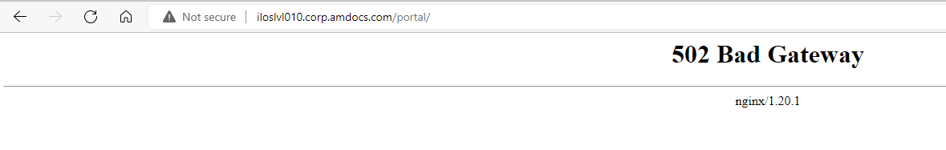

When trying to boot onp I am getting:

3aci404@iloslvl010.corp.amdocs.com:l3aci404>onprestart
Job for amdocs-onp-tomcat@l3aci404.service failed because start of the service was attempted too often. See "systemctl status amdocs-onp-tomcat@l3aci404.service" and "journalctl -xe" for details.
To force a start use "systemctl reset-failed amdocs-onp-tomcat@l3aci404.service" followed by "systemctl start amdocs-onp-tomcat@l3aci404.service" again.

[Tue Jun 27 13:33:12 IDT 2023] [ERROR] Evaluation of /ossusers1/oss/users/l3aci404/onp/conf/server.xml.template file fails. Exiting.
[Tue Jun 27 13:33:42 IDT 2023] [WARN] CATALINA_PID_DIR is empty. CATALINA_PID_DIR will be set to /ossusers1/oss/users/l3aci404/onp/logs.

[Tue Jun 27 13:33:44 IDT 2023] [ERROR] Evaluation of /ossusers1/oss/users/l3aci404/onp/conf/server.xml.template file fails. Exiting.

FIX:

I did the following...
- recreate asm_home (copied uams_ctc.xml and uams_mm.store from ARM) and set UAMS password to plain text in uams.properties
cd asm_home ( on the home directory )
vi uams.properties ( update the UAMS password to set UAMS password to plain text)
ll /ossusers1/oss/users/l3rci404/JEE/armdomain/WLS/armdomain/ASM_HOME
cp /ossusers1/oss/users/l3rci404/JEE/armdomain/WLS/armdomain/ASM_HOME/uams_ctc.xml .
cp /ossusers1/oss/users/l3rci404/JEE/armdomain/WLS/armdomain/ASM_HOME/uams_mm.store .

- sourced the property file (run it from home directory)
$ . ./onp_properties.sh
- cd onp-ansible-orchestration/
- ran the onp prepare yaml
$ ansible-playbook onp-p2cc-prepare.yml -i inventory -vvv | tee -a onp-pcc-prepare.log
- ran the onp encrypt yaml
$ ansible-playbook onp-p2cc-encrypt.yml -i inventory -vvv | tee -a onp-pcc-encrypt.log
- loaded in to consul
/opt/amdocs/fnd/P2CC/scripts/populate_to_consul.sh -repo $HOME/pushToCC_ONP

[2:20 PM] Simon Baddeley
you can then check the decryption
[2:20 PM] Simon Baddeley
~/cc_home/tools/cc-tool --string='${cc:onp/sso/bootstrap/password}' -au SysCtcUser -ah ~/asm_home
[2:21 PM] Simon Baddeley
should return a password rather than an encrypted string

After install onp we set this one:
in /opt/amdocs/onp/ etc

As root update /opt/amdocs/onp/onp-server/conf/sso.properties.template, comment out the lines
com.amdocs.onp.sso.integration.provider.uxf.uams.db.host
com.amdocs.onp.sso.integration.provider.uxf.uams.db.instance
This will prevent uams.properties from being auto-generated.
Add the following line to /opt/amdocs/onp/onp-server/conf/sso.properties.template so that the custom integration is used.
com.amdocs.onp.sso.integration.adapter.uxf.uams.system_properties = amdocs.uams.config.resource=config/cust/ad/cramer
- for this one I copy the file to other directory and update it.
- Then I copy it back

sudo cp sso.properties.template /opt/amdocs/onp/onp-server/conf/.

the above changes should work

you also need to change onp/bin/start.sh , add these lines to the bottom of the file
sed -I ‘/*LOGIN_STEPS/d’ ~/asm_home/uams.properties
sed -I ‘/*LOGOUT_STEPS/d’ ~/asm_home/uams.properties

source ${FND_TOMCAT}/scripts/lib/tomcatInstanceActivateLib.sh

Then add this to the end of onp/bin/setenv.sh.template
echo "LOGIN_STEPS=step.init, step.log, step.account.update, step.ldap.autho, step.ldap.update.properties, step.account, step.props, step.sess, step.multibackend.auth, step.constraint, step.ext.tkt, step.profile" >> ~/asm_home/uams.properties
echo "LOGOUT_STEPS=step.auth, step.account, step.multibackend.auth, step.log, step.sess" >> ~/asm_home/uams.properties

you can then add the LDAP config to uams.properties

Finally as root add the custom jar file casm9_classes.jar to /opt/amdocs/onp/sso-adapter-uxf-war/AmdocsOSS/wars/sso-adapter-uxf-war.war in WEB-INF/lib

/opt/amdocs/onp/onp-server/conf/sso.properties.template

mkdir temp
cd temp
cp /opt/amdocs/onp/onp-server/conf/sso.properties.template .
sudo cp sso.properties.template /opt/amdocs/onp/onp-server/conf/.

ISSUE:
when booting onp on ANN env i am getting this:

l3stann3@illin4331.corp.amdocs.com:l3stann3> sudo systemctl start amdocs-onp-tomcat@$LOGNAME.service
Job for amdocs-onp-tomcat@l3stann3.service failed because the control process exited with error code. See "systemctl status amdocs-onp-tomcat@l3stann3.service" and "journalctl -xe" for details.
Also I can see in log:

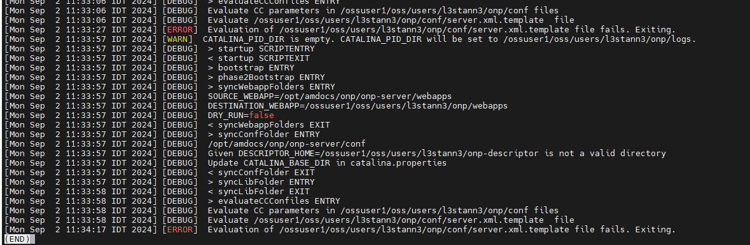

Please run: ~/cc_home/tools/cc-tool --string='${cc:onp/asmDBpassword}' -au SysCtcUser -ah ~/asm_home

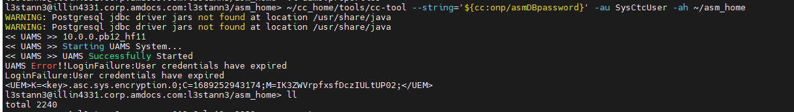

I can see:

UAMS Error!!LoginFailure:User credentials have expired
LoginFailure:User credentials have expired
FIX:

- recreate asm_home (copied uams_ctc.xml and uams_mm.store from ARM) and set UAMS password to plain text in uams.properties
cd asm_home ( on the home directory )
vi uams.properties ( update the UAMS password to set UAMS password to plain text)
ll /ossusers1/oss/users/l3rci404/JEE/armdomain/WLS/armdomain/ASM_HOME
cp /ossusers1/oss/users/l3rci404/JEE/armdomain/WLS/armdomain/ASM_HOME/uams_ctc.xml .
cp /ossusers1/oss/users/l3rci404/JEE/armdomain/WLS/armdomain/ASM_HOME/uams_mm.store .

Please run again:

~/cc_home/tools/cc-tool --string='${cc:onp/asmDBpassword}' -au SysCtcUser -ah ~/asm_home

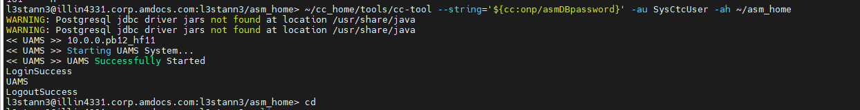

Now it’s good.

Please boot onp

ISSUE:

Error while validating ASM ticket: Unable to authenticate admin user

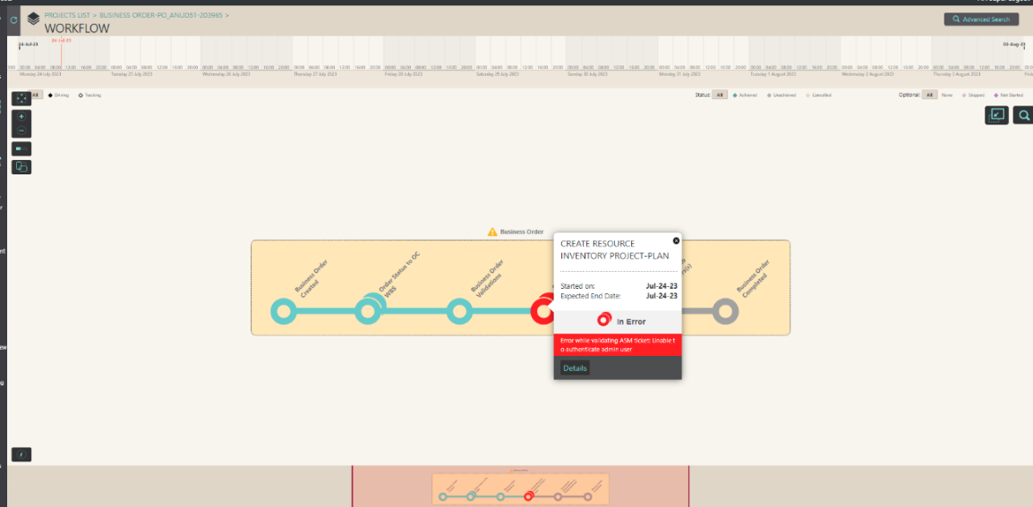

FIX:

I’ve updated the admin user password in CramerConfig.xml and restarted ARM, please try again.

ISSUE:

Failing in ANN refresh ST04

[sshexec] [shellscript] *****************************************************************************
[sshexec] [shellscript] For Repository /infraoss/l3/STORAGE/rm/474/STORE_474_75/proj/ann/metadata/bin/ANNMetadata/repository/Level3ANNRepo operation distribute start...
[sshexec] [shellscript] *****************************************************************************
[sshexec] [shellscript] Temporary project created.
[sshexec] [shellscript] Jul 25, 2023 2:42:59 PM com.amdocs.oss.ide.mm.cli.CLIDistributionController executeBuildDistribution
[sshexec] [shellscript] SEVERE: Source Repository version is not compatible.
[sshexec]
[sshexec] [shellscript] *****************************************************************************
[sshexec] [shellscript] For Repository /infraoss/l3/STORAGE/rm/474/STORE_474_75/proj/ann/metadata/bin/ANNMetadata/repository/Level3ANNRepo operation distribute end...
[sshexec] [shellscript] *****************************************************************************
[sshexec] [shellscript]
[sshexec] [shellscript] !ENTRY org.eclipse.core.resources 2 10035 2023-07-25 14:42:59.873
[sshexec] [shellscript] !MESSAGE The workspace will exit with unsaved changes in this session.
[sshexec] [shellscript] Distribution ended and checking status now
[sshexec]
[sshexec]
[sshexec] BUILD FAILED
[sshexec] /ossuser1/oss/oss/l3stann4/genesisTmpDir/build.xml:3089: The following error occurred while executing this line:
[sshexec] /ossuser1/oss/oss/l3stann4/genesisTmpDir/build.xml:3100: The following error occurred while executing this line:
[sshexec] /ossuser1/oss/oss/l3stann4/genesisTmpDir/build_oss.xml:2484: FAILED TO DISTRIBUTE THE MM REPO. FOR THE SPECIFIC ERROR PLEASE CHECK /ossuser1/oss/oss/l3stann4/.Refreshlog/mmrepo_logs/CLI.log MM CLI LOG
[sshexec]
[sshexec] Total time: 28 seconds
[scp] Disconnecting from illin2134 port 22
[scp] Caught an exception, leaving main loop due to Socket closed

BUILD FAILED
/infraoss/l3/GENESIS/GENESIS_474/GENESIS/build.xml:251: The following error occurred while executing this line:
/infraoss/l3/GENESIS/GENESIS_474/GENESIS/build.xml:908: Remote command failed with exit status 1

ISSUE:

[sshexec] [shellscript] *****************************************************************************
[sshexec] [shellscript] For Repository /infraoss/l3/STORAGE/rm/400/STORE_400_9947/proj/ann/metadata/bin/ANNMetadata/repository/Level3ANNRepo operation distribute start...
[sshexec] [shellscript] *****************************************************************************
[sshexec] [shellscript] Temporary project created.
[sshexec] [shellscript] Sep 18, 2023 5:46:14 PM com.amdocs.oss.ide.mm.cli.CLIDistributionController executeBuildDistribution
[sshexec] [shellscript] SEVERE: Source Repository version is not compatible.
[sshexec] [shellscript] *****************************************************************************
[sshexec] [shellscript] For Repository /infraoss/l3/STORAGE/rm/400/STORE_400_9947/proj/ann/metadata/bin/ANNMetadata/repository/Level3ANNRepo operation distribute end...
[sshexec] [shellscript] *****************************************************************************
[sshexec] [shellscript]
[sshexec] [shellscript] !ENTRY org.eclipse.core.resources 2 10035 2023-09-18 17:46:14.804
[sshexec] [shellscript] !MESSAGE The workspace will exit with unsaved changes in this session.
[sshexec] [shellscript] Distribution ended and checking status now
[sshexec]
[sshexec] BUILD FAILED
[sshexec] /ossusers1/oss/users/l3aci404/genesisTmpDir/build.xml:3089: The following error occurred while executing this line:
[sshexec] /ossusers1/oss/users/l3aci404/genesisTmpDir/build.xml:3100: The following error occurred while executing this line:
[sshexec] /ossusers1/oss/users/l3aci404/genesisTmpDir/build_oss.xml:2482: FAILED TO DISTRIBUTE THE MM REPO. FOR THE SPECIFIC ERROR PLEASE CHECK /ossusers1/oss/users/l3aci404/.Refreshlog/mmrepo_logs/CLI.log MM CLI LOG
[sshexec]
[sshexec] Total time: 31 seconds
[scp] Disconnecting from iloslvl010.corp.amdocs.com port 22
[scp] Caught an exception, leaving main loop due to Socket closed

BUILD FAILED
/infraoss/l3/GENESIS/GENESIS_400/GENESIS/build.xml:251: The following error occurred while executing this line:
/infraoss/l3/GENESIS/GENESIS_400/GENESIS/build.xml:908: Remote command failed with exit status 1

Total time: 1 minute 1 second
Build step 'Deploy from Genesis - CNT' marked build as failure
Finished: FAILURE

FIX:

Please login to /ossusers1/oss/users/l3aci404/ANN_StandaloneWebLogic/mm/eclipse/plugins

Delete all files with the name 10.0.0.1.jar

For example, this one: com.amdocs.oss.ide.mm.log_10.0.0.1.jar

Run refresh again.

FIX:

  - take backup of ANN_StandaloneWebLogic folder
  - copy it from ST05 (l3sta215@illin4142)
  - update the files under ANN_StandaloneWebLogic/mm/scripts/ with correct value of ST04
  - same for ANN_StandaloneWebLogic/mm/temp.properties
  - try to find more properties and update them.
  - Run the refresh.

ISSUE:

sshexec] [sshexec] cmd : /tmp/ctlrm01/copy_ear.ksh
[sshexec] [shellscript] ear name - ARMWebInterface-ear
[sshexec] [shellscript] <name>CramerServer_ARMWebInterface-ear</name>
[sshexec] [shellscript] ##### REDEPLOYING ARMWebInterface-ear EAR FILE #######
[sshexec] [shellscript] weblogic.Deployer invoked with options: -adminurl t3://iloslvl034:7001 -username weblogic -name CramerServer_ARMWebInterface-ear -redeploy
[sshexec] [shellscript] <Aug 1, 2023 9:37:45 PM IDT> <Info> <J2EE Deployment SPI> <BEA-260121> <Initiating redeploy operation for application, CramerServer_ARMWebInterface-ear [archive: null], to configured targets.>
[sshexec] [shellscript] Task 1 initiated: [Deployer:149026]redeploy application CramerServer_ARMWebInterface-ear on CramerServer.
[sshexec] [shellscript] Task 1 deferred: [Deployer:149026]redeploy application CramerServer_ARMWebInterface-ear on CramerServer.
[sshexec]
[sshexec] [shellscript] Target state: redeploy deferred on Server CramerServer
[sshexec] [shellscript] java.rmi.RemoteException: [Deployer:149145]Unable to contact "CramerServer". Deployment is deferred until "CramerServer" becomes available. WARNING: If this is a redeploy app and contains JSP pages that have been touched, these JSP changes wont be reflected when the server starts unless precompile is set to true in weblogic.xml
[sshexec]
[sshexec] [shellscript]
[sshexec] [shellscript]
[sshexec] [shellscript] ear name - GLMARMRestAPI-ear
[sshexec] [shellscript] <name>CramerServer_GLMARMRestAPI-ear</name>
[sshexec] [shellscript] ##### REDEPLOYING GLMARMRestAPI-ear EAR FILE #######
[sshexec] [shellscript] weblogic.Deployer invoked with options: -adminurl t3://iloslvl034:7001 -username weblogic -name CramerServer_GLMARMRestAPI-ear -redeploy
[sshexec] [shellscript] <Aug 1, 2023 9:37:48 PM IDT> <Info> <J2EE Deployment SPI> <BEA-260121> <Initiating redeploy operation for application, CramerServer_GLMARMRestAPI-ear [archive: null], to configured targets.>
[sshexec] [shellscript] Task 2 initiated: [Deployer:149026]redeploy application CramerServer_GLMARMRestAPI-ear on CramerServer.
[sshexec] [shellscript] Task 2 deferred: [Deployer:149026]redeploy application CramerServer_GLMARMRestAPI-ear on CramerServer.
[sshexec] [shellscript] Target state: redeploy deferred on Server CramerServer
[sshexec] [shellscript] java.rmi.RemoteException: [Deployer:149145]Unable to contact "CramerServer". Deployment is deferred until "CramerServer" becomes available. WARNING: If this is a redeploy app and contains JSP pages that have been touched, these JSP changes wont be reflected when the server starts unless precompile is set to true in weblogic.xml
[sshexec] [shellscript]
[sshexec] [shellscript]
[sshexec] [shellscript] ear name - ARMRestAPI-ear
[sshexec] [shellscript] <name>CramerServer_ARMRestAPI-ear</name>
[sshexec] [shellscript] ##### REDEPLOYING ARMRestAPI-ear EAR FILE #######
[sshexec] [shellscript] weblogic.Deployer invoked with options: -adminurl t3://iloslvl034:7001 -username weblogic -name CramerServer_ARMRestAPI-ear -redeploy
[sshexec] [shellscript] <Aug 1, 2023 9:37:51 PM IDT> <Info> <J2EE Deployment SPI> <BEA-260121> <Initiating redeploy operation for application, CramerServer_ARMRestAPI-ear [archive: null], to configured targets.>
[sshexec] [shellscript] Task 3 initiated: [Deployer:149026]redeploy application CramerServer_ARMRestAPI-ear on CramerServer.
[sshexec] [shellscript] Task 3 deferred: [Deployer:149026]redeploy application CramerServer_ARMRestAPI-ear on CramerServer.
[sshexec] [shellscript] Target state: redeploy deferred on Server CramerServer
[sshexec] [shellscript] java.rmi.RemoteException: [Deployer:149145]Unable to contact "CramerServer". Deployment is deferred until "CramerServer" becomes available. WARNING: If this is a redeploy app and contains JSP pages that have been touched, these JSP changes wont be reflected when the server starts unless precompile is set to true in weblogic.xml
[sshexec] [shellscript]
[sshexec] [shellscript]
[sshexec] [shellscript] ear name - rm-wizards-wrap-ear
[sshexec] [shellscript] <name>CramerServer_rm-wizards-wrap-ear</name>
[sshexec] [shellscript] ##### REDEPLOYING rm-wizards-wrap-ear EAR FILE #######
[sshexec] [shellscript] weblogic.Deployer invoked with options: -adminurl t3://iloslvl034:7001 -username weblogic -name CramerServer_rm-wizards-wrap-ear -redeploy
[sshexec] [shellscript] <Aug 1, 2023 9:37:54 PM IDT> <Info> <J2EE Deployment SPI> <BEA-260121> <Initiating redeploy operation for application, CramerServer_rm-wizards-wrap-ear [archive: null], to configured targets.>
[sshexec] [shellscript] Task 4 initiated: [Deployer:149026]redeploy application CramerServer_rm-wizards-wrap-ear on CramerServer.
[sshexec] [shellscript] Task 4 deferred: [Deployer:149026]redeploy application CramerServer_rm-wizards-wrap-ear on CramerServer.
[sshexec] [shellscript] Target state: redeploy deferred on Server CramerServer
[sshexec] [shellscript] java.rmi.RemoteException: [Deployer:149145]Unable to contact "CramerServer". Deployment is deferred until "CramerServer" becomes available. WARNING: If this is a redeploy app and contains JSP pages that have been touched, these JSP changes wont be reflected when the server starts unless precompile is set to true in weblogic.xml
[sshexec] [shellscript]
[sshexec] [shellscript]
[sshexec] [shellscript] ear name - AmdocsOSS-Cust-Inv-Service
[sshexec] [shellscript] <name>CramerServer_AmdocsOSS-Cust-Inv-Service</name>
[sshexec] [shellscript] ##### REDEPLOYING AmdocsOSS-Cust-Inv-Service EAR FILE #######
[sshexec] [shellscript] weblogic.Deployer invoked with options: -adminurl t3://iloslvl034:7001 -username weblogic -name CramerServer_AmdocsOSS-Cust-Inv-Service -redeploy
[sshexec] [shellscript] <Aug 1, 2023 9:37:57 PM IDT> <Info> <J2EE Deployment SPI> <BEA-260121> <Initiating redeploy operation for application, CramerServer_AmdocsOSS-Cust-Inv-Service [archive: null], to configured targets.>
[sshexec] [shellscript] Task 5 initiated: [Deployer:149026]redeploy application CramerServer_AmdocsOSS-Cust-Inv-Service on CramerServer.
[sshexec] [shellscript] Task 5 deferred: [Deployer:149026]redeploy application CramerServer_AmdocsOSS-Cust-Inv-Service on CramerServer.
[sshexec] [shellscript] Target state: redeploy deferred on Server CramerServer
[sshexec] [shellscript] java.rmi.RemoteException: [Deployer:149145]Unable to contact "CramerServer". Deployment is deferred until "CramerServer" becomes available. WARNING: If this is a redeploy app and contains JSP pages that have been touched, these JSP changes wont be reflected when the server starts unless precompile is set to true in weblogic.xml
[sshexec] [shellscript]
[sshexec] [shellscript]
[sshexec] [shellscript] ear name - are-circuit-ear
[sshexec] [shellscript] <name>CramerServer_are-circuit-ear</name>
[sshexec]
[sshexec] [shellscript] ##### REDEPLOYING are-circuit-ear EAR FILE #######
[sshexec] [shellscript] weblogic.Deployer invoked with options: -adminurl t3://iloslvl034:7001 -username weblogic -name CramerServer_are-circuit-ear -redeploy
[sshexec] [shellscript] <Aug 1, 2023 9:38:01 PM IDT> <Info> <J2EE Deployment SPI> <BEA-260121> <Initiating redeploy operation for application, CramerServer_are-circuit-ear [archive: null], to configured targets.>
[sshexec] [shellscript] Task 6 initiated: [Deployer:149026]redeploy application CramerServer_are-circuit-ear on CramerServer.
[sshexec] [shellscript] Task 6 deferred: [Deployer:149026]redeploy application CramerServer_are-circuit-ear on CramerServer.
[sshexec] [shellscript] Target state: redeploy deferred on Server CramerServer
[sshexec] [shellscript] java.rmi.RemoteException: [Deployer:149145]Unable to contact "CramerServer". Deployment is deferred until "CramerServer" becomes available. WARNING: If this is a redeploy app and contains JSP pages that have been touched, these JSP changes wont be reflected when the server starts unless precompile is set to true in weblogic.xml
[sshexec]
[sshexec] [shellscript]
[sshexec] [shellscript]
[sshexec]
[sshexec] BUILD FAILED
[sshexec] /ossusers1/oss/users/ctlrm01/genesisTmpDir/build.xml:3089: The following error occurred while executing this line:
[sshexec] /ossusers1/oss/users/ctlrm01/genesisTmpDir/build.xml:3100: The following error occurred while executing this line:
[sshexec] /ossusers1/oss/users/ctlrm01/genesisTmpDir/build_oss.xml:3349: The following error occurred while executing this line:
[sshexec] /ossusers1/oss/users/ctlrm01/genesisTmpDir/build_oss.xml:3378: The following error occurred while executing this line:
[sshexec] /ossusers1/oss/users/ctlrm01/genesisTmpDir/build_oss.xml:911: FAILED TO DEPLOY EAR FILES
[sshexec]

FIX:

cd JEE/armdomain/WLS/armdomain/config

cp -r config.xml config.xml_bckAug012023

remove:

< <name>CramerServer_ARMRestAPI-ear</name>
< <target>CramerServer</target>
< <module-type>ear</module-type>
< <source-path>/ossusers1/oss/users/ctlrm01/ResourceManagementWebLogic3/deployments/ARMRestAPI-ear.ear</source-path>
< <security-dd-model>DDOnly</security-dd-model>
< <staging-mode xsi:nil="true"></staging-mode>
< <plan-staging-mode xsi:nil="true"></plan-staging-mode>
< <cache-in-app-directory>false</cache-in-app-directory>
< </app-deployment>
< <app-deployment>
< <name>CramerServer_AmdocsOSS-Cust-Inv-Service</name>
< <target>CramerServer</target>
< <module-type>ear</module-type>
< <source-path>/ossusers1/oss/users/ctlrm01/ResourceManagementWebLogic3/deployments/AmdocsOSS-Cust-Inv-Service.ear</source-path>
< <security-dd-model>DDOnly</security-dd-model>
< <staging-mode xsi:nil="true"></staging-mode>
< <plan-staging-mode xsi:nil="true"></plan-staging-mode>
< <cache-in-app-directory>false</cache-in-app-directory>
< </app-deployment>
< <app-deployment>
554,583d533
< <security-dd-model>DDOnly</security-dd-model>
< <staging-mode xsi:nil="true"></staging-mode>
< <plan-staging-mode xsi:nil="true"></plan-staging-mode>
< <cache-in-app-directory>false</cache-in-app-directory>
< </app-deployment>
< <app-deployment>
< <name>CramerServer_rm-wizards-wrap-ear</name>
< <target>CramerServer</target>
< <module-type>ear</module-type>
< <source-path>/ossusers1/oss/users/ctlrm01/ResourceManagementWebLogic3/deployments/rm-wizards-wrap-ear.ear</source-path>
< <security-dd-model>DDOnly</security-dd-model>
< <staging-mode xsi:nil="true"></staging-mode>
< <plan-staging-mode xsi:nil="true"></plan-staging-mode>
< <cache-in-app-directory>false</cache-in-app-directory>
< </app-deployment>
< <app-deployment>
< <name>CramerServer_GLMARMRestAPI-ear</name>
< <target>CramerServer</target>
< <module-type>ear</module-type>
< <source-path>/ossusers1/oss/users/ctlrm01/ResourceManagementWebLogic3/deployments/GLMARMRestAPI-ear.ear</source-path>
< <security-dd-model>DDOnly</security-dd-model>
< <staging-mode xsi:nil="true"></staging-mode>
< <plan-staging-mode xsi:nil="true"></plan-staging-mode>
< <cache-in-app-directory>false</cache-in-app-directory>
< </app-deployment>
< <app-deployment>
< <name>CramerServer_are-circuit-ear</name>
< <target>CramerServer</target>
< <module-type>ear</module-type>
< <source-path>/ossusers1/oss/users/ctlrm01/ResourceManagementWebLogic3/deployments/are-circuit-ear.ear</source-path>

Clean cache/ tmp logs

Restart ARM

Run refresh

ISSUE:

Jenkins is not coming up

Aug 7, 2023 8:30:49 AM GMT> <Info> <Security> <BEA-090906> <Changing the default Random Number Generator in RSA CryptoJ from ECDRBG128 to FIPS186PRNG. To disable this change, specify -Dweb
logic.security.allowCryptoJDefaultPRNG=true.>
<Aug 7, 2023 8:30:49 AM GMT> <Info> <WebLogicServer> <BEA-000377> <Starting WebLogic Server with Java HotSpot(TM) 64-Bit Server VM Version 24.51-b03 from Oracle Corporation.>
<Aug 7, 2023 8:30:50 AM GMT> <Info> <Management> <BEA-141107> <Version: WebLogic Server 12.1.3.0.0 Wed May 21 18:53:34 PDT 2014 1604337 >
<Aug 7, 2023 8:30:51 AM GMT> <Notice> <WebLogicServer> <BEA-000365> <Server state changed to STARTING.>
<Aug 7, 2023 8:30:51 AM GMT> <Info> <WorkManager> <BEA-002900> <Initializing self-tuning thread pool.>
<Aug 7, 2023 8:30:51 AM GMT> <Info> <WorkManager> <BEA-002942> <CMM memory level becomes 0. Setting standby thread pool size to 256.>
<Aug 7, 2023 8:30:51 AM GMT> <Notice> <Log Management> <BEA-170019> <The server log file /app/ossusers/l3jenkins/JEE/jenkins/servers/adminserver/logs/adminserver.log is opened. All server s
ide log events will be written to this file.>
<Aug 7, 2023 8:30:51 AM GMT> <Emergency> <Store> <BEA-280060> <The store "WLS_DIAGNOSTICS" encountered a fatal error, and it must be shut down: weblogic.store.PersistentStoreFatalException: [Store:280105]The persistent file store "WLS_DIAGNOSTICS" cannot open file WLS_DIAGNOSTICS000000.DAT.
weblogic.store.PersistentStoreFatalException: [Store:280105]The persistent file store "WLS_DIAGNOSTICS" cannot open file WLS_DIAGNOSTICS000000.DAT.
at weblogic.store.io.file.BaseStoreIO.openInternal(BaseStoreIO.java:170)
at weblogic.store.io.file.FileStoreIO.open(FileStoreIO.java:64)
at weblogic.store.internal.PersistentStoreImpl.recoverStoreConnections(PersistentStoreImpl.java:476)
at weblogic.store.internal.PersistentStoreImpl.open(PersistentStoreImpl.java:453)
at weblogic.store.xa.PersistentStoreManagerXA.createFileStore(PersistentStoreManagerXA.java:117)
Truncated. see log file for complete stacktrace
Caused By: java.io.IOException: Error from fcntl() for file locking, Resource temporarily unavailable, errno=11
at weblogic.store.io.file.direct.DirectIONative.openConsiderLock(Native Method)
at weblogic.store.io.file.direct.DirectIONativeImpl.openConsiderLock(DirectIONativeImpl.java:35)
at weblogic.store.io.file.direct.DirectFileChannel.<init>(DirectFileChannel.java:64)
at weblogic.store.io.file.direct.DirectIOManager.openBasic(DirectIOManager.java:275)
at weblogic.store.io.file.FileStoreIO.staticOpen(FileStoreIO.java:76)
Truncated. see log file for complete stacktrace
>
No matching store mbean found for =WLS_DIAGNOSTICS, must be a default store.
<Aug 7, 2023 8:30:51 AM GMT> <Critical> <Health> <BEA-310006> <Critical subsystem PersistentStore.WLS_DIAGNOSTICS has failed. Setting server state to FAILED.
Reason: weblogic.store.PersistentStoreFatalException: [Store:280105]The persistent file store "WLS_DIAGNOSTICS" cannot open file WLS_DIAGNOSTICS000000.DAT.>
<Aug 7, 2023 8:30:51 AM GMT> <Critical> <WebLogicServer> <BEA-000385> <Server health failed. Reason: health of critical service 'PersistentStore.WLS_DIAGNOSTICS' failed>
<Aug 7, 2023 8:30:51 AM GMT> <Notice> <WebLogicServer> <BEA-000365> <Server state changed to FAILED.>
<Aug 7, 2023 8:30:51 AM GMT> <Error> <> <BEA-000000> <THREAD DUMP from JVM taken at 'Mon Aug 7 08:30:51 2023'

<Aug 7, 2023 8:53:08 AM GMT> <Notice> <WebLogicServer> <BEA-000365> <Server state changed to STARTING.>
Aug 07, 2023 8:53:08 AM weblogic.wsee.WseeCoreMessages logWseeServiceStarting
INFO: The Wsee Service is starting
Jenkins home directory: /app/ossusers/l3jenkins/.jenkins found at: EnvVars.masterEnvVars.get("JENKINS_HOME")
<Aug 7, 2023 8:53:15 AM GMT> <Notice> <Log Management> <BEA-170027> <The server has successfully established a connection with the Domain level Diagnostic Service.>
Aug 07, 2023 8:53:16 AM jenkins.InitReactorRunner$1 onAttained
INFO: Started initialization
Aug 07, 2023 8:53:16 AM jenkins.InitReactorRunner$1 onTaskFailed
SEVERE: Failed Inspecting plugin /app/ossusers/l3jenkins/.jenkins/plugins/checkstyle.jpi
java.io.IOException: Failed to expand /app/ossusers/l3jenkins/.jenkins/plugins/checkstyle.jpi
at hudson.ClassicPluginStrategy.explode(ClassicPluginStrategy.java:484)
at hudson.ClassicPluginStrategy.createPluginWrapper(ClassicPluginStrategy.java:150)
at hudson.PluginManager$1$3$1.run(PluginManager.java:240)
at org.jvnet.hudson.reactor.TaskGraphBuilder$TaskImpl.run(TaskGraphBuilder.java:169)
at org.jvnet.hudson.reactor.Reactor.runTask(Reactor.java:282)
at jenkins.model.Jenkins$7.runTask(Jenkins.java:904)
at org.jvnet.hudson.reactor.Reactor$2.run(Reactor.java:210)
at org.jvnet.hudson.reactor.Reactor$Node.run(Reactor.java:117)
at java.util.concurrent.ThreadPoolExecutor.runWorker(ThreadPoolExecutor.java:1145)
at java.util.concurrent.ThreadPoolExecutor$Worker.run(ThreadPoolExecutor.java:615)
at java.lang.Thread.run(Thread.java:744)
Caused by: Error while expanding /app/ossusers/l3jenkins/.jenkins/plugins/checkstyle.jpi
java.util.zip.ZipException: archive is not a ZIP archive
at org.apache.tools.ant.taskdefs.Expand.expandFile(Expand.java:190)
at org.apache.tools.ant.taskdefs.Expand.execute(Expand.java:132)
at hudson.ClassicPluginStrategy.unzipExceptClasses(ClassicPluginStrategy.java:556)
at hudson.ClassicPluginStrategy.explode(ClassicPluginStrategy.java:481)
... 10 more
Caused by: java.util.zip.ZipException: archive is not a ZIP archive
at org.apache.tools.zip.ZipFile.positionAtEndOfCentralDirectoryRecord(ZipFile.java:771)
at org.apache.tools.zip.ZipFile.positionAtCentralDirectory(ZipFile.java:707)
at org.apache.tools.zip.ZipFile.populateFromCentralDirectory(ZipFile.java:452)
at org.apache.tools.zip.ZipFile.<init>(ZipFile.java:214)
at org.apache.tools.ant.taskdefs.Expand.expandFile(Expand.java:168)
... 13 more

<Aug 7, 2023 8:53:16 AM GMT> <Error> <jenkins.InitReactorRunner> <BEA-000000> <Failed Inspecting plugin /app/ossusers/l3jenkins/.jenkins/plugins/checkstyle.jpi
java.io.IOException: Failed to expand /app/ossusers/l3jenkins/.jenkins/plugins/checkstyle.jpi
at hudson.ClassicPluginStrategy.explode(ClassicPluginStrategy.java:484)

<Aug 7, 2023 8:53:16 AM GMT> <Error> <Server> <BEA-002606> <The server is unable to create a server socket for listening on channel "Default[1]". The address 127.0.0.1 might be incorrect or another process is using port 10150: java.net.BindException: Address already in use>
<Aug 7, 2023 8:53:16 AM GMT> <Emergency> <Security> <BEA-090087> <Server failed to bind to the configured administrator port. The port may already be in use by another process.>
<Aug 7, 2023 8:53:16 AM GMT> <Error> <Server> <BEA-002606> <The server is unable to create a server socket for listening on channel "Default". The address 4.72.83.83 might be incorrect or another process is using port 10150: java.net.BindException: Address already in use>
Aug 07, 2023 8:53:16 AM jenkins.InitReactorRunner$1 onTaskFailed

FIX:

lsof -n -i | grep 10150

can see java process are running.

Kill the process and boot WL
on the host there is a java process running for weblogic, execute "ps -ef|grep java"
it's process 11118
please kill the process and try again to boot Jenkins

issue:

checking core HF in ANN env

fix:

yum --show-duplicates list amdocs-ann-app

l3stann4@illin2134.corp.amdocs.com:l3stann4> yum --show-duplicates list amdocs-ann-app
Loaded plugins: product-id, search-disabled-repos
Installed Packages
amdocs-ann-app.noarch 21.01.96-2618 @cmn-ann-core
Available Packages
amdocs-ann-app.noarch 21.01.79-2549 cmn-ann-core
amdocs-ann-app.noarch 21.01.89-2584 cmn-ann-core
amdocs-ann-app.noarch 21.01.96-2618 cmn-ann-core
amdocs-ann-app.noarch 21.01.99-2591 cmn-ann-core
amdocs-ann-app.noarch 21.01.100-2676 cmn-ann-core
amdocs-ann-app.noarch 21.01.102-2701 cmn-ann-core
l3stann4@illin2134.corp.amdocs.com:l3stann4>

for apply core HF in ANN:

please open the HF under path:

/infraoss/l3/STORAGE/INFRA/CORE_INSTALLABLES/ANN2101/Installation-Archive-V2101

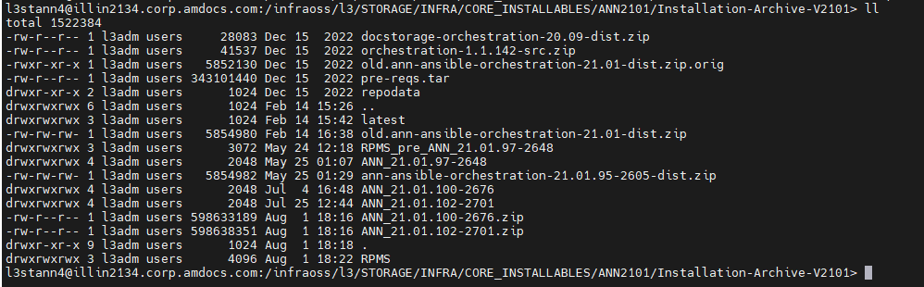

Please refresh the ANN env.

After refresh, please check HF’s are in the env with command:

yum --show-duplicates list amdocs-ann-app

Update ANN LEVEL debug:

To change log level edit –
/ossuser1/oss/oss/l3stann4/JEE/config/ann-logback.xml
/ossuser1/oss/oss/l3stann4/JEE/config/java.util.logging.properties

Will create a list of server for each env and share with you.

<root level="trace">
Update ARM debug Level:
l3strm07@illin4141.corp.amdocs.com:l3strm07/JEE/armdomain/WLS/armdomain> ll logging.properties

Issue:
When booting WL I am getting this issue:

starting weblogic server...
Java HotSpot(TM) 64-Bit Server VM warning: ignoring option MaxPermSize=1024m; support was removed in 8.0
javax.management.JMRuntimeException: Failed to load MBeanServerBuilder class weblogic.management.jmx.mbeanserver.WLSMBeanServerBuilder: java.lang.ClassNotFoundException: weblogic.management.jmx.mbeanserver.WLSMBeanServerBuilder
at javax.management.MBeanServerFactory.checkMBeanServerBuilder(MBeanServerFactory.java:503)
at javax.management.MBeanServerFactory.getNewMBeanServerBuilder(MBeanServerFactory.java:539)
at javax.management.MBeanServerFactory.newMBeanServer(MBeanServerFactory.java:316)
at javax.management.MBeanServerFactory.createMBeanServer(MBeanServerFactory.java:231)
at javax.management.MBeanServerFactory.createMBeanServer(MBeanServerFactory.java:192)
at java.lang.management.ManagementFactory.getPlatformMBeanServer(ManagementFactory.java:469)
at sun.management.jmxremote.ConnectorBootstrap.startRemoteConnectorServer(ConnectorBootstrap.java:464)
at sun.management.Agent.startAgent(Agent.java:257)
at sun.management.Agent.startAgent(Agent.java:447)
Caused by: java.lang.ClassNotFoundException: weblogic.management.jmx.mbeanserver.WLSMBeanServerBuilder
at java.net.URLClassLoader.findClass(URLClassLoader.java:381)
at java.lang.ClassLoader.loadClass(ClassLoader.java:424)
at sun.misc.Launcher$AppClassLoader.loadClass(Launcher.java:335)
at java.lang.ClassLoader.loadClass(ClassLoader.java:357)
at javax.management.MBeanServerFactory.loadBuilderClass(MBeanServerFactory.java:446)
at javax.management.MBeanServerFactory.checkMBeanServerBuilder(MBeanServerFactory.java:488)
... 8 more
Exception thrown by the agent : javax.management.JMRuntimeException: Failed to load MBeanServerBuilder class weblogic.management.jmx.mbeanserver.WLSMBeanServerBuilder: java.lang.ClassNotFoundException: weblogic.management.jmx.mbeanserver.WLSMBeanServerBuilder

FIX:

Change the permissions for this folder to 777:

/opt/weblogic1221/wlserver_12.2.1/installation/oracle_common

Or it’s better to delete the weblogic1221 and open it again from tar

Issue:

USM is not coming up

<Aug 23, 2023, 1:47:22,590 PM CLT> <Warning> <org.jboss.weld.Bootstrap> <BEA-000000> <WELD-001210: Warning when validating file:/ossuser1/osshome/oss/usmusr01/JEE/usmusr01/WLS/usmusr01/servers/CramerServer/stage/usm-services-rest-webapp_war/usm-services-rest-webapp_war/WEB-INF/beans.xml@13 against xsd. schema_reference.4: Failed to read schema document 'http://www.springframework.org/schema/beans/spring-beans.xsd', because 1) could not find the document; 2) the document could not be read; 3) the root element of the document is not <xsd:schema>.>
<Aug 23, 2023, 1:51:40,126 PM CLT> <Warning> <org.jboss.weld.Bootstrap> <BEA-000000> <WELD-001210: Warning when validating file:/ossuser1/osshome/oss/usmusr01/JEE/usmusr01/WLS/usmusr01/servers/CramerServer/stage/usm-services-rest-webapp_war/usm-services-rest-webapp_war/WEB-INF/beans.xml@15 against xsd. schema_reference.4: Failed to read schema document 'http://www.springframework.org/schema/context/spring-context-4.0.xsd', because 1) could not find the document; 2) the document could not be read; 3) the root element of the document is not <xsd:schema>.>
<Aug 23, 2023, 1:53:50,558 PM CLT> <Warning> <org.jboss.weld.Bootstrap> <BEA-000000> <WELD-001210: Warning when validating file:/ossuser1/osshome/oss/usmusr01/JEE/usmusr01/WLS/usmusr01/servers/CramerServer/stage/usm-services-rest-webapp_war/usm-services-rest-webapp_war/WEB-INF/beans.xml@17 against xsd. schema_reference.4: Failed to read schema document 'http://cxf.apache.org/schemas/jaxrs.xsd', because 1) could not find the document; 2) the document could not be read; 3) the root element of the document is not <xsd:schema>.>
<Aug 23, 2023, 1:56:00,862 PM CLT> <Warning> <org.jboss.weld.Bootstrap> <BEA-000000> <WELD-001210: Warning when validating file:/ossuser1/osshome/oss/usmusr01/JEE/usmusr01/WLS/usmusr01/servers/CramerServer/stage/usm-services-rest-webapp_war/usm-services-rest-webapp_war/WEB-INF/beans.xml@18 against xsd. schema_reference.4: Failed to read schema document 'http://cxf.apache.org/schemas/jaxrs.xsd', because 1) could not find the document; 2) the document could not be read; 3) the root element of the document is not <xsd:schema>.>
<Aug 23, 2023, 2:00:18,398 PM CLT> <Warning> <org.jboss.weld.Bootstrap> <BEA-000000> <WELD-001210: Warning when validating file:/ossuser1/osshome/oss/usmusr01/JEE/usmusr01/WLS/usmusr01/servers/CramerServer/stage/usm-services-rest-webapp_war/usm-services-rest-webapp_war/WEB-INF/beans.xml@19 against xsd. schema_reference.4: Failed to read schema document 'http://www.springframework.org/schema/beans/spring-beans.xsd', because 1) could not find the document; 2) the document could not be read; 3) the root element of the document is not <xsd:schema>.>

Fix:

java param not set in setDomainEnv.sh.. It was missing the param “-Dorg.jboss.weld.xml.disableValidating=true”.

l3adm_illin3639

AWR report:

We have job for it but it’s not working good:

http://iloslvl011.corp.amdocs.com:7001/jenkins/job/AWR_UTILITY/

Login to the share folder from the oracle user that you need the report:

/infraoss/l3/STORAGE/INFRA/scripts

Run it like this:
./awrutility illin4245 L3STRM03 27/08/2023,18 27/08/2023,21 avi.saar@amdocs.com

LB boot in tef pru:

lb boot:

pruadm@inospru147:pruadm/APACHE/httpd-2.4.39/bin> ./apachectl start

ISSUE:

When refreshing ANN I am getting this issue.

It’s taking Version 10 and not 21.01

[sshexec] [shellscript] /usr/java/jdk1.8.0_74/bin/java -Xms512m -Xmx4096m -XX:MaxPermSize=3072m -XX:-UseGCOverheadLimit -jar /ossusers1/oss/users/l3aci404/ANN_StandaloneWebLogic/mm/eclipse/plugins/org.eclipse.equinox.launcher_1.3.100.v20150511-1540.jar -application com.amdocs.oss.ide.mm.cli.BuildDistribute -clean -op distribute -repository /infraoss/l3/STORAGE/rm/400/STORE_400_9947/proj/ann/metadata/bin/ANNMetadata/repository/Level3ANNRepo -changes /ossusers1/oss/users/l3aci404/.Refreshlog/mmrepo_logs/delta -connectstring iloslvl010:1521@L3RCI404:ANN01METADATA/ANN01METADATA -logfile /ossusers1/oss/users/l3aci404/.Refreshlog/mmrepo_logs/distributionLog.log -fileloglevel info -consoleloglevel severe -validationscope no_validation | tee -a /ossusers1/oss/users/l3aci404/.Refreshlog/mmrepo_logs/CLI.log
[sshexec] [shellscript] java.lang.RuntimeException: Unable to aquire PluginConverter service during generation for: /ossusers1/oss/users/l3aci404/ANN_StandaloneWebLogic/mm/eclipse/plugins/com.amdocs.oss.ide.mm.build_10.0.0.1.jar
[sshexec] [shellscript] at org.eclipse.equinox.internal.frameworkadmin.utils.Utils.convertPluginManifest(Utils.java:154)
[sshexec] [shellscript] at org.eclipse.equinox.internal.frameworkadmin.utils.Utils.basicLoadManifest(Utils.java:82)
[sshexec] [shellscript] at org.eclipse.equinox.internal.frameworkadmin.utils.Utils.getOSGiManifest(Utils.java:217)
[sshexec] [shellscript] at org.eclipse.equinox.internal.frameworkadmin.equinox.EquinoxBundlesState.installBundle(EquinoxBundlesState.java:556)
[sshexec]
[sshexec] [shellscript] at org.eclipse.equinox.internal.simpleconfigurator.manipulator.SimpleConfiguratorManipulatorImpl.updateBundles(SimpleConfiguratorManipulatorImpl.java:560)
[sshexec] [shellscript] at org.eclipse.equinox.internal.frameworkadmin.equinox.EquinoxManipulatorImpl.load(EquinoxManipulatorImpl.java:348)
[sshexec]
[sshexec] [shellscript] at org.eclipse.equinox.internal.p2.touchpoint.eclipse.LazyManipulator.loadDelegate(LazyManipulator.java:55)
[sshexec] [shellscript] at org.eclipse.equinox.internal.p2.touchpoint.eclipse.LazyManipulator.getConfigData(LazyManipulator.java:108)
[sshexec] [shellscript] at org.eclipse.equinox.internal.p2.touchpoint.eclipse.actions.UninstallBundleAction.uninstallBundle(UninstallBundleAction.java:74)
[sshexec] [shellscript] at org.eclipse.equinox.internal.p2.touchpoint.eclipse.actions.UninstallBundleAction.execute(UninstallBundleAction.java:32)
[sshexec]
[sshexec] [shellscript] at org.eclipse.equinox.internal.p2.engine.ParameterizedProvisioningAction.execute(ParameterizedProvisioningAction.java:38)
[sshexec] [shellscript] at org.eclipse.equinox.internal.p2.engine.Phase.mainPerform(Phase.java:183)
[sshexec] [shellscript] at org.eclipse.equinox.internal.p2.engine.Phase.perform(Phase.java:95)
[sshexec] [shellscript] at org.eclipse.equinox.internal.p2.engine.PhaseSet.perform(PhaseSet.java:47)
[sshexec] [shellscript] at org.eclipse.equinox.internal.p2.engine.Engine.perform(Engine.java:75)
[sshexec] [shellscript] at org.eclipse.equinox.internal.p2.engine.Engine.perform(Engine.java:44)
[sshexec] [shellscript] at org.eclipse.equinox.internal.p2.reconciler.dropins.ProfileSynchronizer.executePlan(ProfileSynchronizer.java:805)
[sshexec] [shellscript] at org.eclipse.equinox.internal.p2.reconciler.dropins.ProfileSynchronizer.performAddRemove(ProfileSynchronizer.java:202)
[sshexec] [shellscript] at org.eclipse.equinox.internal.p2.reconciler.dropins.ProfileSynchronizer.synchronize(ProfileSynchronizer.java:141)
[sshexec] [shellscript] at org.eclipse.equinox.internal.p2.reconciler.dropins.Activator.synchronize(Activator.java:469)
[sshexec] [shellscript] at org.eclipse.equinox.internal.p2.reconciler.dropins.Activator.start(Activator.java:177)
[sshexec] [shellscript] at org.eclipse.osgi.internal.framework.BundleContextImpl$3.run(BundleContextImpl.java:771)
[sshexec] [shellscript] at org.eclipse.osgi.internal.framework.BundleContextImpl$3.run(BundleContextImpl.java:1)
[sshexec] [shellscript] at java.security.AccessController.doPrivileged(Native Method)
[sshexec] [shellscript] at org.eclipse.osgi.internal.framework.BundleContextImpl.startActivator(BundleContextImpl.java:764)
[sshexec] [shellscript] at org.eclipse.osgi.internal.framework.BundleContextImpl.start(BundleContextImpl.java:721)
[sshexec] [shellscript] at org.eclipse.osgi.internal.framework.EquinoxBundle.startWorker0(EquinoxBundle.java:941)
[sshexec] [shellscript] at org.eclipse.osgi.internal.framework.EquinoxBundle$EquinoxModule.startWorker(EquinoxBundle.java:318)
[sshexec] [shellscript] at org.eclipse.osgi.container.Module.doStart(Module.java:571)
[sshexec] [shellscript] at org.eclipse.osgi.container.Module.start(Module.java:439)
[sshexec] [shellscript] at org.eclipse.osgi.container.ModuleContainer$ContainerStartLevel.incStartLevel(ModuleContainer.java:1582)
[sshexec] [shellscript] at org.eclipse.osgi.container.ModuleContainer$ContainerStartLevel.incStartLevel(ModuleContainer.java:1562)
[sshexec] [shellscript] at org.eclipse.osgi.container.ModuleContainer$ContainerStartLevel.doContainerStartLevel(ModuleContainer.java:1533)
[sshexec] [shellscript] at org.eclipse.osgi.container.ModuleContainer$ContainerStartLevel.dispatchEvent(ModuleContainer.java:1476)
[sshexec] [shellscript] at org.eclipse.osgi.container.ModuleContainer$ContainerStartLevel.dispatchEvent(ModuleContainer.java:1)
[sshexec] [shellscript] at org.eclipse.osgi.framework.eventmgr.EventManager.dispatchEvent(EventManager.java:230)
[sshexec] [shellscript] at org.eclipse.osgi.framework.eventmgr.EventManager$EventThread.run(EventManager.java:340)
[sshexec] [shellscript] java.lang.RuntimeException: Unable to aquire PluginConverter service during generation for: /ossusers1/oss/users/l3aci404/ANN_StandaloneWebLogic/mm/eclipse/plugins/com.amdocs.oss.ide.mm.cablemanager_10.0.0.1.jar
[sshexec] [shellscript] at org.eclipse.equinox.internal.frameworkadmin.utils.Utils.convertPluginManifest(Utils.java:154)
[sshexec] [shellscript] at org.eclipse.equinox.internal.frameworkadmin.utils.Utils.basicLoadManifest(Utils.java:82)
[sshexec] [shellscript] at org.eclipse.equinox.internal.frameworkadmin.utils.Utils.getOSGiManifest(Utils.java:217)
[sshexec] [shellscript] at org.eclipse.equinox.internal.frameworkadmin.equinox.EquinoxBundlesState.installBundle(EquinoxBundlesState.java:556)
[sshexec] [shellscript] at org.eclipse.equinox.internal.simpleconfigurator.manipulator.SimpleConfiguratorManipulatorImpl.updateBundles(SimpleConfiguratorManipulatorImpl.java:560)
[sshexec] [shellscript] at org.eclipse.equinox.internal.frameworkadmin.equinox.EquinoxManipulatorImpl.load(EquinoxManipulatorImpl.java:348)
[sshexec] [shellscript] at org.eclipse.equinox.internal.p2.touchpoint.eclipse.LazyManipulator.loadDelegate(LazyManipulator.java:55)
[sshexec] [shellscript] at org.eclipse.equinox.internal.p2.touchpoint.eclipse.LazyManipulator.getConfigData(LazyManipulator.java:108)
[sshexec] [shellscript] at org.eclipse.equinox.internal.p2.touchpoint.eclipse.actions.UninstallBundleAction.uninstallBundle(UninstallBundleAction.java:74)
[sshexec] [shellscript] at org.eclipse.equinox.internal.p2.touchpoint.eclipse.actions.UninstallBundleAction.execute(UninstallBundleAction.java:32)
[sshexec] [shellscript] at org.eclipse.equinox.internal.p2.engine.ParameterizedProvisioningAction.execute(ParameterizedProvisioningAction.java:38)
[sshexec] [shellscript] at org.eclipse.equinox.internal.p2.engine.Phase.mainPerform(Phase.java:183)
[sshexec] [shellscript] at org.eclipse.equinox.internal.p2.engine.Phase.perform(Phase.java:95)
[sshexec] [shellscript] at org.eclipse.equinox.internal.p2.engine.PhaseSet.perform(PhaseSet.java:47)
[sshexec] [shellscript] at org.eclipse.equinox.internal.p2.engine.Engine.perform(Engine.java:75)
[sshexec] [shellscript] at org.eclipse.equinox.internal.p2.engine.Engine.perform(Engine.java:44)
[sshexec] [shellscript] at org.eclipse.equinox.internal.p2.reconciler.dropins.ProfileSynchronizer.executePlan(ProfileSynchronizer.java:805)
[sshexec] [shellscript] at org.eclipse.equinox.internal.p2.reconciler.dropins.ProfileSynchronizer.performAddRemove(ProfileSynchronizer.java:202)
[sshexec] [shellscript] at org.eclipse.equinox.internal.p2.reconciler.dropins.ProfileSynchronizer.synchronize(ProfileSynchronizer.java:141)
[sshexec] [shellscript] at org.eclipse.equinox.internal.p2.reconciler.dropins.Activator.synchronize(Activator.java:469)
[sshexec] [shellscript] at org.eclipse.equinox.internal.p2.reconciler.dropins.Activator.start(Activator.java:177)
[sshexec] [shellscript] at org.eclipse.osgi.internal.framework.BundleContextImpl$3.run(BundleContextImpl.java:771)
[sshexec] [shellscript] at org.eclipse.osgi.internal.framework.BundleContextImpl$3.run(BundleContextImpl.java:1)
[sshexec] [shellscript] at java.security.AccessController.doPrivileged(Native Method)
[sshexec]
[sshexec] [shellscript] at org.eclipse.osgi.internal.framework.BundleContextImpl.startActivator(BundleContextImpl.java:764)
[sshexec] [shellscript] at org.eclipse.osgi.internal.framework.BundleContextImpl.start(BundleContextImpl.java:721)
[sshexec] [shellscript] at org.eclipse.osgi.internal.framework.EquinoxBundle.startWorker0(EquinoxBundle.java:941)
[sshexec] [shellscript] at org.eclipse.osgi.internal.framework.EquinoxBundle$EquinoxModule.startWorker(EquinoxBundle.java:318)
[sshexec] [shellscript] at org.eclipse.osgi.container.Module.doStart(Module.java:571)
[sshexec] [shellscript] at org.eclipse.osgi.container.Module.start(Module.java:439)
[sshexec] [shellscript] at org.eclipse.osgi.container.ModuleContainer$ContainerStartLevel.incStartLevel(ModuleContainer.java:1582)
[sshexec] [shellscript] at org.eclipse.osgi.container.ModuleContainer$ContainerStartLevel.incStartLevel(ModuleContainer.java:1562)
[sshexec] [shellscript] at org.eclipse.osgi.container.ModuleContainer$ContainerStartLevel.doContainerStartLevel(ModuleContainer.java:1533)
[sshexec] [shellscript] at org.eclipse.osgi.container.ModuleContainer$ContainerStartLevel.dispatchEvent(ModuleContainer.java:1476)
[sshexec] [shellscript] at org.eclipse.osgi.container.ModuleContainer$ContainerStartLevel.dispatchEvent(ModuleContainer.java:1)
[sshexec] [shellscript] at org.eclipse.osgi.framework.eventmgr.EventManager.dispatchEvent(EventManager.java:230)
[sshexec] [shellscript] at org.eclipse.osgi.framework.eventmgr.EventManager$EventThread.run(EventManager.java:340)
[sshexec] [shellscript] java.lang.RuntimeException: Unable to aquire PluginConverter service during generation for: /ossusers1/oss/users/l3aci404/ANN_StandaloneWebLogic/mm/eclipse/plugins/com.amdocs.oss.ide.mm.cache_10.0.0.1.jar
[sshexec] [shellscript] at org.eclipse.equinox.internal.frameworkadmin.utils.Utils.convertPluginManifest(Utils.java:154)
[sshexec] [shellscript] at org.eclipse.equinox.internal.frameworkadmin.utils.Utils.basicLoadManifest(Utils.java:82)
[sshexec] [shellscript] at org.eclipse.equinox.internal.frameworkadmin.utils.Utils.getOSGiManifest(Utils.java:217)
[sshexec] [shellscript] at org.eclipse.equinox.internal.frameworkadmin.equinox.EquinoxBundlesState.installBundle(EquinoxBundlesState.java:556)
[sshexec] [shellscript] at org.eclipse.equinox.internal.simpleconfigurator.manipulator.SimpleConfiguratorManipulatorImpl.updateBundles(SimpleConfiguratorManipulatorImpl.java:560)
[sshexec] [shellscript] at org.eclipse.equinox.internal.frameworkadmin.equinox.EquinoxManipulatorImpl.load(EquinoxManipulatorImpl.java:348)
[sshexec] [shellscript] at org.eclipse.equinox.internal.p2.touchpoint.eclipse.LazyManipulator.loadDelegate(LazyManipulator.java:55)
[sshexec] [shellscript] at org.eclipse.equinox.internal.p2.touchpoint.eclipse.LazyManipulator.getConfigData(LazyManipulator.java:108)
[sshexec] [shellscript] at org.eclipse.equinox.internal.p2.touchpoint.eclipse.actions.UninstallBundleAction.uninstallBundle(UninstallBundleAction.java:74)
[sshexec] [shellscript] at org.eclipse.equinox.internal.p2.touchpoint.eclipse.actions.UninstallBundleAction.execute(UninstallBundleAction.java:32)
[sshexec] [shellscript] at org.eclipse.equinox.internal.p2.engine.ParameterizedProvisioningAction.execute(ParameterizedProvisioningAction.java:38)
[sshexec] [shellscript] at org.eclipse.equinox.internal.p2.engine.Phase.mainPerform(Phase.java:183)
[sshexec] [shellscript] at org.eclipse.equinox.internal.p2.engine.Phase.perform(Phase.java:95)
[sshexec] [shellscript] at org.eclipse.equinox.internal.p2.engine.PhaseSet.perform(PhaseSet.java:47)
[sshexec] [shellscript] at org.eclipse.equinox.internal.p2.engine.Engine.perform(Engine.java:75)
[sshexec]
[sshexec] [shellscript] at org.eclipse.equinox.internal.p2.engine.Engine.perform(Engine.java:44)
[sshexec]
[sshexec] [shellscript] at org.eclipse.equinox.internal.p2.reconciler.dropins.ProfileSynchronizer.executePlan(ProfileSynchronizer.java:805)
[sshexec] [shellscript] at org.eclipse.equinox.internal.p2.reconciler.dropins.ProfileSynchronizer.performAddRemove(ProfileSynchronizer.java:202)
[sshexec] [shellscript] at org.eclipse.equinox.internal.p2.reconciler.dropins.ProfileSynchronizer.synchronize(ProfileSynchronizer.java:141)
[sshexec] [shellscript] at org.eclipse.equinox.internal.p2.reconciler.dropins.Activator.synchronize(Activator.java:469)
[sshexec] [shellscript] at org.eclipse.equinox.internal.p2.reconciler.dropins.Activator.start(Activator.java:177)
[sshexec] [shellscript] at org.eclipse.osgi.internal.framework.BundleContextImpl$3.run(BundleContextImpl.java:771)
[sshexec] [shellscript] at org.eclipse.osgi.internal.framework.BundleContextImpl$3.run(BundleContextImpl.java:1)
[sshexec] [shellscript] at java.security.AccessController.doPrivileged(Native Method)
[sshexec] [shellscript] at org.eclipse.osgi.internal.framework.BundleContextImpl.startActivator(BundleContextImpl.java:764)
[sshexec] [shellscript] at org.eclipse.osgi.internal.framework.BundleContextImpl.start(BundleContextImpl.java:721)
[sshexec] [shellscript] at org.eclipse.osgi.internal.framework.EquinoxBundle.startWorker0(EquinoxBundle.java:941)
[sshexec] [shellscript] at org.eclipse.osgi.internal.framework.EquinoxBundle$EquinoxModule.startWorker(EquinoxBundle.java:318)
[sshexec] [shellscript] at org.eclipse.osgi.container.Module.doStart(Module.java:571)
[sshexec]
[sshexec] [shellscript] at org.eclipse.osgi.container.Module.start(Module.java:439)
[sshexec] [shellscript] at org.eclipse.osgi.container.ModuleContainer$ContainerStartLevel.incStartLevel(ModuleContainer.java:1582)
[sshexec] [shellscript] at org.eclipse.osgi.container.ModuleContainer$ContainerStartLevel.incStartLevel(ModuleContainer.java:1562)
[sshexec] [shellscript] at org.eclipse.osgi.container.ModuleContainer$ContainerStartLevel.doContainerStartLevel(ModuleContainer.java:1533)
[sshexec] [shellscript] at org.eclipse.osgi.container.ModuleContainer$ContainerStartLevel.dispatchEvent(ModuleContainer.java:1476)
[sshexec] [shellscript] at org.eclipse.osgi.container.ModuleContainer$ContainerStartLevel.dispatchEvent(ModuleContainer.java:1)
[sshexec] [shellscript] at org.eclipse.osgi.framework.eventmgr.EventManager.dispatchEvent(EventManager.java:230)
[sshexec] [shellscript] at org.eclipse.osgi.framework.eventmgr.EventManager$EventThread.run(EventManager.java:340)
[sshexec] [shellscript] java.lang.RuntimeException: Unable to aquire PluginConverter service during generation for: /ossusers1/oss/users/l3aci404/ANN_StandaloneWebLogic/mm/eclipse/plugins/com.amdocs.oss.ide.mm.cli_10.0.0.1.jar
[sshexec] [shellscript] at org.eclipse.equinox.internal.frameworkadmin.utils.Utils.convertPluginManifest(Utils.java:154)
[sshexec] [shellscript] at org.eclipse.equinox.internal.frameworkadmin.utils.Utils.basicLoadManifest(Utils.java:82)
[sshexec] [shellscript] at org.eclipse.equinox.internal.frameworkadmin.utils.Utils.getOSGiManifest(Utils.java:217)
[sshexec] [shellscript] at org.eclipse.equinox.internal.frameworkadmin.equinox.EquinoxBundlesState.installBundle(EquinoxBundlesState.java:556)
[sshexec] [shellscript] at org.eclipse.equinox.internal.simpleconfigurator.manipulator.SimpleConfiguratorManipulatorImpl.updateBundles(SimpleConfiguratorManipulatorImpl.java:560)
[sshexec] [shellscript] at org.eclipse.equinox.internal.frameworkadmin.equinox.EquinoxManipulatorImpl.load(EquinoxManipulatorImpl.java:348)
[sshexec] [shellscript] at org.eclipse.equinox.internal.p2.touchpoint.eclipse.LazyManipulator.loadDelegate(LazyManipulator.java:55)
[sshexec] [shellscript] at org.eclipse.equinox.internal.p2.touchpoint.eclipse.LazyManipulator.getConfigData(LazyManipulator.java:108)
[sshexec] [shellscript] at org.eclipse.equinox.internal.p2.touchpoint.eclipse.actions.UninstallBundleAction.uninstallBundle(UninstallBundleAction.java:74)
[sshexec] [shellscript] at org.eclipse.equinox.internal.p2.touchpoint.eclipse.actions.UninstallBundleAction.execute(UninstallBundleAction.java:32)
[sshexec] [shellscript] at org.eclipse.equinox.internal.p2.engine.ParameterizedProvisioningAction.execute(ParameterizedProvisioningAction.java:38)
[sshexec] [shellscript] at org.eclipse.equinox.internal.p2.engine.Phase.mainPerform(Phase.java:183)
[sshexec] [shellscript] at org.eclipse.equinox.internal.p2.engine.Phase.perform(Phase.java:95)
[sshexec] [shellscript] at org.eclipse.equinox.internal.p2.engine.PhaseSet.perform(PhaseSet.java:47)
[sshexec] [shellscript] at org.eclipse.equinox.internal.p2.engine.Engine.perform(Engine.java:75)
[sshexec] [shellscript] at org.eclipse.equinox.internal.p2.engine.Engine.perform(Engine.java:44)
[sshexec]
[sshexec] [shellscript] at org.eclipse.equinox.internal.p2.reconciler.dropins.ProfileSynchronizer.executePlan(ProfileSynchronizer.java:805)
[sshexec]
[sshexec] [shellscript] at org.eclipse.equinox.internal.p2.reconciler.dropins.ProfileSynchronizer.performAddRemove(ProfileSynchronizer.java:202)
[sshexec] [shellscript] at org.eclipse.equinox.internal.p2.reconciler.dropins.ProfileSynchronizer.synchronize(ProfileSynchronizer.java:141)
[sshexec] [shellscript] at org.eclipse.equinox.internal.p2.reconciler.dropins.Activator.synchronize(Activator.java:469)
[sshexec] [shellscript] at org.eclipse.equinox.internal.p2.reconciler.dropins.Activator.start(Activator.java:177)
[sshexec] [shellscript] at org.eclipse.osgi.internal.framework.BundleContextImpl$3.run(BundleContextImpl.java:771)
[sshexec] [shellscript] at org.eclipse.osgi.internal.framework.BundleContextImpl$3.run(BundleContextImpl.java:1)
[sshexec] [shellscript] at java.security.AccessController.doPrivileged(Native Method)
[sshexec] [shellscript] at org.eclipse.osgi.internal.framework.BundleContextImpl.startActivator(BundleContextImpl.java:764)
[sshexec] [shellscript] at org.eclipse.osgi.internal.framework.BundleContextImpl.start(BundleContextImpl.java:721)
[sshexec] [shellscript] at org.eclipse.osgi.internal.framework.EquinoxBundle.startWorker0(EquinoxBundle.java:941)
[sshexec] [shellscript] at org.eclipse.osgi.internal.framework.EquinoxBundle$EquinoxModule.startWorker(EquinoxBundle.java:318)
[sshexec] [shellscript] at org.eclipse.osgi.container.Module.doStart(Module.java:571)
[sshexec] [shellscript] at org.eclipse.osgi.container.Module.start(Module.java:439)
[sshexec] [shellscript] at org.eclipse.osgi.container.ModuleContainer$ContainerStartLevel.incStartLevel(ModuleContainer.java:1582)
[sshexec] [shellscript] at org.eclipse.osgi.container.ModuleContainer$ContainerStartLevel.incStartLevel(ModuleContainer.java:1562)
[sshexec] [shellscript] at org.eclipse.osgi.container.ModuleContainer$ContainerStartLevel.doContainerStartLevel(ModuleContainer.java:1533)
[sshexec] [shellscript] at org.eclipse.osgi.container.ModuleContainer$ContainerStartLevel.dispatchEvent(ModuleContainer.java:1476)
[sshexec] [shellscript] at org.eclipse.osgi.container.ModuleContainer$ContainerStartLevel.dispatchEvent(ModuleContainer.java:1)
[sshexec] [shellscript] at org.eclipse.osgi.framework.eventmgr.EventManager.dispatchEvent(EventManager.java:230)
[sshexec] [shellscript] at org.eclipse.osgi.framework.eventmgr.EventManager$EventThread.run(EventManager.java:340)
[sshexec] [shellscript] java.lang.RuntimeException: Unable to aquire PluginConverter service during generation for: /ossusers1/oss/users/l3aci404/ANN_StandaloneWebLogic/mm/eclipse/plugins/com.amdocs.oss.ide.mm.coreedit_10.0.0.1.jar

FIX:

Login to l3aci404@iloslvl010.corp.amdocs.com:l3aci404/ANN_StandaloneWebLogic/mm/eclipse/plugins

Delete the cache from the java files

10380 rm javax.xml.rpc_1.1.0.v201209140446/META-INF/ECLIPSE_.RSA javax.xml.soap_1.2.0.v201005080501/META-INF/ECLIPSE_.RSA javax.xml.soap_1.2.0.v201005080501/META-INF/ECLIPSE_.RSAjavax.xml.soap_1.2.0.v201005080501/META-INF/ECLIPSE_.RSA org.apache.ant_1.9.6.v201510161327/META-INF/ECLIPSE_.RSA org.apache.axis_1.4.0.v201411182030/META-INF/ECLIPSE_.RSA org.apache.commons.discovery_0.2.0.v201004190315/META-INF/ECLIPSE_.RSA org.eclipse.core.runtime.compatibility.registry_3.6.0.v20150318-1505/META-INF/ECLIPSE_.RSA org.eclipse.epp.package.jee_4.5.2.20160218-0600/META-INF/ECLIPSE_.RSA org.eclipse.equinox.launcher.gtk.linux.x86_64_1.1.300.v20150602-1417/META-INF/ECLIPSE_.RSA org.eclipse.jdt.debug_3.9.1.v20160128-1343/META-INF/ECLIPSE_.RSA org.eclipse.m2e.archetype.common_1.6.2.20150902-0001/META-INF/ECLIPSE_.RSA org.eclipse.m2e.maven.indexer_1.6.2.20150902-0001/META-INF/ECLIPSE_.RSA org.eclipse.m2e.maven.runtime_1.6.2.20150902-0001/META-INF/ECLIPSE_.RSA org.eclipse.m2e.maven.runtime.slf4j.simple_1.6.2.20150902-0001/META-INF/ECLIPSE_.RSA org.eclipse.pde.build_3.9.100.v20150521-1524/META-INF/ECLIPSE_.RSA org.eclipse.platform_4.5.2.v20160212-1500/META-INF/ECLIPSE_.RSA org.eclipse.ui.themes_1.1.1.v20151026-1355/META-INF/ECLIPSE_.RSA org.junit_4.12.0.v201504281640/META-INF/ECLIPSE_.RSA

ISSUE:

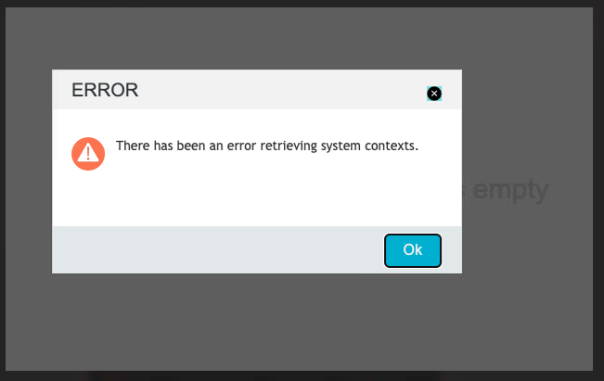

Issue found in WL log:

l3anu07@amd07adc-uat.adc1.level3.com:l3anu07/JEE/logs> less AnnServer_20231011_142424.log
ERROR_CODE=50701: I/O error on GET request for https://amd07adc-uat.adc1.level3.com:443/AmdocsOSS/Configurations/services/rest/v1/config/amdocs.oss.ann.services.url.system: sun.security.validator.ValidatorException: PKIX path building failed: sun.security.provider.certpath.SunCertPathBuilderException: unable to find valid certification path to requested target; nested exception is javax.net.ssl.SSLHandshakeException: sun.security.validator.ValidatorException: PKIX path building failed: sun.security.provider.certpath.SunCertPathBuilderException: unable to find valid certification path to requested target
com.amdocs.oss.ann.exception.SearchException: I/O error on GET request for https://amd07adc-uat.adc1.level3.com:443/AmdocsOSS/Configurations/services/rest/v1/config/amdocs.oss.ann.services.url.system: sun.security.validator.ValidatorException: PKIX path building failed: sun.security.provider.certpath.SunCertPathBuilderException: unable to find valid certification path to requested target; nested exception is javax.net.ssl.SSLHandshakeException: sun.security.validator.ValidatorException: PKIX path building failed: sun.security.provider.certpath.SunCertPathBuilderException: unable to find valid certification path to requested target
at com.amdocs.oss.ann.search.rs.model.proxy.impl.DefaultSystemServiceClientProxy.getSystems(DefaultSystemServiceClientProxy.java:101)
at com.amdocs.oss.ann.search.rs.system.SystemServiceImpl.getProfiledSystems(SystemServiceImpl.java:98)
at sun.reflect.NativeMethodAccessorImpl.invoke0(Native Method)
at sun.reflect.NativeMethodAccessorImpl.invoke(NativeMethodAccessorImpl.java:62)
at sun.reflect.DelegatingMethodAccessorImpl.invoke(DelegatingMethodAccessorImpl.java:43)
at java.lang.reflect.Method.invoke(Method.java:498)
at org.apache.cxf.service.invoker.AbstractInvoker.performInvocation(AbstractInvoker.java:179)
at org.apache.cxf.service.invoker.AbstractInvoker.invoke(AbstractInvoker.java:96)
at org.apache.cxf.jaxrs.JAXRSInvoker.invoke(JAXRSInvoker.java:201)
at org.apache.cxf.jaxrs.JAXRSInvoker.invoke(JAXRSInvoker.java:104)
at org.apache.cxf.interceptor.ServiceInvokerInterceptor$1.run(ServiceInvokerInterceptor.java:59)
at org.apache.cxf.interceptor.ServiceInvokerInterceptor.handleMessage(ServiceInvokerInterceptor.java:96)
at org.apache.cxf.phase.PhaseInterceptorChain.doIntercept(PhaseInterceptorChain.java:308)
at org.apache.cxf.transport.ChainInitiationObserver.onMessage(ChainInitiationObserver.java:121)
at org.apache.cxf.transport.http.AbstractHTTPDestination.invoke(AbstractHTTPDestination.java:267)
This communication is the property of Lumen Technologies and may contain confidential or privileged information. Unauthorized use of this communication is strictly prohibited and may be unlawful. If you have received this communication in error, please immediately notify the sender by reply e-mail and destroy all copies of the communication and any attachments.

FIX:
Fixing by coping the certificate again:

cd ../anndomain/config/certificates/

mkdir old

mv asri.deviat.keystore.pkcs12 asri.deviat.truststore.pkcs12 old
cp /app/infraoss/l3/STORAGE/INFRA/CERTIFICATES/iatdev/*.pkcs12 .

ANN GUI is not opening:

Please do the following:
sudo systemctl status nginx
sudo systemctl start nginx
sudo systemctl enable nginx

Update new instance for AMC
PFB the mail the list of config files I updated with new DB host in Genesis

- L3AMC

amc-9.0.0-install.properties.tmp
AmcMaster.topology
EnvVariables.properties
amc.database-config.properties
amc.configuration-config.properties
AmcRunSqlPIConList.xml
AmcRunSqlPIConList.xml.sav
GenesisDB.properties
ant.install.properties
GenesisDB.properties
Tnsname.ora

- L3ADM

ARM_E2E_USER_Import/

As soon as we

Lets try to test all configuration are good, to be ready in the next release in PROD

Issue:

Falling in the job: LEVEL3_SFO_P1_GENERATE_HF_JOB_FOR_DEV_MAIN

Started by user Shailendra Singh Negi
[EnvInject] - Loading node environment variables.
Building on master in workspace /ossuser1/users/users/jenkins/jenkins-production/jobs/LEVEL3_SFO_P1_GENERATE_HF_JOB_FOR_DEV_MAIN/workspace
[workspace] $ /bin/sh -xe /ossuser1/users/users/jenkins/apache-tomcat/apache-tomcat-7.0.42/temp/hudson7818213960017606395.sh
+ cd /infraoss/l3/STORAGE/INFRA/prepare-artifact-hf/DevMain
+ '[' NO == YES ']'
+ '[' NO == YES ']'
+ '[' NO == YES ']'
+ '[' YES == YES ']'
+ curl -s -X POST -H 'Authorization: Uams UGF0aGlrR0BVbml4MTEh' -H 'Content-Type: application/xml' -d @HF_sql.xml http://illin3643:10888/amc_illin3643/rest/hotfix/CreateHotfixRequest
Build step 'Execute shell' marked build as failure
Finished: FAILURE

FIX:

Boot the AMC TOOL in illin3643

to disable archive:

sqlplus / as sysdba
archive log list
shutdown immediate
startup mount
alter database noarchivelog;
alter database open;
ISSUE in ATT MEX:

Started by user anonymous
[EnvInject] - Loading node environment variables.
Building remotely on auabuild_ntcibuild in workspace /home/auabuild/workspace/1021_2023P4S5_4525_FLOW_FLOW
Using remote perforce client: ATT_MEXICO_AUA_1021_2023P4S5_4525_BUILD-1242682980
[1021_2023P4S5_4525_FLOW_FLOW] $ /opt/perforce/p4 workspace -o ATT_MEXICO_AUA_1021_2023P4S5_4525_BUILD-1242682980
Caught exception communicating with perforce. Access for user 'com.tek42.perforce.PerforceException: Access for user '
at com.tek42.perforce.parse.AbstractPerforceTemplate.getPerforceResponse(AbstractPerforceTemplate.java:406)
at com.tek42.perforce.parse.AbstractPerforceTemplate.getPerforceResponse(AbstractPerforceTemplate.java:301)
at com.tek42.perforce.parse.Workspaces.getWorkspace(Workspaces.java:61)
at hudson.plugins.perforce.PerforceSCM.getPerforceWorkspace(PerforceSCM.java:1641)
at hudson.plugins.perforce.PerforceSCM.getPerforceWorkspace(PerforceSCM.java:1602)
at hudson.plugins.perforce.PerforceSCM.checkout(PerforceSCM.java:907)
at hudson.model.AbstractProject.checkout(AbstractProject.java:1252)
at hudson.model.AbstractBuild$AbstractBuildExecution.defaultCheckout(AbstractBuild.java:604)
at jenkins.scm.SCMCheckoutStrategy.checkout(SCMCheckoutStrategy.java:86)
at hudson.model.AbstractBuild$AbstractBuildExecution.run(AbstractBuild.java:513)
at hudson.model.Run.execute(Run.java:1706)
at hudson.model.Build.run(Build.java:112)
at hudson.model.ResourceController.execute(ResourceController.java:88)
at hudson.model.Executor.run(Executor.java:231)
ERROR: Unable to communicate with perforce. Access for user '
Finished: FAILURE

FIX:

=========================== Delivery steps ===========================

Check before starting :

- Check attmexoss creds in Jenkins

Jenkins -> manage Jenkins -> Configure System -> Perforce SCM and in PCI Tools P4 Connection Details for SCM

18-May-2022 Elad Nachshon:
attmexoss / AttMexOSS_1!

tar czf backups/OSS2101.pre-reinstall.tgz .StorageMetadata .asp .xpi installer ResourceManagementWebLogic3 storage installer-resources JEE
ISSUE:

Getting this error when booting WL

pldarm01@ilospld184:pldarm01/JEE/pldarm01/logs

starting weblogic server...
Java HotSpot(TM) 64-Bit Server VM warning: ignoring option MaxPermSize=1024m; support was removed in 8.0
Error: Could not find or load main class weblogic.Server
weblogic.20240213_100834.log (END)

FIX:

Login to jenkins@ilostfc001 and copy the WL to the ilospld184 server under /opt:

jenkins@ilostfc001:/infraoss/tfc/programs> ll weblogic1221_patch.tar
-rwxr-xr-x 1 tfcadm wladmin 1094809600 Feb 19 2019 weblogic1221_patch.tar

ISSUE:

,FaultID=18DBC2B830BA347E556C1D141AD,Message=com.cramer.core.sso.CramerSSOException: Error caught during user sync process.javax.naming.NamingException: java.sql.SQLException: Attempt to set connection harvestable to false but the connection is already closed.

FIX:

Please reboot ARM

Please boot again webswing and check again

Change parameters in file for nexus issue:

  - Put the war file backup folder tal and open it:
  - Check which files need to be updated
  - jar -tvf sfo-war-10.0.0.0.0.war.30.10.23 | grep npm-shrinkwrap.json
  - don’t open all the war. release just the file we need to update:

jar -xvf sfo-war-10.0.0.0.0.war.30.10.23 app/amdocs/smallcell/components/business//:q!:/npm-shrinkwrap.json

- update the file: cd app/amdocs/smallcell/components/business/projects-list/
- vi npm-shrinkwrap.json
- pack the file to the war:
jar -uvf sfo-war-10.0.0.0.0.war.30.10.23 app/amdocs/smallcell/components/business/projects-list/npm-shrinkwrap.json

- delete the app file which you open:
rm -rf app
- do the same for all files you need to update

jar -xvf sfo-war-10.0.0.0.0.war.30.10.23 app/amdocs/smallcell/components/business/projects-list/npm-shrinkwrap.json

Change parameters in file for nexus issue:

  - Put the war file backup folder tal and open it:

/lvlhome/lvl/cclvl/mb_cclvl/.m2_CTL_V21_20232508_OGS_AUG25/repository/com/amdocs/oss/sfo/sfo-war/10.0.0.0.0/avi

jar xvf sfo-war-10.0.0.0.0.war

  - Run this coomend to change the ip from 10.247.24.18 to 10.247.24.11:

find -type f | xargs perl -p -i -e 's#10.247.24.18#10.247.24.11#g'

find -type f | xargs perl -p -i -e 's#10.247.24.18#10.247.24.11#g'

  - check if the ip was changed:

1026 find . -type f | xargs grep 10.247.24.18
1027 find . -type f | xargs grep 10.247.24.11

4. run this command to pack the war back in avi folder:

jar uf sfo-war-10.0.0.0.0.war *

put the war back to the main folder.

ZIP folder:

zip -r folder.zip folder

zip -r mec-home_update.zip mec-home

check the key in MEC:

keytool -list -v -keystore /ossusers1/oss/users/mecusr01/mec-home/properties/keystore.jks |less

password: Unix11

ISSUE:

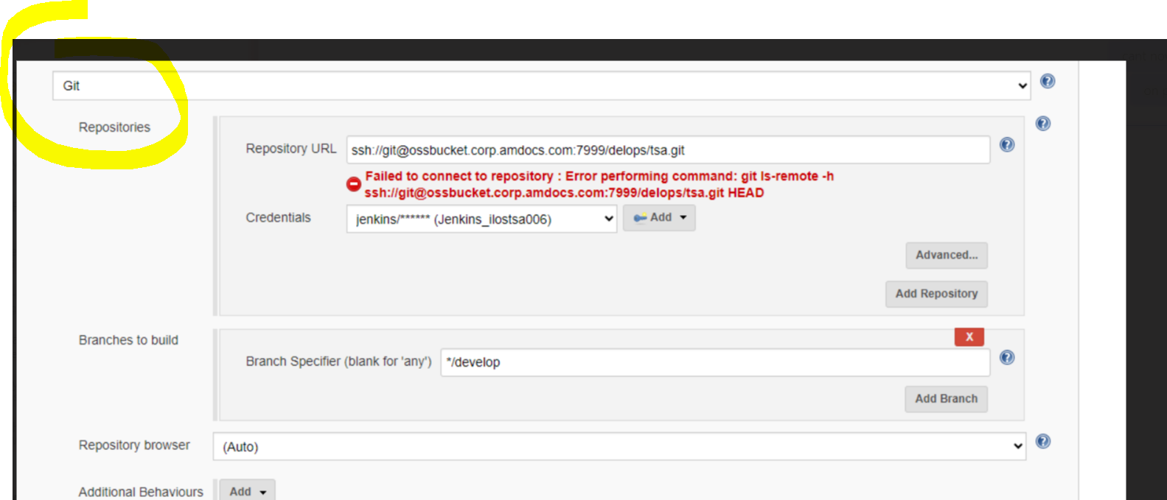

FIX:

We found In the Jenkins unix server that git is missing:

    - copy git from another Jenkins to /usr/bin/git
    - run in the env: git clone ssh://git@ossbucket:7999/delops/tsas.git

ISSUE:

Hi Avi,
java.lang.IllegalArgumentException: CRM License could not be installed. Check the installation log file for more information.
The SOMUSR01 seems to be missing ACL privilege.

SQL> select utl_inaddr.get_host_name,utl_inaddr.get_host_address from dual;
select utl_inaddr.get_host_name,utl_inaddr.get_host_address from dual
*
ERROR at line 1:
ORA-24247: network access denied by access control list (ACL)
ORA-06512: at "SYS.UTL_INADDR", line 4
ORA-06512: at "SYS.UTL_INADDR", line 35
ORA-06512: at line 1

Please check.

FIX:

First login with sys dba and run:
sqlplus / as sysdba

GRANT EXECUTE ON SYS.UTL_INADDR TO SOM05;

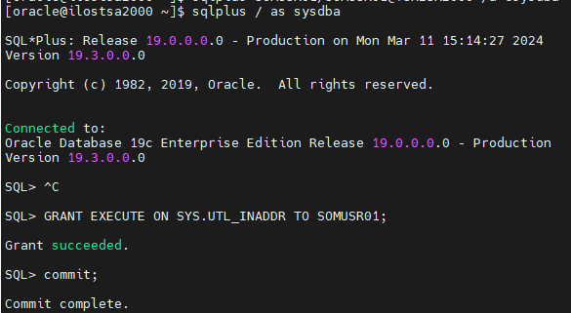

GRANT EXECUTE ON SYS.UTL_INADDR TO SOMUSR01;

Now login wit: oracle@ilostsa2000 ~]$ sqlplus SOMUSR01/SOMUSR01@TSAISR2000

exec sys.DBMS_NETWORK_ACL_ADMIN.CREATE_ACL('ACL_SOMUSR01.xml','ACL for dt3somt201', 'SOMUSR01', TRUE, 'resolve');
exec sys.DBMS_NETWORK_ACL_ADMIN.ASSIGN_ACL('ACL_SOMUSR01.xml','*');
exec sys.DBMS_NETWORK_ACL_ADMIN.ADD_PRIVILEGE('ACL_SOMUSR01.xml','SOMUSR01', TRUE, 'resolve');

ISSUE:

Getting this issue when booting ANN WebSwing:

2024-03-13 14:31:55.221:INFO:oejus.SslContextFactory:Enabled Protocols [TLSv1, TLSv1.1, TLSv1.2] of [SSLv2Hello, SSLv3, TLSv1, TLSv1.1, TLSv1.2]
2024-03-13 14:31:55.225:WARN:oejuc.AbstractLifeCycle:FAILED SslSelectChannelConnector@0.0.0.0:50151: java.net.BindException: Address already in use
java.net.BindException: Address already in use
at sun.nio.ch.Net.bind0(Native Method)
at sun.nio.ch.Net.bind(Net.java:433)
at sun.nio.ch.Net.bind(Net.java:425)
at sun.nio.ch.ServerSocketChannelImpl.bind(ServerSocketChannelImpl.java:223)
at sun.nio.ch.ServerSocketAdaptor.bind(ServerSocketAdaptor.java:74)
at org.eclipse.jetty.server.nio.SelectChannelConnector.open(SelectChannelConnector.java:187)
at org.eclipse.jetty.server.AbstractConnector.doStart(AbstractConnector.java:316)
at org.eclipse.jetty.server.nio.SelectChannelConnector.doStart(SelectChannelConnector.java:265)
at org.eclipse.jetty.server.ssl.SslSelectChannelConnector.doStart(SslSelectChannelConnector.java:631)
at org.eclipse.jetty.util.component.AbstractLifeCycle.start(AbstractLifeCycle.java:64)
at org.eclipse.jetty.server.Server.doStart(Server.java:293)
at org.eclipse.jetty.util.component.AbstractLifeCycle.start(AbstractLifeCycle.java:64)
at org.webswing.ServerMain.main(ServerMain.java:317)
at sun.reflect.NativeMethodAccessorImpl.invoke0(Native Method)
at sun.reflect.NativeMethodAccessorImpl.invoke(NativeMethodAccessorImpl.java:62)
at sun.reflect.DelegatingMethodAccessorImpl.invoke(DelegatingMethodAccessorImpl.java:43)
at java.lang.reflect.Method.invoke(Method.java:498)
at main.Main.main(Main.java:62)
2024-03-13 14:31:55.226:WARN:oejuc.AbstractLifeCycle:FAILED org.eclipse.jetty.server.Server@60215eee: java.net.BindException: Address already in use

FIX:
kill all process in USM and ODO and reboot ANN include onp.

After ANN is up good boot ODO and USM

ISSUE:

ANN GUI is open fine, but I am getting this issue when login to DEVICE:

I can see this error in log:

2024-03-20 12:05:45,636 INFO [Thread-88] (Los.java:40) [Split5467590102:VGtzbWF1NUNOcE10R3htdkN9SU5qTlhLWkl4YW1zRmZjQldDNkJWMA==:65579532661cRMWizards-RM] ,FaultID=18E5B52EE5AD6CA60D9DB2403C4,Message=CramerInstanceLocator error: unable to retrieve application attributes for tier com.cramer.instancelocatorlocator.web for application name L3STRM07

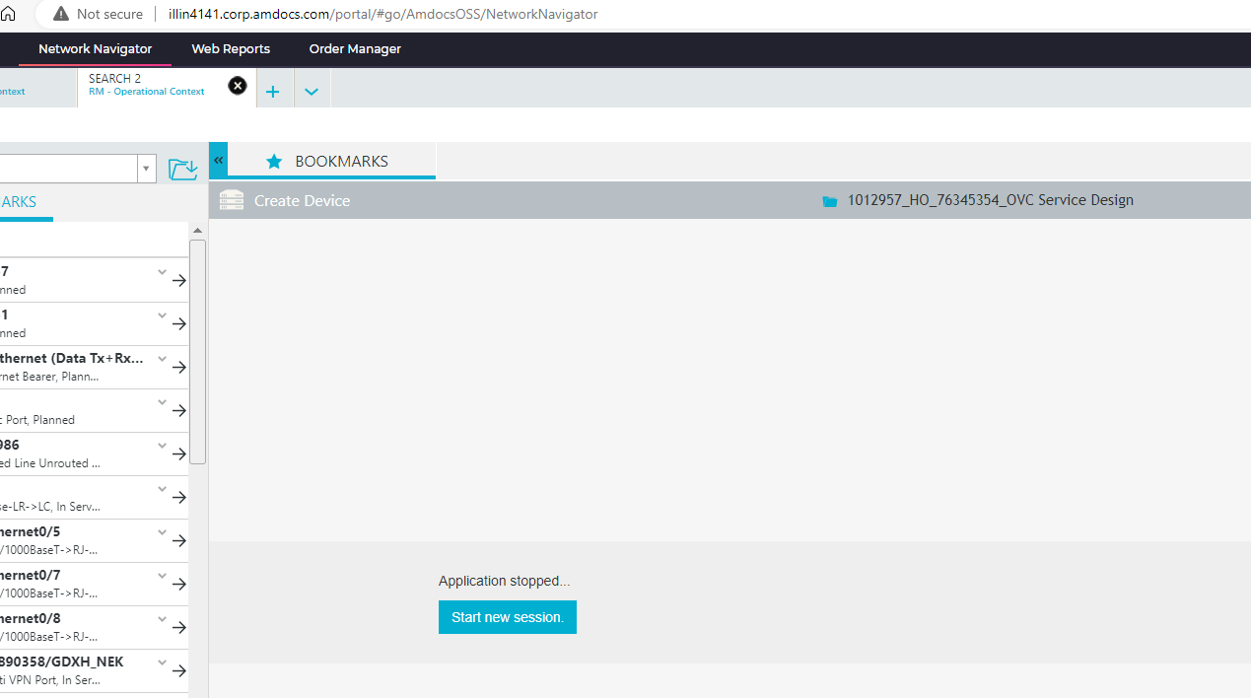

FIX:

Please copy from WebSwing folder backup the file webswing.config

( the instance is different in the file)

Please reboot the WebSwing and check again.

Hi All,
IAT02 env is working now.
I am sharing the fixes for all the issues I faced on IAT02, I will request you to pay attention to the email and learn from it.
Here are the fixes for the issues :

- ANN Login Failure: Login to ONP was failing because in ANN ${HOME}/asm_home/uams.properties all the LDAP Properties were commented.

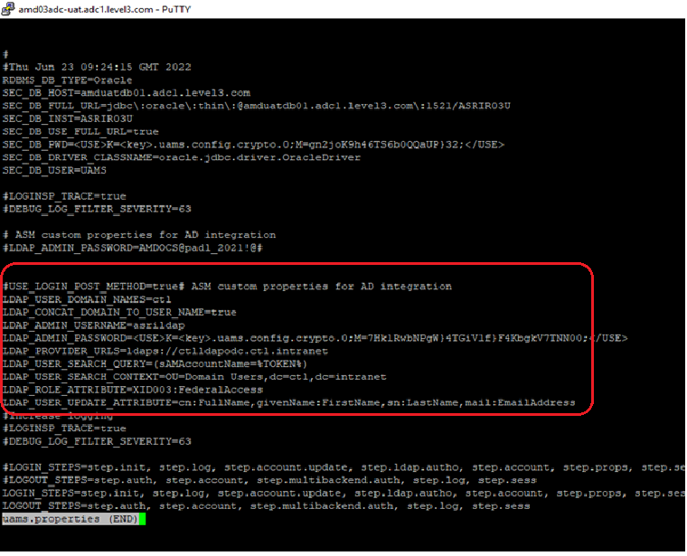

- Webswing Issue : webswing.conf has incorrect port for USM (it was 30203). The correct value for IAT02 is 30303 .
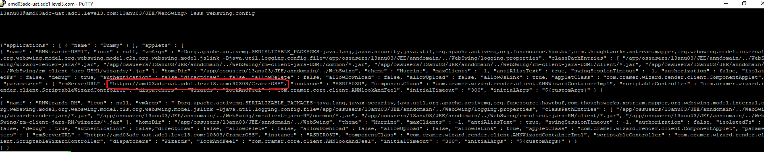

- USM Issue: USM Env had issues after restart, the problem was with dimensionparameter having Instancename as lowercase value asris03u. I corrected it to uppercase value ASRIS03U.
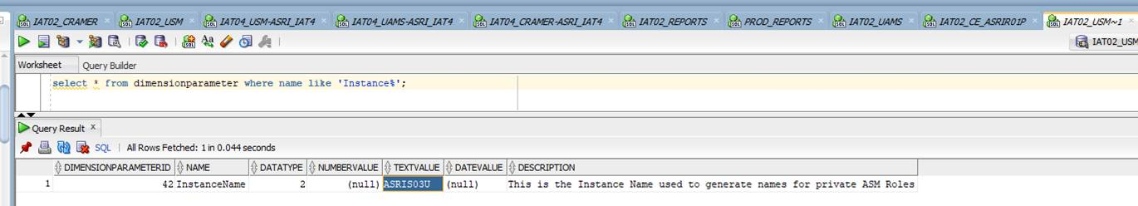

- SDV/CE: SDV and Circuit Editor tables aredatasource and areparameter had some incorrect value.
AREDATASORUCE Issues: @Araceli Cortes Martinez we will have to fix the Clonning script and Properties file here.
- DATASOURCESCHMA column had values of DATASOURCEUSER , instead the correct values are the DB InstanceName/SID/Service Name . Please find below screenshot with expected values.
- DATASOURCEUSER column for ODO had values as L3ODO03_AFFSUSER , the correct value is L3ODO03_AFFUSER (removed S).

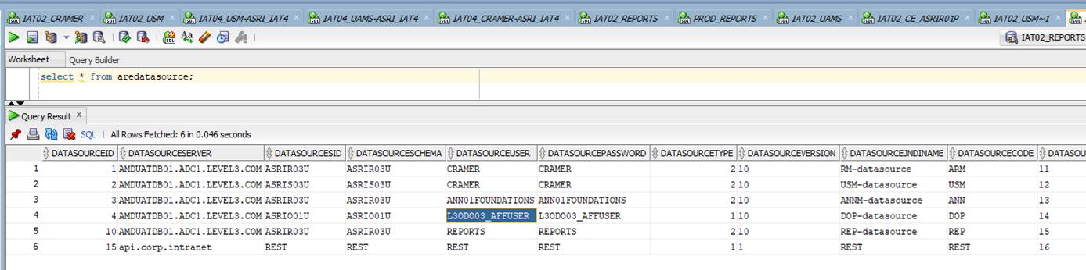
AREPARAMETER:
- All the selected values were incorrect, the host and port both were the same , so the url was http://amd03adc-uat.adc1.level3.com: amd03adc-uat.adc1.level3.com/areapi/AreDataService , instead of http://amd03adc-uat.adc1.level3.com:11301/areapi/AreDataService .
I have corrected it. Please find screenshot of expected values.

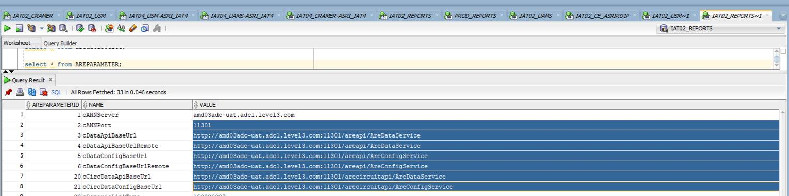
ISSUE:

Start Loading library ... JNIEngine
ASCF Jar Versions: UIFCommon.jar=9.22.0.pb00hf02, AmdocsCore.jar=9.0.0.pb00_hf17, UIFServer.jar=9.22.0.pb00hf02
<Mar 20, 2024 3:36:13,234 PM IST> <Warning> <EJB> <BEA-010227> <EJB exception occurred during invocation from home or business: com.amdocs.oss.sm.components.util.internal.ejb.ComponentsInitManagerBean_kh71x
5_Intf of EJB: components.ComponentsInitManager(Application: asmsServer_somusr03_AsmsApp, EJBComponent: AsmsComponentsEjbDesc.jar) generated exception: com.clarify.cbo.CboError: Login failed for user 'Asmsa
1'. Message: 'Error in login step amdocs.uamsimpl.server.login.step.session.SessionStepModule$TraceSessionStep in commit method'

Caused By: com.clarify.cbo.CboError: Login failed for user 'Asmsa1'. Message: 'Error in login step amdocs.uamsimpl.server.login.step.session.SessionStepModule$TraceSessionStep in commit method'

FIX:

Login to UAMS DB and do the following:

SQL> truncate table SEC_SESSION;

Table truncated.

SQL> truncate table SEC_SESSION_IDLE;

Table truncated.

SQL> commit;

ISSUE:

Failing on this job in TSA: TSA_4000_SM_NIGHTLY_CI_INC_BUILD_NUM

Started by flow project TSA_4000_SM_NIGHTLY_CI_FLOW build number #169
Running as SYSTEM
Notifying parent flow TSA_4000_SM_NIGHTLY_CI_FLOW #169 that I have started
[EnvInject] - Loading node environment variables.
Building remotely on mb_cctsa_ilostsa006 in workspace /osshome/os/mb_cctsa/workspace/TSA_4000_SM_NIGHTLY_CI_FLOW
[scripts] $ ant -file ci-utils.xml -DVERSION=DevMain -Dbuild.mode=daily -Dbranch.name=DevMain inc_build_number
Error: Could not find or load main class org.apache.tools.ant.launch.Launcher
Build step 'Invoke Ant' marked build as failure
Notifying parent flow TSA_4000_SM_NIGHTLY_CI_FLOW #169 that I have completed
Finished: FAILURE

FIX:

Login to mb_cctsa@ilostsa006 and copy the tools folder from:

ilostsa006-/osshome/os/mb_cctsa/.bck_do_not_delete> tools.zip

to home directory and unzip it.

ilostsa006-/osshome/os/mb_cctsa/tools> ll
total 25296
drwxrwxr-x 6 mb_cctsa mb_cctsa 4096 Mar 6 10:12 ant
drwxrwxr-x 6 mb_cctsa mb_cctsa 4096 Mar 6 10:12 ant-1.7.0
-rwxrwxr-x 1 mb_cctsa mb_cctsa 20986332 Mar 7 14:48 ant-1.7.0.gtz
-rwxrwxr-x 1 mb_cctsa mb_cctsa 3932 Mar 7 14:48 ci-utils.xml
drwxrwxr-x 4 mb_cctsa mb_cctsa 4096 Mar 6 10:12 hudson.plugins.sonar.SonarRunnerInstallation
drwxrwxr-x 3 mb_cctsa mb_cctsa 4096 Mar 6 10:12 hudson.tasks.Maven_MavenInstallation
drwxrwxr-x 6 mb_cctsa mb_cctsa 4096 Mar 6 10:12 maven
drwxrwxr-x 6 mb_cctsa mb_cctsa 4096 Mar 6 10:12 maven-3.0.4
-rwxrwxr-x 1 mb_cctsa mb_cctsa 4884462 Mar 7 14:48 maven304.gtz
ilostsa006-/osshome/os/mb_cctsa/tools>

now run again the job.

ISSUE:

<Mar 27, 2024 10:51:53 AM IST> <Critical> <WebLogicServer> <BEA-000386> <Server subsystem failed. Reason: A MultiException has 2 exceptions. They are:
1. java.lang.IllegalStateException: TimerManager is in STOPPED state
2. java.lang.IllegalStateException: Unable to perform operation: post construct on weblogic.ejb.container.timer.EJBTimerStarterActivator

A MultiException has 2 exceptions. They are:
1. java.lang.IllegalStateException: TimerManager is in STOPPED state
2. java.lang.IllegalStateException: Unable to perform operation: post construct on weblogic.ejb.container.timer.EJBTimerStarterActivator

at org.jvnet.hk2.internal.ClazzCreator.create(ClazzCreator.java:447)
at org.jvnet.hk2.internal.SystemDescriptor.create(SystemDescriptor.java:456)
at org.glassfish.hk2.runlevel.internal.AsyncRunLevelContext.findOrCreate(AsyncRunLevelContext.java:225)
at org.glassfish.hk2.runlevel.RunLevelContext.findOrCreate(RunLevelContext.java:82)
at org.jvnet.hk2.internal.Utilities.createService(Utilities.java:2488)
Truncated. see log file for complete stacktrace
Caused By: java.lang.IllegalStateException: TimerManager is in STOPPED state
at weblogic.timers.internal.TimerManagerImpl.schedule(TimerManagerImpl.java:488)
at weblogic.ejb.container.timer.EJBTimerManager.scheduleTimer(EJBTimerManager.java:191)
at weblogic.ejb.container.timer.EJBTimerManager.enableDisabledTimers(EJBTimerManager.java:147)
at weblogic.ejb.container.timer.EJBTimerManager.start(EJBTimerManager.java:617)
at weblogic.ejb.container.timer.EJBTimerStarter.startTimerManagers(EJBTimerStarter.java:60)
Truncated. see log file for complete stacktrace
>
<Mar 27, 2024 10:51:53 AM IST> <Notice> <WebLogicServer> <BEA-000365> <Server state changed to FAILED.>
<Mar 27, 2024 10:51:53 AM IST> <Error> <WebLogicServer> <BEA-000383> <A critical service failed. The server will shut itself down.>
<Mar 27, 2024 10:51:53 AM IST> <Notice> <WebLogicServer> <BEA-000365> <Server state changed to FORCE_SHUTTING_DOWN.>
<Mar 27, 2024 10:51:53 AM IST> <Notice> <Server> <BEA-002607> <Channel "Default", listening on 10.234.101.23:29940, was shut down.>
<Mar 27, 2024 10:51:53 AM IST> <Notice> <Server> <BEA-002607> <Channel "Default[1]", listening on fe80:0:0:0:250:56ff:fe91:2021:29940, was shut down.>
<Mar 27, 2024 10:51:53 AM IST> <Notice> <Server> <BEA-002607> <Channel "Default[2]", listening on 0:0:0:0:0:0:0:1:29940, was shut down.>
<Mar 27, 2024 10:51:53 AM IST> <Notice> <Server> <BEA-002607> <Channel "Default[3]", listening on 127.0.0.1:29940, was shut down.>
Mar 27, 2024 10:51:53 AM weblogic.wsee.WseeCoreMessages logWseeServiceHalting

FIXED:
The uams.properties was updated with environment variable: STEP_CONS_INACTIVE_TIME=100000

ISSUE:

Started by flow project TSA_4000_SM_NIGHTLY_CI_FLOW build number #184
Running as SYSTEM
Notifying parent flow TSA_4000_SM_NIGHTLY_CI_FLOW #184 that I have started
[EnvInject] - Loading node environment variables.
Building remotely on mb_cctsa_ilostsa006 in workspace /osshome/os/mb_cctsa/workspace/TSA_4000_SM_NIGHTLY_CI_FLOW
Run condition [Always] enabling prebuild for step [BuilderChain]
Run condition [And] enabling prebuild for step [BuilderChain]
Run condition [Or] enabling prebuild for step [Changes build description]
[TSA_4000_SM_NIGHTLY_CI_FLOW] $ /bin/ksh /tmp/jenkins7190650698414453356.sh
delete file - IsRanAlready.txt
[TSA_4000_SM_NIGHTLY_CI_FLOW] $ /bin/ksh /tmp/jenkins6562972977106372569.sh
Run condition [Always] enabling perform for step [BuilderChain]
[TSA_4000_SM_NIGHTLY_CI_FLOW] $ /bin/ksh /tmp/jenkins7226434194545340118.sh
job name = build
latestSmartClientClFromP4 = 12504895
/osshome/os/mb_cctsa/p4SmartClientChangeList.txt file found.
Found changes in smartClient
Build step 'Conditional steps (multiple)' marked build as failure
Notifying parent flow TSA_4000_SM_NIGHTLY_CI_FLOW #184 that I have completed
Finished: FAILURE

FIX:

Login to mb_cctsa env and delete the file jobStartChangeList.txt

ISSUE:

When running SOM installation:

[11:43:51] [ERROR] amdocs.installer.util.exitpoint.impl.ExitPointInstallManager executeExitPoint fail with java.lang.RuntimeException java.lang.RuntimeException: java.lang.IllegalArgumentException: CRM Lice
nse could not be installed. Check the installation log file for more information.
[11:43:51] [ERROR] class com.amdocs.oss.sm.xpi.exitpoint.db.LicInstall exit point failure Stack Trace is -
java.lang.RuntimeException: java.lang.IllegalArgumentException: CRM License could not be installed. Check the installation log file for more information.
at com.amdocs.oss.sm.xpi.exitpoint.AsmsDBExitPointBase.raiseException(AsmsDBExitPointBase.java:83)
at com.amdocs.oss.sm.xpi.exitpoint.AsmsDBExitPointBase.raiseException(AsmsDBExitPointBase.java:66)

Check in Home if your getting in JavaOutput.log this:

Caused by: java.sql.SQLException: ORA-24247: network access denied by access control list (ACL)
ORA-06512: at "SYS.UTL_INADDR", line 4
ORA-06512: at "SYS.UTL_INADDR", line 35
ORA-06512: at line 1

FIX:

First login with sys dba and run: sqlplus / as sysdba
GRANT EXECUTE ON SYS.UTL_INADDR TO SOMUSR01;



GRANT EXECUTE ON SYS.UTL_INADDR TO SOMUSR01;

Now login wit: oracle@ilostsa2000 ~]$ sqlplus SOMUSR01/SOMUSR01@TSAISR2000

exec sys.DBMS_NETWORK_ACL_ADMIN.CREATE_ACL('ACL_SOMUSR01.xml','ACL for dt3somt201', ' SOMUSR01', TRUE, 'resolve');
exec sys.DBMS_NETWORK_ACL_ADMIN.ASSIGN_ACL('ACL_ SOMUSR01.xml','*');
exec sys.DBMS_NETWORK_ACL_ADMIN.ADD_PRIVILEGE('ACL_ SOMUSR01.xml','SOMUSR01', TRUE, 'resolve');

Open new version:

http://illin1161:8080/job/Version_Creation_OSS_illin1696/19/parameters/

Parameters [Jenkins]

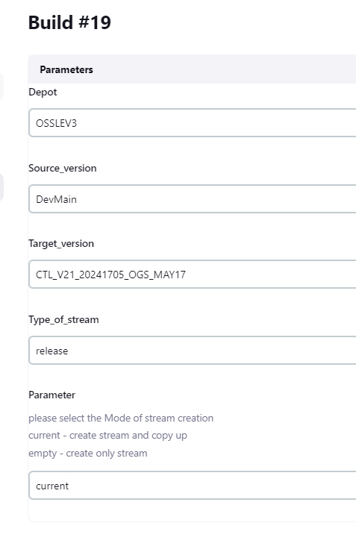

ISSUE:

Graph is not present in the GUI

FIX:

      - Login to the UNIX server which you have the Jenkins
      - Run rpm -qa | grep graphviz for checking
      - Run yum install graphviz -y for install the Graph.

ISSUE:
When login to inproc I am getting this error: Error in login step amdocs.uamsimpl.server
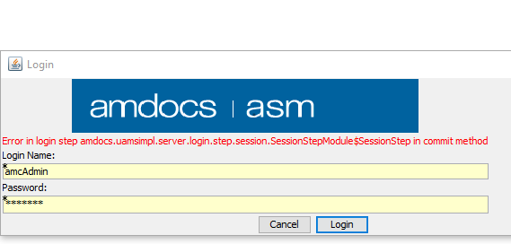

FIX:
usmusr01@ilostsa008:usmusr01> sqlplus UAMS/UAMS@TSAUSM08

SQL> truncate table SEC_SESSION;

Table truncated.

SQL> truncate table SEC_SESSION_IDLE;

Table truncated.

Try to login again

ISSUE:
they need to crate tablespace:
DMU_DATA
TOOLS
UNDOTBS2
USM_ACCESS_DATA
USM_ACCESS_INDEX
USM_EQUIPMENT_DATA
USM_EQUIPMENT_INDEX
USM_INTERNET_DATA
USM_INTERNET_INDEX
USM_TV_DATA
USM_TV_INDEX
USM_WIRELINE_DATA
USM_WIRELINE_INDEX
XDB
FIX:

Run this for every table:
CREATE TABLESPACE XDB DATAFILE '/oravl02/oradata/TSAISR004/XDB.dbf' SIZE 1024M;

ISSUE:

When running XPI installation I am getting:

./installer/bin/XPI.sh: line 15: 1990911: Killed
+ [ 137 -eq 0 ]
+ echo 'Xpi Installation Failed please check Xpi logs '
Xpi Installation Failed please check Xpi logs
+ exit 1
Build step 'Execute shell' marked build as failure
Finished: FAILURE

FIX:

Please add more memory and CPU ( we can do it via VRA)

Issue:

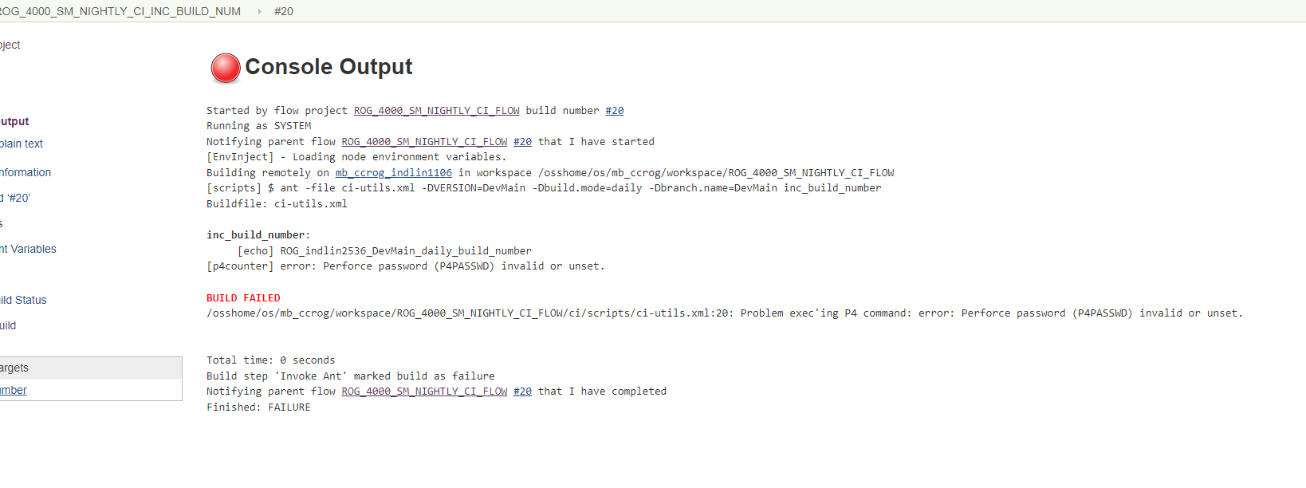

FIX:
Hi Anat,
I just wanted to thank you for your help and time – thanks to you the issue was fixed!
First we grepped in the reference TSA env the P4 password, then we found the password in “.p4pass” file is: Unix17!
Then we logged in to the rogers env and logged in with the same password to P4.
Thank you!
Asaf

ilostsa006-/osshome/os/mb_cctsa1> grep "p4 login" .*
grep: .cache: Is a directory
.cshrc:#p4 login < ~/.pass/.p4pass
ilostsa006-/osshome/os/mb_cctsa1> vi ~/.pass/.p4pass (to see the password)

indlin1106-/osshome/os/mb_ccrog> p4 login
Enter password:
User ccsmcom logged in.

ISSUE:

tarted by user Avi Saar
Running as SYSTEM
[EnvInject] - Loading node environment variables.
Building remotely on mb_cctsa2_ilostsa006 in workspace /osshome/os/mb_cctsa2/workspace/TSA_4200_SM_NIGHTLY_CI_FLOW
[scripts] $ ant -file ci-utils.xml -DVERSION=TestMain -Dbuild.mode=daily -DSTORAGE_HOME=/infraoss/tsa/STORAGE_LOCAL -Dbranch.name=TestMain -DSTORAGE_ACCOUNT=/infraoss/tsa/STORAGE_LOCAL -DSTORAGE_HOST=ilostsa006 create_buildlab_last_directory
Buildfile: ci-utils.xml

load_build_number:
[echo] P4 build number is : 61

create_build_number_directory:
[echo] mkdir -p /infraoss/tsa/STORAGE_LOCAL/ASMS/TestMain/daily/61
[exec] Permission denied, please try again.
[exec] Permission denied, please try again.
[exec] mb_cctsa2@ilostsa006: Permission denied (publickey,gssapi-keyex,gssapi-with-mic,password).

BUILD FAILED
/osshome/os/mb_cctsa2/workspace/TSA_4200_SM_NIGHTLY_CI_FLOW/ci/scripts/ci-utils.xml:30: exec returned: 255

Total time: 0 seconds
Build step 'Invoke Ant' marked build as failure
Finished: FAILURE

FIX:

Please do ssh to the env itself

./AddSSHEnv.ksh mb_cctsa2 ilostsa006

Patch checking:

Login to oracle user and run the following:

L3RCI404 /oravl01/oracle> setenv JAVA_HOME /usr/java/jdk1.8.0_74
L3RCI404 /oravl01/oracle> setenv WL_DIR /opt/weblogic12214
L3RCI404 /oravl01/oracle> setenv PATH $WL_DIR/OPatch:$PATH
L3RCI404 /oravl01/oracle> $WL_DIR/OPatch/opatch lsinventory -oh $WL_DIR/ -oui_loc $WL_DIR/oui/ -jdk ${JAVA_HOME}

ISSUE:

ppserver_deploy_action=deploy migrate_src_ossui_database_user_installer_name=CRAMER_INSTALLER webswing_server_port=40550 migrate_src_ossui_database_port=1521 appserver_vendor_home=/opt/weblogic12214/wlserver database_user_ann_name=ANN01 d2_2_plugin_datasource_password=CRAMERDIRECTORY d2_1_plugin_datasource_password=CRAMER_COMMON migrate_src_ossui_database_user_installer_password='"'"''"'"' database_port=1521 d1_plugin_database_name=L3UCI407 d1_plugin_database_port=1521 /usr/bin/python /ossusers1/oss/users/l3aci407/.ansible/tmp/ansible-tmp-1719305926.8-25302-236169995124757/AnsiballZ_yum_amdocs.py && sleep 0'
<iloslvl012.corp.amdocs.com> EXEC /bin/sh -c 'rm -f -r /ossusers1/oss/users/l3aci407/.ansible/tmp/ansible-tmp-1719305926.8-25302-236169995124757/ > /dev/null 2>&1 && sleep 0'
[WARNING]: The value 2 (type int) in a string field was converted to u'2' (type
string). If this does not look like what you expect, quote the entire value to
ensure it does not change.
[WARNING]: The value 30 (type int) in a string field was converted to u'30'
(type string). If this does not look like what you expect, quote the entire
value to ensure it does not change.
fatal: [iloslvl012.corp.amdocs.com]: FAILED! => {
"changed": false,
"cmd": "sudo /bin/yum install -y -d 2 amdocs-fdn-db",
"invocation": {
"module_args": {
"debuglevel": "2",
"diff_format": "txt",
"disablerepo": null,
"enablerepo": null,
"exclude": null,
"generate_rpm_diff": false,
"install_group": "30",
"install_top": true,
"name": [
"amdocs-fdn-db"
],
"state": "latest",
"update_cache": true,
"yum_path": "sudo /bin/yum"
}
},
"msg": "Error: Nothing to do",
"rc": 1,
"stderr": "Error: Nothing to do\n",
"stderr_lines": [
"Error: Nothing to do"
],
"stdout": "Loaded plugins: product-id, search-disabled-repos, subscription-manager\n\nThis system is not registered with an entitlement server. You can use subscription-manager to register.\n\nNo package amdocs-fdn-db available.\n",
"stdout_lines": [
"Loaded plugins: product-id, search-disabled-repos, subscription-manager",
"",
"This system is not registered with an entitlement server. You can use subscription-manager to register.",
"",
"No package amdocs-fdn-db available."
]
}

PLAY RECAP *********************************************************************
127.0.0.1 : ok=0 changed=0 unreachable=0 failed=0 skipped=7 rescued=0 ignored=0
iloslvl012.corp.amdocs.com : ok=34 changed=27 unreachable=0 failed=1 skipped=13 rescued=0 ignored=0

FIX:

Issue was solved.

Problem was found under /infraoss/l3/STORAGE/INFRA/CORE_INSTALLABLES/ANN2101/Installation-Archive-V2101/RPMS

The following files removed from the folder and the ANN was failed to install ANN.

After restoring the file from backup flow is running fine.

-rwxr-xr-x 1 l3adm users 17969620 Dec 15 2022 core-mm-plugin-lib-21.01.2-2157.rpm
-rwxr-xr-x 1 l3adm users 1647184 Dec 15 2022 ann-arm-mm-dataset-21.01.72-2512.rpm
-rwxr-xr-x 1 l3adm users 43020 Dec 15 2022 ann-arm-db-21.01.rpm
-rwxr-xr-x 1 l3adm users 12540 Dec 15 2022 rpm-db-create-tables-1.1.142.rpm
-rwxr-xr-x 1 l3adm users 12840 Dec 15 2022 ann-usm-db-21.01.rpm
-rwxr-xr-x 1 l3adm users 12806664 Dec 15 2022 oss-stm-10.4.242.rpm
-rwxr-xr-x 1 l3adm users 16513760 Dec 15 2022 ann-view-adapter-app-21.01.rpm
-rwxr-xr-x 1 l3adm users 9616 Dec 15 2022 config-db-21.01.rpm
-rwxr-xr-x 1 l3adm users 20411728 Dec 15 2022 ann-iwm-adapter-app-21.01.rpm
-rwxr-xr-x 1 l3adm users 132860768 Dec 15 2022 documentstorage-app-20.09.rpm
-rwxr-xr-x 1 l3adm users 108519072 Dec 15 2022 documentstorage-adapter-app-20.09.rpm
-rwxr-xr-x 1 l3adm users 4416 Dec 15 2022 rpm-db-init-data-1.1.142.rpm
-rwxr-xr-x 1 l3adm users 41232 Dec 15 2022 ann-mm-repo-21.01.rpm
-rwxr-xr-x 1 l3adm users 17245112 Dec 15 2022 ann-rest-security-adapter-app-21.01.rpm
-rwxr-xr-x 1 l3adm users 16956388 Dec 15 2022 graph-service-app-21.01.rpm
-rwxr-xr-x 1 l3adm users 50066760 Feb 14 2023 config-app-21.01.37-2359.rpm
-rwxr-xr-x 1 l3adm users 42004 Feb 14 2023 fdn-db-21.01.31-1988.rpm
-rwxr-xr-x 1 l3adm users 1529916 May 25 2023 ann-mm-plugin-lib-21.01.56-2450.rpm
-rwxr-xr-x 1 l3adm users 50075120 May 25 2023 config-app-21.01.91-2591.rpm
-rwxr-xr-x 1 l3adm users 106668924 May 25 2023 fdn-app-21.01.37-2359.rpm
-rwxr-xr-x 1 l3adm users 2830388 May 25 2023 relations-tree-app-21.01.51-2384.rpm

Hi Team,

The war file (sfo-war-10.0.0.0.0.war) for SFO run with the following servers:

mb_cclvl@illin569.corp.amdocs.com:mb_cclvl/.m2_CTL_V21__20231711_OGS__NOV17/repository/com/amdocs/oss/sfo/sfo-war/10.0.0.0.0/sfo-war-10.0.0.0.0.war

http://10.247.24.18:8081/repository/npm-registry/alphanum-sort

http://10.247.24.11:8081/repository/npm.delivery.releases/dop-table/-/dop-table-0.9.0.tgz

Eran suggested to move the data to CTL nexus in illin3643 server and use it instead of those servers:

http://illin3643:8081/nexus/#welcome

please suggest if it’s possible from our side to do it.

ISSUE:

When installation xpi:

14:48:40] [ERROR] Following modules can't be upgraded:USM OSSAPI DeliveryEngine SitePlanner RouteFinder ResourcePlanner
[14:48:40] [ INFO] com.cramer.install.xpi.core.exitpoint.ValidateSelectedProducts Validating the list of products to be installed
[14:48:40] [ INFO] com.cramer.install.xpi.core.exitpoint.ValidateSelectedProducts Exit point ended
[14:48:40] [ INFO] com.cramer.install.xpi.de.exitpoint.SetProviderEndPointsPreExitPoint validate start
[14:48:40] [ INFO] Parameter Name :jee.appserver.type
[14:48:40] [ INFO] amdocs.installer.workflow.InstallerWorkflowManager Running exit point updateResource from owner account.
[14:48:40] [ERROR]
amdocs.installer.exceptions.XPIException: (Installer1-000090) Exit point was failed in <pre-execution> of the entire topology. Error code is: <External_Messages_GUI_MISS_PARAMETER>, Error message is: <(Installer1-000321)

1) dir.db.password is a mandatory parameter
>
at amdocs.installer.workflow.AbstractWorkflowManager.handleExitPointStatusList(AbstractWorkflowManager.java:1272)
at amdocs.installer.workflow.AbstractWorkflowManager.execute(AbstractWorkflowManager.java:201)
at amdocs.installer.workflow.InstallerWorkflowManager.install(InstallerWorkflowManager.java:192)
at amdocs.installer.api.impl.InstallerToolkitImpl.install(InstallerToolkitImpl.java:368)
at amdocs.installer.engine.workflow.InstallWorkflowExecutor.doExecute(InstallWorkflowExecutor.java:450)
at amdocs.installer.engine.workflow.AbstractSilentDeployExecutor.execute(AbstractSilentDeployExecutor.java:137)
at amdocs.installer.api.cli.services.MainFlowBootstrapService.execute(MainFlowBootstrapService.java:185)
at sun.reflect.NativeMethodAccessorImpl.invoke0(Native Method)
at sun.reflect.NativeMethodAccessorImpl.invoke(NativeMethodAccessorImpl.java:62)
at sun.reflect.DelegatingMethodAccessorImpl.invoke(DelegatingMethodAccessorImpl.java:43)
at java.lang.reflect.Method.invoke(Method.java:498)
at com.amdocs.installer.Main.executeFlow(Main.java:293)
at com.amdocs.installer.Main.main(Main.java:90)
[14:48:40] [ WARN] Analyzer results are empty
[14:48:40] [ INFO] Generated diff report /users/tsa/tsausm3/.xpi/installations/ResourceManagementWebLogic3/reports/20240716144832/diffReport.xml
[14:48:40] [ INFO] Generated packages report /users/tsa/tsausm3/.xpi/installations/ResourceManagementWebLogic3/reports/20240716144832/packagesReport.xml
[14:48:40] [ INFO] Update support disabled, skipping topology lightpersist.
[14:48:42] [ERROR] ACMException @ FileUtils.encryptFile(/users/tsa/tsausm3/.xpi/installations/ResourceManagementWebLogic3/work/EnvVariables.properties) amdocs.acmarch.exceptions.ArchResourceException: (JF1-000176) An error occurred while trying to access the {0} file.
[14:48:42] [ERROR] ACMException @ FileUtils.encryptFile(/users/tsa/tsausm3/.xpi/installations/ResourceManagementWebLogic3/work/XPIEnvVariables.properties) amdocs.acmarch.exceptions.ArchResourceException: (JF1-000176) An error occurred while trying to access the {0} file.
[14:48:42] [ERROR] Command line activation failed. (exit status 40 )
[14:48:42] [ INFO] XPI process ended at 16/Jul/2024 02:48:42 PM
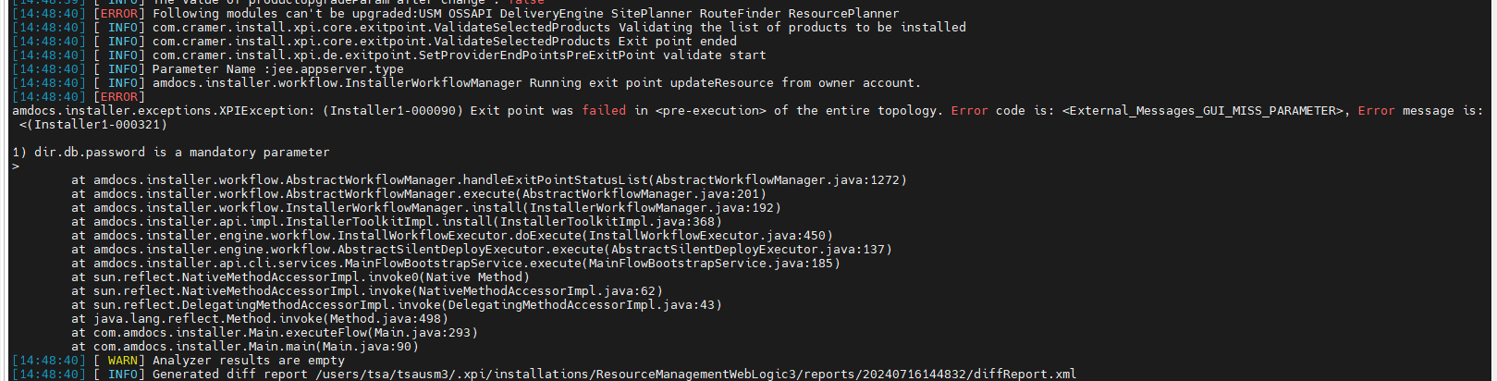

FIX:

you need clean-up the env

go to dist10/dba directory

then login as CRADBA/CRADBA123 as sysdba

then run drop_all.sql

once it's successful

run create_all.sql

then clean -up the app and re-run
ISSUE:

$ java -cp /users/tsa/prdsom1 SocketTest 10105
Port 10105 is closed.

ISSUE:

Hi @Avi Saar,

While running the order we are getting table does not exist error in USM logs but in DB we are able to see the tables.
Please Check.

PSB Error:
at weblogic.work.ExecuteThread.run(ExecuteThread.java:360)
Caused By: Error : 942, Position : 72, Sql = select USCM.name, USCM.columnname from USMSERVICECHARACTERISTIC_M USCM, USMSERVICETYPECHARACTERISTIC USTC WHERE USCM.USMCHARACTERISTICID = USTC.USTC2USMSERVICECHARACTERISTIC, OriginalSql = select USCM.name, USCM.columnname from USMSERVICECHARACTERISTIC_M USCM, USMSERVICETYPECHARACTERISTIC USTC WHERE USCM.USMCHARACTERISTICID = USTC.USTC2USMSERVICECHARACTERISTIC, Error Msg = ORA-00942: table or view does not existat oracle.jdbc.driver.T4CTTIoer11.processError(T4CTTIoer11.java:513)
at oracle.jdbc.driver.T4CTTIoer11.processError(T4CTTIoer11.java:461)
at oracle.jdbc.driver.T4C8Oall.processError(T4C8Oall.java:1104)
at oracle.jdbc.driver.T4CTTIfun.receive(T4CTTIfun.java:550)
at oracle.jdbc.driver.T4CTTIfun.doRPC(T4CTTIfun.java:268)
at oracle.jdbc.driver.T4C8Oall.doOALL(T4C8Oall.java:655)
at oracle.jdbc.driver.T4CPreparedStatement.doOall8(T4CPreparedStatement.java:270)

FIX:

Add grant to CRAMER_COMMON user:

I login to TOD with CRADBA user to check which grants we have on other DB ILOSTSA2002:1521/TSAISR2002

SELECT grantee,count(*) FROM DBA_TAB_PRIVS where grantee like 'CRAMER_COMMON' group by grantee;

select * FROM DBA_TAB_PRIVS where grantee like 'CRAMER_COMMON';

I can see 2 grants are missing for me in TSAISR2006

I run this command to add the grants:

GRANT SELECT, INSERT, UPDATE, DELETE ON USMSERVICECHARACTERISTIC_M TO CRAMER_COMMON;

GRANT SELECT ON USMSERVICETYPECHARACTERISTIC TO CRAMER_COMMON;

Siphiwo Bonke did this too to resolve the issue:

I have granted SELECT ON cramer tables to CRAMER_READ role and granted this role to common

ISSUE:

The weblogic version 12.2.1 does not match with expected weblogic version 14.1.1

FIX:

I clean the env and copy the dist10 folder from other env.

ISSUE:

ERROR at line 1:
ORA-01658: unable to create INITIAL extent for segment in tablespace USERS
ORA-06512: at line 2

FIX:

USERS TS was cleaned up and extended

ISSUE:

QL> exec pkgsession.configuresession('4ac84ffd31beb9ff6043307a8ea70b59e088508fabec9b7bfc9171f33691f626');
BEGIN pkgsession.configuresession('4ac84ffd31beb9ff6043307a8ea70b59e088508fabec9b7bfc9171f33691f626'); END;

*
ERROR at line 1:
ORA-24247: network access denied by access control list (ACL)
ORA-06512: at "CRAMER.PKGSESSIONCONTEXT", line 585
ORA-06512: at "CRAMER.PKGSESSIONCONTEXT", line 1384
ORA-06512: at "SYS.UTL_INADDR", line 19
ORA-06512: at "SYS.UTL_INADDR", line 40
ORA-06512: at line 1
ORA-06512: at "CRAMER.PKGSESSIONCONTEXT", line 1280
ORA-06512: at "CRAMER.PKGSESSIONCONTEXT", line 1478
ORA-06512: at "CRAMER.PKGSESSIONCONTEXT", line 221
ORA-06512: at "CRAMER.PKGSESSIONCONTEXT", line 570
ORA-06512: at "CRAMER.PKGSESSION", line 26
ORA-06512: at line 1

FIX:

exec DBMS_NETWORK_ACL_ADMIN.CREATE_ACL('netacl.xml', 'Allow usage to the UTL network packages', 'CRAMER', TRUE, 'connect');
exec DBMS_NETWORK_ACL_ADMIN.ADD_PRIVILEGE('netacl.xml' ,'CRAMER', TRUE, 'resolve');
exec DBMS_NETWORK_ACL_ADMIN.ASSIGN_ACL('netacl.xml','*');

run these as CRADBA
ISSUE:

getting :"amdocs.uams.UamsOperationException: Maximum number of open log files is reached"

FIX:
Go to this path(the location of uams.properties)
/osshome/os/somusr01/ASMS/JEE/ASMSProduct/resources/asmsDomain_somusr01/asms_res/amd_home
And do rm *.log

ERROR:

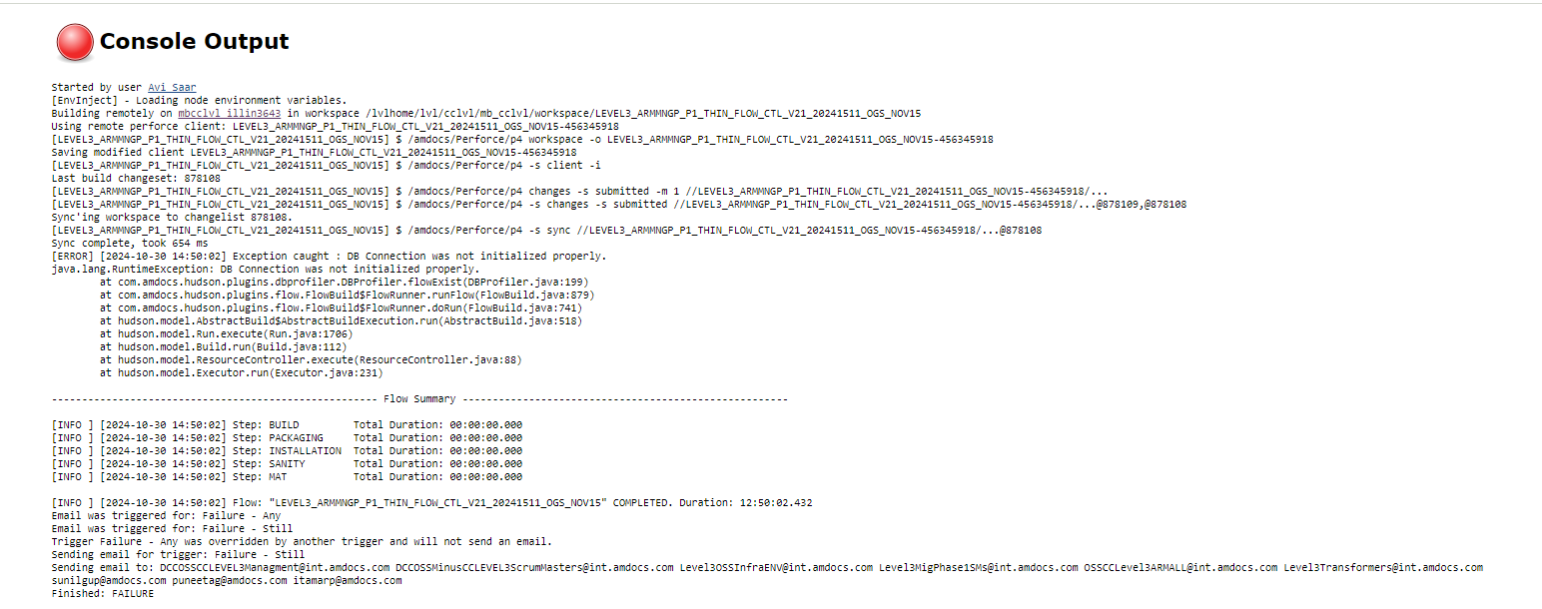
Started by user Avi Saar
[EnvInject] - Loading node environment variables.
Building remotely on mbcclvl_illin3643 in workspace /lvlhome/lvl/cclvl/mb_cclvl/workspace/LEVEL3_ARMMNGP_P1_THIN_FLOW_CTL_V21_20241511_OGS_NOV15
Using remote perforce client: LEVEL3_ARMMNGP_P1_THIN_FLOW_CTL_V21_20241511_OGS_NOV15-456345918
[LEVEL3_ARMMNGP_P1_THIN_FLOW_CTL_V21_20241511_OGS_NOV15] $ /amdocs/Perforce/p4 workspace -o LEVEL3_ARMMNGP_P1_THIN_FLOW_CTL_V21_20241511_OGS_NOV15-456345918
Saving modified client LEVEL3_ARMMNGP_P1_THIN_FLOW_CTL_V21_20241511_OGS_NOV15-456345918
[LEVEL3_ARMMNGP_P1_THIN_FLOW_CTL_V21_20241511_OGS_NOV15] $ /amdocs/Perforce/p4 -s client -i
Last build changeset: 878108
[LEVEL3_ARMMNGP_P1_THIN_FLOW_CTL_V21_20241511_OGS_NOV15] $ /amdocs/Perforce/p4 changes -s submitted -m 1 //LEVEL3_ARMMNGP_P1_THIN_FLOW_CTL_V21_20241511_OGS_NOV15-456345918/...
[LEVEL3_ARMMNGP_P1_THIN_FLOW_CTL_V21_20241511_OGS_NOV15] $ /amdocs/Perforce/p4 -s changes -s submitted //LEVEL3_ARMMNGP_P1_THIN_FLOW_CTL_V21_20241511_OGS_NOV15-456345918/...@878109,@878108
Sync'ing workspace to changelist 878108.
[LEVEL3_ARMMNGP_P1_THIN_FLOW_CTL_V21_20241511_OGS_NOV15] $ /amdocs/Perforce/p4 -s sync //LEVEL3_ARMMNGP_P1_THIN_FLOW_CTL_V21_20241511_OGS_NOV15-456345918/...@878108
Sync complete, took 654 ms
[ERROR] [2024-10-30 14:50:02] Exception caught : DB Connection was not initialized properly.
java.lang.RuntimeException: DB Connection was not initialized properly.
at com.amdocs.hudson.plugins.dbprofiler.DBProfiler.flowExist(DBProfiler.java:199)
at com.amdocs.hudson.plugins.flow.FlowBuild$FlowRunner.runFlow(FlowBuild.java:879)
at com.amdocs.hudson.plugins.flow.FlowBuild$FlowRunner.doRun(FlowBuild.java:741)
at hudson.model.AbstractBuild$AbstractBuildExecution.run(AbstractBuild.java:518)
at hudson.model.Run.execute(Run.java:1706)
at hudson.model.Build.run(Build.java:112)
at hudson.model.ResourceController.execute(ResourceController.java:88)
at hudson.model.Executor.run(Executor.java:231)

------------------------------------------------------ Flow Summary ------------------------------------------------------

[INFO ] [2024-10-30 14:50:02] Step: BUILD Total Duration: 00:00:00.000
[INFO ] [2024-10-30 14:50:02] Step: PACKAGING Total Duration: 00:00:00.000
[INFO ] [2024-10-30 14:50:02] Step: INSTALLATION Total Duration: 00:00:00.000
[INFO ] [2024-10-30 14:50:02] Step: SANITY Total Duration: 00:00:00.000
[INFO ] [2024-10-30 14:50:02] Step: MAT Total Duration: 00:00:00.000

[INFO ] [2024-10-30 14:50:02] Flow: "LEVEL3_ARMMNGP_P1_THIN_FLOW_CTL_V21_20241511_OGS_NOV15" COMPLETED. Duration: 12:50:02.432
Email was triggered for: Failure - Any
Email was triggered for: Failure - Still
Trigger Failure - Any was overridden by another trigger and will not send an email.
Sending email for trigger: Failure - Still
Sending email to: DCCOSSCCLEVEL3Managment@int.amdocs.com DCCOSSMinusCCLEVEL3ScrumMasters@int.amdocs.com Level3OSSInfraENV@int.amdocs.com Level3MigPhase1SMs@int.amdocs.com OSSCCLevel3ARMALL@int.amdocs.com Level3Transformers@int.amdocs.com sunilgup@amdocs.com puneetag@amdocs.com itamarp@amdocs.com
Finished: FAILURE

FIX:

Restart Jenkins and found instance is down:

Oct 30, 2024 2:50:01 PM com.amdocs.hudson.utils.DBConnections.DatabaseUtils createNewCoiConn
SEVERE: problem establishing conenction to DB jdbc:oracle:thin:@illin3643:1521:L3JENKIN .
java.sql.SQLException: Listener refused the connection with the following error:
ORA-12505, TNS:listener does not currently know of SID given in connect descriptor

Boot instance and check build again

ISSUE:

Hi Araceli/Avi,
The LDAP implementation now needs to be performed on IAT03, and this env is not in a working condition.
Since the timelines to perform ldap changes on PROD is this weekend, we need to prioritize this item to the top of the list.
The UAMS DB that it points to is “AMDDRDBADC02.ADC1.LEVEL3.COM:1521/ASRIR05U”, and the DB details is incorrect.
It seems the Consul is setup with that DB Details.
Do you have an idea of how to update the consul details , because updating asm_home/uams.properties is not helping.
Because on ONP Restart its reverting the values in uams.properties to whats there in the consul.
Correct UAMS DB Details are : AMDUATDB02.ADC1.LEVEL3.COM:1521/ASRIR05U

FIX:
I would like to summarize the steps I did for the onp issue:

As Arvind mention the DB details are incorrect and onp is not getting up with correct details.

- Under ANN env login to pushToCC_ONP/dbp and update the DB details in onp.properties file. (make backup before)
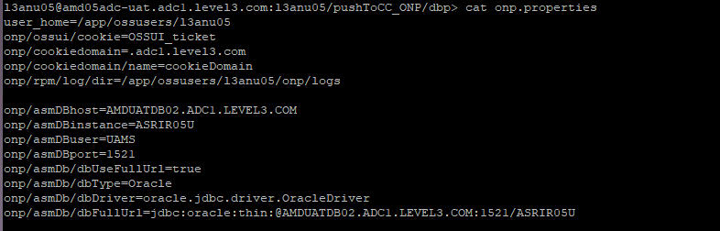

- Take onp down and run onp installation:
cd asm_home ( on the home directory )
vi uams.properties ( update the UAMS password to set UAMS password to plain text)
ll /app/ossusers/l3arm05/JEE/l3arm05Domain/WLS/l3arm05Domain/ASM_HOME

cp /app/ossusers/l3arm05/JEE/l3arm05Domain/WLS/l3arm05Domain/ASM_HOME/uams_ctc.xml .
cp /app/ossusers/l3arm05/JEE/l3arm05Domain/WLS/l3arm05Domain/ASM_HOME/uams_mm.store .

- sourced the property file (run it from home directory)
$ . ./onp_properties.sh
- cd onp-ansible-orchestration/
- ran the onp prepare yaml
$ ansible-playbook onp-p2cc-prepare.yml -i inventory -vvv | tee -a onp-pcc-prepare.log
- ran the onp encrypt yaml
$ ansible-playbook onp-p2cc-encrypt.yml -i inventory -vvv | tee -a onp-pcc-encrypt.log
- loaded in to consul
/opt/amdocs/fnd/P2CC/scripts/populate_to_consul.sh -repo $HOME/pushToCC_ONP

check UAMS is connected fine:
~/cc_home/tools/cc-tool --string='${cc:onp/sso/bootstrap/password}' -au SysCtcUser -ah ~/asm_home
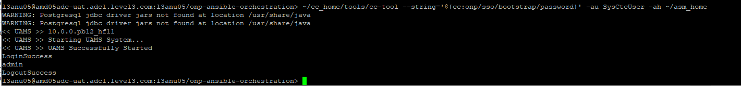
After onp installation run successfully please do the following changes:
in /opt/amdocs/onp/etc

As root update /opt/amdocs/onp/onp-server/conf/sso.properties.template, comment out the lines:
#com.amdocs.onp.sso.integration.provider.uxf.uams.db.host
#com.amdocs.onp.sso.integration.provider.uxf.uams.db.instance
This will prevent uams.properties from being auto-generated.
Add the following line to /opt/amdocs/onp/onp-server/conf/sso.properties.template so that the custom integration is used.
com.amdocs.onp.sso.integration.adapter.uxf.uams.system_properties = amdocs.uams.config.resource=config/cust/ad/cramer

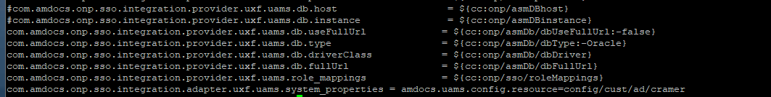
- for this one I copy the file to another directory and update it.
- Then I copy it back

sudo cp sso.properties.template /opt/amdocs/onp/onp-server/conf/.

Also need to change onp/bin/start.sh , add these lines to the bottom of the file
sed -I ‘/*LOGIN_STEPS/d’ ~/asm_home/uams.properties
sed -I ‘/*LOGOUT_STEPS/d’ ~/asm_home/uams.properties
source ${FND_TOMCAT}/scripts/lib/tomcatInstanceActivateLib.sh

Then add this to the end of onp/bin/setenv.sh.template
echo "LOGIN_STEPS=step.init, step.log, step.account.update, step.ldap.autho, step.ldap.update.properties, step.account, step.props, step.sess, step.multibackend.auth, step.constraint, step.ext.tkt, step.profile" >> ~/asm_home/uams.properties
echo "LOGOUT_STEPS=step.auth, step.account, step.multibackend.auth, step.log, step.sess" >> ~/asm_home/uams.properties

We can then add the LDAP config to uams.properties

Finally, as root add the custom jar file casm9_classes.jar to /opt/amdocs/onp/sso-adapter-uxf-war/AmdocsOSS/wars/sso-adapter-uxf-war.war in WEB-INF/lib
Please boot onp and check.
ISSUE:

Stuck thread Error in MS1 Console Logs:

Avi/Soumya , as i can see Stuck thread Error in MS1 Console Logs ?

Please check this

<Mar 11, 2025 1:21:01,658 PM SAST> <Error> <WebLogicServer> <BEA-000337> <[STUCK] ExecuteThread: '14' for queue: 'weblogic.kernel.Default (self-tuning)'
has been busy for "695" seconds working on the request "Http Request Information: weblogic.servlet.internal.ServletRequestImpl@29384fbe[POST /crm]
", which is more than the configured time (StuckThreadMaxTime) of "600" seconds in "server-failure-trigger". Stack trace:
java.util.logging.FileHandler.publish(FileHandler.java:698)
java.util.logging.Logger.log(Logger.java:738)
amdocs.core.logging.Logger.log_(Logger.java:1194)
amdocs.core.logging.Logger.doLog(Logger.java:1167)
amdocs.core.logging.Logger.log(Logger.java:1022)
amdocs.core.CoreRuntimeException.logThis(CoreRuntimeException.java:185)
amdocs.core.CoreRuntimeException.<init>(CoreRuntimeException.java:118)
com.amdocs.uif.common.UifRuntimeException.<init>(UifRuntimeException.java:100)
com.amdocs.uif.common.UifDisplayableException.<init>(UifDisplayableException.java:45)
com.amdocs.uif.common.SessionTimedOutException.<init>(SessionTimedOutException.java:19)
com.amdocs.uif.server.UifServerRequestResponseMgr.dispatch(UifServerRequestResponseMgr.java:928)
com.amdocs.uif.server.UifController.doPost(UifController.java:453)
javax.servlet.http.HttpServlet.service(HttpServlet.java:707)
javax.servlet.http.HttpServlet.service(HttpServlet.java:790)
com.amdocs.oss.sm.core.internal.UifControllerProxy.service(UifControllerProxy.java:36)
weblogic.servlet.internal.StubSecurityHelper$ServletServiceAction.run(StubSecurityHelper.java:295)
weblogic.servlet.internal.StubSecurityHelper$ServletServiceAction.run(StubSecurityHelper.java:260)
weblogic.servlet.internal.StubSecurityHelper.invokeServlet(StubSecurityHelper.java:137)

Same with MS2 Console Logs

<Mar 11, 2025 2:30:16,855 PM SAST> <Error> <WebLogicServer> <BEA-000337> <[STUCK] ExecuteThread: '44' for queue: 'weblogic.kernel.Default (self-tuning)' has been busy for "688" seconds working on the request "Http Request Information: weblogic.servlet.internal.ServletRequestImpl@7c345892[POST /crm]
", which is more than the configured time (StuckThreadMaxTime) of "600" seconds in "server-failure-trigger". Stack trace:
java.util.logging.FileHandler.publish(FileHandler.java:698)
java.util.logging.Logger.log(Logger.java:738)
amdocs.core.logging.Logger.log_(Logger.java:1194)
amdocs.core.logging.Logger.doLog(Logger.java:1167)
amdocs.core.logging.Logger.log(Logger.java:1022)
amdocs.core.CoreRuntimeException.logThis(CoreRuntimeException.java:185)
amdocs.core.CoreRuntimeException.<init>(CoreRuntimeException.java:118)
com.amdocs.uif.common.UifRuntimeException.<init>(UifRuntimeException.java:100)
com.amdocs.uif.common.UifDisplayableException.<init>(UifDisplayableException.java:45)
com.amdocs.uif.common.SessionTimedOutException.<init>(SessionTimedOutException.java:19)
com.amdocs.uif.server.UifServerRequestResponseMgr.dispatch(UifServerRequestResponseMgr.java:928)
com.amdocs.uif.server.UifController.doPost(UifController.java:453)
javax.servlet.http.HttpServlet.service(HttpServlet.java:707)
javax.servlet.http.HttpServlet.service(HttpServlet.java:790)
com.amdocs.oss.sm.core.internal.UifControllerProxy.service(UifControllerProxy.java:36)
weblogic.servlet.internal.StubSecurityHelper$ServletServiceAction.run(StubSecurityHelper.java:295)
weblogic.servlet.internal.StubSecurityHelper$ServletServiceAction.run(StubSecurityHelper.java:260)
weblogic.servlet.internal.StubSecurityHelper.invokeServlet(StubSecurityHelper.java:137)
weblogic.servlet.internal.ServletStubImpl.execute(ServletStubImpl.java:353)

FIX: we need to provide the Stuck thread log to the divlaloper.
Login to the PROD server

prdsom1@bssprd122
mkdir thread_dump
do psu to see the process id.
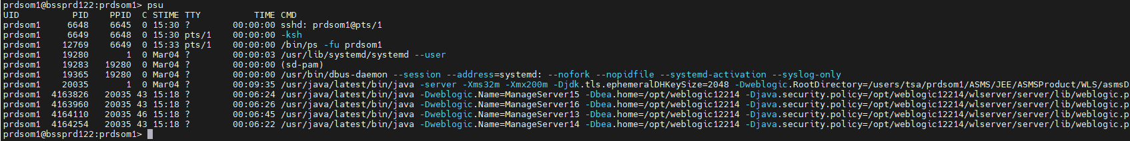
Login to thread_dump folder and run:
jstack 4164110 > MageServer13.thread_dump
this will create the log which DEV need to check:
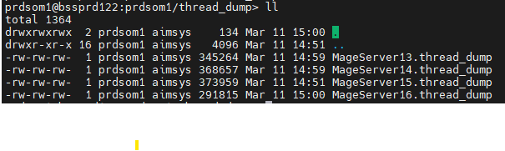

do the same in all servers which have the issue.

Login to console server MangeServer1,2,3,4,5……..

Go to Monitoring Threads

See if we have 0 which is good or other which is not good.

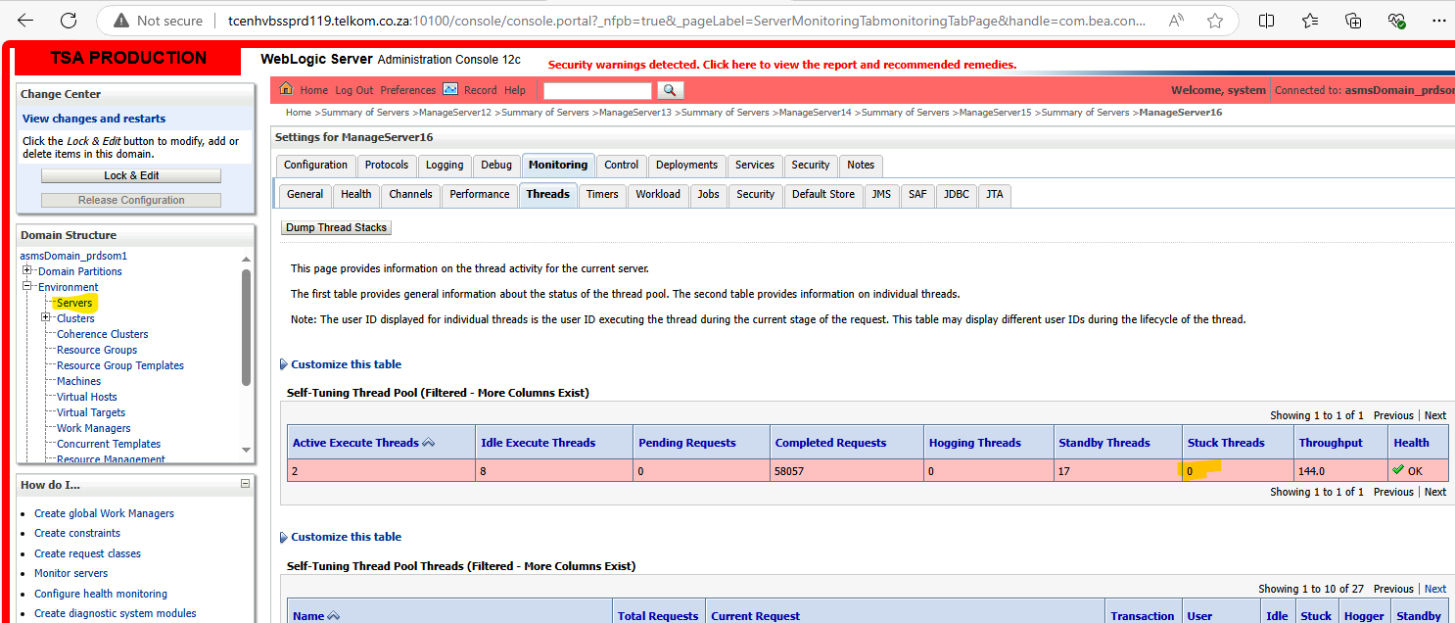

In case we don’t have 0 please run the thread_dump as we did above:

Login to thread_dump folder and run:
jstack 4164110 > MageServer13.thread_dump

ISSUE:

When running installation on somusr01@ilostsa2005 I am getting this issue:

TSA-4400-SM_installation_4400 #3 Console [Jenkins]

+ scp 'mb_cctsa3@ilostsa006:/osshome/os/mb_cctsa3/workspace/TSA_4400_SM_NIGHTLY_CI_FLOW/xpi/target/output/*.lic' /osshome/os/somusr01
+ scp mb_cctsa3@ilostsa006:/osshome/os/mb_cctsa3/workspace/TSA_4400_SM_NIGHTLY_CI_FLOW/xpi/target/output/License.dtd /osshome/os/somusr01
+ scp 'mb_cctsa3@ilostsa006:/osshome/os/mb_cctsa3/workspace/TSA_4400_SM_NIGHTLY_CI_FLOW/xpi/target/output/asms-*-package-*-Linux.jar' /osshome/os/somusr01
+ scp mb_cctsa3@ilostsa006:/osshome/os/mb_cctsa3/workspace/TSA_4400_SM_NIGHTLY_CI_FLOW/xpi/target/output/silent/topology/single_instance_local_rdm.topology /osshome/os/somusr01
+ scp mb_cctsa3@ilostsa006:/osshome/os/mb_cctsa3/workspace/TSA_4400_SM_NIGHTLY_CI_FLOW/xpi/target/output/amdocs-installer.tar /osshome/os/somusr01
+ scp 'mb_cctsa3@ilostsa006:/osshome/os/mb_cctsa3/workspace/TSA_4400_SM_NIGHTLY_CI_FLOW/xpi/target/output/xps-*.jar' /osshome/os/somusr01
+ scp 'mb_cctsa3@ilostsa006:/osshome/os/mb_cctsa3/workspace/TSA_4400_SM_NIGHTLY_CI_FLOW/xpi/target/output/ASM-*.jar' /osshome/os/somusr01
+ echo 'XPI Installation.'
XPI Installation.
+ ./installer/bin/xpi_installer.sh --mem huge --perm huge -i -p /osshome/os/somusr01/asms-tsa-9.22.0.2-package-daily-56-Linux.jar -t single_instance_local_rdm.topology -pr single_instance_local_rdm.properties
Java HotSpot(TM) 64-Bit Server VM warning: ignoring option MaxPermSize=512m; support was removed in 8.0
OSGi container failure
org.osgi.framework.BundleException: The bundle "com.amdocs.xpi.packmgmt_9.22.0.8_202302020326 [1]" could not be resolved. Reason: Missing Constraint: Import-Package: com.amdocs.config; version="0.0.0"
at org.eclipse.osgi.framework.internal.core.AbstractBundle.getResolverError(AbstractBundle.java:1317)
at org.eclipse.osgi.framework.internal.core.AbstractBundle.getResolutionFailureException(AbstractBundle.java:1301)
at org.eclipse.osgi.framework.internal.core.BundleHost.startWorker(BundleHost.java:319)
at org.eclipse.osgi.framework.internal.core.AbstractBundle.start(AbstractBundle.java:284)
at org.eclipse.osgi.framework.internal.core.AbstractBundle.start(AbstractBundle.java:276)
at com.amdocs.installer.Main.installBundles(Main.java:246)
at com.amdocs.installer.Main.main(Main.java:88)
+ [ 255 -eq 0 ]
+ echo 'Xpi Installation Failed please check Xpi logs '
Xpi Installation Failed please check Xpi logs
+ exit 1
Build step 'Execute shell' marked build as failure
Finished: FAILURE

FIX:

Please copy the installer folder from other env.

I copy it from somusr01@ilostsa2008

somusr01@ilostsa2008.corp.amdocs.com:somusr01> scp -r installer somusr01@ilostsa2005:

ISSUE:

Hi Amdocs Team,

Post IAT4 upgrade activities are completed to match June code base. (https://lumen.atlassian.net/browse/EDPSRI-22507) Webswing is failing to come up, tried restarting both ARM and ANN / webswing few times. Seeing below Error in the log. Validated user affsupertst is not locked in IAT4 in ASM smart admin. Could you please take a look and assist us in resolving this issue further.

faultString: com.cramer.core.common.CramerException caused by java.lang.Exception: Invalid user name affsupertst or password or your user account is locked.
at com.cramer.core.sso.ASMTicketHelper.login(ASMTicketHelper.java:439)

FIX:
Hello Avi,

First, I took a backup and then updated the username and password information for affsupertst and applied the changes to the file.
Once you restart the environment, the information in that file gets encrypted.

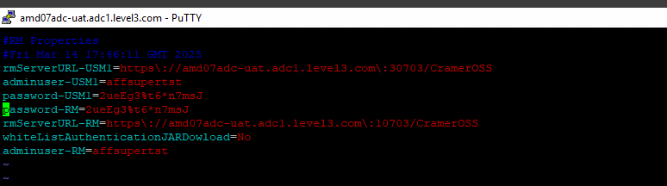

ISSUE:

When installation ANN env I am getting this issue:

"https://ilcap03.corp.amdocs.com/pulp/content/Amdocs_IT/DEV/RH79/content/dist/rhel/server/7/7.9/x86_64/os/repodata/repomd.xml: [Errno 14] curl#60 - \"Peer's certificate issuer has been marked as not trusted by the user.\"",
"Trying other mirror.",

FIXED:

Please do the following steps with sudo permission

subscription-manager unregister
subscription-manager clean
yum clean all
rpm -qa | grep katello | xargs rpm -e
rpm -Uvh http://ilcap03.corp.amdocs.com/pub/katello-ca-consumer-latest.noarch.rpm
subscription-manager register --org="Amdocs_IT" --activationkey="RH79" --force
subscription-manager repos --disable=* --enable=rhel*

If it’s not working, ask UNIX team to fix. (Daniel Piatkovsky help me on this)

ISSUE:

- Please share how you fix the issue on report IAT3 when booting WL?

User credentials have expired
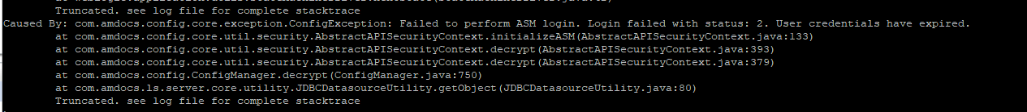

FIXED:

Cd to ASM_HOME

Vi uams_ctc.xml

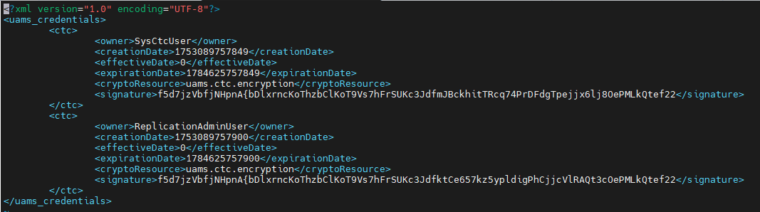

Check the expirationdate:

<expirationDate>1784625757849</expirationDate>

Take just the number in yellow and put it in site:

https://www.epochconverter.com/

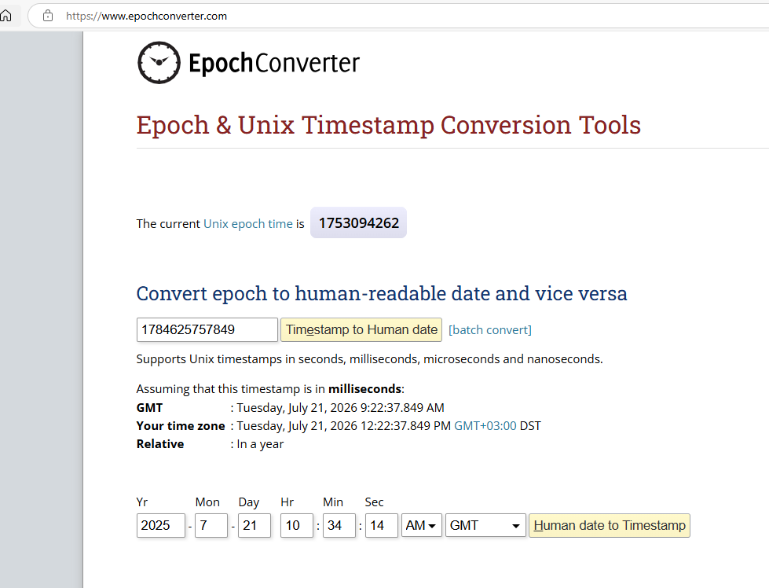

It will provide you the expirationDate of the User credentials.

Please ask Rick to fix it.

ISSUE:

After reboot AMC on Site I am getting this problem:

Connection could not be established, IO Error: The Network Adapter could not establish the connection
amdocs.uams.UamsNotFoundException: <<UAMS 900008: Object Tksmau33GCd6VqaHHYadGEmgrp7GhPcaq29ZkO40 was not found in the repository.>>
at

FIX:
every time the HF tool gets restarted it reverts to old DB

I have this file in there that I copy back after restart. AmcRunSqlPIConList.xml_updated

l3amc@amd03adc-uat.adc1.level3.com:l3amc/Amc-amd03adc-uat.adc1.level3.com/config>

so you are doing after restart cp AmcRunSqlPIConList.xml_updated AmcRunSqlPIConList.xml

now AMC is working fine.

