Citrix login:

User: AD29315

Password: PossibleWelcome40

Share doc:
https://amdocs.sharepoint.com/sites/CenturyLinkOSSDevelopmentTeam/Shared%20Documents/Forms/AllItems.aspx?newTargetListUrl=/sites/CenturyLinkOSSDevelopmentTeam/Shared%20Documents&viewpath=/sites/CenturyLinkOSSDevelopmentTeam/Shared%20Documents/Forms/AllItems.aspx&id=/sites/CenturyLinkOSSDevelopmentTeam/Shared%20Documents/Infra%20Documents&viewid=c4b786e1-4863-4c5c-bc0d-8ad1ece298eb

HF TOOL on site:

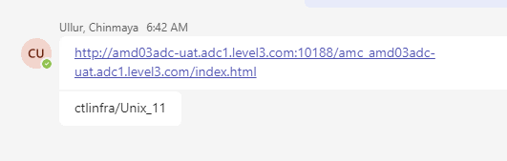

ARM CI - http://illin3643.corp.amdocs.com:7001/jenkins/view/Builds/

ARM Build machine - mb_cclvl_illin3643 / Technology11!

mb_cclvl@illin3643
4Getit$
PET ODO new order
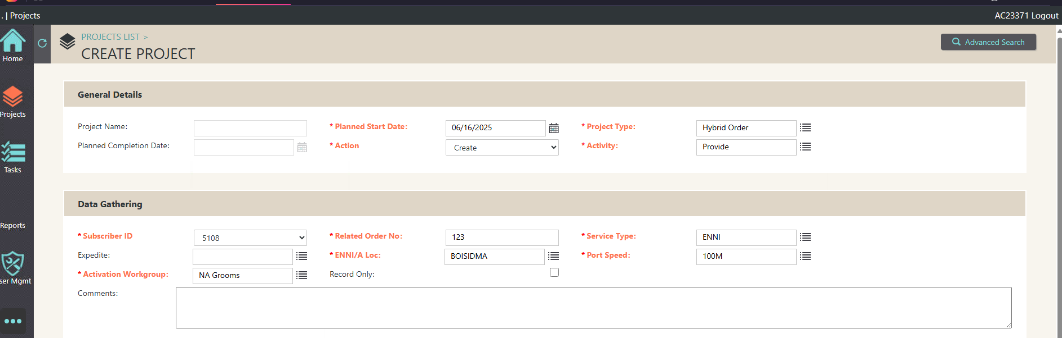
Jenkins:
ssh jenkins@illin3643
Technology11!
NEXUS:
Ssh nexus@illin3643

Technology11!

NEXUS GUI: http://illin3643:8081/nexus/#welcome
admin/admin123
ARM2101 CI - http://iloslvl011.corp.amdocs.com:7001/jenkins/view/ARM2101%20CI%20FLOW/

ARM Devmain CI env - ssh l3rci400@iloslvl004
SFO (ODO) jenkins - http://illin569:7070/view/Builds/

ssh jenkins@illin569
Unix11!
Jenkins
sonar@illin569
4Getit$

sstart='/lvlhome/lvl/cclvl/sonar/Sonar/sonarqube-4.0/bin/linux-x86-64/sonar.sh start'

AMC :
avisaa / Unix11!
http://illin3643:10888/amc_illin3643
http://illin569:10888/amc_illin569

CTL_V10_20232001_OGS_JAN20

l3rci400 - ARM
l3aci400 - ANN
l3ici400 - IWS
l3uci400 - USM
l3oci400 - ODO
l3rpci400 - Reports

ST Refresh jenkins - http://iloslvl011.corp.amdocs.com:7001/jenkins/view/ST_Incremental_Refresh/
iloslvl063
[11:11 AM] Aman Dua
jenkins@iloslvl011
Technology11!

*Level3 OSS Infra ENV <Level3OSSInfraENV@amdocs.com>

Transfer BUILD to site After it’s in the JUMP server:

Login to citrix: using CUID username/password

CITRIX: MyWorkSpace Portal (centurylink.com)
then it will ask for Mobile+ code
login to putty
use this server to pick up build from jump server

login to this server using own unix credentials
(we use oleg user to login to the putty)
then "sudo su - l3adm"

cd /app/infraoss/l3/STORAGE

run below on CTL server

scp -rp l3adm@10.1.113.81:~/STORE_469_7.tar.gz .

Technology11!

just need to copy the tar.gz , CTL infra will do the rest

ARM and ANN 2021 Steps for restart ANN 21 on St4:

ARM:ctlrm01@iloslvl034
ANN:l3stann4@illin2134
Technology11!
- In ANN we need the console to be up:

consul/scripts

nohup ./startAgent.sh &

Step 1 - Kill everything running
ps -fu $USER | grep java | grep -v slave | grep -v grep | awk '{print $2}' | xargs kill -9

If cache needs to be cleared
cd /ossuser1/oss/oss/l3stann4/JEE/annDomain/servers/AdminServer
rm -rf tmp cache
cd /ossuser1/oss/oss/l3stann4/JEE/annDomain/servers/ANNServer
rm -rf tmp cache

Step 2 - Run the below aliases to Start the Apps one by one.

onprestart (this one will boot the console):

check log - /ossuser1/oss/oss/l3stann4/onp/logs/catalina.out

(we can do it manually by login to consul/scripts and run: nohup ./startAgent.sh &)

nodestart

adminstart
check last admin server log - /ossuser1/oss/oss/l3stann4/JEE/logs/adminserver*
Wait till RUNNING

annstart
check last ANN server log - /ossuser1/oss/oss/l3stann4/JEE/logs/AnnServer_*
Wait till RUNNING

webstart
Check log - /ossuser1/oss/oss/l3stann4/JEE/WebSwing/webswing.out

Step3 - Done

simonba/Welcome1
Move HF Manually:

- Login to: l3amc@illin3643 (Technology11!)
l3amc@illin3643:l3amc/hotfix/HOTFIX/ARM/Release_DEV_PROD_20012023
Technology11!

- run: scp -r HF_100034100 l3adm@illin4249:.

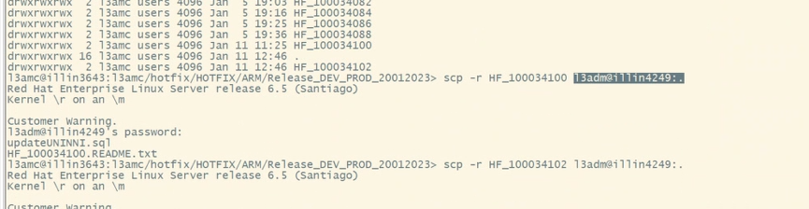

3.
Login to citirx server and do the copy:

Amcd0

scp -rp l3adm@10.1.113.81:~/HF_100034102 .
Illin4336 10.1.113.80
Illin4249 10.1.113.81

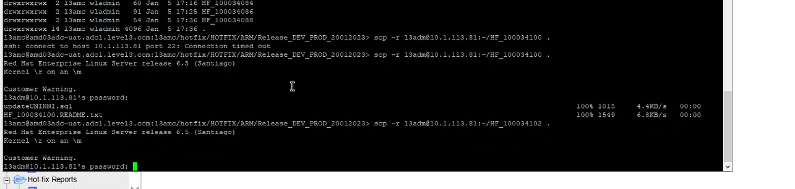

AMC on site:

Amc (level3.com)
http://amd03adc-uat.adc1.level3.com:10188/amc_amd03adc-uat.adc1.level3.com/

Avisaar

Unix11!
UNIX on site:
13amc@amd03adc-uat.adc1.level3.com

ONP ISSUE:

When login to ANN GUI I am getting this issue:

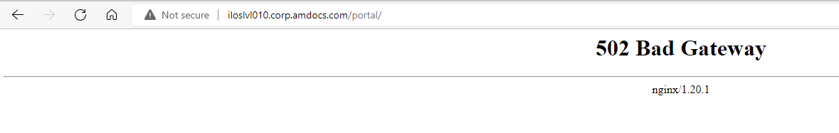

When trying to boot onp I am getting:

3aci404@iloslvl010.corp.amdocs.com:l3aci404>onprestart
Job for amdocs-onp-tomcat@l3aci404.service failed because start of the service was attempted too often. See "systemctl status amdocs-onp-tomcat@l3aci404.service" and "journalctl -xe" for details.
To force a start use "systemctl reset-failed amdocs-onp-tomcat@l3aci404.service" followed by "systemctl start amdocs-onp-tomcat@l3aci404.service" again.

[Tue Jun 27 13:33:12 IDT 2023] [ERROR] Evaluation of /ossusers1/oss/users/l3aci404/onp/conf/server.xml.template file fails. Exiting.
[Tue Jun 27 13:33:42 IDT 2023] [WARN] CATALINA_PID_DIR is empty. CATALINA_PID_DIR will be set to /ossusers1/oss/users/l3aci404/onp/logs.

[Tue Jun 27 13:33:44 IDT 2023] [ERROR] Evaluation of /ossusers1/oss/users/l3aci404/onp/conf/server.xml.template file fails. Exiting.

FIX:

I did the following...
- recreate asm_home (copied uams_ctc.xml and uams_mm.store from ARM) and set UAMS password to plain text in uams.properties
cd asm_home
vi uams.properties ( update the UAMS password to set UAMS password to plain text)
ll /ossusers1/oss/users/l3rci404/JEE/armdomain/WLS/armdomain/ASM_HOME
cp /ossusers1/oss/users/l3rci404/JEE/armdomain/WLS/armdomain/ASM_HOME/uams_ctc.xml .
cp /ossusers1/oss/users/l3rci404/JEE/armdomain/WLS/armdomain/ASM_HOME/uams_mm.store .

- sourced the property file (run it from home directory)
$ . ./onp_properties.sh
- cd onp-ansible-orchestration/
- ran the onp prepare yaml
$ ansible-playbook onp-p2cc-prepare.yml -i inventory -vvv | tee -a onp-pcc-prepare.log
- ran the onp encrypt yaml
$ ansible-playbook onp-p2cc-encrypt.yml -i inventory -vvv | tee -a onp-pcc-encrypt.log
- loaded in to consul
/opt/amdocs/fnd/P2CC/scripts/populate_to_consul.sh -repo $HOME/pushToCC_ONP

[2:20 PM] Simon Baddeley
you can then check the decryption
[2:20 PM] Simon Baddeley
~/cc_home/tools/cc-tool --string='${cc:onp/sso/bootstrap/password}' -au SysCtcUser -ah ~/asm_home
[2:21 PM] Simon Baddeley
should return a password rather than an encrypted string

Upload file to NEXUS:
Ssh nexus@illin3643

Technology11!

NEXUS GUI: http://illin3643:8081/nexus/#welcome
admin/admin123
NEXUS GUI: http://illin569:8081/nexus/#welcome
admin/admin123

- login to nexus GUI
- go to this path for taking just the details:

http://illin3643:8081/nexus/#view-repositories;releases~browseindex
Group: com.cramer.ann.search-webapp
Artifact: search-webapp-ear

Version: 21.0.0.1 ( depend on the version )

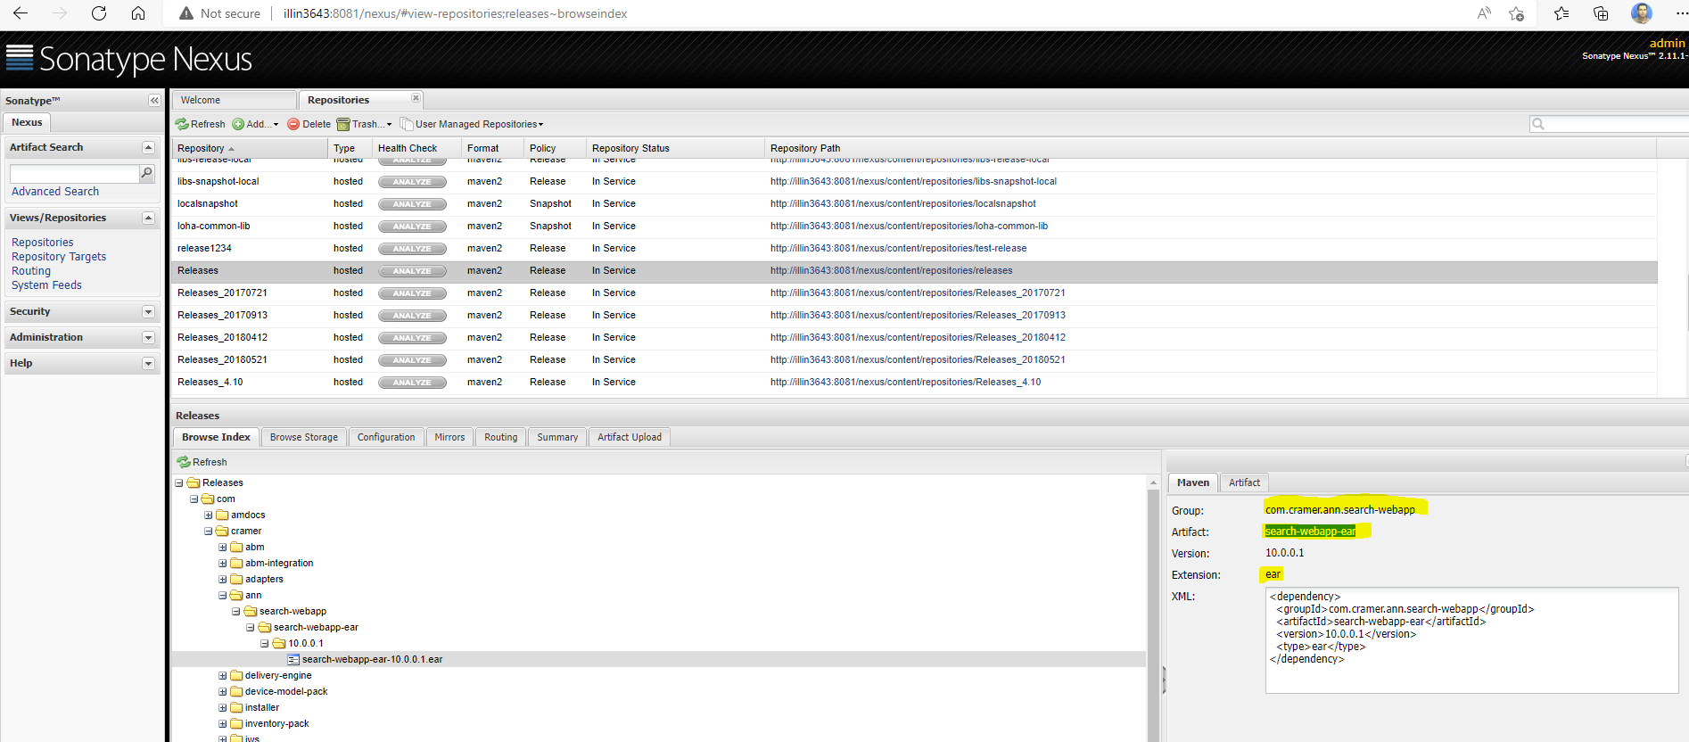

- login to Repositories -> Releases -> and click on Artifact Upload tab
http://illin3643:8081/nexus/#view-repositories;releases~uploadPanel

- put the details you need : ( the name of the ear we put is search-webapp-ear even the ear name we save on our PC is search-webapp-ear-21.0.0.1.ear )

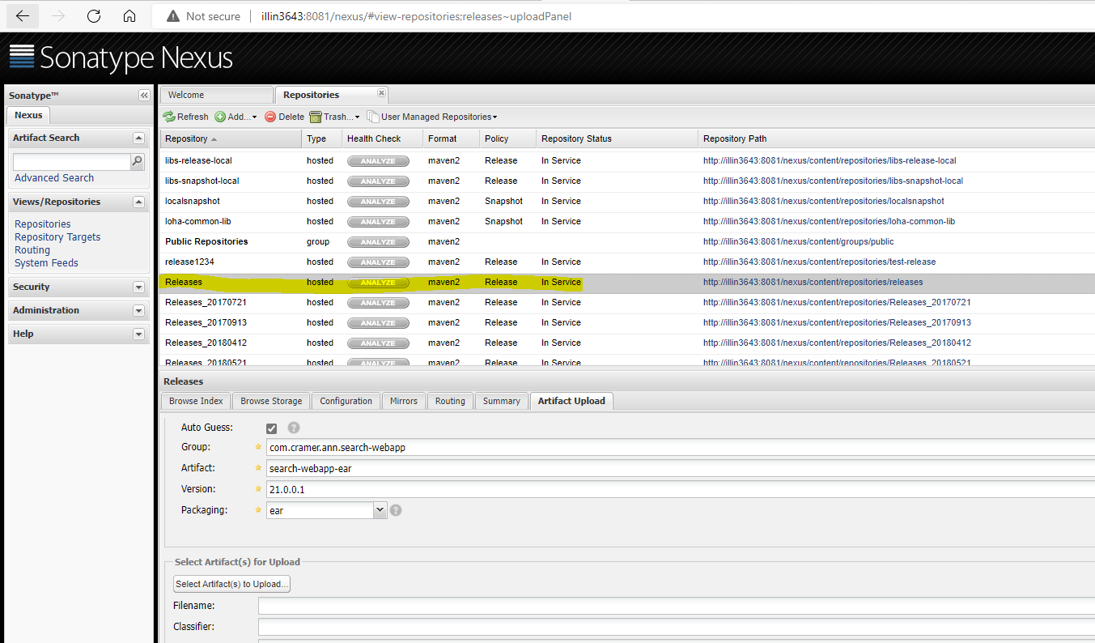

Now click on “Select Artifact to Upload”

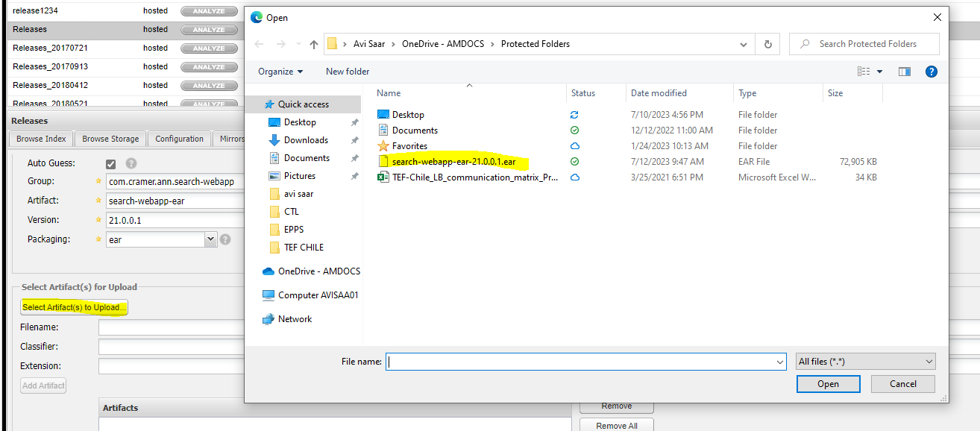
After this part do the following:
click on “Upload Artifact”
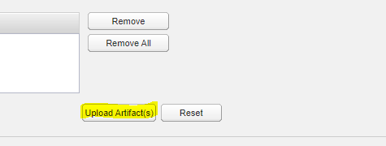

Change parameters in file for nexus issue:

  - Put the war file backup folder tal and open it:
  - Check which files need to be updated
  - jar -tvf sfo-war-10.0.0.0.0.war.30.10.23 | grep npm-shrinkwrap.json
  - don’t open all the war. release just the file we need to update:

jar -xvf sfo-war-10.0.0.0.0.war.30.10.23 app/amdocs/smallcell/components/business//:q!:/npm-shrinkwrap.json

- update the file: cd app/amdocs/smallcell/components/business/projects-list/
- vi npm-shrinkwrap.json
- pack the file to the war:
jar -uvf sfo-war-10.0.0.0.0.war.30.10.23 app/amdocs/smallcell/components/business/projects-list/npm-shrinkwrap.json

- delete the app file which you open:
rm -rf app
- do the same for all files you need to update

jar -xvf sfo-war-10.0.0.0.0.war.30.10.23 app/amdocs/smallcell/components/business/projects-list/npm-shrinkwrap.json

Change parameters in file for nexus issue:

  - Put the war file backup folder tal and open it:

/lvlhome/lvl/cclvl/mb_cclvl/.m2_CTL_V21_20232508_OGS_AUG25/repository/com/amdocs/oss/sfo/sfo-war/10.0.0.0.0/avi

jar xvf sfo-war-10.0.0.0.0.war

  - Run this coomend to change the ip from 10.247.24.18 to 10.247.24.11:

find -type f | xargs perl -p -i -e 's#10.247.24.18#10.247.24.11#g'

find -type f | xargs perl -p -i -e 's#10.247.24.18#10.247.24.11#g'

  - check if the ip was changed:

1026 find . -type f | xargs grep 10.247.24.18
1027 find . -type f | xargs grep 10.247.24.11

4. run this command to pack the war back in avi folder:

jar uf sfo-war-10.0.0.0.0.war *

put the war back to the main folder.

Hi Team,

IAT4 Issue fixed and GUI is up without any error:

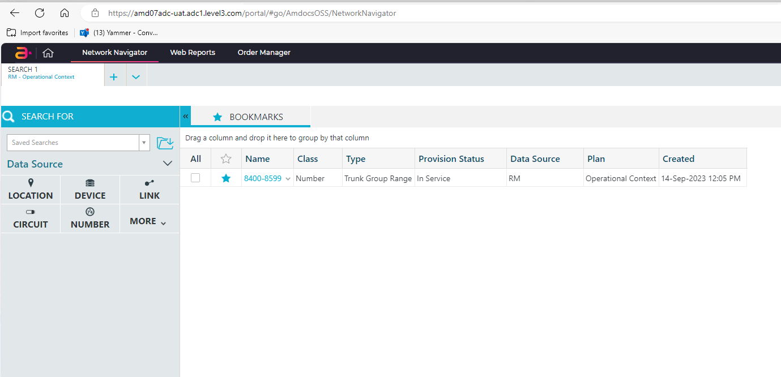

Issue found in WL log:

l3anu07@amd07adc-uat.adc1.level3.com:l3anu07/JEE/logs> less AnnServer_20231011_142424.log
ERROR_CODE=50701: I/O error on GET request for https://amd07adc-uat.adc1.level3.com:443/AmdocsOSS/Configurations/services/rest/v1/config/amdocs.oss.ann.services.url.system: sun.security.validator.ValidatorException: PKIX path building failed: sun.security.provider.certpath.SunCertPathBuilderException: unable to find valid certification path to requested target; nested exception is javax.net.ssl.SSLHandshakeException: sun.security.validator.ValidatorException: PKIX path building failed: sun.security.provider.certpath.SunCertPathBuilderException: unable to find valid certification path to requested target
com.amdocs.oss.ann.exception.SearchException: I/O error on GET request for https://amd07adc-uat.adc1.level3.com:443/AmdocsOSS/Configurations/services/rest/v1/config/amdocs.oss.ann.services.url.system: sun.security.validator.ValidatorException: PKIX path building failed: sun.security.provider.certpath.SunCertPathBuilderException: unable to find valid certification path to requested target; nested exception is javax.net.ssl.SSLHandshakeException: sun.security.validator.ValidatorException: PKIX path building failed: sun.security.provider.certpath.SunCertPathBuilderException: unable to find valid certification path to requested target
at com.amdocs.oss.ann.search.rs.model.proxy.impl.DefaultSystemServiceClientProxy.getSystems(DefaultSystemServiceClientProxy.java:101)
at com.amdocs.oss.ann.search.rs.system.SystemServiceImpl.getProfiledSystems(SystemServiceImpl.java:98)
at sun.reflect.NativeMethodAccessorImpl.invoke0(Native Method)
at sun.reflect.NativeMethodAccessorImpl.invoke(NativeMethodAccessorImpl.java:62)
at sun.reflect.DelegatingMethodAccessorImpl.invoke(DelegatingMethodAccessorImpl.java:43)
at java.lang.reflect.Method.invoke(Method.java:498)
at org.apache.cxf.service.invoker.AbstractInvoker.performInvocation(AbstractInvoker.java:179)
at org.apache.cxf.service.invoker.AbstractInvoker.invoke(AbstractInvoker.java:96)
at org.apache.cxf.jaxrs.JAXRSInvoker.invoke(JAXRSInvoker.java:201)
at org.apache.cxf.jaxrs.JAXRSInvoker.invoke(JAXRSInvoker.java:104)
at org.apache.cxf.interceptor.ServiceInvokerInterceptor$1.run(ServiceInvokerInterceptor.java:59)
at org.apache.cxf.interceptor.ServiceInvokerInterceptor.handleMessage(ServiceInvokerInterceptor.java:96)
at org.apache.cxf.phase.PhaseInterceptorChain.doIntercept(PhaseInterceptorChain.java:308)
at org.apache.cxf.transport.ChainInitiationObserver.onMessage(ChainInitiationObserver.java:121)
at org.apache.cxf.transport.http.AbstractHTTPDestination.invoke(AbstractHTTPDestination.java:267)
This communication is the property of Lumen Technologies and may contain confidential or privileged information. Unauthorized use of this communication is strictly prohibited and may be unlawful. If you have received this communication in error, please immediately notify the sender by reply e-mail and destroy all copies of the communication and any attachments.

Fixing by coping the certificate again:

cd ../anndomain/config/certificates/

mkdir old

mv asri.deviat.keystore.pkcs12 asri.deviat.truststore.pkcs12 old
cp /app/infraoss/l3/STORAGE/INFRA/CERTIFICATES/iatdev/*.pkcs12 .
ANN GUI is not opening:

Please do the following:
sudo systemctl status nginx
sudo systemctl start nginx
sudo systemctl enable nginx

ISSUE:
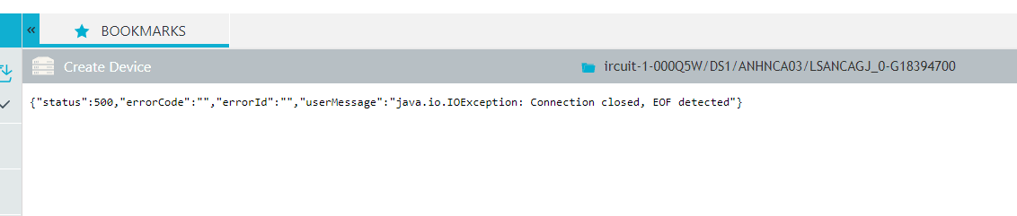

FIX:

Hi Avi,
The fix was to correct the port in dir_attributevalue , the url was https, but the port was incorrectly configured.
Here are the steps to fix the issue.
- Login to ARM CRAMER DB
- Execute below query :
select * from dir_Attributevalue where VALUE like 'http%';

- The query was returning , 10101 (this is http port) as port in the url, I corrected it to 10103 (that’s the https port) .

Incorrect url:
https://amd01adc-uat.adc1.level3.com:10101/CramerOSS/
https://amd01adc-uat.adc1.level3.com:10101/CramerOSS/Client/

Correct URL :
https://amd01adc-uat.adc1.level3.com:10103/CramerOSS/
https://amd01adc-uat.adc1.level3.com:10103/CramerOSS/Client/

Boot TOMCAT:

Login to apache-tomcat-8.5.40/bin
./startup.sh

ps -fu $USER | grep tomcat ( to see process is up)

check log under Login to apache-tomcat-8.5.40/logs

from Arvind:
Hi All,
We found the root cause for the failure on ST04.
The Core HF installation was using some files for preparing the environment again , and due to which it happen to corrupt the env.
Below are the files/folders that I would request INFRA to verify before installing ANN Hotfixes on any env.
As a additional step please verify the below:

- env.properties on root folder of ANN user has all the properties correct.
- Compare CramerConfig.xml, ARMInternal.jar, uams.properties files between
pre-reqs/plugin-resources/USM1 VS JEE/annDomain/plugin-resources/USM1
pre-reqs/plugin-resources/RM VS JEE/annDomain/plugin-resources/RM

Here are the files that were corrupted on ST04, since the hf installation already modified the Webswing and ANN files.
- env.properties having incorrect Instance name (ASRIR01D) on ST04 :
Corrupted Value
rm.2.server.instance=ASRIR01D

Correct value
rm.2.server.instance=CHISR005

Files that got impacted after HF installation:
/ossuser1/oss/oss/l3stann4/JEE/annDomain/plugin-resources/RM/CramerConfig.xml
/ossuser1/oss/oss/l3stann4/JEE/WebSwing/webswing.config

Solution: correct env.properties and also the impacted files.

- L3STRM04 happened due to pre-req had wrong configuration files.
/ossuser1/oss/oss/l3stann4/pre-reqs/plugin-resources/USM1/ASM_HOME/uams.properties

Solution: Correct the DB details inside uams.properties
Align pre-reqs plugin-resources folder with the main/working files.
Compare
/ossuser1/oss/oss/l3stann4/pre-reqs/plugin-resources/
/ossuser1/oss/oss/l3stann4/JEE/annDomain/plugin-resources/

Correct CramerConfig.xml, ARMInternal.jar, uams.properties

- New VPN tunnel
A new VPN tunnel was configured to facilitate HF transfers from Amdocs to Lumen. HF transfer tests were successfully executed using the Jenkins process, and the transferred files were verified on the Lumen server.
The following scripts were updated with the new IP address

User = l3amc
Server = amd03adc-uat.adc1.level3.com
Path=/app/ossusers/l3amc/.SyncHF

Old Velue = export REMOTE_HOST=10.1.113.80
New Value = export REMOTE_HOST=193.43.246.253

